1. Removed the Comparable interface because it never been used. Code smell: Dead code.

**Offending Code:**

public int compareTo(Object o)

{

return 1;

}

1. Made protected field to private in the Hero class because of security.

Offending code: private double chanceToBlock;

In Class Sorceress public field changed to private to prevent access from outside class.

Offending Code:

**public** **final** **int** MIN_ADD = 25;

**public** **final** **int** MAX_ADD = 50;

Changed code:

**private** **final** **int** MIN_ADD = 25;

**private** **final** **int** MAX_ADD = 50;



**Offending Code:**

Public Thief (){  
 super(“Thief”, 75, 6, .8, 20, 40, 0.5);

}

**The above code was changed to the code bellow because it more easy to read and understand.**

**private** **static** String *name*="Thief";

**private** **static** **int** *hitPoints* =75;

**private** **static** **int** *attackSpeed* =6;

**private** **static** **double** *chanceToHit*=.8;

**private** **static** **int** *damageMin*=20;

**private** **static** **int** *damageMax*=40;

**private** **static** **double** *chanceToBlock*=0.5;

**public** Thief()

{

**super**(*name*, *hitPoints*, *attackSpeed*, *chanceToHit*, *damageMin*, *damageMax*, *chanceToBlock*);

}

1. Removed Keyboard class, and instituted Scanner Object throughout code

**Original:** 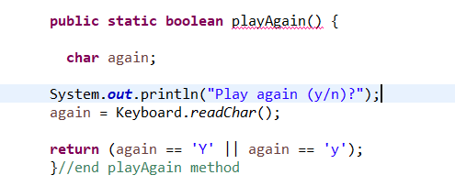

**New:** 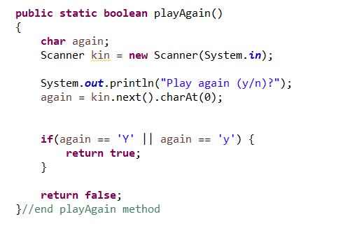

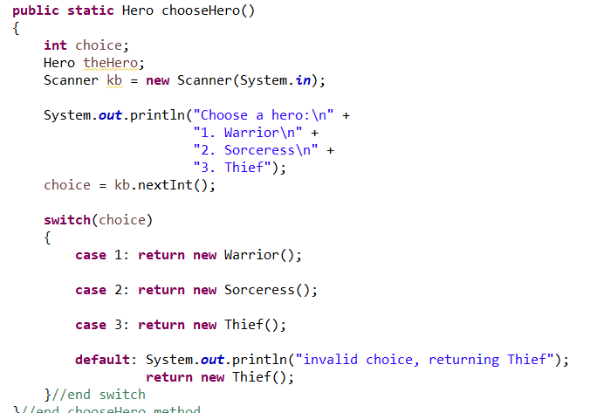

1. We created a HeroFactory class because of object creation is done in one place.

Old code:

public static Hero chooseHero()

{

int choice;

Hero theHero;

Scanner kb = new Scanner(System.in);

System.out.println("Choose a hero:\n" +

"1. Warrior\n" +

"2. Sorceress\n" +

"3. Thief");

choice = kb.nextInt();

switch(choice)

{

case 1: return new Warrior();

case 2: return new Sorceress();

case 3: return new Thief();

default: System.out.println("invalid choice, returning Thief");

return new Thief();

}//end switch

}//end chooseHero method

**New Code :**

**public** **class** HeroFactory {

**public** Hero createHero(){

**int** choice;

System.*out*.println("Choose a hero:\n" +

"1. Warrior\n" +

"2. Sorceress\n" +

"3. Thief");

choice = Keyboard.*readInt*();

Hero hero = **null**;

**if**(choice == 1){

hero = **new** Warrior();

**return** hero;

}**else** **if**(choice == 2){

hero=**new** Sorceress();

**return** hero;

}**else** **if**(choice == 3){

hero = **new** Thief();

**return** hero;

}**else**{

System.*out*.println("invalid choice, returning Thief");

**return** **new** Thief();

}

}

}