
PROJECT DOCUMENTATION
GeoPilot
Your Geospatial Research Companion
Navigate Data. Discover Insights.

 Document details
Author | Md Khadem Ali
Academic affiliation | Department of Geography and Environment, National University, Bangladesh
Research domain | GeoAI and geospatial analytics
Version | 1.0.0 (source release)
Document date | 29 October 2026
License | MIT
Platform | Google Chrome, Manifest V3 (Chrome 116 or later)
GitHub profile | github.com/mdkhademali
Repository | https://github.com/mdkhademali/GeoPilot
Website | khademali.com

Status: not published on the Chrome Web Store. Verified in the build environment: type check, lint, 39 automated tests and the production build. Not yet tested in a live Chrome browser.

Contents
01 |  | Overview
02 |  | Technology stack
03 |  | Features
04 |  | Architecture
05 |  | Permissions and privacy
06 |  | Installation
07 |  | Development scripts
08 |  | Testing
09 |  | Measured build output
10 |  | Project structure
11 |  | Known limitations
12 |  | Chrome Web Store checklist
13 |  | Roadmap
14 |  | Acknowledgements
15 |  | About the author

 1 Overview
GeoPilot is a Manifest V3 Chrome extension for GIS, remote sensing and GeoAI work. A compact popup gives quick access to tools, and a side panel hosts the full workspace. Core tools run locally with no backend, no telemetry and no API keys. The only external request is a DOI lookup to api.crossref.org, and it happens only when the user presses the Look up button.

9  Modules | 8  Spectral indices | 23  Official resources | 39  Tests passing | 0  Host permissions

Verification status
Type check (strict TypeScript), ESLint, Prettier, 39 Vitest tests and the production build all pass in the build environment. The extension has not been loaded or tested in a real Chrome browser, because none was available. See section 11 for what remains unverified.

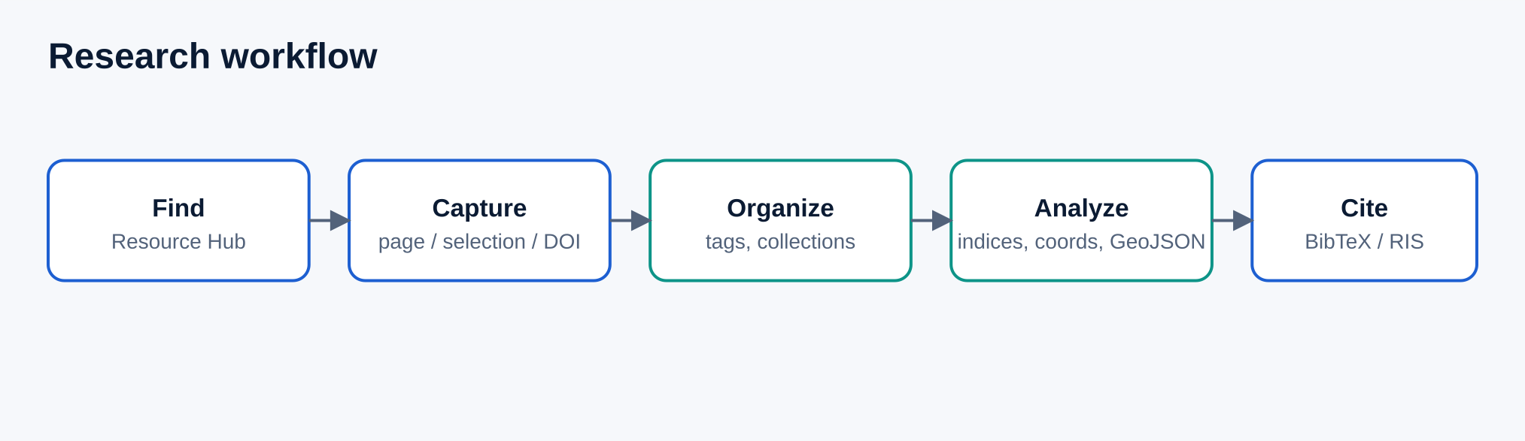

 2 Technology stack
Layer | Technology | Purpose
Language | TypeScript (strict mode) | Typed interfaces and safe refactoring
UI | React 18, Tailwind CSS 3, Lucide | Popup and side-panel interfaces, design system
Build | Vite (multi-entry) | Popup, side panel and service worker bundles
Geodesy | proj4js | UTM and geographic coordinate projection
Citations | Citation.js (core, BibTeX, RIS) | Citation parsing and export
Testing | Vitest, Testing Library | Unit and component tests
Quality | ESLint, Prettier | Linting and formatting
Tooling | sharp, archiver | Icon and figure generation, ZIP packaging

 3 Features
GeoPilot is organised into nine modules. All of them work offline except DOI lookup.
 Resource Hub  23 curated links to official geospatial resources (Earth Engine, Copernicus, USGS, NASA, QGIS, GDAL, STAC and more). Searchable, filterable, with favorites. |  Coordinate Converter  Decimal degrees, DMS and UTM conversion on WGS 84 with range validation, examples, copy buttons and datum notes.
 Spectral Index Lab  NDVI, NDWI, MNDWI, NDBI, EVI, SAVI, BSI and NBR with formulas, limitations, references and sensor band mappings. Zero denominators are reported, not hidden. |  GeoJSON Toolkit  JSON and structure validation, geometry counts, bounding box, ring-closure checks, coordinate-range warnings, format, minify, copy and download.
 Research Companion  Save pages and selections with their source, write notes, add tags and collections, search, and look up DOIs through Crossref with clear provenance labels. |  Citation Utilities  Export BibTeX, RIS and CSL-JSON. Import BibTeX, RIS and CSL-JSON with validation.
 Code Library  11 original, attributed snippets for Python, R, GEE JavaScript and PyQGIS, with dependencies, notes and one-click copy. |  Workflow Guides  12 educational guides covering flood, drought, LULC, urban heat, water change, climate risk, vulnerability, disaster risk, accessibility, location-allocation, routing and digital twins.
 Personal Workspace
Dashboard built from real local data, command palette (Ctrl or Cmd + K), light and dark themes, JSON backup and restore, and a confirmed clear-all action.

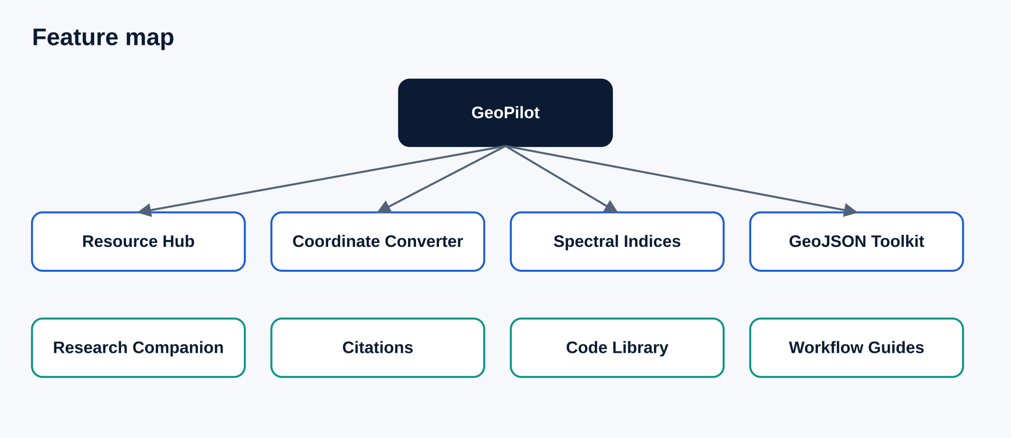

Behaviour notes
- The dashboard shows only counts derived from stored data: saved items, notes, bookmarks, favorites and recently used tools.
- Metadata retrieved from Crossref is labelled "Crossref-verified" and kept visually separate from user-entered content.
- Spectral index thresholds are not presented as universal. Users are reminded to apply scale factors, offsets and cloud masking.
- GeoJSON checks are structural. The tool does not claim full RFC 7946 or OGC conformance.

 4 Architecture
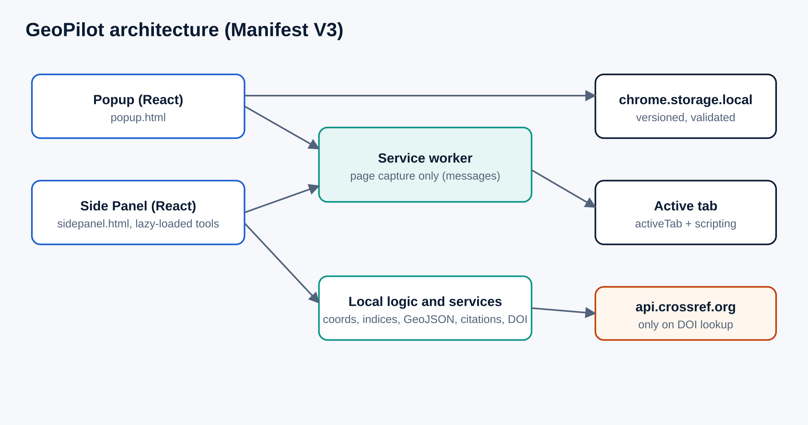
- Popup and side panel: separate React entry points sharing components and the storage layer. Side-panel tools are lazy-loaded.
- Service worker: handles one message (page capture). It checks the sender and injects a self-contained function with chrome.scripting.executeScript under activeTab. No content scripts are declared.
- Feature modules: pure logic (coordinates, indices, GeoJSON, citations) is separated from React views and unit tested.
- Storage: chrome.storage.local with a versioned schema. Every load and import is sanitized: oversized fields are truncated, newer schemas are rejected, and only http and https URLs are kept.
- Services: the Crossref client and the messaging helpers.

 5 Permissions and privacy
Privacy is a design requirement. GeoPilot asks for four permissions and no host permissions.
Permission | Why it is needed
storage | Save notes, bookmarks and settings in chrome.storage.local on the device.
activeTab | Read the title, URL, selection and meta tags of the current tab after the user clicks the toolbar icon.
scripting | Run the page-capture function in the active tab.
sidePanel | Provide the main workspace.

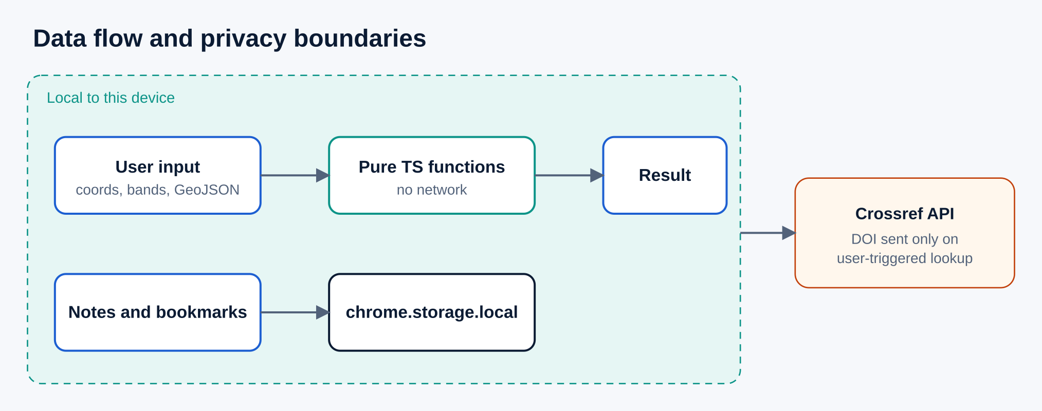
- Extension-page CSP: script-src 'self'; object-src 'self'; connect-src https://api.crossref.org.
- Notes, selections and bookmarks never leave the device. There is no telemetry, no account and no API key.
- Imported files are validated for size, structure and URL scheme. Imported content is never executed.

 6 Installation
Requirements: Node.js 20 or later, npm, and Chrome 116 or later.
- Install dependencies and build:
npm ci
npm run build

- Open chrome://extensions and turn on Developer mode.
- Choose Load unpacked and select the dist/ folder.
- Pin GeoPilot, then click its icon or press Alt+G to open the popup.
- For page capture, click the toolbar icon on the page you want to save, then use Save current page or Save selected text.

 7 Development scripts
Command | Purpose
npm run build | Type check, build and verify the output files
npm test | Run the Vitest suite
npm run lint | Run ESLint
npm run typecheck | Run tsc in strict mode
npm run format | Format the code with Prettier
npm run icons | Regenerate the PNG icons from the SVG source
npm run package | Create release/GeoPilot-v1.0.0.zip

 8 Testing
The automated suite has 39 tests in 6 files, and all of them pass.
Area | What is covered
Coordinates | Reference UTM values, central meridian, southern hemisphere, round trips, DMS parsing, range and zone validation
Spectral indices | Known values for all eight indices, zero denominators, missing and invalid input
GeoJSON | Valid and invalid structures, unclosed rings, projected-coordinate warning, size limit, format and minify
Storage | Serialization round trip, import validation, migration of unversioned data, URL sanitizing
Search | Multi-token matching, accent and case insensitivity
Citations | BibTeX, RIS and JSON export, BibTeX and RIS import, rejection of bad input
Crossref | DOI normalization, mapping with provenance, 404, 429, 5xx, network and unreadable responses (mocked)
Components | Coordinate tool, index lab, GeoJSON tool, resource search and favorites

Not covered
Real Chrome runtime behaviour: popup, side panel, page capture, shortcut and cross-context storage events. Run the manual checklist in section 12 before publishing.

 9 Measured build output
Sizes are minified and uncompressed, measured from the dist/ folder. Load time was not measured.
Item | Size
Total dist/ | 543.6 KB
JavaScript total | 523.0 KB
Popup initial load | about 156 KB JavaScript plus 11 KB CSS
Largest chunk: Citation.js bundle | 167.6 KB
Shared React chunk | 151.1 KB
proj4 chunk | 133.7 KB

 10 Project structure
geopilot/
manifest.json popup.html sidepanel.html
src/
popup/ sidepanel/ background/
features/ coordinates spectral-indices geojson
research citations snippets workflows resources
storage/ services/ data/ hooks/ types/ utils/ styles/
tests/
docs/ figures/
scripts/ public/icons/ branding/ dist/

 11 Known limitations
Unverified items
- Loading and using the extension in a real Chrome browser has not been done.
- Opening the side panel on a specific tool from the popup uses setOptions with a hash path. The user-gesture requirement and hash handling are untested.
- Live Crossref requests were not made; tests use mocked responses.
- Dependency licenses still need a review before store submission.

- Page capture needs a click on the toolbar icon on the target page first. Chrome internal pages cannot be captured.
- Selection capture reads the page selection only, not cross-origin iframes.
- UTM is limited to 80°S to 84°N, and only WGS 84 is supported.
- Abstracts depend on what Crossref returns for a DOI.
- No real screenshots are included, because no browser was available.

 12 Chrome Web Store checklist
- Load unpacked and manually test every module
- Verify opening the side panel from the popup
- Capture real 1280 × 800 screenshots and a 440 × 280 promo tile
- Host PRIVACY.md at a public URL
- Justify each permission in the developer dashboard
- Confirm dependency licenses
- Register a developer account and upload a ZIP of the dist/ contents

 13 Roadmap
Ideas, not commitments.
Area | Idea
Quality | End-to-end tests in a real browser
Geodesy | UPS support for polar regions and more datum transformations
Data | CSV and KML import to GeoJSON
Citations | Rendered citation styles such as APA
Platform | Optional sync and localization

 14 Acknowledgements
GeoPilot builds on React, Vite, Tailwind CSS, Lucide, proj4js, Citation.js, Vitest, Testing Library, ESLint, Prettier and sharp, each distributed under its own license. Linked datasets and services belong to their respective providers.

15 About the author
Md Khadem Ali
Department of Geography and Environment, National University, Bangladesh
Researcher in GeoAI and geospatial analytics at the Department of Geography and Environment, National University, Bangladesh. His work covers disaster risk management, urban resilience, environmental monitoring and spatial data science, applied mainly to Bangladesh.
Website khademali.com
 GitHub github.com/mdkhademali

