**Ineuron_PowerBI_Assignment1**

1. **Install Power BI Desktop and share the final screenshot of the report view page which appears when power desktop starts.**

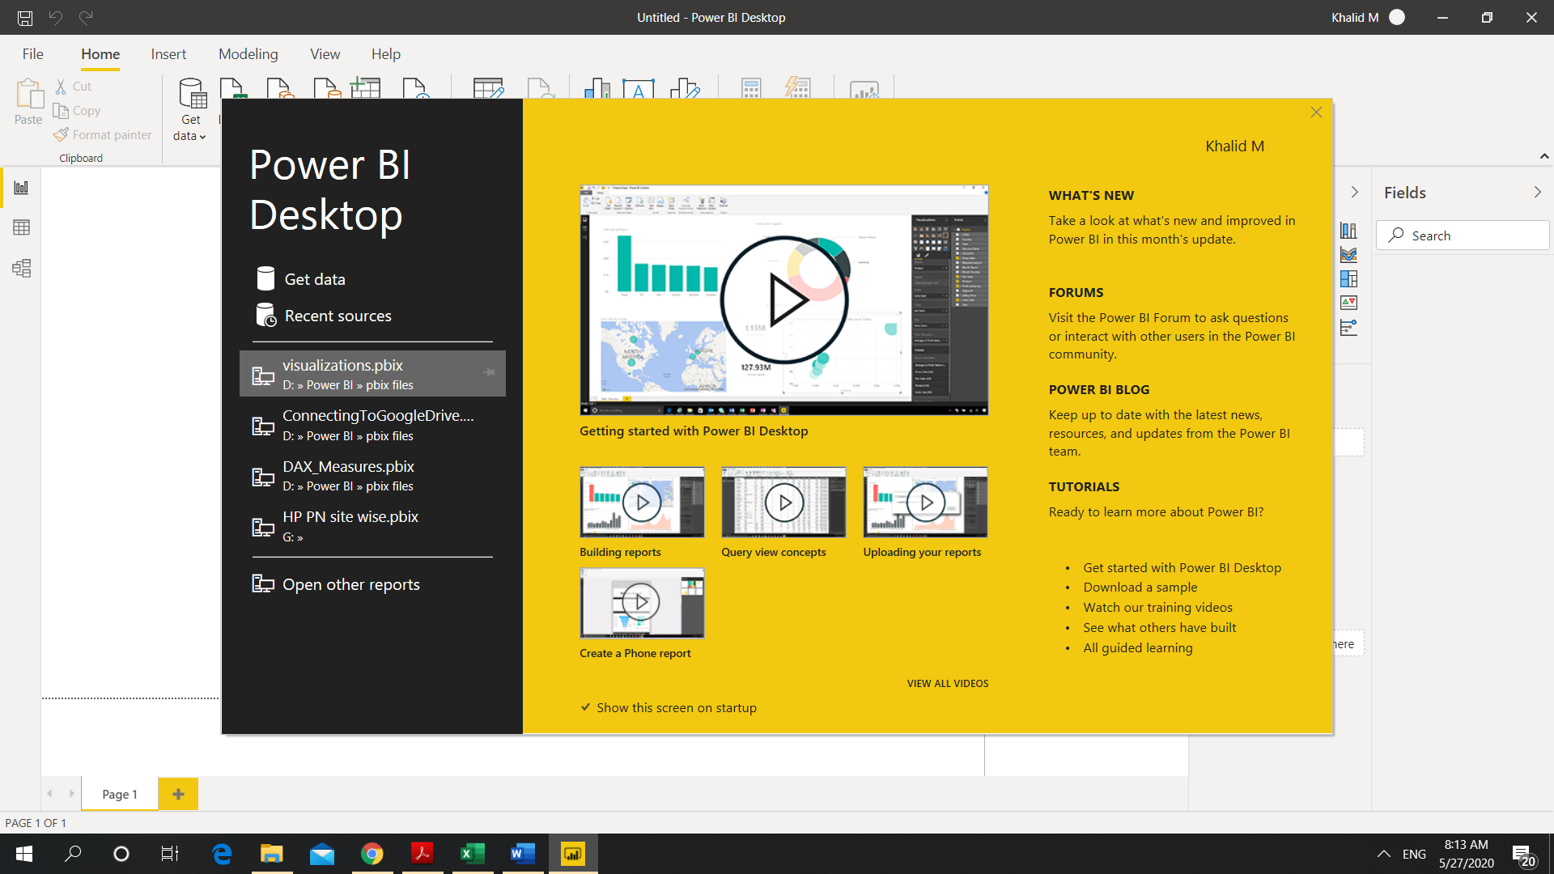

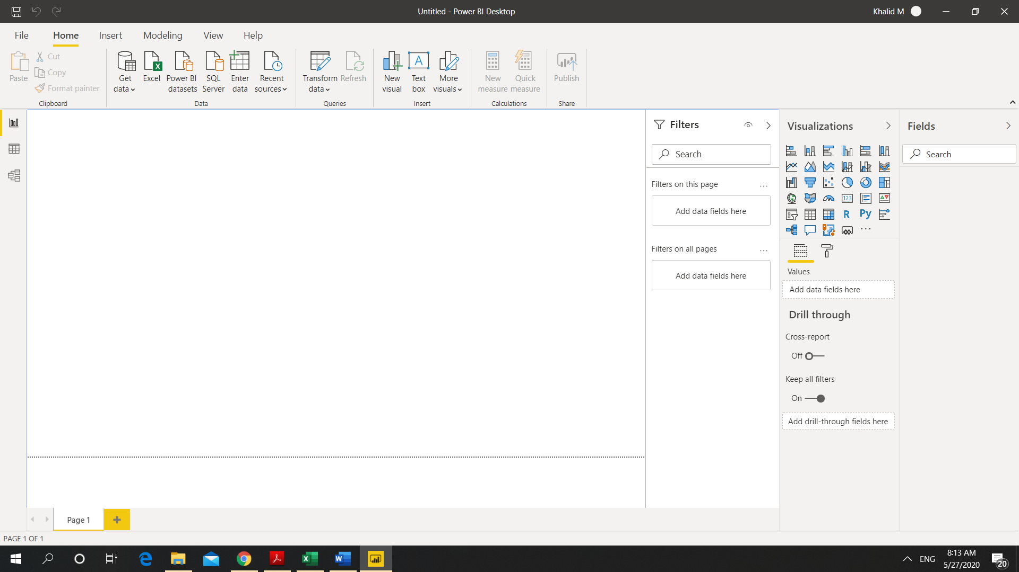

1. **Prepare a document and with the following screenshot − Report View − Data View − Model View − Power Query Editor − Advance Editor**

**Report View:**

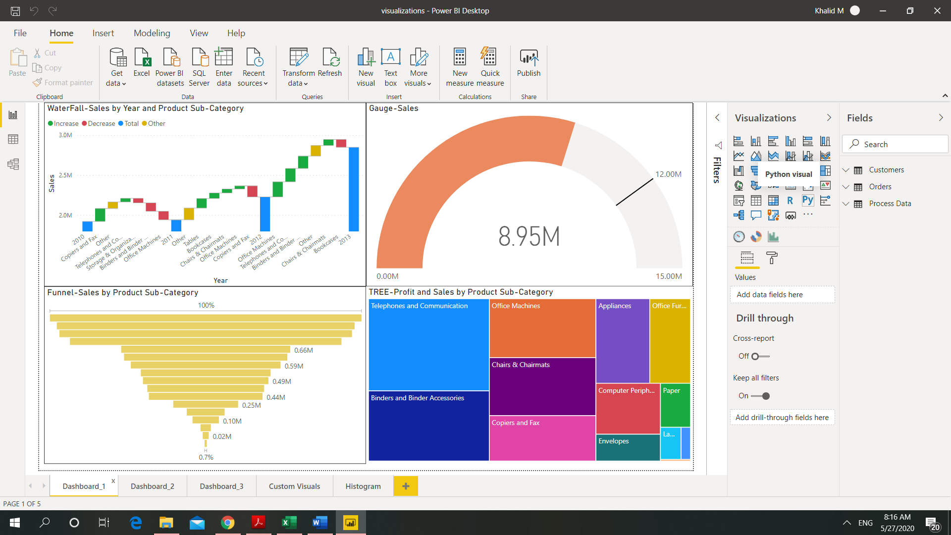

**Data View:**

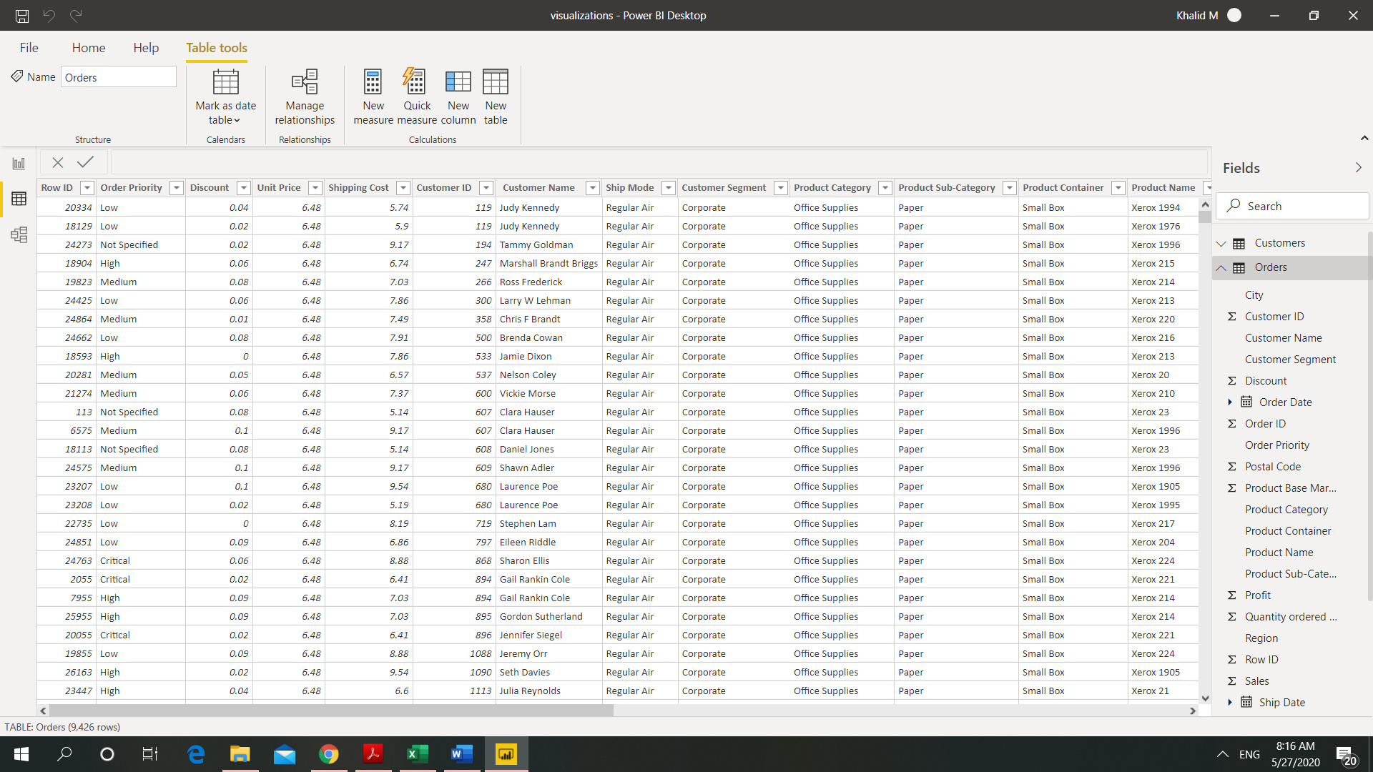

**Model View:**

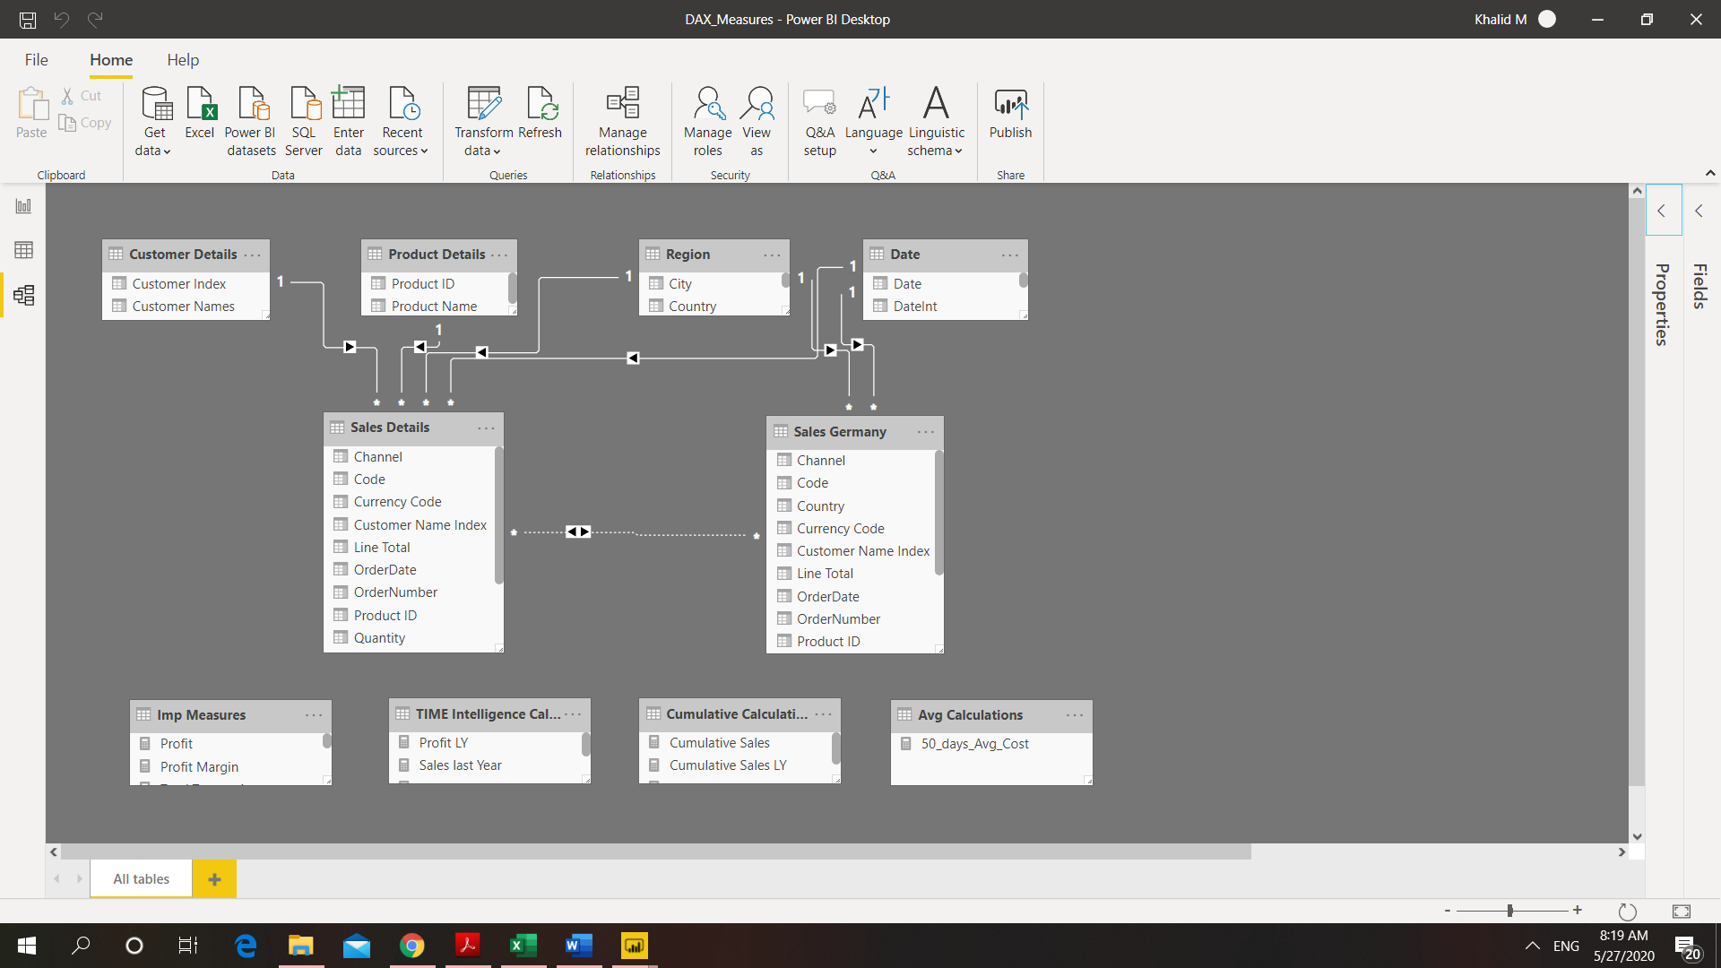

**Power Query Editor:**

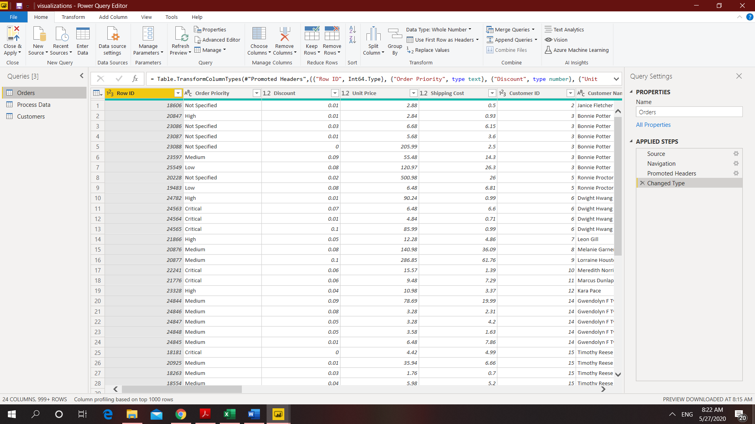

**Advance Editor:**

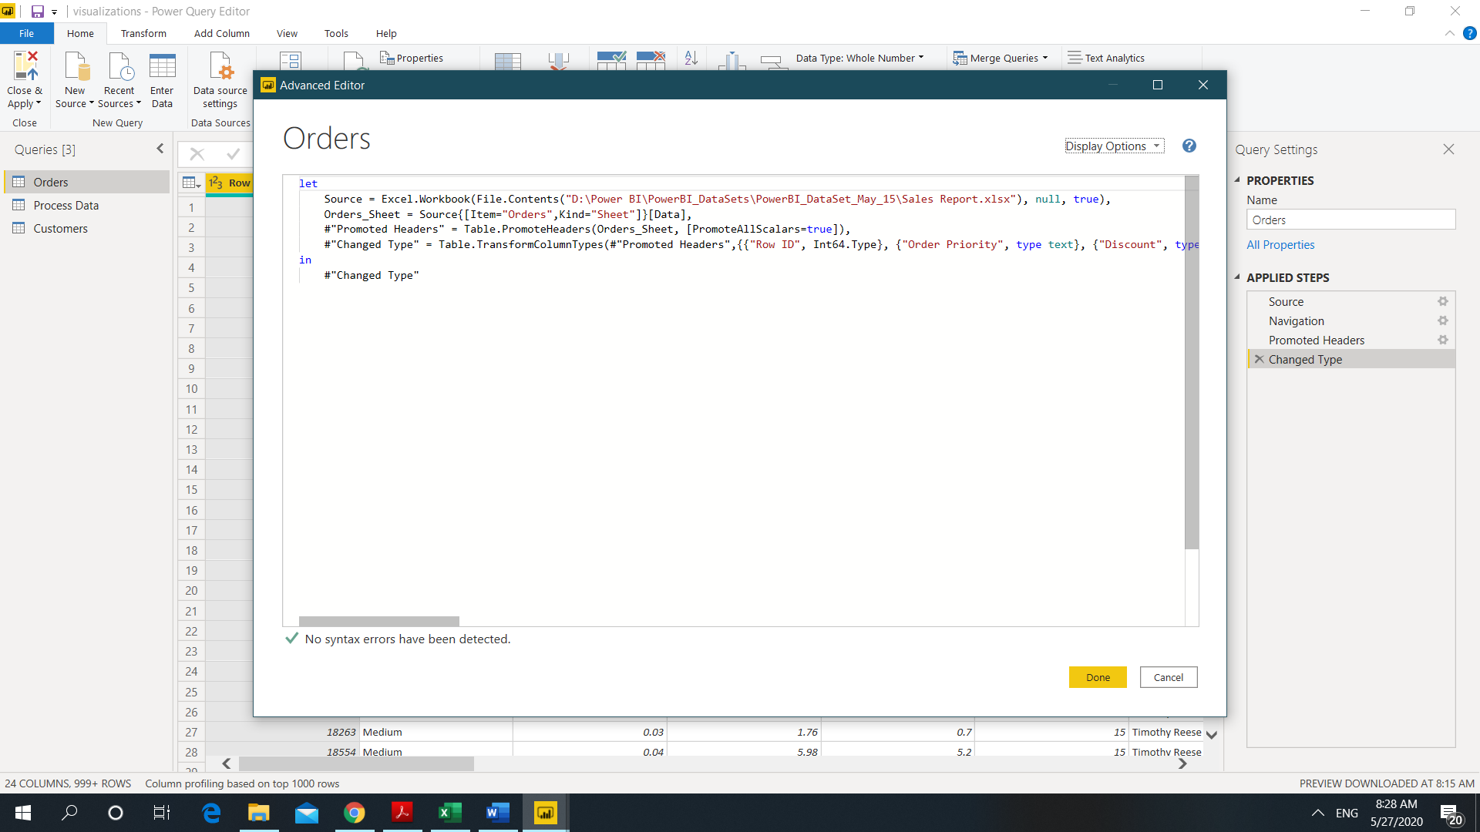

1. **Prepare a document with details of the following along with their price − Power BI Desktop − Power BI Pro − Power BI Premium**

A Power BI Pro license is required to:

* Distribute content to other users, and for peer-to-peer sharing and collaboration.
* Publish content to Power BI Premium.
* Receive content from another user unless the user is associated with dedicated capacity in Power BI Premium.
* Publish content to Power BI Report Server.

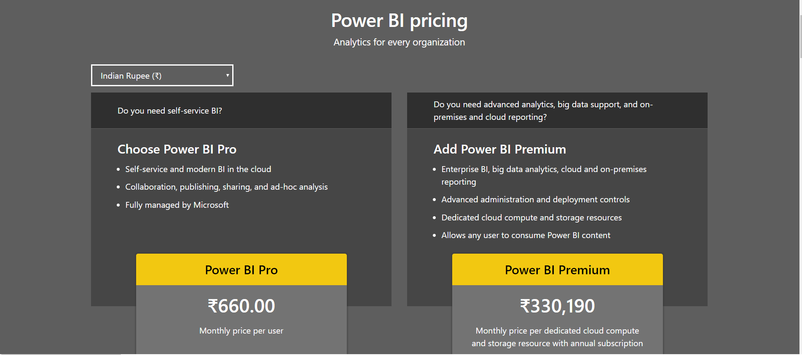

Power BI Desktop:

