In this project we implemented a simple segmentation algorithm and identify connected
components in an image. Then calculated shape features on connected component.

1) Do the segmentation of the image based on an analysis of the intensities in the image
(i.e. create a histogram, decide on a threshold and do the segmentation). Used a simple
thresholding strategy to find the valley between two peaks.
The threshold does ‘non-maxima & non-minima’ suppression on the histogram. It iterates through the histogram and based on a predetermined value delta (amount of data to compare), it keeps the maximum and minimum values. For our case, we assumed the lowest minima is the threshold value. Histogram was smoothen by using 1D averaging mask : (1/9,2/9,3/9,2/9,1/9). We compared our result with otsu’s method.
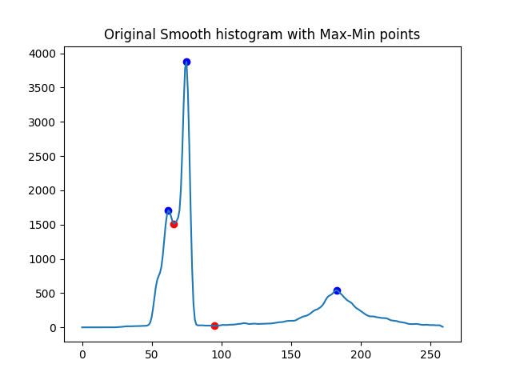
Coins
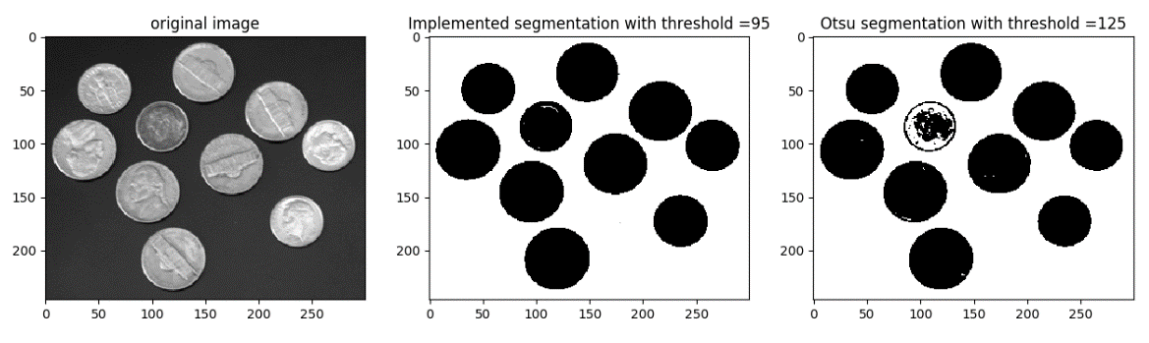

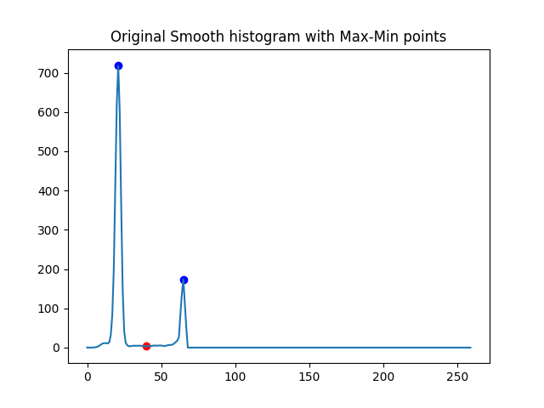
Hinge
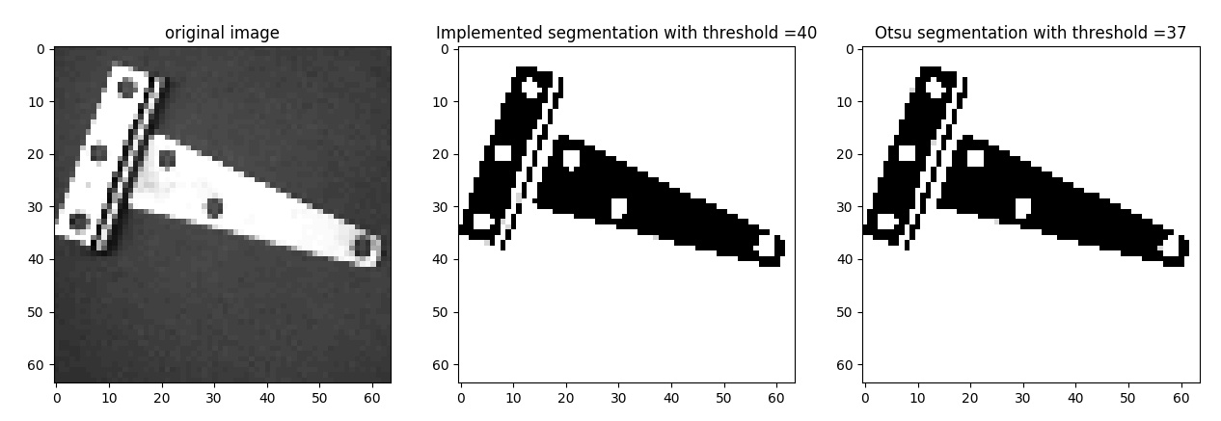

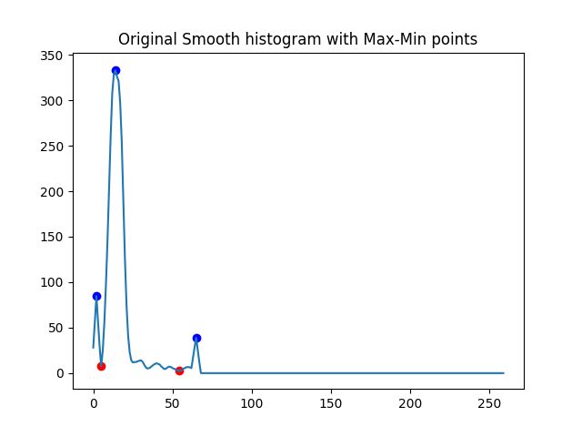
Hinges
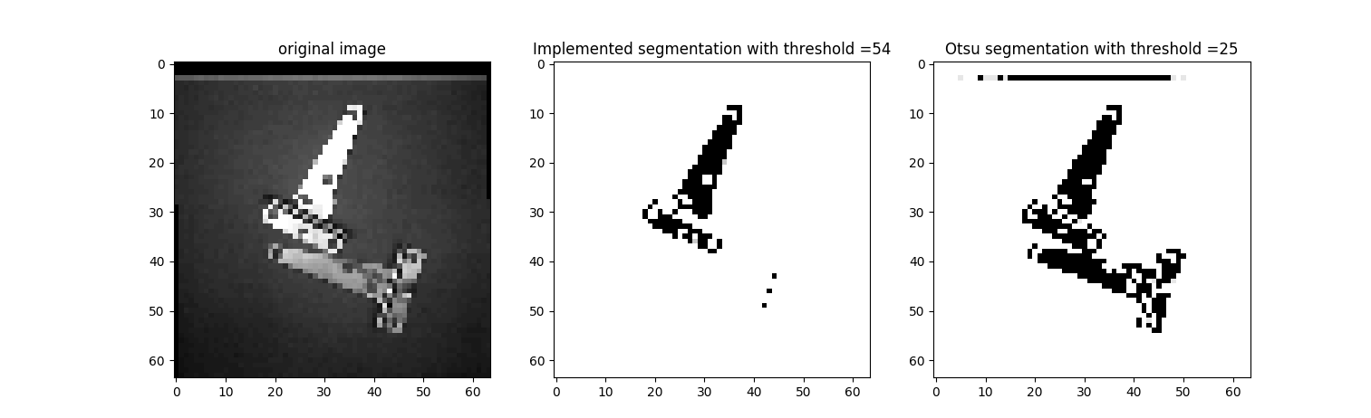
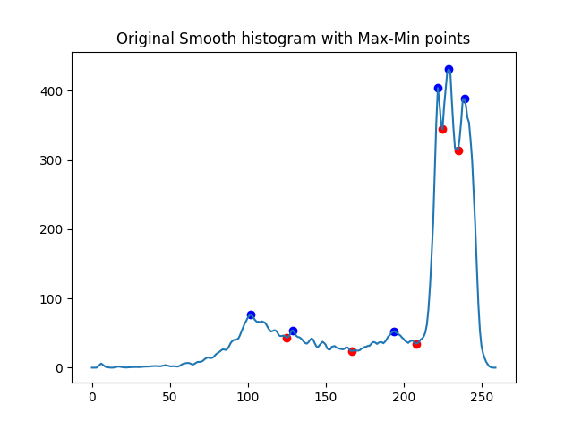
Keys
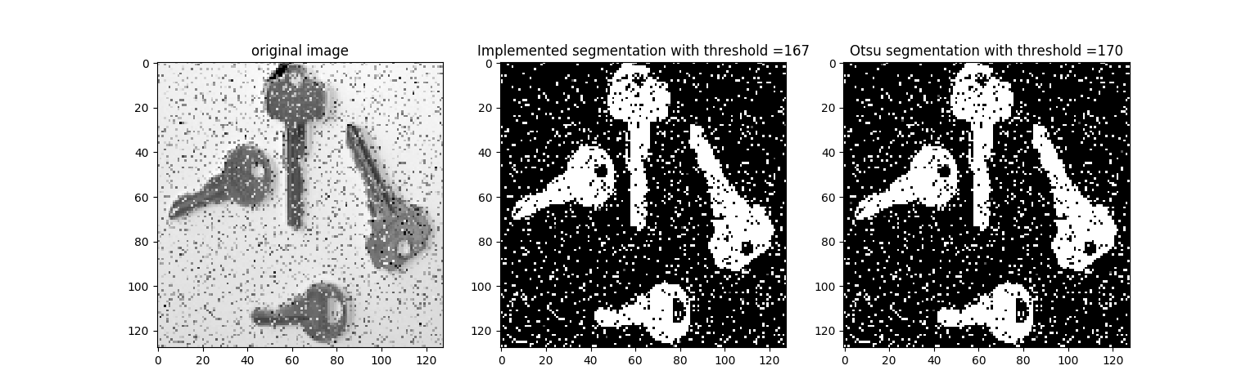
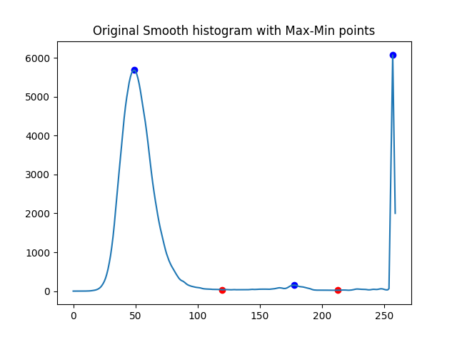
Pill-set
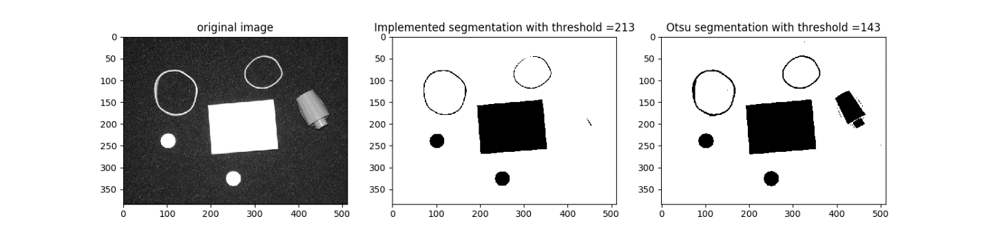
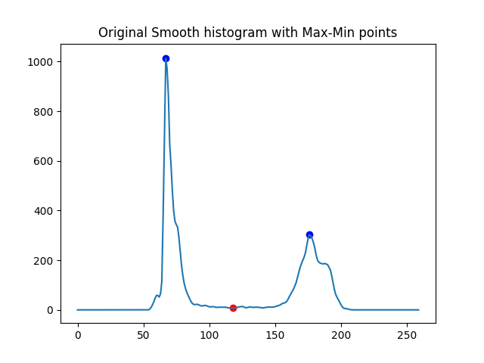
Shapes 1
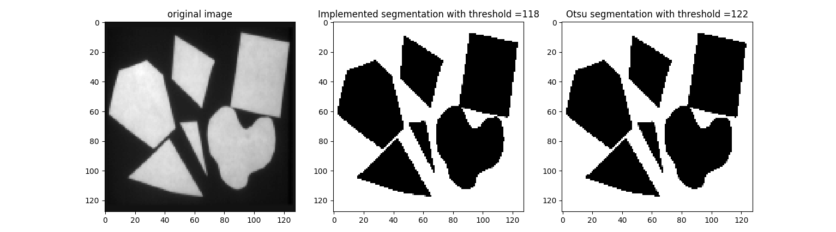
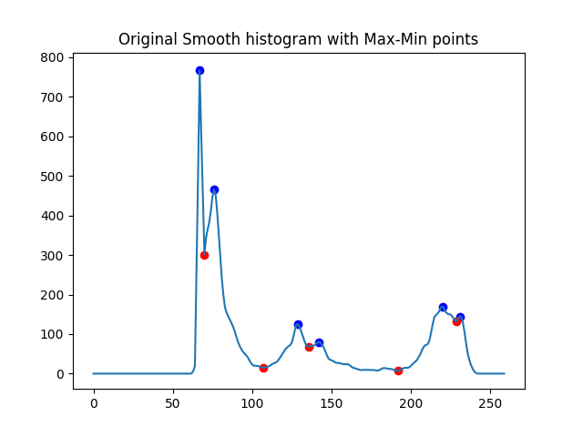
Shapes 2
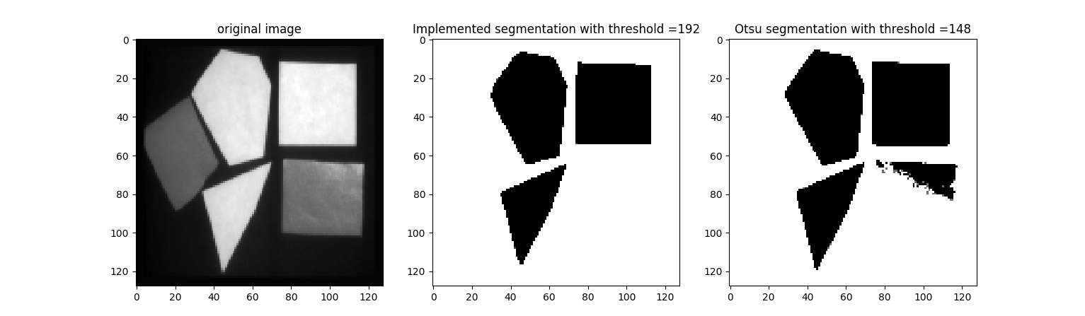
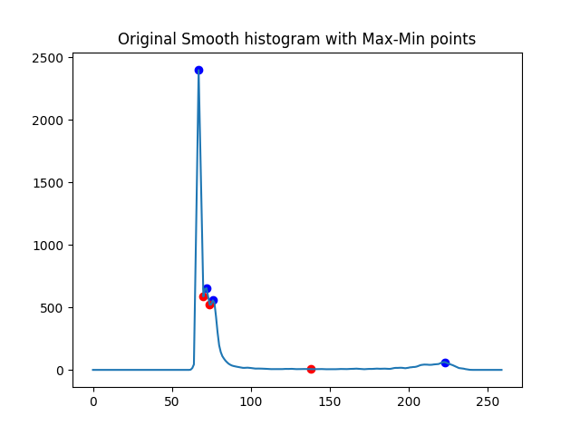
Shapes 3
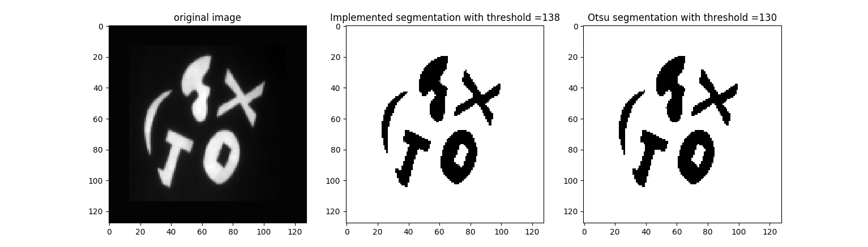
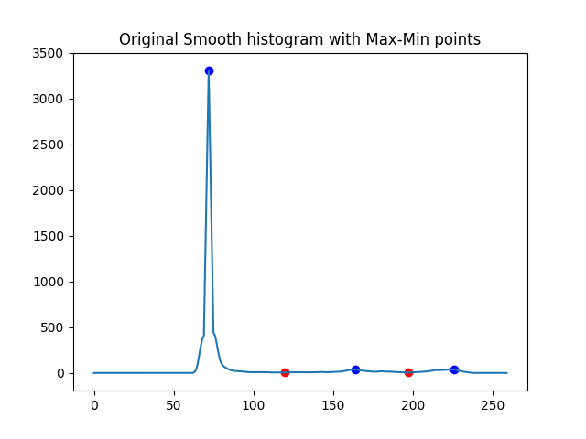
Shapes 4
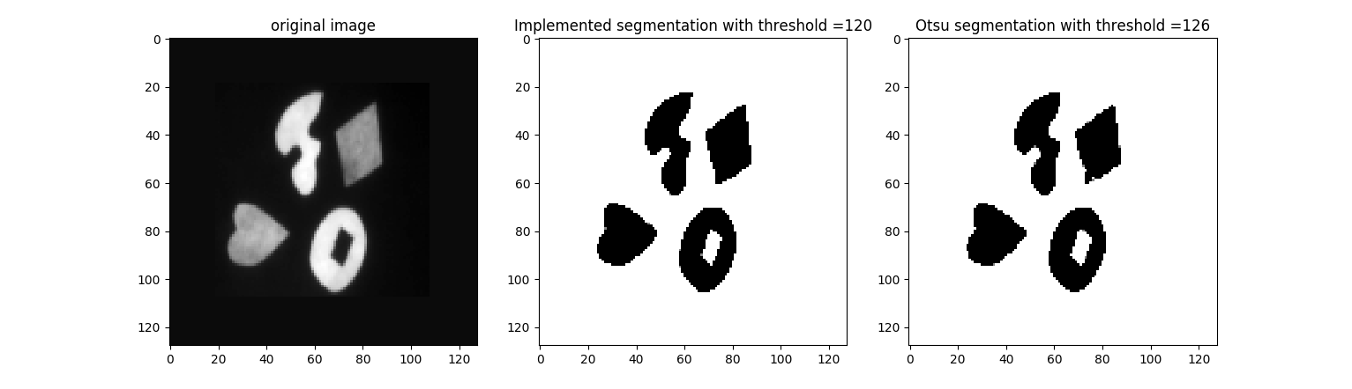

Comments on histogram threshold segmentation:
- Implemented threshold method works well when histogram is bi-modal. For more than two modes Otsu’s method performs better. Using a weighted average to determine threshold (threshold value closer to higher peak) may improve the result.
- Even with noisy input segmentation works reasonably well.

2) Perform a connected component analysis on the resulting binary image of step 1. Use
4-connected neighbor definition and the algorithm described in class for this.
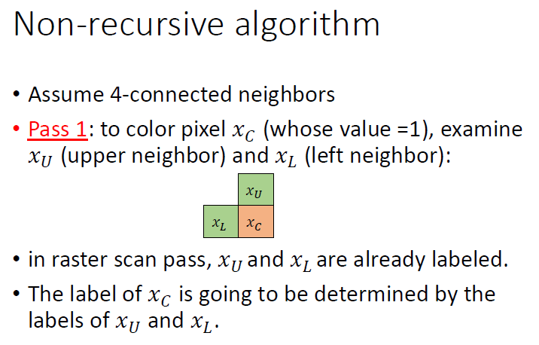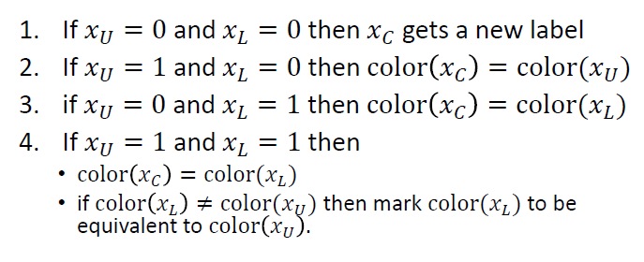
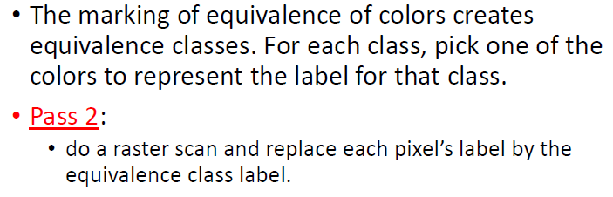

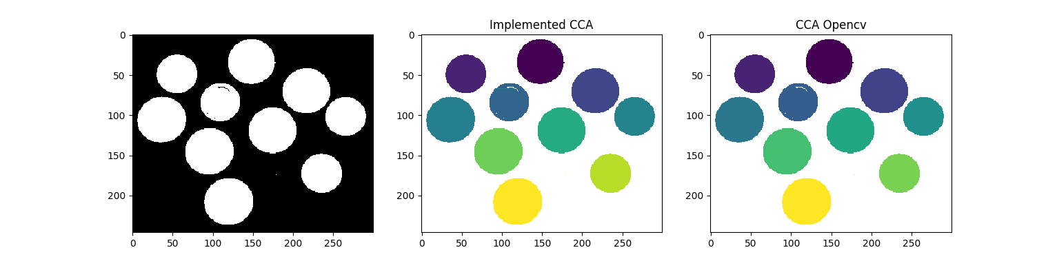

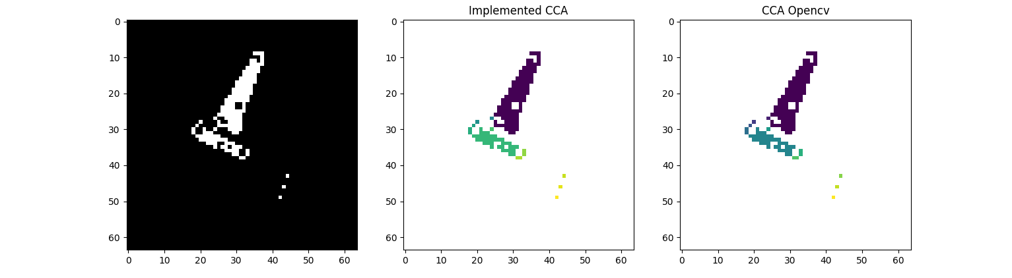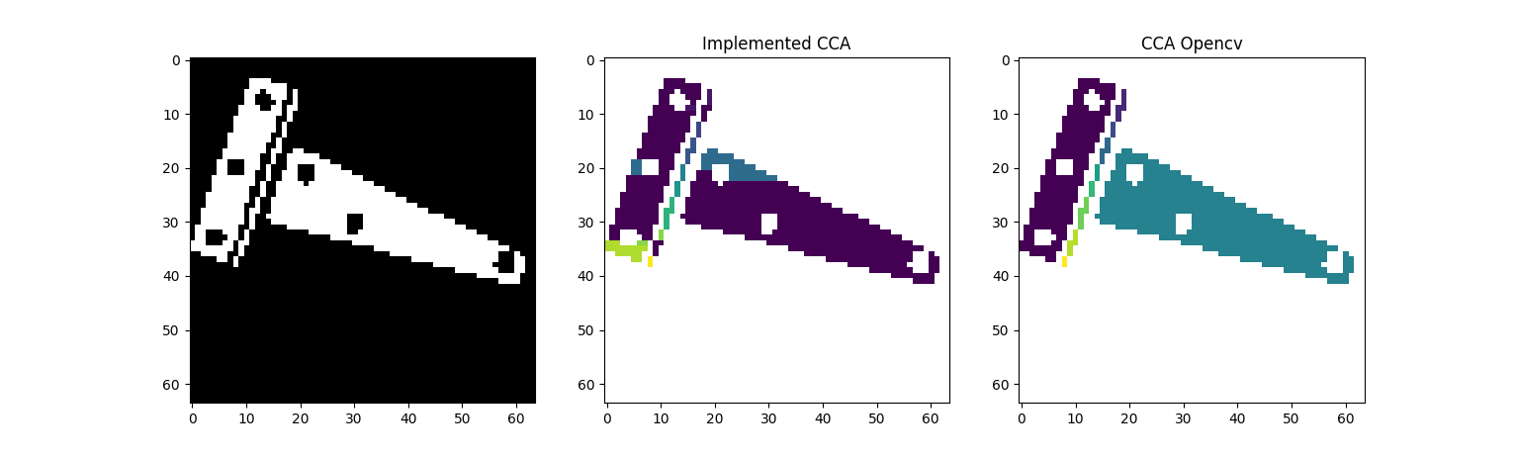
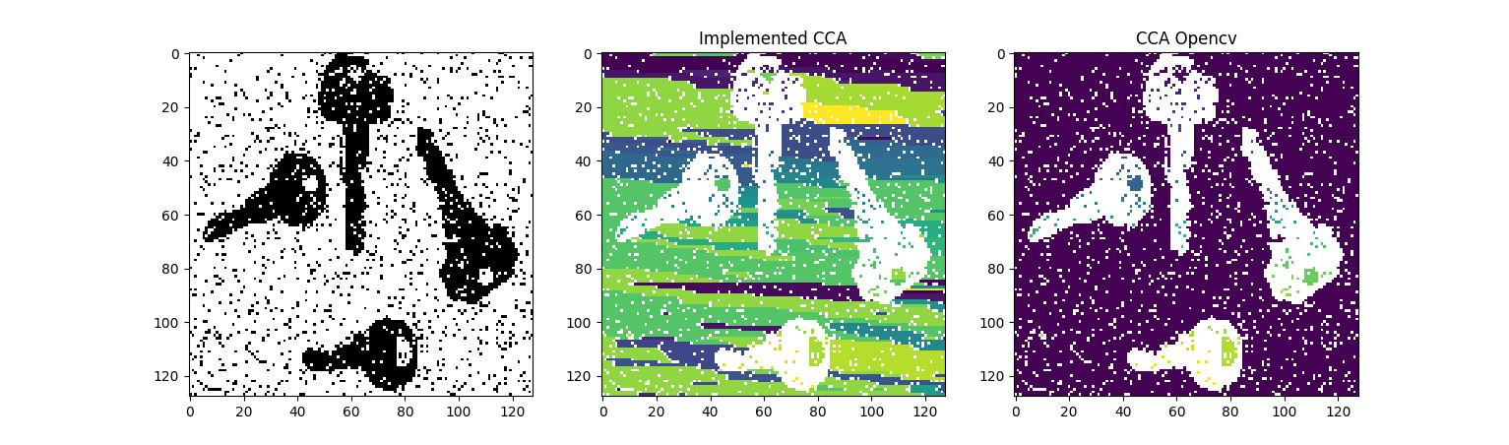
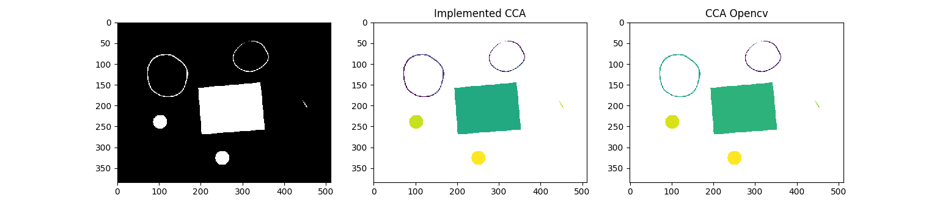

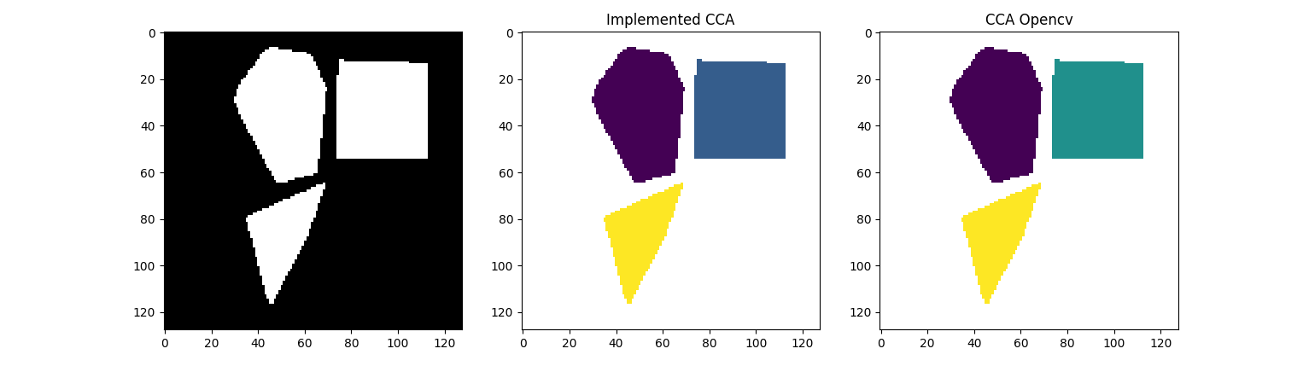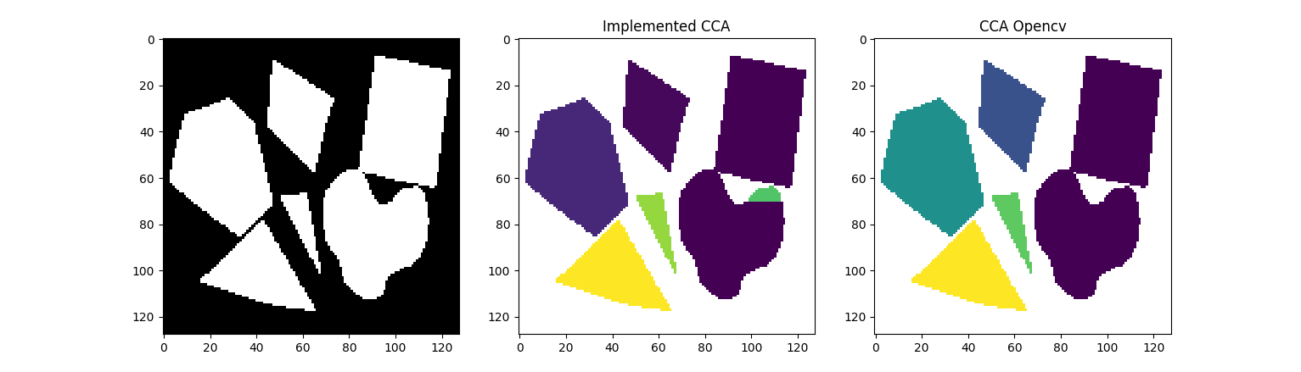
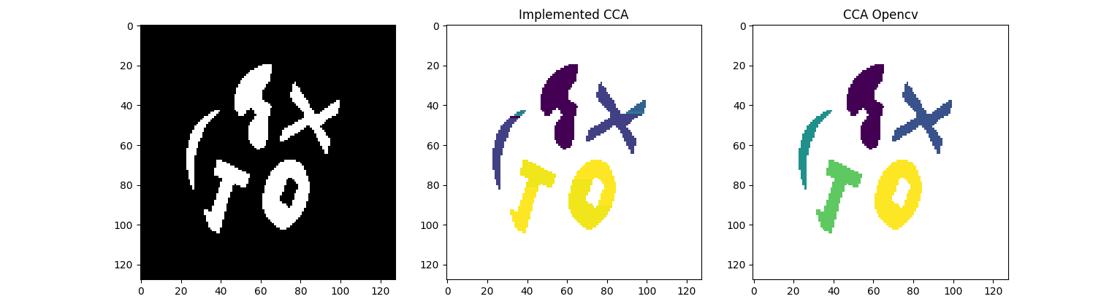
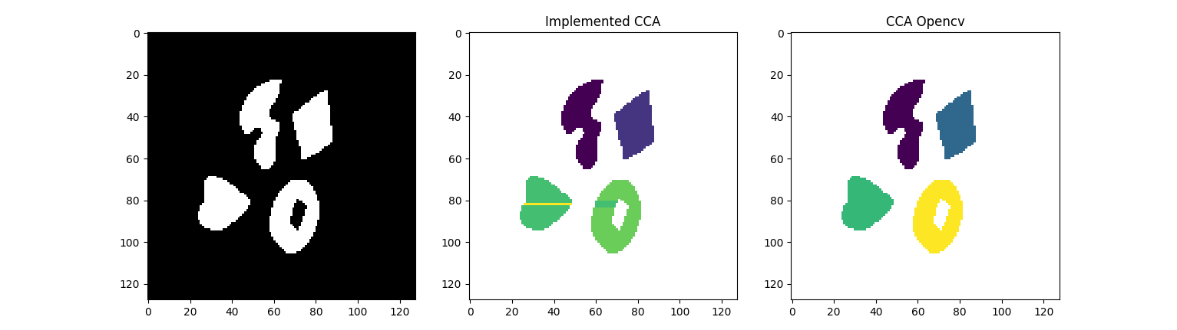
Comments on CCA:
- Performs reasonably well. Had a few hiccups when connected-components are really small. Hugely dependent on how good the segmentation is.
- Fails completely for noisy image.
- Can be improved using 8 connected component.
3) For each component identified compute some features that will be useful in describing
its shape. The features you are to compute are the following:
(a) Area, A.
(b) The centroid
(c) Second order moments around the centroid (i.e., central moments).
(d) Perimeter, P
(e) Compactness measure as defined by P²=4piA.
(f) An elongation measure computed from second order central moments given further
below.
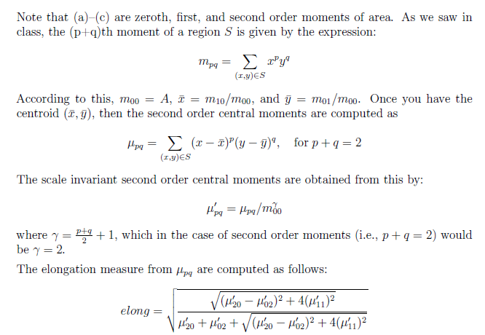
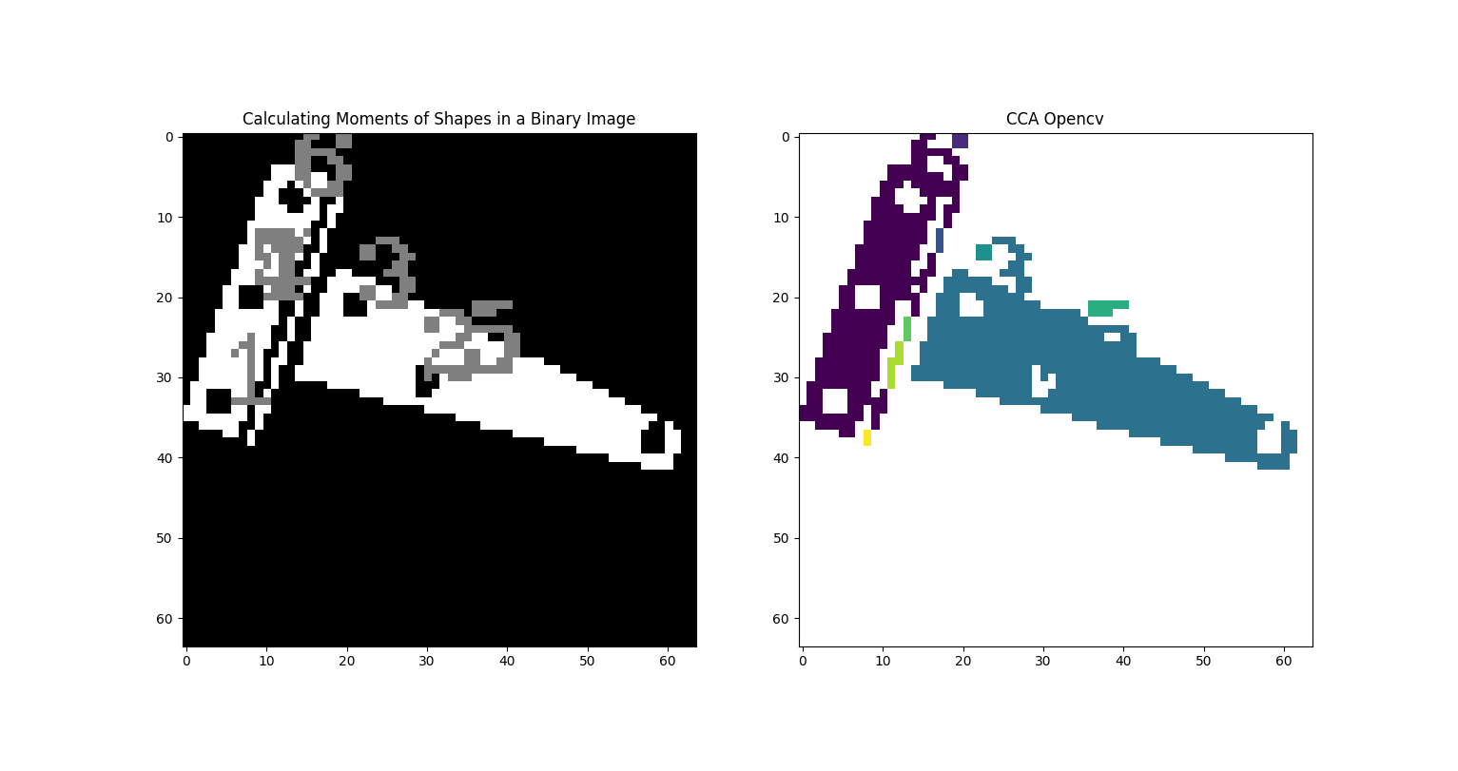
Hinge
Shapes found : 7
Moments for shape 1
Center (4, 33)
Area 15.0
mu20 0.0924609053497943
mu02 0.07037037037036498
mu11 0.0
Perimeter 14.485281229019165
Compactness 1.1131475625057927
Elogation 0.3456281033549841
Moments for shape 2
Center (29, 30)
Area 16.5
mu20 0.06689793558481294
mu02 0.09906533965303758
mu11 -0.011614461109408626
Perimeter 15.071067690849304
Compactness 1.0954542198506352
Elogation 0.43925699520732503
Moments for shape 3
Center (21, 21)
Area 14.0
mu20 0.07993197278911254
mu02 0.07993197278911254
mu11 0.0
Perimeter 13.656854152679443
Compactness 1.0601405419456786
Elogation 0.0
Moments for shape 4
Center (8, 20)
Area 14.0
mu20 0.07993197278911544
mu02 0.07993197278911254
mu11 0.0
Perimeter 13.656854152679443
Compactness 1.0601405419456786
Elongation 1.34702058990622e-07
Moments for shape 5
Center (34, 29)
Area 429.0
mu20 0.3165492388192763
mu02 0.06153080007547224
mu11 0.10772035328248326
Perimeter 130.56854152679443
Compactness 3.1623501094884925
Elongation 0.6847839213842148
Moments for shape 6
Center (13, 7)
Area 14.5
mu20 0.08348481328103453
mu02 0.08348481328103291
mu11 0.015009043238983118
Perimeter 14.727921724319458
Compactness 1.190433304090277
Elongation 0.39036595373421723
Moments for shape 7
Center (8, 20)
Area 219.5
mu20 0.06455352711255433
mu02 0.381429839594161
mu11 -0.1298157128515137
Perimeter 161.29646337032318
Compactness 9.432032780832376
Elongation 0.6919339352739294
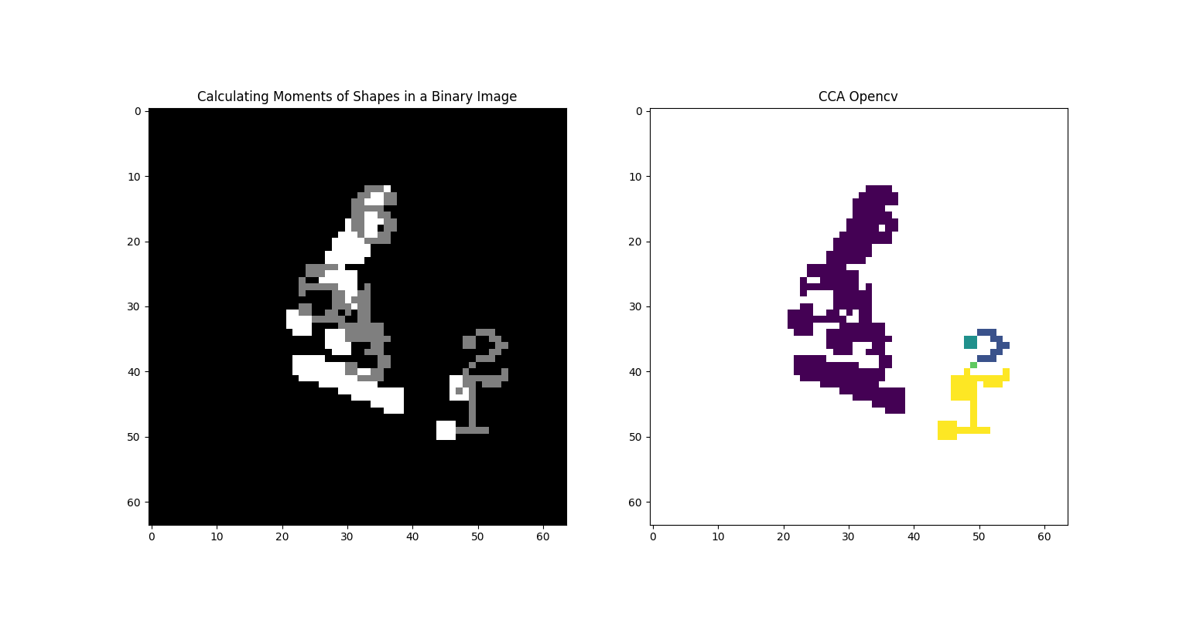
Hinges
Shapes found : 6
Moments for shape 1
Center (45, 49)
Area 4.0
mu20 0.08333333333331439
mu02 0.08333333333325754
mu11 0.0
Perimeter 8.0
Compactness 1.2732395447351628
Elongation 5.840038639982836e-07
Moments for shape 2
Center (47, 42)
Area 6.0
mu20 0.05555555555555555
mu02 0.125
mu11 0.0
Perimeter 10.0
Compactness 1.3262911924324612
Elongation 0.5270462766947299
Moments for shape 3
Center (29, 41)
Area 53.0
mu20 0.3549259157261092
mu02 0.07394676291316539
mu11 0.13570225383669052
Perimeter 42.14213538169861
Compactness 2.666535330355995
Elongation 0.6904214424357934
Moments for shape 4
Center (28, 35)
Area 8.5
mu20 0.08306759843500258
mu02 0.08306759843502777
mu11 0.009781305832620373
Perimeter 11.41421353816986
Compactness 1.2197285698954283
Elongation 0.32457123474029603
Moments for shape 5
Center (22, 32)
Area 8.0
mu20 0.0833333333333286
mu02 0.08333333333331439
mu11 0.020833333333328596
Perimeter 10.828427076339722
Compactness 1.1663553915641325
Elongation 0.44721359549994266
Moments for shape 6
Center (30, 20)
Area 74.5
mu20 0.07548876962734336
mu02 0.30706401794922183
mu11 -0.11628801814457725
Perimeter 51.21320307254791
Compactness 2.801545895242355
Elongation 0.6795350841613619
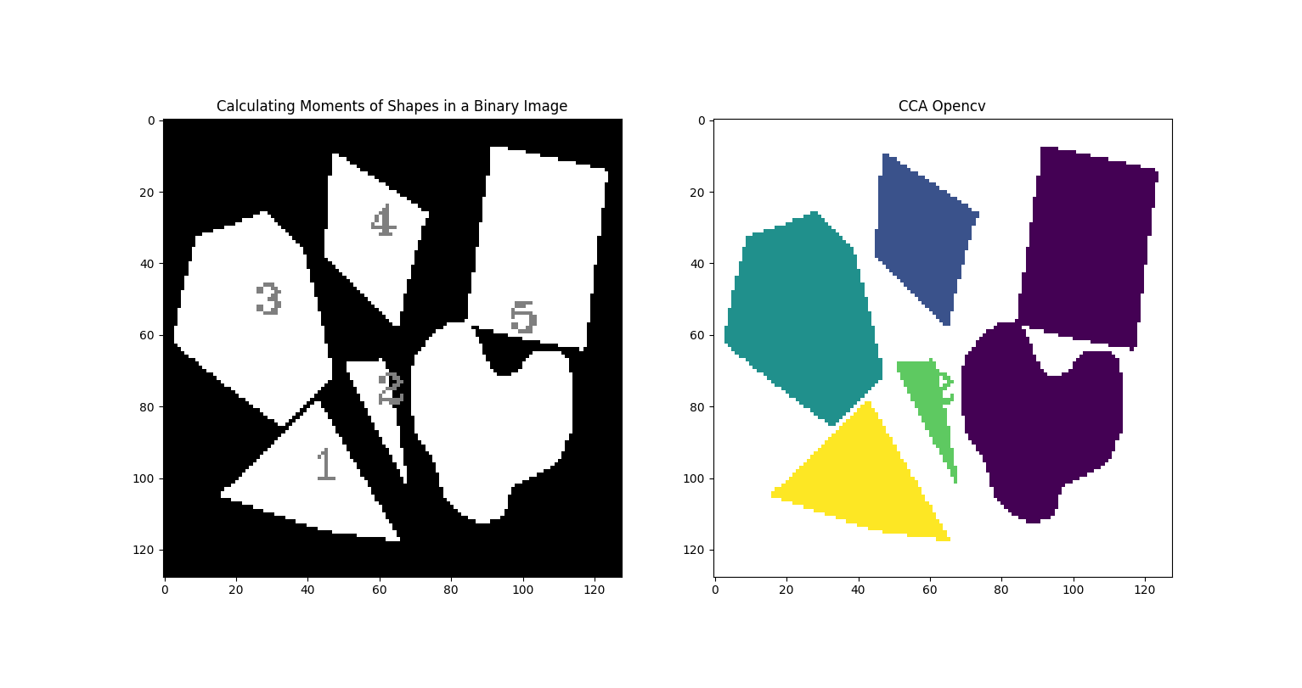
Shapes 1
Shapes found : 5
Moments for shape 1
Center (41, 100)
Area 856.5
mu20 0.11653354147302813
mu02 0.08105050376576435
mu11 0.025920526449833337
Perimeter 139.43859779834747
Compactness 1.8064618003059207
Elongation 0.4911668348129967
Moments for shape 2
Center (59, 79)
Area 186.0
mu20 0.06559001562048403
mu02 0.3230516045045239
mu11 0.11014396523489618
Perimeter 85.94112491607666
Compactness 3.1599430805213626
Elongation 0.6824748876852494
Moments for shape 3
Center (25, 54)
Area 1682.5
mu20 0.06234203128393855
mu02 0.11185961903111974
mu11 0.018641056473586822
Perimeter 164.752308011055
Compactness 1.283802088139468
Elongation 0.5122849663628394
Moments for shape 4
Center (57, 32)
Area 764.5
mu20 0.058384659146493496
mu02 0.13360388899162987
mu11 0.026361193858997652
Perimeter 123.63961005210876
Compactness 1.5912114659528842
Elongation 0.568871256711881
Moments for shape 5
Center (96, 59)
Area 3233.0
mu20 0.04878339487946385
mu02 0.2317225117492772
mu11 -0.05093551814399461
Perimeter 348.4507908821106
Compactness 2.9885968923763135
Elongation 0.6537721658502534
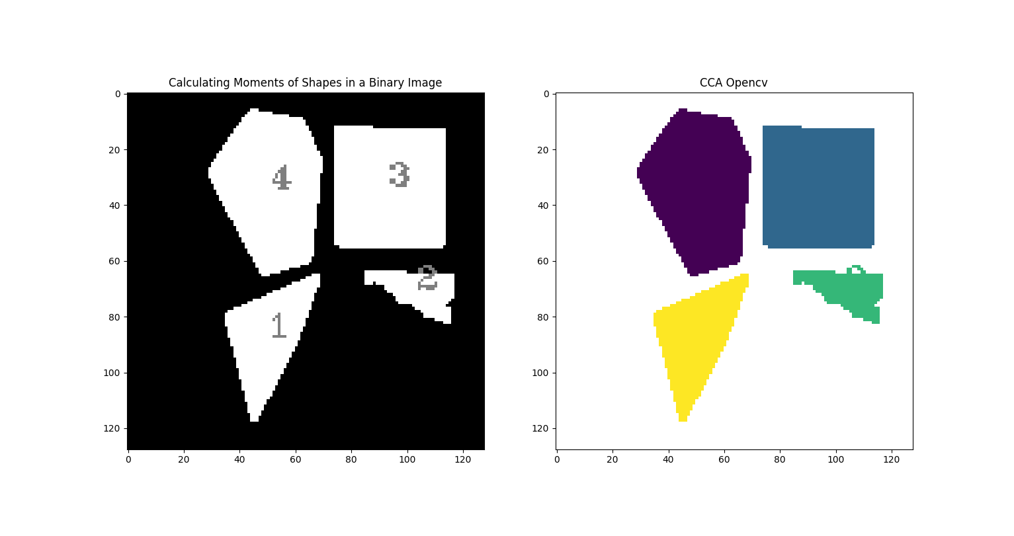
Shapes 2
Shapes found : 4
Moments for shape 1
Center (50, 87)
Area 834.5
mu20 0.06707204526621012
mu02 0.15924019666868128
mu11 -0.04635727152363894
Perimeter 143.63960921764374
Compactness 1.9674886007161685
Elongation 0.6051044317389114
Moments for shape 2
Center (103, 70)
Area 318.0
mu20 0.19216250694395964
mu02 0.06068018653424445
mu11 0.05168527605065089
Perimeter 93.4558435678482
Compactness 2.18562646063281
Elongation 0.6309743262131283
Moments for shape 3
Center (93, 33)
Area 1649.5
mu20 0.07692135635636713
mu02 0.09045329197659385
mu11 0.0014876262338956764
Perimeter 162.24264061450958
Compactness 1.2698950444077444
Elongation 0.27649732315653414
Moments for shape 4
Center (51, 34)
Area 1660.5
mu20 0.05273832134644186
mu02 0.1277034634668004
mu11 0.010041271971969409
Perimeter 166.95331728458405
Compactness 1.3357997610872205
Elongation 0.5484063773544917
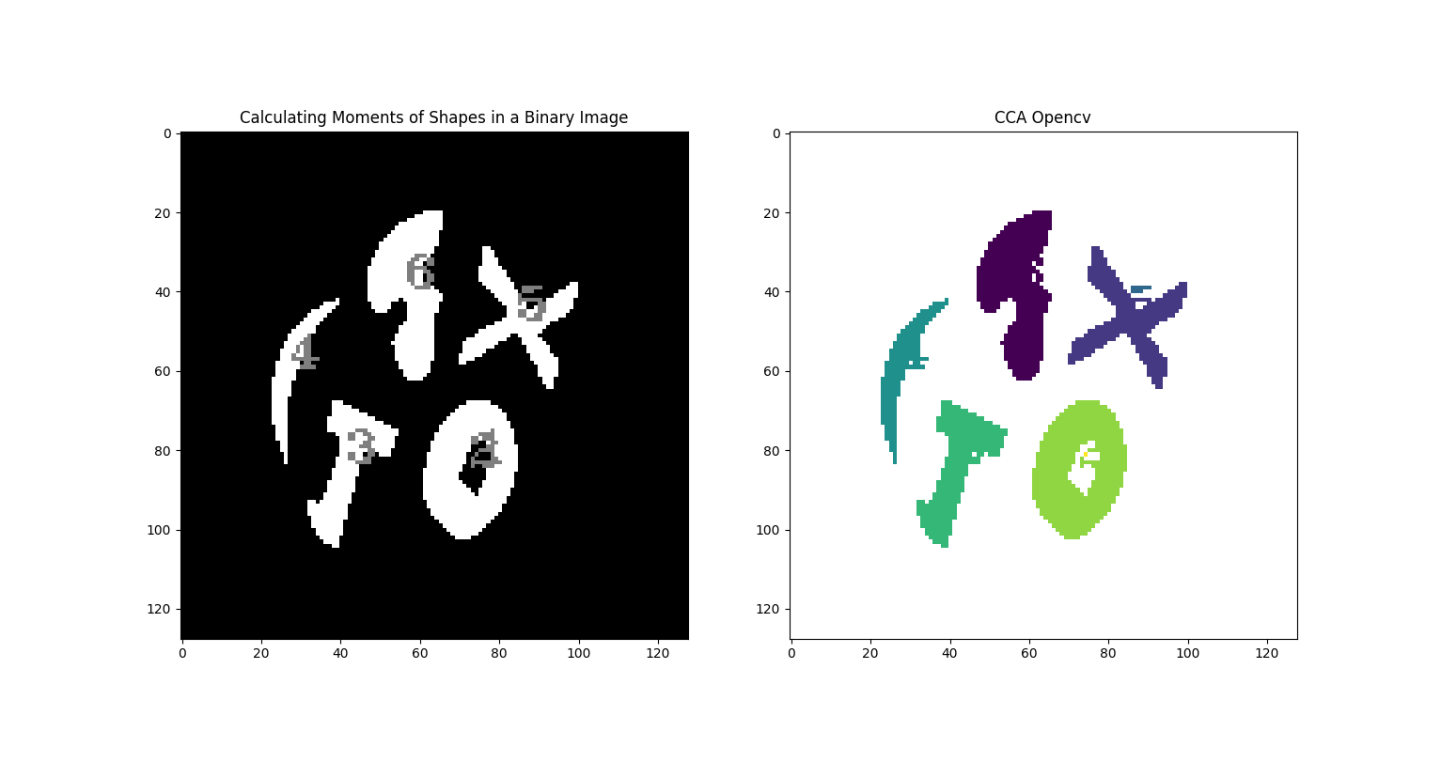
Shapes 3
Shapes found : 6
Moments for shape 1
Center (74, 83)
Area 89.5
mu20 0.04974029337139461
mu02 0.15186921722403277
mu11 -0.026523618646497275
Perimeter 40.870057225227356
Compactness 1.4851748705293828
Elongation 0.6028203280519302
Moments for shape 2
Center (72, 84)
Area 581.5
mu20 0.05465431303756504
mu02 0.12072635385186561
mu11 -0.01550350664704495
Perimeter 93.49747347831726
Compactness 1.196300178837077
Elongation 0.5420920394575374
Moments for shape 3
Center (41, 83)
Area 281.0
mu20 0.07927968819880238
mu02 0.3404572898326445
mu11 -0.10322314068996494
Perimeter 107.25483322143555
Compactness 3.257748547835472
Elongation 0.6650745787419455
Moments for shape 4
Center (27, 59)
Area 132.5
mu20 0.09835216991207504
mu02 0.680352505759786
mu11 -0.213478822562699
Perimeter 97.0121921300888
Compactness 5.652321992970494
Elongation 0.6935729383142425
Moments for shape 5
Center (84, 47)
Area 283.5
mu20 0.18006171736528814
mu02 0.19947674132340198
mu11 0.028891142463085783
Perimeter 145.0954531431198
Compactness 5.909417569821299
Elongation 0.37199796594248563
Moments for shape 6
Center (56, 39)
Area 438.0
mu20 0.0419733513502555
mu02 0.2716838206849555
mu11 0.009450749748249726
Perimeter 122.56854152679443
Compactness 2.729443207258434
Elongation 0.6508278361917369
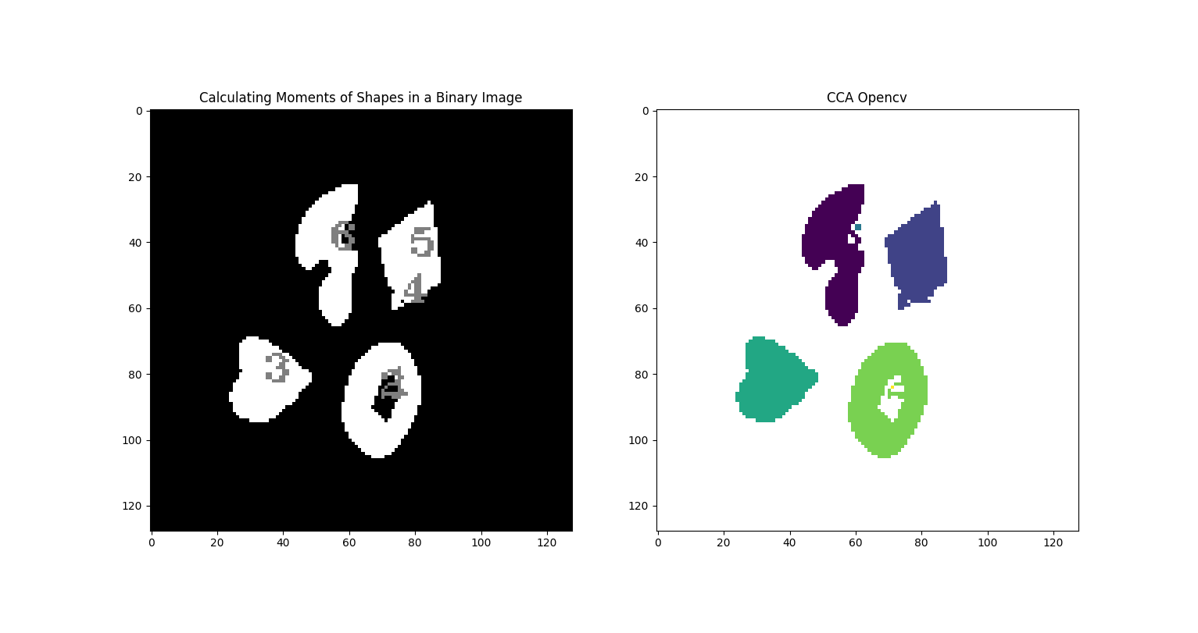
Shapes 4
Shapes found : 6
Moments for shape 1
Center (71, 86)
Area 91.5
mu20 0.04889147644073012
mu02 0.14993958178875486
mu11 -0.02357470575979148
Perimeter 40.870057225227356
Compactness 1.4527120318292872
Elongation 0.5994230095482433
Moments for shape 2
Center (69, 87)
Area 586.0
mu20 0.05399598443794238
mu02 0.12179736695110192
mu11 -0.014708469488715313
Perimeter 94.08326029777527
Compactness 1.2020353435166935
Elongation 0.5440454180438618
Moments for shape 3
Center (34, 82)
Area 391.5
mu20 0.07613985504858706
mu02 0.09571085049360943
mu11 -0.005589647039743871
Perimeter 80.6690468788147
Compactness 1.3227330985754109
Elongation 0.3405097479394655
Moments for shape 4
Center (76, 58)
Area 2.0
mu20 0.08333333333303017
mu02 0.08333333333325754
mu11 0.0
Perimeter 5.656854152679443
Compactness 1.2732395011540298
Elongation 1.1680077279969655e-06
Moments for shape 5
Center (78, 44)
Area 371.0
mu20 0.05129253946192563
mu02 0.13883208743405748
mu11 -0.012209518409848723
Perimeter 85.59797871112823
Compactness 1.5716044336209243
Elongation 0.5686957466131558
Moments for shape 6
Center (54, 42)
Area 439.0
mu20 0.041876077433748264
mu02 0.2685821867531959
mu11 0.01013871342052501
Perimeter 120.56854128837585
Compactness 2.6350789330005417
Elongation 0.6503956256888345
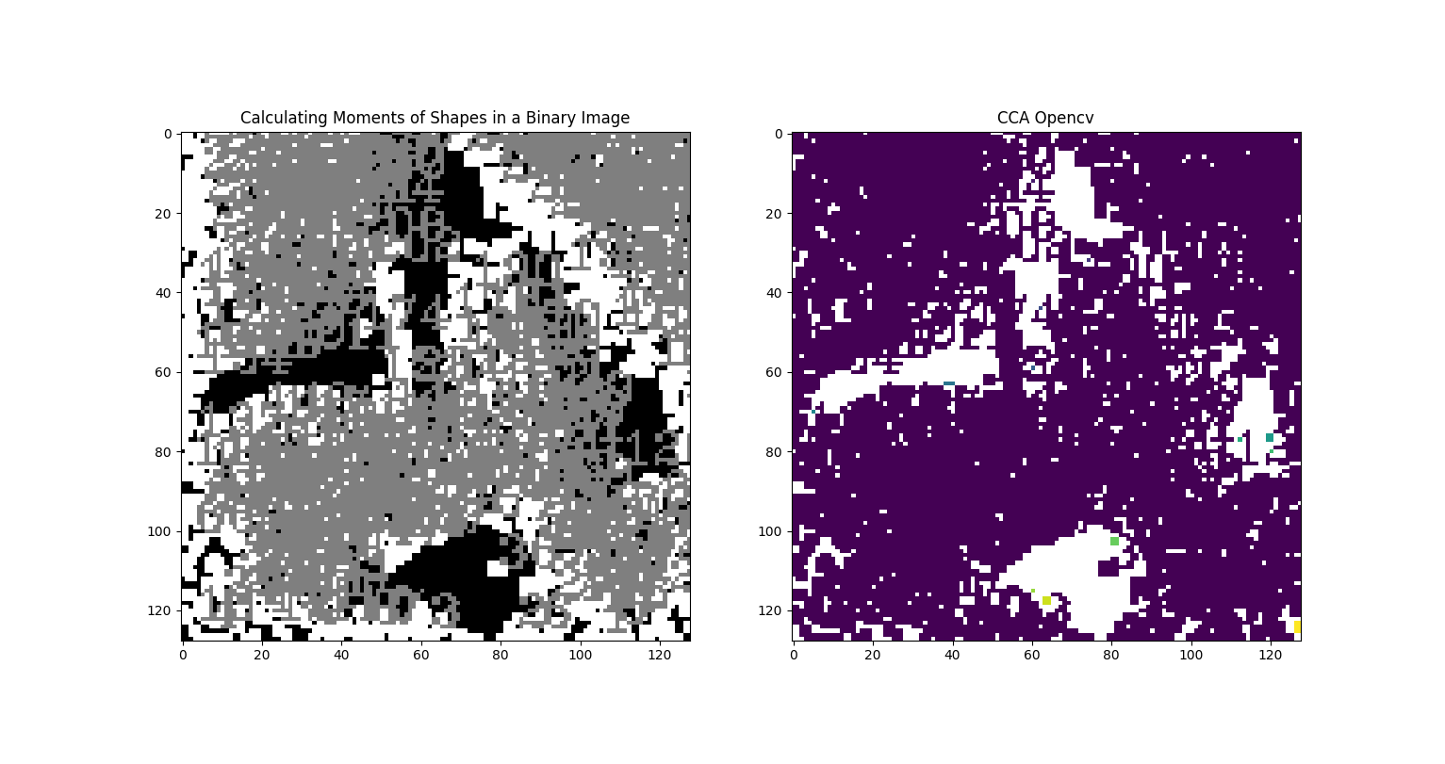
Keys
Shapes found : 284
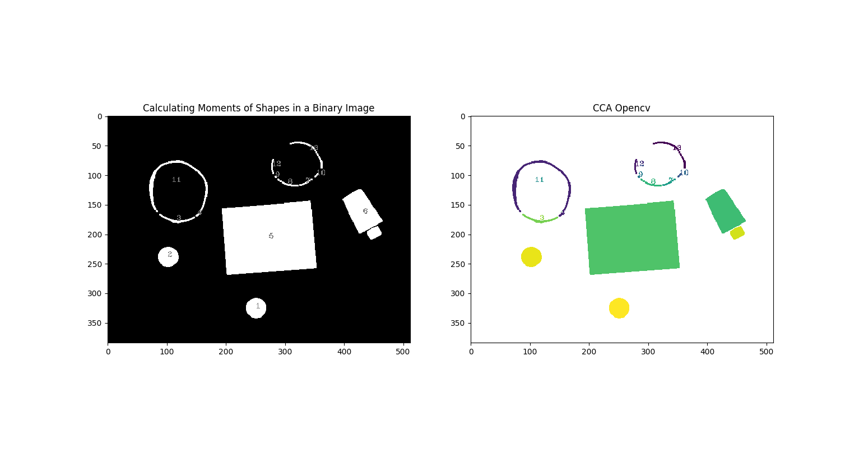
Pillset
Shapes found : 13
Moments for shape 1
Center (250, 325)
Area 883.0
mu20 0.07880401896902389
mu02 0.08044541799648638
mu11 -0.00010377633795292489
Perimeter 110.56854128837585
Compactness 1.101774185127508
Elongation 0.1014018949884407
Moments for shape 2
Center (101, 238)
Area 876.5
mu20 0.0822077949805792
mu02 0.07711873561468441
mu11 -0.0003952902596230656
Perimeter 111.15432798862457
Compactness 1.1217368067699638
Elongation 0.17695212454534823
Moments for shape 3
Center (116, 176)
Area 180.0
mu20 1.4554869684499234
mu02 0.07213944139614425
mu11 0.1307041609510607
Perimeter 141.39696836471558
Compactness 8.838891990326646
Elongation 0.6925278963588497
Moments for shape 4
Center (151, 167)
Area 16.0
mu20 0.10677083333325754
mu02 0.10677083333325754
mu11 -0.0703125
Perimeter 16.485280990600586
Compactness 1.3516456823486132
Elongation 0.6301260378127392
Moments for shape 5
Center (272, 207)
Area 16935.0
mu20 0.11129332545190648
mu02 0.06264400827132761
mu11 -0.004019906060930999
Perimeter 542.2253956794739
Compactness 1.3815437538482163
Elongation 0.4699715049596495
Moments for shape 6
Center (431, 165)
Area 3032.5
mu20 0.07353051422228996
mu02 0.13412960683422218
mu11 0.053906740034797423
Perimeter 301.2619730234146
Compactness 2.3816501057599724
Elongation 0.6109552581390368
Moments for shape 7
Center (334, 113)
Area 43.0
mu20 0.7986445637906383
mu02 0.1921979616049968
mu11 -0.37683159973333336
Perimeter 55.79898953437805
Compactness 5.762014530143648
Elongation 0.7028542559908323
Moments for shape 8
Center (304, 115)
Area 75.0
mu20 1.3303857777775991
mu02 0.13726281481480435
mu11 0.38352059259257393
Perimeter 84.62741661071777
Compactness 7.598905429936884
Elongation 0.7010492522283689
Moments for shape 9
Center (283, 103)
Area 8.0
mu20 0.08333333333212067
mu02 0.08333333333325754
mu11 0.02083333333303017
Perimeter 10.828427076339722
Compactness 1.1663553915641325
Elongation 0.44721359549873774
Moments for shape 10
Center (352, 100)
Area 21.0
mu20 0.17681675844946176
mu02 0.17681675844939576
mu11 -0.15206241226636816
Perimeter 23.313708305358887
Compactness 2.0596506252295748
Elongation 0.6799746990863849
Moments for shape 11
Center (108, 112)
Area 711.0
mu20 1.971504017075397
mu02 0.8554490191009586
mu11 -0.0776725458744071
Perimeter 489.3036046028137
Compactness 26.79645636200784
Elongation 0.5338517173224004
Moments for shape 12
Center (277, 85)
Area 49.0
mu20 0.01892706270375037
mu02 1.000468908929662
mu11 0.0006452810194968604
Perimeter 55.31370830535889
Compactness 4.968892558940523
Elongation 0.7003864077227889
Moments for shape 13
Center (340, 58)
Area 162.0
mu20 1.6583154926887338
mu02 1.193104396819215
mu11 1.2244227839967186
Perimeter 177.39696836471558
Compactness 15.458505640164486
Elongation 0.6829583699121953
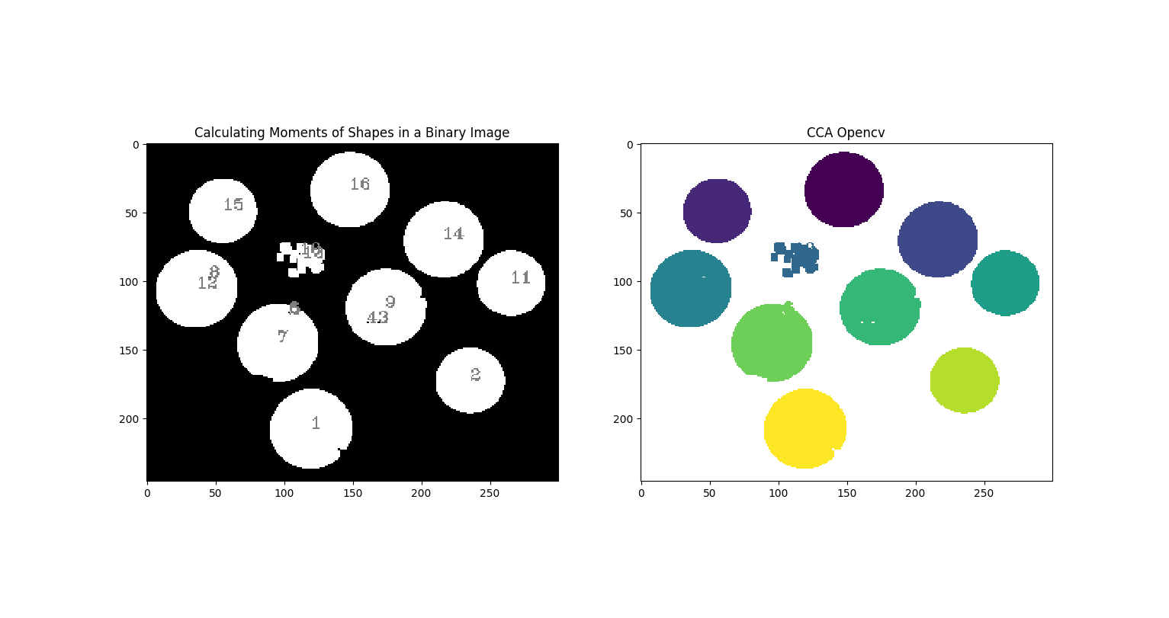
Coins
Shapes found : 16
Moments for shape 1
Center (119, 207)
Area 2651.5
mu20 0.08236710326422093
mu02 0.07729340619427144
mu11 -0.0027821620816834867
Perimeter 199.9238806962967
Compactness 1.1995762286372873
Elongation 0.2122254869228236
Moments for shape 2
Center (235, 172)
Area 1822.0
mu20 0.0837512233053824
mu02 0.07569281589147123
mu11 1.3756219198460037e-05
Perimeter 160.36753058433533
Compactness 1.1232453953224997
Elongation 0.219338686036211
Moments for shape 3
Center (168, 130)
Area 4.0
mu20 0.10416666666606034
mu02 0.0625
mu11 0.0
Perimeter 7.656854152679443
Compactness 1.166355372497387
Elongation 0.4472135954980056
Moments for shape 4
Center (160, 130)
Area 4.0
mu20 0.10416666666606034
mu02 0.0625
mu11 0.0
Perimeter 7.656854152679443
Compactness 1.166355372497387
Elongation 0.4472135954980056
Moments for shape 5
Center (104, 124)
Area 2.0
mu20 0.08333333333303017
mu02 0.08333333333303017
mu11 0.0
Perimeter 5.656854152679443
Compactness 1.2732395011540298
Elongation 0.0
Moments for shape 6
Center (103, 123)
Area 2.0
mu20 0.08333333333303017
mu02 0.08333333333303017
mu11 0.0
Perimeter 5.656854152679443
Compactness 1.2732395011540298
Elongation 0.0
Moments for shape 7
Center (95, 144)
Area 2560.5
mu20 0.08453090001014125
mu02 0.07519984064807912
mu11 -0.0005608995329581637
Perimeter 191.0954532623291
Compactness 1.1349221282967878
Elongation 0.23572978868294114
Moments for shape 8
Center (45, 97)
Area 4.0
mu20 0.10416666666662877
mu02 0.0625
mu11 0.0
Perimeter 7.656854152679443
Compactness 1.166355372497387
Elongation 0.4472135954998359
Moments for shape 9
Center (173, 119)
Area 2503.0
mu20 0.08260830353399118
mu02 0.07687995978383595
mu11 -0.00023745427705679082
Perimeter 190.50966572761536
Compactness 1.1538870953102465
Elongation 0.18651147573724675
Moments for shape 10
Center (111, 80)
Area 2.0
mu20 0.08333333333303017
mu02 0.08333333333303017
mu11 0.0
Perimeter 5.656854152679443
Compactness 1.2732395011540298
Elongation 0.0
Moments for shape 11
Center (264, 101)
Area 1797.5
mu20 0.08382767474898468
mu02 0.07562067906931888
mu11 -0.000894468263272744
Perimeter 158.6101713180542
Compactness 1.1137386862566114
Elongation 0.2237040754671143
Moments for shape 12
Center (36, 105)
Area 2569.5
mu20 0.08428058703268261
mu02 0.07527317144448617
mu11 -0.002745414101763805
Perimeter 189.09545230865479
Compactness 1.1073978667875675
Elongation 0.24902972221564662
Moments for shape 13
Center (113, 83)
Area 484.5
mu20 0.15648135329536458
mu02 0.07717960005324659
mu11 0.02098473184713046
Perimeter 163.8406196832657
Compactness 4.408994107397737
Elongation 0.5267354350992869
Moments for shape 14
Center (215, 69)
Area 2468.5
mu20 0.08352706916988918
mu02 0.07590914520339896
mu11 -0.0015842773830414768
Perimeter 185.9238805770874
Compactness 1.1143647223651068
Elongation 0.22181630550309184
Moments for shape 15
Center (55, 48)
Area 1787.0
mu20 0.08417165914041085
mu02 0.07531417864530848
mu11 -0.0012028830639480874
Perimeter 158.36753129959106
Compactness 1.1168577883513742
Elongation 0.23327680227265538
Moments for shape 16
Center (147, 33)
Area 2434.0
mu20 0.08377426799408655
mu02 0.07566591128623228
mu11 -0.001286248864708218
Perimeter 184.5096663236618
Compactness 1.113032405914737
Elongation 0.22505751460290227

Comments on Moments:
- Depends highly on segmentation. If segmentation is bad and has smaller connected component, will produce unnecessary results. Morphological operation is recommended in these situations before applying moments.
- Completely fails for noisy image.
- From Pillset image:
For circle: Compactness 1.101774185127508 Elongation 0.1014018949884407
For rectangle: Compactness 2.3816501057599724 Elongation 0.6109552581390368
Compactness value for circle is very close to 1. Also, circle has lower compactness and elongation value than rectangle. So, numbers make sense
- Elongation is given as a value between 0 and 1. If the ratio is equal to 1, the object is roughly square or circularly shaped. As the ratio decreases from 1, the object becomes more elongated. Compactness has a minimum value of 1 (for circle). It increases as objects become less compact.

