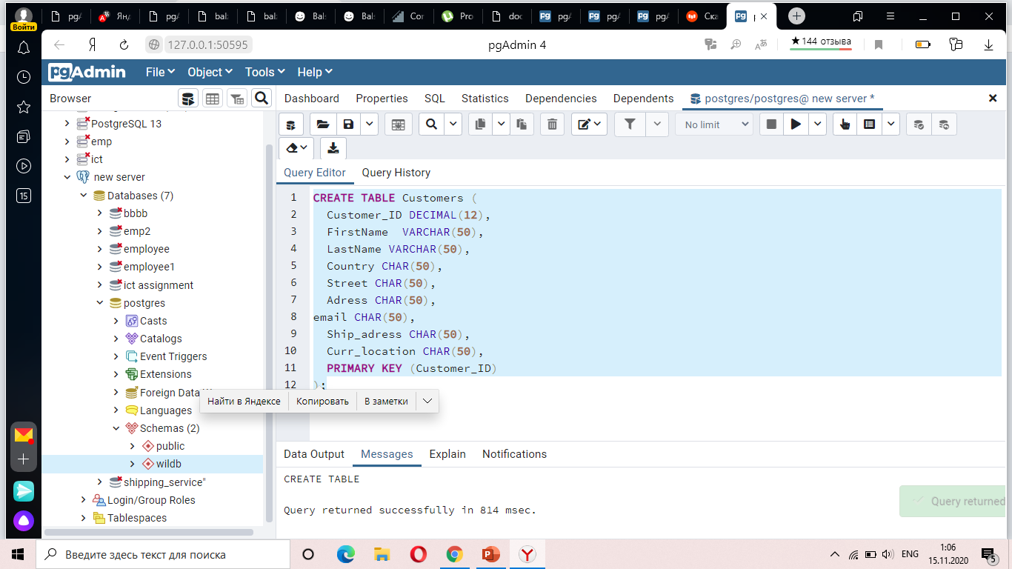

**COSTUMER TABLE**

CREATE TABLE Customers (

Customer_ID DECIMAL(12),

FirstName VARCHAR(50),

LastName VARCHAR(50),

Country CHAR(50),

Street CHAR(50),

Adress CHAR(50),

email CHAR(50),

Ship_adress CHAR(50),

Curr_location CHAR(50),

PRIMARY KEY (Customer_ID)

); //our first table is successfully created.

(Address)

**PAYMENT TABLE** 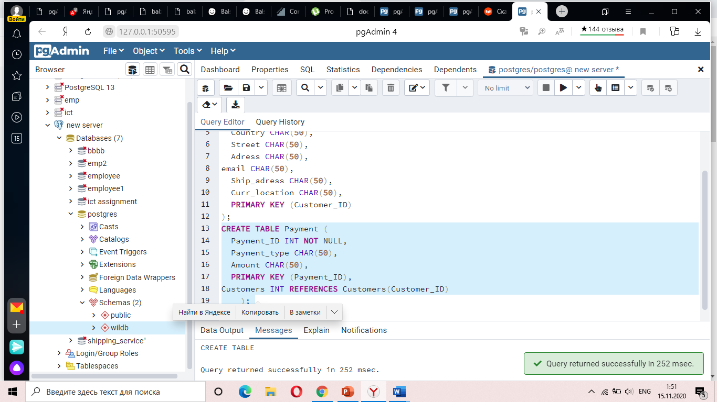

CREATE TABLE Payment (

Payment_ID INT NOT NULL,

Payment_type CHAR(50),

Amount CHAR(50),

PRIMARY KEY (Payment_ID),

Customers INT REFERENCES Customers(Customer_ID)

); //Successfully FK has created between two tables

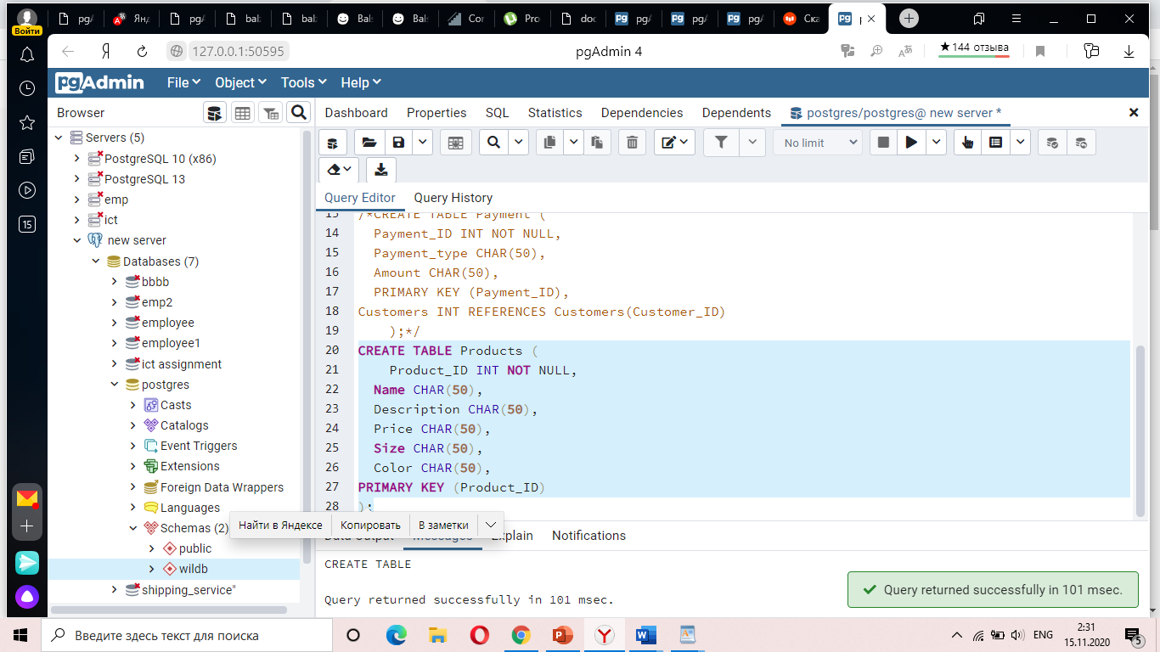

//created a new table, which called “Products”

CREATE TABLE Products (

Product_ID INT NOT NULL,

Name CHAR(50),

Description CHAR(50),

Price CHAR(50),

Size CHAR(50),

Color CHAR(50),

PRIMARY KEY (Product_ID)

);

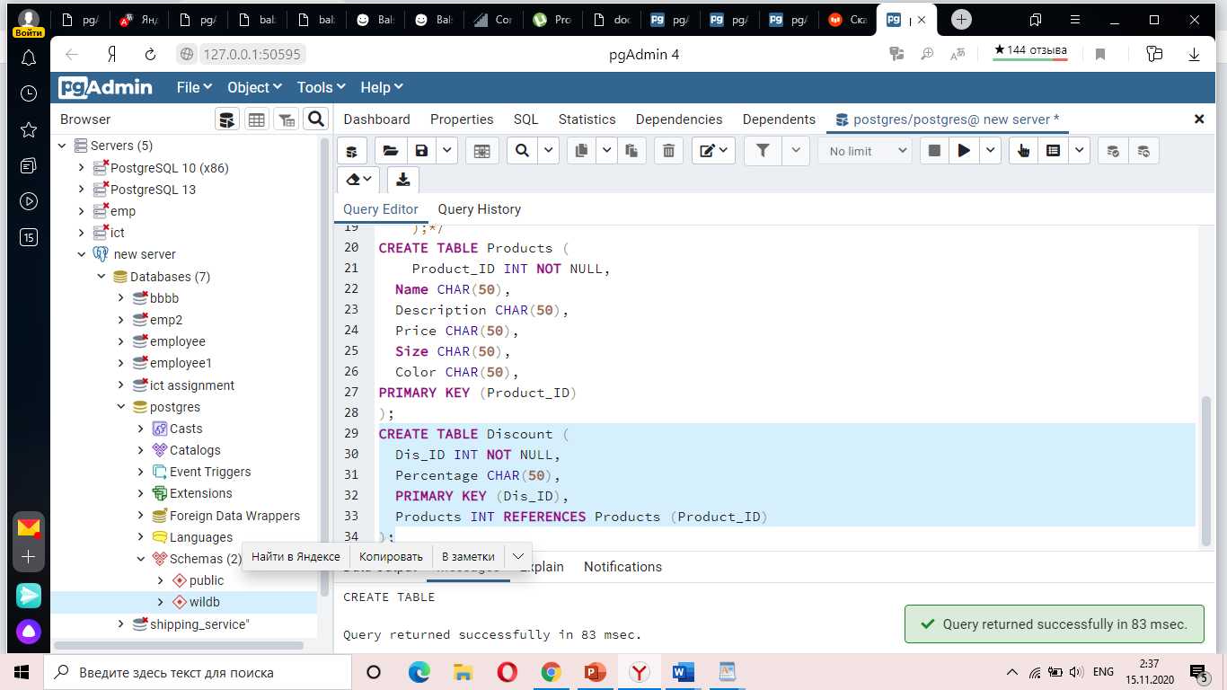

// Successfully FK has created between Products and Discount.

**The Discount Table**

CREATE TABLE Discount (

Dis_ID INT NOT NULL,

Percentage CHAR(50),

PRIMARY KEY (Dis_ID),

Products INT REFERENCES Products (Product_ID)

);

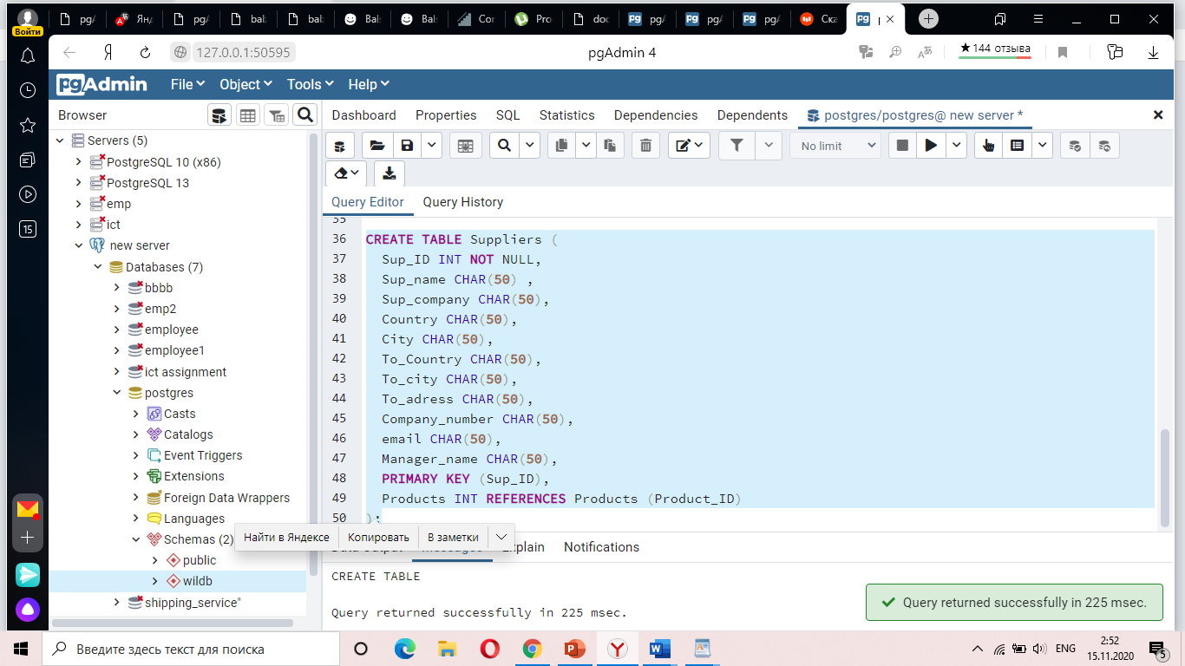

**Table of Suppliers**

CREATE TABLE Suppliers (

Sup_ID INT NOT NULL,

Sup_name CHAR(50) ,

Sup_company CHAR(50),

Country CHAR(50),

City CHAR(50),

To_Country CHAR(50),

To_city CHAR(50),

To_adress CHAR(50),

Company_number CHAR(50),

email CHAR(50),

Manager_name CHAR(50),

PRIMARY KEY (Sup_ID),

Products INT REFERENCES Products (Product_ID)

); // Successfully FK has created between Products and Suppliers

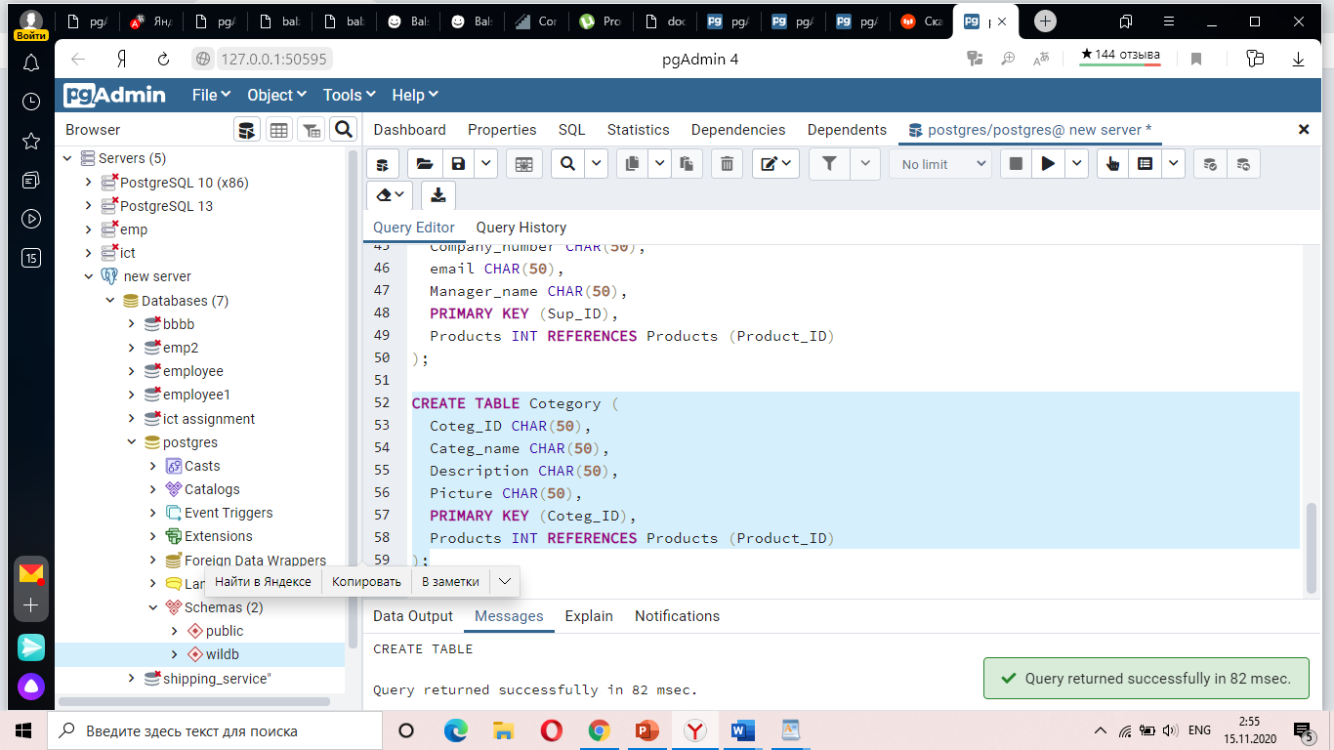

**Table of Cotegory (Category)**

CREATE TABLE Cotegory (

Coteg_ID CHAR(50),

Categ_name CHAR(50),

Description CHAR(50),

Picture CHAR(50),

PRIMARY KEY (Coteg_ID),

Products INT REFERENCES Products (Product_ID)

);

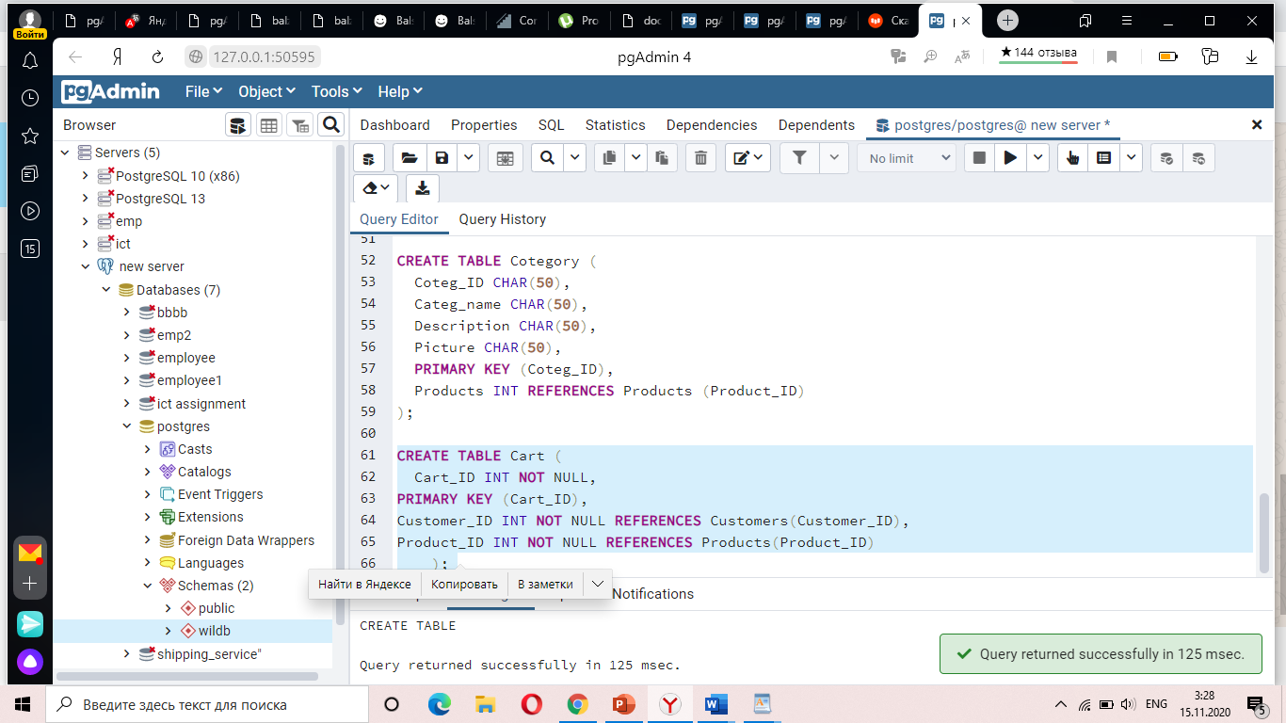

**CART TABLE**

CREATE TABLE Cart (

Cart_ID INT NOT NULL,

PRIMARY KEY (Cart_ID),

Customer_ID INT NOT NULL REFERENCES Customers(Customer_ID),

Product_ID INT NOT NULL REFERENCES Products(Product_ID)

); //table is successfully created with 2 FK.

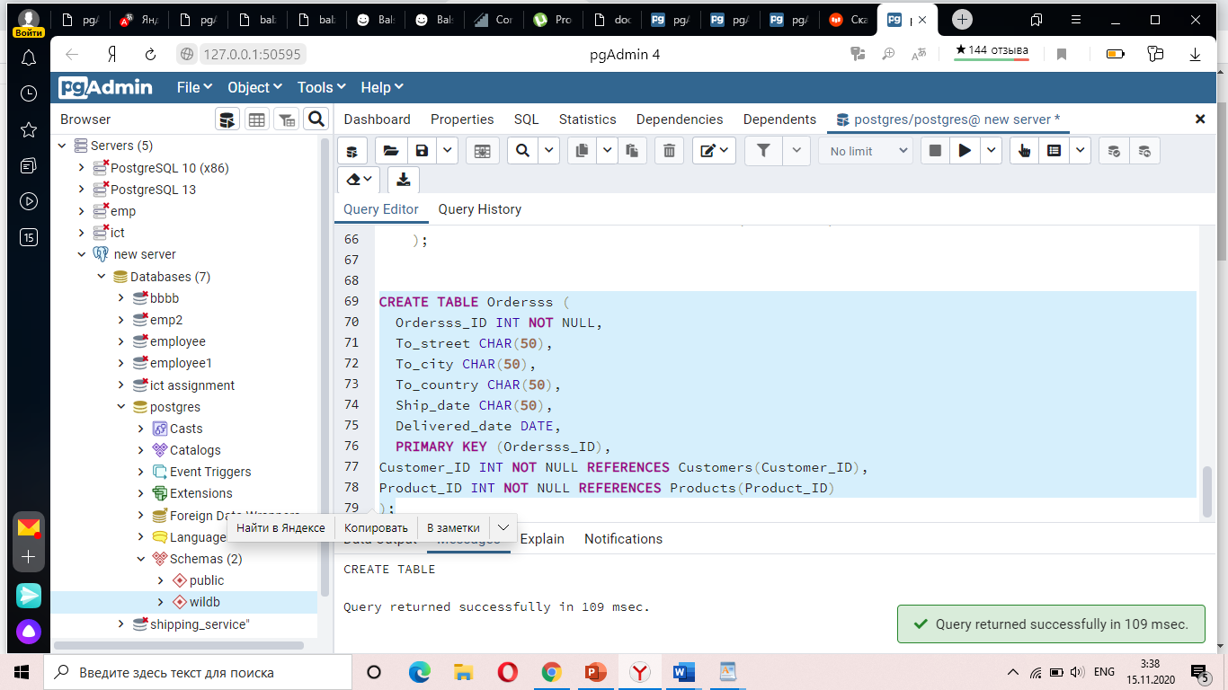

**Table Order**

CREATE TABLE Ordersss (

Ordersss_ID INT NOT NULL,

To_street CHAR(50),

To_city CHAR(50),

To_country CHAR(50),

Ship_date CHAR(50),

Delivered_date DATE,

PRIMARY KEY (Ordersss_ID),

Customer_ID INT NOT NULL REFERENCES Customers(Customer_ID),

Product_ID INT NOT NULL REFERENCES Products(Product_ID)

); //has created with 2 FK. OUR <int> means datatype.

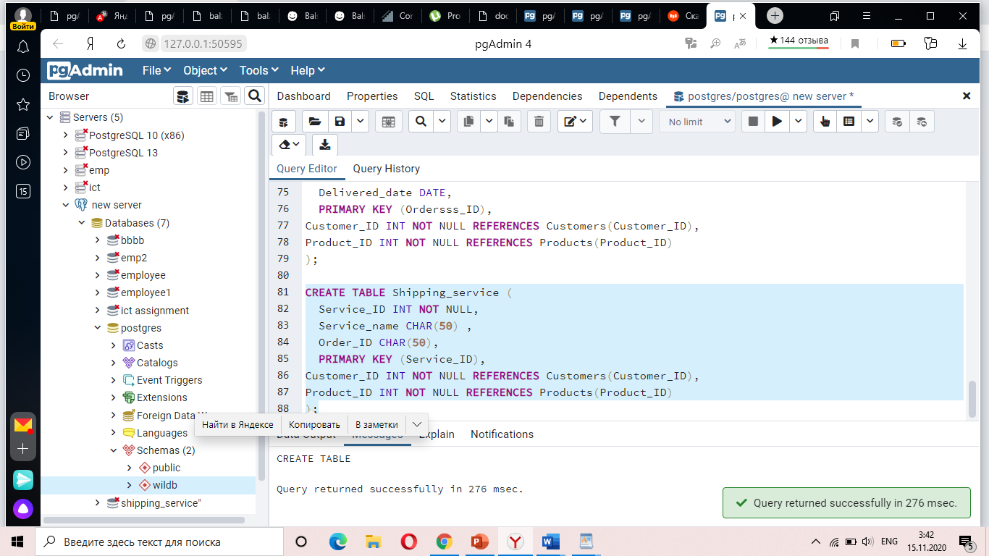

**SHIPPING_S TABLE**

CREATE TABLE Shipping_service (

Service_ID INT NOT NULL,

Service_name CHAR(50) ,

Order_ID CHAR(50),

PRIMARY KEY (Service_ID),

Customer_ID INT NOT NULL REFERENCES Customers(Customer_ID),

Product_ID INT NOT NULL REFERENCES Products(Product_ID)

); //it’s created like “Cart table”

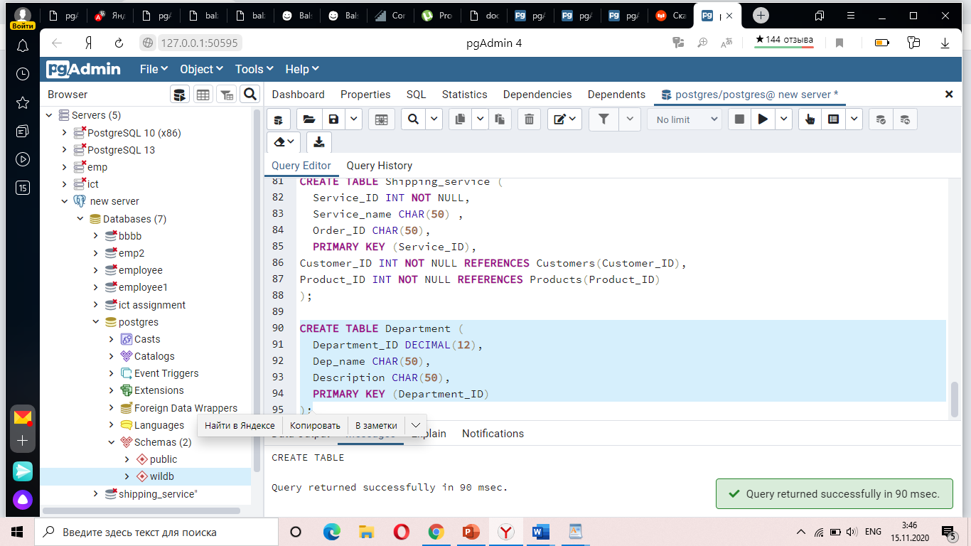

**DEPARTMENT TABLE**

CREATE TABLE Department (

Department_ID DECIMAL(12),

Dep_name CHAR(50),

Description CHAR(50),

PRIMARY KEY (Department_ID)

);

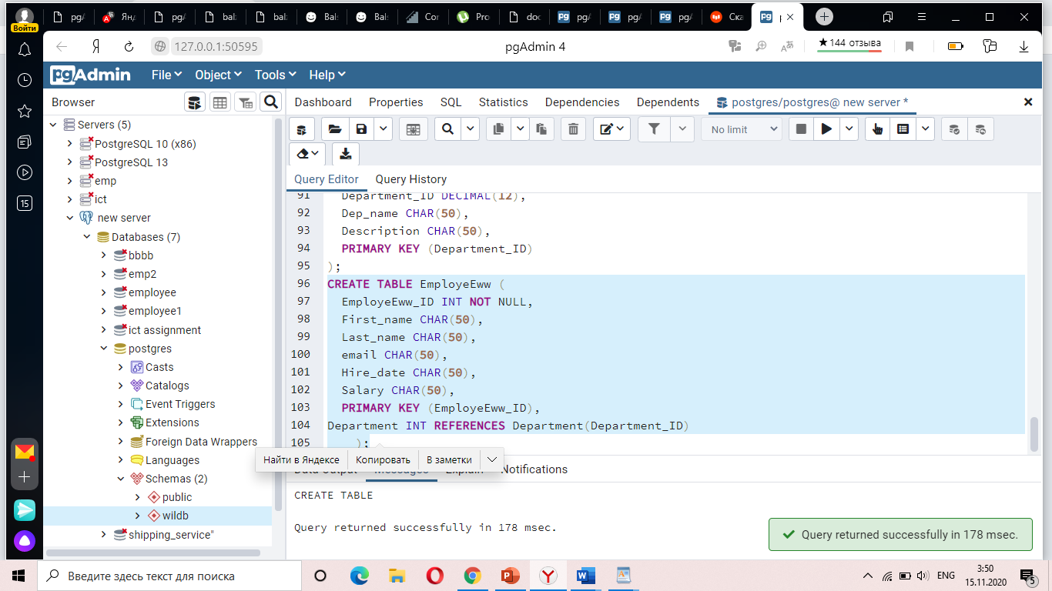

**EMPLOYEE TABLE**

CREATE TABLE EmployeEww (

EmployeEww_ID INT NOT NULL,

First_name CHAR(50),

Last_name CHAR(50),

email CHAR(50),

Hire_date CHAR(50),

Salary CHAR(50),

PRIMARY KEY (EmployeEww_ID),

Department INT REFERENCES Department(Department_ID)

);//changed name of table, because I have table “Employee”, and forgot delete it.

Employee table has created successfully. Also FK has created between two tables.

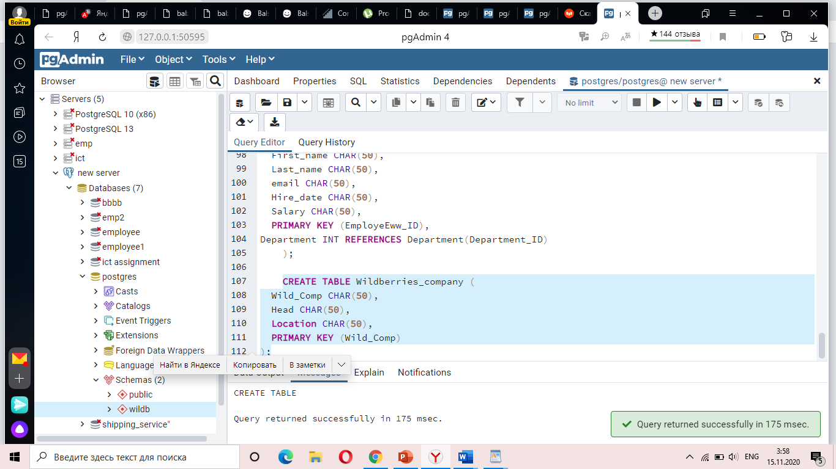

//created our main table

CREATE TABLE Wildberries_company (

Wild_Comp CHAR(50),

Head CHAR(50),

Location CHAR(50) ,

PRIMARY KEY (Wild_Comp)

);