Michael Christensen
November 24, 2013
CS 450
Homework 7
Written Exercises:
- Suppose that you are sampling a bandlimited signal whose highest frequency is 10 KHz. At what rate would you have to sample this signal assuming perfect reconstruction? At what rate would you have to sample it if the reconstruction filter was a low-pass filter with an imperfect cutoff at 10 KHz but allowed some frequencies up to 15 Khz?

Assuming perfect reconstruction, the Nyquist rate states that the sampling rate must be twice the maximum/highest frequency. Since the highest frequency here is 10 Khz, the the sampling rate should be 20 Khz.

If the reconstruction filter was a low-pass filter with an imperfect cutoff at 10 Khz but allowed some frequencies up to 15 Khz, the sampling rate would have to be 30 Khz. This is because if this sampling rate was lower, it would cause the 15 Khz frequencies to merge with the lower ones and there not to be cleanly separated periods.

- Given the following image locations and values, calculate the value of the image at (2.7,4.8) using bilinear interpolation.
Location Value
(2, 4) 7
(2, 5) 8
(3, 4) 8
(3, 5) 10

v = ax + by + cxy + d

7 = a2 + b4 + c2*4 + d
8 = a2 + b5 + c2*5 + d
8 = a3 + b4 + c3*4 + d
10 = a3 + b5 + c3*5 + d

Using numpy's linalg module, these are the values for a through d: a= -3, b = -1, c = 1, d = 9. For verification:

7 = -3*2 + -1*4 + 1*8 + 9 = -6 – 4 + 8 + 9 = 7
8 = -3*2 + -1*5 + 1*10 + 9 = -6 – 5 + 10 + 9 = 8
8 = -3*3 + -1*4 + 1*12 + 9 = -9 – 4 + 12 + 9 = 8
10 = -3*3 + -1*5 +1*15 + 9 = -9 – 5 + 15 + 9 = 10

This is the code for this system:
a = np.array([[2,4,8,1],[2,5,10,1],[3,4,12,1],[3,5,15,1]])
b = np.array([7,8,8,10])
co = np.linalg.solve(a,b)

Thus, the value of the image at (2.7, 4.8) is:
v = -3 * 2.7 + -1 * 4.8 + 1 * (2.7 * 4.8) + 9
= -8.1 – 4.8 + 12.96 + 9 = 9.06

- Use bilinear warping to produce a mapping from the quadrilateral (0,0), (1,0), (1.1, 1.1), (0,1) to the unit square.

v = ax + by + cxy + d

One system of equations for x' and one for y':

x': quadr → unitsq
0 = a*0 + b*0 + c*(0*0) + d (0,0) → (0,0)
1 = a*1 + b*0 + c*(1*0) + d (1,0) → (1,0)
1 = a*1.1 + b*1.1 + c*(1.1*1.1) + d (1.1,1.1) → (1,1)
0 = a*0 + b*1 + c*(0*1) + d (0,1) → (0,1)

y': quadr → unitsq
0 = a*0 + b*0 + c*(0*0) + d (0,0) → (0,0)
0 = a*1 + b*0 + c*(1*0) + d (1,0) → (1,0)
1 = a*1.1 + b*1.1 + c*(1.1*1.1) + d (1.1,1.1) → (1,1)
1 = a*0 + b*1 + c*(0*1) + d (0,1) → (0,1)

Using numpy's linalg module,

For x', these are the values for a through d: a= 1, b = 0, c = -0.08264463, d = 0, and this is the code used to solve both systems of equations:

a = np.array([[0, 0, 0, 1], [1, 0, 0, 1], [1.1, 1.1, 1.1*1.1, 1], [0, 1, 0, 1]])
b = [0, 1, 1, 0]
co = np.linalg.solve(a,b)

For y', these are the values for a through d: a= 0, b = 1, c = -0.08264463, d = 0, and this is the code used to solve both systems of equations:

a = np.array([[0, 0, 0, 1], [1, 0, 0, 1], [1.1, 1.1, 1.1*1.1, 1], [0, 1, 0, 1]])
b = [0, 0, 1, 1]
co = np.linalg.solve(a,b)

Thus to get the x' mapping use
x' = x – 0.08264463(xy)
And to get the y' mapping use
y' = y – 0.08264463(xy)
Programming Exercises:
Part A: Image Resizing (Magnification)
Code is found at the end of this document.
Original Parrots.png:
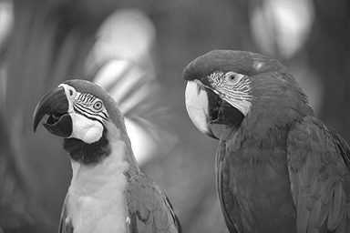

Parrots magnified by 2:
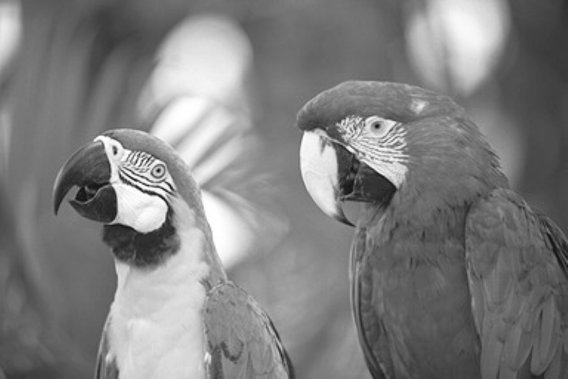
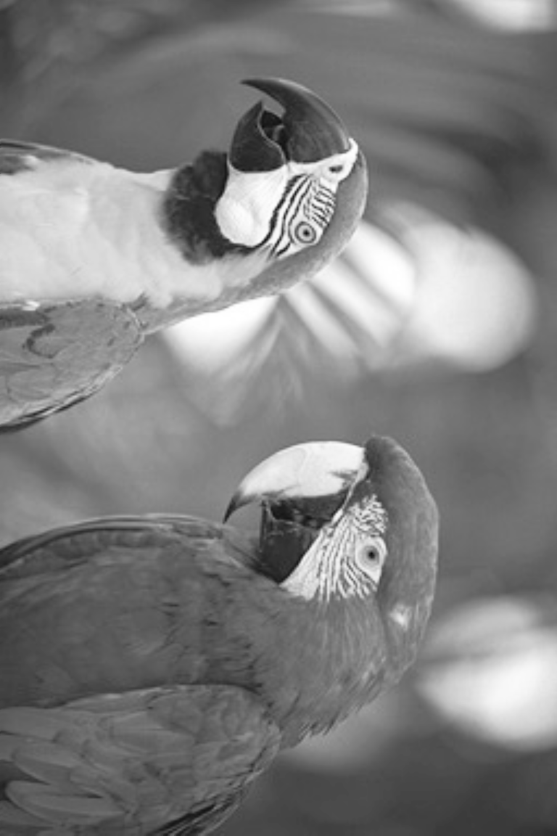
Parrots magnified by 3 (scaled to 87% of image's real size to fit on this page):
Part B: Image Resizing (Reduction);
Parrots reduced by 4 and 8:
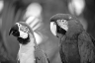

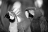

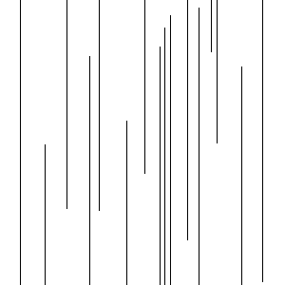
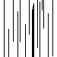
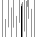
testImage2.png original and reduced by 4 and 8:

testImage3.png original and reduced by 4 and 8:
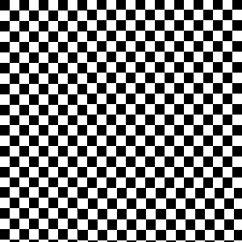
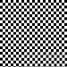
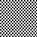
testImage4.png original and reduced by 4 and 8:
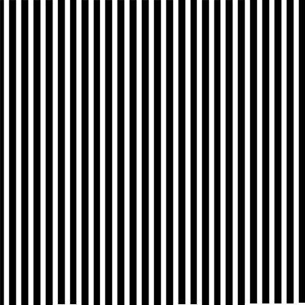
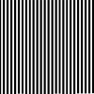
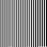

Is there anything you have to do differently from Part A in order to make this work well?
I took an average of the surrounding pixels in the source image, thinking that this would work because the destination image will have less discernible detail.
Part C: Image Warping:
Parrots.png rotated by one 120 degree rotation:
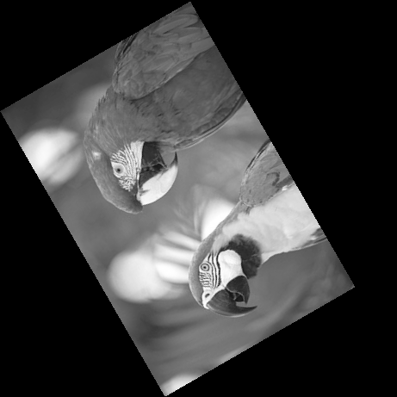

Parrots.png rotated by 8 15 degree rotations:
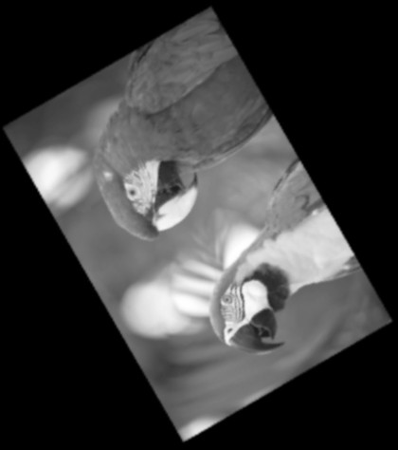
Here are the images as they looked after each intermediate rotation:
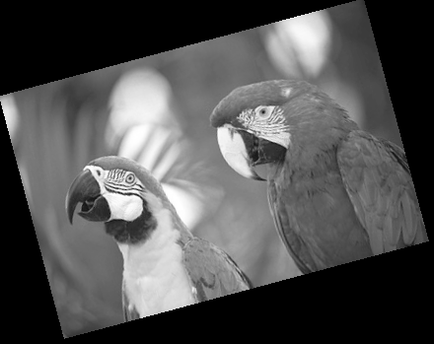
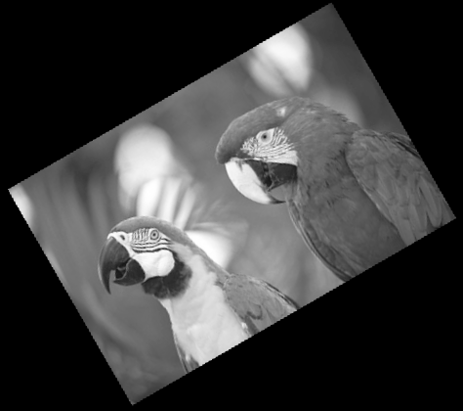
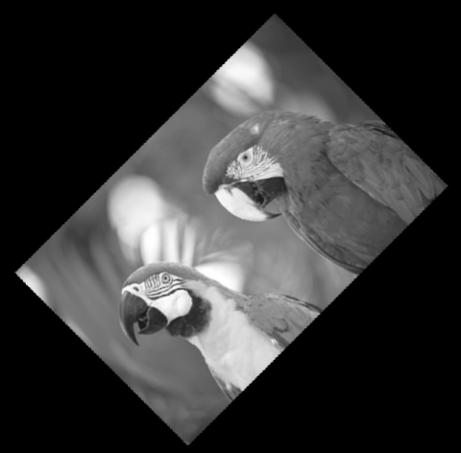

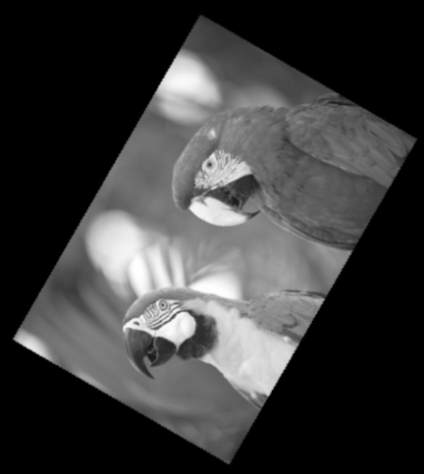
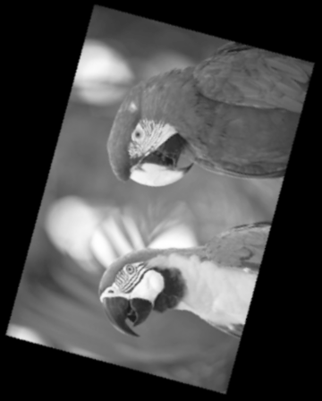
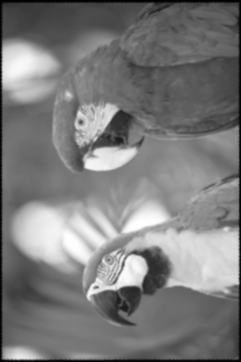

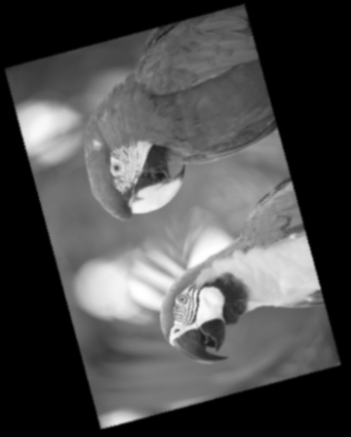

The final image caused by rotating the original by 8 15 degree individual rotations had a significant loss in detail, which I believe was caused by the fact that each rotation involved mapping pixels from the new image to the average of the surrounding pixels in the original image. Therefore, since each rotation involved creating a new image from a previous image created from averages, the averages compounded, until the final image was essentially composed of the average of 7 previous averages. The one 120 degree rotation, on the other hand, only did this backward mapping once, preserving greater detail.

Challenges:
My biggest challenge was with the image warping and figuring out how to do the individual rotations consecutively. The written part took less than an hour, and the programming part took 6 – 8 hours (I can't really remember accurately since I did this over a very wide period of time).
Code:
import matplotlib.pyplot as pl
import numpy as np
import math
import matplotlib.cm as cm

#Image resizing (Magnification)
def parta():

#Read in an image
img = pl.imread('parrots.png')

#Magnify it by a specified (integer) factor
#using bilinear interpolation
magnifications = (2, 3)

for mag in magnifications:
newimg = np.zeros(np.multiply(img.shape, mag), img.dtype)

for r in range(newimg.shape[0]):
for c in range(newimg.shape[1]):
#Backward Mapping

#Get inverse (where this current (r,c) pixel is
#located in the original image, which is probably not
#exactly on a pixel)
x, y = (r/float(mag), c/float(mag))
fracx = x - int(x)
fracy = y - int(y)

#Get the four closest points (upperleft, upperright, bottomleft, bottomright)
#from the original image to interpolate from
p1 = (int(x), int(y)) #upperleft (closer to zero)
p2 = (int(x), int(y) + 1) #upperright
p3 = (int(x) + 1, int(y)) #bottomleft
p4 = (int(x) + 1, int(y) + 1) #bottomright

# Getting the original images surrounding values, checkign bounds
old1 = img[p1]
old2 = None
if p2[1] == img.shape[1]:
old2 = img[p1]
else:
old2 = img[p2]
old3 = None
if p3[0] == img.shape[0]:
old3 = img[p1]
else:
old3 = img[p3]
old4 = None
if p4[0] == img.shape[0] or p4[1] == img.shape[1]:
old4 = img[p1]
else:
old4 = img[p4]

#Interpolate (using the unit-square approach from wikipedia and www.cse.unr.edu/~looney/cs674/mgx6/unit6.pdf)
val = old1*(1-fracx)*(1-fracy) + old3*fracx*(1-fracy) + old2*(1-fracx)*fracy + old4*fracx*fracy
newimg[r,c] = val

pl.imsave("ParrotsMagnifiedBy%d"%(mag),newimg, cmap=cm.Greys_r)

# Image Resizing (Reduction)
def partb():
images = ('parrots.png', 'testImage2.png', 'testImage3.png', 'testImage4.png')

for imgname in images:
#Read in an image
img = pl.imread(imgname)

#Reduce it by a specified (integer) factor
reductions = (4, 8)

for red in reductions:
newimg = np.zeros(np.multiply(img.shape, 1/float(red)), img.dtype)

for r in range(newimg.shape[0]):
for c in range(newimg.shape[1]):

val = get_average((r*red,c*red), red, img)
newimg[r,c] = val

pl.imsave("%sReducedBy%d.png"%(imgname, red), newimg, cmap=cm.Greys_r)

def get_average(point, reduction, img):
#Get average from img in this layout:
#[(r,c), ........, (r,c+red-1)]
#[............................]
#[(r+red-1),,(r+red-1,c+red-1)]

mat = np.zeros(img.shape)
mat[point[0]:point[0]+reduction, point[1]:point[1]+reduction] = np.ones((reduction,reduction))
res = np.multiply(mat, img)
res = res.sum()/float(reduction**2)
return res

# Image Warping
def partc():
images = ['parrots.png']

#######################
#1 120 degree increment
#Read in an image
img = pl.imread('parrots.png')

#img.shape[0] --> height
#img.shape[1] --> length
origcorners = [(0, 0),
(0, img.shape[1]),
(img.shape[0], 0),
(img.shape[0], img.shape[1])]
largestdist = np.sqrt(img.shape[0]**2 + img.shape[1]**2)
newimg = np.zeros((largestdist, largestdist))
midpoint = np.divide(img.shape,2)
angle = 120.0
newcorners = []
for corn in origcorners:
x = corn[0]
y = corn[1]
newcorner = ((x-midpoint[0])*math.cos(math.radians(angle)) - (y-midpoint[1])*math.sin(math.radians(angle)) + midpoint[0],
(x-midpoint[0])*math.sin(math.radians(angle)) + (y-midpoint[1])*math.cos(math.radians(angle)) + midpoint[1])
newcorners.append(newcorner)
#print newcorners

xs = map(lambda(x): x[0], newcorners)
ys = map(lambda(x): x[1], newcorners)
minx = int(np.min(xs))
maxx = int(np.max(xs))
miny = int(np.min(ys))
maxy = int(np.max(ys))

for x in range(minx, maxx):
for y in range(miny, maxy):
u = (x-midpoint[0])*math.cos(math.radians(-angle)) - (y-midpoint[1])*math.sin(math.radians(-angle)) + midpoint[0]
v = (x-midpoint[0])*math.sin(math.radians(-angle)) + (y-midpoint[1])*math.cos(math.radians(-angle)) + midpoint[1]

#Get the four closest points
#from the original image to interpolate from
p1 = (int(u), int(v)) #upperleft (closer to zero)
p2 = (int(u), int(v) + 1) #upperright
p3 = (int(u) + 1, int(v)) #bottomleft
p4 = (int(u) + 1, int(v) + 1) #bottomright

val = 0.0
if u < 0 or u >= img.shape[0] - 1 or v < 0 or v >= img.shape[1] - 1:
val = 0.0
else:
# Getting the original images surrounding values
old1 = img[p1]
old2 = img[p2]
old3 = img[p3]
old4 = img[p4]

#Interpolate
b = np.array([old1, old2, old3, old4])
a = np.array([[p1[0], p1[1], p1[0]*p1[1], 1], [p2[0], p2[1], p2[0]*p2[1], 1],
[p3[0], p3[1], p3[0]*p3[1], 1], [p4[0], p4[1], p4[0]*p4[1], 1]])
coef = np.linalg.solve(a, b)
val = coef.dot(np.array([u, v, u*v, 1]))

r = x + (0 - minx)
c = y + (0 - miny)
newimg[r,c] = val

pl.imsave("ParrotsRotatedOnly120.png", newimg, cmap=cm.Greys_r)

#######################
#8 15 degree increments
#Note: this code isn't perfectly efficient, as it continually
#increases the size of the image because of the poor way in which I
#calculate the needed size of the next image that will result after rotation
#I manually cropped out the surrounding black parts of the huge images that
#resulted for report.
img = pl.imread('parrots.png')
for n in range(8):
print n
#img.shape[0] --> height
#img.shape[1] --> length
origcorners = [(0, 0),
(0, img.shape[1]),
(img.shape[0], 0),
(img.shape[0], img.shape[1])]
largestdist = np.sqrt(img.shape[0]**2 + img.shape[1]**2)
newimg = np.zeros((largestdist, largestdist))
midpoint = np.divide(img.shape,2)
angle = 15.0
newcorners = []
for corn in origcorners:
x = corn[0]
y = corn[1]
newcorner = ((x-midpoint[0])*math.cos(math.radians(angle)) - (y-midpoint[1])*math.sin(math.radians(angle)) + midpoint[0],
(x-midpoint[0])*math.sin(math.radians(angle)) + (y-midpoint[1])*math.cos(math.radians(angle)) + midpoint[1])
newcorners.append(newcorner)
#print newcorners

xs = map(lambda(x): x[0], newcorners)
ys = map(lambda(x): x[1], newcorners)
minx = int(np.min(xs))
maxx = int(np.max(xs))
miny = int(np.min(ys))
maxy = int(np.max(ys))

for x in range(minx, maxx):
for y in range(miny, maxy):
u = (x-midpoint[0])*math.cos(math.radians(-angle)) - (y-midpoint[1])*math.sin(math.radians(-angle)) + midpoint[0]
v = (x-midpoint[0])*math.sin(math.radians(-angle)) + (y-midpoint[1])*math.cos(math.radians(-angle)) + midpoint[1]

#Get the four closest points
#from the original image to interpolate from
p1 = (int(u), int(v)) #upperleft (closer to zero)
p2 = (int(u), int(v) + 1) #upperright
p3 = (int(u) + 1, int(v)) #bottomleft
p4 = (int(u) + 1, int(v) + 1) #bottomright

val = 0.0
if u < 0 or u >= img.shape[0] - 1 or v < 0 or v >= img.shape[1] - 1:
val = 0.0
else:
# Getting the original images surrounding values
old1 = img[p1]
old2 = img[p2]
old3 = img[p3]
old4 = img[p4]

#Interpolate
b = np.array([old1, old2, old3, old4])
a = np.array([[p1[0], p1[1], p1[0]*p1[1], 1], [p2[0], p2[1], p2[0]*p2[1], 1],
[p3[0], p3[1], p3[0]*p3[1], 1], [p4[0], p4[1], p4[0]*p4[1], 1]])
coef = np.linalg.solve(a, b)
val = coef.dot(np.array([u, v, u*v, 1]))

r = x + (0 - minx)
c = y + (0 - miny)
newimg[r,c] = val
img = newimg

#pl.imshow(img, cmap=cm.Greys_r)
pl.show()
pl.imsave("ParrotsRotated%d.png"%((n+1)*15), img, cmap=cm.Greys_r)

def run():
parta()
partb()
partc()

if __name__ == "__main__":
run()

