Michael Christensen
October 28, 2013
CS 465
Project 6 (PGP and S/MIME)
Email Platforms and Tools Used:
For PGP I used Gmail with the Chrome extension Mailvelope, which was relatively simple to use (compared to S/MIME tools) because the extension itself can generate public/private key pairs as well as easily import your friends' public keys into the key ring. To encrypt a message, you use Gmail's message editor to create the message and then click on the extension's lock button to encrypt the message using each recipient's imported public keys. When a message signed by another person arrives, the extension can easily decrypt the messages when I enter in the pass-phrase securing my private key. For S/MIME, I retrieved a free certificate from StartCom Ltd and imported this certificate (a .p12) into Thunderbird. With that, I could sign a message to my peer so that he would have my certificate and be able to encrypt messages to me (and using the reverse process, vice versa).

Difference between PGP and S/MIME:
PGP (Pretty Good Privacy) is a model of trust used to digitally sign and encrypt Internet communication like email via a web of trust. Two parties each generate public/private key pairs and exchange the public keys (a la RSA) , which is where this trust comes into play. There are no certificates involved in this exchange, so I must have confidence that the key given to me from the other person is what it was originally when it was created by my friend, and that my friend really gave it to me (rather than it being the product of some attacker/man-in-the-middle). Then to send a message, if a signature is desired, Party A uses his private key to sign the message, and if encryption is desired, uses Party B's public key to encrypt it. Party B then uses her private key to decrypt the message and uses Party A's public key to verify the signature (since only A knows A's private key, supposedly).
S/MIME (Secure Multipurpose Internet Mail Extension) on the other hand relies on a hierarchal, top-down model of certificate authorities instead of a web of trust between parties like PGP. Both parties obtain and install a certificate from a certificate authority, which allow them to bind their public key to their identifying information and allow others to confirm this binding when receiving their messages.

Parts of the process that were difficult to use/understand:
The two most difficult parts of the process were figuring out how S/MIME works exactly (since the Internet does a poor job explaining it anywhere) and figuring out how to properly create, import, and verify digital certificates into my mail client (Thunderbird). I had one error where the email client wouldn't let me send the message I was attempting to sign because it (the mail client) couldn't verify the certificate I had imported, despite the same process working flawlessly on my companion's mail client. I solved the problem by disabling the verification temporarily because I was positive the certificate I was using (mine) was authentic since I had just generated it straight from the CA. I did, however, verify my companion's certificate to be sure it was authentic.

Past experience with secure email and prospect for continued use of secure email technology in the future:
I have no past experience with secure email, the reason being that I had 1. never heard of the idea of securing email (naively thinking that web mail clients like Gmail were secure enough) and 2. never had need to secure any my communication (or didn't realize the need to). I also don't intend to use this in the future because of the hassle it was to set up anything with the recipients of my messages, especially encrypting messages via S/MIME, which was the most confusing method. I may consider using secure mail if Gmail integrates the Mailvelope extension's functionality directly into the client so that more people are exposed to it, but then that might involve trusting Gmail itself as a third party, which is something we're trying to avoid.

Who I worked with and the ease/difficulty of preparation for exchange:
I worked with Mike Curtis for this project to exchange our emails in PGP and S/MIME. It was fairly easy to prepare using the Mailvelope since both of us regularly use Chrome and Gmail. S/MIME, on other hand, presented difficulties because we approached obtaining certificates differently (some websites make it easier and more obvious than others), but we eventually found it was easiest if we agreed on the same website we found was easiest and the same mail client (Thunderbird) so we could help each other with the set-up.

Screen-shots attached in the following pages (which according to the directions do not count toward the 2 page limit).

Self-Grading:
Well written report within the length guidelines – 20/20 pts
Successfully exchanged both PGP and S/MIME messages – 20/20 pts
Successfully exchanged email with a fellow student – 10/10 pts
Total: 50/50
Screenshots of the process (evidence we did it):
PGP:
Me Sending to Mike Curtis:
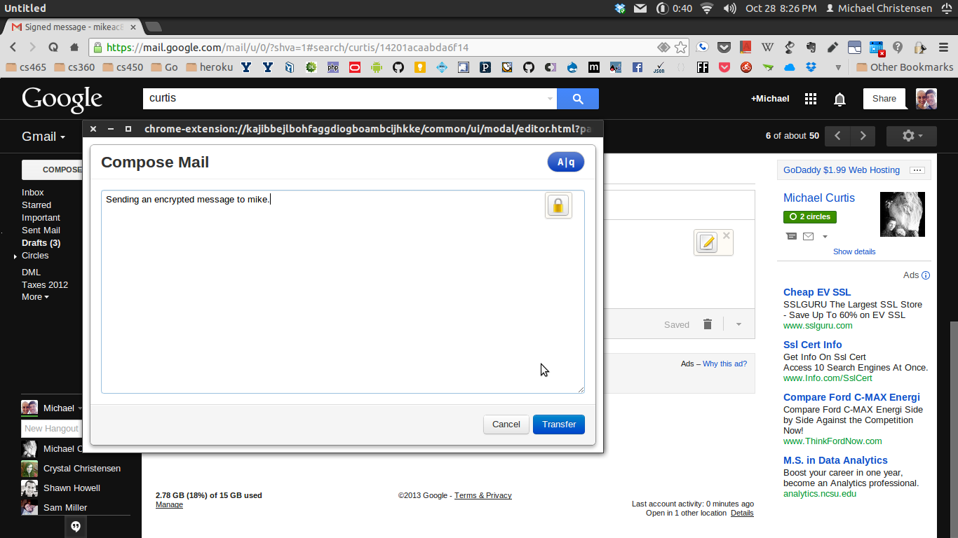
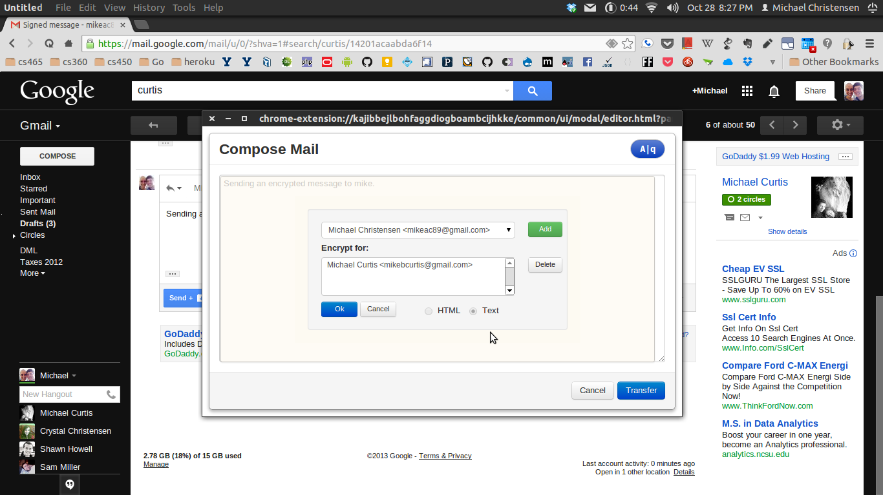

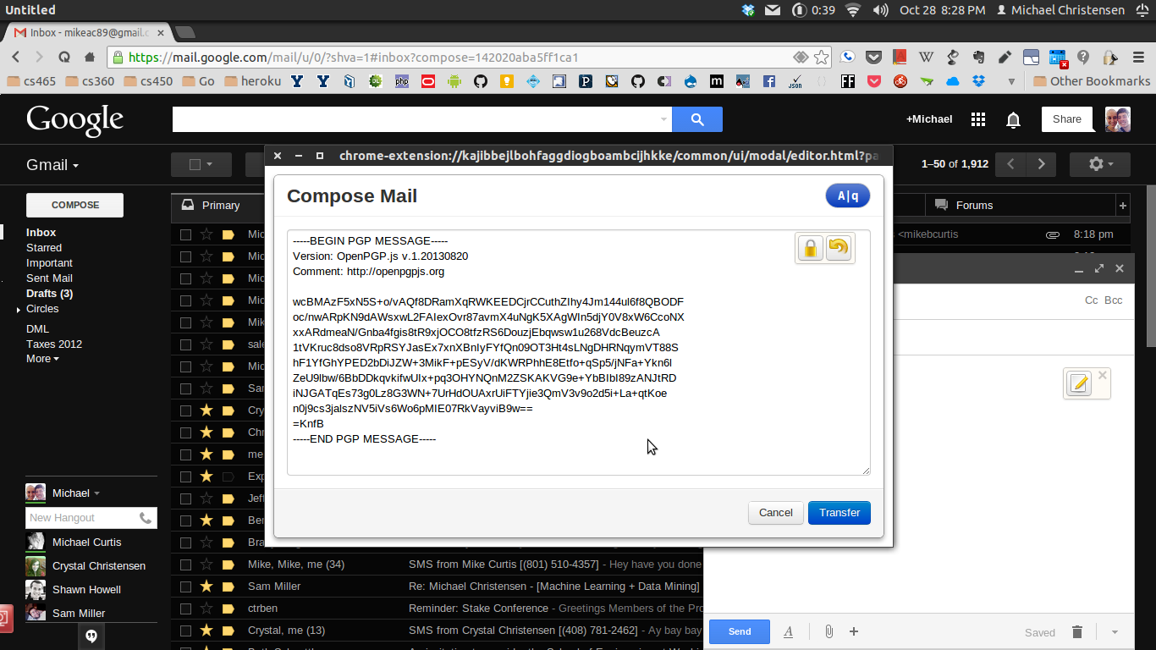
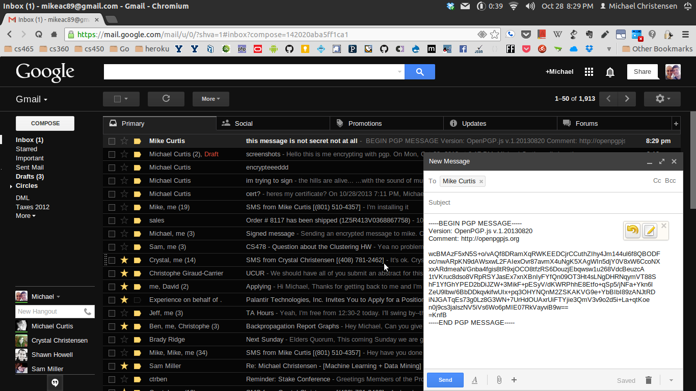

Me receiving and un-encrypting messages from Mike Curtis:
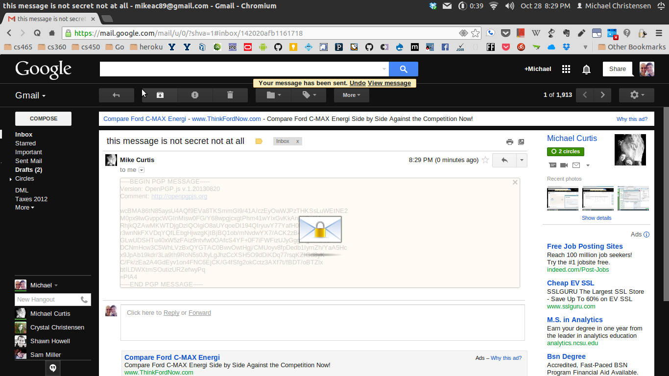
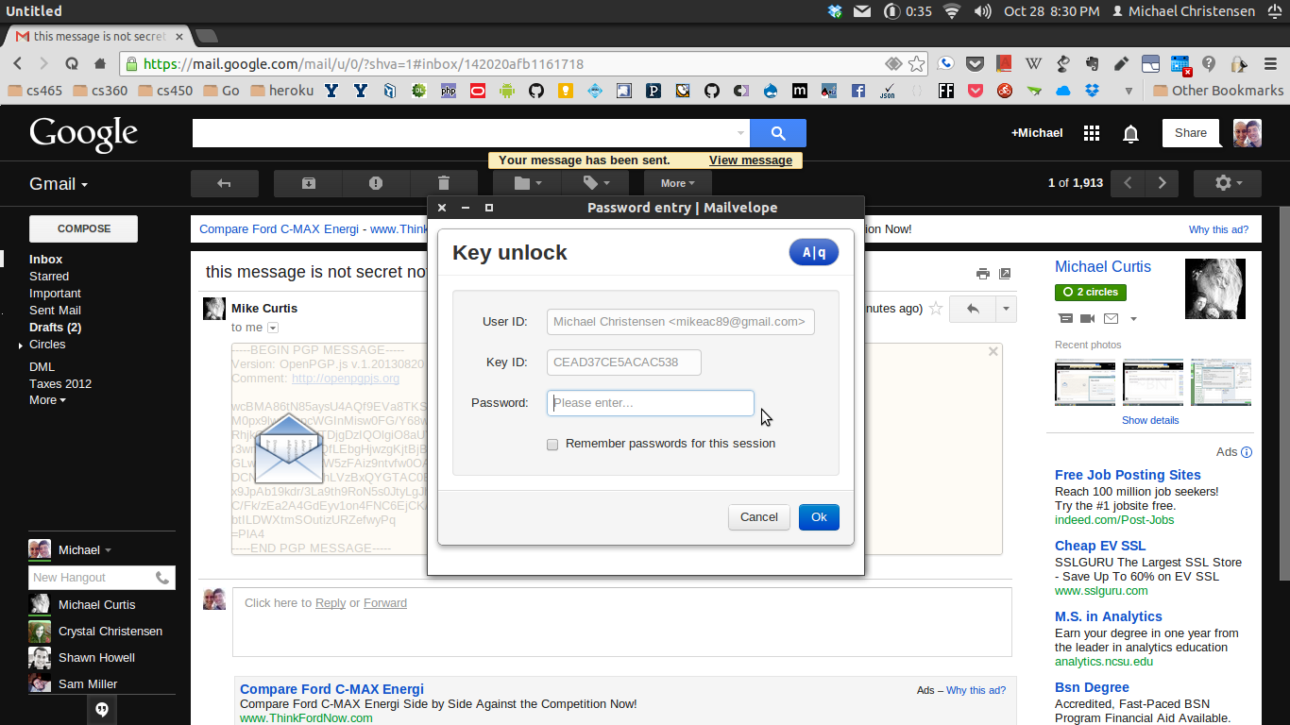

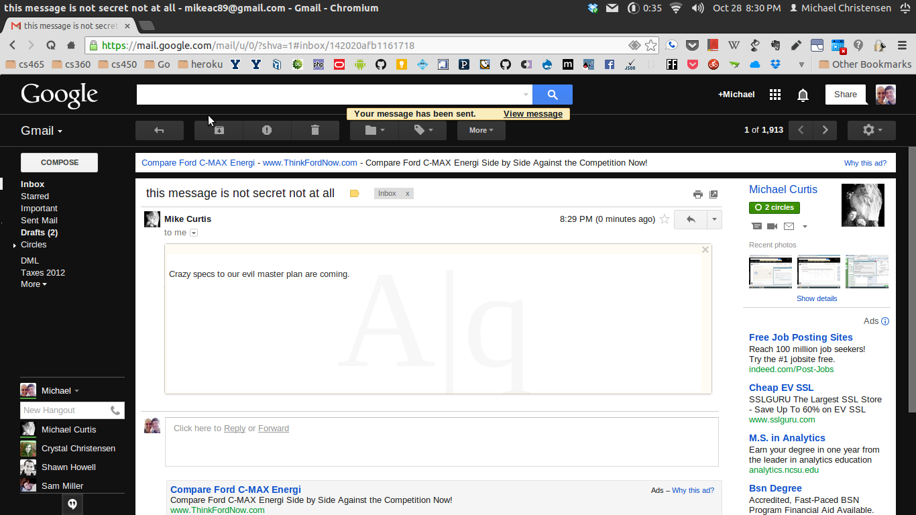

Mike Curtis Decrypting my Encrypted Messages:
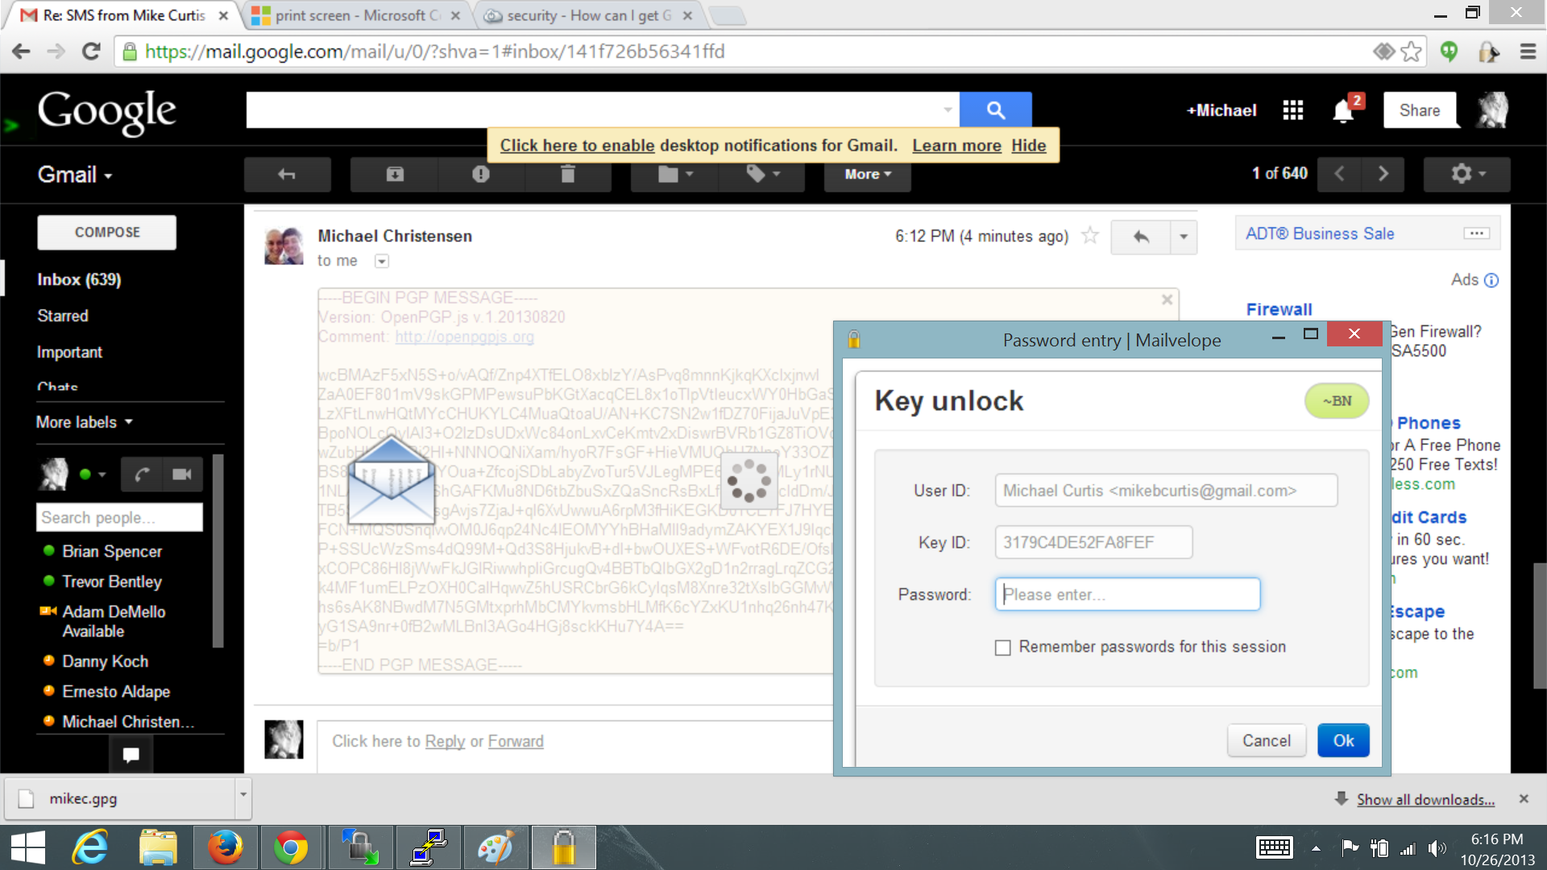

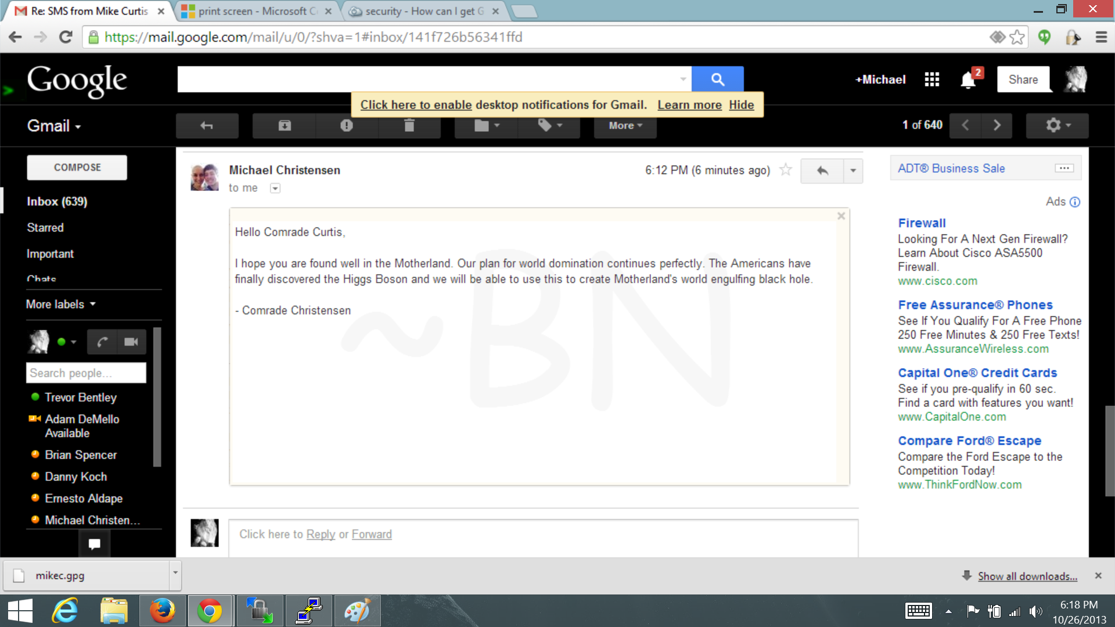

S/MIME:
Me sending a signed message to Mike Curtis:
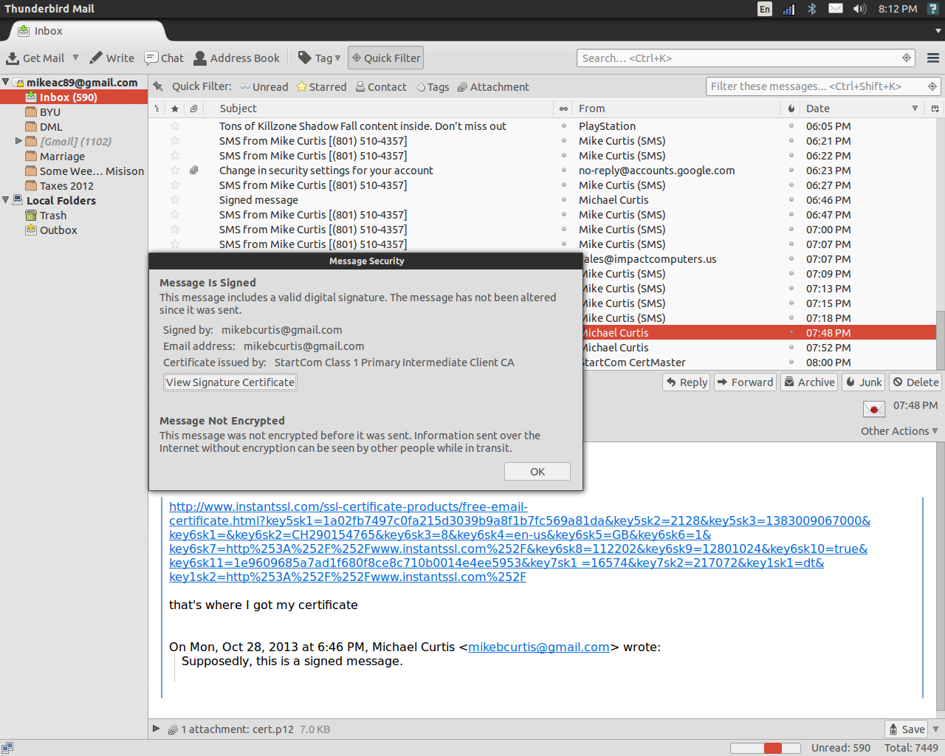

Me sending a signed and encrypted message to Mike Curtis:
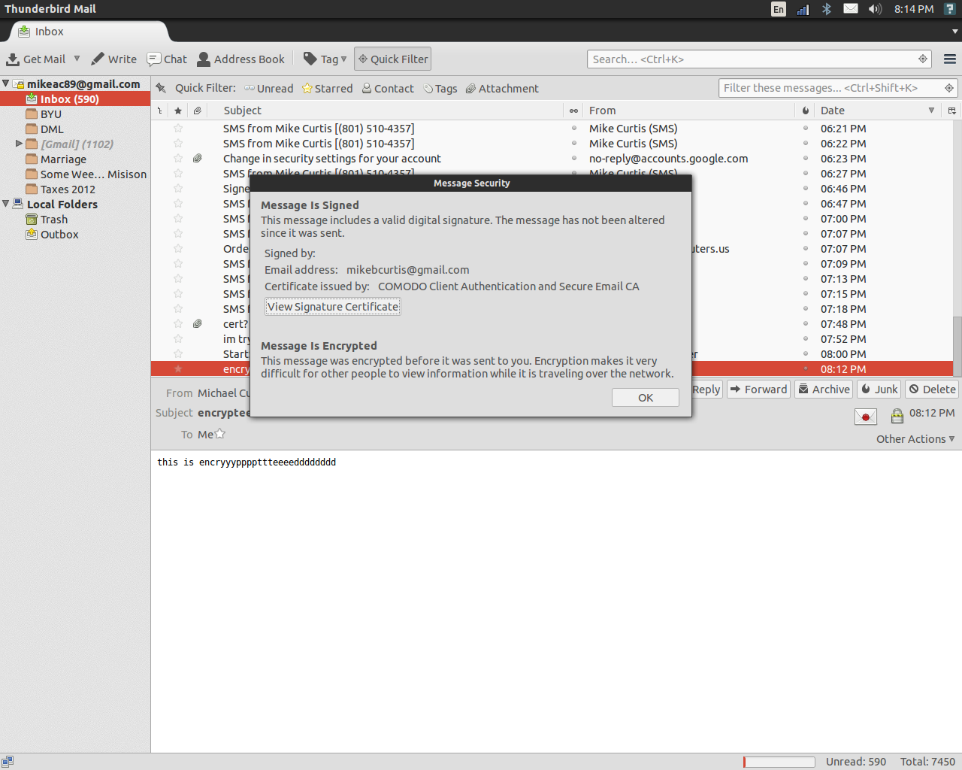
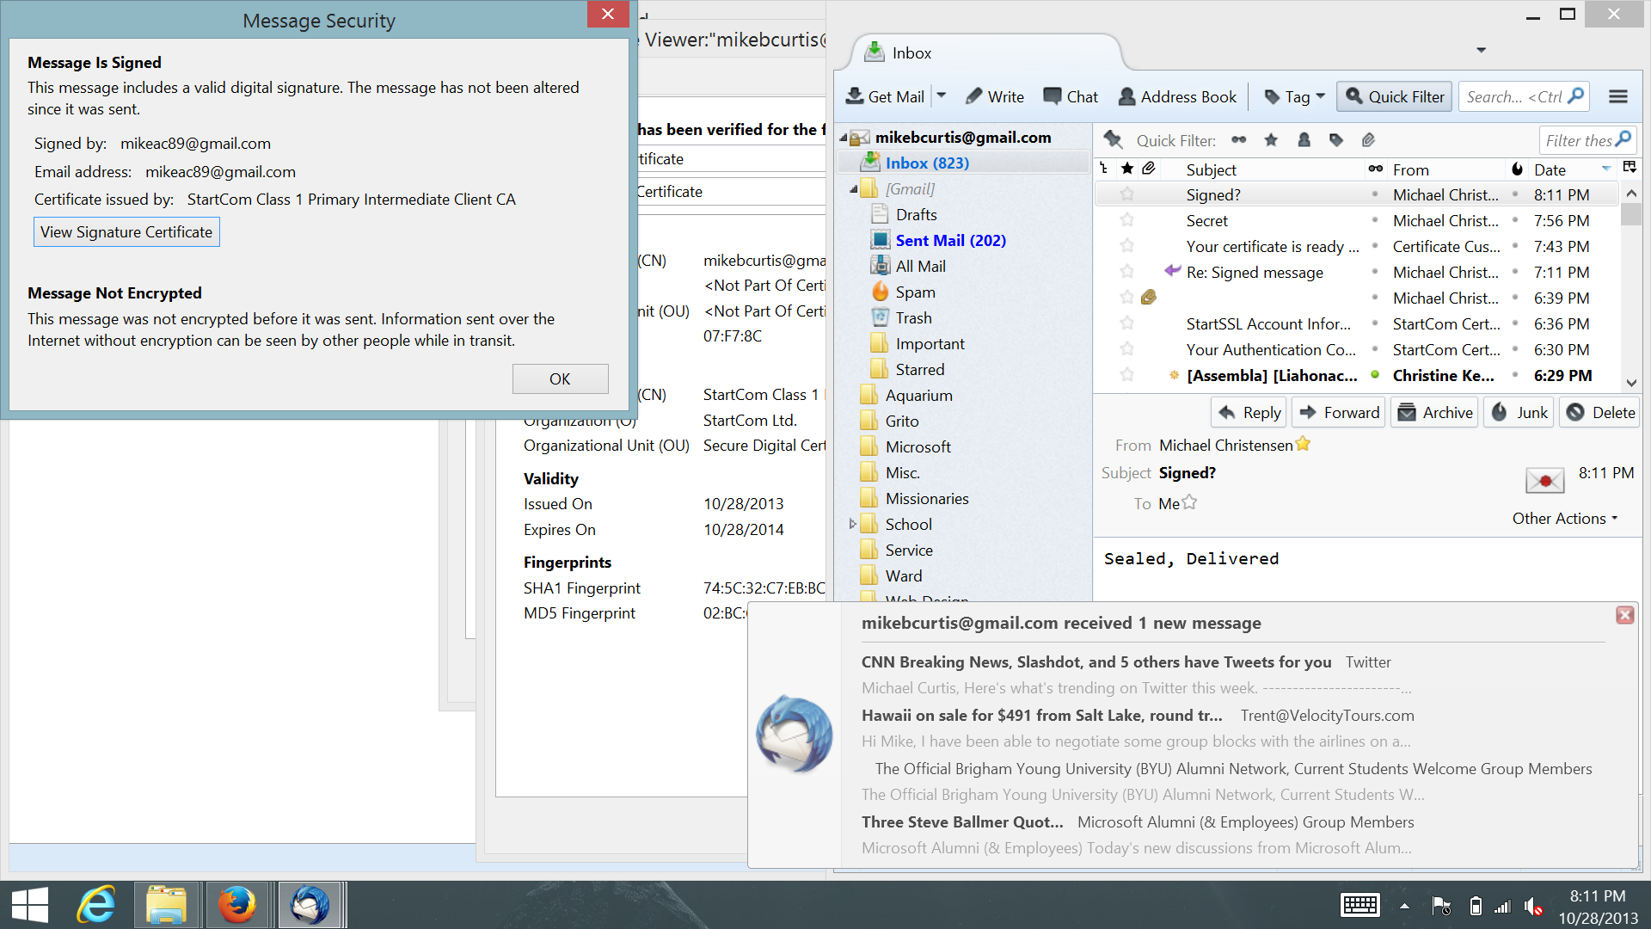
Mike Curtis receiving my Signed Message:

Mike Curtis receiving my Signed and Encrypted Message:
