ASSIGNMENT ON INTRODUCTION TO DATABASE

Problem Statement: There can be multiple customers, who can place multiple orders on the site. Now a sales person can handle these orders will distribute into multiple sales persons (One order will be assign to one salesperson only). So a sales person can have multiple orders of multiple customers

Q1. Create Database

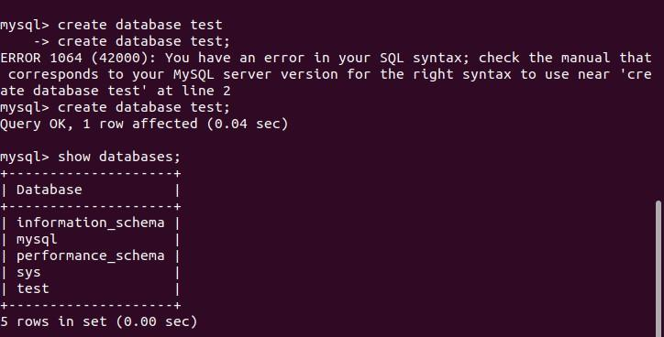

Q2. Design Schema

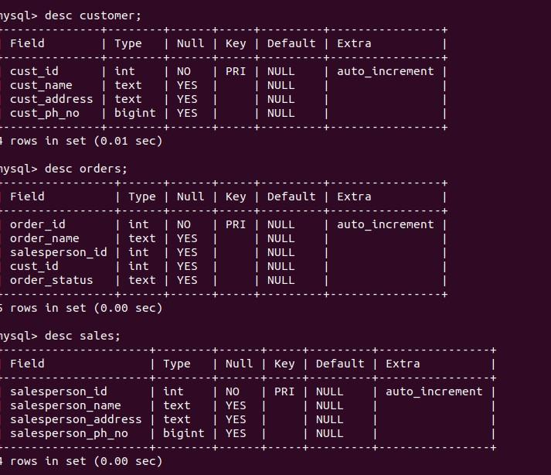

Q3. Create tables

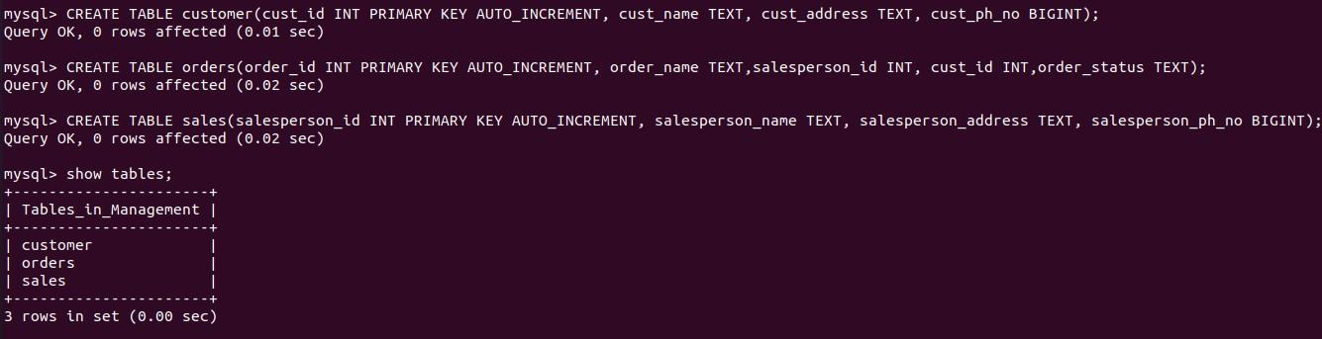

Q4. Insert sample data 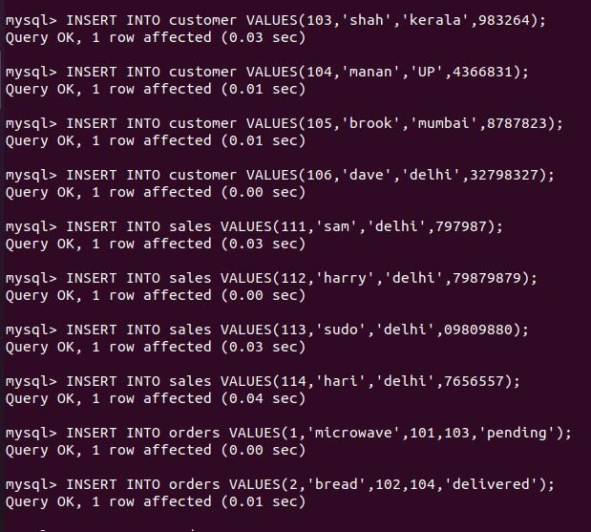

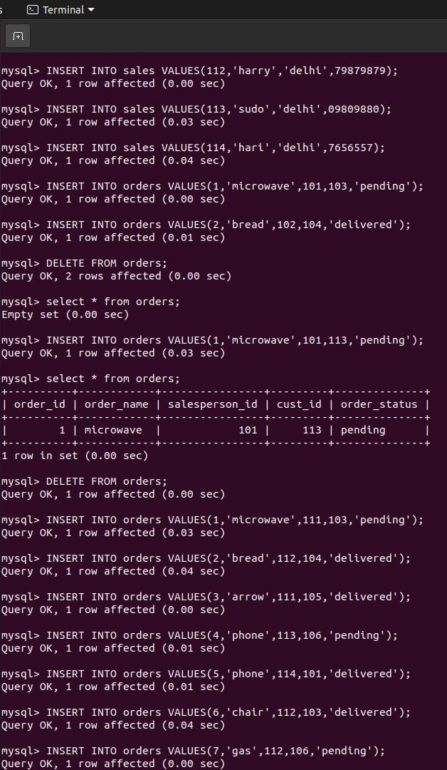

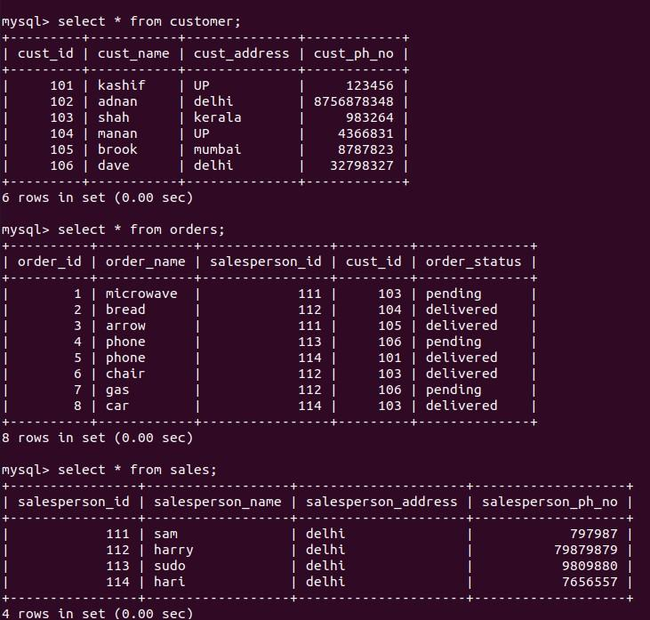

Q5. Find the sales person have multiple orders. 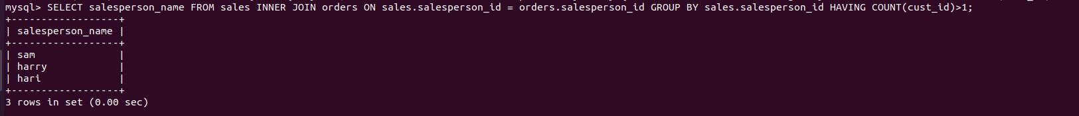

Q6. Find the all sales person details along with order details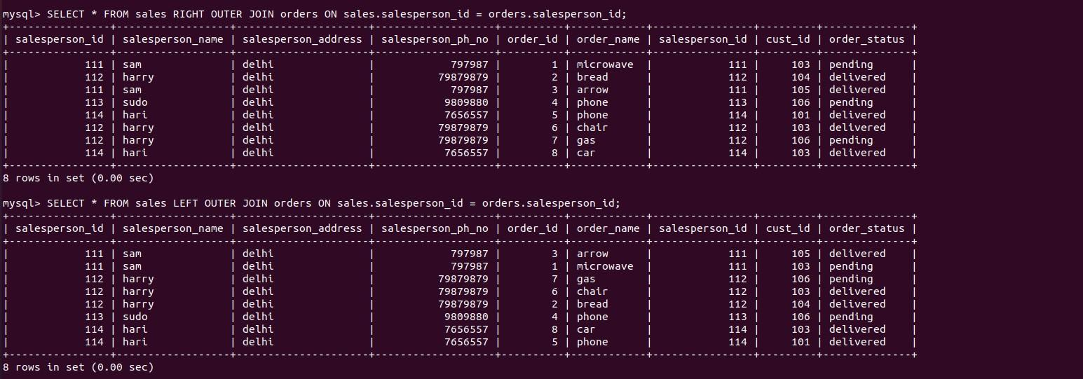

Q7. Create index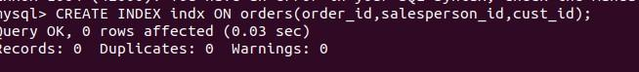

Q8. How to show index on a table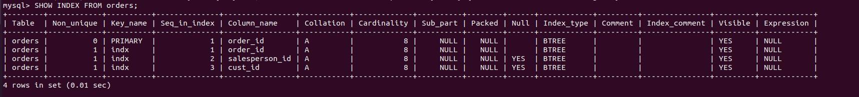

Q9. Find the order number, sale person name, along with the customer to whom that order belongs to