Assignment on Introduction to version control

Q1.Git Setup <https://confluence.atlassian.com/bitbucket/set-up-git-744723531.html>

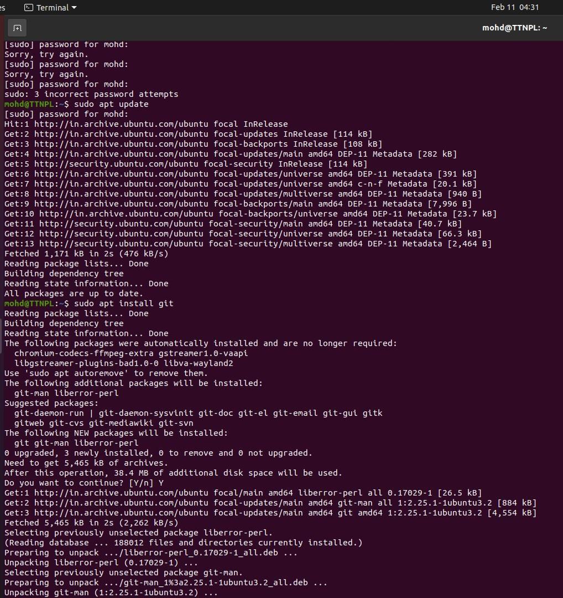

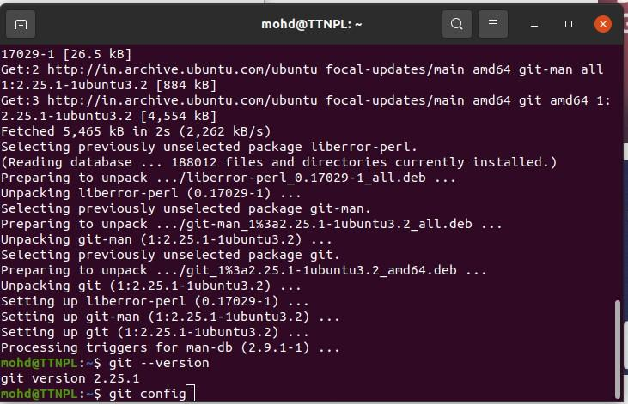

Q2. Initialize a Git Repository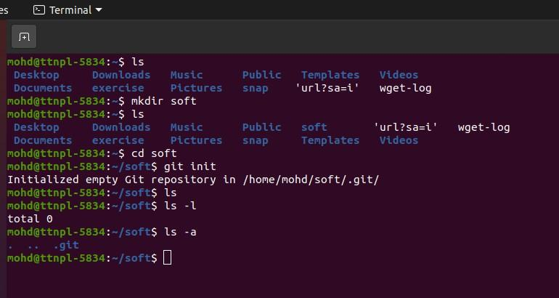

Q3. Add files to the repository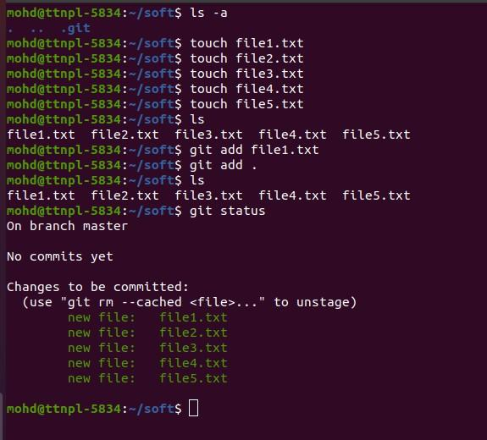

Q4. Unstage 1 file

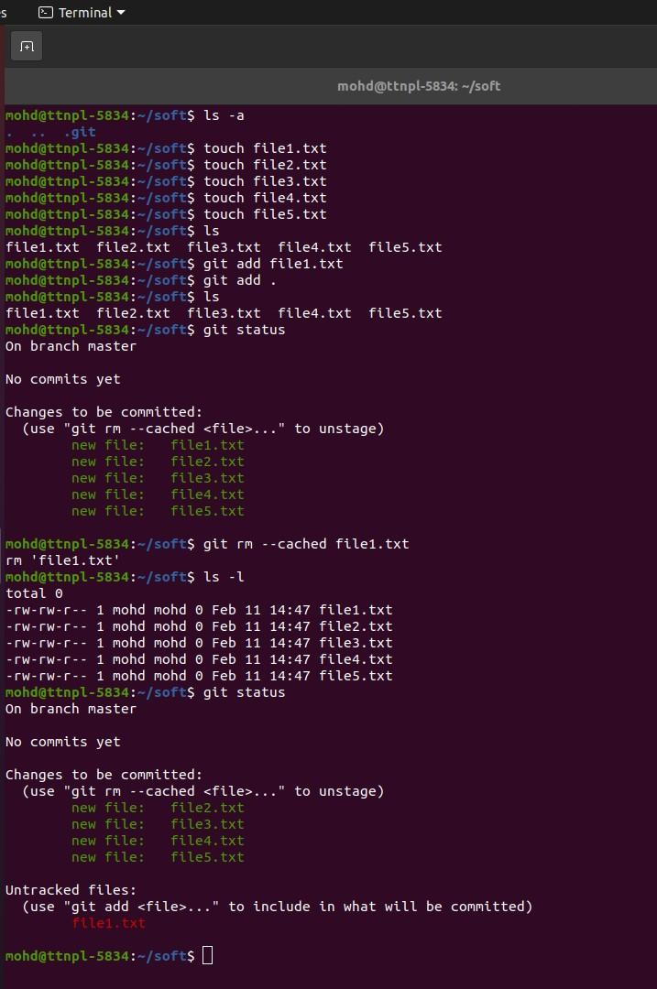

Q5. Commit the file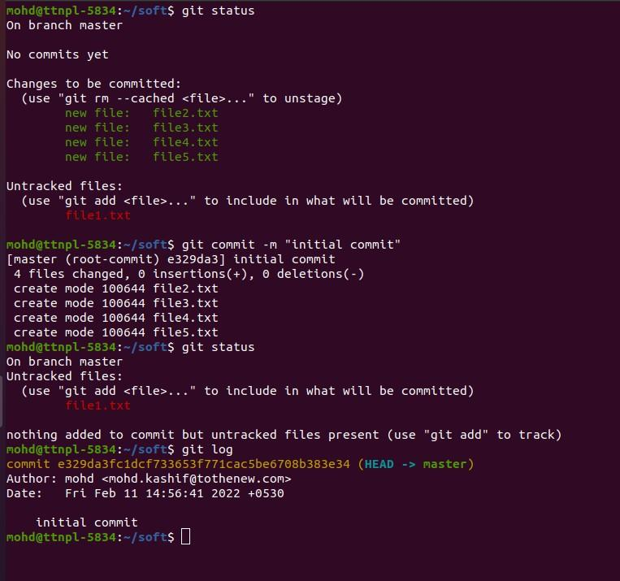

Q6. Add a remote

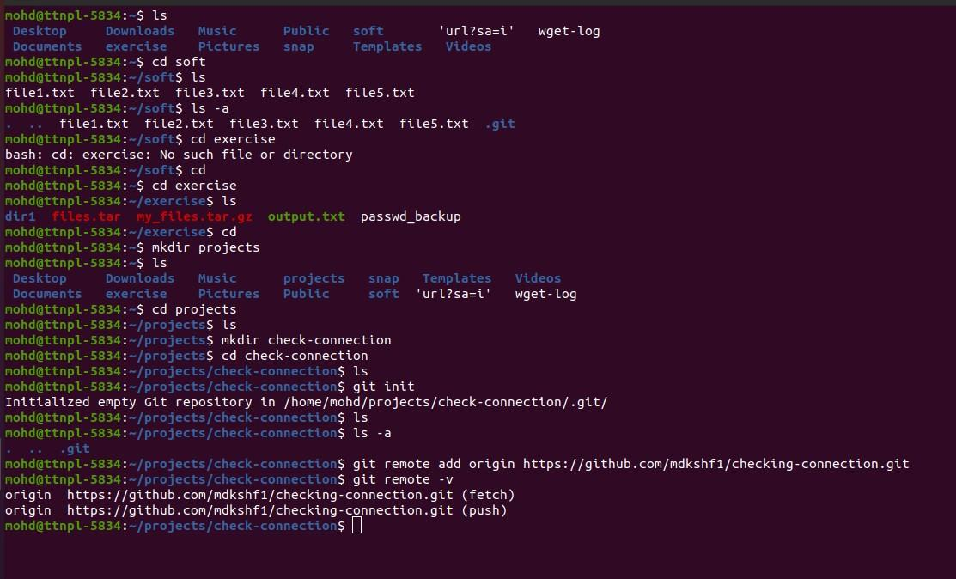

Q7. Undo changes to a particular file

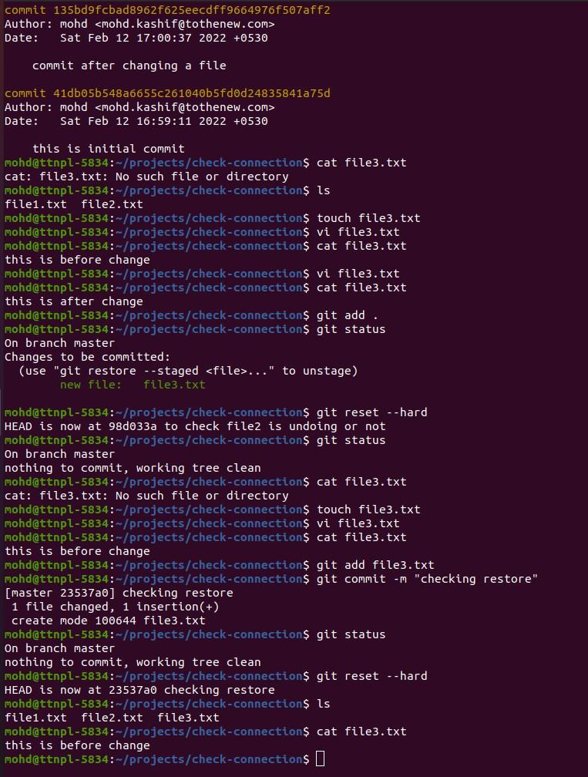

Q8. Push changes to Github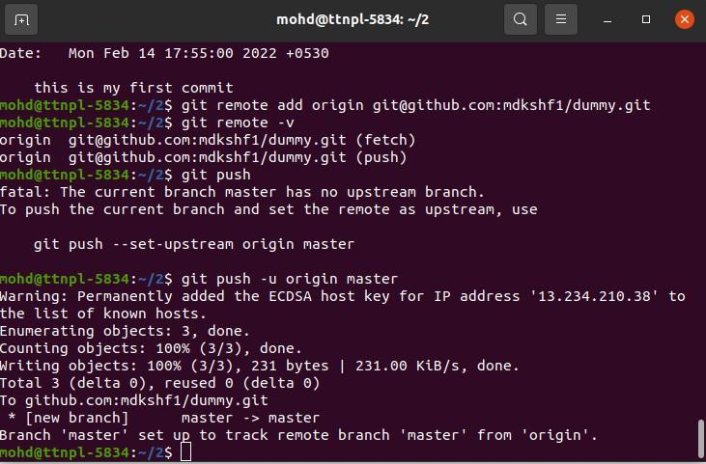

Q9. Clone the repository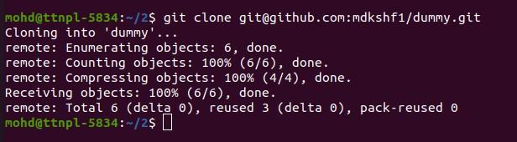

Q10. Add changes to one of the copies and pull the changes in the other.

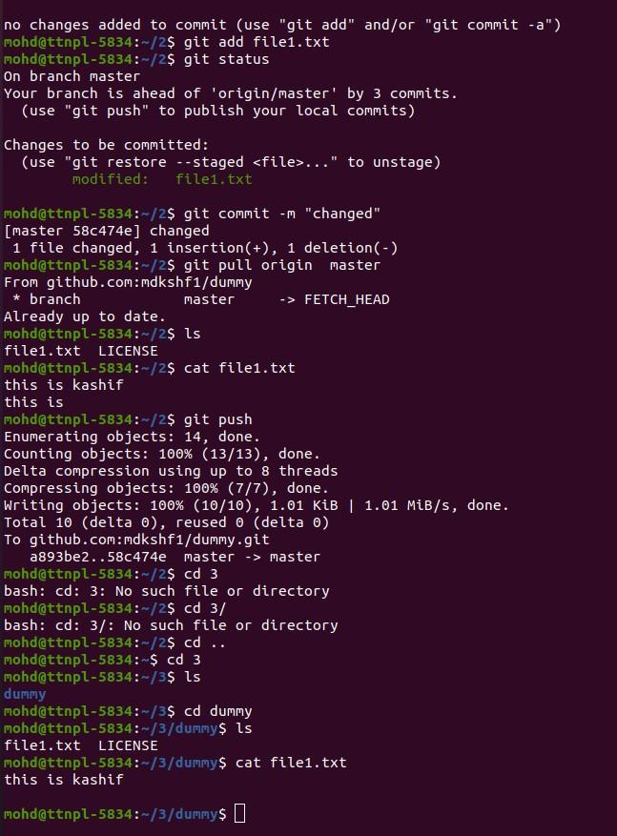

Q11. Check differences between a file and its staged version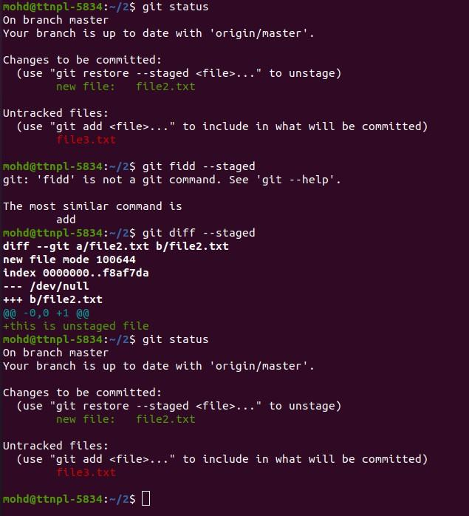

Q12. Ignore a few files to be checked in

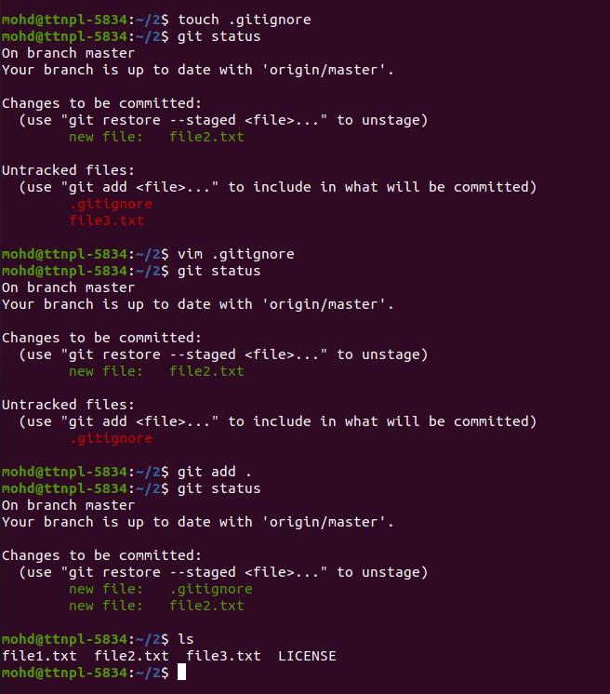

Q13. Create a new branch.

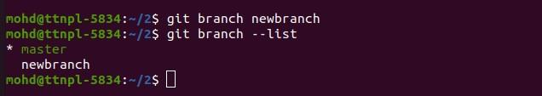

Q14. Diverge them with commits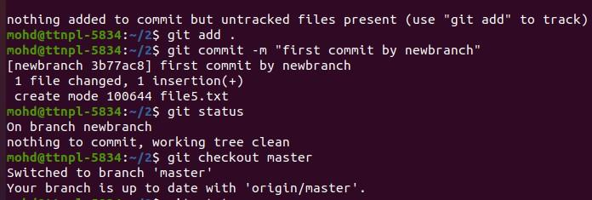

Q15. Edit the same file at the same line on both branches and commit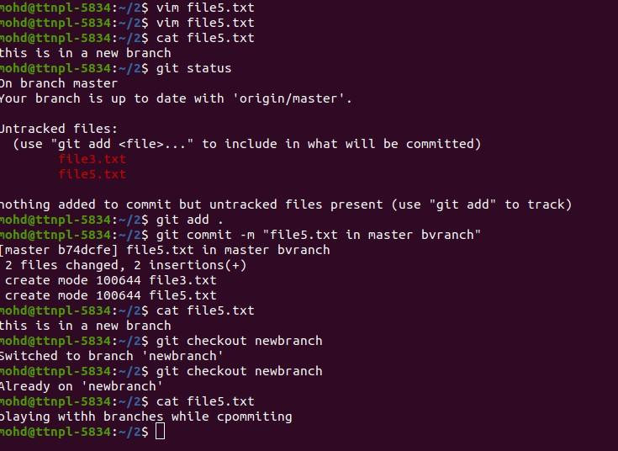

Q16. Try merging and resolve merge conflicts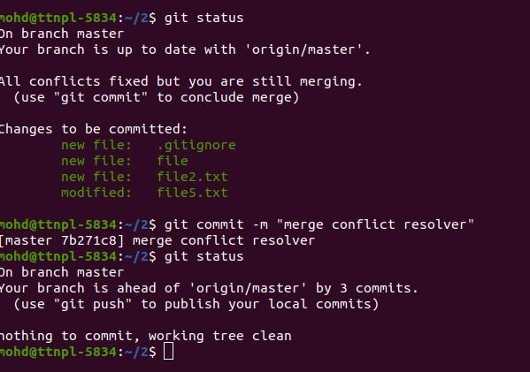

Q17. Stash the changes and pop them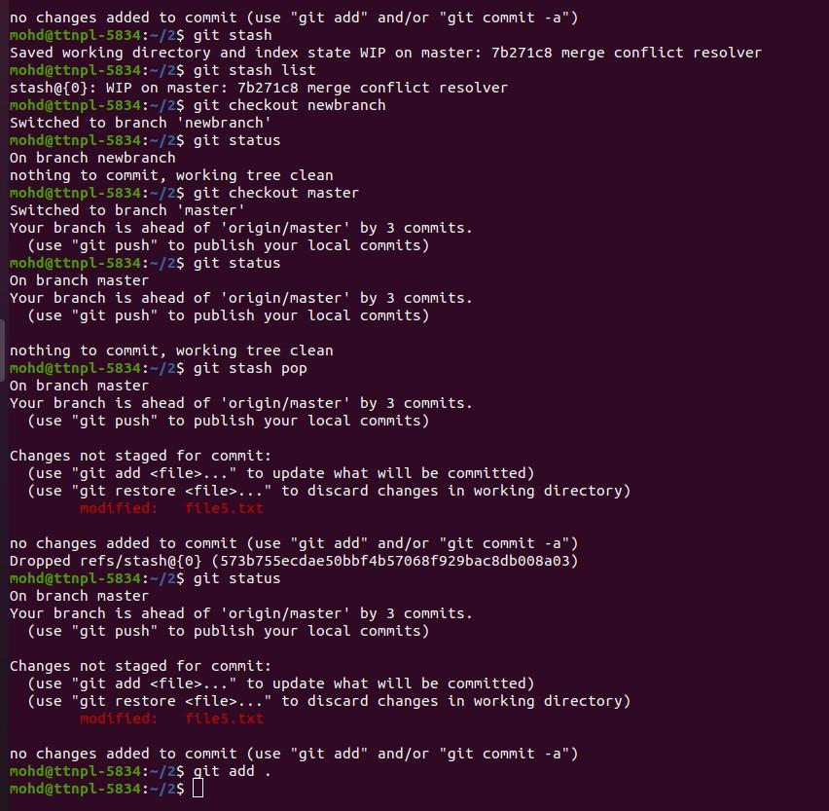

Q18. Add the following code to your .bashrc file : color_prompt="yes"  
parse_git_branch() {  
git branch 2> /dev/null | sed -e '/^[^*]/d' -e 's/* \(.*\)/(\1)/'  
}  
if [ "$color_prompt" = yes ]; then  
PS1='\u@\h\[\033[00m\]:\[\033[01;34m\]\W\[\033[01;31m\] $(parse_git_branch)\[\033[00m\]\$ '  
else  
PS1='\u@\h:\W $(parse_git_branch)\$ '  
fi  
unset color_prompt force_color_prompt

