Instructions for Using an NRCS-Developed .lyr file to Symbolize NHD Data in ArcMap

the .lyr file:
A layer (.lyr) file is created in order to save everything about the layer, such as the symbolization, labeling, classifications, and other information describing the appearance and actions of the layer. NHD .lyr files are provided to you with your downloaded NHD data, for ease of symbolization.
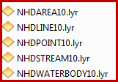

To use the .lyr file:

Bring the data downloaded from the Gateway into your ArcMap session.
- In the ArcMap TOC, right click on the data layer, go to Properties, and click on the Symbology tab.
- On the left hand side of the Symbology tab, click on Categories → Unique Values
- In the Value field, click the down arrow and choose “FTYPE”.
- Click the Import button – be sure the radio button “Import Symbology definition from another layer in the map or from a layer file” is active. Browse to the applicable .lyr file that came with the Gateway NHD order.
- Click OK; Click OK again to verify the correct Value Field.
- Click Apply, then OK.
- Repeat this process for each layer that you want to symbolize.
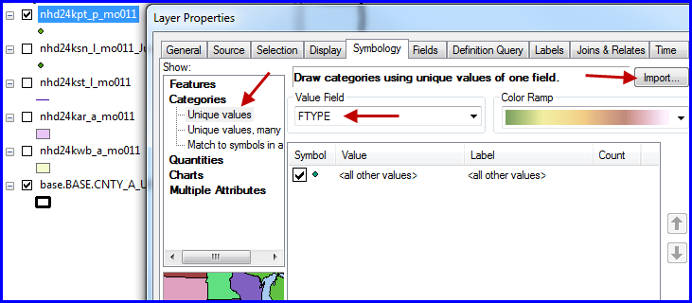

your data is now symbolized by FTYPE for NHD, using the supplied .lyr files.
