QUEENSBOROUGH COMMUNITY COLLEGE

Department of Engineering Technology

ET-501

Lab2 - Equations, Tables, Graphs, and WordArt

Word 2013 comes with many advanced features including an equation editor, table generator, graphing program, clipart and wordart feature to name just a few. In this exercise, we will introduce some of these features to you.

Tables give you an excellent way of working with columns or tabular data. A table is simply a grid of columns and rows. The intersection of a column and a row is a rectangular box referred to as a **cell**. Each cell is independent and can be sized or formatted. As a technical person, you will find the Word for Windows equation editor and graphing capability most useful.

Part I

1. Start **Word** and Open the equation editor by clicking the **Insert tab,** and then clicking on  **Equation.**

2. Create the following equations by typing the equation, inserting a tab or some spaces and typing the corresponding text. Your work should be formatted as below.

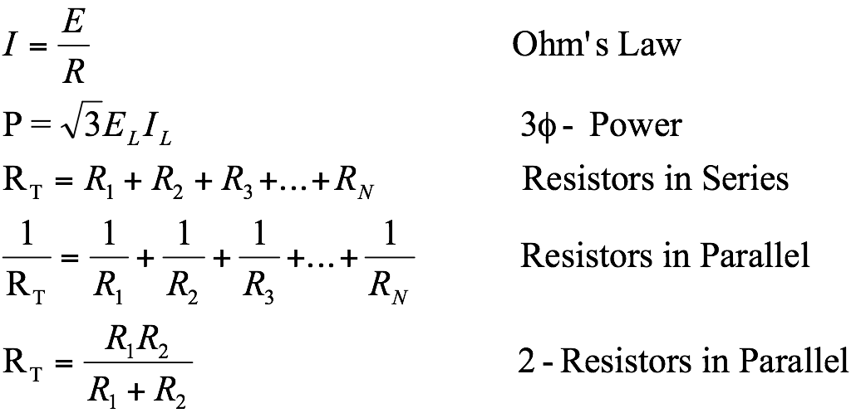

3. Save the document as Lab2P1. Print out all of the equations on a single page and hand them in with your lab report. Close the document.

PART II

4. Open a new document and create a *six row by three column* table using the **table button** on the **Insert tab**.

1. Select the entire table (**Layout tab, Select, Select Table**) and increase the row height to *two* lines (24 points) by choosing **Properties** from the tool bar. If necessary, click on the **Row Tab**, and click on the **Specify height** box. Type **24 pt** or **2 li** (instead of 0") to increase the row height to two lines. Next change **At least** to **Exactly**. Click **OK**. *Note: Be certain to include the units* **pt** *or* **li**.
2. With the entire table selected, choose the **Design Tab, and click Borders ( Borders and Shading)** from the tool bar and select a line width of **1.5 pt** for the border. Also select the **All** boxif necessary and click on the **OK** button.
3. With the entire **table selected**, on the **Layout Tab** choose **Properties,** click on the **Cell Tab**, and click on **Center** to change the alignment to vertical centering. Click **OK** and **deselect** the table by clicking anywhere on the page outside of the table. Select the **Home tab** and drag the mouse to select all of the cells in the table and change the horizontal cell alignment to **Centered**.
4. Type the headings PRICE, PRODUCT1, and PRODUCT2 across the first row. To create subscripts first select the letter and then pull down the **Font** menue from the **Home Tab**.
5. Select the first row and choose the **Layout Tab**.  **Click on Properties, Table Tab, and then Borders and Shading.** Click on the **Shading tab** and change the shading (Fill:) to 2**5%. Click OK** and **OK** againto exit.
6. Type the data shown below into each cell. Your table should look like the one shown below.

|  |  |  |
| --- | --- | --- |
| PRICE | US Products | Asia Products |
| 100 | 1500 | 9000 |
| 200 | 2000 | 8000 |
| 300 | 2500 | 7000 |
| 400 | 3000 | 6000 |
| 500 | 3500 | 5000 |

1. Save your table as Lab2P2.

PART III

1. Skip a few lines after your table to locate your graph. Create a graph of your table by **Chart** from the **Insert tab**. Select **X-Y Scatter**, and choose **Scatter with Straight Lines and Markers**. Click **OK**.
2. You will need to resize the table for a 3 x 6 size. Stretch from the lower right mark to resize the table.
3. Replace the data in the spreadsheet with the data you created in table in Part II.
4. Once you have entered the data click on the close button (upper right cormer) to insert the graph.
5. **Select** the entire graph and click on the **Layout tab** and select **Chart Title**. Enter the title **Price vs. Product Sold.**

Select Axis Titles. (X) Axis, Price ($), (Y) Axis, Units Sold.

1. Click on white area of screen to insert chart in document.
2. Position the graph to be approximately centered under the table. Your graph should look like the one shown below.
3. Save your graph and table as Lab2P3. Print your table and graph together on the same page for your lab report. Close the document.

# PART IV

1. Open a new document. On the **Insert Tab** click on **Wordart**.
2. Choose a WordArt Letter Style.
3. Type your name in place of *Your Text Here*. Experiment with tools on the Wordart toolbab to further change the appearance of the text. When you have completed your WordArt design, click on an unused portion of the screen to exit WordArt and return to your document.
4. Create two more pieces of WordArt using different styles, shapes, fonts and sizes. You can change the color, border, or shadow if you like and experiment with any of the options like rotating.

Save your WordArt as Lab2P4. Print out a copy of your WordArt on a single sheet of paper for your report. Close the document.

PART V

1. Open a new document. On the **Insert Tab** click on the **SmartArt** button.
2. Select a Graphic from the list.
3. Create a graphic with som text (see an example below).

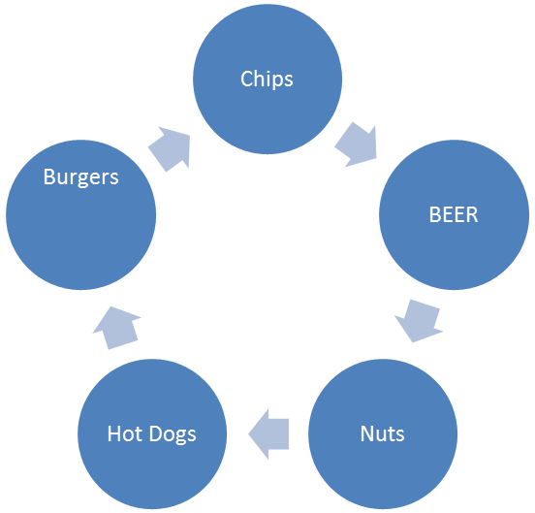

Save your SmartArt as Lab2P5. Print out a copy of your SmartArt on a single sheet of paper for your report. Close the document.

PART VI

1. Open a new document. On the **Insert Tab** click on the **Shapes** button.
2. Select a 3 different shapes from the list. Click on the page to insert the shape into your document.

Save your Shapes as Lab2P6. Print out a copy of your SmartArt on a single sheet of paper for your report. Close the document.

Part VII

1. Create a six by ten table similar to the one below. Search the Internet for technology products and complete the table. Your table will have 9 products.

| **Item** | **Category** | **Qty** | **Image** | **Description** | **Cost** |
| --- | --- | --- | --- | --- | --- |
| [Objet Connex 350](http://www.stratasys.com/3d-printers/design-series/precision/objet-connex350) | 3D Printer | 1 |  | The Objet Connex 350 prints as many as 14 material properties simultaneously in a single part, to eliminate time-consuming assembly and to support a wide variety of rapid prototyping needs. | $220,000 |
| [Projet 3510 – SD](http://www.3dsystems.com/3d-printers/professional/projet-3500-sd)  [3D Systems](http://www.3dsystems.com/3d-printers/professional/projet-3500-sd) | 3D Printer | 1 |  | The ProJet 3510 SD delivers high quality, durable plastic parts in UV-curable plastic in a range of colors and translucencies, as well as tensile strengths. Support material is a white, melt-away wax that produces prints not possible with typical FDM printing. | $55,000 |