QUEENSBOROUGH COMMUNITY COLLEGE

Department of Engineering Technology

ET-501

Lab #1 Introduction to Microsoft Word

Microsoft Word is a full-featured word processing program that allows you to efficiently and economically create professional looking documents such as memoranda, letters, reports, and resumes, and revise them easily. To improve the accuracy of your writing, Word can check your spelling and grammar. You can use Word's thesaurus to add variety and precision to your writing. With Word, you can easily include tables and graphics in your documents. You can also use Word's desk-top publishing features to create brochures, advertisements and newsletters.

### Starting Microsoft Word

1. From the Windows 7 desktop click the **Start button** and then point to **ALL Programs.**
2. Scroll to the Microsoft Office Folder. **Expand** the Microsoft Office Folder by clicking on it. Select and click on Microsoft Word 2010 to open the program.

**Practice with Fonts:**

A **font** is a set of characters with a special design, identified by a name. The **font style** refers to bold, italic, underlined. **Font size** is measured in points. The higher the number the larger the character. A character is a letter, number or special symbol like a period. In this part of this laboratory exercise you will type your name on the page five (5) times using the clipboard (copy and paste) and change the font and size of each occurrence of your name.

1. In the document you have opened, type your first and last name and *press the* **Enter** **key**.
2. **Highlight your name.** To do this you place the mouse pointer on the first letter of your first name. Press the left mouse button down, hold it down and drag the mouse to the right until your entire name is highlighted and then let go of the mouse button.
3. From the **Clipboard** menu select (top left), click **COPY** (Note: you can also press **Ctrl+C**.)
4. Position the insertion pointer (I-beam) on the next line by pointing and clicking in front of the paragraph symbol **(¶)**.
5. From the **Clipboard** menu select, **PASTE** and *press* *the* **Enter** **key**.(Note: you can also press **Ctrl+V**.)
6. Repeat steps #4and #5 three more times, until your name appears five times on your screen. The screen should look something like this:

## Michael Lawrence

Michael Lawrence

Michael Lawrence

Michael Lawrence

Michael Lawrence

1. Highlight your name on the first line. Change the font to one of your choice.
2. Highlight your name on the second line. Change the font to a different one and select the font style boldface.
3. Highlight your name on the third line. Use the same font as for line 2 but this time instead of boldface use italics.
4. Highlight your name on the fourth line. Change the font to Times New Roman and the font size to 20.
5. Highlight your name on the fifth line and select a font, font style and font size of your choice.
6. Save your document and call it **Lab1Name.** (File, SaveAs)
7. Print out a copy of your document.
8. Exit Word by selecting **Exit** from the **File** menu.
9. Your completed project might look something like what is shown below.

## Michael Lawrence

**Michael Lawrence**

*Michael Lawrence*

Michael Lawrence

*Michael Lawrence*

#### Project 1

1. Start Word for Windows to create the Jazzicians Flyer (see attachment). Refer to Starting Microsoft Word above if necessary.
2. If the Caps Lock indicator is off, press the Caps Lock key and type *THE JAZZICIANS*.
3. Turn off the Caps Lock and press the Enter key to move to the beginning of the next line. Press the Enter key again to skip one more line.
4. If necessary, Click on the Show/Hide button (¶) to display nonprinting characters. Note that paragraph mark (¶) is displayed (but not printed) to indicate that the Enter key was pressed and that a period is displayed (but not printed) to indicate a space.
5. Type *present the* and press the Enter key twice. Be careful, Word may capitalize the “p”. If it does change it back to lowercase.
6. Type *4th Annual Festival of Jazz* and press the Enter key six times.
7. Type the first paragraph in the body of the announcement: *Join us for a fun-filled day of entertainment for the whole family*. Press the Enter key.
8. Type the next paragraph in the body of the announcement: *The fun starts at 10:00 a.m. and ends at 11:00 p.m. on Saturday, October 14, 2012, at Riverfront Park*. Press the Enter key.
9. Type the last paragraph of the body of the announcement: *Festival attractions include games, rides, food, crafts, and live music from the talented artists of The Brass Beat, Dave and the Hornets, and The Nance Lance Band*. Press the Enter key three times and type the last line of the announcement: *Hope to see you there!*
10. Save your work using the filename **Flyer**.
11. Press Ctrl + Home to position the insertion bar (I-beam) at the beginning of the document.
12. Select the first line of text (THE JAZZICIANS). Click on the Bold button. While the text is still selected using the Times New Roman font, click on the Font Size box arrow and change the font size to 48. Finally, with the text still selected click on the Centering button.
13. Select the next line of text (present the). Using the Times New Roman font change the font size to 20. Click on the Italics button. Click on the Centering button.
14. Select the third line of text (4th Annual Festival of Jazz). Using the Times New Roman font change the font size to 36. Click on the Bold button. Click on the Underline button. Click on the Centering button.
15. Select just the word Jazz in the third line of text. Click on the Italics button.
16. Select the three paragraphs to be bulleted. Using the Times New Roman font change the font size to 20. Click on the bullet button.
17. Select only the words Saturday, October 14, 2012. Click on the Bold button.
18. Select the last line of text (Hope to see you there!). Change the font size to20. Change the font to Arial. With the font still selected, click on Font, the Advanced tab, and change the Spacing from Normal to **Expanded** from the drop down menu and clicking OK. With the text still selected click on the Centering button.
19. Save your work using the same filename and location.
20. Position the insertion pointer (I-beam) where the graphic is to be inserted (by clicking the mouse on the third paragraph mark (¶) between the lines  *4th Annual Festival of Jazz* and *Join us for a fun-filled day of entertainment for the whole family*).
21. Click on the **Insert** Tab**,** and then the **Clip Art** button**. Click** in the **Search for** box**,** type **Jazz,** click on the **Go** button and scroll to find the *Jazz clip art.* Click on it to insert it into your document. **Note:** Microsoft often changes the clip art library. If the file is not there select another appropriate file.
22. Click anywhere in the graphic. Click on the **Centering** Button.
23. Click anywhere in the graphic. Position the mouse pointer on the right, middle sizing handle (the mouse pointer will change to a double arrow). Drag the sizing handle to the right until the picture width is similar to the sample. Note this will distort the aspect ratio of the image.
24. Drag the bottom, middle sizing handle until the picture height is similar to the sample.
25. Press Ctrl + Home to position the insertion pointer at the beginning of the document. Click on the **Review Tab**. Click on Spelling & Grammar. Word checks the spelling as you type however you still may find some spelling or grammar errors. Decide whether to accept or change the errors and suggestions. You can click Ignore or Ignore All to bypass these words. Correct any other spelling errors.
26. If necessary make any spacing adjustments so that your flyer looks like the sample. You may need to delete some of the lines around the clip art to make things fit neatly.
27. Save your work.
28. Print the document Flyer.doc.

**THE JAZZICIANS**

*present the*

**4th Annual Festival of *Jazz***



* Join us for a fun-filled day of entertainment for the whole family.
* The fun starts at 10:00 a.m. and ends at 11:00 p.m. on **Saturday, October 14, 1996**, at Riverfront Park.
* Festival attractions include games, rides, food, crafts, and live music from the talented artists of The Brass Beat, Dave and the Hornets, and The Nance Lance Band.

Hope to see you there!

**Project 2**

1. Use the attached Sailing Club flyer and the directions from the first project you completed to help you with this assignment. See the document for the text and use the clipart from within Microsoft Word to provide the graphic (of the sailboat).

• Display the first heading line, SAILING CLUB, in 36 point Arial font.

• Display the second heading line in 24 point Arial font.

• The picture (search for **sailing**) is to be sized so it is as wide as the second line of the document (Monthly Meeting).

• The next three lines display in 14 point Times New Roman.

• The bulleted list has a one-inch indent and is in 18 point Times New Roman.

• The next line is 14 point Times New Roman.

• The last two lines are 18 point Arial.

• The entire document is to be in Boldface.

1. Use page preview to vertically center the document on the page. In other words, have the same amount of space before the first line of the document and below the last line of the document.
2. Save and print the document

# **Project 3**

1. Design and create a simple one page flyer on any topic you choose using appropriate fonts, font styles, font sizes, clipart, spacing, and layout. Listed below are some ideas for topics:

* Club Meeting
* Sale of Goods
* Help Wanted
* Lost Pet
* Invitation
* Notice of Event
* Announcement

**SAILING CLUB**

**Monthly Meeting**

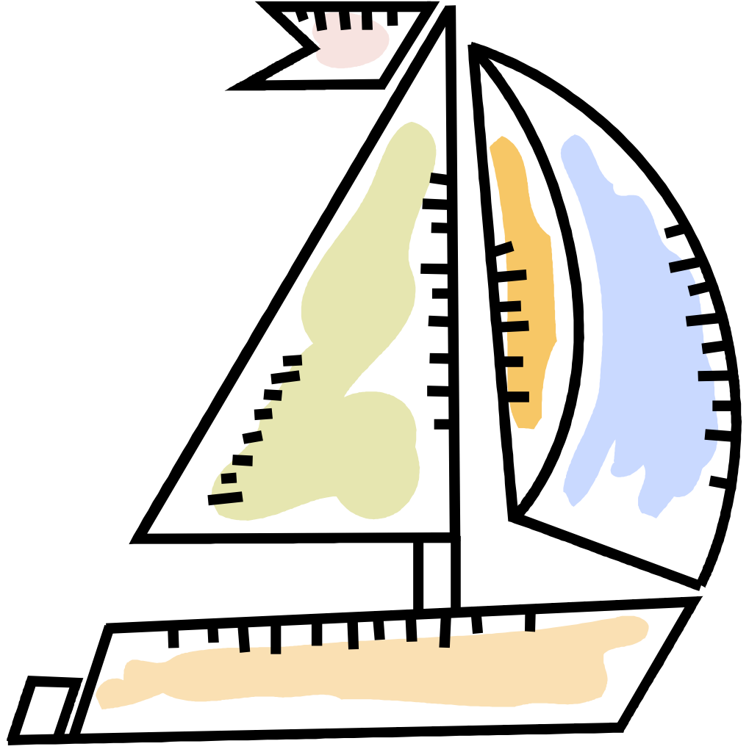

**Plan to attend the meeting of the Sailing Club on May 1, 2012, in the auditorium of Queensborough Community College.**

**Ranger Robin Hood will lecture on:**

**• Harbor Patrol rules and regulations**

**• Basic sailing techniques**

**Please call Little John, (718) 631-6207, to make your reservation.**

**Reservations Required**

**See You There!**