CURRICULUM VITAE – Student. Siphamandla Masondo

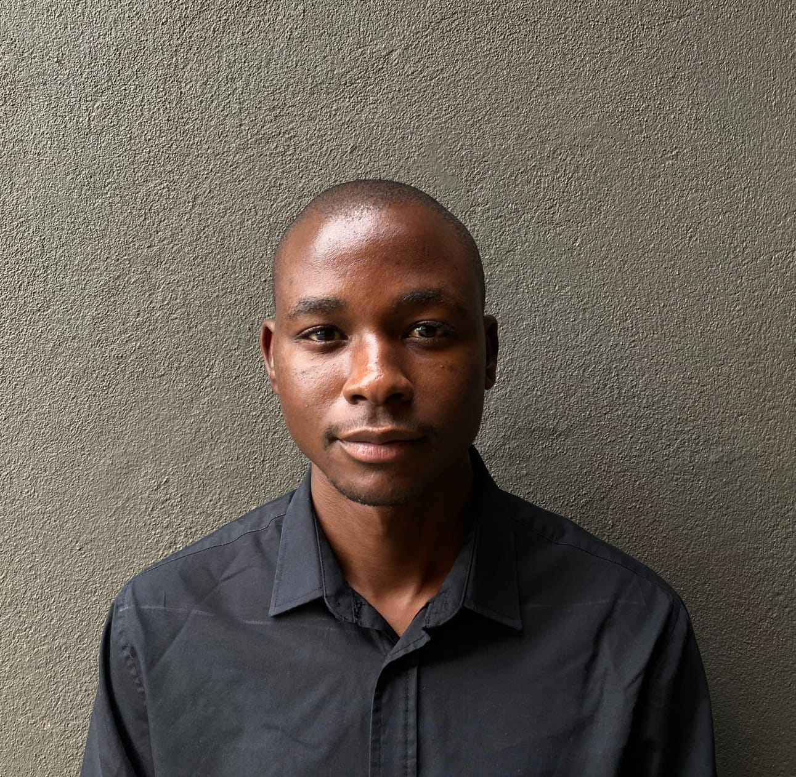
Full Name Siphamandla Masondo
Date of Birth 2004/01/02 (see certified ID copy here)
Nationality South African
Languages English (Excellent), Isizulu (Excellent), Basic Xhosa.
Contact Cell Phone +(27) 63 742 5074
E-mail address sphamasondo04@gmail.com
LinkedIn Account LinkedIn.com/in/Siphamandla Masondo
University Specialisation BSc (Eng) in Civil Engineering Specialisation
Current Occupancy Final Year Student (see certified 2026 university proof of registration here)
Home Address Nqutu Town, KwaZulu-Natal, South Africa (see certified proof of home residence here)
School Work Address Forest Hill Complex Residence UCT, Mowbray 7700, Cape Town, South Africa

QUALIFICATIONS AND REGISTRATIONS

BSc.Eng (Civil Engineering) University of Cape Town. 2022 - Present. (see latest university transcript here)
National Senior Certificate (with 5 distinctions) Klwana Combined Public School. 2021. (see Matric Certificate here and Principal’s reference letter here )

COMPUTER LITERACY

- Microsoft Office (Word, Excel, PowerPoint, Outlook, Teams)
- Autodesk (AutoCAD – Drafting software, Revit – Planning & BIM software, Civil 3D – Design software)
- PROKON – Structural analysis and design software
- PTV VISUM – Transport planning & management software
- EPANET – Water Supply & Modelling software
- ArcGIS – Infrastructure planning & Site management software
- Google Earth Pro – Site visualisation software

AWARDS & PROFESSIONAL AFFIATIONS

- UCT Dean’s Merit List - 2023 & 2024. (see reference letters from the Deputy Dean here)
- Ranked 5th among the Top 10 Matric Achievers in the Nqutu Circuit Mayoral Awards 2021
- Member of the Golden Key International Society, 2023 - Present
- Member of the SA Institute of Civil Engineering (SAICE), Credential ID: 2023403373
- Member of The Institution of Structural Engineers (IStructE), Credential ID: 082014957
- University Prizes - UCT Bursary, Ian Scott Bursary, John Sellick Bursary, Rolls Royce Solution SA Bursary

ABOUT ME SUMMARY
I am a final year student, motivated to work as a civil consulting engineer after graduation. Towards my career in civil engineering, I am passionate, energetic, respectful, and trustworthy combined with a strong sense of ethical responsibility in my work assignments. As of 2026, I am currently working hard towards obtaining my degree in first class honours, striving to achieve excellency and deep understanding of my field. Beyond academics, I actively engage in volunteering activities, reflecting my passion for service and contributing to something greater than myself.

CAREER ENHANCING COURSES

Course Title Course Provider
- CRITICAL THINKING (see highlighted here) University of Cape Town, Department of Philosophy

ACADEMIA EMPLOYMENT RECORD

Employer: University of Cape Town
Director and mentor: Prof. Neil Armitage (Pr. Eng)
Period employed: Feb 2026 - Present: Full time employment
Position held: Teaching assistant
I was appointed by the Department of Civil Engineering as a Teaching Assistant for the 3rd-year undergraduate course, Hydraulic Engineering, for the 2026 academic year, working alongside Professor Neil Armitage who is currently a course convenor and lecture for the subject. During my employment, considerable experience has been gained in university teaching, advising, and public speaking. My role during the course was theory consulting, lab advisor, tutorial advisor, and invigilating of assessments. (please note reference letter not yet available).
Notable teaching topics of the course:
- Design of pressured hydraulic systems, Selection of hydraulic pumps using KSB Etanorm and KSB WKL catalogue, and Design of gravity open flow channels.

CONSULTING EXPERIENCE DURING UNDERGRADUTE

Employer: Kukhanya Projects (Pty) Ltd, Consulting Engineering Company.
Director and mentor: Mbongeni Mabuza (Pr. Tech Eng), MBA
Period employed: 9 January 2023 – 17 February 2023: Vacation employment, Ballito Office
Position held: Civil vacation student
During employment at Kukhaya Projects extensive experience has been gained in the design, management and construction supervision of water infrastructure supply projects. Key areas involved with include: project stakeholder’s meetings, water reticulation design, pump station design, draughting, and site supervision. Much time has been spent on construction sites and in existing or new buildings during projects. (see company reference letter from the Managing Director here)

Selected Consulting Projects
Important projects involved with while at Kukhanya Projects include:
- Sonkombo Water Supply. Involved in preliminary design work, site investigation, stakeholder meetings (Ndwedwe Municipality, KZN)
- Umhlathuze Water Plant Upgrade - I was heavily involved in the construction supervision of the new pumpstation design, and attending meetings (Richards Bay, KZN).

VOLUNTEEERING
I volunteered as a tutor at UCT Leo Marquard Hall Residence, during my undergraduate studies. As part of a team responsible for supervising, mentoring, educating and inspiring a group of over 100 first-year university students in the engineering faculty. I was latter recognised with a UCT Bronze Medal for leadership (see reference letter from Deputy Head Student here and award confirmation here).
University of Cape Town:
Feb – Nov 2024


In this role I work as a Health Promotion agent with UCT senior medical students, from the faculty of health science. I assist with wellness screening initiatives at Cape Town local community clinics by administering patient surveys in waiting areas to identify health literacy gaps and potential health risk factors. I am responsible for accurately capturing and managing survey data to support health promotion efforts. I help flag patients who may benefit from targeted health education and counselling (please note reference letter not yet available).
UCT SHAWCO:
Apr – Present 2026


REFERENCES

Name: Mr Mncedisi Phakathi
Company: Kukhanya Projects (Pty) Ltd
Position: Senior Project Manager, Ballito Office (KZN)
Contacts phone: (+27) 73 202 3963
Email address: mncedisi@kukhanyaprojects.co.za

