Quant Option Research Platform
Technical White Paper v3.0
Research, Strategy, Portfolio, Risk, Hedge, and Reporting System
Author: Jingzhe Yang
Research period: 2026-01-02 to 2026-06-10

This document is the official technical white paper for the Quant Option Research Platform. It consolidates the original Seven-Goal research project and the subsequent platform extension, including market data cleaning, strategy library expansion, portfolio management, Greeks monitoring, hedge recommendation, automation, and reporting.

Table of Contents
Executive Summary
Part I - Research Foundation
1. Project Background
2. Dataset and Data Engineering
3. Data Preprocessing and Cleaning
4. Volatility Analytics
5. Signal Methodology
6. Strategy Construction
7. Backtesting Framework
8. Transaction Cost and Robustness Analysis
Part II - Quant Research Platform
9. System Architecture
10. Expanded Strategy Library
11. Portfolio Engine
12. Greeks and Risk Monitoring
13. Hedge Recommendation
14. Automation and Reporting
15. Portfolio Performance
16. Current Limitations and Future Work
Appendix A. Project Directory
Appendix B. Software Environment
Appendix C. Version History

Executive Summary
Item | Value
Document Version | v3.0
Trading Days | 107
Filtered Sessions | 107
Active Position Days | 15
Strategies | ATM Straddle Prototype, Long ATM Strangle, Butterfly, Calendar
Final NAV | 1,000,000.00
Max Drawdown | -0.1187%
Daily Pipeline | Completed
Word Report | Completed

Major Contributions
- Built an end-to-end option research workflow from raw market data to strategy evaluation.
- Constructed implied volatility, volatility smile, volatility surface, term structure, and Greeks research outputs.
- Implemented market-session cleaning for auction, lunch break, after-close, and invalid observations.
- Expanded the strategy layer from a prototype strategy into a modular strategy library.
- Built PositionBook, PnL Engine, NAV Engine, Exposure Engine, Risk Monitor, Hedge Translator, and Alert Engine.
- Implemented a daily pipeline that processes 107 trading days and generates portfolio time series and reports.
- Built a reusable Word-based reporting system for external presentation and future GitHub release.

Part I - Research Foundation

1. Project Background
Phase I established the original seven-goal foundation of the Quant Option Research Platform. The objective was to build an end-to-end workflow from raw option market data to implied volatility modelling, Greeks analysis, strategy construction, backtesting, and robustness evaluation.
- Data Acquisition
- Data Preprocessing
- Data Cleaning
- Implied Volatility Surface and Term Structure Construction
- Strategy Construction
- Backtesting Framework
- Risk and Robustness Analysis
The completion of these seven goals transformed the project from a collection of independent scripts into a reproducible option research framework.

2. Dataset and Data Engineering
The project uses intraday Chinese index option and futures market data. The original dataset is stored in compressed CSV/XZ format and contains option quotes, transaction records, order book information, futures prices, strike prices, maturities, and option symbols.
- Compressed raw dataset size is approximately 8 GB.
- Full decompressed dataset size exceeds 300 GB.
- Each trading day contains multiple option contracts across strikes and maturities.
- Futures prices are used as the underlying input for Black-76 option pricing.
- Intermediate outputs are stored in CSV and Parquet formats for reproducibility and efficiency.

3. Data Preprocessing and Cleaning
Before volatility estimation and strategy construction, raw market observations must be standardized and cleaned. The preprocessing layer extracts contract metadata, aligns underlying futures prices, standardizes trading dates, and prepares option prices for implied volatility and Greeks calculation.
- Parse option symbols to extract call/put type.
- Extract strike price and maturity code from contract symbols.
- Align option observations with corresponding futures prices.
- Detect missing or incomplete trade records.
- Identify unavailable or invalid option prices.
- Check implied volatility convergence and extreme IV values.
- Validate smile, surface, term-structure, and Greeks datasets.
This stage ensures that downstream volatility analytics and strategy modules operate on internally consistent research datasets.

4. Volatility Analytics
The volatility analytics layer estimates implied volatility using the Black-76 model and studies the empirical distribution, smile, surface, and term structure of option-implied volatility. These outputs provide the quantitative foundation for strategy construction and later portfolio risk analysis.

4.1 Black-76 Implied Volatility
Black-76 is used because the underlying asset is represented by futures prices. Market option prices are inverted numerically to obtain implied volatility, which then becomes the core input for smile, surface, term-structure, signal, and Greeks analysis.

4.2 Implied Volatility Distribution
Before studying cross-sectional volatility structures, the empirical distribution of implied volatility is examined. The histogram summarizes the overall shape of implied volatility observations, while the boxplot highlights dispersion and potential extreme values.
Figure 4.1 Implied Volatility Distribution
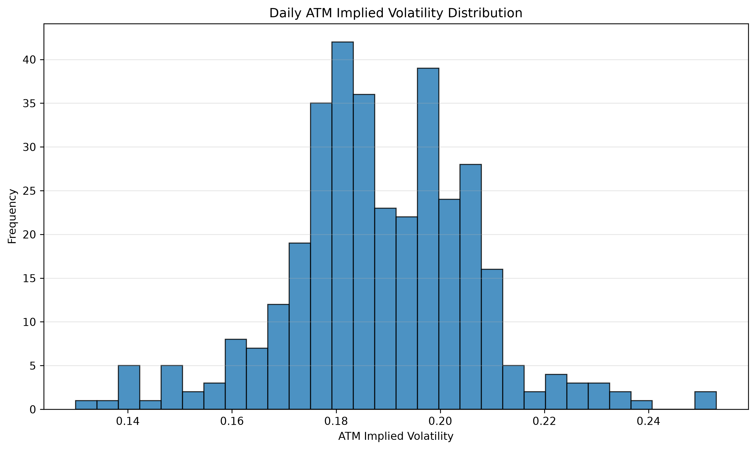
Empirical distribution of implied volatility observations in the research sample. The chart summarizes the central concentration, dispersion, and right-tail behaviour of the estimated IV values.
Figure 4.2 Implied Volatility Boxplot
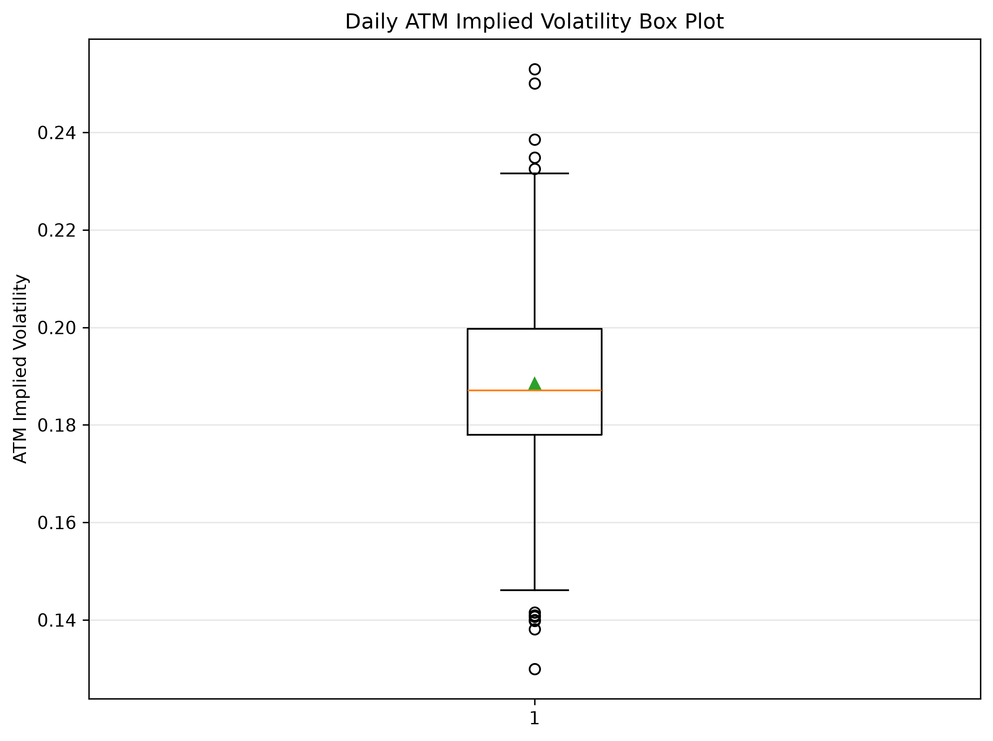
Boxplot of implied volatility observations, highlighting the median, interquartile range, and potential extreme values across the sample.

4.3 Volatility Smile
The volatility smile is constructed by grouping implied volatility observations across moneyness buckets. The observed smile shows higher implied volatility in the wings, especially on the downside, which is consistent with demand for tail protection.
Figure 4.3 Overall Near-Expiry Volatility Smile
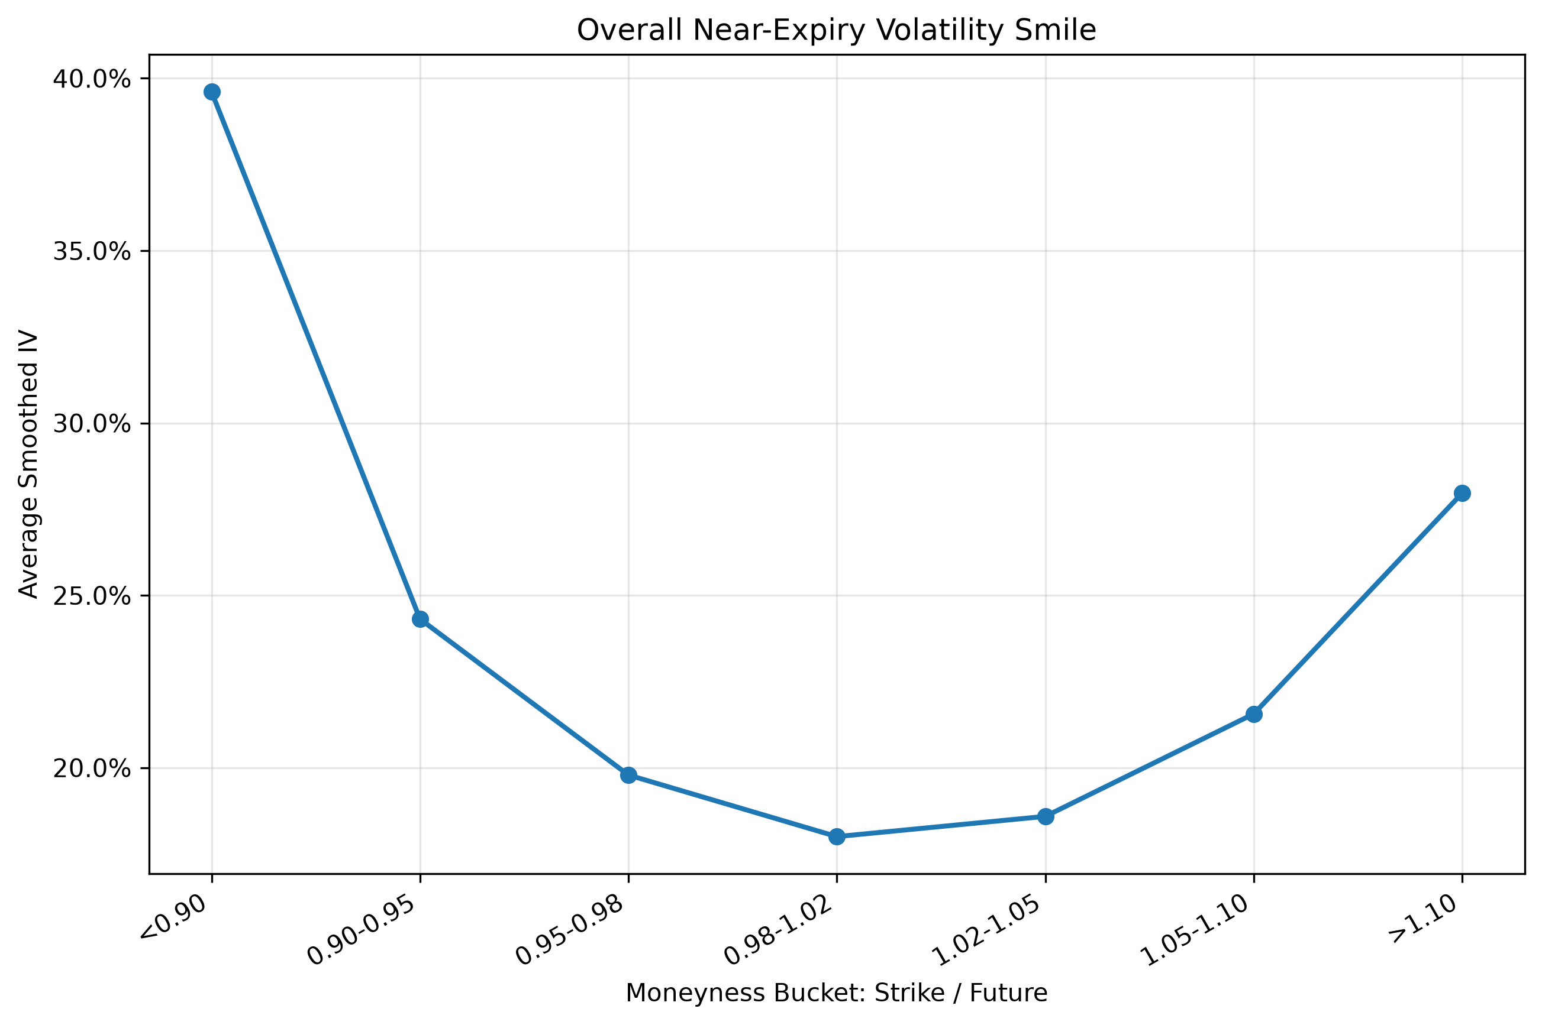
Average implied volatility across moneyness buckets for near-expiry option contracts. The elevated left wing indicates stronger implied volatility for lower-moneyness options.
The overall smile pattern confirms that implied volatility is not constant across moneyness. This supports the need for strike-aware strategy construction rather than relying only on a single ATM volatility estimate.

4.4 Volatility Surface
The volatility surface maps implied volatility across both strike and maturity dimensions. It provides a two-dimensional representation of how option prices embed risk across moneyness and time to maturity.
Figure 4.4 Near-Expiry Volatility Surface Heatmap
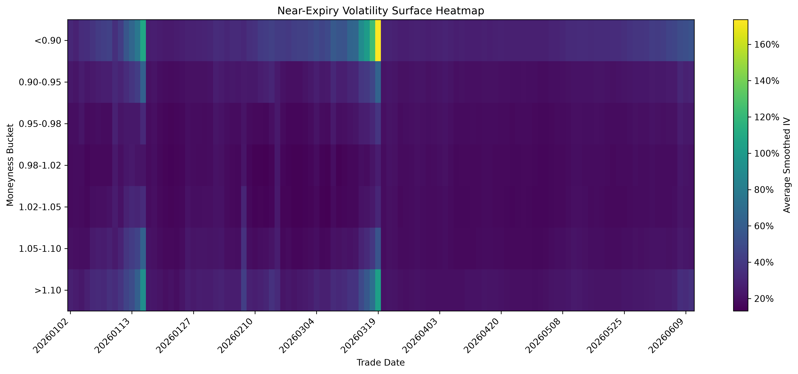
Daily near-expiry implied volatility across moneyness buckets. The heatmap jointly illustrates the time-series evolution and cross-sectional shape of the volatility surface.
The surface view is especially useful because it connects smile behaviour and term-structure behaviour in one object. This becomes important for calendar spreads, maturity selection, and volatility-regime analysis.

4.5 ATM Term Structure
The ATM term structure is constructed by aggregating at-the-money implied volatility across maturity buckets. It summarizes how implied volatility changes from near-term to longer-dated contracts.
Figure 4.5 Overall ATM Implied Volatility Term Structure
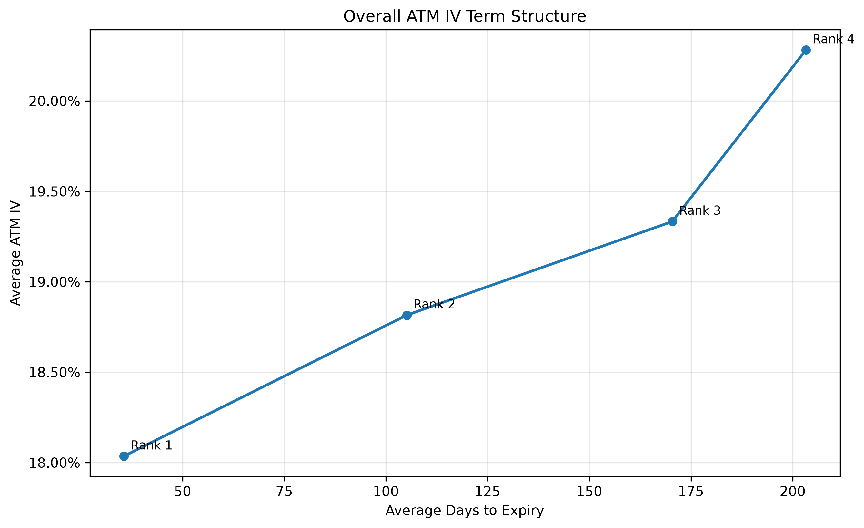
Average at-the-money implied volatility across maturity ranks. The curve summarizes how option-implied volatility changes from near-term to longer-dated contracts.
The ATM term structure provides an important empirical foundation for calendar spread research, because calendar strategies depend directly on the relative pricing of near-expiry and longer-expiry option exposure.

4.6 Key Findings
- The implied volatility distribution shows meaningful dispersion across observations.
- The volatility smile exhibits a U-shaped structure.
- Left-tail implied volatility is higher, reflecting downside protection demand.
- The volatility surface jointly captures moneyness and maturity effects.
- The ATM term structure is generally upward sloping.
- Short-dated options show stronger distortions and greater sensitivity.
- These volatility structures provide the empirical foundation for strategy construction.

5. Signal Methodology
The original strategy prototype uses volatility-related indicators to identify potential entry points. The signal framework is research-stage and should not yet be interpreted as a finalized production alpha model.

5.1 Signal Inputs
- ATM implied volatility
- Implied volatility z-score
- Term-structure slope
- Signal strength score
- Entry threshold

5.2 Score and Threshold
The signal score is computed first from volatility-related features. The value 80 is not itself calculated from market data; it is an entry threshold applied to the signal score. When signal_score is greater than or equal to 80, the strategy treats the signal as strong enough to open a position.

5.3 Current Limitation
The exact signal_score formula should be documented directly from the source code once a formal Signal Engine is completed. At the current stage, the signal threshold should be treated as a research parameter.

6. Strategy Construction
The Phase I prototype strategy converts volatility signals into option positions. The initial implementation focuses on a signal-based ATM straddle or strangle structure.

6.1 Entry Rule
A position is opened when the signal score exceeds the predefined entry threshold.

6.2 Position Structure
- Long ATM call
- Long ATM put
- Long volatility exposure
- Reduced directional bias compared with outright futures exposure
- Positive exposure to large realized movement

6.3 Exit Rule
Positions are closed when the signal weakens or when the holding-period rule is reached.

6.4 Assessment
The prototype successfully establishes a link between volatility analytics and systematic option strategy construction. It also provides a foundation for future strategy types such as calendar spreads, volatility arbitrage, and multi-factor option portfolios.

7. Backtesting Framework
A rule-based backtesting engine was implemented to evaluate whether volatility signals can be converted into systematic option trades. The framework records entry date, exit date, holding period, entry signal score, exit signal score, position return, equity curve, and drawdown.
Metric | Value
Total Trades | 4
Winning Trades | 3
Losing Trades | 1
Win Rate | 75%
Final Equity | 1.305
Cumulative Return | 30.5%
Maximum Drawdown | -0.92%
Average Holding Period | Approximately 4 trading days

7.1 Interpretation
- The prototype generated positive performance within the available sample.
- The final equity reached 1.305, corresponding to a cumulative return of 30.5%.
- The maximum drawdown was -0.92%.
- The strategy generated 4 completed trades, with 3 winners and 1 loser.
- The result should be interpreted as proof-of-framework rather than definitive alpha validation.

7.2 Limitation
Because the trade sample contains only four completed trades, statistical confidence is limited. Future backtesting should expand the historical sample and introduce realistic execution assumptions.

8. Transaction Cost and Robustness Analysis
A quantitative strategy should not only generate promising backtest results, but also demonstrate robustness under different assumptions. This chapter evaluates the stability of the proposed option strategies by examining transaction costs, signal sensitivity, holding-period assumptions, and overall portfolio behaviour.

8.1 Robustness Testing Framework
- Signal threshold sensitivity analysis
- Transaction cost sensitivity analysis
- Holding-period sensitivity analysis
- Performance comparison across parameter configurations
- Integrated robustness dashboard
Rather than relying on a single parameter configuration, the research framework evaluates whether strategy behaviour remains stable under alternative assumptions. This improves confidence that the observed performance is not driven by one particular parameter choice.
Figure 8.1 Robustness Dashboard
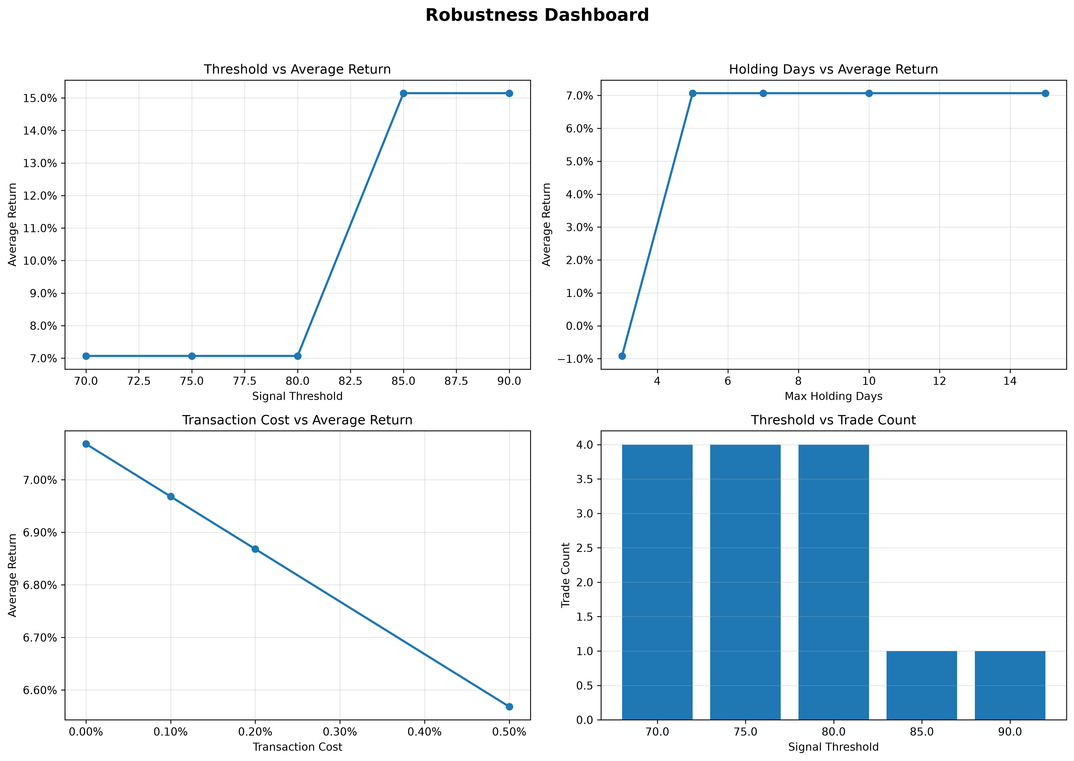
Integrated sensitivity results across signal thresholds, transaction-cost assumptions, and holding-period configurations. The dashboard provides a compact comparison of how strategy performance changes under alternative research settings.

8.2 Portfolio Backtest Behaviour
The portfolio equity curve summarizes the cumulative effect of all executed option positions. Although the current sample is limited, the equity curve provides a direct visualization of the evolution of portfolio value throughout the research period.
Figure 8.2 Option Strategy Equity Curve
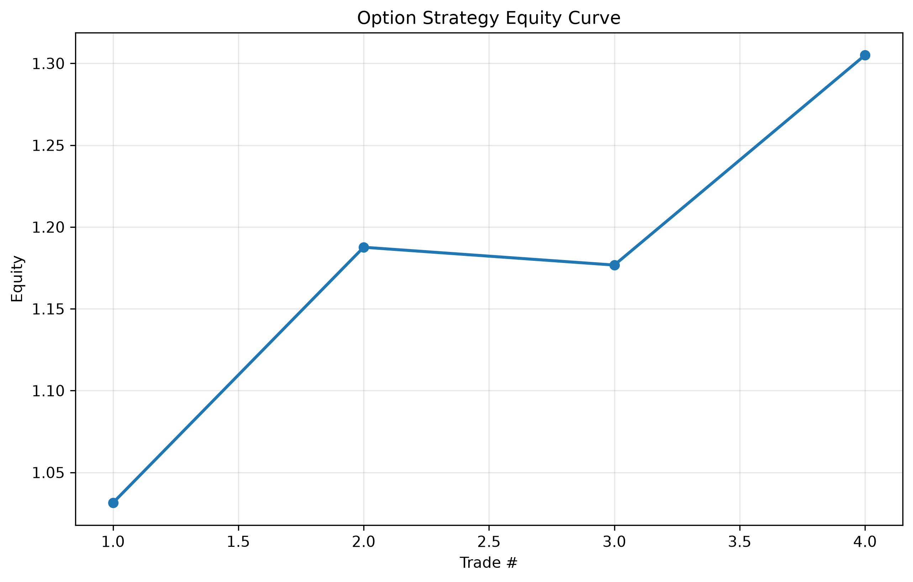
Cumulative equity generated by the completed option trades in the current research sample. The curve should be interpreted as proof of framework because the backtest contains only four completed trades.
The individual trade return chart complements the equity curve by showing the realized net return of each completed position. Three of the four trades produced positive returns, while one trade generated a small loss. Because the sample contains only four completed trades, the chart should be interpreted as a transparent trade-level summary rather than an estimate of the statistical return distribution.
Figure 8.3 Individual Trade Returns
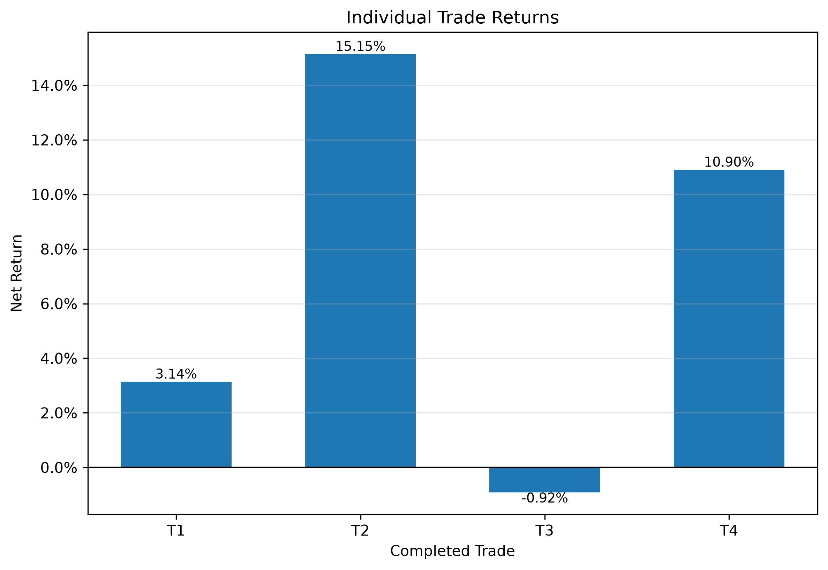
Net return of each completed option trade. Three trades produced positive returns and one produced a small loss. With only four observations, the figure is intended as a trade-level summary rather than a statistical return-distribution estimate.

8.3 Transaction Cost Analysis
Transaction costs are particularly important for option strategies because bid-ask spreads and market liquidity vary substantially across contracts. Sensitivity analysis demonstrates whether the observed strategy performance remains economically meaningful after introducing reasonable transaction-cost assumptions.
Although the current implementation adopts simplified transaction-cost assumptions, the testing framework has been designed so that more realistic commission schedules, slippage models, and execution costs can be incorporated without changing the overall architecture.

8.4 Signal Validation
Signal quality is evaluated by comparing signal scores with subsequent strategy returns. A stronger relationship between score and realized performance indicates that the signal generation framework captures economically meaningful information.
Figure 8.4 Entry Signal Score versus Net Return
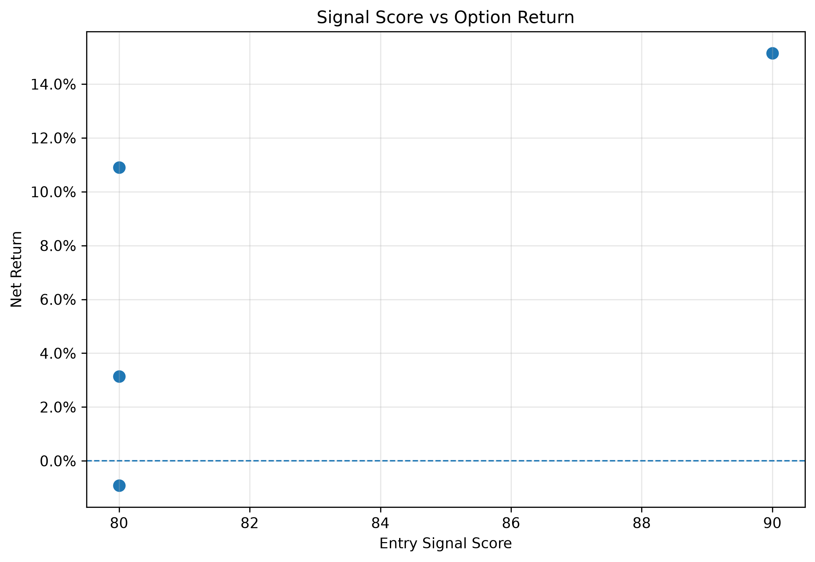
Relationship between entry signal score and subsequent net trade return. The chart provides an initial diagnostic of signal informativeness, but the small trade sample prevents strong statistical conclusions.
The signal-validation framework therefore provides additional evidence that the signal score is informative rather than being an arbitrary ranking statistic.

8.5 Overall Assessment
The robustness framework has been successfully established and integrated into the research platform. Although the current dataset covers only a limited research period, the testing infrastructure is reusable and can be directly applied to future datasets without modification.
- Backtest behaviour remains broadly consistent under multiple parameter settings.
- Transaction-cost analysis demonstrates that execution assumptions materially affect option strategies.
- Signal validation supports the usefulness of the proposed signal-scoring framework.
- The robustness dashboard provides a unified view of strategy stability.
- The current framework establishes an extensible foundation for future large-sample validation.

Part II - Quant Research Platform

9. System Architecture
Layer | Responsibility
Data | Data loading, inventory checks, trading-day discovery
Market | Trading session rules and market-data filtering
Strategy | Strategy registry and trade construction
Portfolio | PositionBook, PnL Engine, NAV Engine
Risk | Greeks exposure, risk rules, hedge translator
Monitoring | GreekMonitor, PortfolioMonitor, AlertEngine
Reporting | Text reports, Word reports, charts, reusable sections

10. Expanded Strategy Library
The strategy layer has evolved from a single prototype volatility strategy into a structured strategy library. Each strategy is represented as a StrategyRecord, which contains its research motivation, construction rules, Greeks profile, evidence status, performance summary, limitations, and future roadmap.

Strategy Registry Summary
Table 10.1 Strategy Registry Summary
ID | Strategy | Category | Stage | Impl. | Portfolio | Risk | Hedge
S001 | Long ATM Strangle | Volatility | Prototype | Completed | Yes | Yes | Yes
S002 | Long Call Butterfly | Convexity / Defined Risk | Prototype | Completed | Yes | Yes | Yes
S003 | Calendar Spread | Term Structure | Prototype | Completed | Yes | Yes | Yes
Summary of the option strategies currently registered in the platform, including strategy category, implementation stage, portfolio integration, risk monitoring, and hedge support.
The registry-based design makes the documentation extensible. Future strategies such as iron condor, diagonal spread, ratio spread, and volatility arbitrage can be added by registering a new strategy record instead of rewriting the report builder.

10.1 Long ATM Strangle

Strategy Snapshot
Item | Value
Strategy ID | S001
Category | Volatility
Research Stage | Prototype
Implementation | Completed
Portfolio Integration | Yes
Risk Monitoring | Yes
Hedge Recommendation | Yes
Historical Backtest | Completed
Documentation | Complete

Overview
Long ATM Strangle is a long-volatility strategy designed to benefit
from significant underlying price movements regardless of direction.
The strategy purchases a near-the-money call and put option with the
same maturity and seeks situations where realized volatility exceeds
implied volatility.

Research Motivation
- Capture volatility expansion.
- Reduce dependence on directional prediction.
- Create a baseline volatility strategy.
- Provide a foundation for portfolio volatility allocation.

Research Questions
- Can volatility signals identify profitable long-volatility opportunities?
- Can implied volatility underestimate future realized volatility?
- Can this strategy improve portfolio diversification?

Suitable Market Environment
Market Condition | Suitability
High uncertainty | Highly suitable
Expected volatility expansion | Highly suitable
Large expected movement | Suitable
Low volatility environment | Not recommended

Position Construction
- Buy ATM call.
- Buy ATM put.
- Use identical maturity.
- Enter after signal confirmation.

Payoff Characteristics
- Profit increases with large movement in either direction.
- Maximum loss equals premium paid.
- Requires sufficient movement to overcome theta decay.

Greeks Characteristics
Greek | Expected Exposure | Interpretation
Delta | Near Neutral | Limited directional exposure
Gamma | Positive | Benefits from movement
Vega | Positive | Benefits from volatility increase
Theta | Negative | Time decay cost

Signal and Entry Rules
- Signal score exceeds entry threshold.
- Liquidity requirements are satisfied.
- Portfolio risk remains acceptable.

Exit Rules
- Profit target reached.
- Signal weakens.
- Maximum holding period reached.
- Risk limit exceeded.

Current Evidence
Evidence | Status
Payoff Analysis | Available
Greeks Analysis | Available
Portfolio Integration | Available
Risk Monitoring | Available
Backtest | Completed

Backtest / Portfolio Evaluation
Metric | Value
Evidence Source | research\exports\pnl_engine_position_pnl_v1_1.csv, research\exports\portfolio_pnl_timeseries_v1_1.csv, research\exports\portfolio_status_pnl_v1_1.csv
Observations | 17
Trading Dates | 15
Total PnL | -64.80
Average PnL | -3.81
Best PnL | 12.10
Worst PnL | -16.80
Positive Observations | 4
Negative Observations | 10
Win Rate | 28.57%
Average Return | -2.1074%
Best Return | 6.8016%
Worst Return | -9.4435%
Interpretation | Backtested / evaluated on current 2026 sample
Research Reliability | Preliminary due to limited historical coverage
The evaluation results above are generated from the currently available research exports. Because the dataset currently covers only the 2026 sample period, these results should be interpreted as preliminary research evidence rather than final production validation.

Advantages
- Direction neutral.
- Simple structure.
- Positive volatility exposure.

Limitations
- Negative theta.
- Requires large movement.
- Sensitive to volatility crush.

Future Improvements
- Adaptive signal.
- Dynamic strike selection.
- Transaction cost optimization.

Research Roadmap
Version | Milestone
v1.0 | Prototype
v1.1 | Portfolio integration
Future | Adaptive volatility model

References
- Black (1976)
- Hull Options, Futures and Other Derivatives

10.2 Long Call Butterfly

Strategy Snapshot
Item | Value
Strategy ID | S002
Category | Convexity / Defined Risk
Research Stage | Prototype
Implementation | Completed
Portfolio Integration | Yes
Risk Monitoring | Yes
Hedge Recommendation | Yes
Historical Backtest | Completed on current 2026 sample
Documentation | Complete

Overview
The Long Call Butterfly is a defined-risk option structure constructed with three call strikes. It is designed to benefit when the underlying settles near the middle strike. The strategy has limited downside and limited upside, making it useful for researching convexity, strike selection, and range-based market views.

Research Motivation
- Study defined-risk convexity structures.
- Compare limited-risk structures with outright long-volatility premium-buying strategies.
- Explore payoff concentration around a selected target strike.
- Provide a strategy type that can be monitored through portfolio Greeks.

Research Questions
- Can strike-centered convexity structures improve risk-adjusted performance?
- How sensitive is performance to middle-strike selection?
- Can butterfly structures reduce premium cost relative to outright long volatility?
- Can butterfly positions be integrated into a multi-strategy option portfolio?

Suitable Market Environment
Market Condition | Suitability
Expected settlement near target strike | Highly suitable
Moderate directional or range-bound view | Suitable
Low-cost convexity opportunity | Suitable
Large breakout market | Less suitable
Strong volatility expansion | Less suitable than strangle

Position Construction
- Buy one lower-strike call option.
- Sell two middle-strike call options.
- Buy one upper-strike call option.
- Use approximately symmetric strike spacing when possible.
- Use the same expiry for all legs.

Payoff Characteristics
- Maximum profit occurs when the underlying settles near the middle strike at expiry.
- Maximum loss is limited to the net premium paid.
- The payoff is bounded on both upside and downside.
- The strategy is sensitive to strike placement and time to expiration.

Greeks Characteristics
Greek | Expected Exposure | Interpretation
Delta | Depends on underlying location | Can be directional near entry
Gamma | Nonlinear / location-dependent | Convexity changes across price regions
Vega | Usually limited | Less pure long-volatility exposure than strangle
Theta | Location-dependent | Can be favorable near the middle strike

Signal and Entry Rules
- Target strike is identified from current underlying level or strategy signal.
- Strike spacing is valid and approximately symmetric.
- Net premium is within acceptable risk budget.
- Portfolio-level Greeks remain within risk limits.

Exit Rules
- Profit target is reached.
- Underlying moves away from the target zone.
- Maximum holding period is reached.
- Risk exposure becomes inconsistent with portfolio limits.

Current Evidence
Evidence | Status
Payoff Analysis | Available
Greeks Analysis | Available
Portfolio Integration | Available
Risk Monitoring | Available
Historical Backtest | Completed on current 2026 sample
Transaction Cost Test | Research-stage / preliminary
Robustness Dashboard | Research-stage / preliminary

Backtest / Portfolio Evaluation
Metric | Value
Evidence Source | research\exports\portfolio_pnl_timeseries_v1_1.csv, research\exports\portfolio_status_pnl_v1_1.csv
Observations | 16
Trading Dates | 15
Total PnL | 6.50
Average PnL | 0.41
Best PnL | 1.20
Worst PnL | 0.00
Positive Observations | 13
Negative Observations | 0
Win Rate | 100.00%
Average Return | 8.0018%
Best Return | 17.7778%
Worst Return | 0.0000%
Interpretation | Backtested / evaluated on current 2026 sample
Research Reliability | Preliminary due to limited historical coverage
The evaluation results above are generated from the currently available research exports. Because the dataset currently covers only the 2026 sample period, these results should be interpreted as preliminary research evidence rather than final production validation.

Advantages
- Defined maximum loss.
- Lower premium cost than outright long straddle or strangle.
- Useful for range-bound or target-price research.
- Can be integrated into portfolio risk monitoring.

Limitations
- Profit zone is narrow.
- Performance depends strongly on strike selection.
- Limited upside even if the market moves strongly.
- Historical sample is currently limited.
- Transaction-cost and slippage assumptions require further calibration.

Future Improvements
- Automated strike selection.
- Dynamic width selection.
- Full butterfly backtesting across all available trading days.
- Transaction-cost-aware evaluation.
- Comparison with strangle and calendar structures.

Research Roadmap
Version | Milestone
v1.0 | Strategy structure implemented
v1.1 | Portfolio integration
v1.2 | Risk monitoring integration
Future | Full backtest and robustness analysis

References
- Options spread strategy literature
- Convexity and payoff engineering
- Hull Options, Futures and Other Derivatives

10.3 Calendar Spread

Strategy Snapshot
Item | Value
Strategy ID | S003
Category | Term Structure
Research Stage | Prototype
Implementation | Completed
Portfolio Integration | Yes
Risk Monitoring | Yes
Hedge Recommendation | Yes
Historical Backtest | Completed on current 2026 sample
Documentation | Complete

Overview
The Calendar Spread is a term-structure option strategy that compares near-expiry and next-expiry option prices or implied volatility. The strategy is designed to research maturity spread behavior, time decay differences, and term-structure shifts.

Research Motivation
- Study implied volatility term-structure behavior.
- Research differences between near-term and next-term option pricing.
- Create a strategy connected to maturity spread and theta behavior.
- Extend the platform beyond single-expiry volatility structures.

Research Questions
- Can maturity-spread information be converted into systematic option strategies?
- How does near-expiry theta interact with next-expiry Vega?
- Can calendar spreads provide more stable exposure than outright long volatility?
- Can term-structure strategies improve multi-strategy portfolio diversification?

Suitable Market Environment
Market Condition | Suitability
Stable underlying with term-structure opportunity | Highly suitable
Near-term IV distortion | Suitable
Expected term-structure normalization | Suitable
Large immediate directional movement | Less suitable
Severe liquidity imbalance across expiries | Not recommended

Position Construction
- Construct near-expiry option exposure.
- Construct next-expiry option exposure.
- Compare near and next expiry straddle or option prices.
- Enter when the maturity spread or IV spread satisfies strategy conditions.
- Monitor Vega, Theta, and term-structure exposure.

Payoff Characteristics
- Payoff depends on relative changes between near-expiry and next-expiry options.
- The strategy is sensitive to time decay and volatility term-structure movement.
- It may benefit when the chosen maturity spread normalizes in the expected direction.
- Risk depends on underlying movement, IV shift, liquidity, and expiration timing.

Greeks Characteristics
Greek | Expected Exposure | Interpretation
Delta | Can be near neutral | Depends on selected strikes and expiries
Gamma | Mixed | Near-expiry leg often has stronger Gamma
Vega | Term-structure sensitive | Next-expiry leg often dominates Vega exposure
Theta | Mixed | Near-expiry time decay is important

Signal and Entry Rules
- Near and next expiry contracts are both available.
- Term-structure or IV-spread condition is satisfied.
- Liquidity across both maturities is acceptable.
- Portfolio-level Vega and Theta exposure remain within limits.

Exit Rules
- Spread normalizes or profit target is reached.
- Term-structure signal disappears.
- Near expiry becomes too close to expiration.
- Portfolio-level Vega or Theta risk exceeds threshold.

Current Evidence
Evidence | Status
Payoff Analysis | Available
Greeks Analysis | Available
Portfolio Integration | Available
Risk Monitoring | Available
Historical Backtest | Completed on current 2026 sample
Transaction Cost Test | Research-stage / preliminary
Robustness Dashboard | Research-stage / preliminary

Backtest / Portfolio Evaluation
Metric | Value
Evidence Source | research\exports\pnl_engine_position_pnl_v1_1.csv, research\exports\portfolio_pnl_timeseries_v1_1.csv, research\exports\portfolio_status_pnl_v1_1.csv
Observations | 17
Trading Dates | 15
Total PnL | -4,041.80
Average PnL | -237.75
Best PnL | 172.90
Worst PnL | -1,012.80
Positive Observations | 2
Negative Observations | 13
Win Rate | 13.33%
Average Return | -29.5095%
Best Return | 61.6839%
Worst Return | -87.6428%
Interpretation | Backtested / evaluated on current 2026 sample
Research Reliability | Preliminary due to limited historical coverage
The evaluation results above are generated from the currently available research exports. Because the dataset currently covers only the 2026 sample period, these results should be interpreted as preliminary research evidence rather than final production validation.

Advantages
- Directly connected to volatility term structure.
- Can express relative-value views across maturities.
- Useful for studying Theta and Vega interaction.
- Integrated into portfolio, risk, and hedge reporting.

Limitations
- More complex than single-expiry strategies.
- Sensitive to liquidity across expiries.
- Requires careful maturity selection.
- Historical sample is currently limited.
- Hedge calibration is still approximate.

Future Improvements
- Automated maturity-pair selection.
- Term-structure signal calibration.
- Full historical calendar-spread backtesting.
- Transaction-cost-aware evaluation.
- Integration with volatility regime classification.

Research Roadmap
Version | Milestone
v1.0 | Calendar structure implemented
v1.1 | Portfolio integration
v1.2 | Risk and monitoring integration
Future | Full backtest and term-structure signal calibration

References
- Volatility term-structure strategy literature
- Calendar spread option strategy literature
- Hull Options, Futures and Other Derivatives

11. Portfolio Engine
The Portfolio Engine converts strategy-level outputs into portfolio-level positions, PnL, NAV, and performance statistics. It provides the integration layer between individual option strategies and portfolio-level monitoring, risk management, hedge recommendation, and reporting.

11.1 Design Objective
- Convert strategy outputs into standardized portfolio positions.
- Track open positions across trading days.
- Calculate position-level and portfolio-level PnL.
- Maintain NAV, cumulative return, and drawdown history.
- Provide portfolio information for risk monitoring.
- Support both active trading days and flat days.

11.2 Portfolio Architecture
The Portfolio Engine transforms individual strategy signals into a unified portfolio workflow. Each strategy generates positions, which are standardized through PositionBook before entering PnL, NAV, risk, hedge, and reporting modules.
Strategy Layer
│
├── Long ATM Strangle
├── Long Call Butterfly
└── Calendar Spread
↓
PositionBook
↓
PnL Engine
↓
NAV Engine
↓
Risk Engine
↓
Hedge Recommendation
↓
Monitoring
↓
Research Report

11.3 Core Components
Component | Function
PositionBook | Stores standardized open positions and market information.
PnL Engine | Calculates position-level and portfolio-level unrealized PnL.
NAV Engine | Updates account NAV, return, and drawdown.
Risk Engine | Aggregates portfolio Greeks and exposure.
Hedge Engine | Generates risk reduction recommendations.
Reporting Engine | Produces automated research reports.

11.4 Example PositionBook
The following snapshot illustrates how positions from different strategies are standardized inside the PositionBook before portfolio-level PnL, NAV, risk, and hedge calculations are performed.
Trade ID | Strategy | Quantity | Entry Price | Current Price | Market Value | Unrealized PnL | Unrealized Return | Status
1 | long_atm_strangle | 1 | 177.9 | 179.3 | 179.3 | 1.4 | 0.0079 | open
2 | long_call_butterfly | 1 | 4.5 | 5.1 | 5.1 | 0.6 | 0.1333 | open
3 | calendar_spread | 1 | 126.3 | 89.4 | 89.4 | -36.9 | -0.2922 | open

11.5 Position Lifecycle
Signal Generation
│
▼
Strategy Construction
│
▼
Position Standardization
│
▼
PositionBook
│
▼
PnL Calculation
│
▼
Risk Aggregation
│
▼
Hedge Recommendation
│
▼
Portfolio Report

11.6 PnL Engine
The PnL Engine converts position-level market changes into portfolio-level performance statistics.
- Position unrealized PnL = quantity × (current price - entry price).
- Position return measures performance relative to entry cost.
- Portfolio PnL aggregates all open positions.
- Current implementation focuses on mark-to-market unrealized PnL.

11.6.1 Example PnL Calculation
Strategy | Entry | Current | PnL
Calendar Spread | 126.3 | 89.4 | -36.9

11.7 NAV Engine
Initial Capital
│
▼
Portfolio PnL
│
▼
Current NAV
│
▼
Peak NAV
│
▼
Drawdown
- Current NAV = Initial Capital + Portfolio PnL.
- Cumulative return measures NAV growth relative to initial capital.
- Drawdown measures decline from historical NAV peak.

11.8 Flat-Day Handling
- Flat days represent trading days without active positions.
- Including flat days maintains a complete portfolio timeline.
- Flat days improve interpretation of return and risk history.
- Flat days are classified separately from active portfolio states.

11.9 Portfolio Snapshot
Metric | Value
Trading Days | 107
Active Days | 15
Flat Days | 92
Strategies | 3
Latest Risk Status | flat

11.10 Limitations and Future Work
- Realized PnL accounting should be separated from unrealized PnL.
- Transaction cost and execution modeling require further integration.
- Capital allocation and margin management can be improved.
- Future versions should connect Portfolio Engine with automatic execution simulation.

12. Greeks and Risk Monitoring
The Risk Engine continuously evaluates portfolio exposure by aggregating option Greeks across all open positions. Instead of reacting only after profit and loss have changed, the system identifies potential risks before large portfolio losses occur. The resulting risk status is then used by the Hedge Recommendation Engine to determine whether additional risk reduction actions are required.

12.1 Why Greeks Matter
Portfolio profit and loss is ultimately driven by changes in the underlying market, implied volatility, and the passage of time. These effects are summarized by the option Greeks, making Greeks the fundamental inputs of the portfolio risk monitoring system.
Underlying Market
│
▼
Option Price Changes
│
▼
Delta / Gamma / Vega / Theta
│
▼
Portfolio Exposure
│
▼
Risk Engine
Greek | Primary Risk | Role in Portfolio
Delta | Directional exposure | Monitor sensitivity to underlying price movement.
Gamma | Convexity | Measure how quickly Delta changes as the underlying moves.
Vega | Volatility exposure | Monitor changes in implied volatility.
Theta | Time decay | Measure portfolio value erosion through time.
Although profit and loss is the final outcome observed by investors, Greeks provide earlier indications of changing portfolio risk. The Risk Engine therefore monitors Greeks continuously instead of waiting for realized losses to occur.

12.2 Portfolio Greeks Aggregation
Each individual option strategy contributes its own Greeks to the overall portfolio. The Portfolio Engine aggregates these exposures across all open positions before risk classification is performed.
Individual Strategy Greeks
ATM Strangle
Δ Γ V Θ
Butterfly
Δ Γ V Θ
Calendar Spread
Δ Γ V Θ
│
▼
Portfolio Greeks
│
▼
Risk Classification
Portfolio Greeks are computed as the sum of the position-level Greeks. Each position contributes according to its quantity and exposure.
Portfolio Metric | Aggregation Rule
Portfolio Delta | Σ Position Delta
Portfolio Gamma | Σ Position Gamma
Portfolio Vega | Σ Position Vega
Portfolio Theta | Σ Position Theta
Aggregated Greeks provide a concise description of the overall portfolio risk profile and form the direct inputs of the Risk Engine.

12.3 Risk Threshold Framework
After portfolio Greeks have been aggregated, each exposure is compared against predefined portfolio risk limits. The monitoring framework determines whether the current exposure remains acceptable or whether additional attention is required.
Portfolio Greeks
│
▼
Threshold Evaluation
│
▼
Risk Classification
│
▼
Normal / Warning / Critical
This threshold-based framework enables the platform to detect excessive risk before large portfolio losses materialize.

12.4 Risk Classification Logic
The portfolio risk state is determined according to the aggregated Greek exposures. Individual Greeks are evaluated first, after which an overall portfolio risk status is assigned.
Exposure Within Limits
│
▼
NORMAL
│
Threshold Breached
▼
WARNING
│
Large Exposure
▼
CRITICAL
Risk Status | Interpretation
Normal | Portfolio Greeks remain within acceptable limits.
Warning | One or more portfolio exposures approach predefined limits.
Critical | Portfolio exposure exceeds acceptable limits and immediate risk mitigation should be considered.
The assigned risk status becomes the direct input to the Hedge Recommendation Engine described in the following chapter.

12.5 Historical Risk Behaviour
The portfolio risk profile evolves over time as positions are opened, closed, and marked to market. Historical monitoring allows the research platform to identify periods of elevated exposure and evaluate how portfolio risk changes throughout the sample.
Metric | Value
Trading Days | 107
Normal Days | 7
Warning Days | 5
Critical Days | 3
Historical risk monitoring provides a higher-level view of portfolio stability than individual daily observations.

12.6 Portfolio Risk Dashboard
The portfolio dashboard summarizes the major sources of risk currently being monitored by the platform.
Risk Category | Metric | Monitoring
Direction | Net Delta | Continuously monitored
Convexity | Net Gamma | Continuously monitored
Volatility | Net Vega | Continuously monitored
Time Decay | Net Theta | Continuously monitored
Overall Status | Risk Status | Normal / Warning / Critical
The dashboard serves as the operational interface between the Portfolio Engine and the Risk Engine.

12.7 Risk Case Study
The following example illustrates how portfolio Greeks are translated into an overall portfolio risk assessment.
Metric | Observed Value | Interpretation
Net Vega | -993.32 | Large short volatility exposure
Net Delta | 0.033 | Nearly direction neutral
Net Gamma | 0.0013 | Limited convexity exposure
Net Theta | -365.22 | Time decay remains significant
Risk Status | Warning | Further monitoring recommended
Rather than relying solely on portfolio profit and loss, the Risk Engine identifies which specific Greek is responsible for the current portfolio risk profile.

12.8 Connection to Hedge Recommendation
Portfolio Greeks
│
▼
Risk Aggregation
│
▼
Risk Classification
│
▼
Hedge Recommendation
│
▼
Portfolio Adjustment
Risk monitoring does not directly modify portfolio positions. Instead, it provides standardized exposure information to the Hedge Recommendation Engine, which determines whether hedging actions are required.

12.9 Historical Charts
The following figures summarize the historical evolution of portfolio risk exposures during the current research sample.

12.9.1 Risk Summary
Metric | Value
Trading Days | 107
Flat Days | 92
Normal Days | 7
Warning Days | 5
Critical Days | 3
Max Absolute Delta | 0.387943
Max Absolute Vega | 1198.58
Max Absolute Theta | 819.73
Figure 12.1 Portfolio Risk Status Distribution
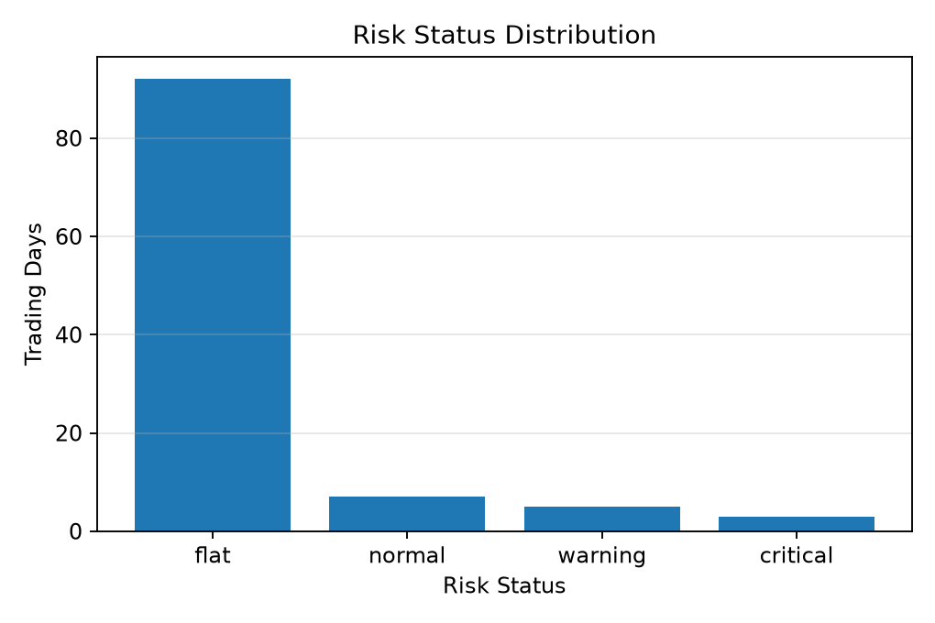
Distribution of daily portfolio risk classifications across the research sample. Each trading day is categorized as Normal, Warning, or Critical according to the predefined portfolio exposure thresholds.
Figure 12.2 Portfolio Net Vega Exposure
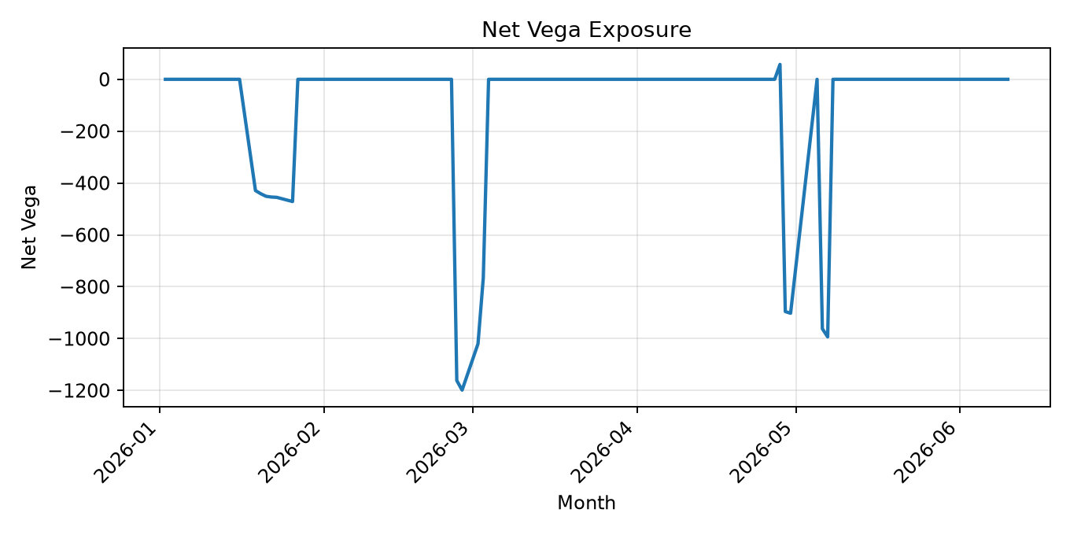
Historical evolution of aggregate portfolio Vega. Positive values indicate increasing sensitivity to implied volatility, while negative values represent short-volatility exposure.
Figure 12.3 Portfolio Net Delta Exposure
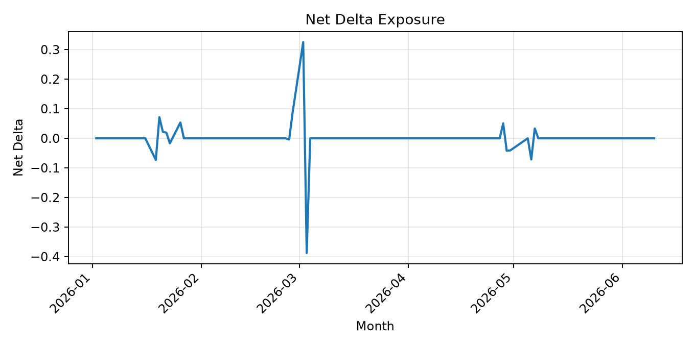
Historical aggregate portfolio Delta. The chart summarizes directional market exposure throughout the research period and provides an indication of overall directional neutrality.

13. Hedge Recommendation
The Hedge Recommendation Engine provides decision support for portfolio risk management. Instead of automatically executing trades, the current research platform evaluates portfolio exposures, identifies significant risk sources, and recommends appropriate hedge actions to the portfolio manager. This modular architecture separates strategy generation, portfolio management, risk monitoring, and hedge decision making into independent components.

13.1 Design Objectives
- Translate portfolio risk exposures into actionable hedge recommendations.
- Reduce excessive directional, volatility, and time-decay risk.
- Provide transparent and repeatable rule-based hedge logic.
- Support research workflows without automatic trade execution.
- Prepare the platform for future optimization-based hedge engines.

13.2 Why Hedge Recommendation?
The current platform focuses on quantitative research rather than live execution. Hedge outputs are therefore generated as recommendations instead of automatic trades. Researchers remain responsible for reviewing portfolio exposures before any execution takes place.
Component | Current Status
Research Stage | Rule-based recommendation
Trade Execution | Manual
Risk Review | Human validation
Future Direction | Automatic execution engine

13.3 Hedge Decision Pipeline
Portfolio Greeks
│
▼
Risk Aggregation
│
▼
Risk Classification
│
▼
Rule Engine
│
▼
Hedge Recommendation
│
▼
Trader Decision
The Hedge Recommendation Engine receives standardized portfolio risk information from the Risk Engine. Rule-based logic then evaluates portfolio exposures and generates appropriate hedge suggestions.

13.4 Exposure-to-Hedge Translation
Observed Exposure | Primary Risk | Suggested Hedge
Large Positive Delta | Directional Risk | Sell Index Futures
Large Negative Delta | Directional Risk | Buy Index Futures
Large Negative Vega | Volatility Risk | Buy Volatility Exposure
Large Positive Vega | Volatility Risk | Reduce Long Volatility
Large Negative Theta | Time Decay | Reduce Long Premium Positions
Large Gamma | Convexity | Adjust Position Structure

13.5 Rule-Based Decision Engine
The current Hedge Recommendation Engine uses transparent rule-based logic. Each portfolio exposure is evaluated against the corresponding risk status, then converted into a suggested hedge action if the exposure is material.
Portfolio Exposure
│
▼
Risk Level Check
│
▼
Rule Match
│
▼
Hedge Action
│
▼
Recommendation Output
Condition | Recommendation | Reason
Delta normal | No action | Directional exposure is within threshold.
Delta warning / critical | Futures hedge | Use index futures to reduce directional exposure.
Vega warning / critical | Volatility hedge | Use option structures to reduce excessive volatility exposure.
Gamma warning / critical | Structure adjustment | Reduce convexity concentration or rebalance option structures.
Theta warning / critical | Premium reduction | Reduce positions with excessive time decay.

13.6 Example Hedge Decisions
The following examples illustrate how the rule-based Hedge Recommendation Engine translates observed portfolio risk into decision-support outputs.
Risk Metric | Observed Value | Risk Level | Recommendation | Explanation
Net Delta | 0.033 | Normal | No action | Directional exposure is small.
Net Vega | -993.32 | Warning | Monitor / reduce short Vega | Large negative Vega indicates sensitivity to volatility increase.
Net Theta | -365.22 | Warning | Monitor time decay | Negative Theta indicates ongoing premium decay.
Net Gamma | 0.0013 | Normal | No action | Convexity exposure is limited.
These examples are advisory. The current platform does not execute hedge transactions automatically; instead, it provides structured recommendations for human review.

13.7 Current Limitations
- Hedge recommendations are rule-based rather than optimization-based.
- Hedge sizing is approximate and not yet calibrated with transaction costs.
- Execution simulation is not yet implemented.
- Bid-ask spread, slippage, and liquidity constraints are not fully modeled.
- The current engine provides decision support rather than automatic execution.

13.8 Future Automatic Hedge Engine
Current Stage
Rule-Based Recommendation
│
▼
Optimization-Based Hedge Sizing
│
▼
Transaction-Cost-Aware Hedge Selection
│
▼
Execution Simulation
│
▼
Automatic Hedge Engine
The long-term objective is to evolve the current rule-based recommendation system into an optimization-based hedge engine that accounts for transaction costs, liquidity, hedge effectiveness, and portfolio constraints.

14. Automation and Reporting
The Automation Framework integrates all major components of the Quant Option Research Platform into a standardized daily workflow. Instead of manually executing individual scripts, the platform performs data cleaning, strategy generation, portfolio management, risk monitoring, hedge recommendation, and report generation through a reproducible pipeline.

14.1 Design Objective
- Automate the complete daily research workflow.
- Reduce manual intervention during data processing.
- Generate reproducible research outputs.
- Support daily portfolio monitoring.
- Prepare the platform for future scheduled execution.

14.2 Daily Pipeline Architecture
Market Data
│
▼
Session Cleaning
│
▼
Strategy Engine
│
▼
Portfolio Engine
│
▼
Risk Engine
│
▼
Hedge Recommendation
│
▼
Automated Reports
Each module produces standardized outputs that become the inputs of the following stage. This modular architecture improves reproducibility, maintainability, and future extensibility.

14.3 End-to-End Workflow
Stage | Module | Main Output
1 | Market Data | Load option and futures market data
2 | Cleaning | Filter auction, lunch-break and abnormal observations
3 | Strategy | Generate option trading signals
4 | Portfolio | Update PositionBook, NAV and PnL
5 | Risk | Aggregate Greeks and classify portfolio risk
6 | Hedge | Generate hedge recommendations
7 | Reporting | Generate Word documentation and research reports
The workflow guarantees that every research report is generated from the same deterministic sequence of processing steps.

14.4 Automated Report Generation
The reporting subsystem automatically converts portfolio statistics, risk metrics, strategy descriptions, tables, and figures into a publication-quality technical report. The same reporting framework supports academic research, management reporting, and GitHub documentation.
Daily Pipeline
│
▼
CSV / Parquet
│
▼
Portfolio Statistics
│
▼
Word Builder
│
▼
Technical White Paper

14.5 Current Automation Functions
Module | Current Function
Daily Pipeline | Automatically rebuild clean sessions
Portfolio Engine | Update NAV, PnL and portfolio status
Risk Engine | Generate daily portfolio risk statistics
Reporting | Generate Word technical documentation
Research Export | Export CSV and Parquet datasets
These automation modules eliminate repetitive manual processing while ensuring that all intermediate datasets remain reproducible.

14.6 Reproducibility
- Each processing stage produces standardized intermediate outputs.
- Portfolio statistics are generated deterministically from cleaned datasets.
- Research reports are rebuilt automatically from the latest outputs.
- All processing modules are designed to be repeatable using identical inputs.

14.7 Future Production Deployment
Current Research Platform
│
▼
Scheduled Daily Execution
│
▼
Cloud Deployment
│
▼
Automatic Monitoring
│
▼
Production Quant Platform
Future work will integrate task scheduling, cloud deployment, automatic monitoring, and execution infrastructure, allowing the research platform to evolve into a production-ready quantitative research system.

15. Portfolio Performance

15.1 Evaluation Objective
This chapter evaluates the observed performance of the portfolio-level research platform. The objective is not to claim final strategy profitability, but to summarize how the current strategy, portfolio, risk, hedge, and automation modules behave when they are run together on the available 2026 research sample.
- Measure NAV stability across the available trading calendar.
- Evaluate unrealized PnL behaviour from active portfolio positions.
- Measure drawdown and downside pressure.
- Summarize active versus flat portfolio periods.
- Provide a research-stage interpretation of the current platform output.

15.2 Performance Dashboard
Metric | Value
Final NAV | 1,000,000.00
Highest NAV | 1,000,164.00
Lowest NAV | 998,977.00
Maximum Drawdown | -0.1187%
Best Daily PnL | 164.00
Worst Daily PnL | -1,023.00
Active Position Days | 15
Total Trading Days | 107
Metric | Value
Total Trading Days | 107
Active Position Days | 15
Flat Days | 92
Activity Ratio | 14.02%
Evaluation Status | Research-stage platform evaluation
The dashboard shows that the current platform processes the full trading calendar while only holding active positions on a subset of days. This is consistent with a signal-driven option research framework.

15.3 NAV Analysis
The NAV curve measures the portfolio-level account value after incorporating the mark-to-market impact of open positions. In the current sample, NAV remains close to the initial capital for most trading days, reflecting the limited number of active position days and the relatively small position scale used in the research-stage portfolio.
Figure 15.1 Portfolio NAV Curve
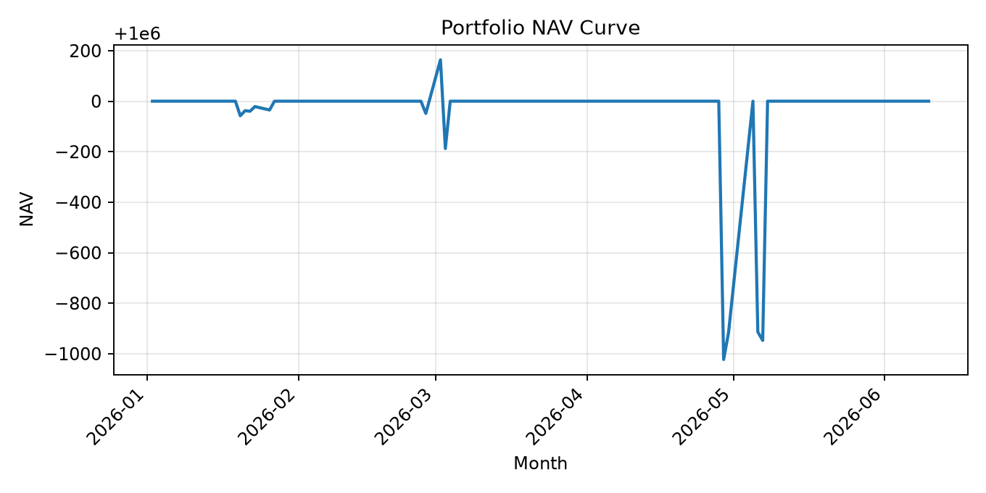
Daily portfolio net asset value across the available research sample. The NAV remains close to the initial capital for most trading days, reflecting the limited number of active position days and conservative research-stage position sizing.

15.4 Unrealized PnL Analysis
Unrealized PnL captures daily mark-to-market changes from open positions. The current PnL profile shows that most days are flat, while active trading periods create concentrated positive or negative PnL observations.
Figure 15.2 Daily Unrealized PnL
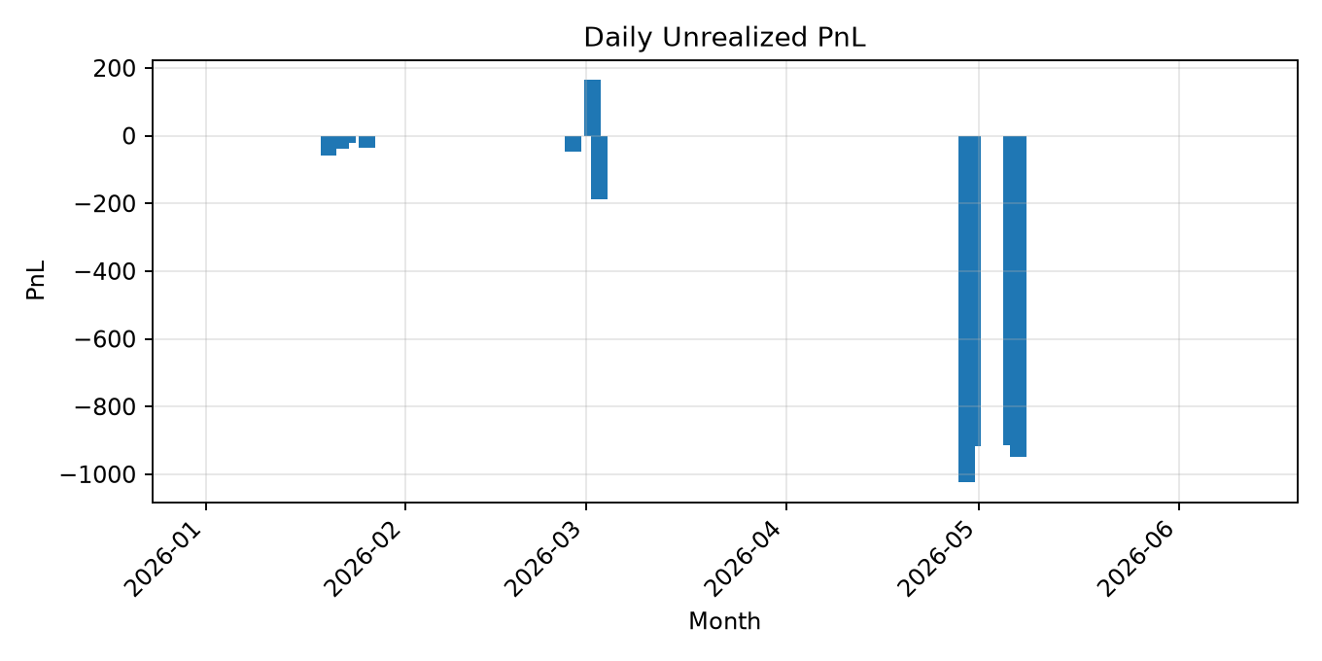
Daily mark-to-market unrealized profit and loss generated by active portfolio positions. Most trading days are flat, while active periods produce concentrated positive and negative PnL observations.

15.5 Drawdown Analysis
Drawdown measures the decline of portfolio NAV from its running peak. Because the platform includes flat days and uses research-stage position sizes, drawdown remains limited in absolute account-level terms. The drawdown chart nevertheless identifies the periods when portfolio losses were most concentrated.
Figure 15.3 Portfolio Drawdown
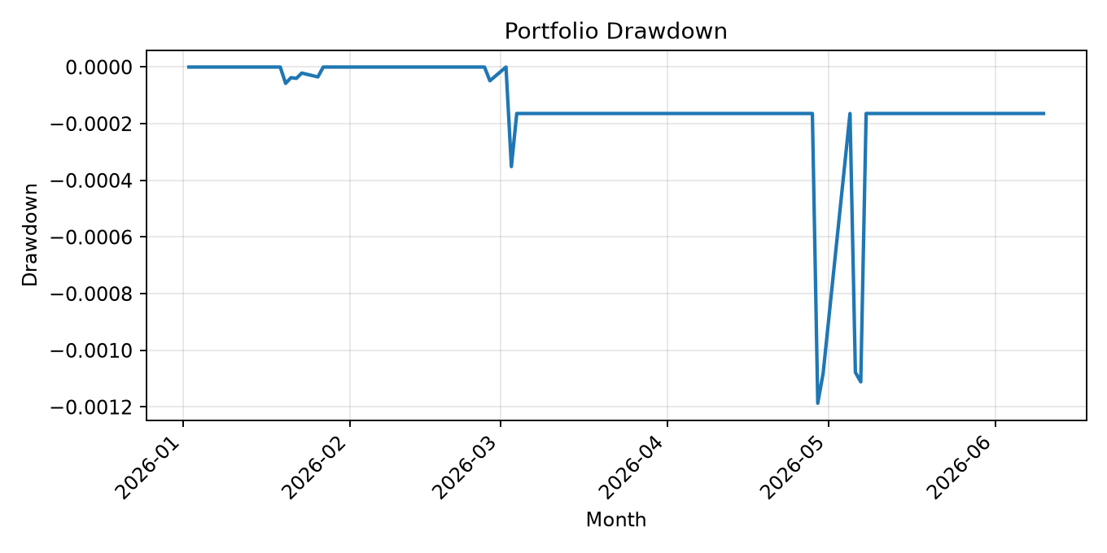
Historical decline in portfolio NAV from its running peak. The chart identifies the periods in which portfolio losses were most concentrated during the current research sample.

15.6 Strategy Contribution
The current portfolio performance is driven by a small number of strategy families, including long-volatility, butterfly, and calendar-spread structures. Strategy-level evidence in Chapter 10 shows that different strategies contribute different PnL profiles: the butterfly structure is relatively stable in the current sample, while the calendar spread contributes larger downside observations.
Strategy | Current Contribution | Interpretation
Long ATM Strangle | Mixed | Long-volatility baseline strategy
Long Call Butterfly | Positive / stable in current sample | Defined-risk convexity structure
Calendar Spread | Negative in current sample | Term-structure strategy requiring further calibration

15.7 Risk Interpretation
Performance should be interpreted together with the risk analysis in Chapter 12. Several negative PnL observations occur during periods of elevated Vega and Theta exposure, especially when calendar-spread positions dominate the portfolio. This confirms the importance of connecting portfolio performance analysis with Greeks monitoring and hedge recommendation.
- NAV stability reflects conservative research-stage position sizing.
- PnL is concentrated on active position days rather than evenly distributed.
- Drawdown is limited at the account level but still useful for identifying weak periods.
- Strategy contribution is uneven, suggesting that future portfolio allocation rules are needed.

15.8 Current Limitations
- The evaluation uses the available 2026 research sample only.
- The current performance statistics are based primarily on mark-to-market unrealized PnL.
- Realized PnL, transaction costs, slippage, bid-ask spread, and fill simulation are not fully integrated.
- Strategy allocation and position sizing rules are still simplified.
- The current results should be treated as platform validation rather than final alpha validation.

16. Current Limitations and Future Work

Current Limitations
- The current sample only covers 2026 year-to-date.
- Some strategies have limited completed historical trade samples.
- Transaction costs, bid-ask spread, slippage, and fill simulation are not fully implemented.
- Signal score formula requires a formal Signal Engine for full documentation.
- Hedge calibration requires empirical estimation.

Future Work
- Build full automatic trade generation across all available trading days.
- Implement complete historical backtesting with trade lifecycle.
- Add transaction costs, slippage, bid-ask spread, and realistic fill assumptions.
- Calibrate hedge instruments using historical Greeks exposure.
- Generate Chinese version after the English v3.0 structure is frozen.
- Update GitHub with README, architecture documentation, sample outputs, and release notes.

Appendix

Appendix A. Project Directory
Path | Purpose
framework/data | Data loading and trading-day discovery
framework/market | Trading sessions and filters
framework/strategy | Strategy registry and construction
framework/portfolio | PositionBook, PnL, NAV
framework/risk | Exposure, hedge rules, hedge translator
framework/monitoring | GreekMonitor, PortfolioMonitor, AlertEngine
framework/reporting | Text, Word, charts, documentation builder
scripts/rebuild | Batch rebuild scripts and daily pipeline
research/exports | Generated CSV outputs
research/reports | Generated reports and documentation

Appendix B. Software Environment
Component | Description
Operating System | Windows 11
Programming Language | Python 3.14
Data Processing | Pandas, NumPy, PyArrow
Scientific Computing | SciPy
Visualization | Matplotlib
Reporting | python-docx
Version Control | Git / GitHub

Appendix C. Version History
Version | Name | Description
v1.0 | Seven-Goal Project Report | Phase I research foundation
v1.1 | Portfolio/Risk Platform | Portfolio, Greeks, hedge, monitoring
v1.2 | Chart Report | Word report with NAV, PnL, Greeks charts
v2.2 | Complete Documentation | Seven-Goal report plus Phase II addendum
v3.0 | Technical White Paper | Reorganized full documentation architecture

