

UNIVERSITY OF ESWATINI
Department of Computer Science

SOFTWARE DESIGN DOCUMENT (SDD)
for the
Smart Gate Access Control System
University of Eswatini: Campus Safety & Access Management
Team Members
STUDENT NAME | STUDENT ID
- Celimpilo Mdluli | 202302334
- Nomkhosi Myeni | 202304148
- Nomsa Manana | 202302257
- Sizolwethu Dlamini | 202304340

Table of Contents

1. Introduction

1.1 Purpose
This Software Design Document (SDD) describes the complete architectural and detailed design of the Smart Gate Access Control System developed for the University of Eswatini (UNESWA). The document translates the system requirements defined in the project plan into a precise design representation that can guide programmers, testers, and system integrators during implementation. It is the primary technical reference for all development activities relating to the Smart Gate system.

This SDD has been prepared in accordance with the IEEE Standard 1016-2009 for Software Design Descriptions and the SDD template adapted from IEEE recommended practices. It is intended for use by the development team, the academic supervisor, university IT personnel, and quality assurance engineers.

1.2 Scope
The Smart Gate Access Control System is a Java-based desktop application integrated with a MySQL relational database, designed to manage, record, and monitor the entry and exit of all persons at the gate of the University of Eswatini main campus at Kwaluseni.
The system replaces the existing manual gate management process, which relies entirely on stationed security guards without any digital record-keeping. The Smart Gate system provides:
- Barcode and QR code card scanning for rapid identity verification of students and staff.
- Real-time recording of all gate events in a structured MySQL database.
- A secure administrator dashboard for managing users, viewing activity logs, and generating reports.
- A guest and visitor management module, allowing temporary access tags to be issued to persons who are not registered UNESWA members.
The system does not include integration with any biometric hardware beyond barcode and QR code scanning and does not manage physical gate actuators (barriers or turnstiles) in its first release. (No fingerprints or face recognition; as long as one has a valid card, access will be granted).

1.3 Overview
This document is organized into eight major sections as follows:

- Section 1 — Introduction: Describes the purpose, scope, and organization of this document, including reference materials and key definitions.
- Section 2 — System Overview: Provides a general description of the Smart Gate system, its context, and its core functionality.
- Section 3 — System Architecture: Presents the high-level architectural design, including subsystem decomposition and design rationale.
- Section 4 — Data Design: Describes the database schema, data structures, and data dictionary.
- Section 5 — Component Design: Provides pseudocode and design descriptions for major system components and classes.
- Section 6 — Human Interface Design: Documents all user interfaces for administrators, guards, students, and visitors, with annotated screenshot placeholders.
- Section 7 — Requirements Matrix: Maps functional requirements to design components.
- Section 8 — Appendices: Provides supplementary diagrams and reference material.

1.4 Reference Material

Reference | Description
IEEE Std 1016-2009 | IEEE Standard for Information Technology. Systems Design — Software Design Descriptions
IEEE Std 830-1998 | IEEE Recommended Practice for Software Requirements Specifications
UNESWA SmartGate Project Plan v1.0 | Smart Gate Access Control System — Software Project Plan (University of Eswatini)
ISO/IEC 25010:2021 | Systems and Software Quality Requirements and Evaluation (SQuaRE) — Quality Models
Oracle Java Code Conventions (2020) | Java code style and naming conventions for all source code in this project
ZXing Library (GitHub, 2023) | Open-source Java barcode and QR code scanning library used for card reading
MySQL 8.x Documentation | Reference for all SQL schema design and query development

1.5 Definitions and Acronyms

Term / Acronym | Definition
UNESWA | University of Eswatini — the client institution for whom this system is developed.
SDD | Software Design Document — this document, describing the design of the Smart Gate system.
RBAC | Role-Based Access Control — a security model in which system permissions are tied to user roles (Admin, Staff, Student, Visitor).
JDBC | Java Database Connectivity — the Java API used to connect the application to the MySQL database.
ZXing | Zebra Crossing — an open-source Java library for decoding barcodes and QR codes from USB scanners.
MVC | Model-View-Controller — the architectural pattern used to separate the UI, business logic, and data access layers.
ER Diagram | Entity-Relationship Diagram — a graphical model of the database tables and their relationships.
DXA | Document eXchangeable units of measure — used internally in Word document sizing.
UAT | User Acceptance Testing — testing conducted with real end-users to validate system functionality.
API | Application Programming Interface — a defined interface for software components to interact.
ENTRY | A gate event recorded when a user scans their card upon entering the campus.
EXIT | A gate event recorded when a user scans their card upon leaving the campus.
Guest Tag | A temporary, numerically identified access pass issued to visitors who are not registered UNESWA members.
SHA-256 | Secure Hash Algorithm 256-bit — used for hashing and storing user passwords securely.
JDK | Java Development Kit — the software development environment used to compile and run the Java application.
SRS | Software Requirements Specification — the document capturing the functional and non-functional requirements of the system.

2. System Overview
The Smart Gate Access Control System is a campus security and access management solution built for the University of Eswatini. It is designed to digitize, automate, and centralize the recording of all gate entry and exit events across the UNESWA campus gate points.
Currently, gate operations at UNESWA rely exclusively on manually stationed security guards. There is no digital record of who enters or exits the campus, no timestamped audit trail, and no mechanism for verifying the identity of individuals passing through campus gates. This creates substantial risks relating to theft, unauthorized access, and the inability to reconstruct campus presence records when security incidents occur.
The Smart Gate system addresses these challenges by providing the following:
- A card-scanning kiosk interface through which registered students and staff scan their university-issued identification cards (barcode or QR code) to record entry or exit events in real time.
- A secure, role-based administrative dashboard that allows authorized administrators to manage user accounts, review gate activity logs, generate statistical reports, and configure system settings.
- A visitor and guest management feature that enables guards to register temporary visitors, assign them numbered guest tags, and log their campus presence independently of the permanent user database.
- A manual ID entry fallback mechanism for situations where a card scanner is unavailable or a card has been lost or damaged.
The system is implemented using Java SE (JDK 11+) with a Java Swing graphical user interface, a MySQL 8.x relational database for persistent data storage, and the ZXing (Zebra Crossing) library for barcode and QR code decoding. Communication between the application and the database is handled through JDBC PreparedStatements to ensure data integrity and protection against SQL injection.

The system supports four distinct user roles: Administrator, Staff, Student, and Guest/Visitor. Each role has clearly defined permissions and interactions with the system.
- The administrator role has unrestricted access to all management and reporting functions.
- Staff and student roles interact with the system only at the gate-scanning interface.
- Guest/visitor roles are entirely managed by the guard or administrator at the gate.
The Smart Gate system is intended to operate as a standalone Java desktop application deployed on gate workstations connected to a shared MySQL server. The application is packaged as an executable JAR file (or Windows EXE wrapper) for ease of deployment on campus hardware.

3. System Architecture

3.1 Architectural Design
The Smart Gate Access Control System employs a three-tier client-server architectural pattern. This architecture partitions the system into three clearly defined and independently maintainable layers: The Presentation Layer, the Business Logic Layer, and the Data Access Layer. Each tier communicates with adjacent tiers only through well-defined interfaces, ensuring separation of concerns and facilitating future system modifications. The three tiers are described as follows:
Tier 1: Presentation Layer (Java Swing GUI)
This layer is responsible for all user-facing screens and interactions. It is built entirely using Java Swing and custom JPanel components. It captures user inputs (card scans, manual ID entries, admin form submissions), displays system feedback (scan results, student details, entry/exit status), and navigates between application views. Key classes include LandingFrame, LoginFrame, DashboardFrame, GateActivityPanel, UserManagementPanel, ReportsPanel, GuestManagementPanel, and SettingsPanel.

Tier 2: Business Logic Layer (Java Service Classes)
This layer contains all application rules, processing logic, and security enforcement. It validates user credentials, enforces RBAC policies, manages gate event logic (including the one-entry-before-exit rule), handles guest tag generation, processes scan results from ZXing, and orchestrates report generation. Key classes include AccessControlService, SessionManager, GateEventService, GuestService, ReportService, and the Theme configuration class.
Tier 3: Data Access Layer (JDBC + MySQL)
This layer handles all interactions with the MySQL database. It uses JDBC PreparedStatements exclusively to execute parameterised queries, preventing SQL injection vulnerabilities. The DBConnection class provides a static factory method for obtaining database connections. Data Access Objects (DAOs) — UserDAO, CardDAO, GateActivityDAO, GuestDAO — encapsulate all database operations for their respective entities.

Figure 3.1 — Three-Tier System Architecture
The SmartGate system employs a three-tier client-server architecture separating the Presentation Layer (Java Swing GUI), Business Logic Layer (Service classes), and Data Access Layer (JDBC + MySQL). The diagram below illustrates all subsystems, their constituent classes, and the communication flows between tiers.

Figure 3.1 below illustrates the high-level subsystem architecture and the relationships between the three tiers.
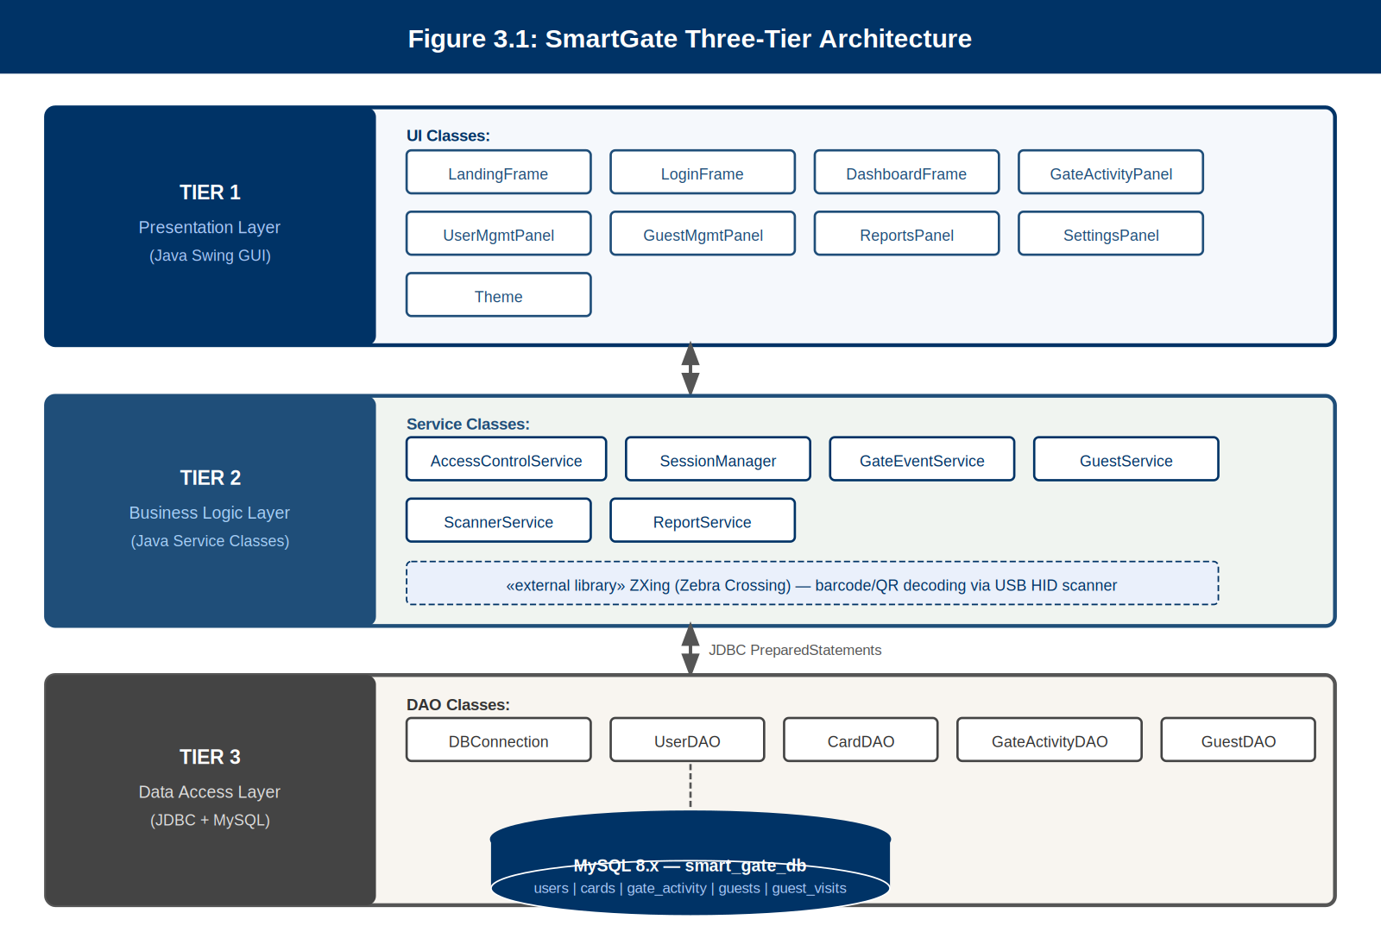

Figure 3.1: SmartGate Three-Tier Architecture Diagram
Tier 1 (Presentation Layer) contains all Java Swing frame and panel classes. Tier 2 (Business Logic Layer) contains all service classes and enforces RBAC policies. Tier 3 (Data Access Layer) encapsulates all MySQL database operations via JDBC PreparedStatements

3.2 Decomposition Description
The following subsections describe the decomposition of the Smart Gate system into its major subsystems and components. An object-oriented approach is used for the decomposition.

3.2.1 Presentation Layer: UI Subsystem
The UI subsystem consists of the following Java Swing frame and panel classes:

Class / Component | Responsibility
LandingFrame | The initial screen displayed on gate workstations. Shows the UNESWA logo, scanner status indicator, a brief 'How It Works' walkthrough, and the scan preview, student details, and entry/exit status panels. Students and staff interact exclusively with this screen.
LoginFrame | Provides a secure administrator login interface with username/ID and password fields. Routes authenticated users to the DashboardFrame based on RBAC role.
DashboardFrame | The main administrative interface. Displays a dark navy sidebar navigation linking to all management panels. Contains stat cards showing daily summary data (total entries, exits, users on campus).
GateActivityPanel | Panel within DashboardFrame showing the live gate activity log table (sortable, filterable). Supports manual ID entry for fallback scanning.
UserManagementPanel | Panel for creating, editing, deactivating, and searching registered user accounts (students, staff, admins) and associating card UIDs.
GuestManagementPanel | Panel for registering temporary visitors, issuing numbered guest tags, logging visit start and end, and viewing active guest sessions.
ReportsPanel | Panel for generating and exporting gate activity reports filtered by date range, gate point, and user role.
SettingsPanel | Panel for configuring database connection parameters and institutional display information (university name, logo path, gate labels).
Theme | A centralised configuration class defining the colour palette (navy, purple accent, white, green/red status colours), fonts, and shared UI constants for visual consistency.

3.2.2 Business Logic Layer: Service Subsystem

Class | Responsibility
AccessControlService | Validates login credentials against the users table. Assigns session roles based on the RBAC model. Enforces role-based navigation restrictions across all panels.
SessionManager | Maintains the currently active user session. Tracks logged-in user identity, role, and session start time. Enforces configurable session timeout on inactivity.
GateEventService | Processes gate scan events. Determines whether the scanned card belongs to a registered user. Enforces the one-entry-before-exit rule. Inserts validated gate events into the gate_activity table.
GuestService | Manages the full lifecycle of guest/visitor access. Generates unique numbered guest tags, records guest registration data, logs entry and exit events, and marks guest sessions as closed on exit.
ScannerService | Interfaces with the ZXing barcode/QR code decoding library. Reads USB HID scanner input, decodes the card UID, and returns the decoded string to the GateEventService for processing.
ReportService | Queries the gate_activity and guest_visits tables for report data. Aggregates and formats results by date, gate, and role. Supports export to CSV and printable table format.

3.2.3 Data Access Layer: DAO Subsystem

Class | Responsibility
DBConnection | Provides a static getConnection() factory method returning a JDBC Connection object to the smart_gate_db MySQL database. Encapsulates all connection parameters (host, port, database name, username, password).
UserDAO | CRUD operations for the users table. Methods: findByIdNumber(String), findById(int), insertUser(User), updateUser(User), deactivateUser(int), searchUsers(String).
CardDAO | Associates card UIDs with user accounts. Methods: findUserByCardUID(String), registerCard(String cardUID, int userId), deactivateCard(String cardUID).
GateActivityDAO | Inserts and retrieves gate event records. Methods: insertActivity(GateActivity), getActivitiesByDate(Date), getActivitiesByGate(String), getActivitiesByUser(int), getDailySummary().
GuestDAO | Manages temporary visitor records. Methods: registerGuest(Guest), closeGuestSession(int guestId), getActiveGuests(), getGuestHistory(DateRange).

3.2.4 UML Class Diagram
Figure 3.2 below presents the UML class diagram for the Smart Gate system, showing all major classes, their attributes, methods, and relationships (associations, dependencies, and inheritance).

Figure 3.2 — UML Class Diagram
The class diagram presents all major system classes — model entities (User, Card, GateActivity, Guest, GuestVisit), Data Access Objects (UserDAO, CardDAO, GateActivityDAO, GuestDAO, DBConnection), and Service classes (AccessControlService, SessionManager, GateEventService, GuestService, ReportService) — with full attributes, methods, and inter-class relationships (associations, dependencies).

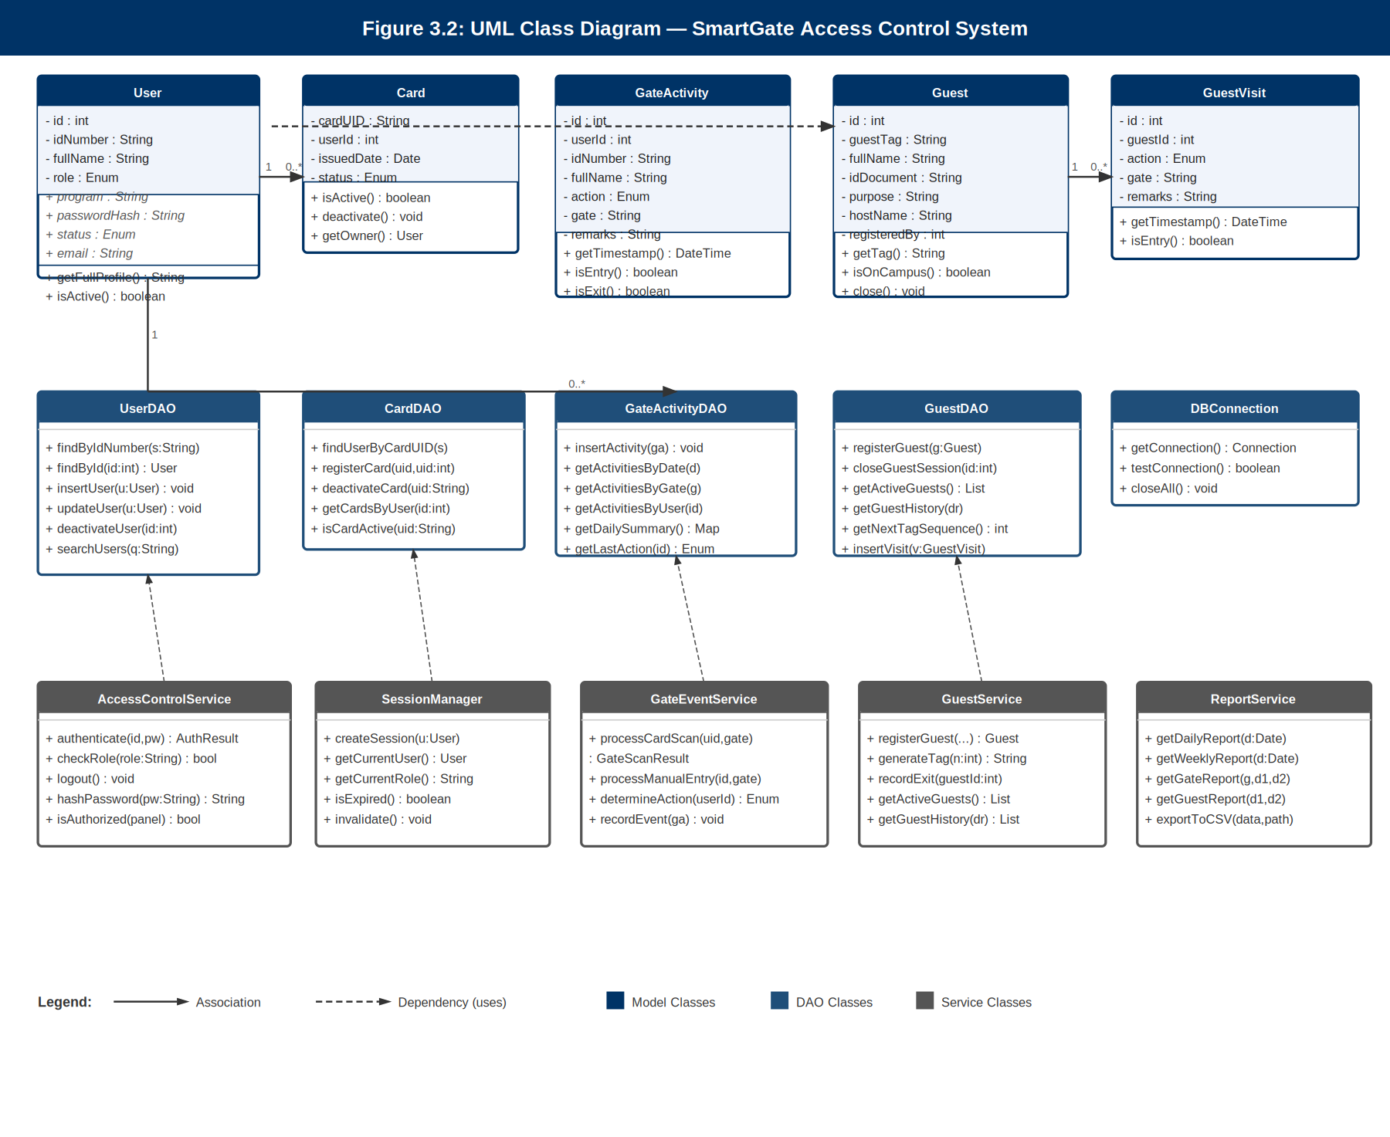
Figure 3.2: UML Class Diagram — SmartGate Access Control System

Key Relationships:
User (1) ──────< Card (N): One user may hold multiple cards; each card belongs to one user.
User (1) ──────< GateActivity (N): Every gate event references exactly one registered user.
Guest (1) ──────< GuestVisit (N): Each guest session may contain multiple entry/exit events.
Service classes depend on DAO classes (dashed dependency arrows); DAOs communicate with the MySQL database via DBConnection

3.2.5 UML Use Case Diagram
Figure 3.3 below presents the UML Use Case Diagram, identifying all actors (Administrator, Guard/Student/Staff, Visitor) and the use cases they participate in.

Figure 3.3 — UML Use Case Diagram
The use case diagram identifies all system actors and their interactions with the SmartGate system. Actors include the Administrator, Guard/Student/Staff (combined scanning actor), Visitor, and the external USB Scanner Device. Use cases are grouped by actor and annotated with include/extend relationships where applicable.

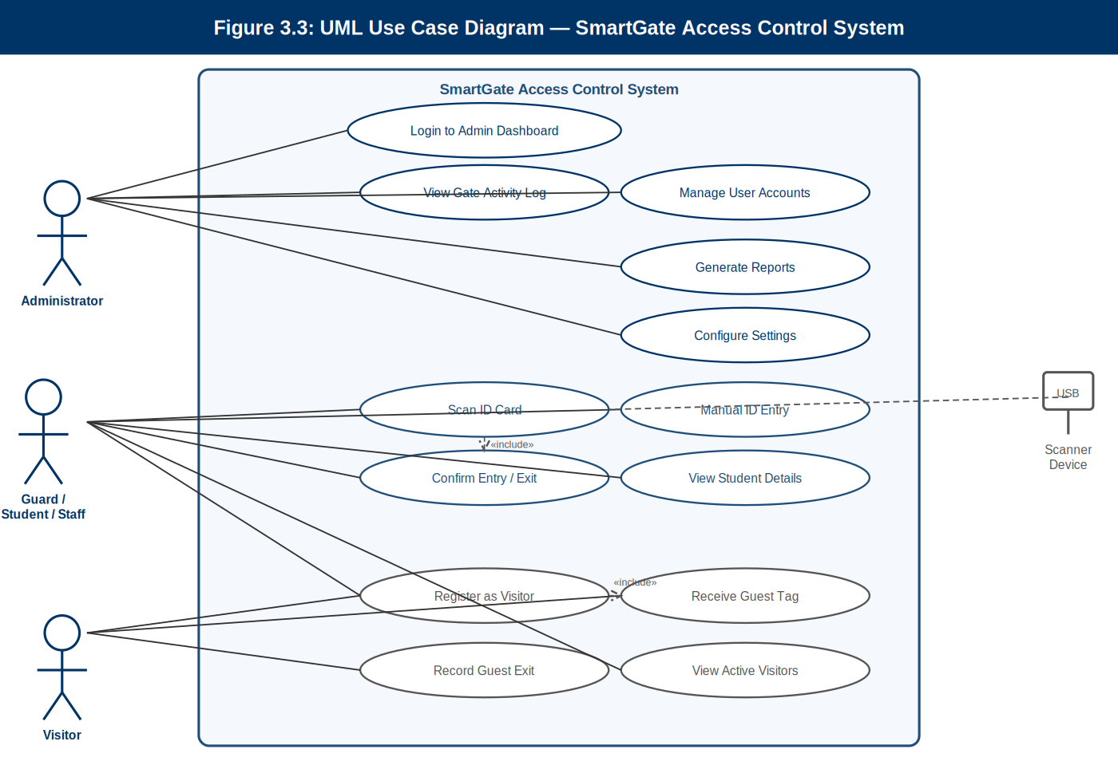
Figure 3.3: UML Use Case Diagram — SmartGate Access Control System

Actor Summary:
Administrator: Login, manage user accounts, generate reports, configure settings, view gate activity log.
Guard / Student / Staff: Scan ID card, confirm entry/exit, manual ID entry, view student details, register visitor, confirm guest exit.
Visitor: Register as visitor, receive guest tag, record guest exit.
USB Scanner Device: External actor that triggers the Scan ID Card use case via USB HID input.

3.2.6 UML Sequence Diagrams
The following sequence diagrams illustrate the key interaction flows within the system.

Figure 3.4a — Sequence Diagram: Card Scan and Gate Entry Flow
This sequence diagram illustrates the complete interaction flow when a student or staff member scans their ID card at the gate. The flow spans from the physical card scan through LandingFrame, ScannerService (ZXing decode), GateEventService (validation and rule enforcement), to GateActivityDAO (database insertion), and back to the UI for result display.

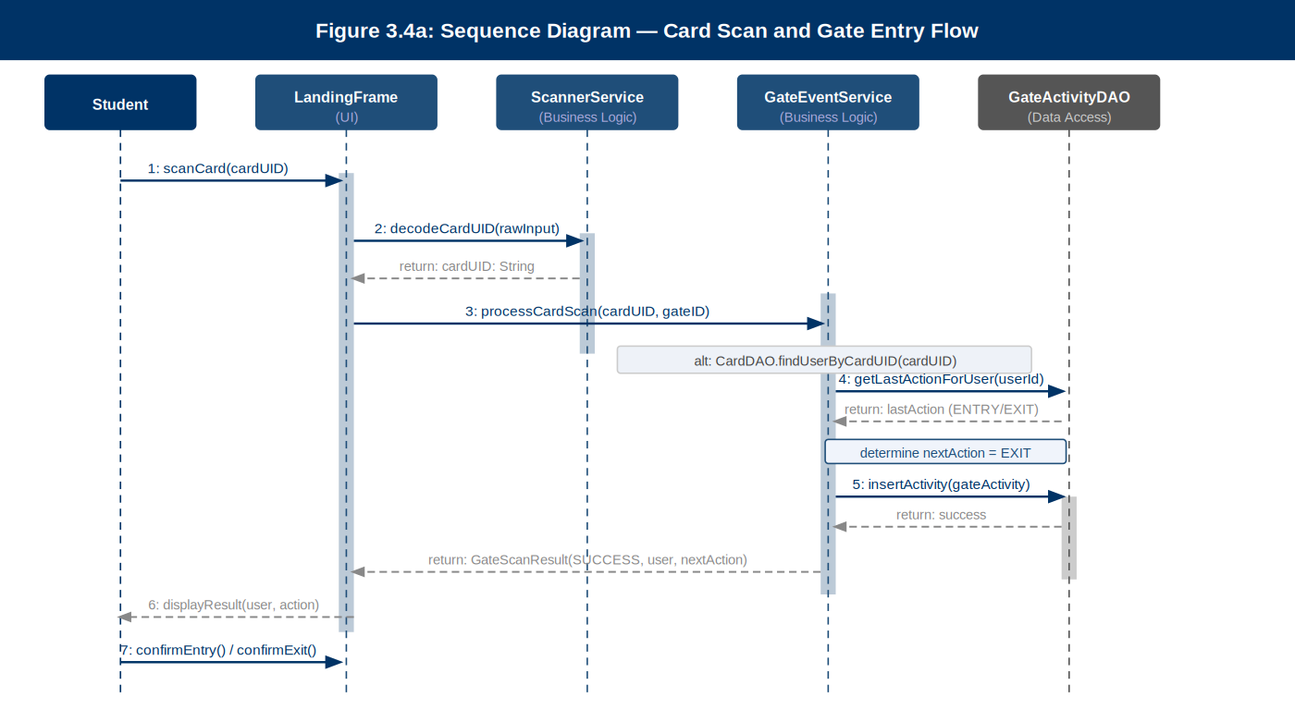
Figure 3.4a: Sequence Diagram — Card Scan and Gate Entry

Flow Steps:
1. Student scans card → LandingFrame receives raw USB HID input.
2. LandingFrame calls ScannerService.decodeCardUID() using ZXing library.
3. Decoded cardUID passed to GateEventService.processCardScan(cardUID, gateID).
4. GateEventService queries CardDAO to resolve user; enforces one-entry-before-exit rule.
5. GateActivityDAO.insertActivity() persists the gate event to MySQL.
6. GateScanResult returned to LandingFrame; user details and action displayed.
7. Guard confirms entry or exit using the coloured action buttons

Figure 3.4b — Sequence Diagram: Administrator Login Flow
This sequence diagram shows the authentication flow for administrator login. Credentials entered in LoginFrame are passed to AccessControlService, which retrieves the user record via UserDAO, performs SHA-256 password hash comparison, creates a session via SessionManager, and routes the authenticated user to the DashboardFrame.

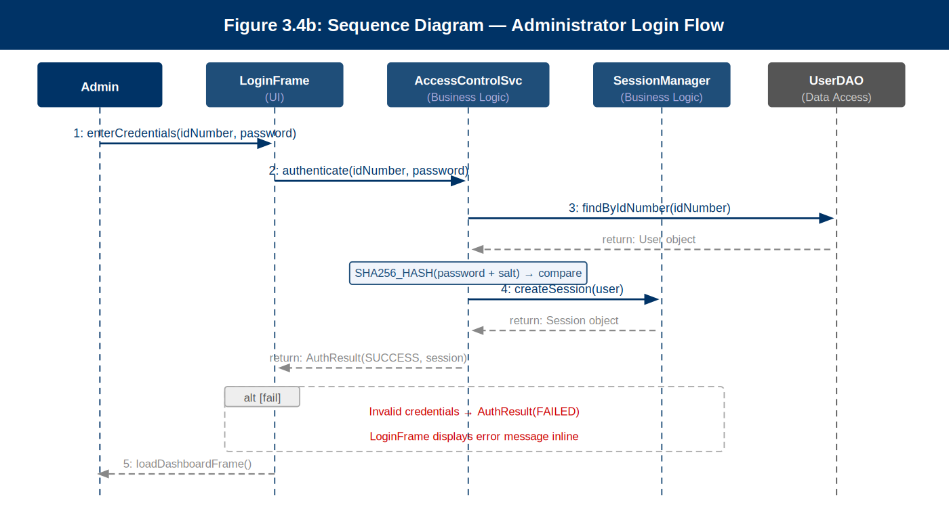
Figure 3.4b: Sequence Diagram — Administrator Login
Flow Steps:
1. Admin enters ID number and password in LoginFrame.
2. LoginFrame calls AccessControlService.authenticate(idNumber, password).
3. AccessControlService queries UserDAO.findByIdNumber() to retrieve user record.
4. SHA-256 hash computed from input + salt and compared to stored passwordHash.
5. On success: SessionManager.createSession(user) instantiates the admin session.
6. AuthResult(SUCCESS) returned; DashboardFrame loaded. On failure: inline error message displayed.

Figure 3.4c — Sequence Diagram: Guest / Visitor Registration Flow
This sequence diagram covers the full guest registration lifecycle. A guard or administrator opens the GuestManagementPanel, enters visitor details, and submits. GuestService retrieves the current user from SessionManager, obtains the next tag sequence number from GuestDAO, generates the formatted guest tag, persists the guest record, and records the initial ENTRY event.

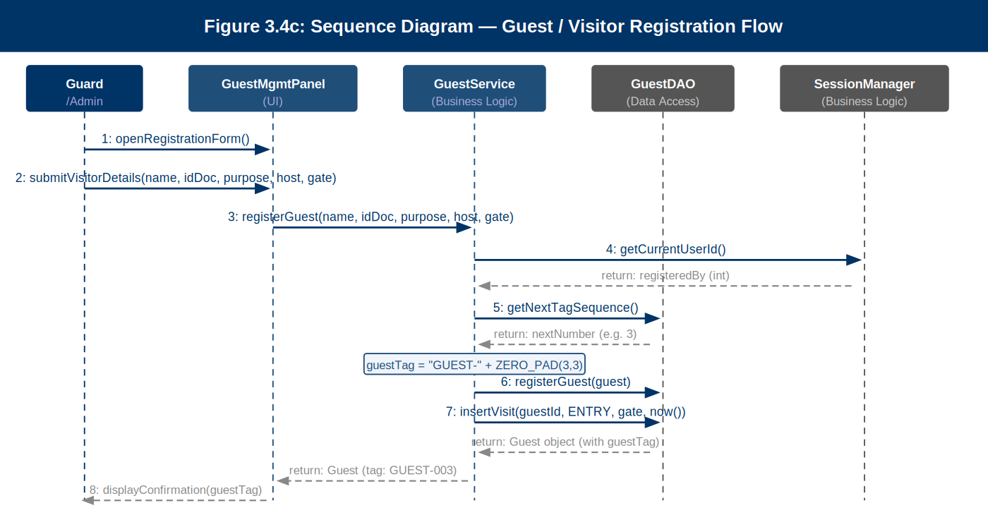
Figure 3.4c: Sequence Diagram — Guest / Visitor Registration

Flow Steps:
1. Guard opens the visitor registration form in GuestManagementPanel.
2. Guard submits visitor details (name, ID document, purpose, host, gate point).
3. GuestService retrieves registering guard identity from SessionManager.
4. GuestDAO.getNextTagSequence() returns the next available tag number.
5. GuestService generates guestTag = GUEST- + ZERO_PAD(n, 3) (e.g., GUEST-003).
6. GuestDAO.registerGuest() persists the guest record; GuestDAO.insertVisit() logs ENTRY event.
7. Guest tag number displayed to guard; physical tag issued to visitor.

3.3 Design Rationale
The three-tier MVC-based architecture was selected for the following reasons:

- Separation of concerns: Separating the UI, business logic, and data access layers ensures that changes to the user interface do not require modification of business logic, and vice versa. This is particularly important for a university project where different team members are assigned to different tiers.
- Maintainability: The modular structure makes it straightforward to add new features (such as additional report types or a mobile interface) without disturbing existing components.
- Security: Centralizing all database interactions within DAO classes and enforcing the exclusive use of JDBC PreparedStatements throughout the data access layer eliminate the risk of SQL injection across the entire application.
- Testability: Service classes and DAO classes can be independently tested using JUnit 5, without requiring the UI to be initialized.
- Appropriateness for Java Swing: Java Swing is a mature and well-understood UI toolkit that does not require an external build system or browser environment, making it suitable for standalone campus gate workstations.

Alternative architectures considered included a web-based application (Java Servlets + JSP) and a JavaFX-based desktop application. The web-based option was rejected because it would introduce server-hosting complexity and dependency on browser availability at gate workstations. JavaFX was considered but rejected in favor of Swing due to the development team's existing Swing expertise and the absence of a JavaFX runtime on all target workstations.

4. Data Design

4.1 Data Description
The Smart Gate system uses a MySQL 8.x relational database named smart_gate_db as its sole persistent data store. The database is designed according to Third Normal Form (3NF) to eliminate data redundancy and ensure referential integrity. Foreign key constraints are enforced at the database level.
The database consists of five principal tables: users, cards, gate_activity, guests, and guest_visits. The users table is the central entity, linked to both cards (for card-to-user binding) and gate_activity (for event logging). The guest tables are independent of the registered user tables, reflecting the distinct nature of temporary visitor access.
Figure 4.1 below shows the Entity-Relationship (ER) Diagram for the smart_gate_db database.

Figure 4.1 — Entity-Relationship (ER) Diagram
The ER diagram presents the complete relational schema of the smart_gate_db MySQL database. Five tables are shown: users (central entity), cards (card-to-user binding), gate_activity (primary audit log), guests (visitor registrations), and guest_visits (visitor entry/exit events). All primary keys, foreign keys, and cardinality relationships are labelled.

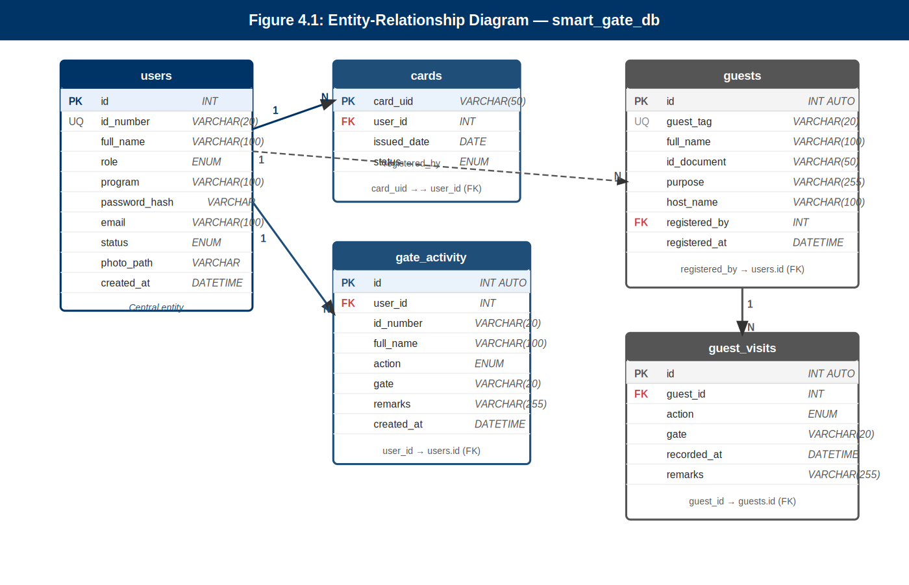
Figure 4.1: Entity-Relationship Diagram — smart_gate_db

Relationships and Cardinalities:
users (1) ──< cards (N): One user may have multiple cards; each card belongs to exactly one user (FK: cards.user_id → users.id).
users (1) ──< gate_activity (N): Every gate event references one registered user (FK: gate_activity.user_id → users.id).
users (1) ──< guests (N): A guard/admin registers multiple visitors (FK: guests.registered_by → users.id).
guests (1) ──< guest_visits (N): Each guest registration may have multiple visit events (FK: guest_visits.guest_id → guests.id).

4.2 Data Dictionary
The following subsections provide a complete description of each database table and its columns.

4.2.1 Table: users
Stores credentials and profile information for all registered system users (students, staff, and administrators).
Column Name | Data Type | Constraint | Description
id | INT | PK, AUTO | Unique internal integer identifier for each user record.
id_number | VARCHAR(20) | UNIQUE, NOT NULL | University-issued ID number (e.g., STU123456 for students, EMP001 for staff). Used as the primary login identifier.
full_name | VARCHAR(100) | NOT NULL | Full name of the user as registered in the university student/staff records.
role | ENUM | NOT NULL | User role: 'STUDENT', 'EMPLOYEE', or 'ADMIN'. Determines system access level (RBAC).
program | VARCHAR(100) | NULL | Academic programme or department (e.g., BSc Computer Science, Human Resources). Applicable to students and staff.
password_hash | VARCHAR(255) | NULL | SHA-256 salted hash of the user's password. Only populated for ADMIN role users. NULL for students and staff.
email | VARCHAR(100) | NULL | Institutional email address of the user. Optional field for contact purposes.
status | ENUM | NOT NULL, DEFAULT 'ACTIVE' | Account status: 'ACTIVE' or 'INACTIVE'. Inactive accounts cannot scan or log in.
photo_path | VARCHAR(255) | NULL | File path to the user's profile photograph for display in the scan preview panel.
created_at | DATETIME | DEFAULT CURRENT_TIMESTAMP | Timestamp recording when the user account was first created in the system.

4.2.2 Table: cards
Stores the association between physical card UIDs and registered user accounts. Each user may have one active card.

Column Name | Data Type | Constraint | Description
card_uid | VARCHAR(50) | PK | The unique barcode or QR code value encoded on the user's physical identification card.
user_id | INT | FK → users.id | Foreign key linking the card to its registered owner in the users table.
issued_date | DATE | NOT NULL | The date on which the card was issued or registered in the system.
status | ENUM | NOT NULL, DEFAULT 'ACTIVE' | Card status: 'ACTIVE' or 'DEACTIVATED'. Deactivated cards are rejected at the scanner.

4.2.3 Table: gate_activity
The primary audit log table. Every card scan or manual ID entry that results in a gate event (entry or exit) is recorded here with full contextual data.
Column Name | Data Type | Constraint | Description
id | INT | PK, AUTO | Unique identifier for each gate event record.
user_id | INT | FK → users.id | Foreign key identifying the user who triggered the gate event.
id_number | VARCHAR(20) | NOT NULL | Denormalised copy of the user's ID number for quick report generation without a join.
full_name | VARCHAR(100) | NOT NULL | Denormalised copy of the user's full name for human-readable log displays.
action | ENUM | NOT NULL | Gate event type: 'ENTRY' or 'EXIT'.
gate | VARCHAR(20) | NOT NULL | Identifier of the gate point at which the event occurred (e.g., 'Gate A', 'Gate B', 'Library Gate').
remarks | VARCHAR(255) | NULL | Optional freetext remarks entered by the guard (e.g., 'Manual entry — card malfunction').
created_at | DATETIME | DEFAULT CURRENT_TIMESTAMP | Exact timestamp of the gate event. This is the primary field for all time-based report filtering.

4.2.4 Table: guests
Stores registration information for temporary visitors who are not registered UNESWA members. Each guest is assigned a numbered tag at the gate.

Column Name | Data Type | Constraint | Description
id | INT | PK, AUTO | Unique identifier for the guest registration record.
guest_tag | VARCHAR(20) | UNIQUE, NOT NULL | Numbered access tag assigned to the visitor (e.g., GUEST-001, GUEST-002). Generated automatically by the system.
full_name | VARCHAR(100) | NOT NULL | Full name of the visiting individual as provided at registration.
id_document | VARCHAR(50) | NOT NULL | Identification document reference (e.g., national ID number, passport number) for visitor verification purposes.
purpose | VARCHAR(255) | NOT NULL | Purpose of visit as stated by the visitor (e.g., 'Interview — HR Department', 'Prospective student tour').
host_name | VARCHAR(100) | NULL | Name of the UNESWA staff member or office hosting the visitor, if applicable.
registered_by | INT | FK → users.id | Foreign key identifying the guard or administrator who registered the visitor.
registered_at | DATETIME | DEFAULT CURRENT_TIMESTAMP | Timestamp of guest registration.

4.2.5 Table: guest_visits
Tracks the entry and exit events for each guest session. A guest may have multiple visit sessions if they exit and re-enter on the same day with the same tag.

Column Name | Data Type | Constraint | Description
id | INT | PK, AUTO | Unique identifier for the visit record.
guest_id | INT | FK → guests.id | Foreign key linking the visit to the registered guest.
action | ENUM | NOT NULL | Visit event type: 'ENTRY' or 'EXIT'.
gate | VARCHAR(20) | NOT NULL | Gate at which the guest entry or exit event was recorded.
recorded_at | DATETIME | DEFAULT CURRENT_TIMESTAMP | Exact timestamp of the visit event.
remarks | VARCHAR(255) | NULL | Optional guard remarks for this visit event.

5. Component Design
This section provides pseudocode and design-level descriptions for the major system components and classes. Each component is described in terms of its attributes, key methods, and algorithmic logic.

5.1 GateEventService — Gate Scan Processing Logic

The GateEventService is the central processing component for all card scan events. Its primary responsibility is to receive a decoded card UID from the ScannerService, validate it against the database, enforce gate rules, and record the resulting event.

METHOD processCardScan(cardUID: String, gateID: String) : GateScanResult
user ← CardDAO.findUserByCardUID(cardUID)
IF user IS NULL THEN
RETURN GateScanResult(FAILED, 'Card not registered')
IF user.status == INACTIVE THEN
RETURN GateScanResult(FAILED, 'Account deactivated')
lastAction ← GateActivityDAO.getLastActionForUser(user.id)
IF lastAction == ENTRY THEN nextAction ← EXIT
ELSE nextAction ← ENTRY
event ← new GateActivity(user.id, user.idNumber, user.fullName, nextAction, gateID, now())
GateActivityDAO.insertActivity(event)
RETURN GateScanResult(SUCCESS, user, nextAction)
END METHOD

5.2 GuestService — Guest Tag Generation and Registration

METHOD registerGuest(fullName, idDocument, purpose, hostName, gateID) : Guest
nextTagNumber ← GuestDAO.getNextTagSequence()
guestTag ← 'GUEST-' + ZERO_PAD(nextTagNumber, 3) // e.g., GUEST-001
guest ← new Guest(guestTag, fullName, idDocument, purpose, hostName, SessionManager.currentUserId)
GuestDAO.registerGuest(guest)
visitEntry ← new GuestVisit(guest.id, ENTRY, gateID, now())
GuestDAO.insertVisit(visitEntry)
RETURN guest // tag number displayed for physical tag printing
END METHOD

5.3 AccessControlService — Authentication and Role Assignment

METHOD authenticate(idNumber: String, password: String) : AuthResult
user ← UserDAO.findByIdNumber(idNumber)
IF user IS NULL OR user.role != ADMIN THEN
RETURN AuthResult(FAILED, 'Invalid credentials')
hashedInput ← SHA256_HASH(password + user.salt)
IF hashedInput != user.passwordHash THEN
RETURN AuthResult(FAILED, 'Invalid credentials')
session ← SessionManager.createSession(user)
RETURN AuthResult(SUCCESS, session)
END METHOD

5.4 ReportService — Report Data Aggregation
The ReportService queries the gate_activity and guest_visits tables and returns aggregated datasets for the ReportsPanel. Key methods include:

- getDailyReport(Date): Returns all gate events for a specified date, grouped by gate and role.
- getWeeklyReport(Date startDate): Aggregates entry and exit totals for each day in a seven-day period.
- getGateReport(String gateID, Date start, Date end): Returns a filtered dataset for a specific gate and date range.
- getGuestReport(Date start, Date end): Returns all guest visit records within the specified date range.
- exportToCSV(List<ReportRow> data, String filePath): Writes the report dataset to a CSV file at the specified path.

6. Human Interface Design

6.1 Overview of User Interface
The Smart Gate system provides two distinct interface contexts: the Gate Scanning Interface and the Administrator Dashboard. These interfaces are designed to serve fundamentally different users — the Gate Scanning Interface is operated by security guards and used by students, staff, and visitors at the point of campus entry or exit, while the Administrator Dashboard is a comprehensive management console accessible only to authorised university administrators.

All interface components follow the UNESWA institutional visual identity: a dark navy blue primary colour (hex #003366), a blue accent (hex #1F4E79), and white text on coloured panels. Action buttons use green for entry confirmation and red for exit confirmation, providing immediate visual clarity for guards operating the scanning station.

The system has been designed with usability as a primary concern. The Gate Scanning Interface requires no user training beyond a brief orientation, as all states are communicated through clear visual indicators (colour changes, status badges, progress bars). The Administrator Dashboard uses a consistent left-side navigation sidebar, ensuring that all management panels are reachable within two clicks from any screen.

6.2 Gate Scanning Interface (Landing Screen)
The Gate Scanning Interface (LandingFrame) is the screen permanently displayed on gate workstations during operating hours. It serves as the primary point of interaction for students and staff and provides the guard with real-time visual feedback on each scan event.

The screen is divided into the following regions:

- Header Bar: Displays the UNESWA logo (top-left), the system title 'Smart Gate Access System', and navigation links (Home, About, Help) on the right.
- Hero Area (Left): Displays the welcome headline 'Welcome to SMART GATE ACCESS SYSTEM' with the tagline 'Secure. Track. Monitor.' and a PROCEED button to initiate a scanning session.
- Scanner Status Indicator (Top-Right): A badge showing 'SCANNER READY' (green dot) or 'SCANNER OFFLINE' (red dot), giving the guard immediate awareness of hardware status.
- How It Works Panel (Bottom-Left): A four-step visual guide showing: (1) Scan Card, (2) View Details, (3) Confirm, (4) Recorded. This educates first-time users.
- Scan Preview Panel (Centre-Bottom): Shows a checkmark and 'CARD DETECTED' message with a progress bar when a card is being read.
- Student Details Panel (Centre-Bottom): Displays the scanned user's profile photo, full name, ID number, programme, and account status badge (Active/Inactive).
- Entry Status Panel (Right-Bottom): Shows the last recorded action (ENTRY or EXIT), the timestamp and date, a contextual alert message, and two action buttons: CONFIRM ENTRY (green) and CONFIRM EXIT (red).
- Feature Footer: A dark footer bar listing four system features: Real-time Tracking, Secure Access, Digital Records, One Entry Before Exit.

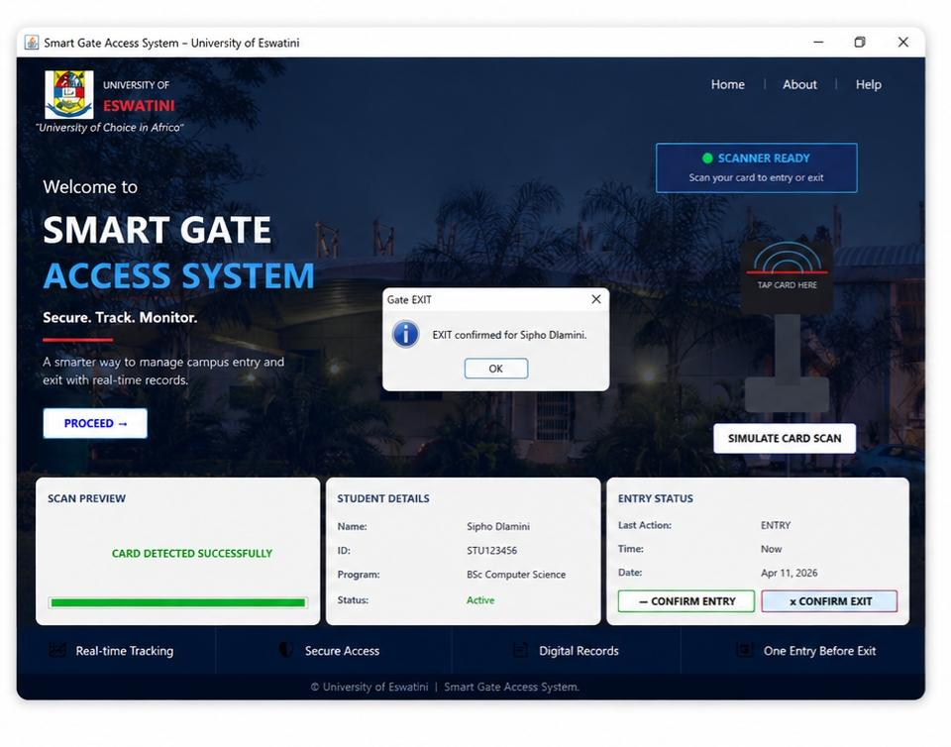
Figure 6.1: Gate Scanning Interface — Landing Screen

6.3 Administrator Login Screen
The Administrator Login Screen (LoginFrame) is the secure entry point to the administrative section of the system. It is accessible by navigating to the Admin Login option from the landing screen.

The screen contains the following elements:

- UNESWA logo and system title for institutional identity.
- A login form with two fields: ID Number / Username and Password. The password field includes an eye icon toggle to reveal or hide the entered password.
- A LOGIN button that triggers the AccessControlService.authenticate() method.
- Error messaging displayed inline below the form if credentials are invalid.
- A link to return to the Gate Scanning Interface without logging in.
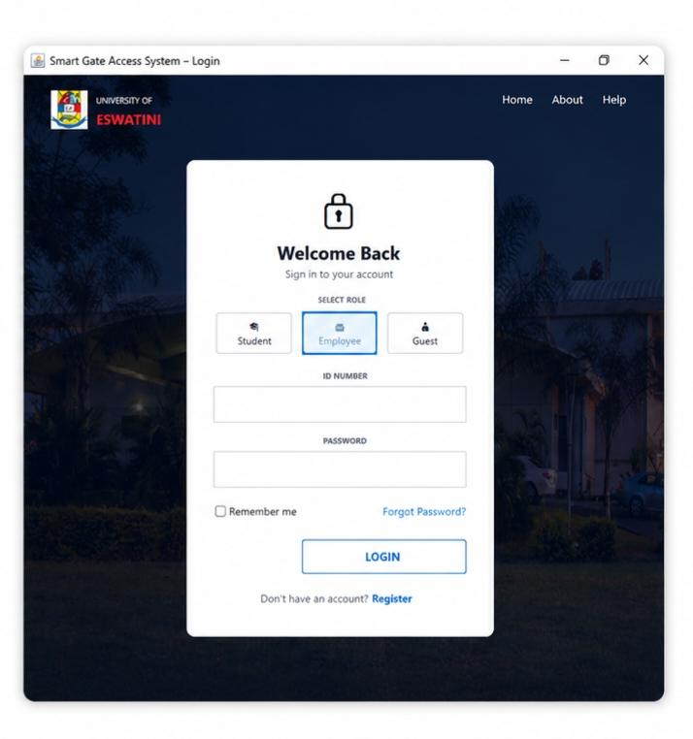

Figure 6.2: Administrator Login Screen

6.4 Administrator Dashboard — Overview
Upon successful login, the administrator is directed to the DashboardFrame. This is the central hub for all administrative functions. It features a dark navy left sidebar with navigation links and a main content area that loads different management panels based on the selected menu item.

The sidebar contains the following navigation items:

- Dashboard (Home) — Summary statistics and recent activity.
- Gate Activity — Live and historical gate event log.
- User Management — Student and staff account administration.
- Guest Management — Visitor registration and tracking.
- Reports — Report generation and export.
- Settings — System configuration.
- Logout — Ends the current admin session securely.
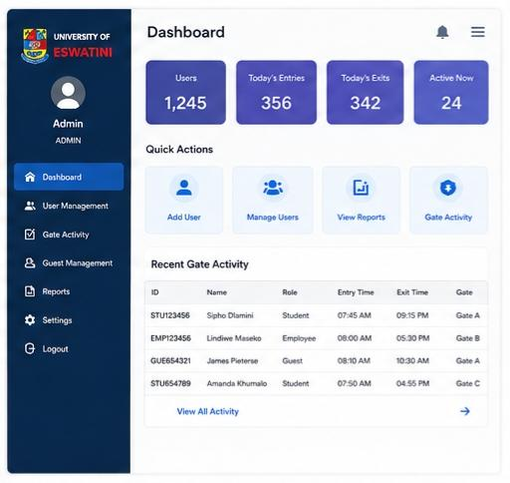
Figure 6.3: Administrator Dashboard — Home Panel

6.5 Dashboard Home Panel — Admin Duties and Responsibilities
The Dashboard Home Panel provides the administrator with an at-a-glance operational summary for the current day. The information displayed updates automatically when the panel is loaded or refreshed.

6.5.1 Daily Statistics Cards
Four summary stat cards are displayed prominently at the top of the home panel:

Total Entries Today | Total Exits Today | Users on Campus | Unique Users Today
Count of ENTRY records for today's date | Count of EXIT records for today's date | Users with last action = ENTRY (currently inside) | Distinct users who have made any gate event today

6.5.2 Recent Gate Activity Table
Below the stat cards, a table displays the most recent gate events (last 20 records). Columns include: Time, ID Number, Full Name, Role, Action (colour-coded green for ENTRY, red for EXIT), and Gate. The administrator can click any row to view full details.

6.6 Gate Activity Panel
The Gate Activity Panel (GateActivityPanel) provides the administrator with a comprehensive view of all gate events. This panel is the administrator's primary tool for monitoring campus movement and investigating incidents.

6.6.1 Panel Features
- A scrollable, sortable table of all gate events with columns: Record ID, Timestamp, ID Number, Full Name, Programme/Dept, Role, Action, Gate, Remarks.
- Filter controls above the table: Date From/To pickers, Gate dropdown selector, Role dropdown selector, and a text Search field for searching by name or ID.
- An APPLY FILTER button and a RESET button to clear all filters.
- A MANUAL ENTRY button that opens a popup dialog for entering a gate event by typing an ID number manually (used when the card scanner is unavailable).
- A row count label showing the number of currently displayed records.

6.6.2 Manual ID Entry (Fallback Mechanism)
The Manual Entry dialog allows the guard or administrator to type a student or staff ID number directly into the system. The system looks up the user, displays their details for confirmation, and then records the event as if a card had been scanned. All manually entered events are flagged with an automatic remark: 'Manual entry — card not available'.

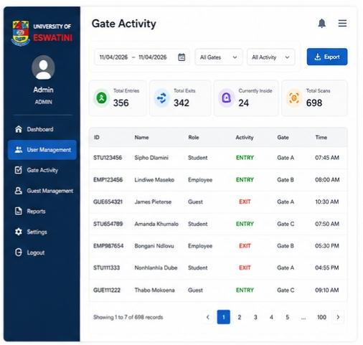
Figure 6.4: Gate Activity Panel — with filters and manual entry

6.7 User Management Panel
The User Management Panel (UserManagementPanel) is where the administrator manages all registered user accounts in the system. This panel covers students, staff, and other administrators

6.7.1 Admin Duties in User Management
The following administrative actions are available in this panel:

- Register New User: Opens a form to add a new student, staff member, or administrator to the users table. Fields include: Full Name, ID Number, Role, Programme/Department, Email, and an optional Profile Photo upload.
- Assign Card to User: After registering a user, the administrator can scan or manually enter a card UID to associate it with the user's account in the cards table.
- Search Users: A search bar allows filtering the user list by name, ID number, or role. Results update dynamically as text is entered.
- View User Profile: Clicking a user row opens a detailed profile view showing all user attributes, their associated card UID, and their recent gate activity summary.
- Edit User Details: Allows updating the user's name, email, programme, or photo. ID Number and Role can only be changed by a super-admin.
- Deactivate / Reactivate User: Changes the user's status between ACTIVE and INACTIVE. Deactivated users are denied entry at the scanner. A confirmation dialog is shown before deactivation.
- Replace Lost Card: Deactivates the old card UID and registers a new one for the same user, maintaining full event history continuity.

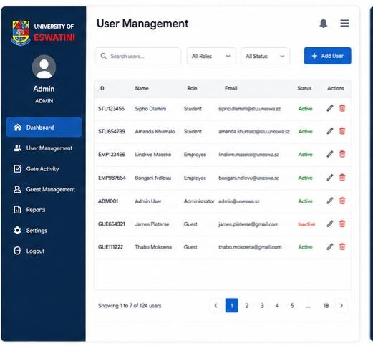
Figure 6.5a: User Management Panel — User List

6.8 Guest and Visitor Management Panel
The Guest Management Panel (GuestManagementPanel) handles all aspects of temporary visitor access. It is designed to accommodate individuals who are not registered UNESWA members — such as prospective students, job applicants, parents, contractors, delivery personnel, and other short-term campus visitors.

The system treats guests with the same procedural rigour as registered users, ensuring that a complete and verifiable record of all campus visitors is maintained at all times, regardless of whether they hold a university card.

6.8.1 Guest Tag System
Each visitor is assigned a unique, sequentially numbered guest tag upon registration (e.g., GUEST-001, GUEST-002). This tag number corresponds to a physical numbered tag or wristband provided by the guard at the gate. The visitor carries this tag for the duration of their campus visit and returns it upon exit. The system:

- Automatically generates the next available tag number in the sequence.
- Records the full name, identification document, purpose of visit, and host name (if applicable) of the visitor.
- Logs an ENTRY event for the visitor at the time of registration.
- Allows the guard to log an EXIT event when the visitor leaves and the tag is returned.
- Marks the guest session as CLOSED upon exit, making the tag number available for reuse on the following day.
- Maintains a permanent historical record of all guest visits, including the registering guard's identity and all timestamps.

6.8.2 Panel Features — Admin Duties in Guest Management
- Register New Visitor: Opens the visitor registration form. Fields: Full Name, ID Document Type (dropdown: National ID / Passport / Driver's License), ID Document Number, Purpose of Visit (freetext), Host Name / Department, Gate Point. On submission, the system generates the guest tag and records the ENTRY event.
- Active Visitors List: A real-time table showing all guests currently on campus (those who have entered but not yet exited). Columns: Tag Number, Full Name, Purpose, Host, Entry Time, Gate.
- Record Guest Exit: The guard selects an active visitor from the table and clicks CONFIRM EXIT. The system records an EXIT event and closes the session. The tag is then marked as available.
- Search Guest History: The administrator can search past guest records by date range, name, or tag number. Results are displayed in a sortable historical table.
- Guest Visit Detail View: Clicking any guest record opens a full detail view showing all registration information and a timeline of the guest's entry and exit events.

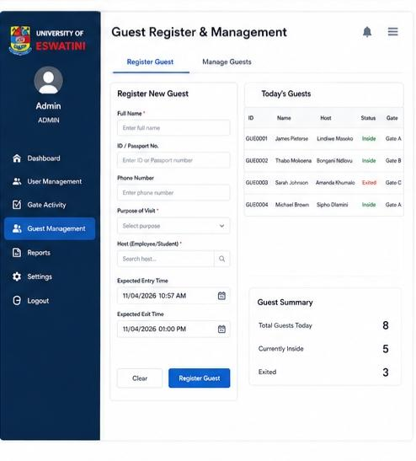
Figure 6.6a: Guest Management Panel — Active Visitors

6.9 Reports Panel
The Reports Panel (ReportsPanel) enables the administrator to generate, view, and export gate activity reports. Reports can be filtered to support operational decision-making, security investigations, and university management reviews.

6.9.1 Admin Duties in Reports
- Generate Daily Report: Produces a summary of all gate events for a selected date, grouped by gate and role (Student / Staff / Guest). Displays total entries, total exits, and peak activity hours.
- Generate Weekly Report: Aggregates gate activity for a selected seven-day period, displaying a day-by-day bar chart and a summary table.
- Generate Gate-Specific Report: Filters events by a specific gate point and date range, useful for evaluating traffic load at individual gates.
- Generate Guest Report: Lists all guest visits within a selected date range, including full registration details and entry/exit timestamps.
- Export to CSV: Exports the currently displayed report dataset to a comma-separated values file saved to the local workstation.
- Print Report: Formats the current report for printing directly from the application.
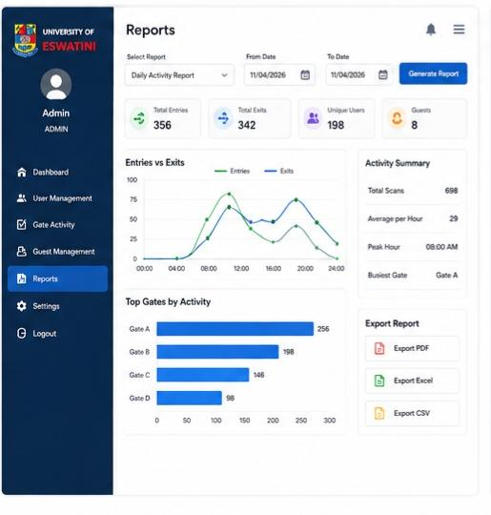
Figure 6.7: Reports Panel — Daily Gate Activity Report

6.10 Settings Panel
The Settings Panel (SettingsPanel) allows the administrator to configure system-level parameters without modifying source code or configuration files manually.

6.10.1 Admin Duties in Settings
- Database Connection Settings: Fields for MySQL host address, port, database name, username, and password. A TEST CONNECTION button allows the administrator to verify the connection before saving. Changes take effect after the application is restarted.
- Institutional Information: Fields for the university name, logo image path, and gate labels (e.g., renaming 'Gate A' to 'Main Entrance'). These values populate all UI headers and report headers.
- Session Timeout: A numeric input field for setting the administrator session inactivity timeout period (in minutes). The default is 30 minutes.
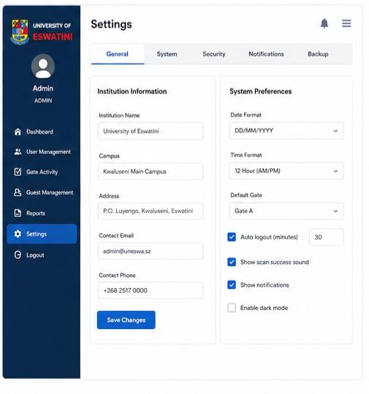
- System Information: A read-only panel displaying the current application version, Java runtime version, and database server version for technical support purposes.

Figure 6.8: Settings Panel — System Configuration

6.11 Screen Objects and Actions Summary
The table below provides a consolidated reference of the main screen objects across all panels and their associated user actions.

Screen / Panel | Object | Action / Behaviour
Landing Screen | Scanner Status Badge | Updates to READY (green) or OFFLINE (red) based on USB scanner connection status.
Landing Screen | Scan Preview Panel | Activates on card detection — shows progress bar and CARD DETECTED message.
Landing Screen | Student Details Panel | Populates with user photo, name, ID, programme, and status on successful card read.
Landing Screen | CONFIRM ENTRY Button | Records an ENTRY event for the scanned user and refreshes the Entry Status panel.
Landing Screen | CONFIRM EXIT Button | Records an EXIT event for the scanned user and refreshes the Entry Status panel.
Login Screen | Password Eye Icon | Toggles password text visibility between hidden (dots) and visible (plaintext).
Login Screen | LOGIN Button | Submits credentials to AccessControlService; routes to Dashboard on success or shows error.
Dashboard Home | Stat Cards | Display live daily counts; click opens the Gate Activity Panel pre-filtered for that metric.
Gate Activity | APPLY FILTER Button | Queries GateActivityDAO with selected filter parameters and refreshes the display table.
Gate Activity | MANUAL ENTRY Button | Opens the Manual ID Entry dialog for fallback ID-number-based gate event recording.
User Management | ADD USER Button | Opens the Add New User form for creating a new registered user account.
User Management | DEACTIVATE Button | Shows confirmation dialog; on confirm, sets user.status = INACTIVE in the database.
Guest Management | REGISTER VISITOR Button | Opens the Visitor Registration form; on submit, generates guest tag and records ENTRY.
Guest Management | CONFIRM EXIT Button | Records EXIT event for selected active visitor and closes the guest session.
Reports Panel | EXPORT CSV Button | Writes the current report dataset to a .csv file via a file-save dialog.
Settings Panel | TEST CONNECTION Button | Attempts a JDBC connection using the currently entered parameters and displays result.

7. Requirements Matrix
The table below cross-references each functional requirement (FR) from the project plan with the design components and data structures that satisfy it. This matrix demonstrates design traceability and supports testing efforts by linking each requirement to an implementable, verifiable component.

FR ID | Requirement | Design Component(s) | Data Element(s)
FR-01 | Users scan ID cards at gate using ZXing-compatible scanner. | ScannerService, GateEventService, LandingFrame (Scan Preview) | cards.card_uid, users table
FR-02 | Each gate event is recorded in real time with user ID, name, role, action, gate, and timestamp. | GateEventService, GateActivityDAO | gate_activity table (all columns)
FR-03 | Secure admin login validated against the database. | AccessControlService, SessionManager, LoginFrame | users.id_number, users.password_hash, users.role
FR-04 | Admin dashboard displays daily entry/exit totals, users on campus, unique users. | DashboardFrame, ReportService | gate_activity.action, gate_activity.created_at
FR-05 | Admin can register users and associate card UIDs. | UserManagementPanel, UserDAO, CardDAO | users table, cards table
FR-06 | Manual ID number entry as fallback for card scanner unavailability. | GateActivityPanel (Manual Entry Dialog), GateEventService | users.id_number, gate_activity.remarks
FR-07 | Reports segmented by day, gate, and role accessible from Reports panel. | ReportsPanel, ReportService | gate_activity table (filtered queries)
FR-08 | Settings panel for DB connection and institutional configuration. | SettingsPanel, DBConnection | Application config file / database settings table
FR-09 (new) | Guest/visitor registration with auto-generated numbered tags and entry/exit logging. | GuestManagementPanel, GuestService, GuestDAO | guests table, guest_visits table
NFR-01 | Scan-to-response time under 2 seconds. | ScannerService, GateEventService (optimised PreparedStatement queries) | cards, gate_activity (indexed on card_uid, user_id)
NFR-02 | Password stored as salted SHA-256 hash; PreparedStatements throughout. | AccessControlService (SHA-256 hashing), all DAO classes | users.password_hash, users.salt
NFR-03 | Interface operable by guards with minimal training. | LandingFrame design (colour-coded buttons, status badges, How It Works panel) | N/A — UI design concern
NFR-04 | System uptime ≥99% during operating hours. | DBConnection (connection pooling, error handling), GateEventService (offline fallback notes) | N/A — reliability concern
NFR-05 | Modular source code with UI/logic/data separation. | MVC three-tier architecture (Frames, Services, DAOs) | N/A — architectural concern

8. Appendices

Appendix A — MySQL Database Creation Scripts (Skeleton)
The following SQL statements define the schema for the smart_gate_db database. These scripts are to be executed on the MySQL 8.x server prior to first application launch.

CREATE DATABASE IF NOT EXISTS smart_gate_db;
USE smart_gate_db;

CREATE TABLE users (
id INT AUTO_INCREMENT PRIMARY KEY,
id_number VARCHAR(20) UNIQUE NOT NULL,
full_name VARCHAR(100) NOT NULL,
role ENUM('STUDENT','EMPLOYEE','ADMIN') NOT NULL,
program VARCHAR(100),
password_hash VARCHAR(255),
email VARCHAR(100),
status ENUM('ACTIVE','INACTIVE') DEFAULT 'ACTIVE',
photo_path VARCHAR(255),
created_at DATETIME DEFAULT CURRENT_TIMESTAMP
);

CREATE TABLE cards (
card_uid VARCHAR(50) PRIMARY KEY,
user_id INT NOT NULL,
issued_date DATE NOT NULL,
status ENUM('ACTIVE','DEACTIVATED') DEFAULT 'ACTIVE',
FOREIGN KEY (user_id) REFERENCES users(id)
);

CREATE TABLE gate_activity (
id INT AUTO_INCREMENT PRIMARY KEY,
user_id INT NOT NULL,
id_number VARCHAR(20) NOT NULL,
full_name VARCHAR(100) NOT NULL,
action ENUM('ENTRY','EXIT') NOT NULL,
gate VARCHAR(20) NOT NULL,
remarks VARCHAR(255),
created_at DATETIME DEFAULT CURRENT_TIMESTAMP,
FOREIGN KEY (user_id) REFERENCES users(id)
);

CREATE TABLE guests (
id INT AUTO_INCREMENT PRIMARY KEY,
guest_tag VARCHAR(20) UNIQUE NOT NULL,
full_name VARCHAR(100) NOT NULL,
id_document VARCHAR(50) NOT NULL,
purpose VARCHAR(255) NOT NULL,
host_name VARCHAR(100),
registered_by INT,
registered_at DATETIME DEFAULT CURRENT_TIMESTAMP,
FOREIGN KEY (registered_by) REFERENCES users(id)
);

CREATE TABLE guest_visits (
id INT AUTO_INCREMENT PRIMARY KEY,
guest_id INT NOT NULL,
action ENUM('ENTRY','EXIT') NOT NULL,
gate VARCHAR(20) NOT NULL,
recorded_at DATETIME DEFAULT CURRENT_TIMESTAMP,
remarks VARCHAR(255),
FOREIGN KEY (guest_id) REFERENCES guests(id)
);

Appendix B — Technology Stack Summary

Component | Technology | Justification
Language | Java SE JDK 11+ | Platform-independent, strongly typed; widely used in academic and enterprise environments.
GUI Framework | Java Swing / JPanel | Native Java UI toolkit; no external browser required; suitable for standalone workstations.
Database | MySQL 8.x | ACID-compliant relational DBMS; integrates seamlessly with Java via JDBC.
DB Connectivity | JDBC PreparedStatements | Prevents SQL injection; standard Java API; supports parameterised queries.
Barcode Scanning | ZXing (Zebra Crossing) | Open-source, Java-native; decodes 1D/2D barcodes and QR codes from USB scanners.
Password Security | SHA-256 with salt | Industry-standard one-way hashing; prevents password exposure from database breaches.
Build Tool | Apache Maven 3.9+ | Manages ZXing, MySQL Connector/J, and other dependencies; builds reproducible JARs.
Version Control | Git / GitHub | Collaborative branching and code review; change tracking across the team.
IDE | IntelliJ IDEA Community | Full Java Swing support; Maven integration; integrated debugger and code analysis.
Deployment | Standalone JAR / EXE wrapper | Self-contained executable for easy installation on gate workstations.

Appendix C — Design Viewpoints (IEEE 1016-2009 Compliance)
The table below maps the design viewpoints required by IEEE Std 1016-2009 to the sections and content of this SDD, demonstrating conformance with the standard.

IEEE 1016 Viewpoint | Design Concern | Addressed In This SDD
Context (5.2) | Services, actors, system boundary | Section 2 (System Overview), Section 3.2.5 (Use Case Diagram)
Composition (5.3) | Subsystem decomposition | Section 3.2 (Decomposition Description), Sections 3.2.1–3.2.3
Logical (5.4) | Class structures and relationships | Section 3.2.4 (UML Class Diagram)
Dependency (5.5) | Module interconnections | Section 3.1 (Architecture), Section 3.2 (DAO/Service dependencies)
Information (5.6) | Persistent data structures | Section 4 (Data Design), Section 4.2 (Data Dictionary)
Interface (5.8) | Component interfaces and APIs | Section 5 (Component Design — method signatures)
Interaction (5.10) | Object messaging and flow | Section 3.2.6 (Sequence Diagrams)
Algorithm (5.12) | Procedural logic | Section 5 (Component Design — pseudocode)
Resource (5.13) | Resource utilisation | Appendix B (Technology Stack), NFR-01 (performance benchmarks)

Appendix D — Glossary of Additional Terms
- PreparedStatement: A precompiled SQL query in JDBC that uses placeholder parameters (?) to prevent SQL injection attacks.
- DAO (Data Access Object): A design pattern in which all database operations for a specific entity are encapsulated in a dedicated class.
- 3NF (Third Normal Form): A database normalisation standard that eliminates transitive dependencies and ensures all non-key attributes depend only on the primary key.
- USB HID: Universal Serial Bus Human Interface Device — the device class used by barcode and QR scanners, which present as keyboard input to the operating system.
- Session Timeout: An automatic logout mechanism that terminates an administrator session after a defined period of inactivity, reducing the risk of unauthorised access to an unattended workstation.
- One-Entry-Before-Exit Rule: A gate event logic rule enforced by the GateEventService ensuring that a user must record an EXIT before they can record another ENTRY. This prevents duplicate entry records.
- Guest Tag: A numbered temporary access identifier assigned to campus visitors who are not registered UNESWA members.

