**Login page**

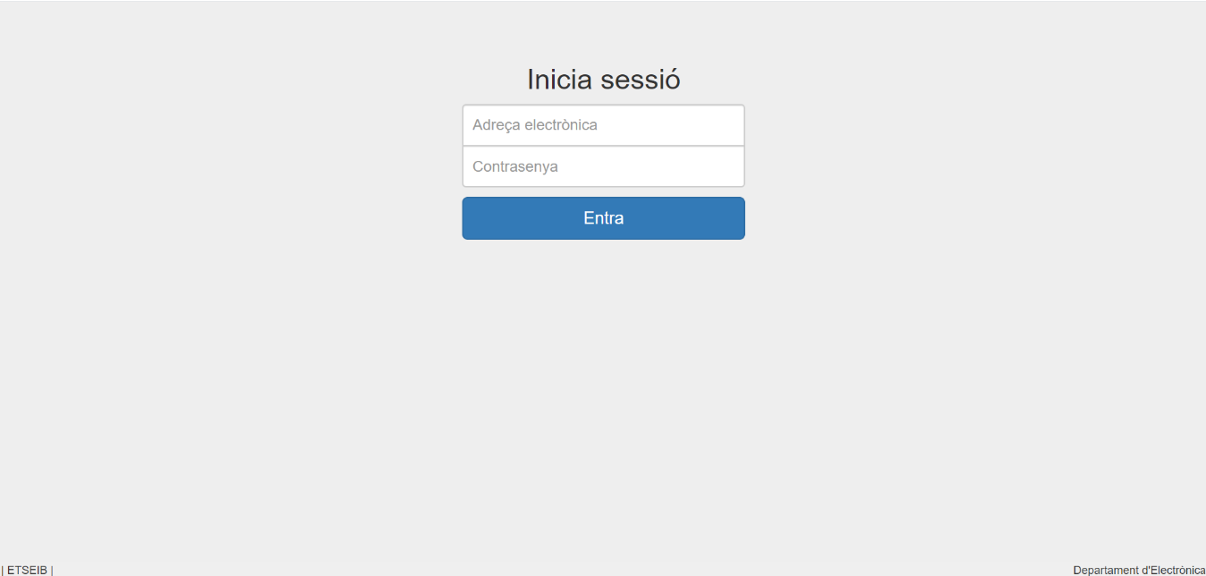

**User interface**

The following screenshots are from the account of a user with state 1. A state 2 user would see exactly the same but without the *Validar* button and the yellow label in the *Ocupació grups* web page.

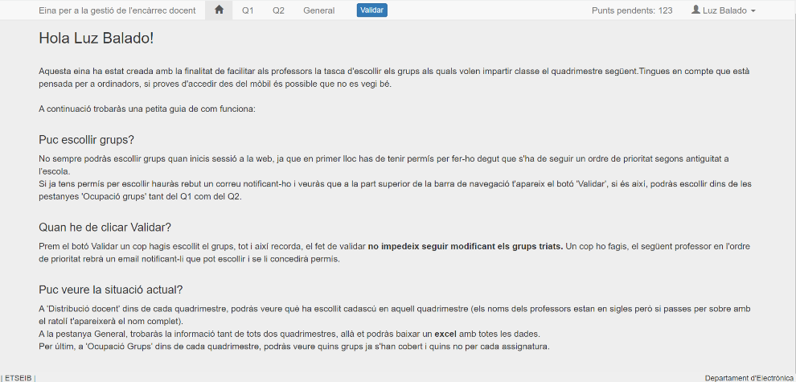

Figure : homepage.

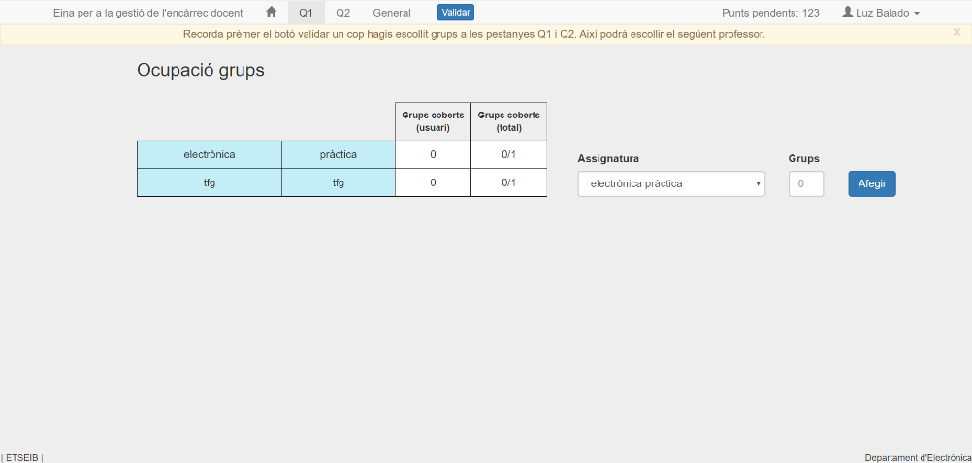

Figure 2: web page for choosing subjects.

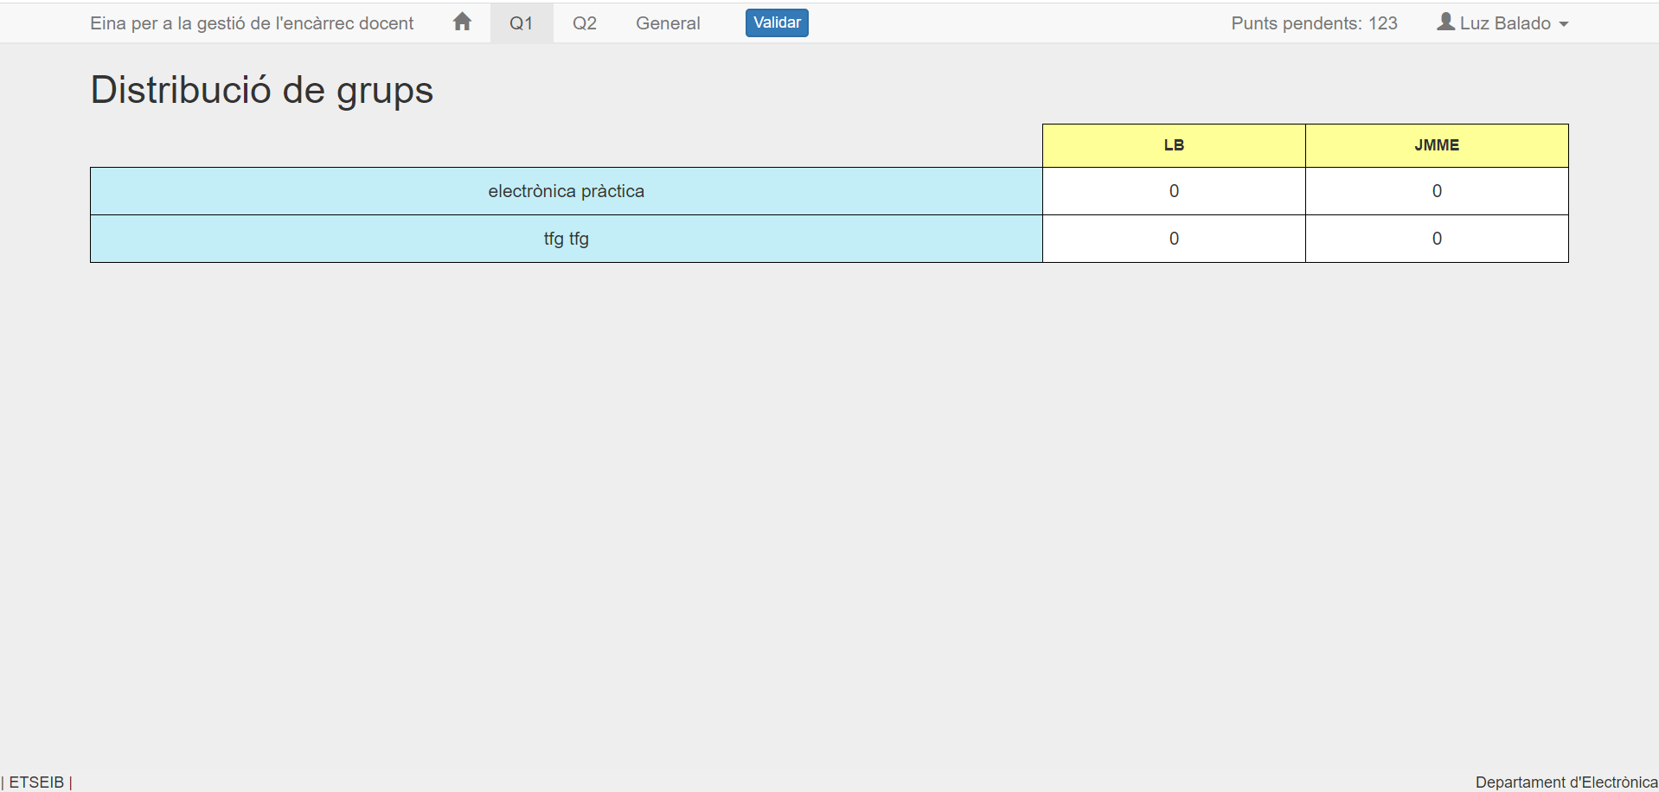

Figure : Group distribution

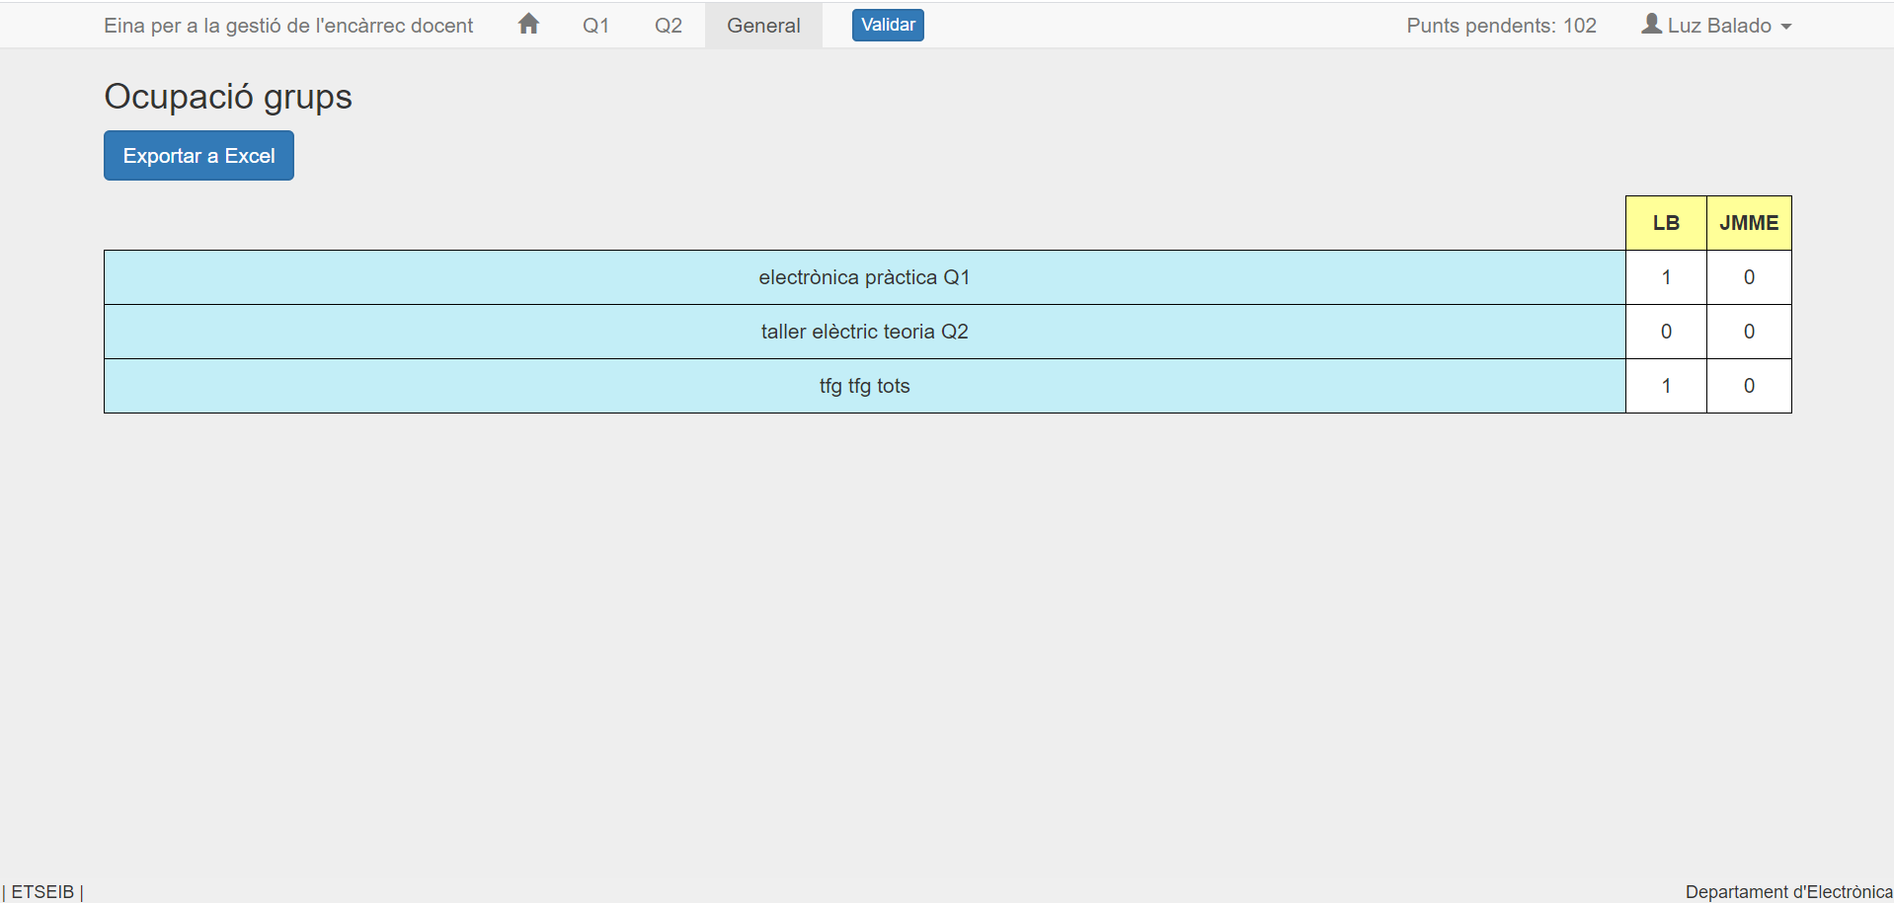

Figure 4: General overview + Exporting to Excel file

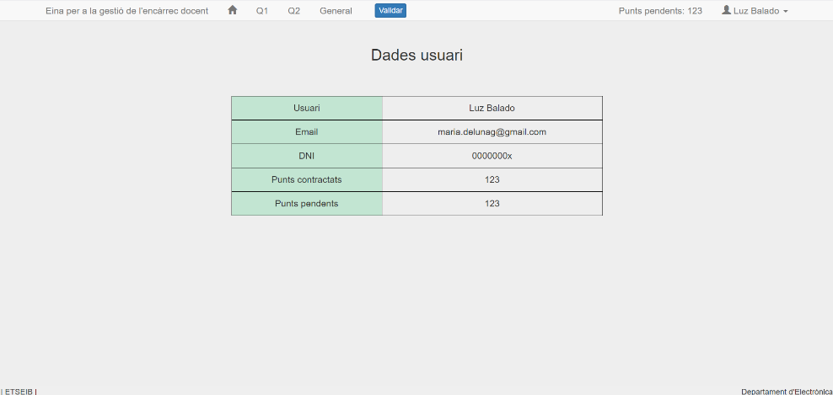

Figure : Personal user data

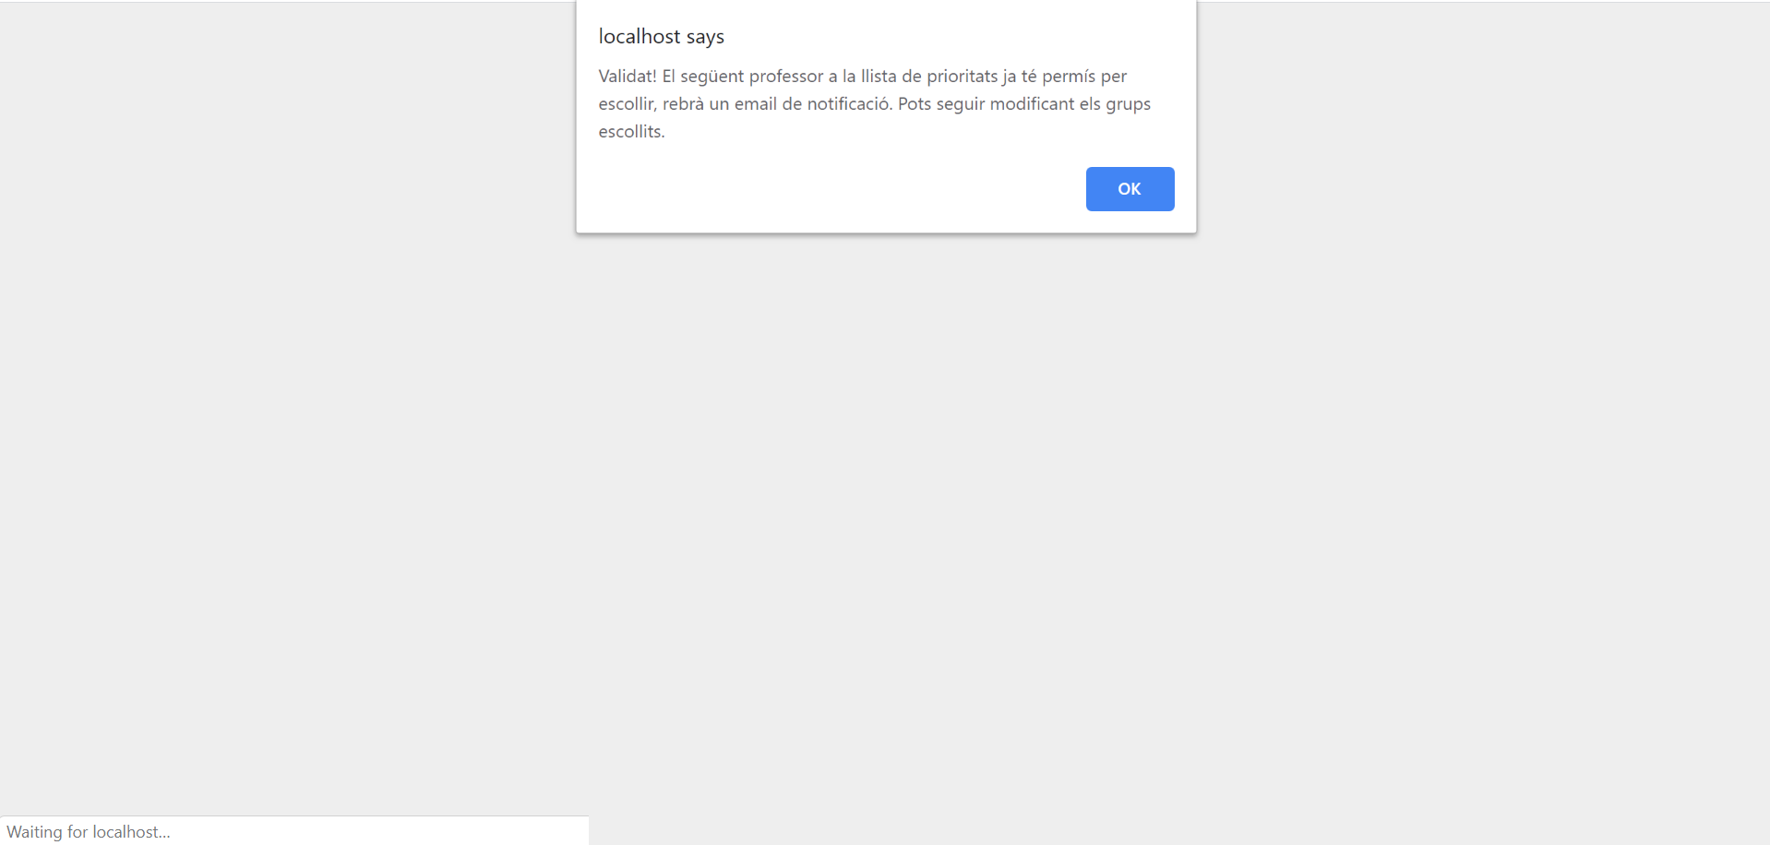

Figure 6: confirmation of choice validated and email to the next user sent.

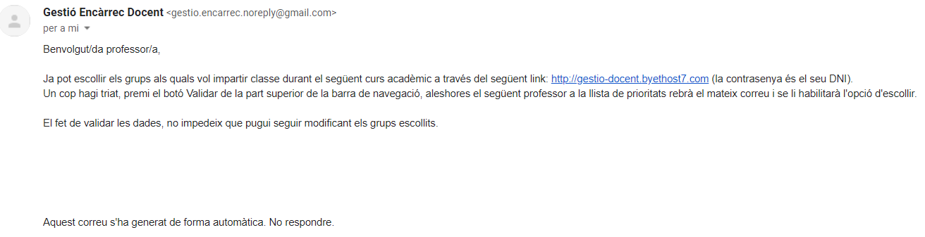

Figure : email sent

The screenshot below is of a state 0 user account, concretely, from the *Ocupació grups* webpage. It is the only webpage that is displayed differently than from users with state 1 or 2.

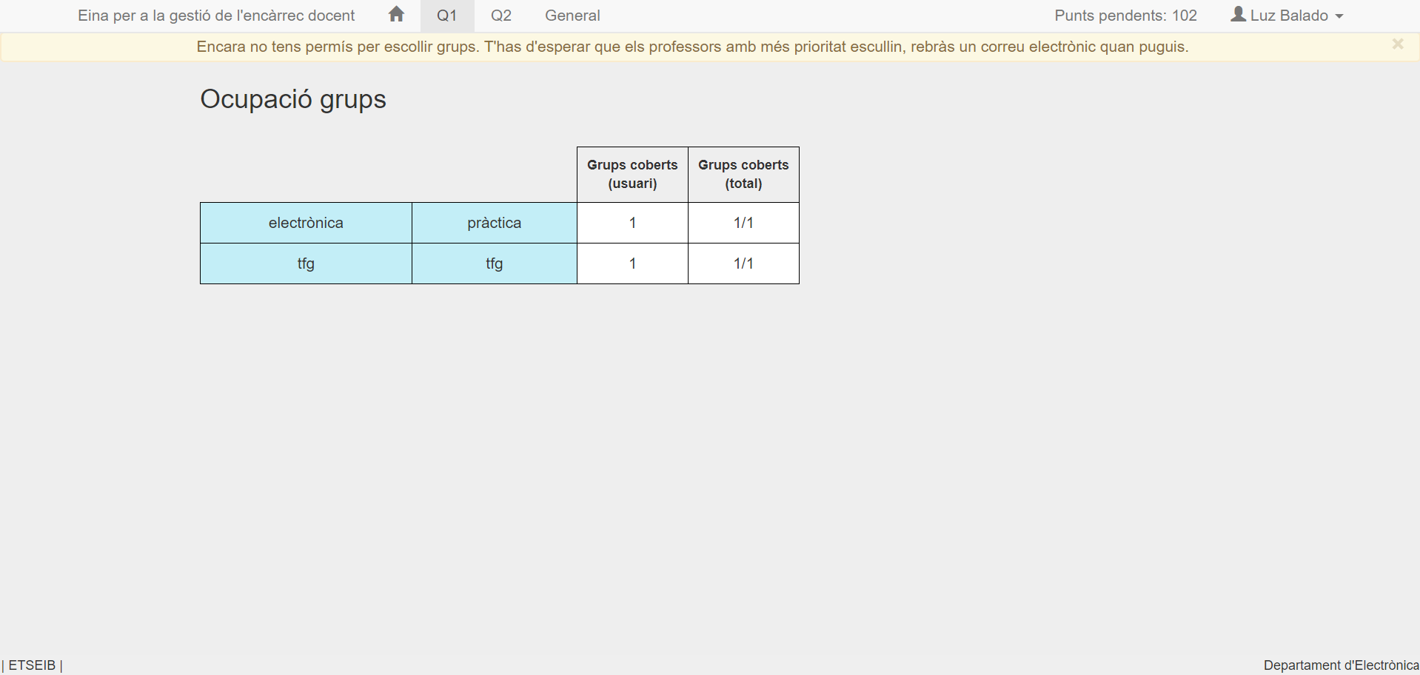

**Admin interface**

