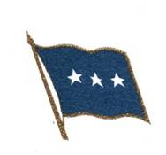
Lieutenant General Richard V. Reynolds
United States Air Force, Retired

cordially invites you to a ceremony
honoring

Colonel Katherine T. Platoni
United States Army Reserve

on the occasion of her retirement

Saturday, the nineteenth of July
two thousand fourteen
at five o’clock in the afternoon

Hilton Garden Inn
3520 Pentagon Park Boulevard
Beavercreek, Ohio

R.s.v.p. by 3 July 2014 Military: Class A Uniform
(937) 260-2276 Civilians: Business Attire
e-mail: samwhilding@gmail.com

Buffet dinner immediately following

