# 6th Annual Symposium: March 3, 2017

**Genomic approaches towards Precision Cancer Medicine**

08.30-09.00 Coffee and snacks

09.00-09.10 Welcome – **Aaron Thorner,** PhD

09.10-09.30 CCGD Updates and Overview – **Anwesha Nag,** PhD

## Lecture (Chair: Neal Lindeman, MD)

09.30-10.15 **Catherine Wu,** MD, DFCI

(Chair: Alex Frieden)

10.15-10.40 **Priscilla Brastianos,** MD, MGH

10.40-11.05 **Mark Pomerantz,** MD, DFCI

11.05-11.30 **Eli Van Allen,** MD, DFCI

11.30-11.55 **Jason Johnson,** PhDand **John Methot,** DFCI

12:00-01.00 Lunch at Yawkey 306/307/308

## Lecture (Chair: Matthew Meyerson, MD, PhD)

01.00-01.45 **Gaddy Getz,** PhD, MGH

**01.45-02.00 Coffee break**

(Chair: Elizabeth Garcia, PhD)

02.00-02.25 **Brian Crompton,** MD,DFCI

02.25-03.10 Clinical Vignettes

**Khanh Do,** MD,DFCI

**Richard Stone,** MD,DFCI

**Katherine Janeway,** MD,DFCI

03.10-03.35 **Brian Wolpin,** MD,DFCI

03.35-04.00 **Lynette Sholl,** MD,BWH

## Lecture (Chair: Laura Macconaill, PhD)

04.00-04.45 **Nikolaus Schultz,** PhD,Memorial Sloan Kettering Cancer Center

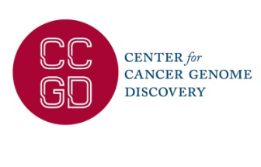04.45-04.50 Closing remarks – **Aaron Thorner**, PhD

**Date**: March 3, 2017

**Venue**: Jimmy Fund Auditorium, Dana-Farber Cancer Institute, 35 Binney St., Boston, MA, 02115

**Registration**: Registration is free but encouraged. To reserve your seat: [www.dana-farber.org/CCGD](http://www.dana-farber.org/CCGD)

**Organized by:** CCGD, Dana-Farber Cancer Institute **Contact:** aaron_thorner@dfci.harvard.edu