24-5-24

Move negative to one side

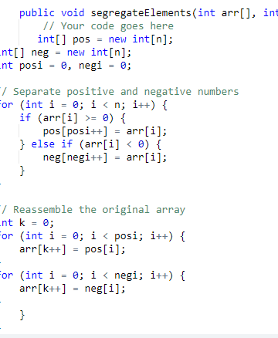

<https://www.geeksforgeeks.org/move-negative-numbers-beginning-positive-end-constant-extra-space/>

Union of array

Missing element in array

Count pairs with given sum

Duplicated in the array

Intersection of array

<https://leetcode.com/problems/intersection-of-two-arrays/submissions/>

Removing duplicates using two pointers leetcode

25-5-24

First non repeating element

First repeating element in array

Subarrays with equal 0s and 1s gfg and leetcode

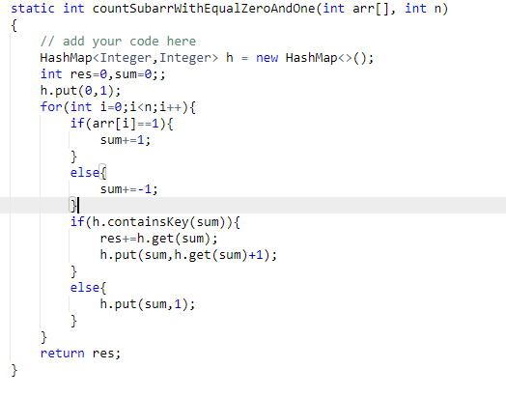

Subarray sum equal to 0

Roatate array by k elements in leetcode optimal solution by reversing array first and reverse by k and reverse from k to n

Move all 0 zero to one side of the array two pointer approach similar to removing duplicates in sorted array.(Also using temp array I can do)

**Length of longest subarray equal to k (Solve again) in 2 days**

Key pair(2 sum) gfg

In this problem note that we can do using hashmap and also pointers using greedy method(sort the array keep two pointer at front and back) add it if sum is bigger reduce last pointer add it again if sum is smaller incremtn first pointer sum it it will go until we find the sum

26-5-24

Majority element

[Find the Largest sum contiguous Subarray](https://www.geeksforgeeks.org/largest-sum-contiguous-subarray/)

Max product subarray

Factorial of large number(solve again in 2 days)

**Longest consecutive subsequence**

Find minimum in rotated array

Minimum number of platform required

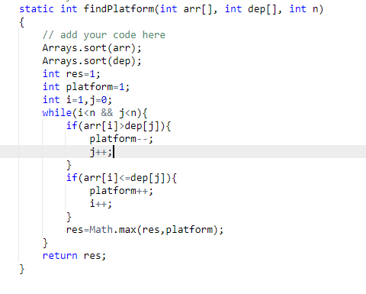

27-5-24

Reverse each word

[Longest Common Prefix](https://www.geeksforgeeks.org/longest-common-prefix-using-sorting/)

Int to roman

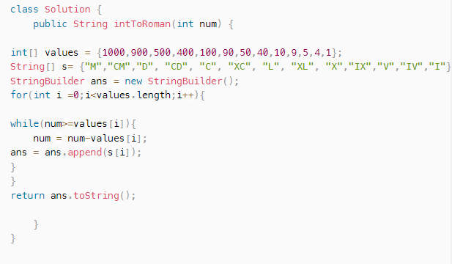

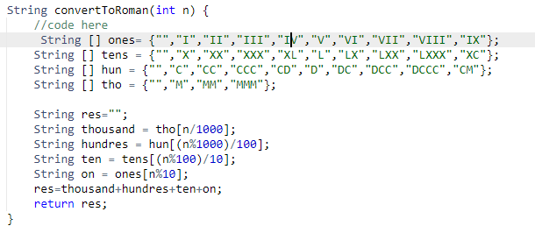

Roman to int

28-5-24

### Check if strings are rotations of each other or not

**Input:**

geeksforgeeks

forgeeksgeeks

**Output:**

1

**Explanation:** s1 is geeksforgeeks, s2 is

forgeeksgeeks. Clearly, s2 is a rotated

version of s1 as s2 can be obtained by

left-rotating s1 by 5 units.

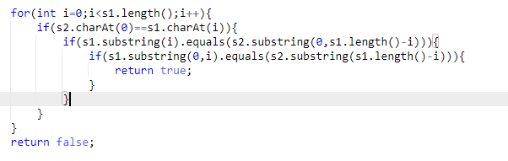

# Check if the given string is shuffled substring of another string

***Input:****str1 = “onetwofour”, str2 = “hellofourtwooneworld”****Output:****YES*

*30-5-24*

# Find the missing and repeating number

***Input:****arr[] = {3, 1, 3}****Output:****Missing = 2, Repeating = 3****Explanation:****In the array, 2 is missing and 3 occurs twice*

***Input:****arr[] = {4, 3, 6, 2, 1, 1}****Output:****Missing = 5, Repeating = 1*

Note:

There are multiple solutions

Use hash array go to that position increment the count.

Run a loop in that hash array check if count is more than 1 and count is 0 store that element s return that

### Find Pair Given Difference

Given an array **arr[]** of size **n** and an integer **x**, return 1 if there exists a pair of elements in the array whose absolute difference is **x**, otherwise, return -1.

**Example 1:**

**Input:**

n = 6  
x = 78

arr[] = {5, 20, 3, 2, 5, 80}

**Output:**1

**Explanation:**Pair (2, 80) have absolute difference of 78.

