**SobujPath: Unleashing the Beauty of Natural Photography**

**By**

**Mahamudullah**

**201-15-3407**

**Md Razib**

**201-15-3637**

**Md. Rakibul islam**

**201-15-3461**

**Nur-E-Jannat Meherin**

**201-15-3529**

**Tanzina Akter Tithe**

**201-15-3259**

**Supervised By**

**Sultan Mahmud**

Lecturer

Department of CSE

Daffodil International University



**DAFFODIL INTERNATIONAL UNIVERSITY**

**DHAKA, BANGLADESH**

**June 2023**

**Table of Contents**

**1. Introduction**.....................................................................................................................1

**2. Motivation**.......................................................................................................................3

**3. Technology Used**.............................................................................................................4

3.1 Front-End Technologies.............................................................................................4

3.2 Back-End Technologies..............................................................................................5

3.3 Database Management................................................................................................6

3.4 Additional Technologies.............................................................................................6

**4. Different Models**.............................................................................................................4

4.1 Use Case Diagram......................................................................................................4

4.2 Activity Diagram........................................................................................................5

4.3 Sequence Diagram.....................................................................................................6

4.4 ER Diagram...............................................................................................................6

4.4 Class Diagram............................................................................................................6

**5. Conclusion**....................................................................................................................12

**6. References**.....................................................................................................................16

**1. Introduction**

SobujPoth is a social media platform for nature photographers. It's a place where people who love capturing the beauty of nature can come together. The website aims to create a lively community where photographers can share their photos, connect with others who have the same passion, and get inspired by each other's work.

Nature photography has become very popular recently. Photographers use their cameras to capture stunning landscapes, wildlife, plants, and other natural elements. SobujPoth was created specifically for these photographers to have a space where they can show their unique perspectives and inspire others.

SobujPoth brings together photographers from different backgrounds and skill levels. It's a supportive environment where they can grow artistically, learn new things, and appreciate the wonders of the natural world. Photographers can showcase their work, get feedback from the community, and reach a wider audience.

The website focuses solely on natural photography, providing a specialized experience. It allows users to explore the world of nature photography, connect with like-minded individuals, and enjoy a more immersive experience compared to general social media platforms.

Through technology and the online community, SobujPoth aims to create a sense of wonder, appreciation, and environmental consciousness. It showcases the beauty and fragility of our natural world, inspiring photographers to capture its essence. It's also a place where photographers can find inspiration, learn new techniques, and connect with others who share their passion.

**2. Motivation**

The motivation behind creating SobujPoth, a natural photography social media platform, was driven by a strong passion for nature and the need for a dedicated space where photographers could showcase their work, connect with like-minded individuals, and inspire others.

Nature photography has gained immense popularity as people are increasingly captivated by the beauty and serenity of the natural world. Through their cameras, photographers could capture awe-inspiring landscapes, unique wildlife encounters, and intricate details of plants and flowers. This genre of photography fosters a sense of connection with nature and promotes environmental consciousness.

SobujPoth was born out of the realization that existing social media platforms do not cater specifically to the needs of nature photographers. There was a lack of focused communities and resources for photographers to flourish and reach a dedicated audience. Thus, SobujPoth was created to fill this gap and provide photographers with a platform tailored to their unique aspirations.

The motivation behind SobujPoth extends beyond sharing beautiful photographs. It aims to build a supportive and interactive community that encourages collaboration, learning, and artistic growth. By bringing together photographers from diverse backgrounds and skill levels, SobujPoth offers a space for meaningful discussions, valuable feedback, and exposure to new perspectives. It serves as a hub of inspiration, enabling photographers to explore the works of others, discover new techniques, and stay up-to-date with the latest trends in nature photography.

**3. Technology Used**

SobujPoth employs a robust set of technologies to create an immersive and user-friendly natural photography social media platform. The following technologies and tools are used in the development of the website:

**Front-End Technologies:**

* HTML (Hypertext Markup Language): HTML provides the structure and layout of the web pages on SobujPoth. It defines the elements and content placement, ensuring proper organization and presentation of the platform's user interface.
* CSS (Cascading Style Sheets): CSS is utilized for the visual styling and design of SobujPoth. It controls the colors, fonts, layouts, and overall aesthetic appeal of the website, enhancing the user experience and creating a visually pleasing interface.

**Back-End Technologies:**

* PHP (Hypertext Preprocessor): SobujPoth leverages PHP as the server-side scripting language. PHP enables dynamic functionality, allowing the website to interact with databases, handle user requests, and process data in real-time. It powers core features such as user registration, login authentication, profile management, and image uploads.

**Database Management:**

* SQL (Structured Query Language): SobujPoth employs SQL for efficient database management. SQL is used to create, modify, and query the database that stores user information, such as account details, profile data, uploaded photographs, and user interactions. It ensures secure data storage, retrieval, and manipulation.

**Additional Technologies:**

* JavaScript: JavaScript is used to add interactivity and enhance the user experience on SobujPoth. It enables dynamic elements, such as image sliders, interactive forms, and real-time updates, enriching the platform's functionality.
* Responsive Design: SobujPoth is designed with a responsive approach, ensuring that the website adapts seamlessly to different screen sizes and devices. Responsive design techniques, including media queries and flexible layouts, allow users to access and enjoy the platform from desktops, laptops, tablets, and mobile phones.

By leveraging a combination of front-end and back-end technologies, along with secure database management and responsive design, SobujPoth provides a seamless and feature-rich experience for photographers to connect, share their work, and engage with the natural photography community. These technologies work together to ensure a secure, visually appealing, and user-friendly platform that encourages creativity, collaboration, and appreciation for the beauty of nature.

**4.** **Different Models**

In the development of SobujPoth, various models were used to capture and visualize different aspects of the system. These models provide a comprehensive understanding of the website's functionalities, interactions, and data structures. The following models were created for SobujPoth:

**Use Case Diagram:**

The Use Case Diagram illustrates the various actions and functionalities that can be performed by different actors within SobujPoth. It identifies the actors, such as photographers, visitors, and administrators, and showcases the relationships and interactions between them. The Use Case Diagram helps to identify the core functionalities of the system and the user roles involved in each action.

**Activity Diagram:**

The Activity Diagram presents a step-by-step representation of the processes and workflows within SobujPoth. It visualizes the sequence of actions and decisions taken by users and the system in response to those actions. The Activity Diagram provides an overview of how users navigate through the website, perform tasks, and interact with different features.

**Sequence Diagram:**

The Sequence Diagram focuses on the interaction and communication between different objects and components within SobujPoth. It illustrates the chronological sequence of messages exchanged between these objects during specific scenarios or use cases. The Sequence Diagram helps to understand the flow of control and the order of events that occur within the system.

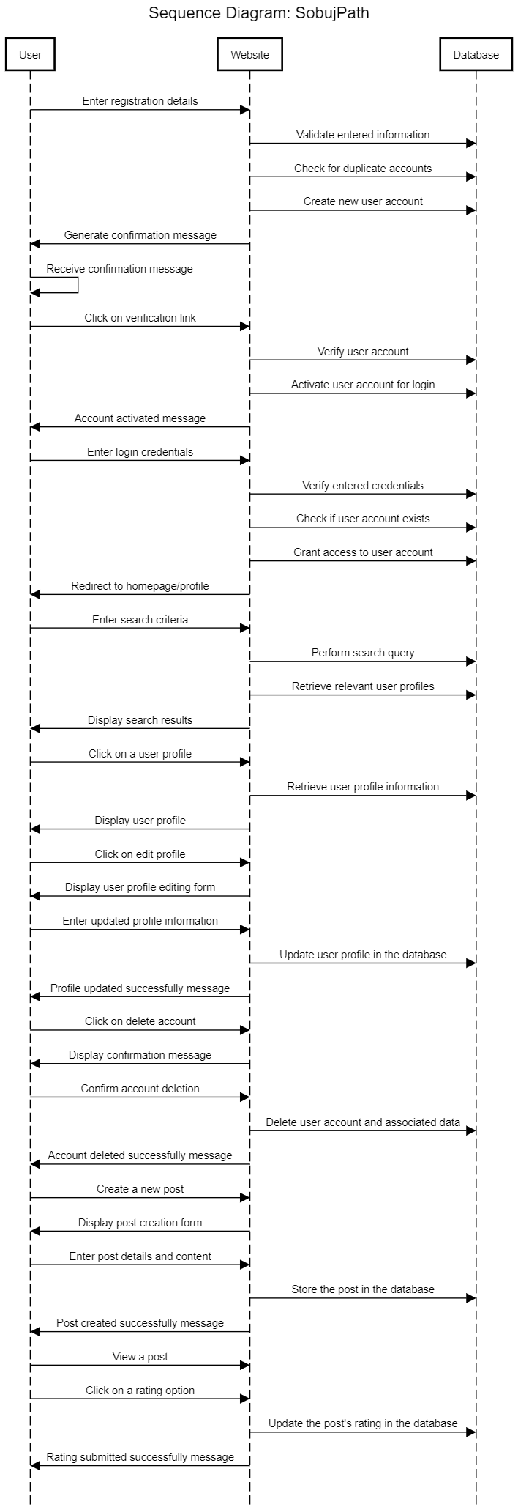

**ER Diagram (Entity-Relationship Diagram):**

The ER Diagram represents the database schema and the relationships between different entities in SobujPoth. It identifies the entities, attributes, and relationships between them, providing a visual representation of the database structure. The ER Diagram helps in designing the database and ensuring the integrity and consistency of data storage.

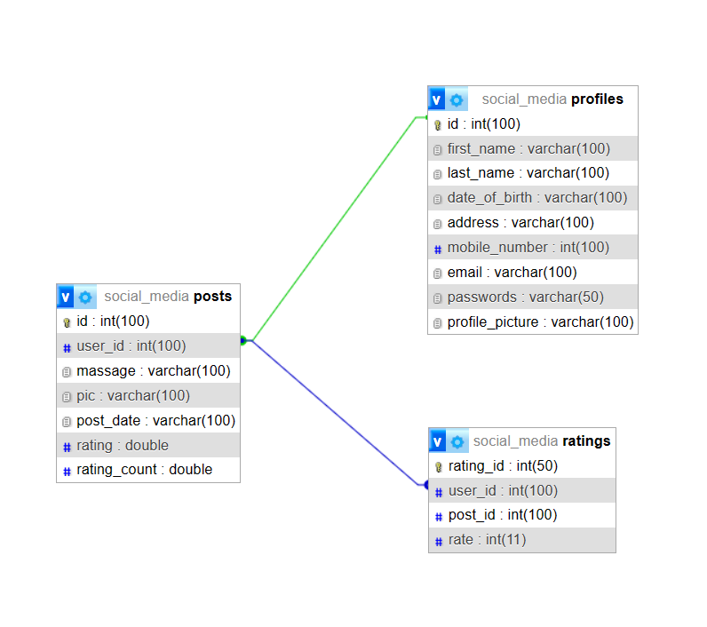

**Class Diagram:**

The Class Diagram illustrates the classes, objects, attributes, and methods involved in SobujPoth's object-oriented design. It captures the static structure of the system and the relationships between different classes. The Class Diagram aids in understanding the system's architecture, inheritance relationships, and the behavior of different classes.

**6. Conclusion**

In conclusion, SobujPoth, the natural photography social media platform, has been successfully developed to provide photographers with a dedicated space to showcase their work, connect with like-minded individuals, and inspire others. Moving forward, there are several exciting future prospects and enhancements planned for SobujPoth to further elevate the user experience and expand its offerings.

One important future direction for SobujPoth is to categorize visitors into distinct groups, such as photographers and enthusiasts. This categorization will allow for tailored content recommendations, personalized interactions, and improved user engagement. By understanding the specific interests and needs of different user segments, SobujPoth can deliver a more targeted and relevant experience to its users.

Security is a top priority, and future efforts will focus on enhancing the platform's security measures. By implementing advanced encryption techniques, strengthening user authentication protocols, and regularly updating security frameworks, SobujPoth aims to ensure the utmost protection of user data and maintain a safe online environment.

Another exciting future plan for SobujPoth involves the development of an Android app. The app will provide users with seamless access to the platform from their mobile devices, enabling them to upload photos, engage with the community, and explore inspiring content on the go. This expansion to the mobile realm will significantly enhance the accessibility and convenience of SobujPoth for photographers worldwide.

To encourage meaningful interactions and discussions among users, SobujPoth will introduce a comment section feature. This will enable users to provide feedback, exchange ideas, and engage in constructive conversations about posted photographs. The comment section will foster a sense of community, collaboration, and mutual learning among photographers and enthusiasts.

SobujPoth is committed to continuous improvement, and future updates will focus on enhancing the website's responsiveness and user interface. By incorporating the latest responsive design techniques and optimizing the graphical user interface (GUI), SobujPoth will ensure a seamless and visually appealing experience across various devices, screen sizes, and browsers.