**ICIN Bank**

**DESCRIPTION**

Create a dynamic and responsive Java online banking web application to deposit, withdraw, and transfer the money between the accounts.

**Background of the problem statement:**

ICIN is one of the top banking firms that accepts deposits from the public for the purpose of lending loans to the public. It also invests an amount in securities.

Recently, the business analysts noticed a drop in the number of customers of the bank. They found out that online banking systems of banks like AXIS and American Express are gaining more profits by eliminating middlemen from the equation. As a result, the team decided to hire a Full Stack developer who can develop an online banking web application with a rich and user-friendly interface. You are hired as one of the Full Stack Java developers and have been asked to develop the web application. The management team has provided you the requirements and their business model so that you can easily arrange different components of the application.

**Solution:**

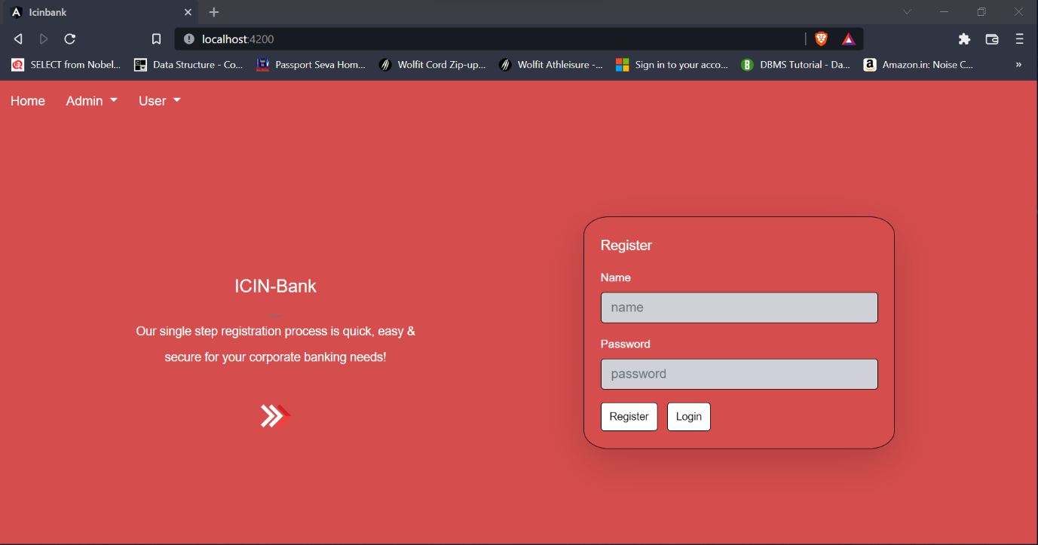

So this is our main entry point of our application, which consist of user registration form. Where user can register them-self, by providing name and password. Since they are new user so balance, savingbalance set to 0 and also all other value set to default value.

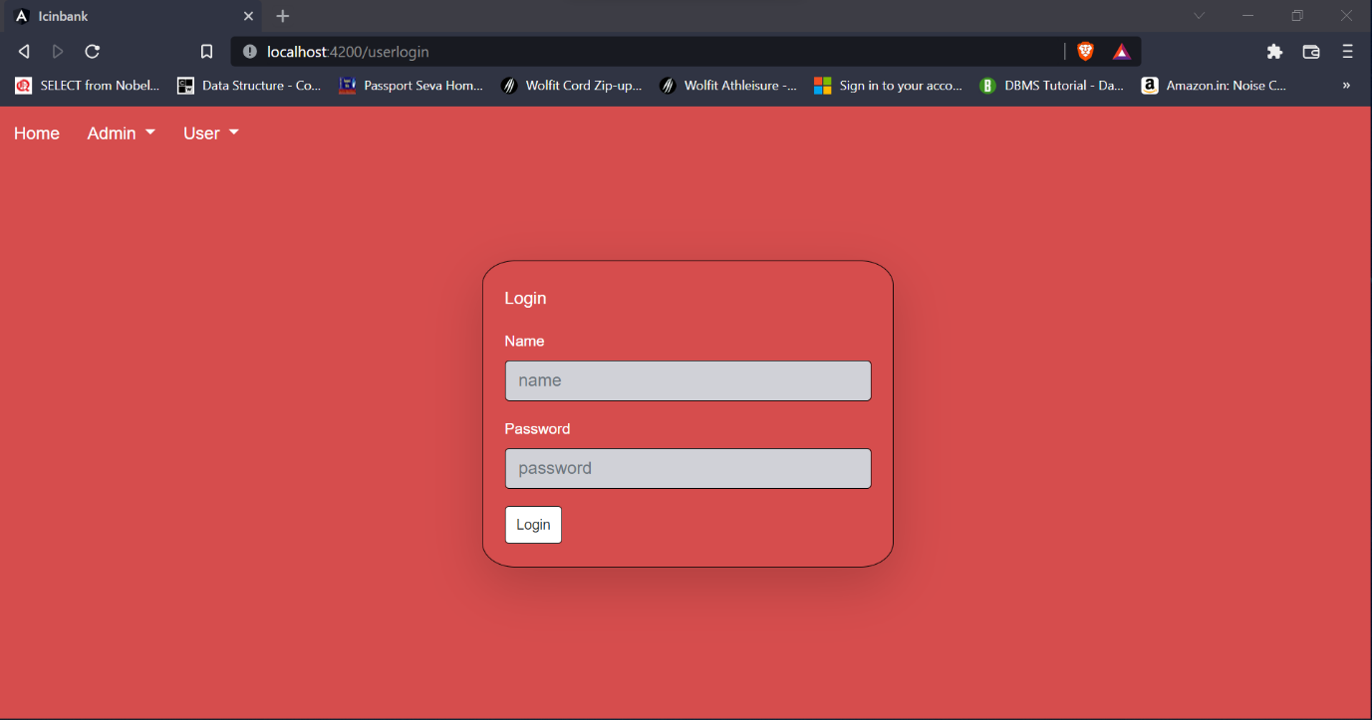

Here user can login with the same credential that was used while registration.

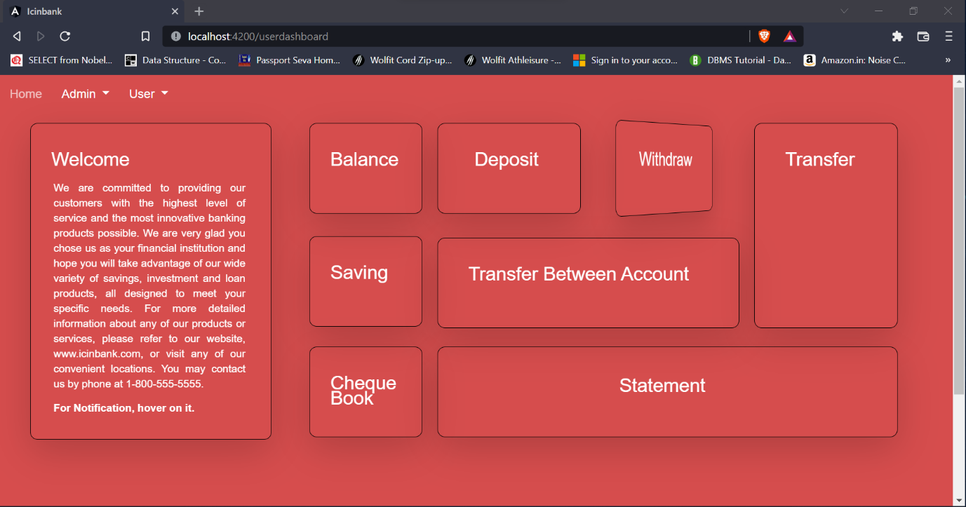

Once they make successful login, they enter into user-dashboard console. Here we have 9 card. Which rotate 180 degree on hover and in the back section of card user can perform different operation.

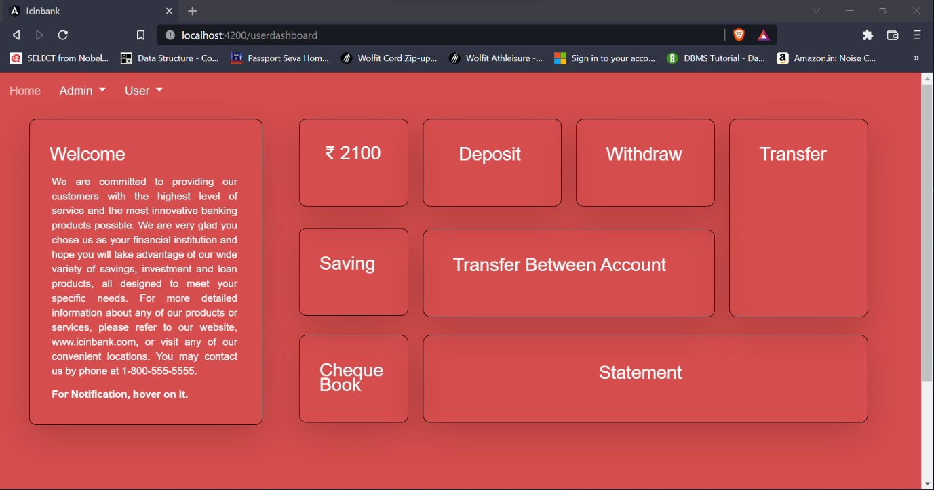

For example, user want to see their balance he/she just need to hover over balance card. This balance card turn 180 degree and them user can see their remaining balance. Similarly they can deposit money, withdraw money etc.

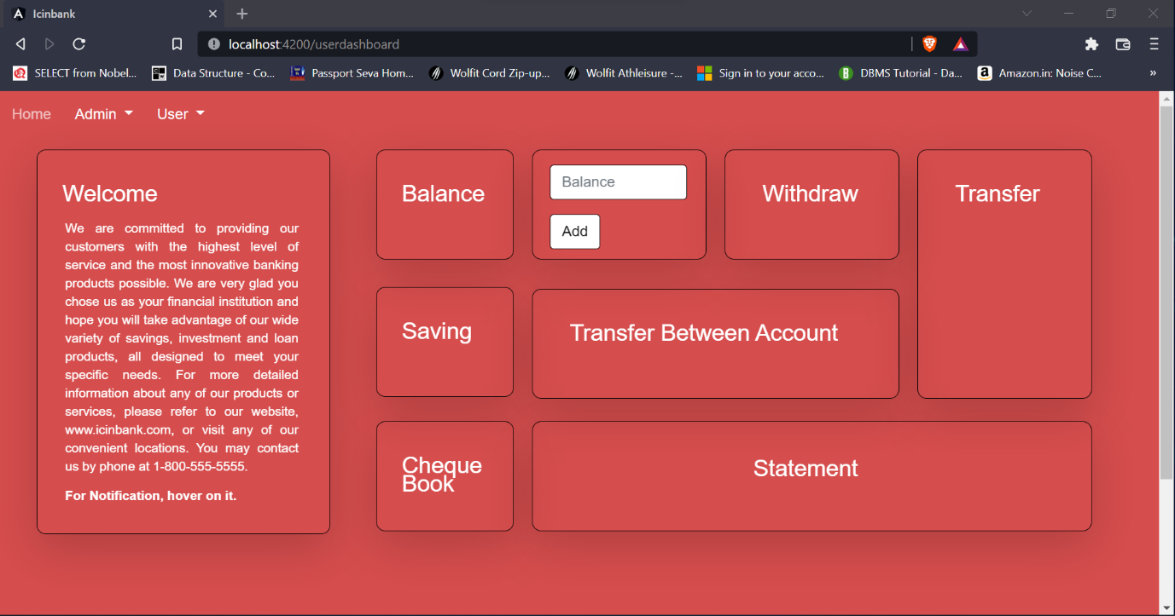

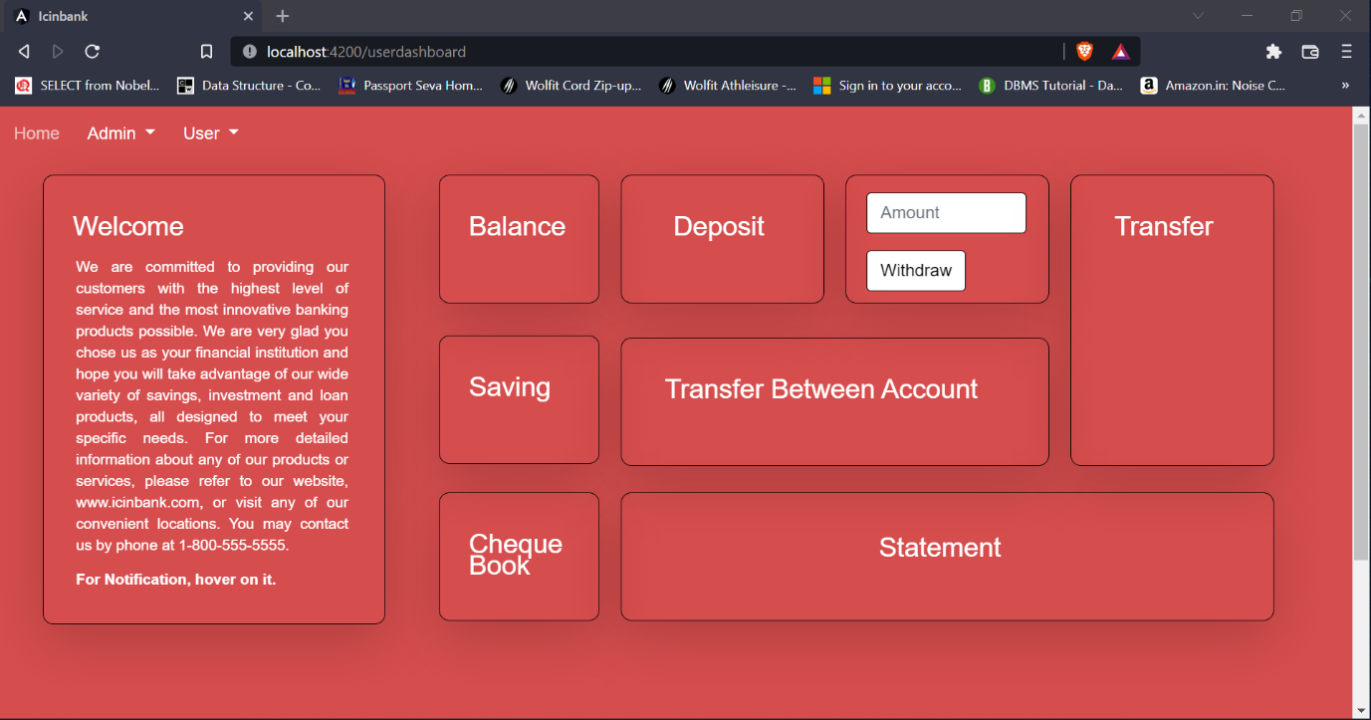

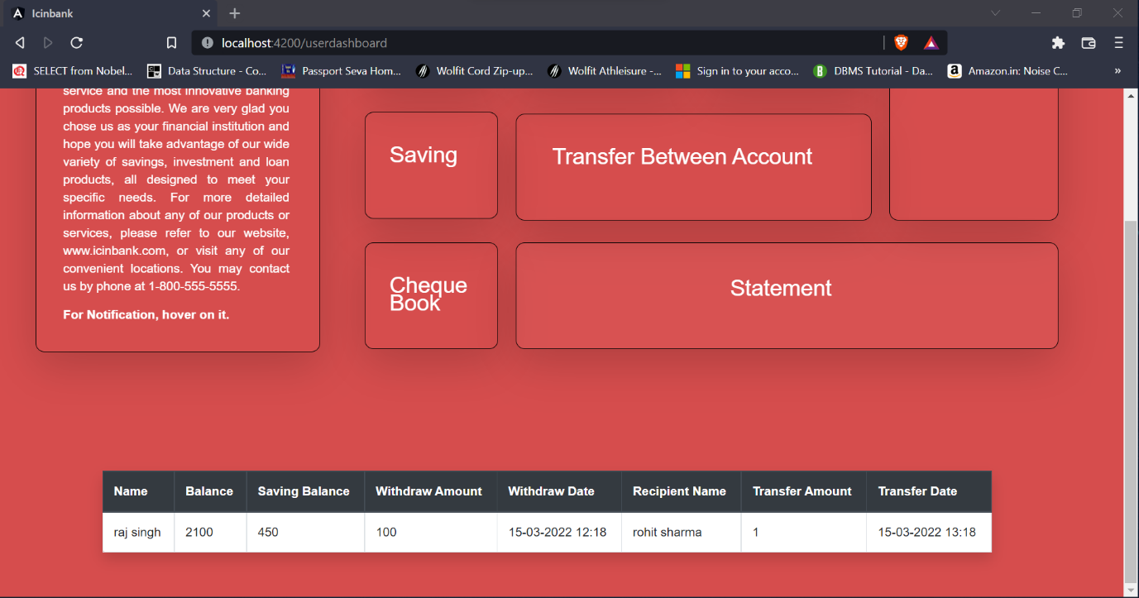

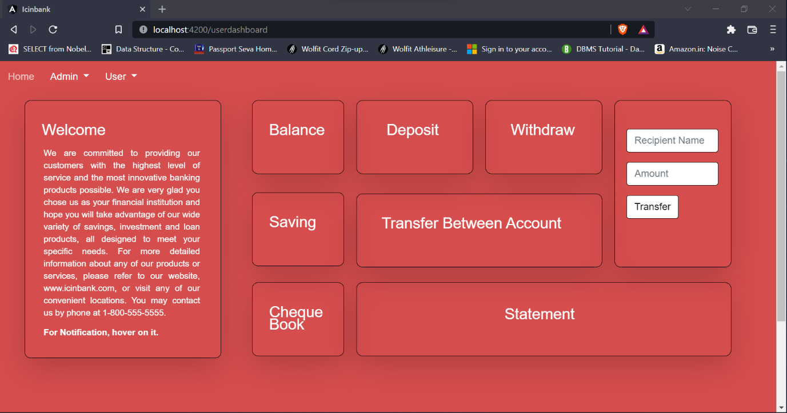

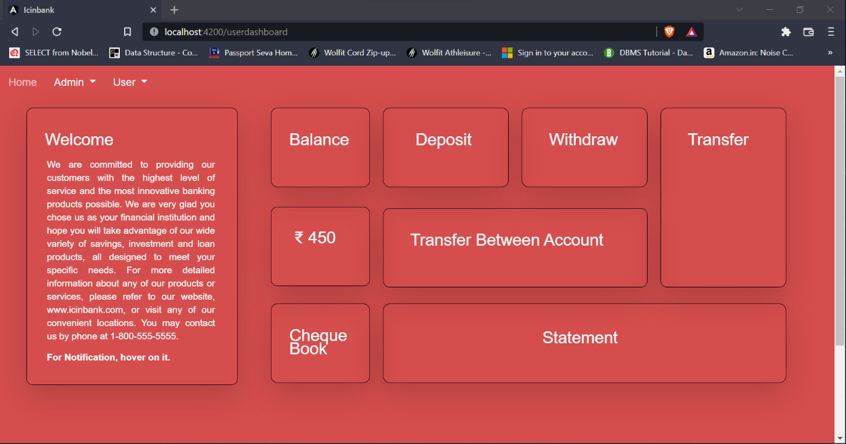

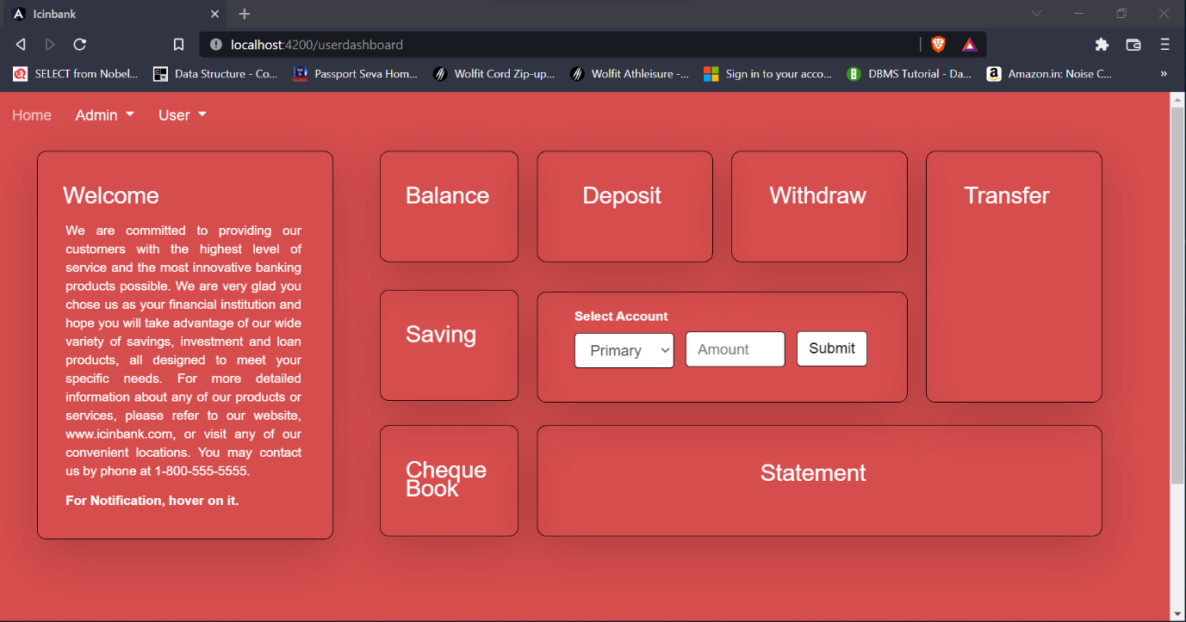



By clicking on statement, they can see the statement of their transactions.

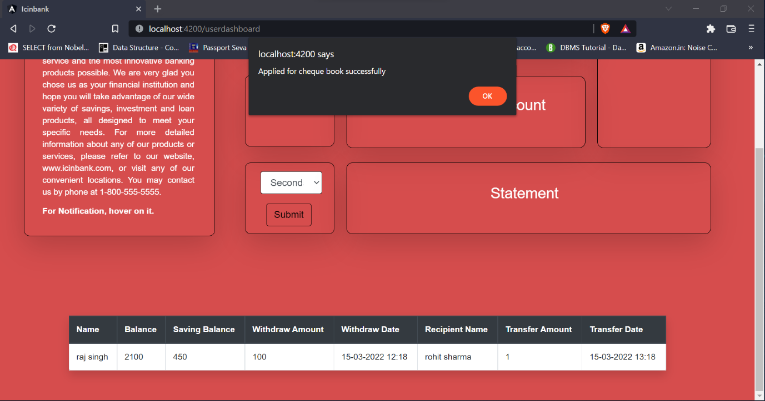

On check book card, user can apply for check-book. They just need to select account and click on submit button.

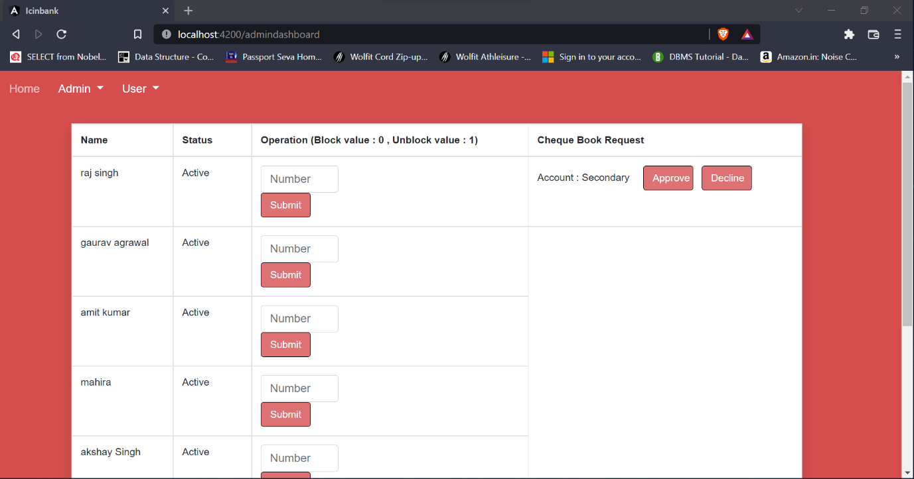

Suppose raj singh apply for check-book for secondary account. His request will be shown to admin dashboard. Here admin have to 2 options. Either he approve request or decline request.

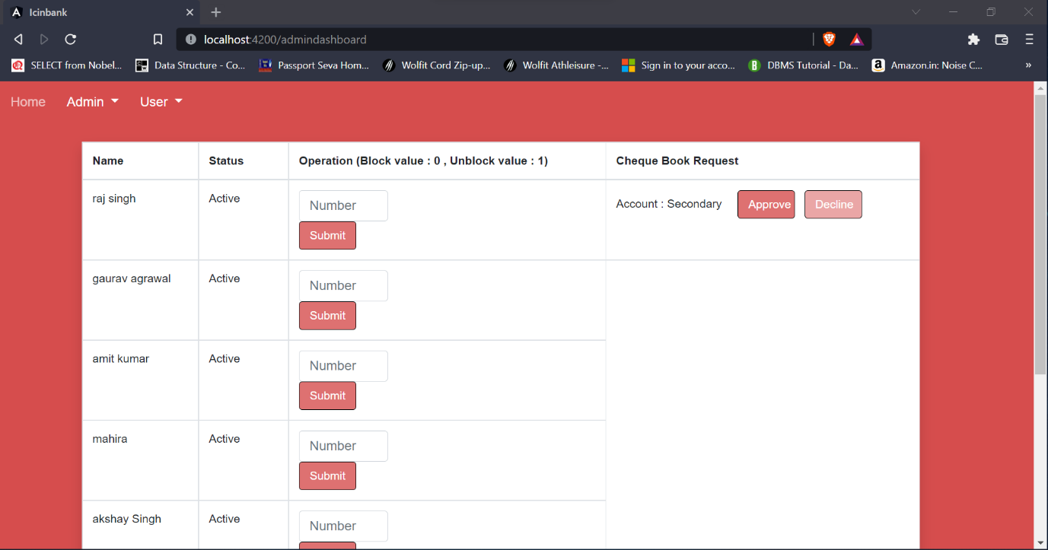

Suppose admin decline request.

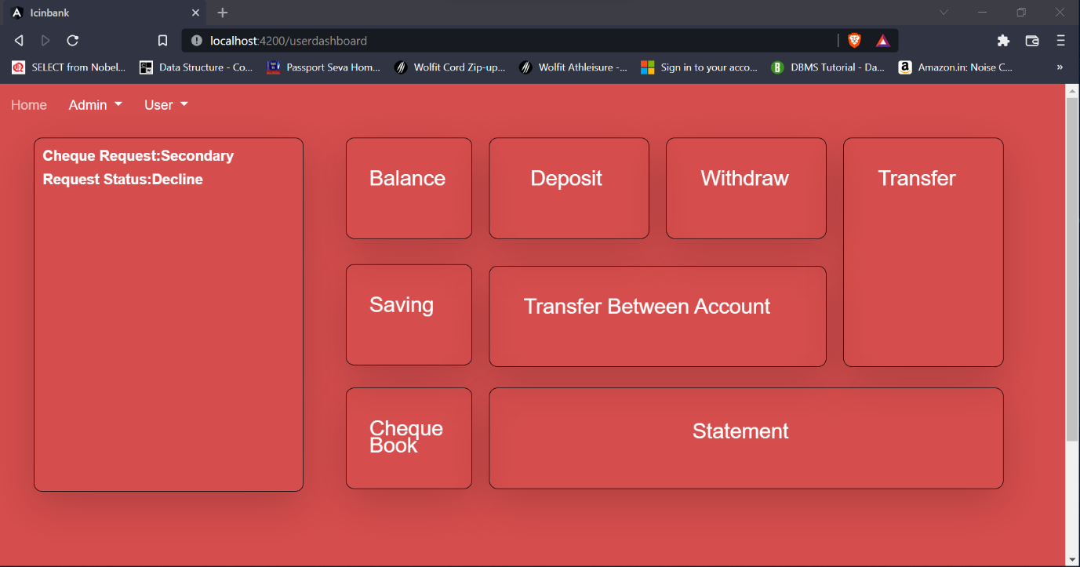

Here user can see his/her request status. As you can see raj singh request for check-book is decline.

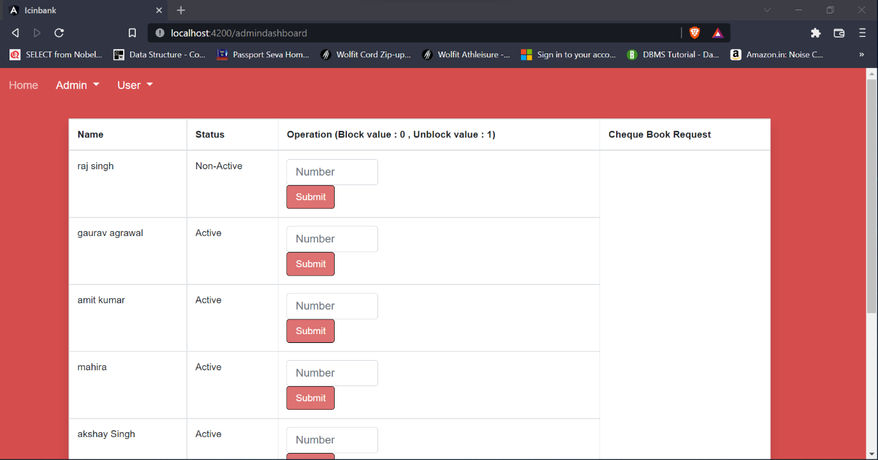

We also provide account blocking feature, here admin can block the account by just passing 0 to block and In order to active again he just need to pass 0.

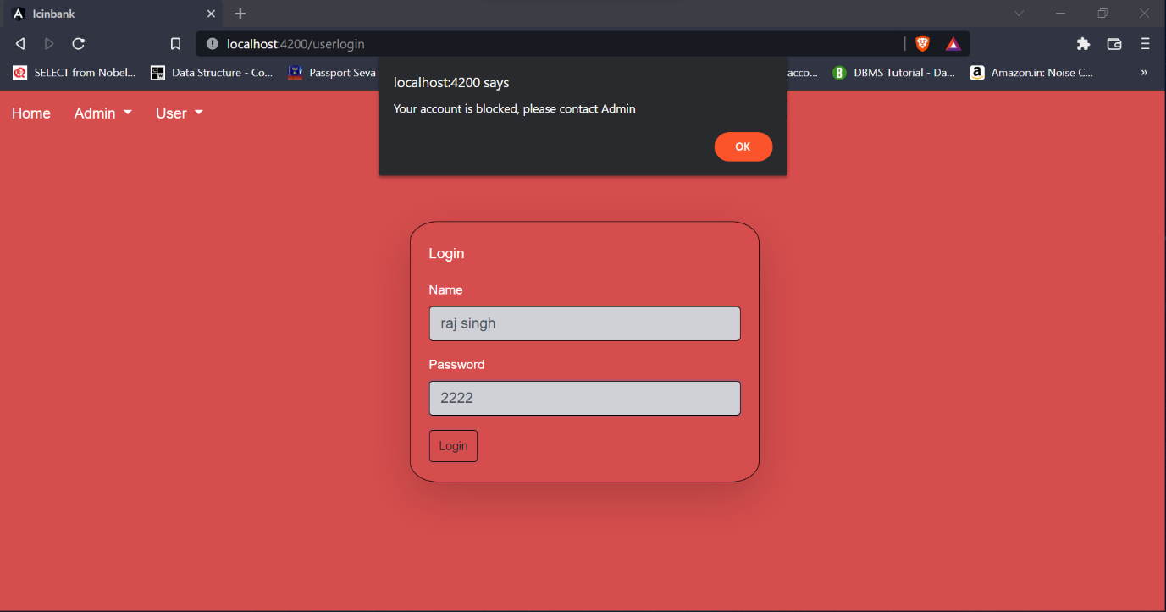

As you can raj singh account is blocked by admin.