**Junior Design Project Report**

**CSE 299 (**Section: 23**)**

LOST AND FOUND



**Submitted By**

Md Minhajul Islam (ID: 2021887642)

Sadia Islam Raida (ID: 2022537642)

Marufur Rashid(ID: 2021443642)

**Supervisor**

Dr. Ahsanur Rahman (Ara2)

Assistant Professor

**ELECTRICAL AND COMPUTER ENGINEERING**

**NORTH SOUTH UNIVERSITY**

Spring 2023

**Agreement Form**

We take great pleasure in submitting our senior design project report on “Lost and Found Human Detection”. This report is prepared as a requirement of the Junior Design Project CSE299, which is a one-semester long design course. This course involves teams of students who build and test IOT devices, web applications, mobile apps or engineering processes. Design projects are selected from proposals submitted by the students, or recommended by the course instructor, or textbook design problems.

We would like to request you to accept this report as a partial fulfillment of Bachelor of Science degree under Electrical and Computer Engineering Department of North South University.

**Declared By:**

………………………………………………

Name: Md Minhajul Islam

ID:2021887642

………………………………………………

Name:Sadia Islam Raida

ID: 2022537642

………………………………………………

Name: Marufur Rashid

ID: 2021443642

**Approved By:**

……………………………

Supervisor

Dr. Ahsanur Rahman

Assistant Professor, Department of Electrical and Computer Engineering

North South University, Dhaka, Bangladesh

.......................................

Dr. Rajesh Palit

Professor & Chair, Department of Electrical and Computer Engineering

North South University, Dhaka, Bangladesh

**Lost and Found Human Detection**

Abstract:

“Lost and Found Human Detection” is a website developed for finding missing persons using Artificial Intelligence. There are mainly two ways of finding a missing person. With the help of Law and using social media platforms. Judging from past experiences, it is time-consuming; in most cases, the result is negative. So, we came up with the idea of finding a lost person using an Artificial Intelligence based website where people can post information about the missing person, and the website will use a face recognition system to match the lost person’s face with the found person’s faces and gives us a result whether the person is found or not by providing a match notification. The key benefits of this website are that the information is confidential, and some admins are in charge of monitoring the system. Secondly, it is not time-consuming and gives an accurate result. People can simply create an account, and after verifying themselves as authentic users, they can post and find their family or relatives easily. Thirdly, with the quick search feature, one can easily find their person by extracting results from thousands of posts. It has a centralised database, and all the user and missing person’s information is stored there.

**Table of Contents**

Table of Contents

**ABSTRACT** ............................................................................................................................................... 1

**Chapter 1: Introduction** .......................................................................................................................... 6-7

1.1 Project Statement ....................................................................................................................... 6

1.2 Motivation .............................................................................................. 6

1.3 Background Research ............................................................................................. 7

**Chapter 2: Project plan ....................................................................................................... 8**

2.1 Timeline & Work-Division: …………………………………………………………………………………. 8

**Chapter 3: PROJECT DESIGN & IMPLEMENTATION ................................................................9-14**

3.1. Tools used .................................................................................................................................. 9

3.2Technical Design .............................................................................................................. 10

3.3 Implementation .................................................................................................................. 13

3.4 Availability............................................................. 14

**Chapter 4: Project Description ....................................................................................................... 14**

**Chapter 5: Project Summary…………………………………………………………………………15-16,23**

**5.1. Results** and Comparison………………………………………………………………………………………….15

5.2. Non-Technical Issues and Solutions……………………………………………………………………15

5.3. Technical Issues and Solutions………………………………………………………………….15

5.4. Future Direction………………………………………………………………………………...16

5.5. Conclusion…………………………………………………………………………………….23

**List of Tables**

Table 1 tools used

**List of Figures**

1. Landing page.
2. Homepage.
3. Login page
4. Registration page
5. Post page
6. Edit page

# **CHAPTER 1**

# **INTRODUCTION**

* 1. **Project Statement:**

Lost and Found Human Detection is a website built for locating missing persons. People can use this website to upload information and photos of their lost person and quickly search through thousands of posts and get the result correctly by avoiding hazards related to the old traditional way.

* 1. **Motivation:**

Bangladesh is an overpopulated country with a population of around 169,487,689. Thousands of people go missing every year. “Dhaka Tribune”, an online newspaper source, stated that every year almost 20,000 children go missing. Even a large number of adults go missing every year. There are several factors behind this. The first one is undoubtedly negligence. Even though Bangladesh has a large population, it is a developing country, and technology is not advanced. People must wait outside Police Stations or post about their missing person on social platforms such as Facebook, Instagram, Twitter, etc. But the rate of finding missing persons is too low, and most of the time, the families go through the unbearable pain of losing their beloved ones. So, to lessen their grief and reunite them with their loved ones, we came up with the idea of building this website. Most of the cases, these missing persons become victims of trafficking and heinous crimes. Locating them fast and helping law enforcement agencies is also a motivation to create this project.



* 1. **Background Research**

“Lost and Found Human Detection” project is a new approach. From searching through Google, we saw that there are some projects where the website is created to search for missing items or people by giving a product or person description. The one closely related to our website is the **“Human Based Lost and Found Project” in Malaysia.** Here a website was built based on the same approach to finding people. People can post information about the missing person. There is a live chat option available there. But the thing that they could not provide is the face recognition system. On our website, along with information, we store the images in a file and zip the file to run in the collab and collab; we have Siamese Network’s trained model, which takes the path location of the zipped folder and matches the faces and gives us a match notification. We do not have a live option like them instead, we instantly provide them with the result and show the accuracy percentage. **Lost items of university students using RFID and email.** This is another website where students can post their missing and found objects and post pictures about them on the website then, the admin can ask questions to verify whether he is the actual owner or not. **Smart Lost and Found Android Application for University using Machine Learning. I**t is an ML-based Android app where they post about their lost items on this app, and show similar products. If they post an image of a watch, the website will show relevant images**. Lost and found management system of a library.** It is a management system where they can post about books lost on campus, and through automated barcode scanning, they can report this to the authorities and keep it in a box specified for the books.

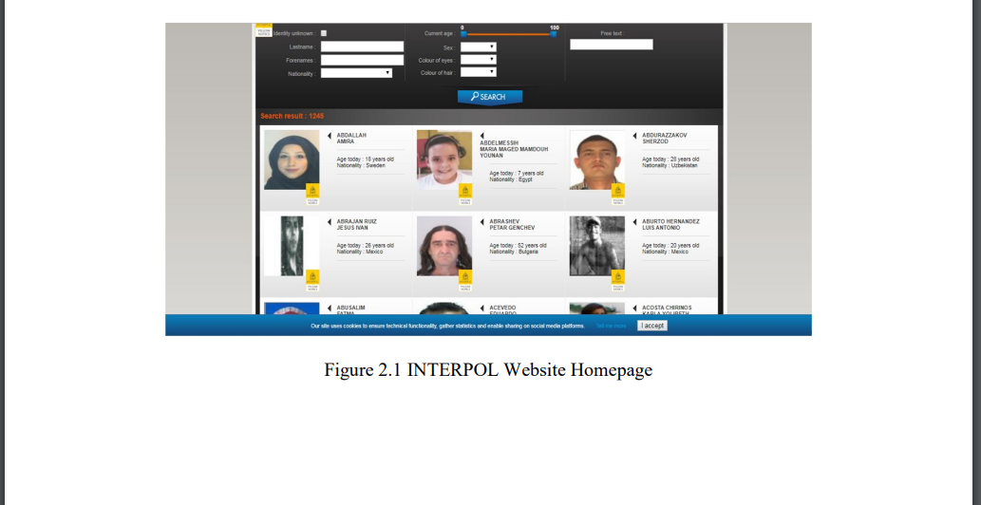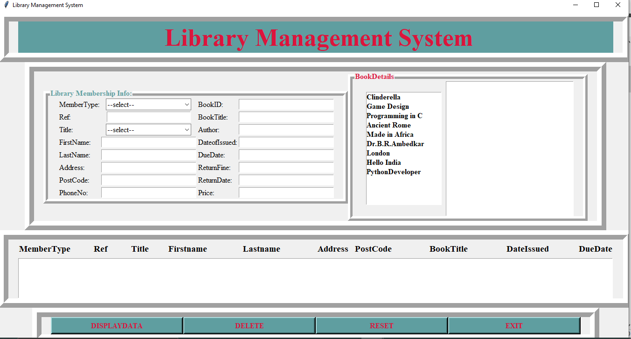

# **CHAPTER 2**

# **PROJECT PLAN**

* 1. **Timeline & Work-Division:**

**Gantt Chart:**



# **CHAPTER 3**

# **PROJECT DESIGN & IMPLEMENTATION**

* 1. **Tools Used:**

**Table 2.1: Description of Tools**

|  |  |  |  |
| --- | --- | --- | --- |
| **Tool** | **What it does** | **Other similar Tools (if any)** | **Why selected this tool** |
| **HTML** | **HTML creates the structure of a website. It provides various elements such as headlines, lists, tables, and paragraphs. Allows insertion of images, videos, and audio. We can also create forms through it.** | **XML (extensible Markup Language),** **Markdown,** **JSON (JavaScript Object Notation),** **YAML (YAML Ain't Markup Language)** | **HTML is a primary language for giving structure to a webpage. It is easy to use compared to other markup languages and is vastly accepted by other browsers.** |
| **CSS** | **CSS means a style sheet called Cascading Style Sheets. It is a code language utilised to portray the physical appearance and arrangement of a written document in HTML or XML. CSS allows creators of websites to distinguish the appearance of a web page from its design and regulate different parts like arrangement, hues, font styles, and movements. Using CSS styles to HTML tags..** | **Sass, Bootstrap, JavaScript, Python, and HTML5 are the foremost choices and rivals to CSS 3.** | **We opted for CSS as our choice due to its ability to separate concerns, flexible formatting, responsiveness, efficiency, consistency, accessibility, compatibility with different browsers, as well as animation and interactivity features.** |
| **JavaScript** | **JavaScript is a slender programming vernacular that web developers frequently employ to fabricate more intricate interchanges whilst engendering web pages, applications, servers, and even games.Developers often utilize JavaScript in conjunction with HTML and CSS. This programming language complements CSS in styling HTML components. Nevertheless, JavaScript retains the ability to facilitate user engagement, a function that CSS unaided is unable to perform.** | **TypeScript,Dart,Kotlin/JS,Elm,CoffeeScript,PureScript are the alternatives of Javascript** | **Because JavaScript excels at delivering interactivity, DOM (Document Object Model) manipulation, a vast ecosystem, flexibility, server-side capabilities, constant advancement, and support, we choose it.** |
| **SQLite** | **SQLite provides a relational database management system (RDBMS) built in a small, standalone, server-free, and zero setup manner. It is a sought-after alternative for small-scale, database-driven applications as well as mobile applications are incorporated into the systems because of its lightweight nature and user-friendly attributes.** | **MySQL,PostgreSQL,MongoDB,Redis are the alternatives of SQLite** | **We used Django in our project.Django has the ability to accommodate several database backends and among them, is SQLite.That why we used SQLite in the backend.** |
| **Django** | **Django is a powerful web development platform that follows the Model-View-Controller (MVC) design paradigm and is written in the dynamic programming language Python. It provides a variety of toolkits and repositories to make the task of building web-based apps easier and more efficient. It prioritises following standard practices above modification, giving developers access to clear defaults and pre-made models to facilitate quick project launch.** | **Ruby on Rails, Laravel, Flask,Asp.Net,Express.JS are the alternatives of Django** | **Django provides pre-built features for rapid development, scalable architecture for small to large projects, built-in security measures to protect against web vulnerabilities,object-Relational Mapping for easier database management,large and active community of developers with many resources available, excellent and comprehensive documentation, robust testing and debugging tools and versatility for a wide range of web applications** |
| **Siamese Network** | **A Siamese Netork is a type of network design used to compare feature vectors for each input and consists of two or more similar subnetworks. This method can be applied for a number of tasks, such as discovering duplication, spotting abnormalities, and facial recognition. By presenting three photographs, two of which will be similar and the third unrelated, the objective is to educate the model to estimate the similarity of images.** | **Triplet Networks,Contrastive Learning,Metric Learning,Neural Embeddings,Pretrained Models are the alternatives.** | **As a beginner Siamese network is more easy and preferable.Thats why we used it.** |
| **Tensor Flow** | **Google-powered TensorFlow is a free and open-source machine learning framework.TensorFlow's graph-based methodology enables efficient computation and automated training model differentiation.** | **PyTorch, MXNet,Caffe,Theano,Torch are similar of the Tensroflow** | **For flexibility, deployment options, and support for research and production we have used it.** |

* 1. **Technical Design**

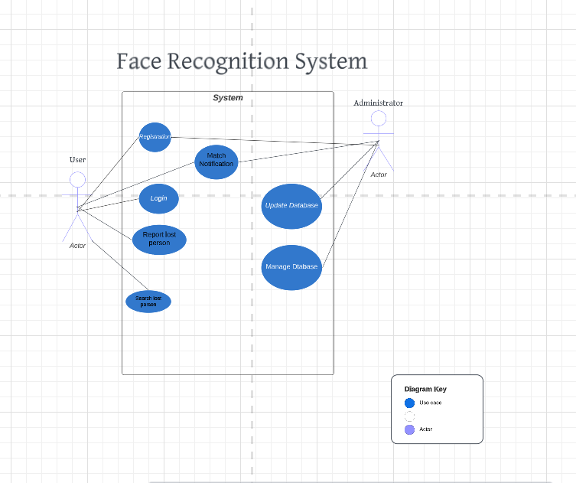

In this use case, there are two actors. User and Administrator. User works with the use cases named Login, Registration, Report lost person and search lost person. Administrator has the power to manage and update database. After matching faces match notification pass through the system to user.

* 1. **Implementation**

1. Datasets:

A dataset of missing and found persons was collected for this “Lost and Found Human Detection” project. This dataset mainly included a description, physical disability (if any), age, area, location, and physical sign.

1. Platform:

Collab.

1. Programming Languages:

Front-End: The Front-End of the project was implemented using HTML, CSS, and JavaScript to create a user-friendly web interface.

Back-End: Django, SQLite

1. Data collection:

At first, we made a consent form regarding picture collection and gave it to our classmates. Then after taking their approval, we took pictures from Facebook. But to train our Siamese Network, we took picture dataset from Kaggle. We trained our website using 2000 images for no. To ensure better performance in future, we are trying to train our Siamese network with 20,000 photos. We collected age, description and other information from social media.

5.Hardware:

|  |  |
| --- | --- |
| **Components:** | **Requirements:** |
| **Windows** | **Windows 11** |
| **Processor** | **11th Gen Intel(R) Core(TM) i5-1135G7** |
| **RAM** | **12.0 GB** |
| **ROM** | **256 GB** |
| **System Type** | **64-bit operating system, x64-based processor** |

* 1. **Availability:**

<https://github.com/mdminhajulislamminhaj/humanlostandfound>

https://drive.google.com/file/d/1xL5A9hKPqdF-IMO6Ambhx1tbBSBlvU4b/view?usp=sharing

# **CHAPTER 4**

# **PROJECT DESCRIPTION**

1. Login and Registration: A user has to register and create an account using first name, last name, phone number, id, email, and password. To use the website, the user has to log in using Email and Password.
2. Quick Search: The user can choose the age, destination, and image and search for the expected result.
3. Match Notification: After searching, if the match is found, then it will show that “ The match is found with _% similarity”.
4. Face Recognition: A face Recognition system can detect face vectors and match the image with the existing image folder.
5. Security: The security system means that the information is confidential, and NID is a must to create an account.
6. User edit: There is an edit option available for the user to edit information after posting an image with a description.

# **CHAPTER 5**

# **PROJECT SUMMARY**

* 1. **Results and Comparison:**

“Lost and Found Human Detection” is a new approach in our country. Compared to developed countries, they have already made face recognition systems for matching and locating missing persons and even criminals and offenders. In Bangladesh, people are nowadays being driven to use not just only social media platforms for entertainment but also using online platforms for other uses. But this one is relevantly new, and if we can connect our website with Law Enforcement agencies, then with their vast database, we can make a powerful website and match missing persons. As it is for our junior design course, we could not get time for a survey, but for data collection, we made a consent form to collect their pictures for our AI system, and they showed interest after hearing about our ideas.

* 1. **Non-technical Issues and Solutions:**

Our project mainly uses face recognition. We had to collect a vast number of images for that. Since a picture is a private thing, we had to take consent from our classmates for that and had to collect pictures from them patiently. Our project had some legal issues. Finding a missing person is strongly related to Law Enforcement, and so we need to take permission to use pictures and information regarding the missing person as it is confidential. Anyone can make fun by posting a person’s image who is not even lost and thus creating an issue for the posted person.

* 1. **Technical Issues and Solutions:**

**Dataset to train the Siamese model**: To train the Siamese Network, we took the dataset from Kaggle. Now Kaggle the image dataset provided by Kaggle has pictures of foreigners, and we are building this website for the local people, so after training the model with foreigners' faces, it is tough to get exact results for Bangladesh users as their facial features are different than ours.

**Enormous Bugs**: Firstly, it was hard to integrate the main CSS with style CSS and had issues with fixing box colours. Replaced advanced JavaScript with normal JavaScript code associated with code while designing the forms. In Collab, we were being failed to extract the zipped archive file. We solved this issue by getting help from online resources. At first, we trained the model using hundred image-based datasets. So, it was not showing accurate results.

**Creating several paths:** For this project, we had to create a large number of data paths in the environment variable, but even after executing it, it was showing data path was not found. So, we uninstalled the software and created the data path again.

**Verifying authentic users:** To register an account, we need NIDand other information. But a user can post many missing photos without those people being lost to just make fun, and doing this frequently can crash the system. So, it was in our plan to restrict the number of posts a user can post here.

* 1. **Future Direction:**

We can improve our website in future by training the model with lakhs of images of the local people of Bangladesh. As mentioned before, Siamese Network can work efficiently only after training it with a vast dataset. It will give us a high-accuracy result. We can enhance the user interface by making it simple and user-friendly. We can make a survey and take their feedback to improve our website. It is a free website, so we do not need to think about cost reduction.

In the near future, if we want to prepare our project for competitions or exhibitions, we can follow these easy steps:

1. Demonstrating the project in front of the specialist after taking feedback from them, we can develop the website.
2. Demonstrate Performance: We have to demonstrate our past successful results in front of them.
3. Practice and Rehearse: We have to practice and prepare ourselves to give a speech in front of the audience so they can be influenced to use our website. Convincing them that our website is the best one out there is the main target in the competition.
4. Creating a Network and Collaborating with others: We can use many competitive platforms to make our website well known and collaborate with others specialised in this field to make the project bigger and well known to people.
5. Practical Applications: We can demonstrate practical applications and how it can be used in emergency cases.

**Home Page:**

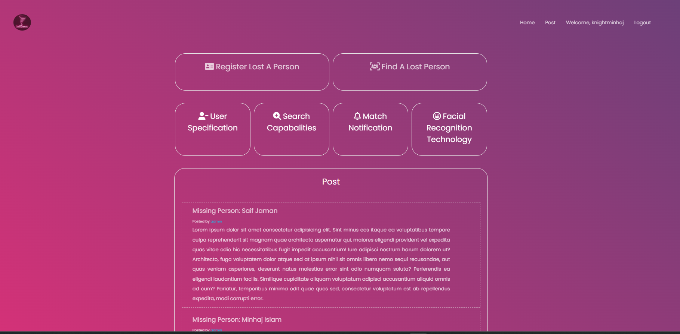

**Registration And Login Form:**

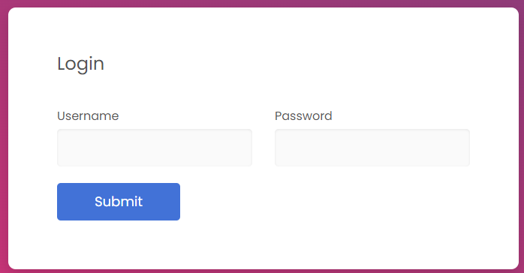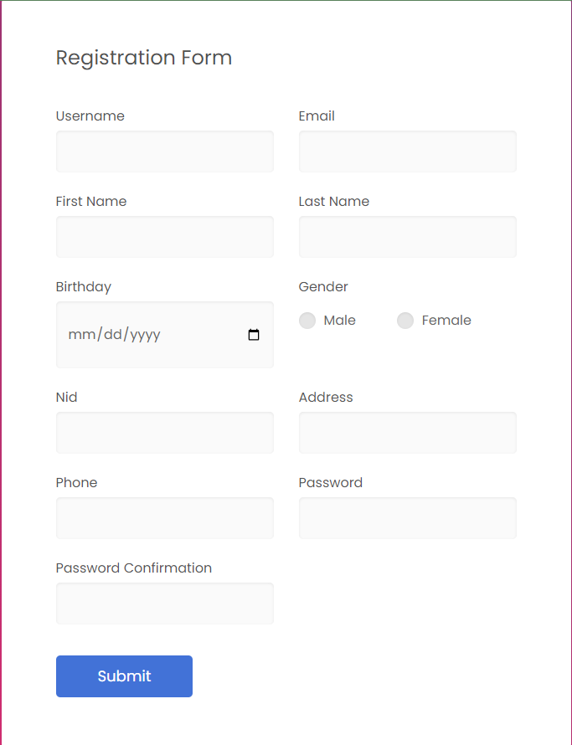

**After Login:**

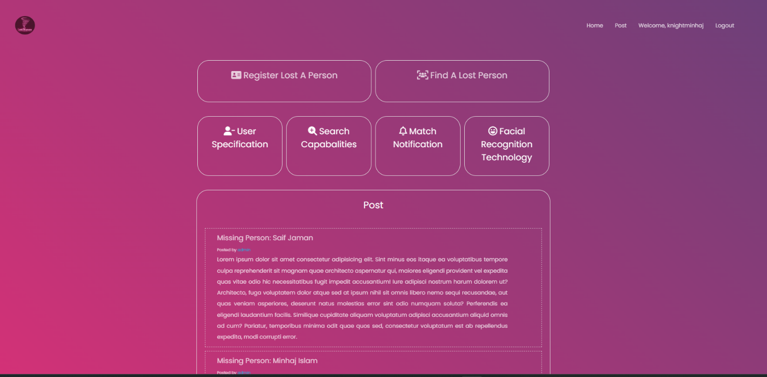

**Post About A Person Page:**

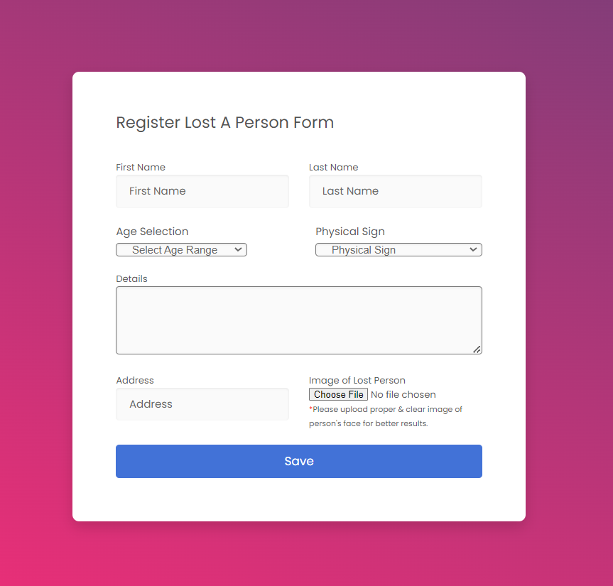

**Find A Person Page:**

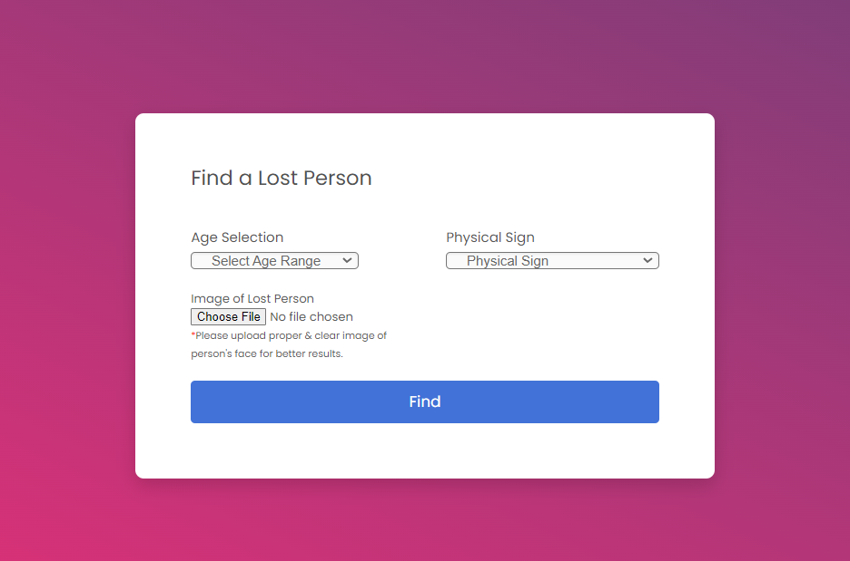

**Result:**

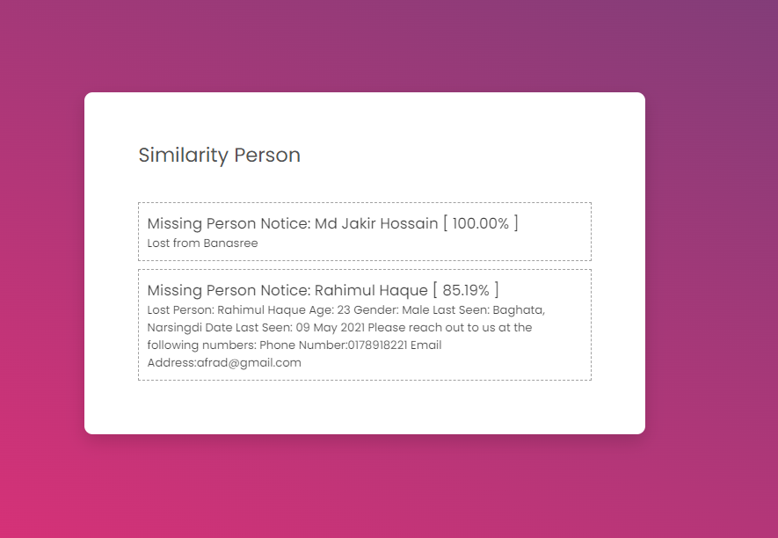

**Information About The Matched Person:**

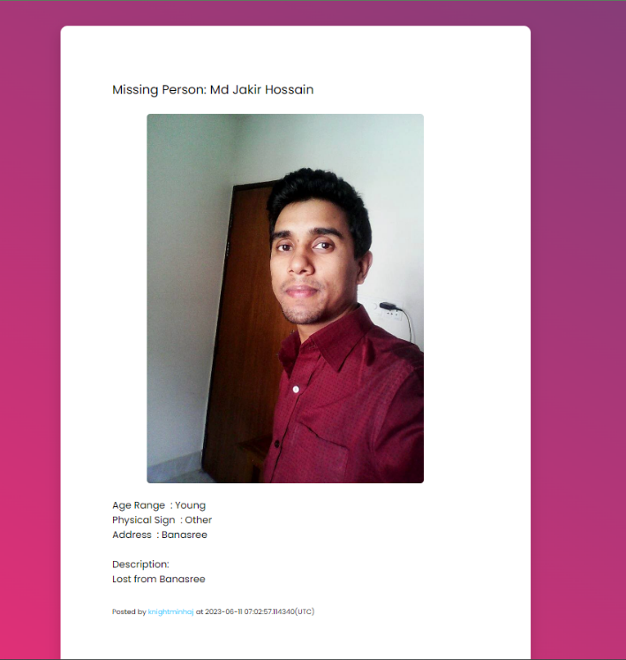

**User Button:**



**User Edit Page and Post Edit Page:**

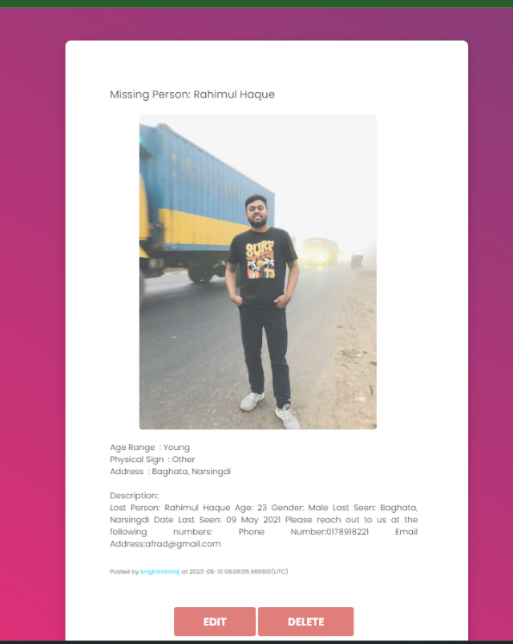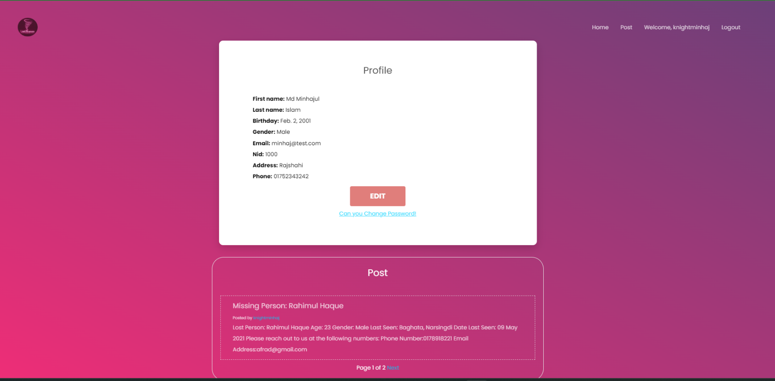

**User Database:**

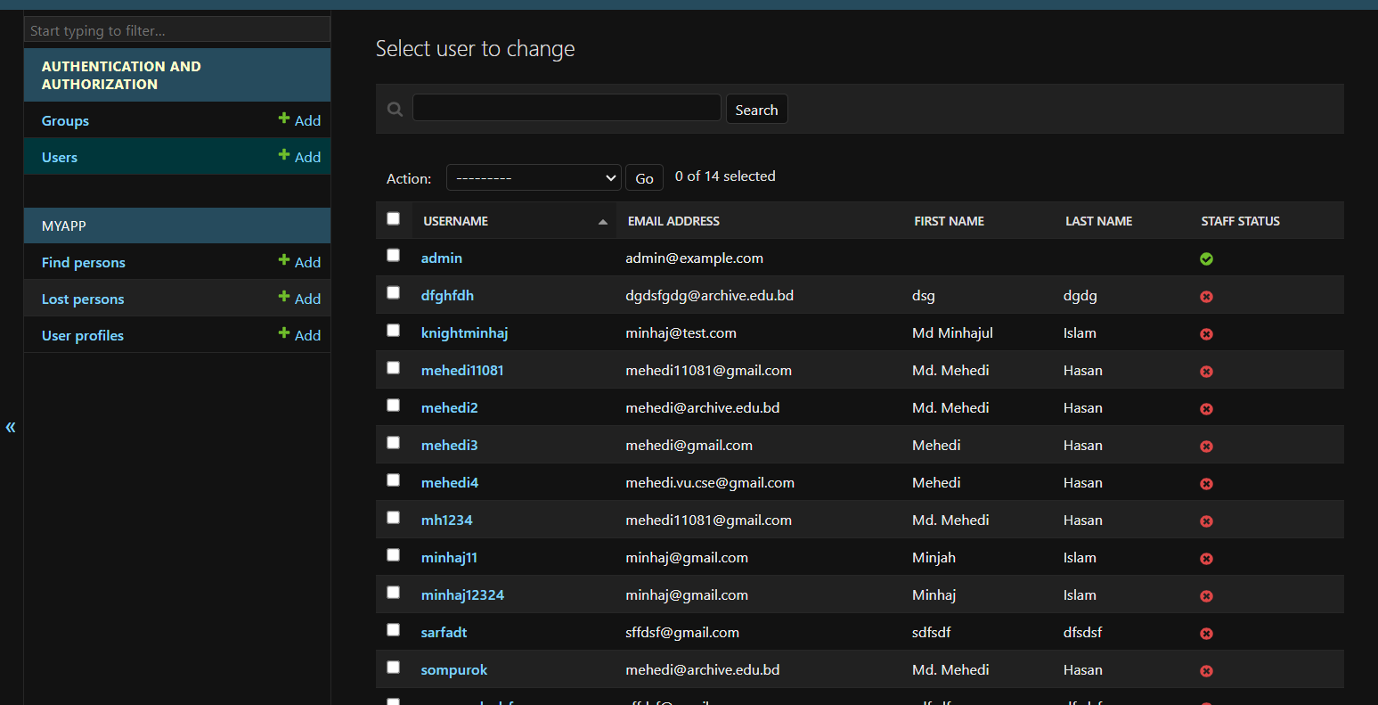

**Lost Person Database:**

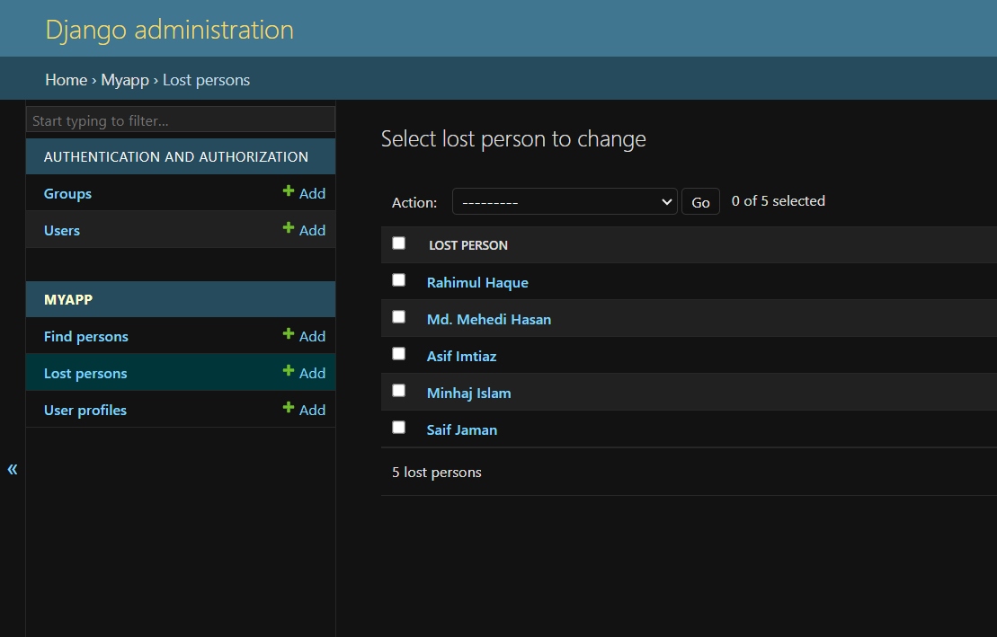

**Find Person Database:**

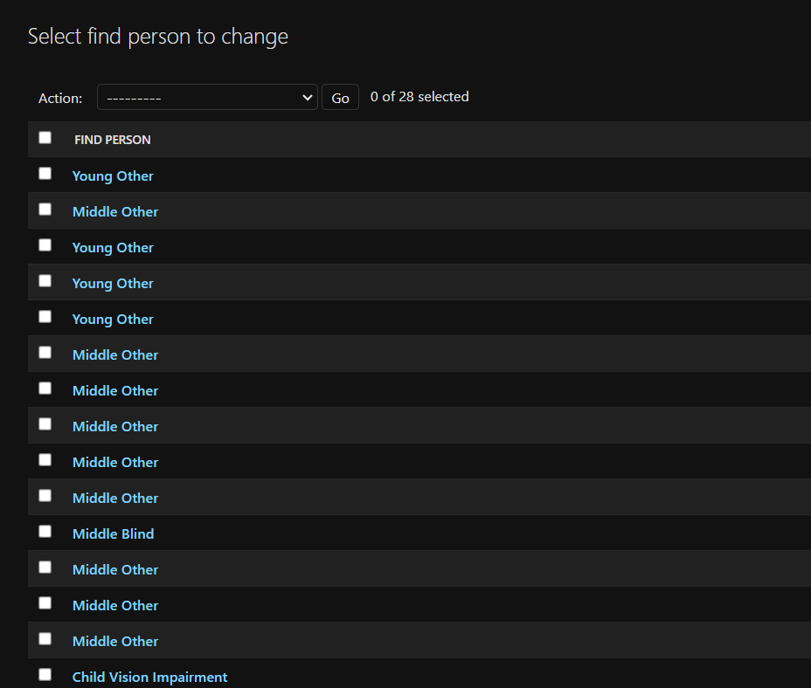

**User Edit Database:**

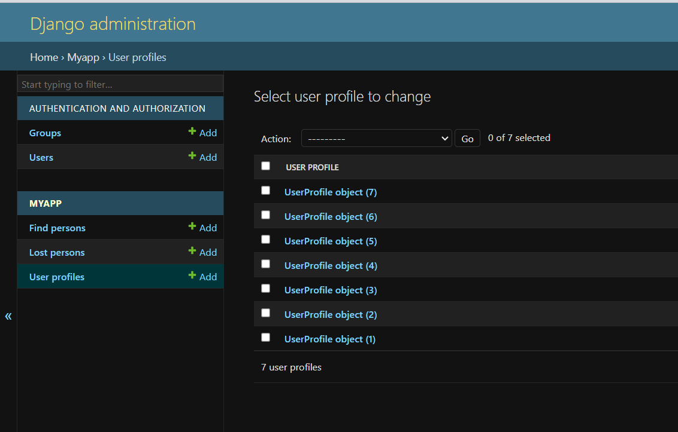

* 1. **Conclusion:**

“Lost and Found Human Detection” is a website built for reuniting people with their loved ones. We used face recognition for matching faces stored in our system with the images posted. It is a significant project because it is free of cost, easy to use, great aid to the Law Enforcement agencies, and reduces criminal activity by locating missing persons as they could have been victims of trafficking and other heinous crimes.

|  |  |
| --- | --- |
| **REFERENCES** | **APPENDIX A** |

1.http://eprints.utar.edu.my/3769/1/16ACB04723_FYP.pdf

(lost and found Malaysia)

2.( lost items of university students using rfid and email)

<https://ir.uitm.edu.my/id/eprint/45937/>

3.(Smart Lost and Found Android Application for University using Machine Learning)

<http://repository.msa.edu.eg/xmlui/handle/123456789/4353>

4. Lost and found management system of a library

<https://www.academia.edu/24932096/Lost_and_found_management_system>

5.https://code-projects.org/lost-and-found-thing-management-in-php-css-javascript-and-mysql-free-download/?fbclid=IwAR2igZfp3xLS3YatB46M0MsWgex9QVrZ1Hf0M82BaL2J1B0j6IleJpTs7yk

|  |  |
| --- | --- |
| **INDIVIDUAL CONTRIBUTIONS** | **APPENDIX B** |

|  |  |  |  |
| --- | --- | --- | --- |
| **Member Name** | **Contribution in Coding** | **Contribution in Preparing reports/presentations** | **Contribution in Other parts** |
| Md Minhajul Islam | Machine Learning ,Backend | Presentations, Table of Figures. | Project Planning |
| Sadia Islam Raida | Frontend | Report 1.3,3.2,3.3,3.4,4.1,5.3,5.4 | Research |
| Marufur Rashid | Backend | Report 1.1,1.2,2.1,3.1,5.1,5.2,5.5 | Resource Manage |