“Heaven’s Light Is Our Guide”

Rajshahi University of Engineering
& Technology

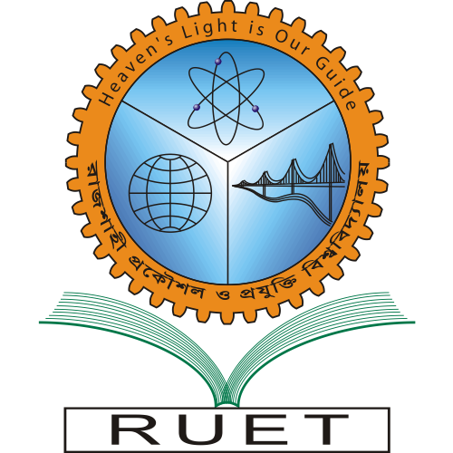

Department of Computer Science & Engineering

CSE-500: Internet Programming Project

Title | Student Information Registration and  Browsing System
Date | 25 February 2014

Submitted to

Project Supervisor | Boshir Ahmed
Designation | Associate Professor
Department | CSE

Submitted by

Member 1 |  | Member 2
Name | Md. Minhazul Haque | Name | Md. Omar Faruk
Roll | 103001 | Roll | 103022

