Student Information Registration and Browsing System

Objective
To build a website implementing database system to provide such a functionality where students can register bu their roll numbers, fill up their information and browse other students' profile. The registation and login system must be secure and sensitive information must not be opened to public.

Features
The web application has been successfully built and deployed. The following features has been ensured.

 User registration system
 Login using roll number and password
 Browse all students' information
 Search students by any terms
 Edit own information
 Delete own account if necessary
 Change own account password
 Sign-out securely

Features Explained

 User Registration System
Students can register their account by providing their Roll Number, Name and a secure Password. The registation form generates alphanumeric password each time the page is loaded. Registering the same roll is not possible.
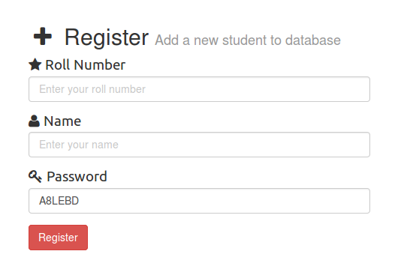

 Login Using Roll Number And Password
Each student can login by their name and password used to register. Login is provided by a uniqeuly generated token and cookie management.
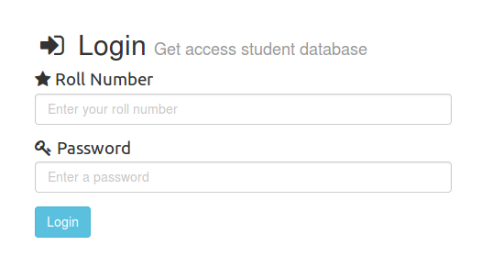

 Browse All Students' Information
Only logged in users can browse the list of registered students. Rolls and names of all registated students are shown in a table with hyperlinks that will take you to their profile.

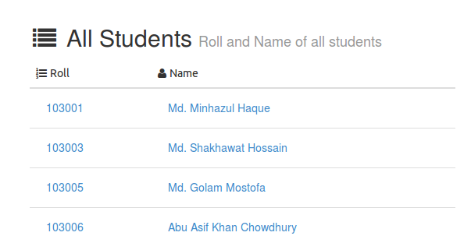

 Search Students By Any Terms
Profiles can be searched using any term, ie name, phone number, address etc.

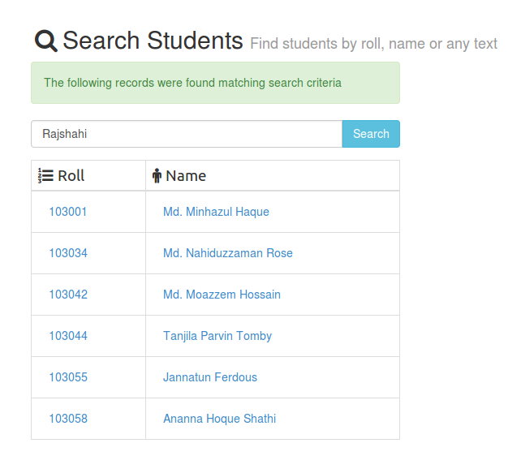
 View Own Information
Any student can view the following information.
- Roll
- Name
- Birthdate
- Email
- Cell Number
- Emergency Number
- Hall Name
- Room No
- Address
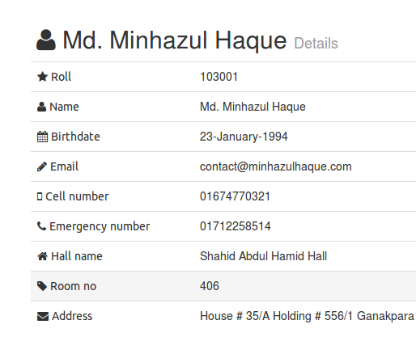

 Edit Own Information
Students can edit only own profile. Editing roll number is not allowed.
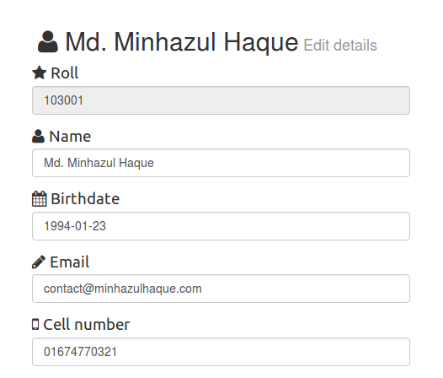

 Delete own account if necessary
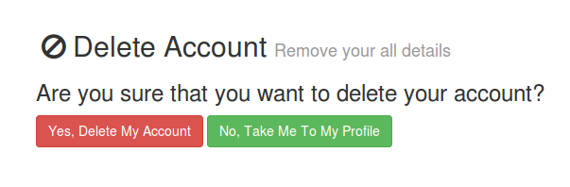
Any student can delete own account for data liberation. He/she has to confirm account deletion. After deletion, his/her record will be deleted from the database permanenetly.

 Change own account password
Account passwords can be changed if necessary.
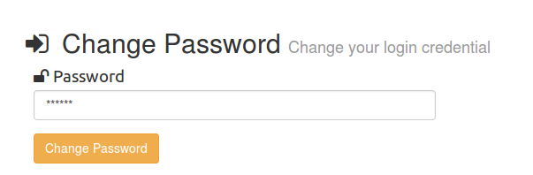

 Sign-out securely
Clicking logout will end the session and destroy all temporary data used to validate credentials.
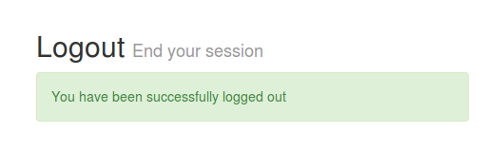

Technical Information
The web application has been build using object-oriented PHP. Designs has been deployed using Bootstrap and Font-awesome framework. Database engine is supported by MySQL. jQuery is used to provide better user interface. The whole project is deployed using moduler PHP files. The project tree is

root@server: tree /use/share/www
├── alerts.php
├── all.php
├── change.php
├── config.php
├── css
│ ├── bootstrap.css
│ ├── datepicker.css
│ ├── fa.css
│ └── style.css
├── db.php
├── delete.php
├── details.php
├── edit.php
├── favicon.ico
├── fonts
│ └── fontawesome.woff
├── footer.php
├── forms.php
├── header.php
├── img
│ └── csebuilding.jpg
├── include.php
├── index.php
├── js
│ ├── bootstrap.js
│ └── jquery.js
├── login.php
├── logout.php
├── navbar.php
├── password.php
├── register.php
├── search.php
└── verify.php

Future Plans
Our future plan is to improve the application into a universal and more versatile CMS so any group of students can use it for easier information sharing perpose.

