What is Terraform?
Terraform is an Infrastructure as Code (IaC) tool. Instead of clicking through a cloud console or running shell scripts to set up servers and networks, you write .tf files describing the infrastructure you want — and Terraform figures out how to make reality match that description.
The key shift is declarative vs imperative thinking:
- Imperative: "Run this command, then that command, then check if it worked"
- Declarative: "Here is what I want to exist" — Terraform handles the how
This means your infra config is version-controlled, reviewable, repeatable, and self-documenting.

The four core concepts
Here's how the pieces relate to each other:
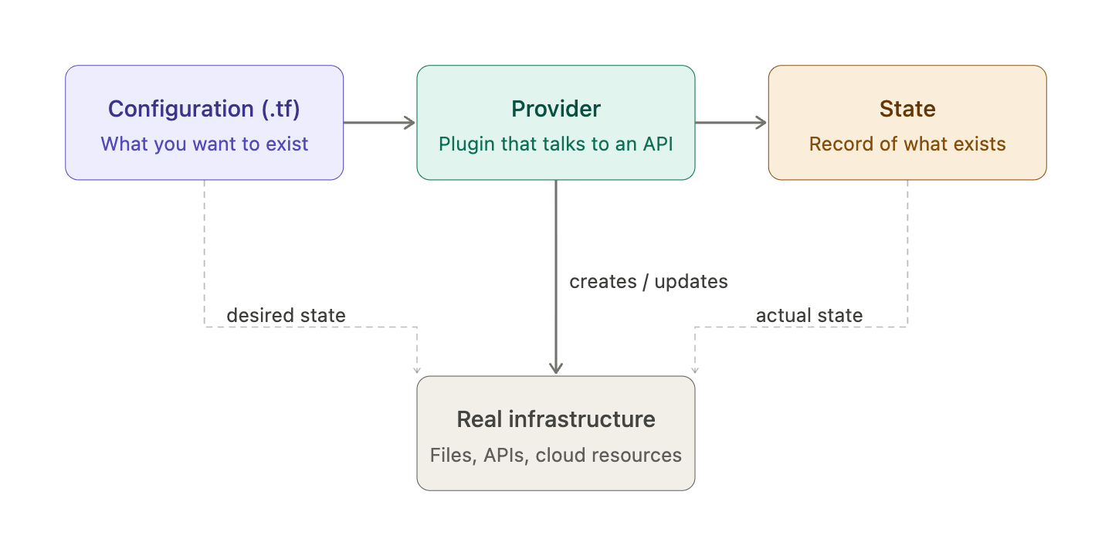
Configuration is the .tf files you write — resources, variables, outputs. This is your desired world.
Providers are plugins (downloaded during terraform init) that know how to talk to specific APIs — AWS, Google Cloud, GitHub, or even just local (your filesystem) and random (no API at all). Each provider exposes resource types you can use.
State (terraform.tfstate) is a JSON file Terraform maintains that maps your config to the real things that exist. It's how Terraform knows "this local_file.myfile in my config corresponds to this actual file at /tmp/hello.txt". Without state, every apply would try to recreate everything from scratch.
Real infrastructure is whatever actually exists — files, servers, DNS records. The provider creates/updates/deletes these. State records what was created so Terraform can track drift and plan future changes.

The init / plan / apply workflow
This is the heartbeat of every Terraform session. Every change you ever make goes through these three commands.
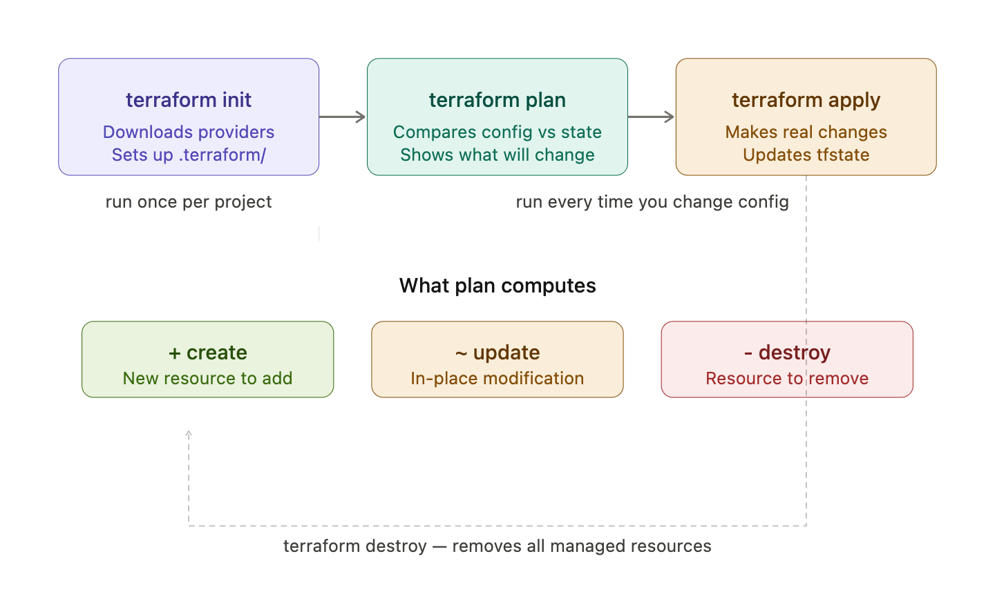
terraform init is a one-time setup step per project. It reads your required_providers block, downloads the provider plugins into .terraform/, and creates a .terraform.lock.hcl file locking exact provider versions. Think of it like npm install — run it once after cloning or adding a new provider.
terraform plan is the preview step. It reads your config, reads the current state file, refreshes against real infrastructure if needed, and then computes a diff — what needs to be created (+), modified (~), or destroyed (-). Crucially, it makes zero changes. It's purely a read operation. You should always read the plan before applying.
terraform apply executes that diff. By default it shows you the plan one more time and asks for confirmation (type yes). It then calls the provider APIs in dependency order, and writes the results back into terraform.tfstate. After a successful apply, config and state are in sync.
terraform destroy is apply in reverse — it plans the deletion of every resource in state and tears it all down.
Variables
Variables are how you make a Terraform config reusable and configurable without touching the resource logic. Let's build the full picture.

Anatomy of an input variable
Every variable lives in a variable block. At minimum you need a name — everything else is optional but recommended:
variable "filename" {
type = string description = "Path where the file will be written" default = "/tmp/hello.txt"
}

The type system
Terraform has primitive types and collection types. Here's the full map:
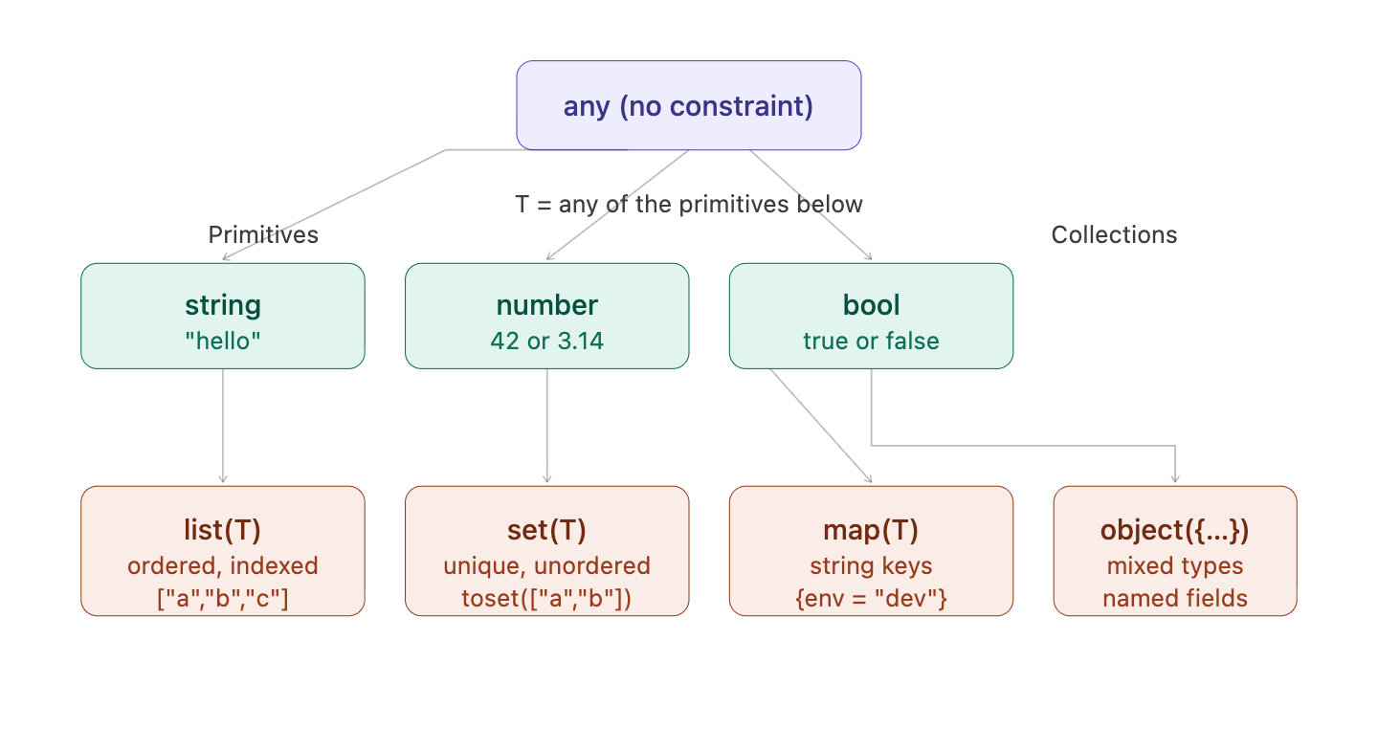

How Terraform resolves variable values
This is the part most people miss — there are multiple ways to pass a value in, and Terraform picks the highest-priority one:
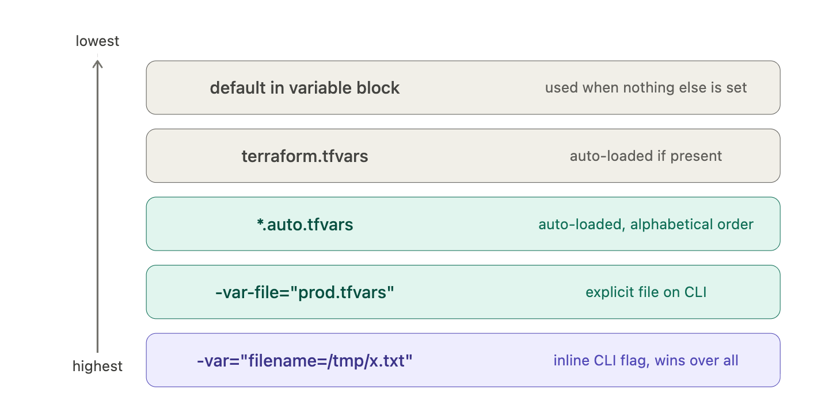
A -var flag on the CLI always wins. The default in the variable block only fires when nothing else provides a value. If a required variable (no default) has no value from any source, Terraform will prompt you interactively — useful for development, annoying in CI where you want it to fail fast instead.

Lifecycles

Why lifecycle rules exist
By default Terraform does the safe thing: destroy then create on replacement, always apply detected drift, delete when you remove a resource from config. Lifecycle rules let you override each of these defaults when the safe default is actually wrong for your situation.
Here's how the four rules map to the four default behaviours they override:
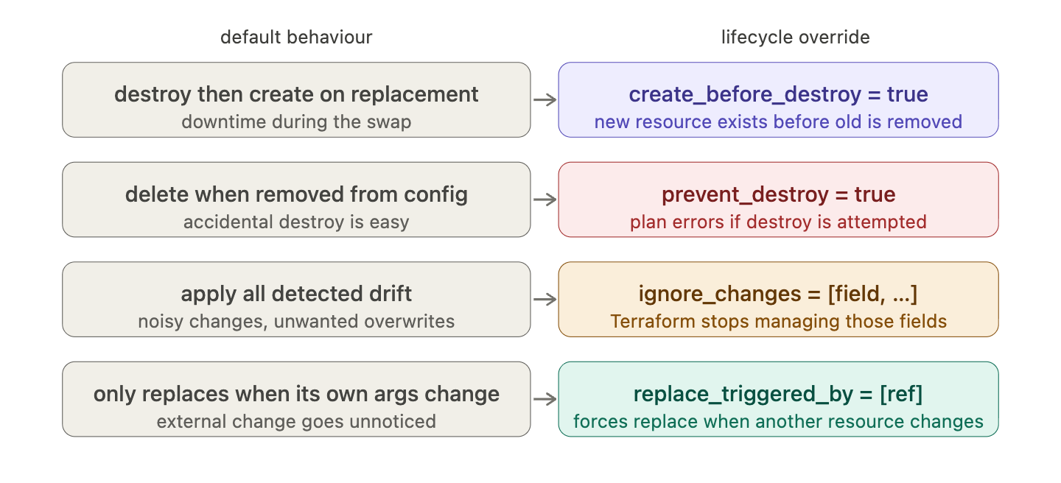

When to reach for each rule
Situation | Rule
Replacing a resource causes downtime | create_before_destroy
Resource holds critical data (DB, bucket, key) | prevent_destroy
An external process manages a field after creation | ignore_changes
Resource must refresh when a dependency rotates | replace_triggered_by
All of the above on one critical resource | combine all four

Worskpaces : What a workspace is
Every Terraform project starts in a workspace called default. A workspace is just a named slot for a separate state file — the config stays identical, but each workspace tracks its own real-world resources independently.
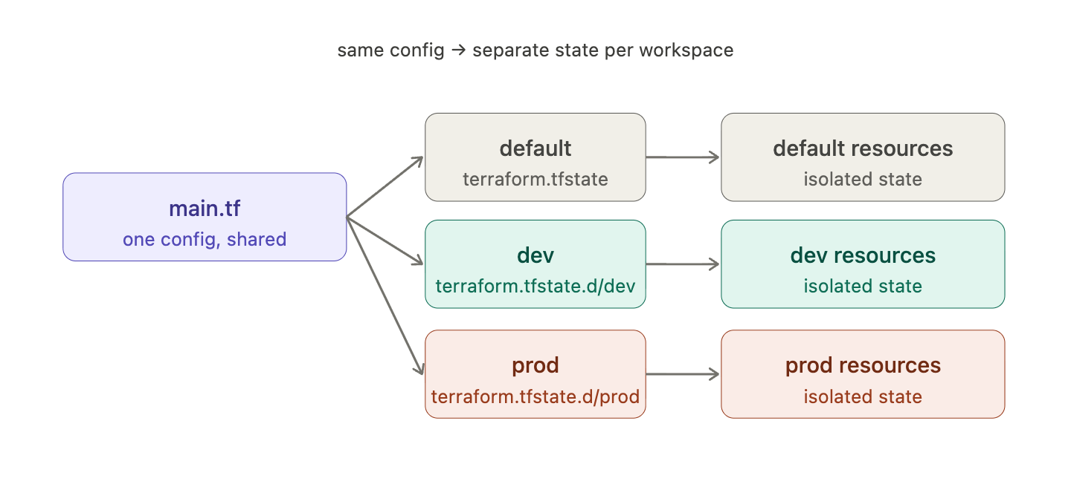

Workspaces vs separate directories — when to use which
This is the real question, and it has a clear answer:
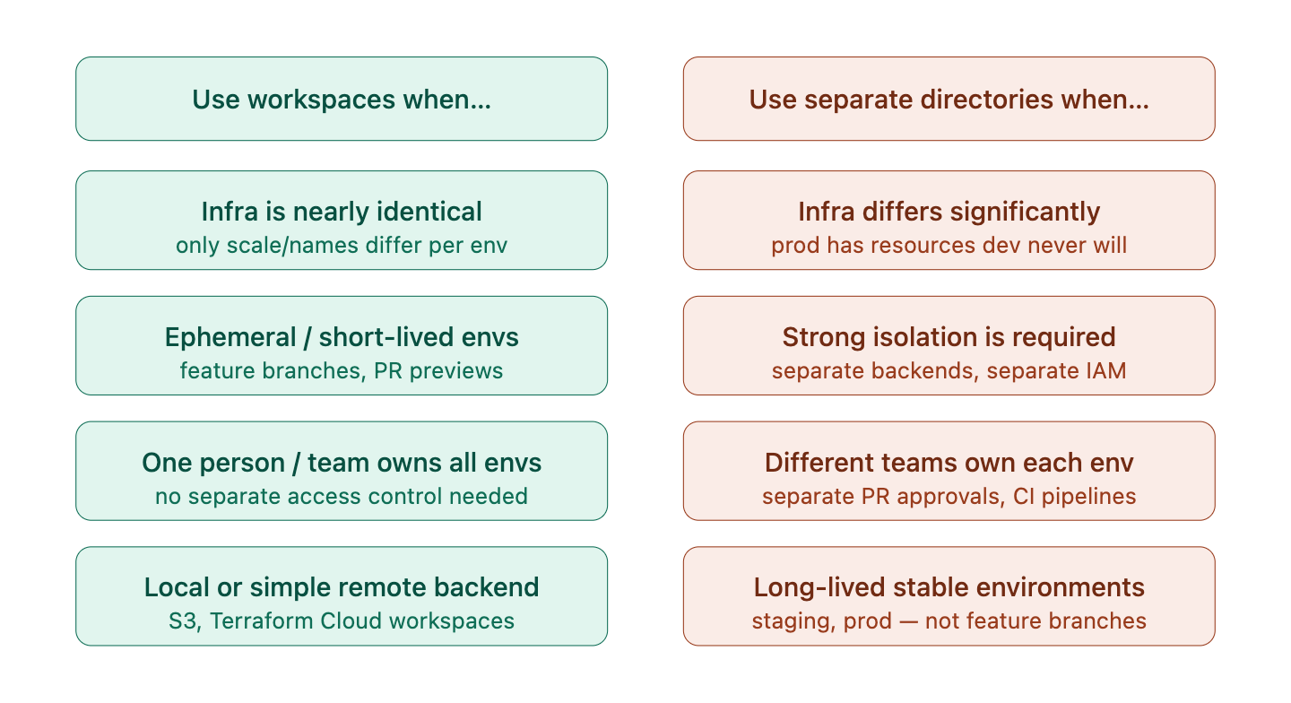

The one thing workspaces don't solve
Workspaces are not a security boundary. They're a state isolation mechanism. If your threat model includes "a developer must not be able to accidentally apply to prod", workspaces won't protect you — a single terraform workspace select prod is all it takes. For that, you need separate backends with separate credentials, enforced at the infrastructure level, which means separate directories.
The Terraform docs themselves recommend workspaces primarily for "multiple deployments of the same infrastructure" — think spinning up identical preview environments per PR, not separating dev from production in a regulated system.

Remote backends
Local state is fine for solo work. The moment a second person or a CI system touches the same infrastructure, you need a remote backend — a shared location where state lives, with locking to prevent concurrent writes.
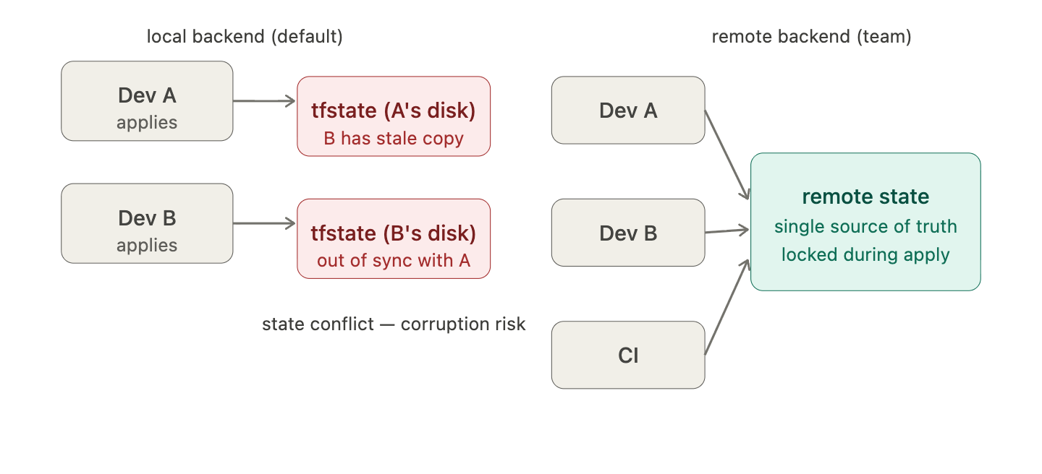

What a module actually is
Every directory containing .tf files is a module. You've already been writing modules — your working directory is the root module. A child module is any module you call with a module block. There's no special syntax to declare a module; the structure is the contract.
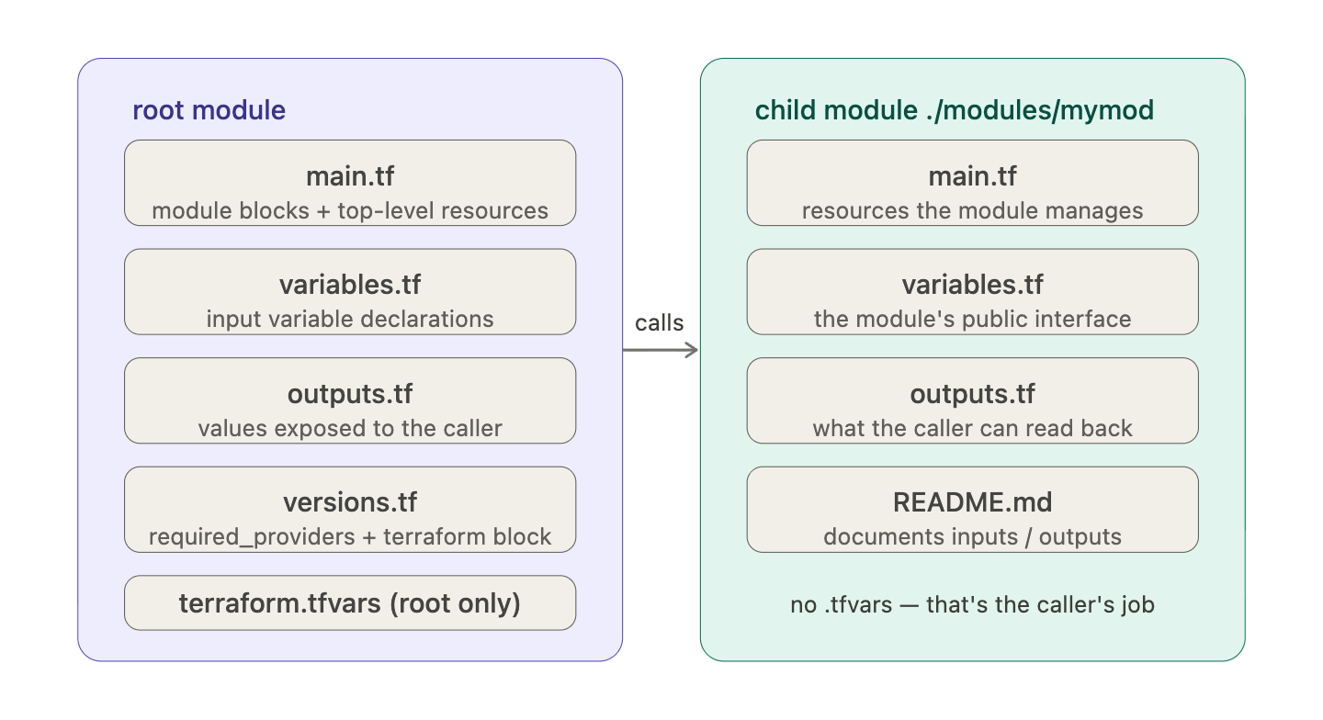
The file names main.tf, variables.tf, outputs.tf are conventions, not requirements. Terraform reads all .tf files in a directory together. But following the convention makes any module instantly readable to anyone who knows Terraform.
A child module never has a terraform.tfvars — that belongs to whoever is calling the module. And child modules should generally not configure backends — only the root module does that.

