……………………………………………...……………………………………………...……………………………………………...……………………………………………………………...………………

**Name:** MD MUBASIR

**Email address:** talk2mubasir0587@gmail.com

**Contact number:** 9831958386

**Anydesk address:** 151 986 252

**Years of Work Experience:** NA

**Date: 1th Aug 2020**

……………………………………………...……………………………………………...……………………………………………...……………………………………………………………...………………

**Self Case Study -2: Oil Storage Tanks**

# Overview

The global oil market is not entirely transparent. Almost all oil-producing nations make an effort to hide their total production, consumption, and storage. Nations do this to indirectly conceal their actual economy from outside and empower their defense system. This practice might lead to a threat to other nations.

For this reason, many startups companies like [Planet](https://www.planet.com/) and [Orbital Insight](https://orbitalinsight.com/) came out to keep eyes on such kind of activities of the nations by satellite imagery. Thye collects satellite imagery of oil storage tanks and estimates reserve volumes.

But the question is how can one estimate the volume of a tank by just a satellite image? Well, this will only be possible when oil is stored in the floating roof/head tank. This particular type of tank is specially designed to store large quantities of petroleum products such as crude oil or condensate. It consists of the top head that sits directly on the top of the oil, which rises or falls with the volume of oil in the tank and makes two shadows around it. As you can see the below image, the shadow on the north side

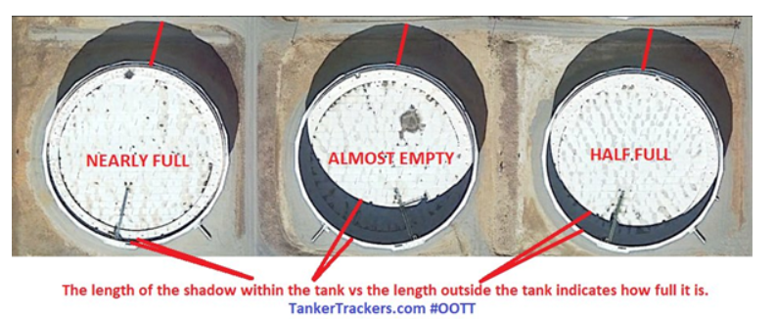

(exterior shadow) of the tank refers to the total height of the tank while the shadow within the tank (interior shadow) shows the depth of the floating head/roof(i.e how much empty tank is). And the volume will be estimated as .

## Dataset (dataset link:<https://www.kaggle.com/towardsentropy/oil-storage-tanks?> )

The dataset contains a bounding box annotated, satellite images were taken from Google Earth of the tank containing industrial areas around the world. There are 2 folders and 3 files in the datasets. Let’s see each of them one by one

1. l**arge_images:** This is a folder/directory that contains 100 satellite raw images of size 4800x4800 each. All the images are named in *id_large.jpg* format.
2. **Image_patches:** The image_patches directory contains 512x512 patches generated from the large image. Each large image is split into 100, 512x512 patches with an overlap of 37 pixels between patches on both axes. Image patches are named following an *id_row_column.jpg* format
3. **labels.json:** It contains labels for all images. Labels are stored as a list of dictionaries, one for each image. Images that do not contain any floating head tanks are given a label of 'skip'. Bounding box labels are in the format of *(x, y)* coordinate pairs of the four corners of the bounding box.
4. **labels_coco.json:** It contains the same labels as the previous file, converted into COCO label format. Here bounding boxes are formatted as *[x_min, y_min, width, height]*.
5. **large_image_data.csv:** It contains metadata about the large image files, including coordinates of the center of each image and the altitude.

## Task

To detect the floated head tank and then estimate the reserved/occupied volume of oil present in it. Followed by this reassemble image patches into the full-size image with volume estimations added.

# 

# Research-Papers/Solutions/Architectures/Kernels

## [1] **A Beginner’s Guide To Calculating Oil Storage Tank Occupancy With Help Of Satellite Imagery** (**blog:** <https://medium.com/planet-stories/a-beginners-guide-to-calculating-oil-storage-tank-occupancy-with-help-of-satellite-imagery-e8f387200178> )

This blog is written by TankerTracker.com itself. It’s one of the services is to track the storage of crude oil in several geographical and geopolitical points of interest using satellite imagery. In this blog, they described in detail how the exterior and interior shadow made by the tanks would help us in estimating the volume of oil present in it. Also compared the images taken by the satellite at a particular time and a month later and showed the changes in oil storage tanks over a month. This blog gave us an intuitive knowledge that how the estimation of the volume is being done.

## [2] A Gentle Introduction to Object Recognition With Deep Learning (blog: <https://machinelearningmastery.com/object-recognition-with-deep-learning/> )

This article has covered the most confusing concept that arises in the mind of a beginner to object detection. First, describe the differences between, object classification, object localization, object recognition, and object detection. Then discussed some major state-of-the-art deep learning algorithms to unfold object recognition tasks.

**Object classification** refers to the assignment of a label to an image that contains a single object. Whereas **object localization** means drawing a bounding box around one or more objects in an image. **Object detection** task combines both object classification and localization. That means it is a more challenging/complex task which first draws a bounding box around the object of interest (OI) by localization technique the with the help of classification assigns a label of each OI. **Object recognition** is nothing but a collection of all the above tasks (i.e classification, localization, and detection).

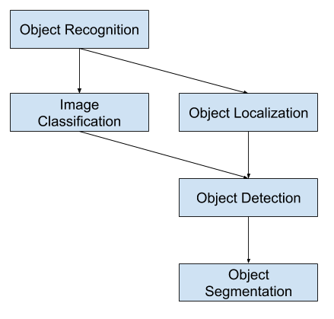

Lastly, two major families of object detection algorithms/models have been talked about that are Region-Based Convolutional Neural Networks**(R-CNN**) and You Only Look Once**(YOLO)**.

## [3 ] Selective Search for Object Recognition (paper: <http://www.huppelen.nl/publications/selectiveSearchDraft.pdf>)

In the object detection task, the most crucial part is object localization because object classification comes after this. The classification depends on the region of interest proposed by localization(in short region proposal). More perfect localization will lead to more perfect object detection. Selective Search is one of the start-of-the-art algorithms that is being used for object localization in some object recognition models like R-CNN and Fast R-CNN.

This algorithm first generates a sub-segment of an input image using Efficient Graph-Based Image Segmentation then combines the smaller similar regions into larger ones using a greedy algorithm. The segment similarity is based on four properties that are color, texture, size, and fill.

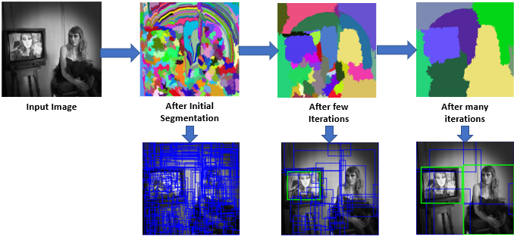

## [4] Rich feature hierarchies for accurate object detection and semantic segmentation (paper:<https://arxiv.org/abs/1311.2524> )

This paper proposed the first R-CNN family model. In this paper first-time convolutional neural network(CNN) was used with Region proposal for the object recognition task. This model is composed of three sub-models, first is **Region Proposal Model (***selective search algorithm***)** which is responsible for generating a candidate bounding box then these region proposals fed into the second **Feature Extractor model(***AlexNet deep CNN***)**, which generates 4096 element vector (i.e feature vector). third **Classifier Model(**linear SVM**)** uses feature vector for classification.

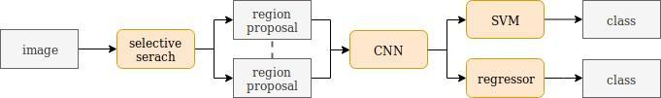

The downside of R-CNN model is as follows

1. Region proposal generation through selective search algorithm is expensive
2. For each proposal, we have to train the entire Feature Extractor Model.

From the above two limitations, we can conclude that this model will be too slow.

## [5] A Fast R-CNN (paper: <https://arxiv.org/abs/1504.08083>)

Fast R-CNN is faster than R-CNN as its name suggests. This model came into the picture by just swapping the **Region Proposal and Feature Extractor** submodels of R-CNN. In the parallel whole image is fed into CNN(feature extractor) and Region Proposal, The feature vector of each proposal is extracted from CNN feature map using ROI(Region of interest) pooling then fed into the FC layer followed by the softmax layer for classification. ROI pooling is responsible for equalizing different shapes of the proposal’s mapped feature vector.

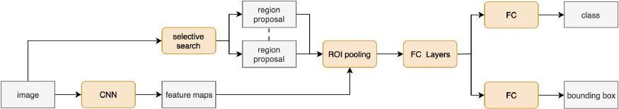

It is faster than R-CNN because we don’t need to train the CNN model for each proposal many times but yet slower because of region proposal with the selective search.

## [6] Region Proposal Network — A detailed view (blog: <https://towardsdatascience.com/region-proposal-network-a-detailed-view-1305c7875853>)

RPN(Region proposal Network) is being used widely for object localization because it is faster than traditional algorithm selective search. It learns the best location of the object of interest from the feature map as CNN learns classification from the feature map. It is responsible for three major tasks, firstly generating anchor box(9 different shapes of anchor boxes from each feature map point), secondly, classify each anchor box as foreground or background (i.e whether it contain an object or not), lastly, Learn the shape offsets for anchor boxes to fit them for objects.

## [7] Faster R-CNN: Towards Real-Time Object Detection with Region Proposal Networks (blog: <https://arxiv.org/abs/1506.01497>)

Faster R-CNN model addresses all the issues of the previous two relative model and use RPN as a region proposal generator. The architecture of this is exactly the same as Fast R-CNN except it used RPN instead of selective search that makes it 34 times faster than Fast R-CNN.

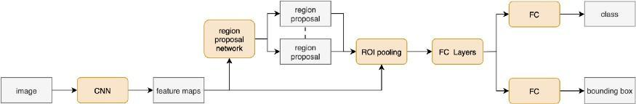

## [8] Estimating the Volume of Oil Tanks Based on High-Resolution Remote Sensing Images (blog: <https://www.researchgate.net/publication/332193936_Estimating_the_Volume_of_Oil_Tanks_Based_on_High-Resolution_Remote_Sensing_Images>)

It proposed the solution to estimate the capacity/volume of an oil tank based on satellite imagery. To calculate the total volume of a tank they required height and radius of the tank. To calculate the height they used the geometrical relationship with the length of shadow projected by it. But calculating the length of shadow was not easy. To highlight the shadow the used HSV(i.e Hue Saturation Value) color space because usually, a shadow has high saturation and increased hue in HSV color space. Then a median method based on sub-pixel subdivision positioning is used to calculate the shadow length of it. Finally, the got radius of the oil tank by the Hough transform algorithm.

In the related work of this paper, the mentioned solution to calculate the height of the building based on the satellite images.

# 

# 

# 

# 

# 

# 

# 

# First Cut Approach

Our problem statement comprises two tasks, first is floated head tank detection and another is shadow extraction and volume estimation of identified tanks. The first task is based on object detection and the second is based on computer vision algorithms. Let’s describe the approach of each task.

## Detection of Floated head tank:

For floated head tank detection we have lots of object detection models like Faster-RNN, YOLO, RetinaNet, SSD, etc. However, our first cut approach will be simple and less time-consuming. For this reason, we would train the YOLO model to fit our dataset after that we would try Fatser-RNN then will do transfer learning for object detection.

## Shadow Extraction and Volume Estimation:

Shadow extraction involves so may computer vision techniques. As the RGB color scheme is not sensitive to shadow thus we first have to convert it into HSV and LAB color space. we will use (H+1)/(V+1) ration image as we have learned from [8] to enhance the shadow part. After that, the enhanced image is filtered by thresholding (threshold value will be decided during the experiment and the best value will be used for the final model ). The thresholded image is then processed with morphological operations(i.e clear noise, clear contour, etc). Finally, We will extract the two tank shadow contours then the occupied volume will be estimated by the formula stated above.