NAME: Md Musarraf Ansari
REGD NO: 2141001054

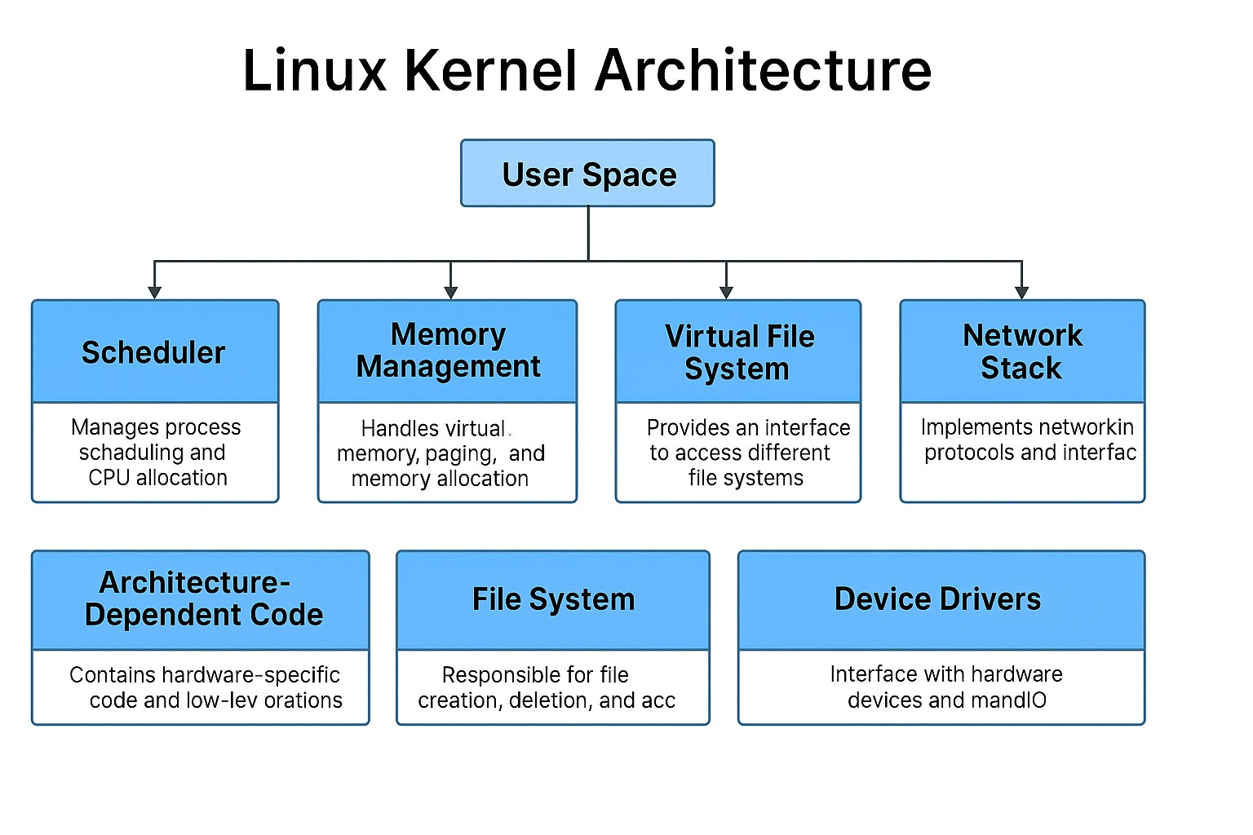
Descriptions of Major Components:

- Process Scheduler:

→Manages process execution by determining which process runs at a given time. →It ensures fair CPU usage and handles multitasking by switching between processes efficiently.

- Memory Management:

→Manages physical and virtual memory, paging, and segmentation.
→It allocates memory to processes and ensures isolation and protection.

- Virtual File System (VFS):

→Provides a uniform interface to access different types of file systems.
→It enables user programs to interact with files and directories regardless of the underlying storage format.

- Network Stack:

→Handles network communication using protocols like TCP/IP.
→Manages sockets, packet routing, and network interfaces.

- Device Drivers:

→Allow the kernel to communicate with hardware devices like disks, keyboards, and printers.
→They translate generic kernel commands into device-specific operations.

- Interprocess Communication (IPC):

→Provides mechanisms like pipes, message queues, and shared memory.
→Enables processes to communicate and synchronize with each other.

- System Call Interface:

→Acts as a bridge between user space and kernel space.
→Provides functions that user applications use to request kernel services.

- Hardware Abstraction Layer (HAL):

→Hides hardware specifics and provides a consistent interface to the kernel. →Ensures portability across different hardware platforms.

