AI ASSISTED CODING LAB 18
ENROLLMENT NO: 2403A52006
NAME: MOHAMMED MUSTAFA
COURSE: CSM(AI/ML)
BATCH: 01

#LAB ASSIGNMENT-18.2

#TASK DESCRIPTION-1:
Movie Database API
Task: Connect to a Movie Database API (e.g., OMDb or TMDB) to fetch details of a movie.
Instructions:
Prompt AI to generate Python code to query the API by movie title. Handle errors like invalid movie name, missing/expired API key, and timeout.
Display title, release year, genre, IMDb rating, and director.

#PROMPT:
Write a Python program that connects to the OMDb API to fetch movie details by title. The program should ask the user for a movie name, call the API, and display the movie’s title, release year, genre, IMDb rating, and director. Handle errors for invalid movie titles, missing or expired API keys, and request timeouts. Keep the code simple and well-commented.
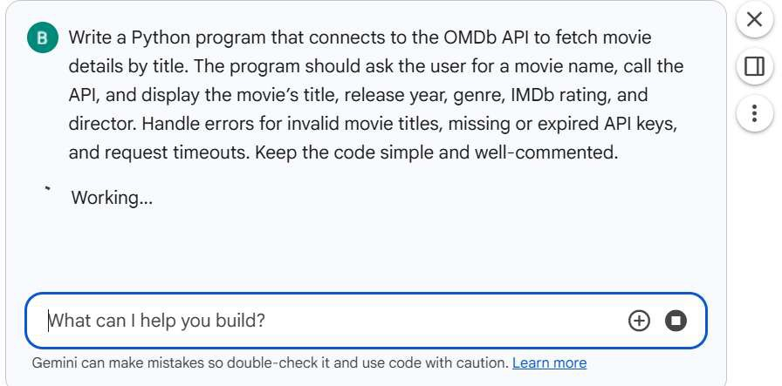

#CODE:

l]
OMDB_API_KEY = "a7166376"
Os

OMDb API Key Setup

To use the OMDb API, you'll need an API key.
- Go to OMDb API and request a free API key.
- Once you have your API key, add it to the Colab secrets manager. Click the "�" icon in the left panel, and add a new secret with the name OMDB_API_KEY and your API key as the value. This ensures your key is stored securely and not directly in your notebook code.

0]
# Import necessary libraries
2s
import requests
from google. col ab import userdata

# Securely retrieve the OMDb API key from Colab secrets
OMDB_API_KEY = userdata. get ( 'OMDB_API_KEY')

# Import necessary libraries import requests
from google. col ab import userdata

# Securely retrieve the OMDb API key from Colab secrets
OMDB_API_KEY = userdata' get ( 'OMDB_API_KEY')

# Check if the API key is available
if not OMDB_API_KEY:
raise ValueError("OMDB_API_KEY not found in Colab secrets. Please add it as instructed above.")

print("OMDb API Key loaded successfully.")

OMOb API Key loaded successfully.

� �1� �� �
0 def get_movie_details(movie_title: str, api_key: str):
Fetches movie details from the OMDb API by title. Args:
movie_title (str): The title of the movie to search for.
api_key (str): Your OMDb API key.

Returns:
rli rt-• /l rlirTir,nl:111"\J r-r,nT::ai.nincr l'l'!r,\1i,::i ric.t-::ailc i-F cMf!S::ll:il�,::i,..1.1io:c


) params =
't': movie_title, tf Search by title
'apikey' : api_key

try:

# Make the API request with a timeout to prevent hanging
response = requests.get(base_url, params=params, timeout=10)
response.raise_for_status() # Raise an HTTPEr-ror for bad responses (4xx or 5xx)

data = response.json()

# Handle OMDb API specific errors
if data. get('Response') == 'False':
error _message = data. get( 'Error', 'Unknown OMDb API error. ' )
# Check for API key issues
if "Invalid API key!" in error _message or "Key expired!" in error _message: print(f"Error: {error_message} Please check your OMDb API key.")
else:
print(f"Error: {error _message} for movie '{movie_title}'. ")
return None

# Extract required details
movie_details = {
'Title' : data. get( 'Title'),

MSH!::11111


'Title': data.get( 'Title'),
)
'Year': data.get( 'Year'),
'Genre': data.get( 'Genre' )J
'IMDb Rating': data.get('imdbRating'), 'Director' : data get ('Director')

return movie_details

except requests. exceptions. Timeout:
print("Error: Request timed out. Please check your internet connection or try again later.") return None
except requests. exceptions. ConnectionError:
print ("Error: Could not connect to the OMDb API. Check your internet connection.") return None
except requests. exceptions. HTTP Error as err:
print(f"Error: HTTP error occurred: {err}") return None
except Exception as e:
print(f"A11 unexpected error occurred: {e}") return None

# - - - Main program execution
wi.a.e..+.+ii
if _name_ == "_main_":
# Ask the user for a movie name

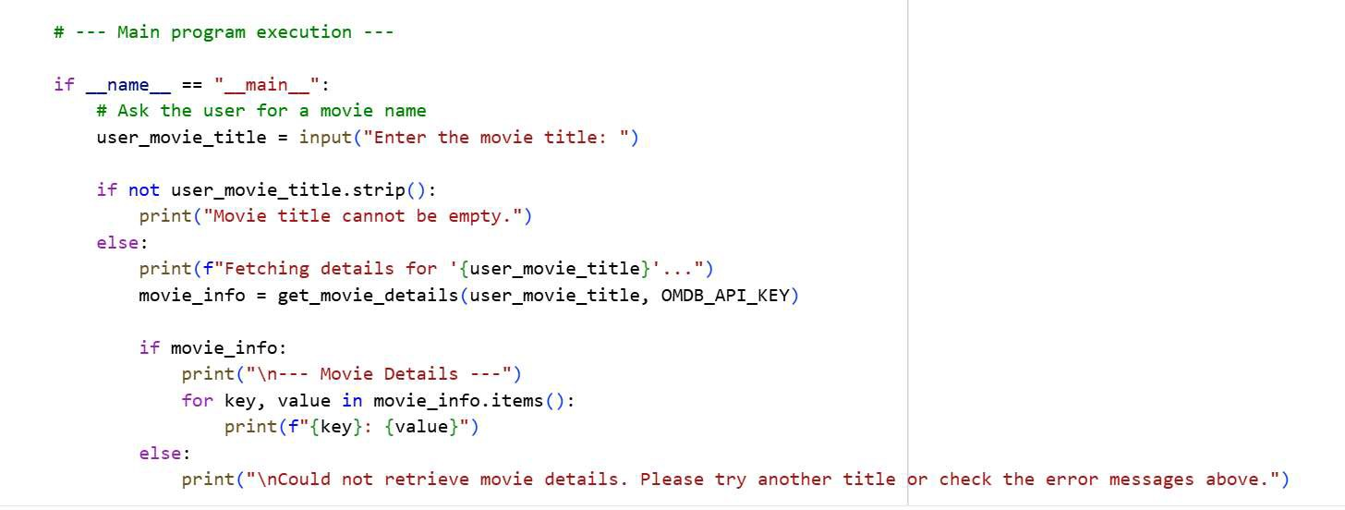

# OUTPUT:


#TASK DESCRIPTION-2:
Public Transport API
Task: Use a Public Transport API (e.g., city bus/train API or mock data) to fetch live arrival times.
Instructions:
- Fetch the next 5 arrivals for a given stop/station ID.
- Handle invalid station codes, unavailable service, and malformed responses.
- Display results in a readable table with route number, destination, and arrival time

#PROMPT:
Write a Python program that connects to a Public Transport API (or uses mock data) to fetch the next 5 arrivals for a given stop or station ID. The program should handle errors such as invalid station codes, unavailable services, and malformed API responses. Display the results in a clean, readable table showing the route number, destination, and arrival time. Keep the code simple, well-commented, and beginner-friendly.
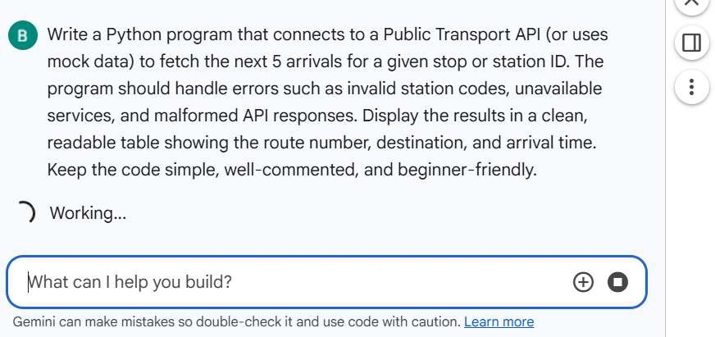

#CODE:

import pandas as pd import time
import random
from datetime import datetime, timedelta def get_mock_arrival_data ( station_id: str):
Simulates fetching public transport arrival data from an API.
Returns mock data for given station_id, simulating errors for certain IDs.

1]
0
- Os
# Simulate network delay
time. sleep (random.uni form(0. 5, l. 5))

if station_id == "INVALI0123":
return {"status"; "error", "message": "Invalid Station ID. Please check the station code."J "code": 404} eli f station_id == "NO_SERVICE":
return {"status"; "error", "message": "No service available at this station currently."J "code": 503} eli f station_id == "MALFORMED":
# Simulate a malformed API response
return {"status"; "success", "data": "This is not valid JSON data for arrivals"} else:
# Generate mock arrival data for a valid station arrivals = []
current_time = datetime. now() for i in ran2e(5):

route_num = f"R{random.randint(l, 99)}"
destination = random. choice( ["Downtown", "Uptown", "Airport", "Central Station", "Suburbia"]) # Generate arrival times in the near future
arrival_time = current_time + timedelta(minutes=random.randint(lJ 30)) arrivals. append({
"route_number": route_num,
"destination": destination,
"scheduled_arrival": arrival_time. strftime ( "%Y-%m-%dT%H:%M :%S")

} )
return {"status": "success", "data": arrivals} print ( "Mock API data function defined.")
Mock API data function defined.

2. Parse and Display Arrival Data

This function will take the data received from our mock API and display it in a user-friendly table. It includes error handling for the different scenarios we defined in the mock API.

2]
- Os def display_arrivals (api_response):
-
Parses the API response and displays the next 5 arrivals in a table.

if not isinstance(api_response, diet) or "status" not in api_response:
print("Error: Malformed API response structure. Expected dictionary with 'status'.") return

if api_response["status"] == "error":
message= api_response.get("message", "An unknown error occurred.") code= api_response.get("code", "N/A")
print(f"API Error (Code: {code}): {message}")

return

if api_response["status"J == "success": data= api_response.get("data")
if not isinstance(data, list):
print("Error: Malformed API response structure. 'data' field is not a list.")
return

if not data:
print("No upcoming arrivals found for this station.")

return

# Prepare data for display parsed_arrivals = []
for arrival in data: try:
route = arrival.get("route_number", "N/A")

destination= arrival.get("destination", "N/A") arrival_time_str = arrival.get("scheduled_arrival", "N/A")

# Format arrival time nicely if arrival_time_str != "N/A":
arrival_dt = datetime.strptime(arrival_time_str, "%Y-%m-%dT%H:%M:%S")
formatted_time = arrival_dt.strftime("%H:%M:%S") # Example: 14:35:01
# Calculate time until arrival time_until = arrival_dt - datetime.now()
minutes_until = int(time_until.total_seconds() / 60)
if minutes_until < 1:
display_time = "Due"
elif minutes_until 1:
display_time "1 min" else:
display_time = f"{minutes_until} mins"
else:
formatted_time "N/A" display_time = "N/A"

parsed_arrivals.append({ "Route": route, "Destination": destination,
"Arrival Time": formatted_time, "Time Until": display_time

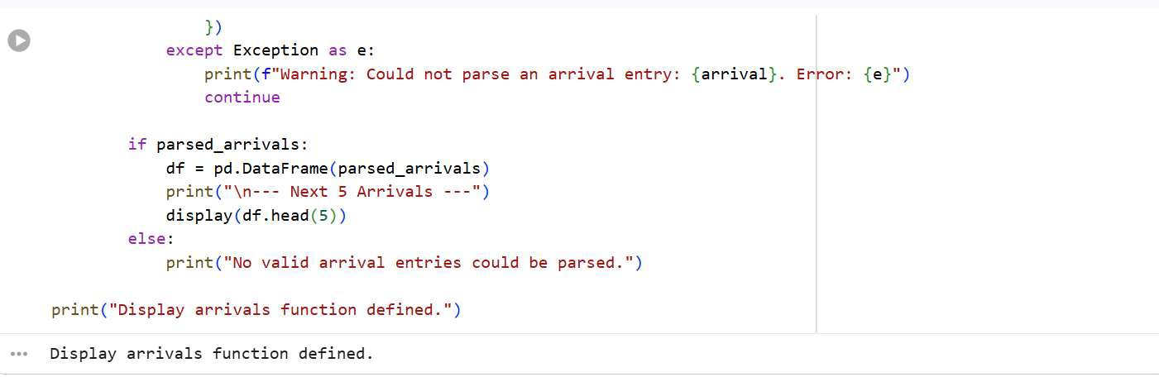
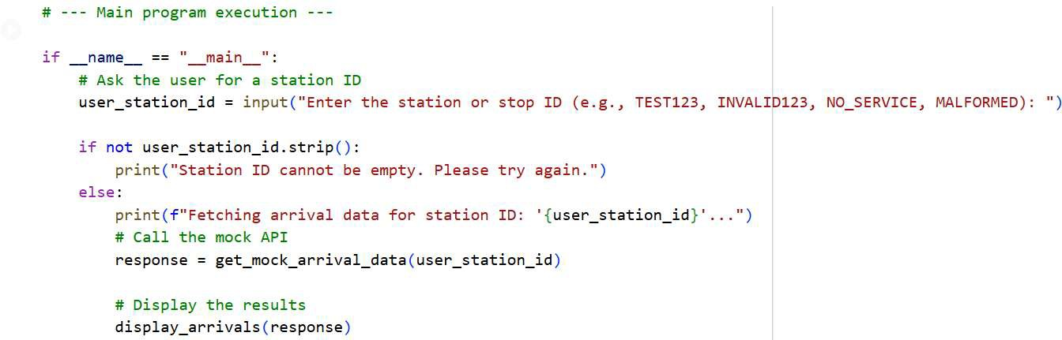

#OUTPUT:
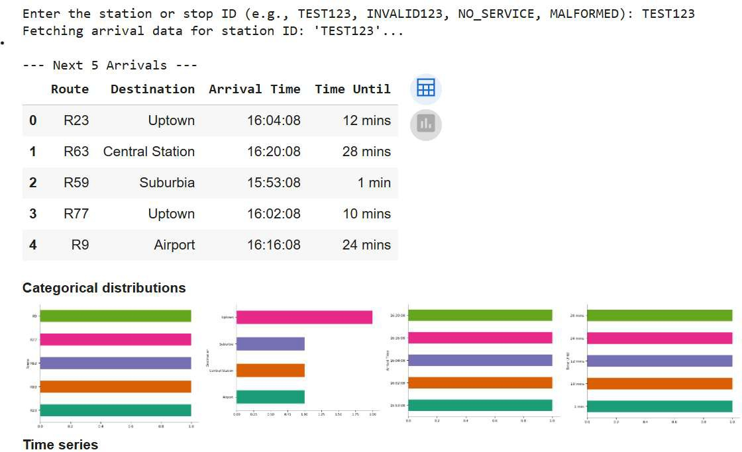

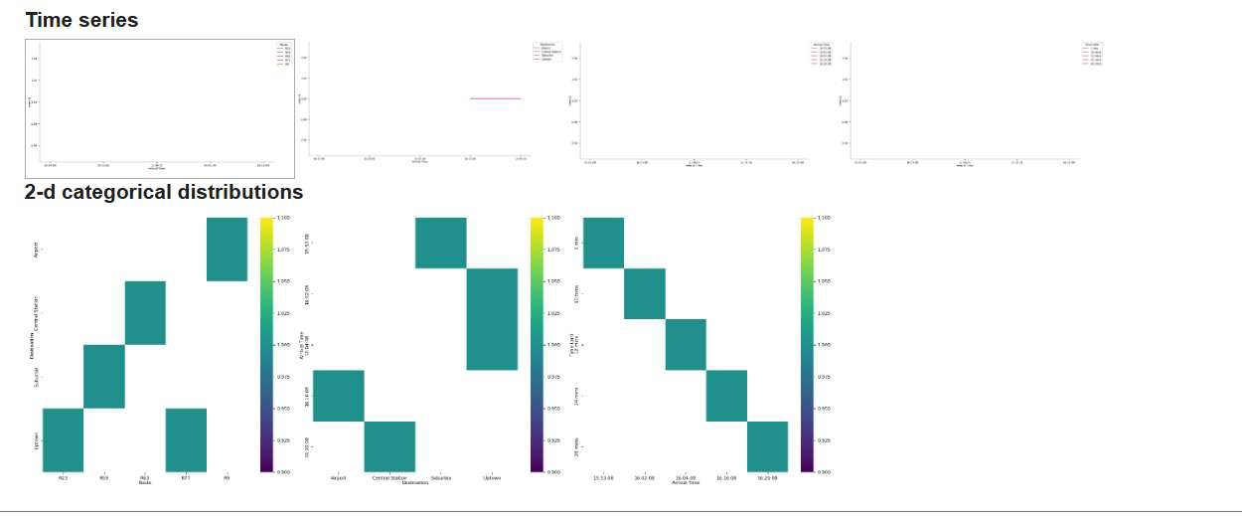

#TASK DESCRIPTION-3:
Stock Market/Financial Data API
Task: Connect to a stock data API (e.g., Alpha Vantage, Yahoo Finance) to fetch daily stock prices.
Instructions:
Prompt AI to generate Python function to query stock data by ticker symbol.
Handle API call limits, invalid ticker symbols, and null responses.
Display opening price, closing price, high, low, and trading volume. Give me perfect and simple prompt for the question

#PROMPT:
Write a Python program that connects to a Stock Market API (such as Alpha Vantage or Yahoo Finance) to fetch daily stock prices by ticker symbol. The program should handle errors like invalid ticker symbols,

API call limits, and null responses. Display the stock’s opening price, closing price, highest price, lowest price, and trading volume in a clear and simple format. Keep the code clean, well-commented, and easy to understand.
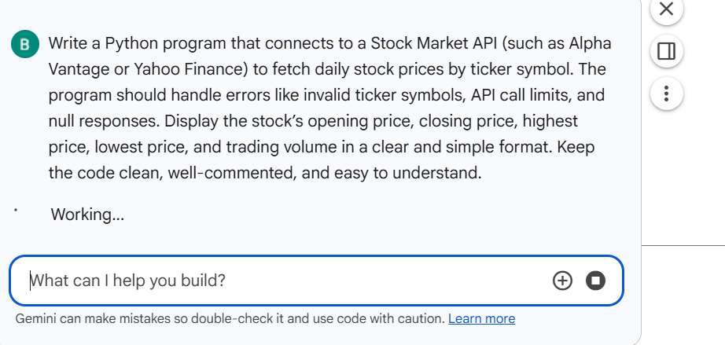

#CODE:
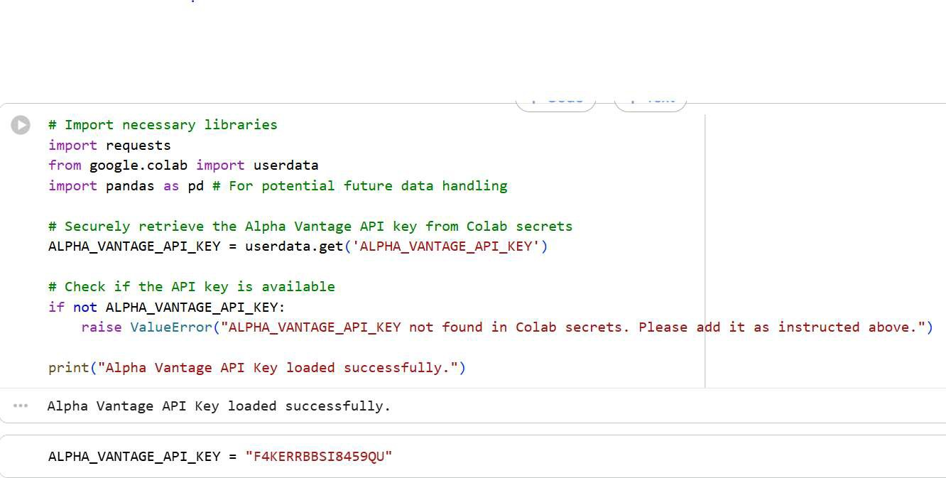

I) def get_stock_prices(ticker_symbol: str, api_key: str):
Fetches daily stock prices from Alpha Vantage for a given ticker symbol. Args:
ticker_symbol (str): The ticker symbol of the stock (e.g., 'AAPL', 'GOOGL').
api_key (str): Your Alpha Vantage API key.

Returns:
diet: A dictionary containing the latest daily stock data if successful, otherwise None.

base_url = "https://www.alphavantage.co/query" params = {
'function': 'TIME_SERIES_DAILY_ADJUSTED',
'symbol': ticker_symbol, 'apikey': api_key,
'outputsize' : 'compact' # Get only the most recent 100 data points
}

try:
response= requests.get(base_url, params=params, timeout=lS) response.raise_for_status() # Raise an HTTPError for bad responses (4xx or Sxx)

data response. j son()

# Handle Alpha Vantage specific error messages
if "Error Message" in data:
print(f"Error: {data['Error Message')} for ticker '{ticker_symbol}'. Please check the ticker symbol or your API key.")

return None

if ''Note'' in data:
print(f"API Note: {data['Note']} for ticker '{ticker _symbol}'. This might indicate API call limits.")

# Depending on the note, you might still get data or need to handle it as an error
# For now, we'll proceed if there's still time series data time_series = data.get('Time Series (Daily)')

if not time series:
print(f"Error: No daily time series data found for '{ticker_symbol}'. Invalid ticker or no data available.")

return None

# Get the latest date available in the time series latest date sorted(time_series.keys(), reverse=True)[0] latest_data = time_series[latest_date]

# Extract and convert to float (or appropriate type) stock_details = {
'Date': latest_date,
'Open': float(latest_data['l. open']),
'High': float(latest_data['2. high']),

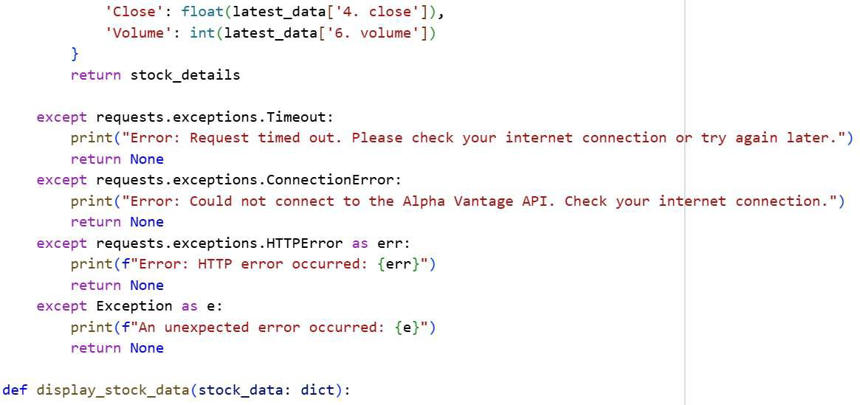
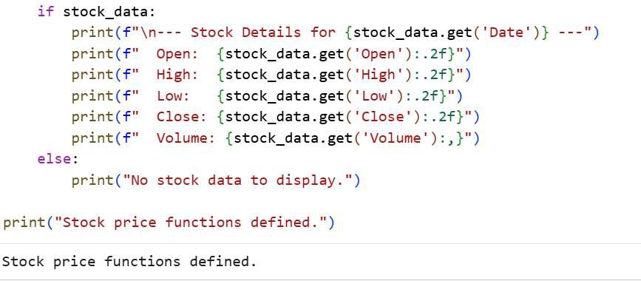
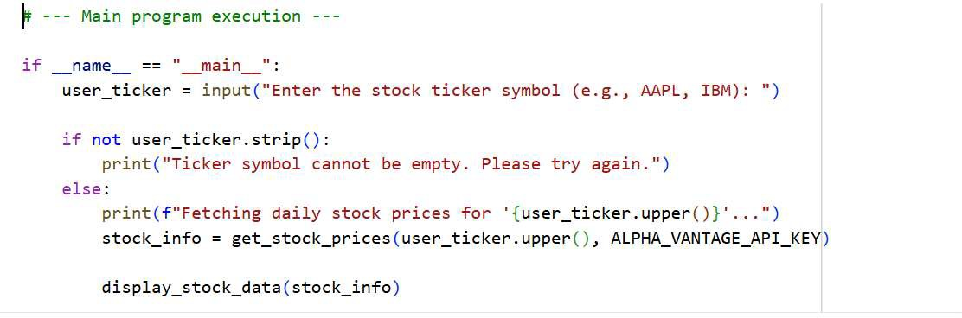

#OUTPUT:

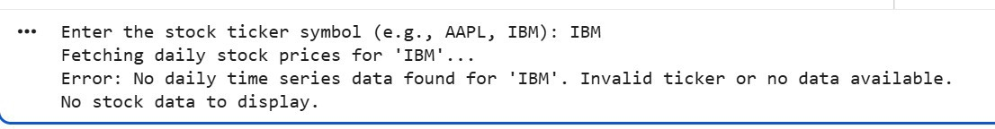

# TASK DISCRIPTION-4:
Real-Time Application: Translation API
Scenario: Build a translator using a free Translation API (e.g., Libre Translate, Google Translate).
Requirements:
Accept input text and target language from the user.
Handle invalid language codes, API quota exceeded, and empty text input.
Display original and translated text clearly.
Implement a retry mechanism if the API fails on the first attempt.

#PROMPT:
Write a Python program that uses a free Translation API (like Libre Translate or Google Translate) to build a simple translator. The program should take text and a target language from the user, then display both the original and translated text clearly. Handle errors such as invalid language codes, empty input, and API quota exceeded. Include a retry mechanism to attempt the translation again if the API request fails the first time. Keep the code clean, well-commented, and easy to understand.

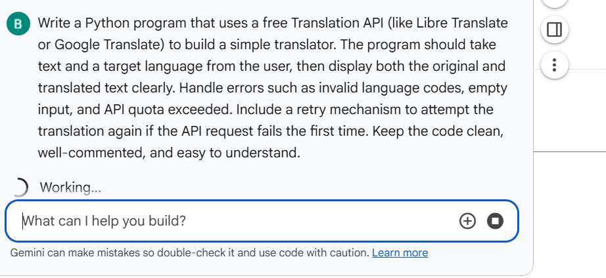

#CODE:
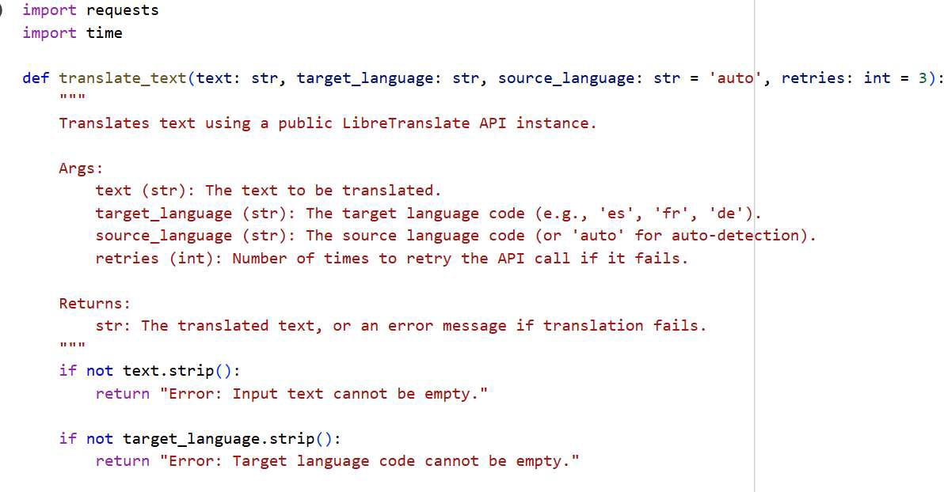

# Using a public LibreTranslate instance. Be aware of rate limits and availability.
# For production, consider self-hosting LibreTranslate or using a dedicated API key service. api_url "https://translate.argosopentech.com/translate"

headers= {
"Content-Type": "application/json"
}
payload= {
"q": text,
"source": source_language, "target": target_language

for attempt in range(retries): try:
response= requests.post(api_url, headers=headers, json=payload, timeout=10) response.raise_for_status() # Raise HTTPError for bad responses (4xx or Sxx)

translation_data = response.json()
translated_text = translation_data.get('translatedText')

if translated_text:
return translated_text else:
# LibreTranslate might return errors in a different format

# LibreTranslate might return errors in a different format
0
error_message = translation_data. get('error', 'Unknown translation error. •)
return f"Translation API Error: {error _message}"

except requests .exceptions. Timeout:
print(f"Attempt {attempt+ 1}/{retries}: Request timed out. Retrying ... ") except requests .exceptions. Connection Error:
print(f"Attempt {attempt + 1}/{retries}: Could not connect to the translation API. Retrying... ")
except requests .exceptions. HTTPError as err: if err.response.status_code == 400:
# Specific handling for 400 Bad Request which oft·enmeans invalid language
print(f"Attempt {attempt+ 1}/{retries}: Invalid language code or bad request (HTTP 400). Please check your language codes. eli f err. response. status_code == 429:
print(f"Attempt {attempt + 1}/{retries}: API quota exceeded or too many requests (HTTP 429). Retrying after a delay ... ") time.sleep(2 *"' attempt) # Exponential backoff
else:
print ( f"Attempt {attempt + l}/ {retries}: HTTP error occurred: {err}. Retrying ... ") except Exception as e:
print(f"Attempt {attempt + 1}/{retries}: An unexpected error occurred: {e}. Retrying ... ")

if attempt < retries - 1:
time.sleep(!) # Short delay before next retry for non-429 errors

return "Error: Translation failed after multiple retries. Please try again later or check your input."

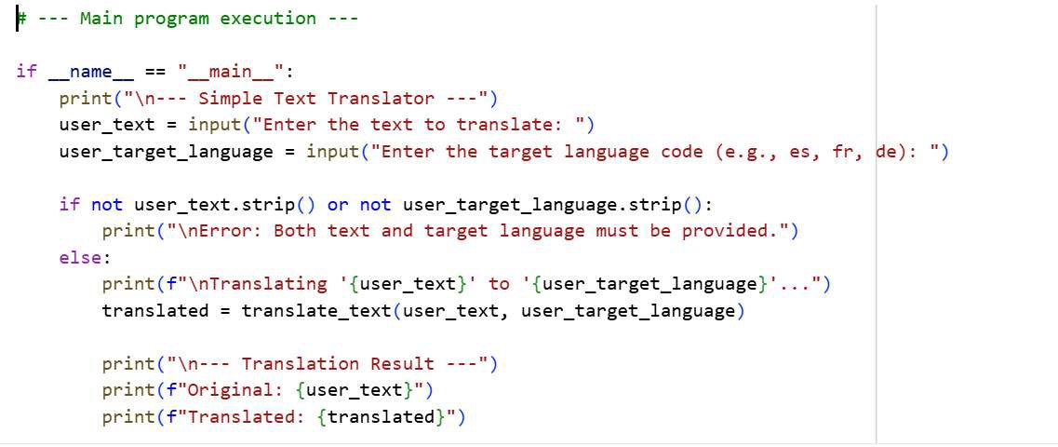

#OUTPUT:
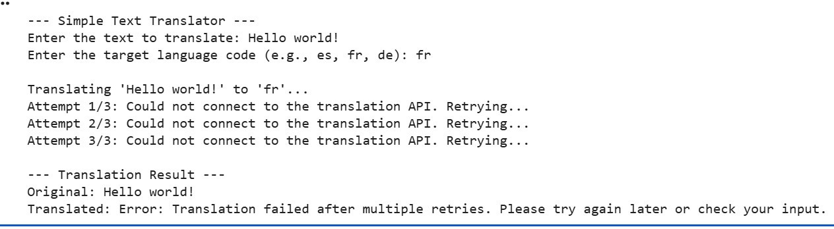

-------- Thank You-------

