COIT12204 Assessment 4: Individual Practical Application of Dual Agent Systems
Md Nur Alam Islam Nafi, Student ID: 12298910
COIT12204 AI-Assisted Software Development, Technical Report

Git repository: https://github.com/mdnafi-6824/COIT12204-A4-task-agent

1. System Overview
In Assessment 3 I built one LangChain agent inside a small task manager. It classifies a task's priority, suggests a due date or writes a weekly summary, behind a FastAPI endpoint. Its evaluation showed the mistakes it makes dates in the past, a date a week away for an overdue task, answers that changed between runs. For this assessment that agent became the Worker and I added a Reviewer that checks every answer before the user sees it. An Orchestrator validates and routes every message, counts the steps, and sends a rejected answer back with the Reviewer's feedback, up to a limit.
So it is a supervisor loop rather than a pipeline. The Worker works, the Reviewer judges, the Orchestrator decides when the conversation is finished. It is exposed through one new endpoint, /api/orchestrator/run, and the A3 dashboard has a new tab that shows every message as it happens.

2. Agent Roles and Responsibilities
Worker. This is the A3 TaskAgent behind the message protocol. execute_task runs one of the three actions. revise_result runs it again with the Reviewer's feedback added to the prompt, so the model fixes the specific problem. Either way it replies to the Reviewer with a review_result message carrying the structured result plus what the Reviewer needs to check it: the real task record, whether the fallback was used, the guardrail warnings and the tools called. If the Worker times out or crashes, its fallback is the rule based answer from A3, which needs no model call.
Reviewer. It accepts review_result and answers the Orchestrator with result_approved or revision_requested. It checks in two layers. The rules run first and always: a date can't be in the past, an overdue task gets a date within three days, a priority has to match the due date rubric unless the owner set one, a summary has to mention overdue work and name an urgent task, and a fallback answer is sent back once so the model gets another go. If the rules pass and the model layer is on, the Reviewer asks the model for a small JSON verdict. The model can add a rejection but can't overturn a rule rejection. If the Reviewer's own model call fails it carries on with the rules and says so.
Both share a base class that checks a message is for them with an intent they accept, and logs it in and out.

3. Communication Protocol Design
Every message is one Pydantic model, AgentMessage:
{"sender": "worker", "receiver": "reviewer", "intent": "review_result",
"content": {"result": {...}, "task": {...}, "fallback_used": false, "warnings": []},
"constraints": {"format": "json", "max_revisions": 2, "timeout_seconds": 45},
"conversation_id": "a1b2c3d4", "step": 1, "in_reply_to": "9f8e7d6c5b", "message_id": "...", "sent_at": "..."}
The schema is validated when a message is built, not when it arrives. A table says which intents each receiver understands, and a message fails if the intent is unknown, the receiver does not accept it, or an agent messages itself. The constraints are bounded too: at most five revisions, a timeout between one second and five minutes. A reply() helper fills in the conversation id, step and in_reply_to, so every message traces back to the one it answers.
The Orchestrator logs ROUTE, each agent logs MSG RECEIVED and MSG SENT, and the Reviewer logs why it approved or rejected, all with the conversation id and step, so one grep on the id gives the whole exchange. The dashboard draws the same messages as bubbles.
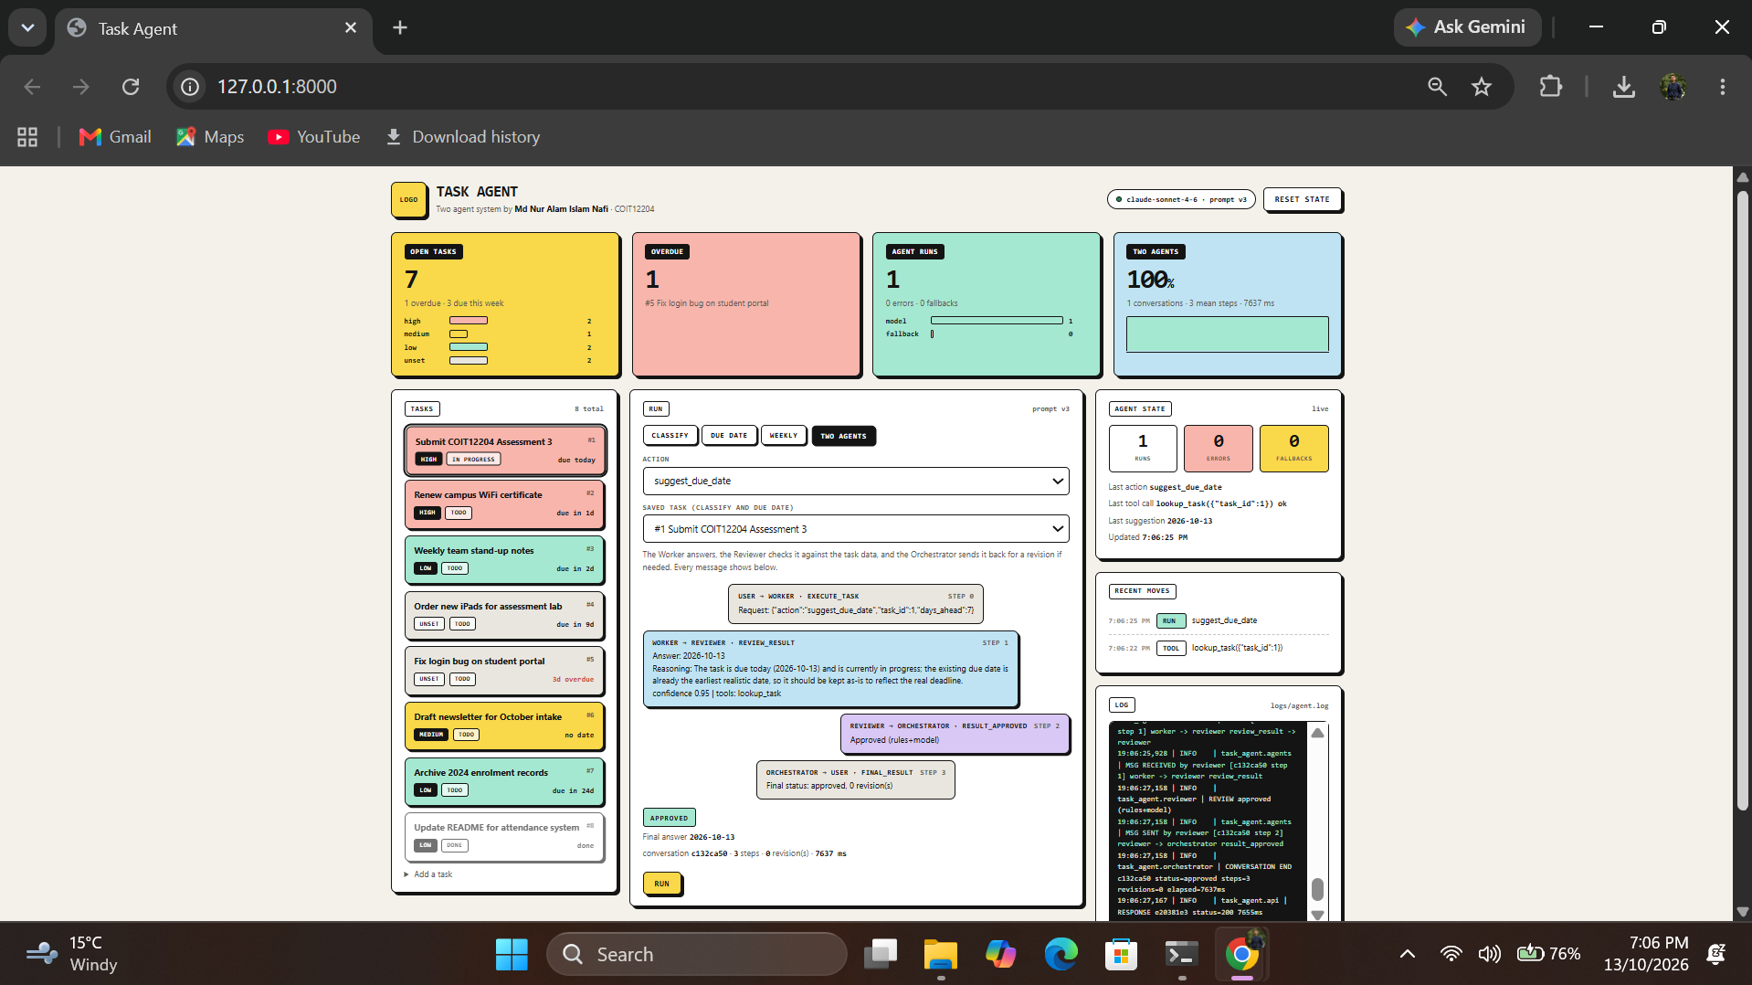
Figure 1: dashboard "Two agents" tab showing a conversation with a rejection and a revision

4. Orchestration Logic
The Orchestrator holds the agents by name. run() creates a conversation, builds the first message (user -> worker, execute_task) and loops. Each turn it routes the current message, appends the reply, and acts on the reply's intent. review_result goes on to the Reviewer. result_approved ends the conversation. revision_requested builds a revise_result message with the feedback and the previous answer, or stops at the revision limit. Anything else is logged as unexpected and the conversation ends with the answer it has. The last message is always orchestrator -> user, final_result, so the hand back is in the log too.
Routing failures are handled in one place. An unregistered receiver is logged as ROUTE ERROR, added to the conversation's errors, and the last good answer is returned as fallback. Every agent call runs in a thread with a deadline from the message constraints. A timeout, an AgentError or any other exception produces an agent_error message and the agent is asked for its fallback. Each conversation keeps counters, a status, the final result and an error list; the last fifty are saved to JSON.
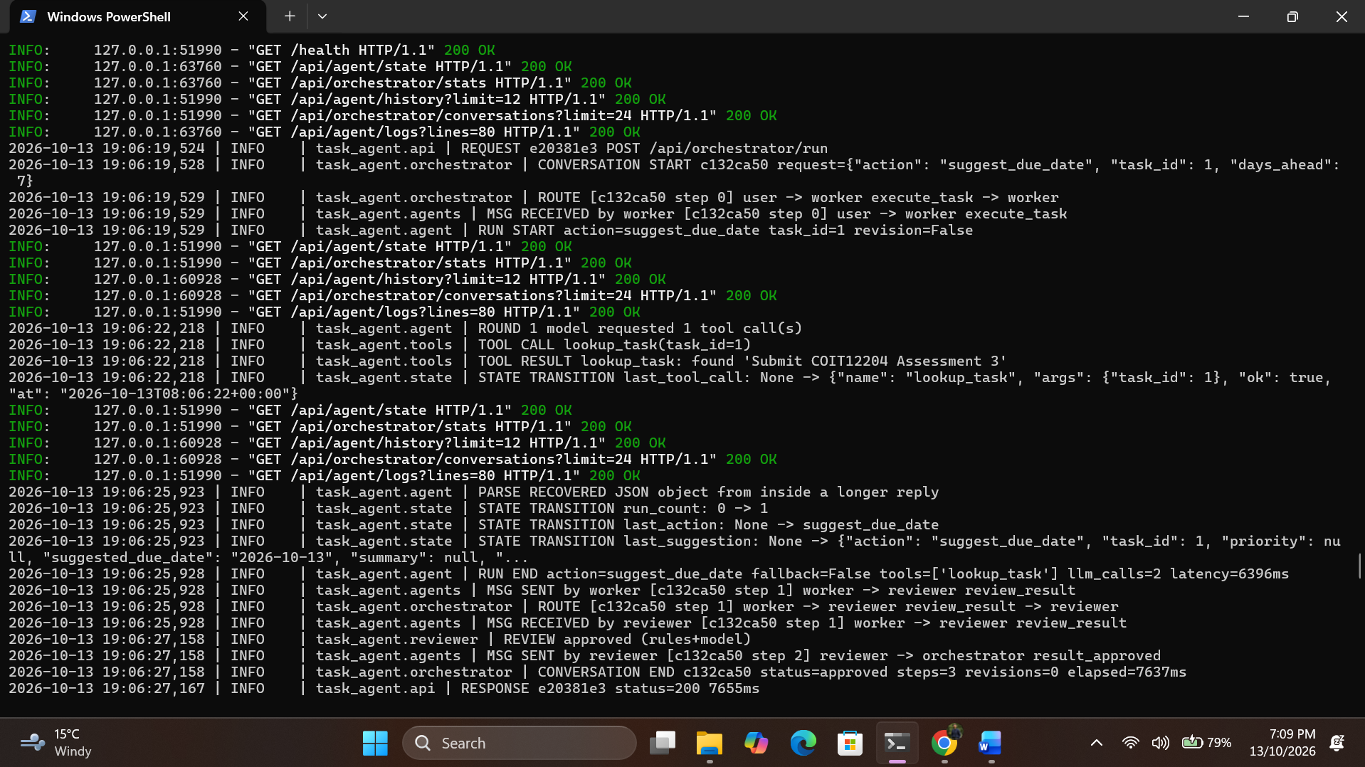
Figure 2: terminal log for one conversation, from CONVERSATION START to CONVERSATION END

5. Resilience Mechanisms
Output validation happens twice. The A3 guardrails run inside the Worker and fix what they can, like moving a past date to today. The Reviewer checks what they cannot, like whether a date is realistic for an overdue task. Max iterations is two limits: MAX_REVISIONS (default 2) caps the review loop, and MAX_STEPS (default 10) is a hard cap on messages in a conversation no matter what. Timeouts are per agent call, 45 seconds by default, enforced by the Orchestrator rather than trusted to the agent. Fallbacks are layered: the Worker falls back to the A3 rules, the Reviewer approves unreviewed with a warning, and the Orchestrator returns the last answer it has with an honest status. Errors are logged as AGENT ERROR, ROUTE ERROR, MSG INVALID and FALLBACK and stored in the conversation so the API response shows them.
All of this is tested without a model. A fake scripts the Worker's model, and the orchestrator tests cover straight approval, rejection and revision, the revision limit, the step cap, a Worker timeout, a Reviewer crash, an unregistered receiver and an agent with no fallback. 116 tests, a few seconds.

6. Evaluation and Failure Analysis
I ran eight cases twice each with Claude Sonnet 4.6 using scripts/evaluate_multi.py, which saves every transcript. I ran it three times, fixing what each run showed, plus a run with the Worker's key broken on purpose.
Run | Approved | Correct | Needed revision | Rejections | Fallbacks | Mean steps | Mean time
First run | 81% | 81% | 3/16 | 9 | 3 | 4.1 | 13.2 s
After fix 1 | 94% | 94% | 2/16 | 5 | 1 | 3.8 | 12.3 s
After fix 2 | 100% | 100% | 0/16 | 0 | 0 | 3.0 | 9.7 s
Worker broken, before | 0% | 0% | 8/8 | 24 | 8 | 9.0 | 10.4 s
Worker broken, after | 100% | 88% | 8/8 | 8 | 0 | 6.0 | 0.8 s
Table 1: two agent evaluation runs. 8 cases, 2 repeats each for the normal runs, Claude Sonnet 4.6 as the Worker and Reviewer model.
Interaction 1, straight approval. Task 2 is marked high and due in two days. The Worker called lookup_task and answered high with confidence 0.98, the rules passed, the model verdict approved. Four messages, about 8 seconds.
Interaction 2, rejection and revision. In the first run the weekly summary was correct, but the Reviewer rejected it with "The task data is None, but the answer references specific tasks with IDs, names, due dates". The Orchestrator sent revise_result with that feedback, the Worker answered again, and the Reviewer rejected it again until the revision limit returned the last answer as max_revisions. The log shows the loop: REVIEW rejected (model), revision 1/2, revision 2/2, CONVERSATION END status=max_revisions steps=9.
Interaction 3, the fallback path. With the Worker's key broken, its answer came from the rule fallback. The Reviewer sent it back once ("The answer came from the worker's fallback rules, not the model. Try again"), the second attempt was also a fallback, and the Reviewer accepted it with the warning "accepted the worker's rule based fallback after one retry". Six messages, under a second, an honest status.
Failure case 1. The summary rejections were my bug. For a weekly summary there is no single task, so the Reviewer's model got task data: None and rejected every correct summary as invented. Passing it the task list the Worker's tools see fixed most of it. One revision still happened, because the Worker said "8 tasks in total" from summarise_tasks while the Reviewer only saw the 4 due that week, so it called the total fabricated. Adding the totals to the context removed the last rejection.
Failure case 2. With the Worker broken, the first design never finished. The rules accepted the second fallback as intended, but the model layer rejected it because the reasoning literally says "fallback" and "authentication error". All eight conversations hit max_revisions after 24 rejections. A smaller one in run two: a 580 character Reviewer feedback tripped the Worker's 500 character input guardrail and crashed the revision. The Orchestrator logged AGENT ERROR, used the Worker's fallback and still finished approved, so the resilience path worked, but it should not have been needed.
Improvements after debugging. First, the Reviewer skips the model layer for a fallback answer on a revision, since the rules have already decided to accept it. That took the broken Worker run from 0% approved in 9 steps to 100% in 6. Second, the Worker trims Reviewer feedback to the guardrail limit instead of crashing. I also added "failed" and "overheat" to the fallback's urgent words after the broken run called "Server room aircon failed" medium.
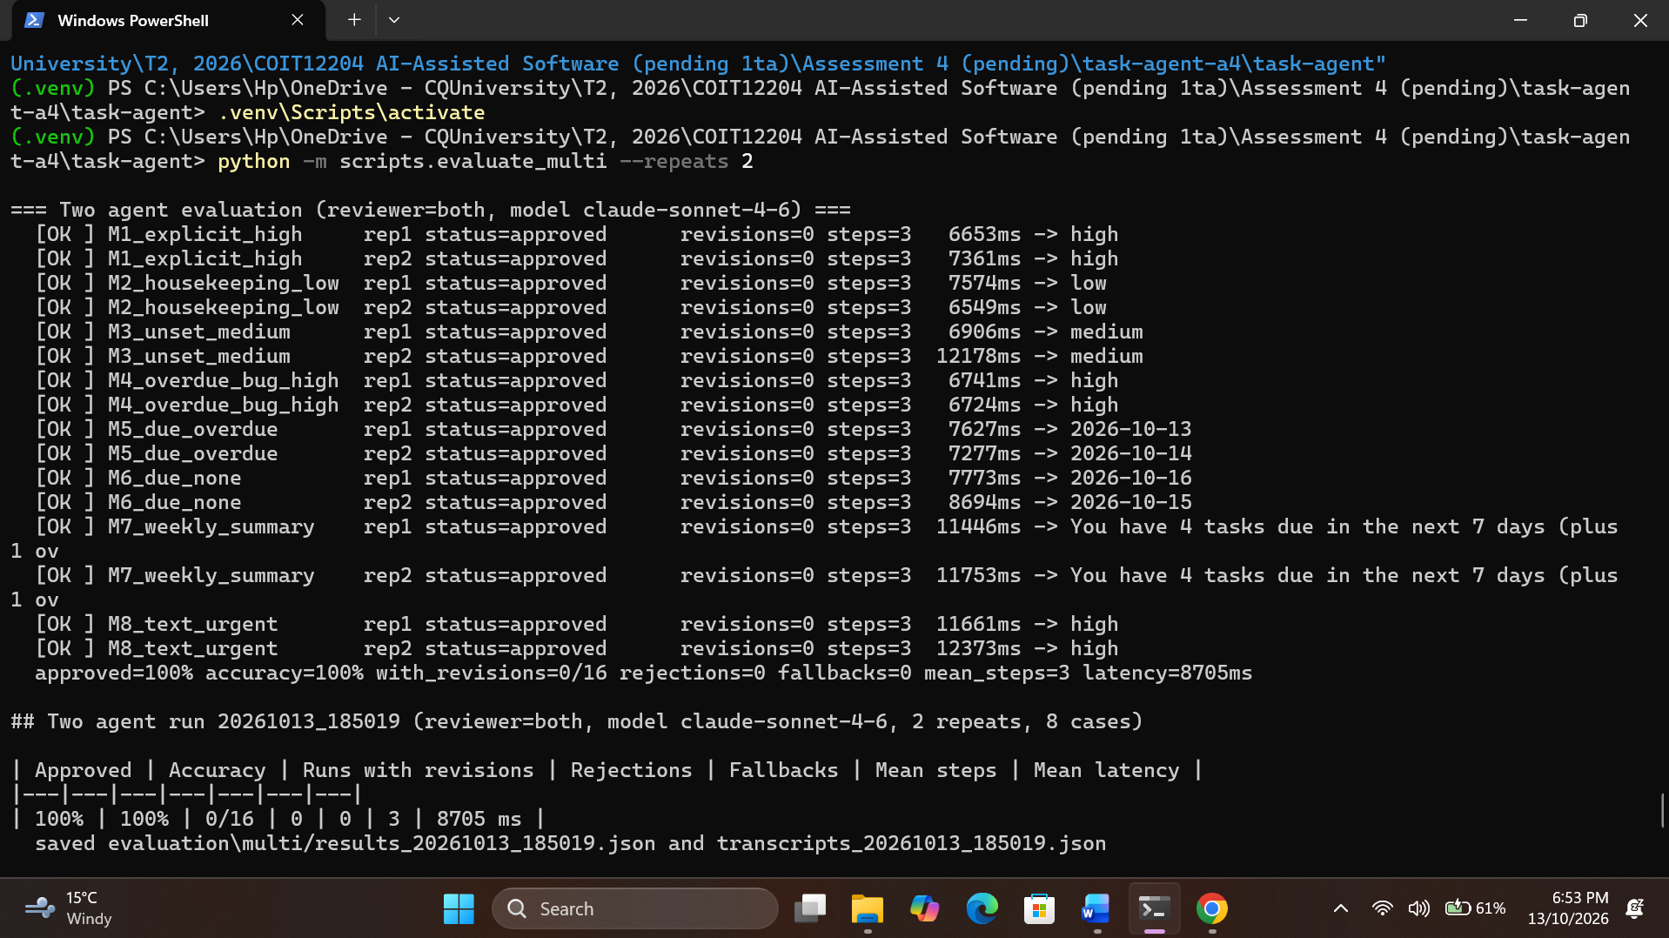
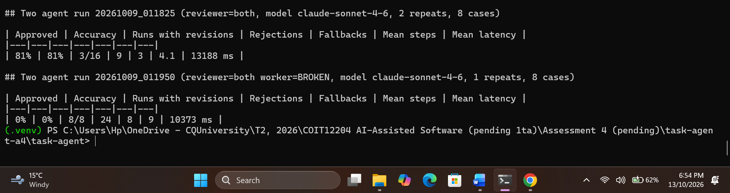
Figure 3: evaluation console output, first run and final run tables

7. Improvements and Future Work
Next, I'd add a Planner agent that breaks "prepare my week" into subtasks and feeds them to the Worker, so the Reviewer sees a whole plan. I'd move the conversation store to SQLite so several API workers could share it and add a reviewer confidence score so borderline answers go to a person instead of back to the Worker. Eight cases twice is a small evaluation; a bigger set with deliberate traps would show how often the Reviewer rejects good answers.

AI assistance declaration
I used ChatGPT to help write and debug the Python code and to draft parts of this report. I ran all the evaluations myself, recorded the failure cases from my own runs, and took all the screenshots from my own laptop.

