COIT12204 Assessment 3: Individual Practical Application of Single Agent Systems
Md Nur Alam Islam Nafi 12298910
COIT12204 AI-Assisted Software Development, Technical Report

1. Introduction
For this assessment I built a single LangChain agent that lives inside a small task manager. The agent does three jobs. It can classify how urgent a task is, it can suggest a due date, and it can write a short summary of what is due in the coming week. A user doesn't talk to the agent directly. The task manager calls it through a FastAPI endpoint, gets back structured JSON, and shows that to the user.
The system has four layers. At the bottom is a JSON file of tasks and three tools that read it. Above that is the agent, which takes a prompt template, binds the tools to the model (Claude Sonnet 4.6 through LangChain) and runs a small loop until the model gives a final answer. Next to the agent is an AgentState object that records what happened on every run. On top is the FastAPI app with validation, error handling and logging. If the model fails for any reason, a rule based fallback still returns a valid answer, so the endpoint doesn't break.
AI assistance. I used Claude (Anthropic) throughout this project: to discuss LangChain and LangGraph API design choices, to help draft and debug test fixtures such as FakeChatModel, and to review this report's structure. All code, prompts and evaluation results were run and checked by me; the analysis and conclusions in Section 6 are based on my own evaluation runs.

2. Agent Design
I used LangChain core components rather than a prebuilt agent class so I could see and log every step. The chain is ChatPromptTemplate | llm.bind_tools(TOOLS). One factory function returns ChatAnthropic or ChatOpenAI depending on a setting. I ran everything on Claude Sonnet 4.6. The template has a system message and a MessagesPlaceholder for the conversation. The JSON schema for the answer comes from PydanticOutputParser, and I inject it as a partial variable. The schema has curly braces, and the template would treat those as placeholders.
There are three tools, all written with @tool. lookup_task returns one task by id, or an error dictionary if the id doesn't exist. list_open_tasks returns tasks that are overdue or due within a given number of days. summarise_tasks returns counts by status and priority. LangChain reads the type hints and docstrings to build the schema the model sees, so the docstrings are written for the model. Tools return error dictionaries instead of raising, so the model gets a chance to explain the problem.
The agent's output is a Pydantic model called AgentResult. It has the action, optional task id, priority, due date and summary fields, a short reasoning string and a confidence between 0 and 1. One schema for every action keeps the endpoint code simple.
The execution flow is in TaskAgent.run(). It builds a human message for the action. For a saved task it only gives the id, so the model has to call lookup_task rather than guess, then invokes the chain. If the reply contains tool calls, each one is executed with tool.invoke, the result goes back as a ToolMessage, and the chain runs again. This is capped at three rounds. When the model answers in text, the parser turns it into an AgentResult. If parsing fails, the agent asks once more for JSON only. If that also fails, or the model raised an exception, the rule based fallback takes over. Output guardrails then check the result, for example moving a past due date up to today and recording a warning.
The system prompt went through three versions. Version 1 was two sentences plus the schema. Version 2 added rules about using tools and answering in JSON only. Version 3 added a priority rubric, date rules and confidence guidance. All three are kept in prompts.py so the evaluation script can compare them.

3. State Management
AgentState is a dataclass in its own module. It tracks seven variables: run count, error count, fallback count, last action, last suggestion, last tool call, and a history list. Every change goes through one method, _transition(), which compares the old and new value and writes a log line like STATE TRANSITION error_count: 0 -> 1. If the value hasn't changed, nothing is logged, which keeps the log readable.
The agent reports two kinds of event. record_tool_call() runs after every tool and stores the name, arguments and whether it succeeded. record_run() runs once at the end of every run() call, whether it succeeded or fell back. It bumps the run count, sets the last action and last suggestion, and increments the error and fallback counters when needed. The history list is capped at 50 entries so it can't grow forever, but the counters keep counting.
For persistence I chose a JSON file. After every run the state saves itself to data/agent_state.json, and the API loads it again on start up. If the file is missing or corrupt, the state starts fresh and logs a warning instead of crashing. I did consider SQLite, but one JSON document was enough for one agent and it's easy to read during a demo.
A typical transition looks like this. Before the first call the snapshot shows every counter at zero. After a successful classify call the log shows run_count: 0 -> 1, last_action: None -> classify_priority, last_tool_call set to lookup_task, and last_suggestion holding the JSON result. If the next call times out, the log adds error_count: 0 -> 1, fallback_count: 0 -> 1 and last_error with the exception name.
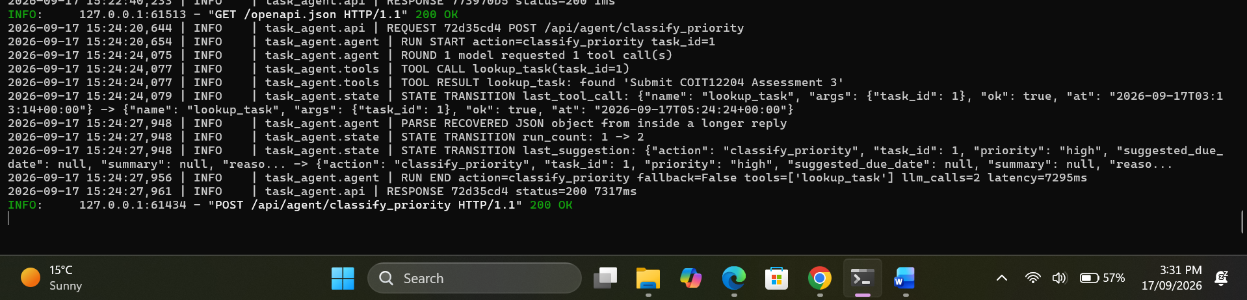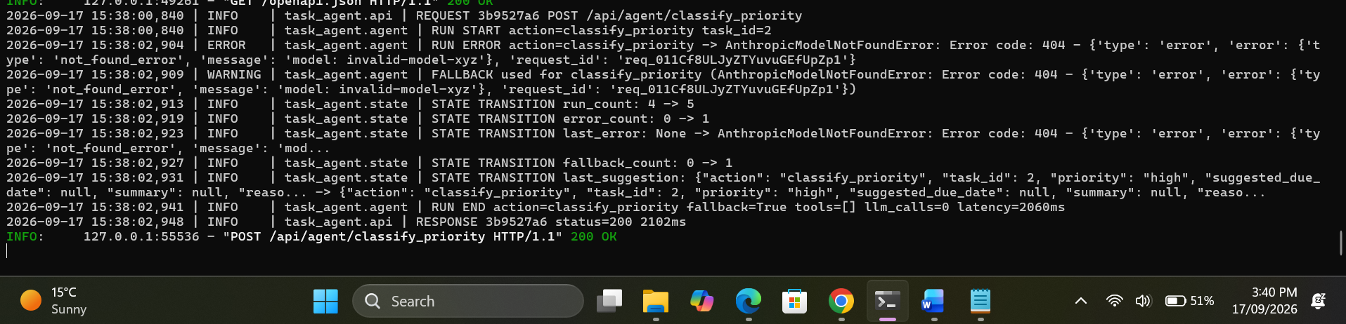
Figure 1: terminal log showing STATE TRANSITION lines for a success followed by a fallback

4. Endpoint Integration
The FastAPI app is built by a create_app() factory. The factory accepts an optional store, state and agent, which is how the tests inject fakes. In production it loads the store and saved state and builds the agent inside the lifespan handler, so nothing heavy happens at import time.
Three agent endpoints are exposed: /api/agent/classify_priority, /api/agent/suggest_due_date and /api/agent/weekly_summary. There are also state, history, log and reset routes, plus task CRUD. A small dashboard at the root URL uses those routes to show the state, history and log live, which is the visual debugging bonus item.
Validation is done with Pydantic request models. Task ids must be at least 1, days ahead 1 to 30, and the classify request needs either a task id or a title, enforced by a model validator. The endpoint checks the task exists before calling the agent, returning 404 if not, and an input guardrail rejects free text over 500 characters or anything resembling a prompt injection, returning 400.
Exception handlers give every error the same shape: an error string, a detail string and the request id. Validation errors return 422, guardrail rejections 400, unknown tasks 404, and anything unexpected 500 with the exception type but not the traceback. Model failures don't reach the client as errors at all; the agent falls back and the endpoint still returns 200 with fallback_used set to true.
A middleware gives each request an eight character id, logs the method and path on the way in, and the status and duration on the way out. The same id goes into the response body and the X-Request-ID header, so a log line can be matched to the call that produced it.
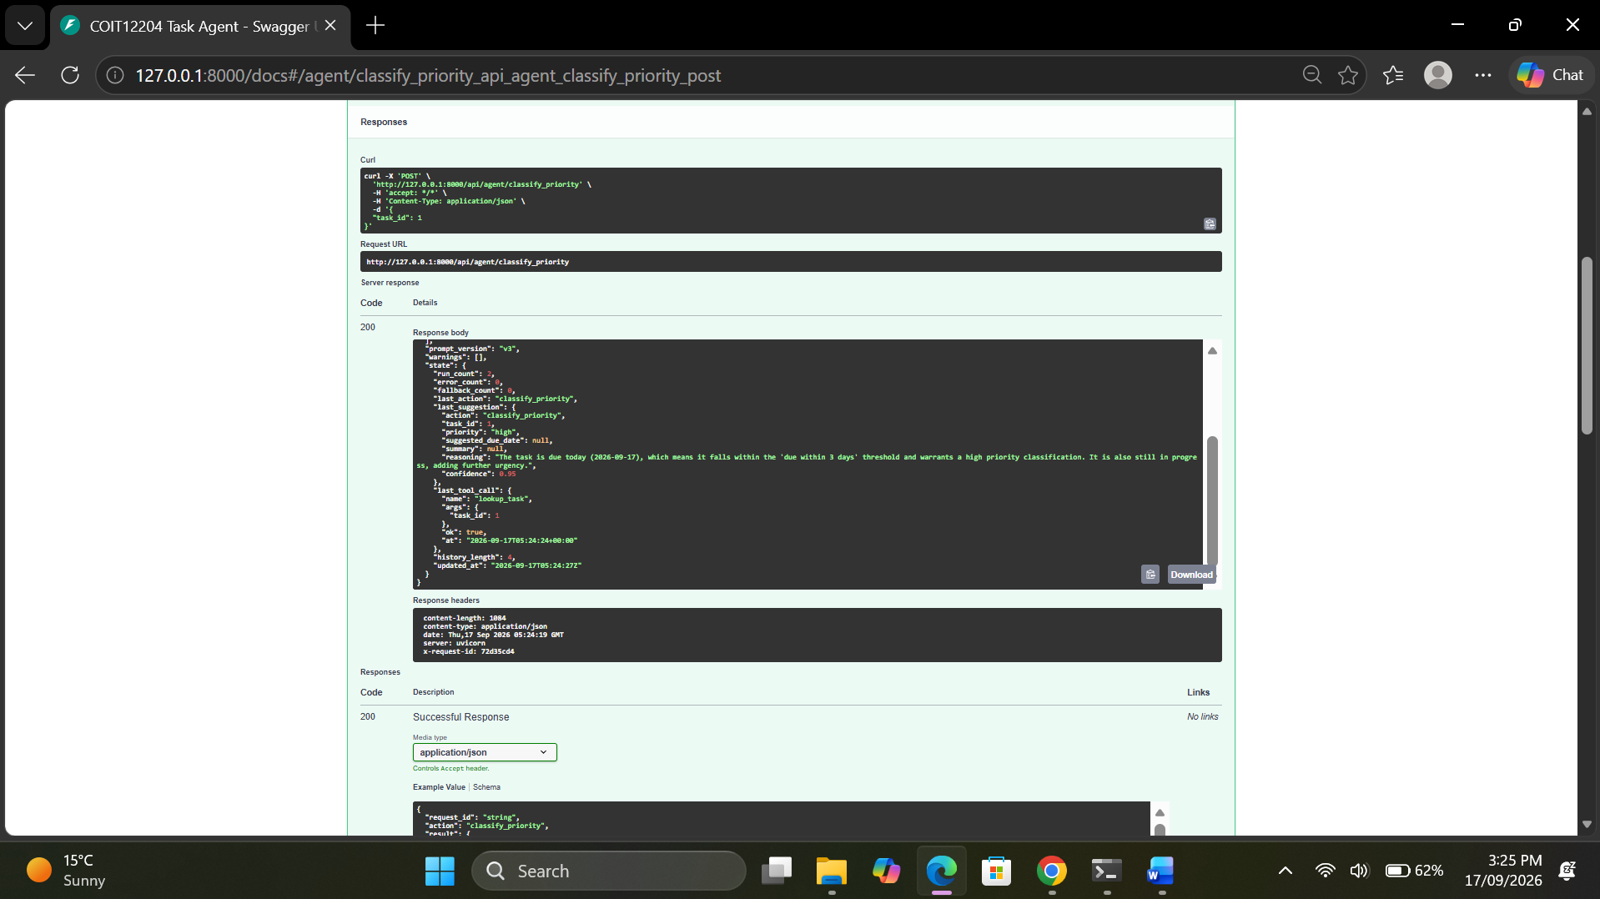
Figure 2: Swagger UI response for classify_priority showing result, tools_called and state

5. Testing Strategy
The suite has 64 tests across four files and runs in under a second with no network. The main thing mocked is the model. tests/fakes.py defines FakeChatModel, a subclass of LangChain's BaseChatModel that replays a scripted list of AIMessage objects. A script can be a tool request, a JSON answer, prose, or an exception. Because it is a real chat model subclass it plugs into the same prompt | llm.bind_tools() chain, so the code under test is the production code. conftest.py uses monkeypatch to replace app.agent.get_llm with a factory that returns the fake, so no test can reach Anthropic or OpenAI. An autouse fixture patches it first with a fake that raises, so any test that reached the real model would fail loudly. The date is frozen to 15 September 2026 by patching today(), so the due date maths is repeatable.
The tool tests call each tool through .invoke() and check the returned dictionaries, the missing id case, and the log lines. The state tests check every counter, the history cap, that unchanged values do not log, that the JSON file round trips, and that a corrupt file starts fresh. The agent tests cover the full flow: a tool call followed by a JSON answer, JSON buried inside a chatty reply, prose followed by a successful retry, two bad answers ending in fallback, an exception ending in fallback, an unknown tool name, a tool error passed back to the model, the tool round limit, the past date guardrail, and prompt injection rejection. The endpoint tests use TestClient and check each route's happy path, four kinds of invalid body, the 404 and 400 paths, a model failure returning 200 with fallback, the state endpoints, and through caplog that request and state log lines carry the right request id.
Some things can't be unit tested. Whether the real model picks the right priority, calls a tool when it should, or returns valid JSON depends on the model, so the evaluation script measures those instead. Latency and rate limits are also outside the tests.
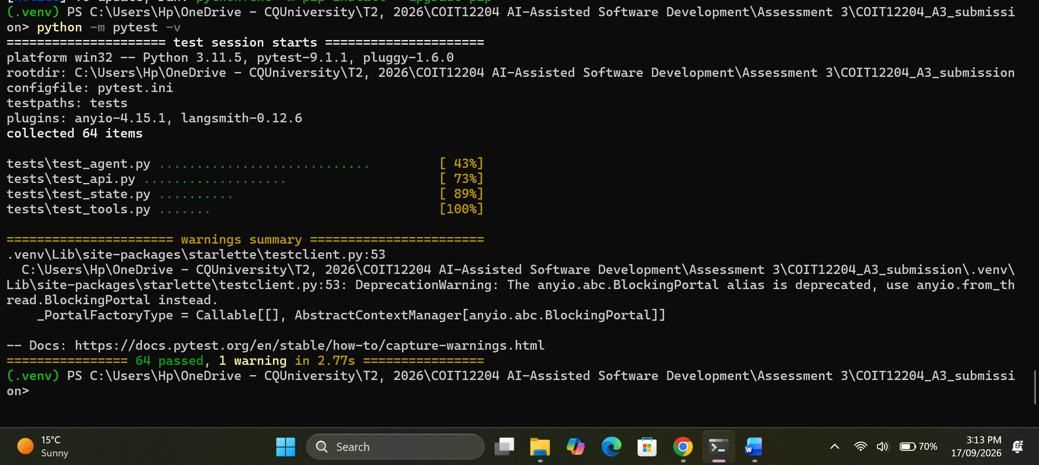
Figure 3: pytest -v output

6. Evaluation of Agent Behaviour
I wrote scripts/evaluate.py to run ten fixed cases against Claude Sonnet 4.6 for each prompt version, twice each. The cases cover clear high and low priority tasks, an unset priority, an overdue task, free text, two due dates, a weekly summary, and a missing task id. Each run records whether the output parsed, whether the answer was correct, which tools were called, whether a retry was needed, and the latency.
Prompt | Parsed | Accuracy | Tool use | Runs needing retry | Consistency | Mean latency
v1 | 100% | 100% | 100% | 16/20 | 90% | 13.1 s
v2 | 95% | 90% | 100% | 13/20 | 80% | 12.7 s
v3 | 100% | 100% | 100% | 15/20 | 100% | 10.3 s
v3 after code fixes | 100% | 100% | 100% | 0/20 | 100% | 7.0 s
Table 1: evaluation results, 10 cases, 2 repeats each, Claude Sonnet 4.6
Accuracy and reliability. Sonnet got the answer right in every run but two, and it never invented a priority for the missing task. It said the task did not exist and set confidence to 0.0. So accuracy wasn't the problem. Reliability was. Only one run out of 60 fell back, but most needed an extra model call.
State behaviour. Across all 60 evaluation runs the state counters matched the trace exactly: run_count incremented once per call, error_count and fallback_count only rose on the single real fallback, and the capped history list kept the most recent entries without losing any counter.
Failure cases. First, in almost every run the model wrote "Here is the priority classification for task 2:" before the JSON, inside a code fence my parser only stripped at the start of a reply, costing a retry — why 16 of 20 v1 runs needed one. Second, under v2 the model narrated its reasoning as a markdown list; on the overdue task it did this twice and fell back to the rule, which suggested a date a week away. Third, v2 called tools it didn't need, like list_open_tasks for a due date, and gave inconsistent due dates for task 6 (15 October vs 13 October), with the overdue task getting 21 September instead of today or tomorrow.
Prompt refinements. Refinement one (v2) told the model to reply with only JSON and to call lookup_task first — it didn't help; retries barely dropped and tool use went up. Refinement two (v3) added today's date and a rule that a suggested date must never be in the past. Refinement three (v3) added the priority rubric and confidence guidance, together taking consistency from 80% to 100%.
Improvements after evaluation. First, the parser now finds the first balanced JSON object anywhere in the reply, taking v3 from 15 retries to 0 and latency from 10.3 to 7.0 seconds. Second, the fallback for an overdue task now suggests tomorrow rather than today plus seven, since the one real fallback gave a bad date for an already late bug.
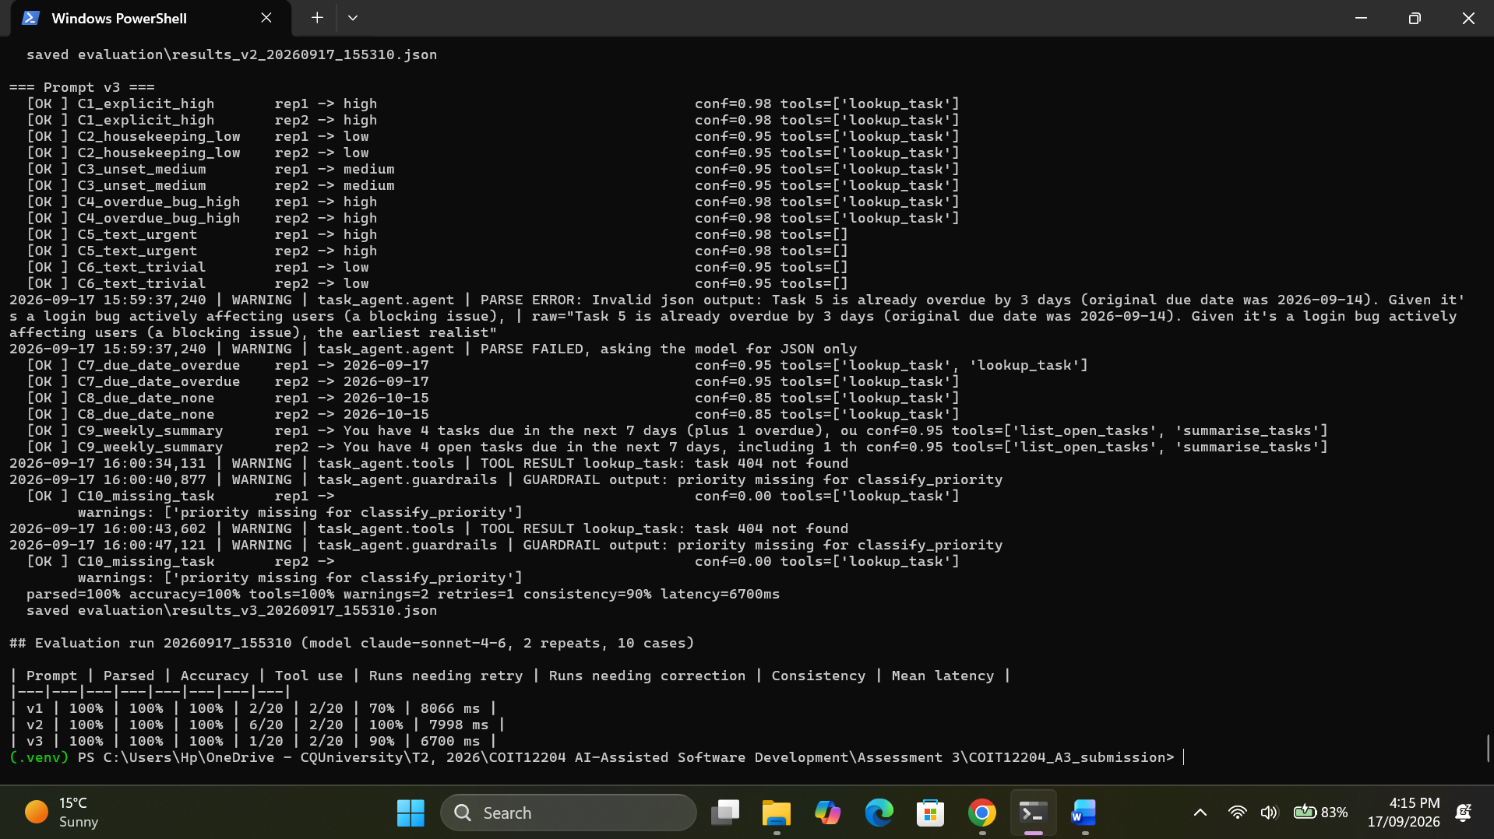
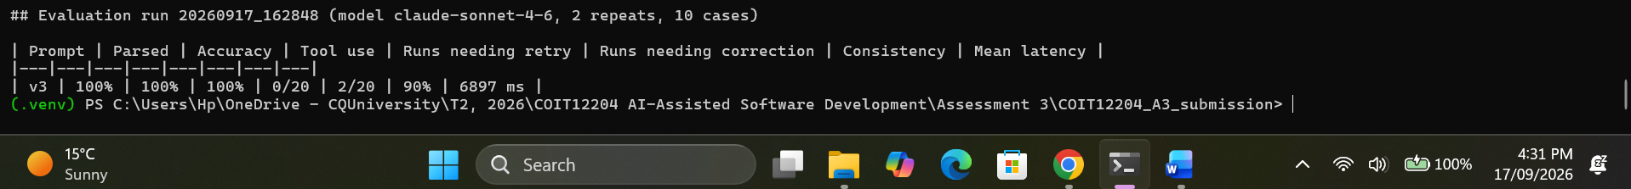
Figure 4: evaluation console output showing the v3 table before and after the fixes
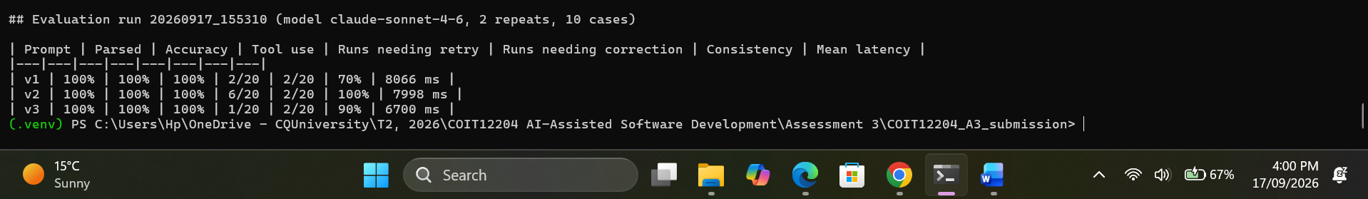
Figure 5: a follow-up evaluation run (all three prompt versions, 2 repeats) showing the same 100% accuracy but consistency varying between 70% and 100% across prompts, reinforcing that ten cases with two repeats is a small sample.

7. Conclusion
The main thing I learned is that the model is the least reliable part of the system, and everything around it must assume that. Structured output, tool results fed back through messages, a bounded loop, a fallback, and state that records every outcome made the agent something I could test and reason about. Writing the fake model taught me more about how LangChain chains work than the real calls did.
If I had more time, I'd move the state to SQLite so several API workers could share it, add a second agent that reviews the first one's answer, and add a chart of retries and latency over time to the dashboard. I'd also grow the evaluation set past ten cases, because two repeats of ten cases is a small sample for measuring consistency.

