**Name : Md Najrul Md Taj Miyan**

**Class : MCA Sem 2**

**Seat No. : 2012204**

**Roll No. : MCA2024022**

**Subject : AI ML**

1. **Implement voting method on titanic dataset by taking random forest as the base estimator**

**import pandas as pd**

**import numpy as np**

**from sklearn.ensemble import RandomForestClassifier, VotingClassifier**

**from sklearn.model_selection import train_test_split**

**from sklearn.metrics import accuracy_score**

**from sklearn.preprocessing import LabelEncoder**

**import seaborn as sns**

**df = sns.load_dataset('titanic')**

**df.head()**

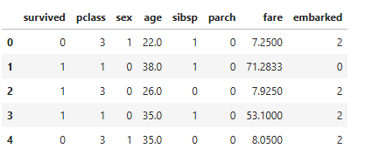

**df = df[['survived', 'pclass', 'sex', 'age', 'sibsp', 'parch', 'fare', 'embarked']]**

**df.dropna(inplace=True)**

**le_sex = LabelEncoder()**

**df['sex'] = le_sex.fit_transform(df['sex'])**

**le_embarked = LabelEncoder()**

**df['embarked'] = le_embarked.fit_transform(df['embarked'])**

**X = df.drop('survived', axis=1)**

**y = df['survived']**

**X_train, X_test, y_train, y_test = train_test_split(X, y, test_size=0.2, random_state=42)**

**rf1 = RandomForestClassifier(n_estimators=50, random_state=1)**

**rf2 = RandomForestClassifier(n_estimators=100, max_depth=5, random_state=2)**

**rf3 = RandomForestClassifier(n_estimators=200, max_depth=10, random_state=3)**

**voting_clf = VotingClassifier(estimators=[**

**('rf1', rf1),**

**('rf2', rf2),**

**('rf3', rf3)**

**], voting='hard')**

**voting_clf.fit(X_train, y_train)**

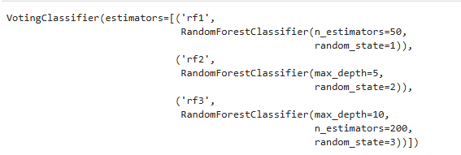

**y_pred = voting_clf.predict(X_test)**

**acc = accuracy_score(y_test, y_pred)**

**print(f"Voting Classifier Accuracy: {acc:.4f}")**



1. **consider the data EMPName=[['Ram','Arun','smita','david'],Age:[29,45,38,52],Department:['sales','marketing','operations','it']]'**

**perform the following transformations:**

**1) create dataframe from the above set of lists**

**2) insert a new column 'Age group' with labels ['young','middle-aged','senior']**

**3) create dummy variable for the categorical feature 'city'**

**import pandas as pd**

**EMPName = ['Ram', 'Arun', 'Smita', 'David']**

**Age = [29, 45, 38, 52]**

**Department = ['sales', 'marketing', 'operations', 'it']**

**City = ['Mumbai', 'Delhi', 'Bangalore', 'Chennai']**

**data = {**

**'EMPName': ['Ram', 'Arun', 'Smita', 'David'],**

**'Age': [29, 45, 38, 52],**

**'Department': ['sales', 'marketing', 'operations', 'it'],**

**'City': ['Mumbai', 'Delhi', 'Bangalore', 'Chennai']**

**}**

**df = pd.DataFrame(data)**

**print(df)**

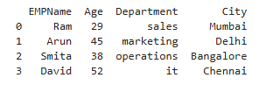

**def age_group(age):**

**if age < 35:**

**return 'young'**

**elif age < 50:**

**return 'middle-aged'**

**else:**

**return 'senior'**

**df['Age group'] = df['Age'].apply(age_group)**

**print("\nDataFrame with 'Age group':\n", df)**

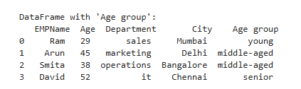

**df_dummies = pd.get_dummies(df, columns=['City'], prefix='City')**

**print("\nDataFrame with dummy variables for 'City':\n", df_dummies)**

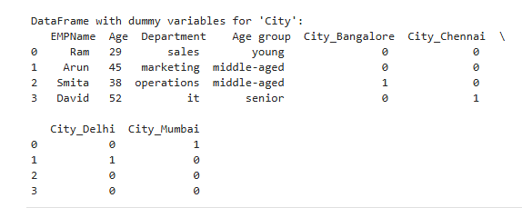

1. **Write a prolog program to solve water jug problem**

**Code:**

**water_jug(X,Y):-X>4,Y>3,write('4l jug overload'),nl.**

**water_jug(X,Y):-X<4,Y>3,write('3l jug overload'),nl.**

**water_jug(X,Y):-X>4,Y>3,write('both jug overloaded'),nl.**

**water_jug(X,Y):-(X=:=0,Y=:=0,nl,write('4L:0 & 3L:0 (Action: fill 3l jug.)'),YY is 3,water_jug(X,YY));**

**(X=:=0,Y=:=0,nl,write('4L:4 & 3L:0 (Action: fill 4l jug.)'),XX is 4,water_jug(XX,Y));**

**(X=:=2,Y=:=0,nl,write('4L:2 & 3L:0 (Action: goal.)'));**

**(X=:=4,Y=:=0,nl,write('4L:1 & 3L:3 (Action: 4l to 3l.)'),XX is X-3,YY is 3,water_jug(XX,YY));**

**(X=:=0,Y=:=3,nl,write('4L:3 & 3L:0 (Action: 3l to 4l.)'),XX is 3,YY is 0,water_jug(XX,YY));**

**(X=:=1,Y=:=3,nl,write('4L:1 & 3L:0 (Action: empty 3l.)'),YY is 0,water_jug(X,YY));**

**(X=:=3,Y=:=0,nl,write('4L:3 & 3L:3 (Action: fill 3l.)'),YY is 3,water_jug(X,YY));**

**(X=:=3,Y=:=3,nl,write('4L:4 & 3L:2 (Action: 3l to 4l.)'),XX is X+1,YY is Y-1,water_jug(XX,YY));**

**(X=:=1,Y=:=0,nl,write('4L:0 & 3L:1 (Action: 4l to 3l.)'),XX is Y,YY is X,water_jug(XX,YY));**

**(X=:=0,Y=:=1,nl,write('4L:4 & 3L:1 (Action: fill 4l.)'),XX is 4,water_jug(XX,YY));**

**(X=:=4,Y=:=1,nl,write('4L:2 & 3L:3 (Action: 4l to 3l.)'),XX is X-Y,YY is Y+2,water_jug(XX,YY));**

**(X=:=2,Y=:=3,nl,write('4L:2 & 3L:0 (Action: empty 3l.)'),YY is 0,water_jug(X,YY));**

**(X=:=4,Y=:=2,nl,write('4L:0 & 3L:2 (Action: empty 4l.)'),XX is 0,water_jug(XX,Y));**

**(X=:=0,Y=:=2,nl,write('4L:2 & 3L:0 (Action: 3l to 4l.)'),XX is Y,YY is X,water_jug(XX,YY)).**

**Output:**

