**Name : Md Najrul Md Taj Miyan**

**Class : FY MCA SEM 2**

**Roll No. : MCA2024022**

**Seat No. : 2012204**

**Subject : Advance Web Technology**

1. **Develop a website using master page and content page for a college portal. Include pages like Home, Departments, and contact.**

Code :

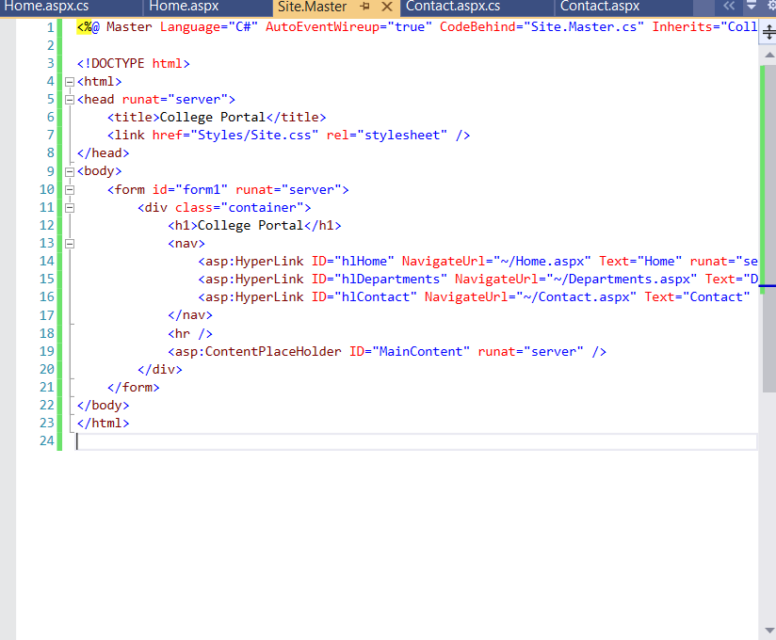

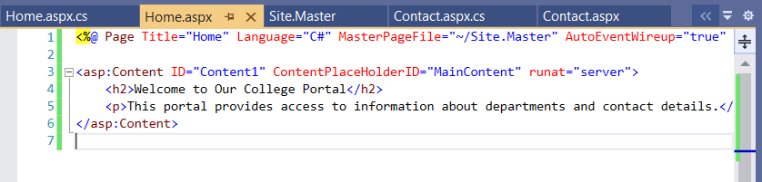

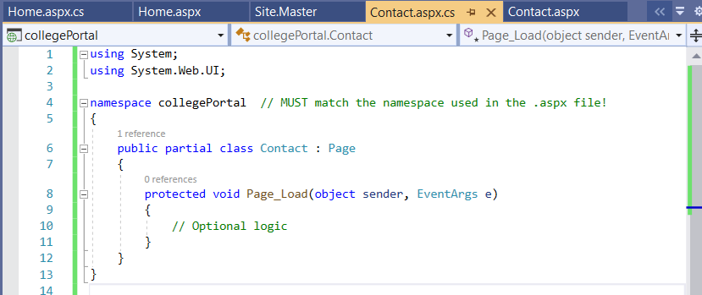

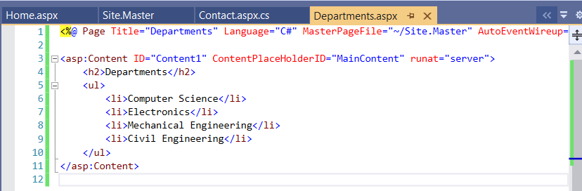

Output :

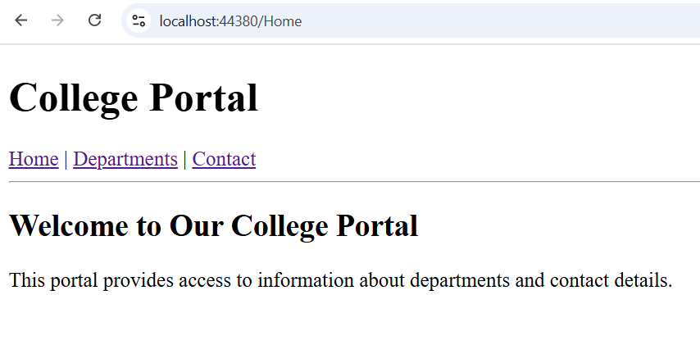

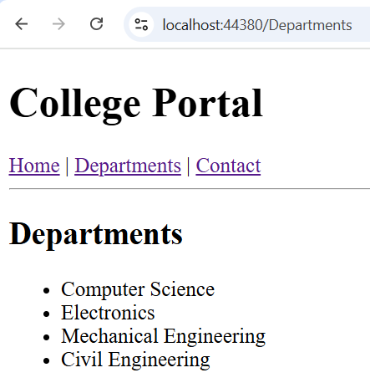

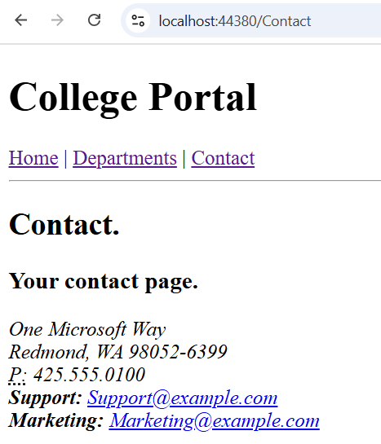

1. **Develop an ASP.NET core MVC app for customer data entry with input validation and using data annotations.**

Code :

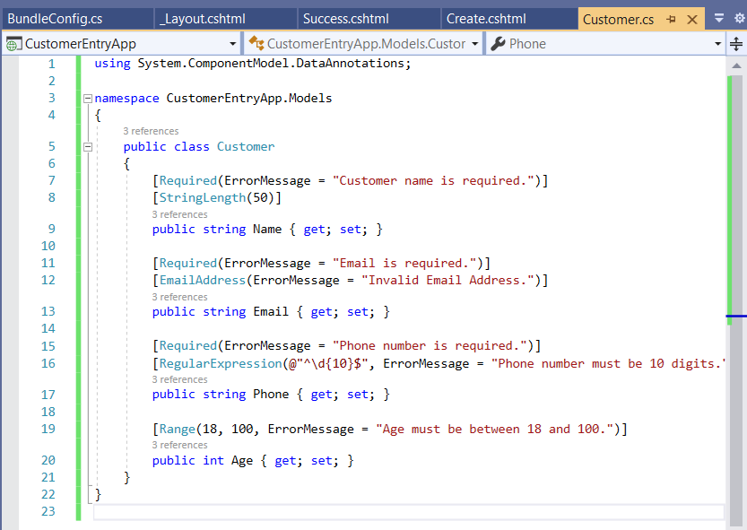

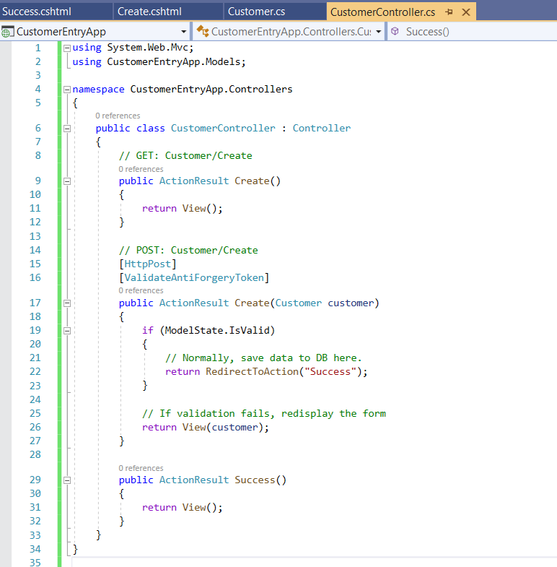

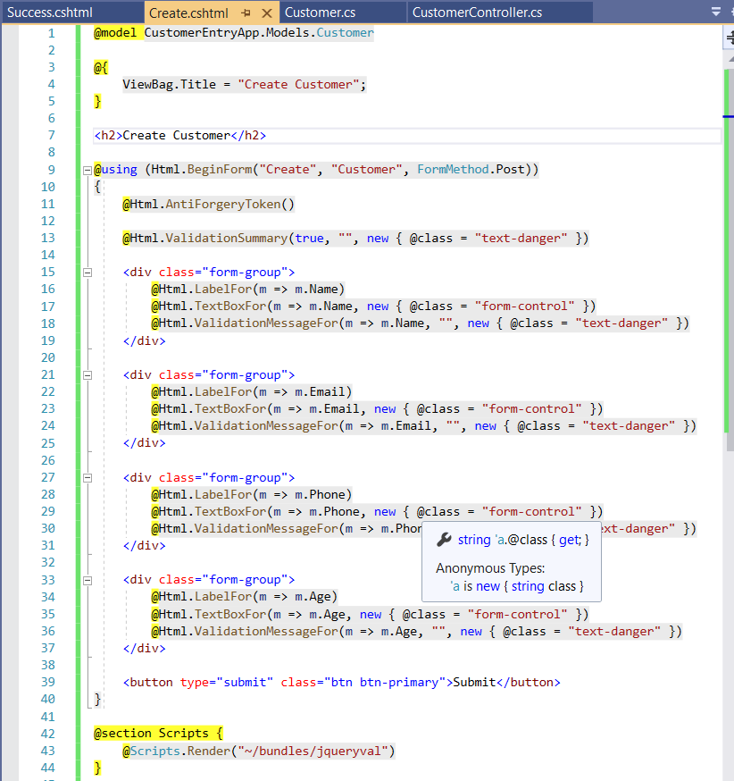

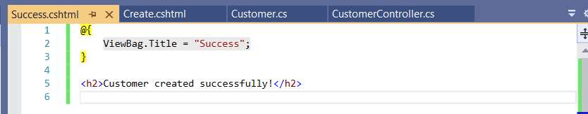

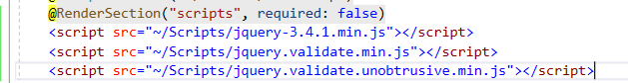

Output:

