**1U RACK Server:**

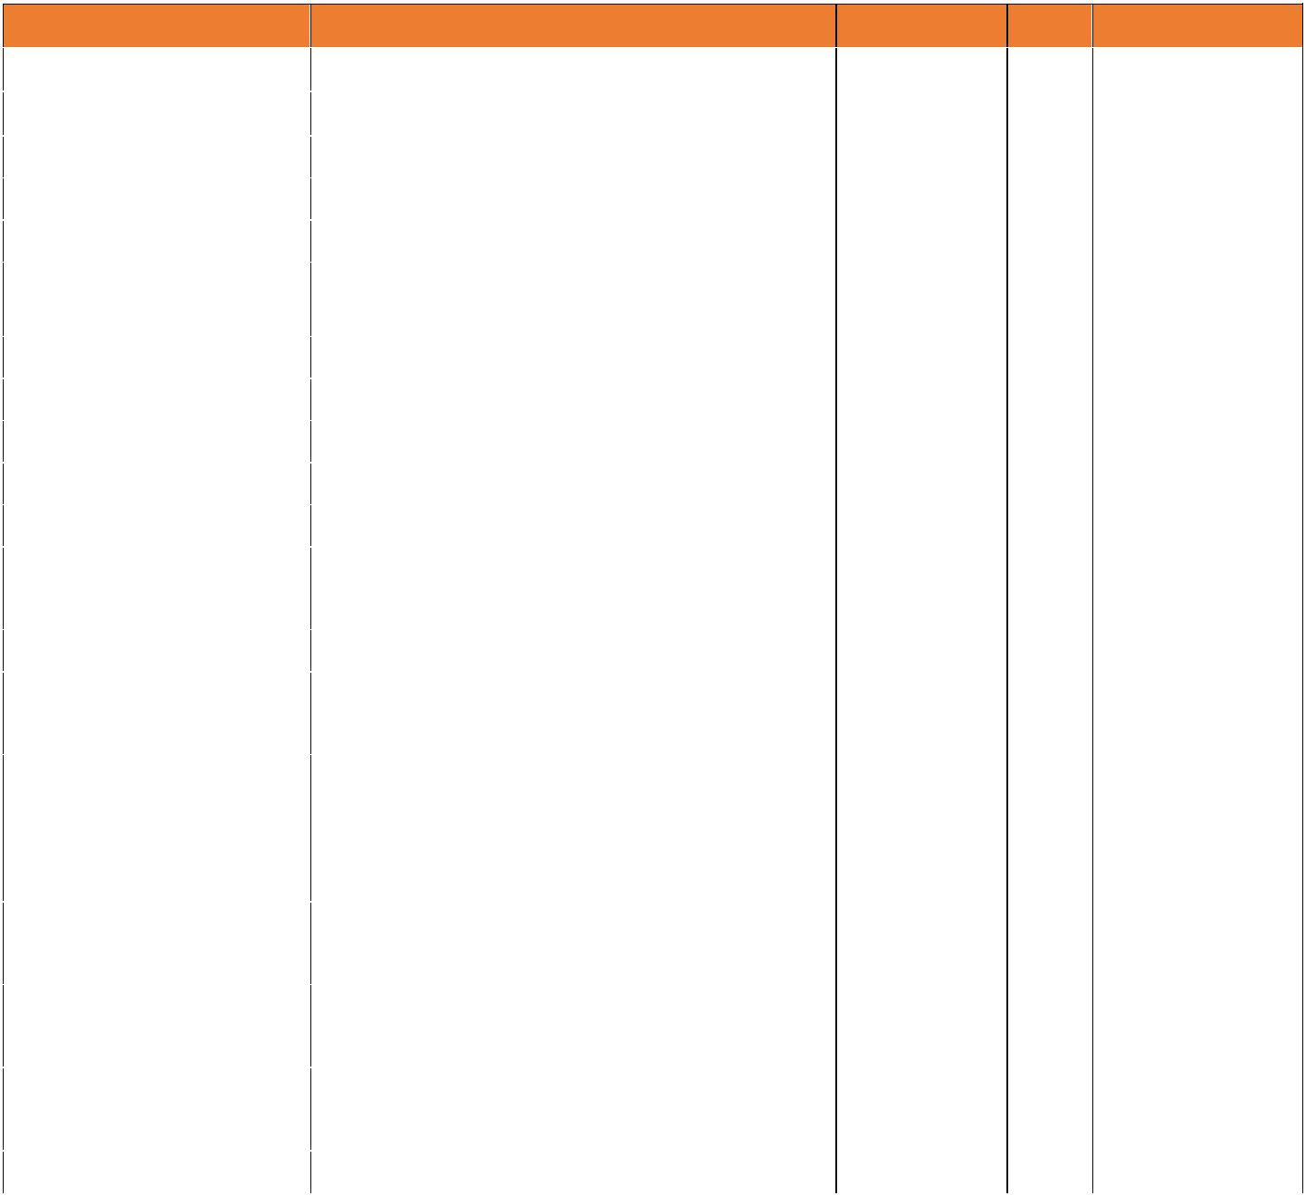

|  |  |  |  |
| --- | --- | --- | --- |
| **Item** | **Item of Description** |  |  |
|  |  |  |  |
| **Brand** | **NEC** |  |  |
|  |  |  |  |
| **Model** | **Express 5800/R110i-1** |  |  |
|  |  |  |  |
|  |  |  |  |
| **Form Factor** | **1U Rack Server** |  |  |
| **Processor** | **Quad Core Intel® Xeon® E3-1220 v6** |  |  |
| **Processor** |  |  |
|  |  |  |
| **Core & Thread** | **4 Core & 4 Threads** |  |  |
| **Number of Processor** | **1 Processor** |  |  |
| **Clock Speed** | **3 GHz** |  |  |
| **Intel® Smart Cache** | **8 MB Smart Cache** |  |  |
|  |  |  |  |
| **QPI** | **8 GT/s DMI3** |  |  |
|  |  |  |  |
| **TDP (Thermal Design** | **72 Watt** |  |  |
| **Power)** |  |
|  |  |
|  |  |  |
| **Chipset** | **Intel® C236 Chipset** |  |
|  |  |
| **RAM** | **16GB DDR4-2400 ECC Unbuffered DIMM** |  |  |
| **Memory expandable up to 64 GB** |  |  |
|  |  |  |
|  |  |  |  |
|  | **1GB RAID Controller with RAID** |  |  |
| **RAID Controller Card** | **Functionality 0/1/5/6/10/50/60, Int.x8,** |  |  |
| **with Flash Backup Unit** | **SAS 12/6Gbps, SATA 6Gbps included** |  |  |
|  | **with Flash Backup Unit** |  |  |
| **Hard Disk Drive** | **2TB (2x1TB), 7,200rpm, 3.5-inch SATA** |  |  |
| **Hot Plug HDD & expandable up to 40 TB.** |  |  |
|  |  |  |
|  |  |  |  |
| **No of Hard Disk Drive** | **4x3.5 inch Hard Disk Drive Bays** |  |  |
| **Bays** |  |  |
|  |  |  |
|  |  |  |  |
| **Network Interface** | **2 x 1000BASE-T LAN Controller** |  |  |
| **Controller** |  |  |
|  |  |  |
|  |  |  |  |
| **Graphics** | **Integrated in Server Management** |  |  |
|  |  |  |  |

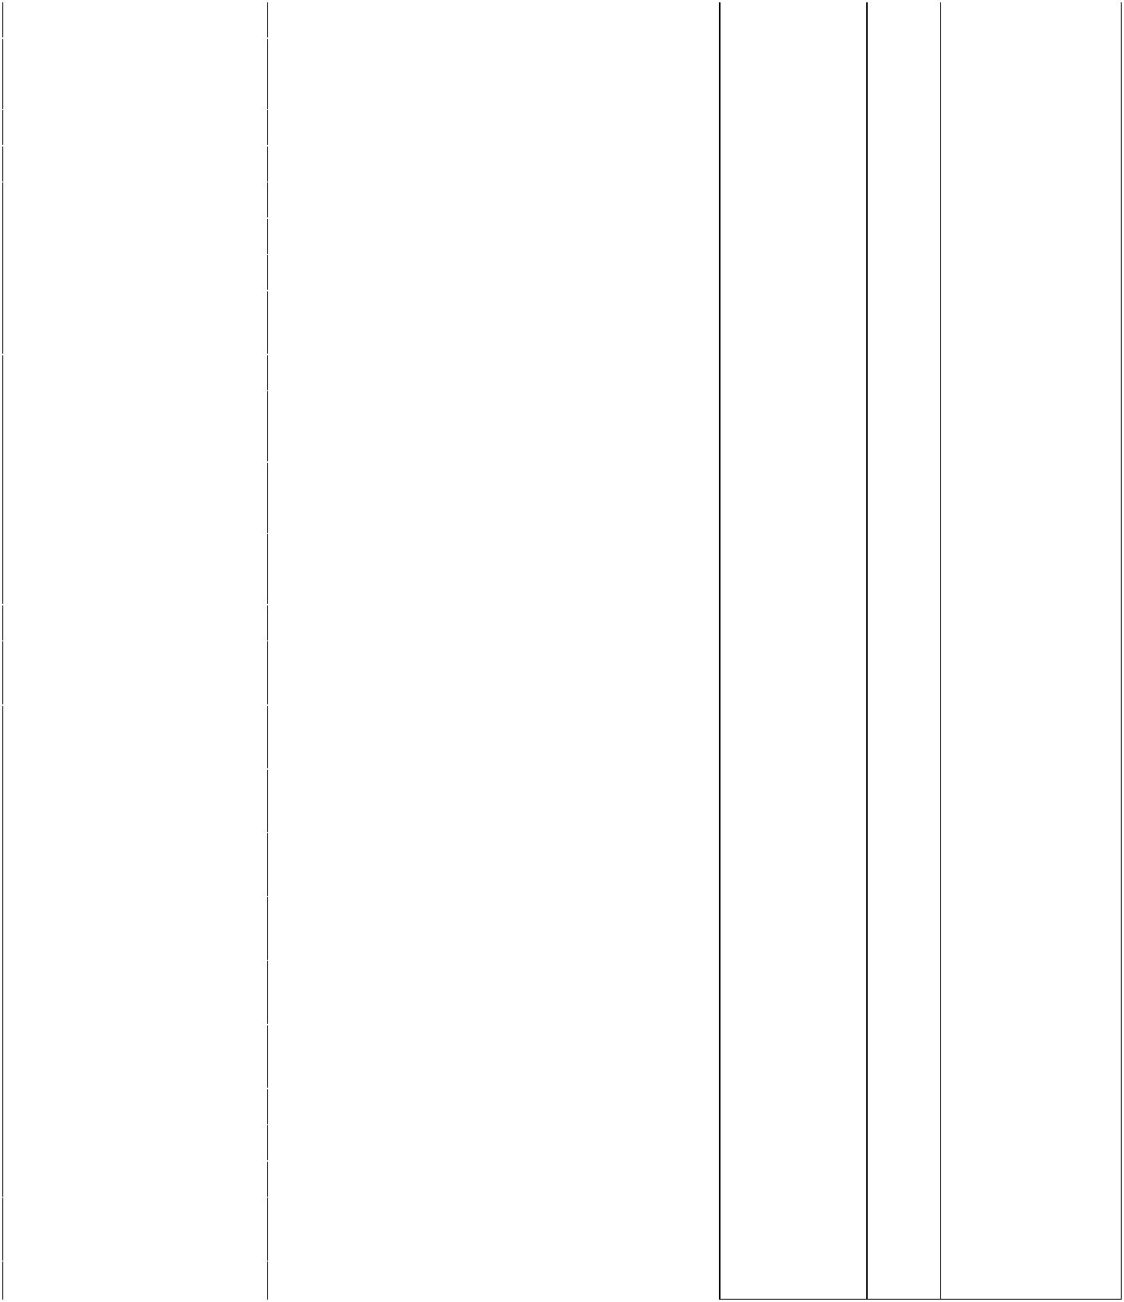

|  |  |  |  |
| --- | --- | --- | --- |
|  | **Controller (32MB)** | |  |
|  |  | |  |
| **Power Supply** | **2x 450 Watt 80 Plus Gold Hot Plug** | |  |
| **Redundant Power Supply** | |  |
|  |  |
|  |  | |  |
| **Optical Drive** | **DVD Super Multi Drive Writer** | |  |
| **System Fan** | **Standard Redundant Cooling Fan** | |  |
|  | **Total: 3 Slots Available** | |  |
|  | **1 x PCIe 3.0 x16 (x16 Connector)** | |  |
| **Expansion Slots** |  | |  |
| **1 x PCIe 3.0 x4 (x8 Connector)** | |  |
|  |  | |  |
|  | **1 x PCIe 3.0 x4 (x8 Connector) Dedicated** | |  |
|  | **RAID Slot** | |  |
|  | **1 x VGA (15-Pin Mini D-sub,1 Rear)** | |  |
|  |  | |  |
|  | **1 to 2 x Serial (9-Pin Mini D-sub, RS232-** | |  |
|  | **C, 1 to 2 Rear)** | |  |
| **Interfaces** |  | |  |
| **6 x USB 3.0 (2 Front, 4 Rear) (Plus 1** | |  |
|  | **Internal USB 3.0)** | |  |
|  |  | |  |
|  | **1 x 1000BASE-T LAN Connector for** | |  |
|  | **Management (RJ-45, 1 Rear)** | |  |
|  |  | |  |
| **Server Management** | **EXPRESSSCOPE Engine 3** | |  |
|  |  | |  |
| **Regulatory and Safety** | **FCC, c-UL, CE, CB, RoHS, WEEE, BSMI,** | |  |
| **CCC** | |  |
|  |  |
| **Supported Operating** |  |
|  |
| **System &** |  |
|  |
| **Virtualization** |  |
| **Microsoft® Windows Server® 2016** | |  |
| **Software** |  |
| **Standard** | |  |
|  |  |
|  | **Microsoft® Windows Server® 2016** | |  |
|  | **Datacenter** | |  |
|  | **Red Hat Enterprise Linux 7.3 or Later** | |  |
|  | **VMware ESXi 6.0 Update 3** | |  |
|  |  | |  |
|  | **VMware ESXi 6.5** | |  |
|  |  | |  |
| **Warranty** | **3 Years Warranty with Spare Parts &** | |  |
| **Labor** | |  |
|  |  |
|  |  | |  |

**RACK:**

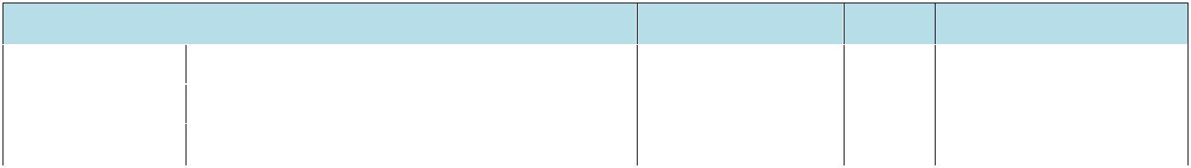

|  |  |  |  |  |  |
| --- | --- | --- | --- | --- | --- |
|  |  | **Description** |  |  |  |
|  |  | **TOTEN RAC** |  |  |  |
| **22U RACK22U Rack (600*1000)** | | |  |  |  |
|  |  | **H-42", W-22", D-28"** |  |  |  |