

**EAST WEST UNIVERSITY**

Fall-2019

**Project Report**

Project Name: Flow control and error control techniques in the data link layer protocols

Course code: CSE350

Course title: Data Communications

Section: 01

**Submitted To:**

​Dr. Maheen Islam

​Associate Professor, Dept. of CSE (EWU)

**Submitted by:** Jannatul Naim

ID: 2017-2-60-029, Dept. of CSE

Md Nayeem

ID: 2017-2-60-028, Dept. of CSE.

Rakibul Hasan Shezan

ID: 2017-2-60-036, Dept. of CSE.

**Introduction:** Our project name is “Flow control and error control techniques in the data link layer protocols”. We complete the project using C++ language.

**Requirement:** The following requirements for the project were given to us:

1. Implement the data link layer protocol, Go Back n Sliding Window(Positive acknowledgement + negative acknowledgement + Retransmission)
2. Implement a routine to compute and verify the CRC checksum of a frame and use CRC-16 as the generator polynomial.

We complete all requirement.

**System Design:**

int main()

slidingf(int left, int right)

**Introduction:** Our project name is

all requ

if(errorcheck(frames[],crc16))

else

File open

File to data entry frames[]

slidingf(1st frame number of windows, last frame number of windows))

Positive Acknowledgment

crc(char *fram,char gen[])

errorcheck(char* input,char cr[])

crc(te,cr)

crc(input,cr)

Randomly insert error

Negative Acknowledgment

**Feature Descriptions:** Here we use Go Back n Sliding Window and CRC Checksum of data communications feature. We also use file built in function, array, loop, if-else condition and different user-define function. It will help to understand the code easily and will help to make changes if needed.

Our user define functions are-

1. sliding( )
2. errorcheak( )
3. crc( )

**Go Back n Sliding Window:** If one frame is lost or damaged, all frames sent since the ack are retransmitted.

**CRC Checksum:** Checksum is a numerical check value calculated from a larger set of data.

**Built in function:** Library functions are the built in function in C++ programming. Every valid C++ program has at least one function, that is main() function.

**main():** Manually code execution starts in this function. We also use switch in this function as the approach of choosing option.

**strcpy():** strcpy function use for string copy.

**system("cls"):** In C/C++, **system**() function runs the shell commands. "**cls**" is a command on some operating **systems** that clears the screen.

**system("pause"):** this function used for  **pause** the programs execution.

**rand():** This function used for generated random value.

**User defined function:** C++ allows programmer to define their own function. A user defined function groups code to perform a specific task and that group of code is given a name (identifier). When a program beings running , the system calls the main() function, that is, the system starts executing codes from main() function.

**sliding( ):** This function used for calling errorcheck() function. If frame has no error, send acknowledgement for next frame. But frame has error, retransmit that frame.

**errorcheck ( ):** This function used for calling crc() function. Then we randomly generated error of frame and again call crc() function.

**crc ():** This function is used for CRC Checksum.

**Array:** Array is the collection of variables.

**Loop:** Loops are used in programming to repeat a specific block until some end condition is met. There are three type of loops in C++ programming. One type of loop is for loop. Here we used for loop.

**if-else:** An if statement can be followed by an optional else statement ,which executes when the Boolean expression is false. If the Boolean expression evaluates to true, then the if block of code will be execute, otherwise else block of code will be execute. Flow the diagram:

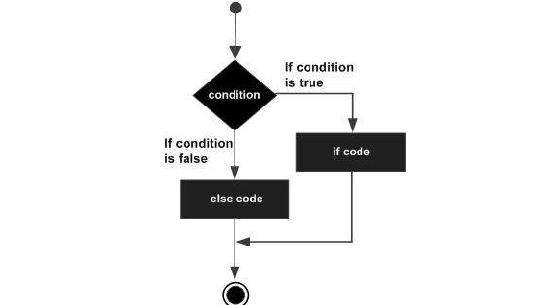

**Implementation:** By completing this project, we learned how working Go Back n Sliding Window and CRC Checksum at a time. And this project's ideas will help us to complete the next time project. So we think this project is important in our futures life will play the role.

**C++ Code for Project:**

#include<bits/stdc++.h>

using namespace std;

//int y[500];

int n=5;

char reminder[500] ;

int slidingf(int , int );

char* crc(char *fram,char gen[]);

int errorcheck(char* input,char cr[]);

char frames[1000][1000];

//bool errorcheck(char ,char );

//char crc(char *fram,char );

int main()

{

int i;

ifstream file;

file.open("E:\\Local Disk G\\8th Semester\\CSE350\\Project\\input.txt");

char x[500];

for(int i=0; i<n; i++)

{

for(int j=0; j<=49; j++)

file>>x[j];

strcpy(frames[i],x);

}

int w;

cout<<"ENTER THE SIZE OF WINDOW: ";

cin>>w;

i=0;

while(i<n)

{

i=slidingf(i,min(i+w-1,n-1));

}

return 0;

}

int slidingf(int left, int right)

{

cout<<"\n\nSending Frames from :"<<left<<" to "<<right<<endl<<endl<<endl;

for (int i=left; i<=right; i++)

{

char crc16[]="11000000000000101";

cout<<"Data that Frame ["<<i<<"]Contains are: ";

for(int j=0;j<=49;j++)

cout<<frames[i][j];

cout<<endl<<endl;

cout<<"Value of CRC16 is: "<<crc16<<endl<<endl;

system("pause");

if(errorcheck(frames[i],crc16))

{

cout<<"Frame ["<<i<<"]Received Successfully.....\n\n";

cout<<"Positive Acknowledgment[ACK-"<<i+1<<"] has been sent\n\n";

system("pause");

system("cls");

}

else

{

cout<<"There is an error in frame "<<i<< "...!!!\n"<<endl;

cout<<"Negative Acknowledgment [ACK- "<<i<<"] has been sent\n\n";

system("pause");

system("cls");

return i;

}

}

system("cls");

cout<<"Acknowledgment["<<right+1<<"] has been sent"<<endl<<endl;

system("pause");

return right+1;

}

int errorcheck(char* input,char cr[])

{

srand(time(NULL));

char te[1000];

int ran1,ran2;

strcpy(te,crc(input,cr));

//cout<<"ckerr"<<zz;

ran1=rand()%4;

ran2=rand()%10;

if(ran1!=0)

{

if(te[ran2]=='0')

te[ran2]='1';

else

te[ran2]='0';

}

strcpy(te,crc(te,cr));

printf("\nResultant Reminder: %s\n\n\n",reminder);

for(int i=0; reminder[i]!='\0'; i++)

if(reminder[i]=='1')

return 0;

return 1;

}

char* crc(char *fram,char gen[])

{

char rem[500],gen1[500],div[500],quot[100];

int i,j;

int genlen,framelen;

static char hold[500];

genlen=strlen(gen);

framelen=strlen(fram);

strcpy(gen1,gen);

for (i=0; i<genlen; i++)

div[i]=fram[i];

for (i=0; i<genlen-1; i++)

fram[framelen+i]='0';

for (i=0; i<framelen; i++)

{

quot[i]=div[0];

if(quot[i]=='0')

{

for (j=0; j<genlen; j++)

gen[j]='0';

}

else

{

for (j=0; j<genlen; j++)

gen[j]=gen1[j];

}

for (j=genlen-1; j>0; j--)

{

if(div[j]==gen[j])

rem[j-1]='0';

else

rem[j-1]='1';

}

rem[genlen-1]=fram[i+genlen];

strcpy(div,rem);

}

strcpy(rem,div);

for (i=0; i<genlen-1; i++)

reminder[i]=rem[i];

for (i=0; i<framelen; i++)

hold[i]=fram[i];

for (j=0; i<genlen+framelen-1; j++)

{

hold[i]=rem[j];

i++;

}

//cout<<"crc"<<endl;

//for(int i=0;yy[i]!='\0';i++)

//cout<<yy<<" ";

// cout<<strlen(yy)<<"\n";

return hold;

}

**Sample Input and Output:**

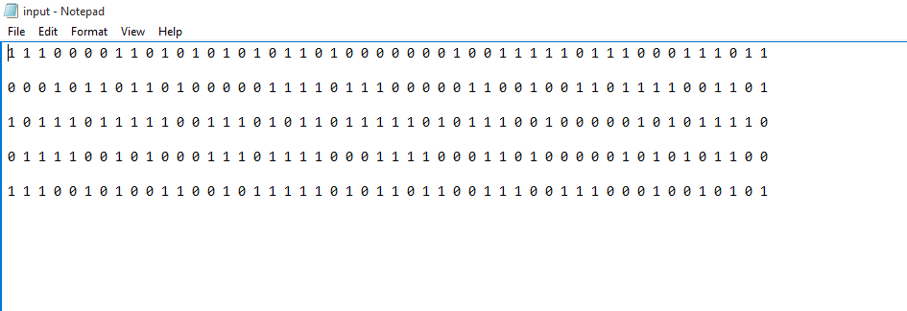

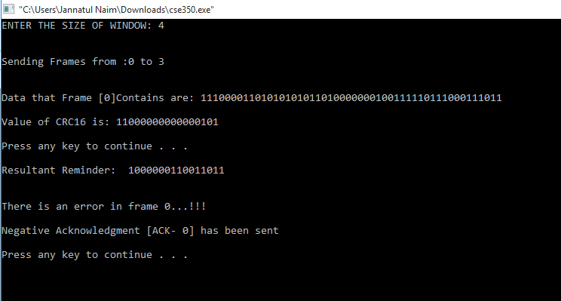

**Limitation:** If we get more time, we could better.

**Conclusion:** Without any doubt this project has made us more comfortable with coding and also enhanced our capacity to code more efficiently.

**Reference:**

1. Data Communications and Networking By Behrouz A Forouzan.

2. Data and computer Communications By William Strallings.