**PROGRAM – 1**

**Q1:** Write a program to find the age of Harry if the birth year is 2000. Assume the Current Year is 2024.

**CODE:** 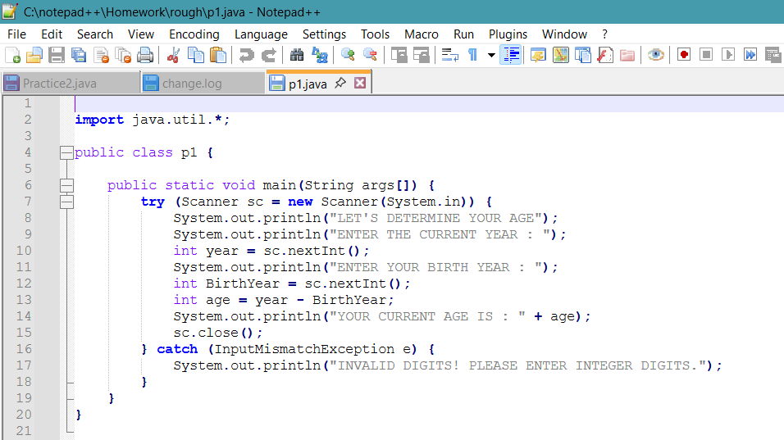

**OUTPUT:**

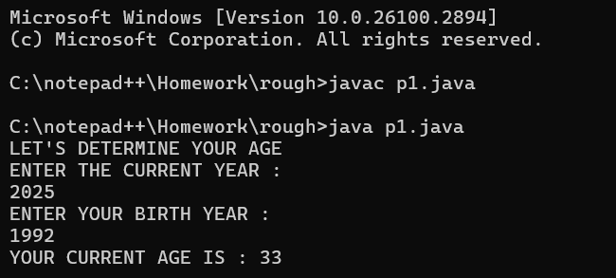

**PROGRAM – 2**

**Q2:** Sam’s mark in Maths is 94, Physics is 95 and Chemistry is 96 out of 100. Find the average percent mark in PCM

**CODE:**

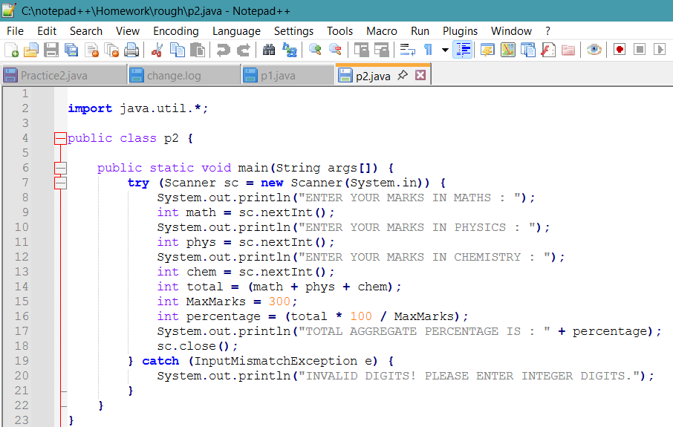

**OUTPUT:**

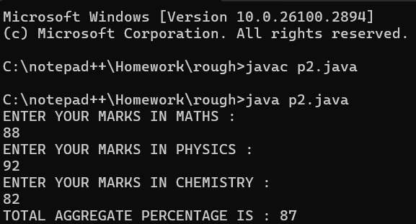

**PROGRAM – 3**

**Q3:** Create a program to convert the distance of 10.8 kilometre to miles.

Hint: 1 km = 1.6 miles

**CODE:**

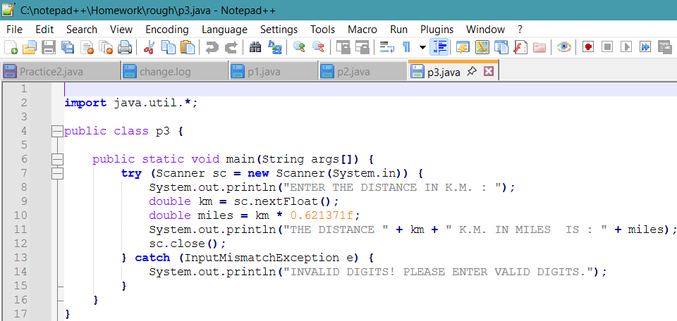

**OUTPUT:**

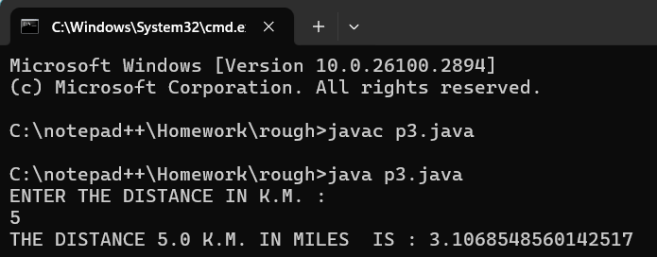

**PROGRAM – 4**

**Q4:** Create a program to calculate the profit and loss in number and percentage based on the cost price of INR 129 and the selling price of INR 191.

**CODE:** 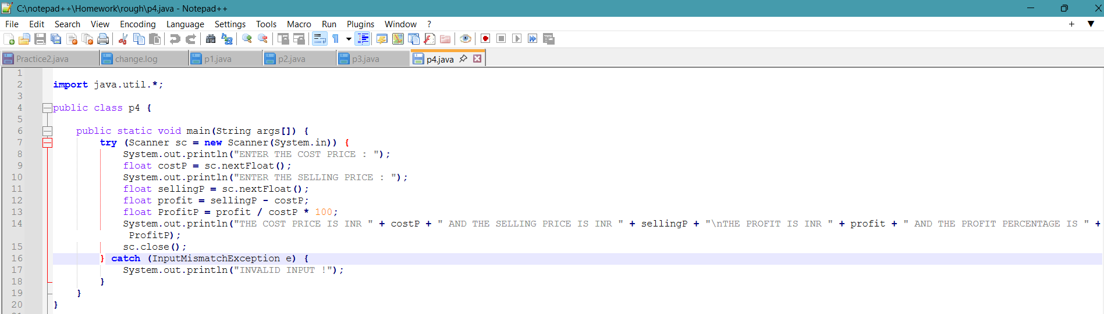

**OUTPUT:**

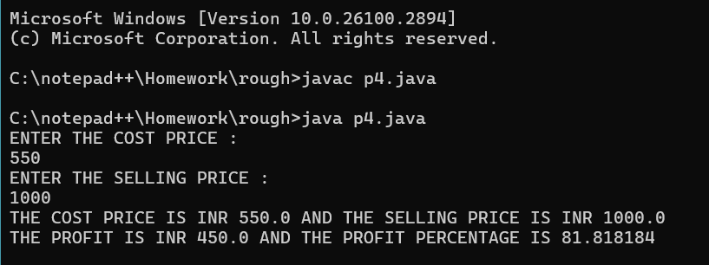

**PROGRAM – 5**

**Q5:** Suppose you have to divide 14 pens among 3 students equally. Write a program to find how many pens each student will get if the pens must be divided equally. Also, find the remaining non-distributed pens.

**CODE:**

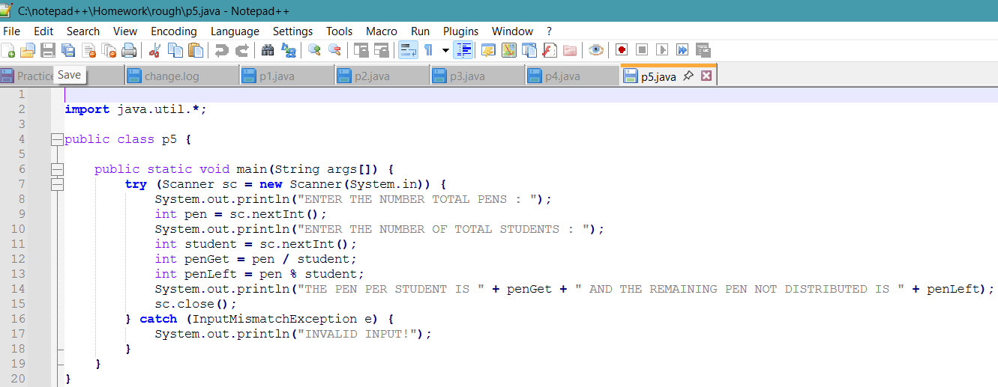

**OUTPUT:**

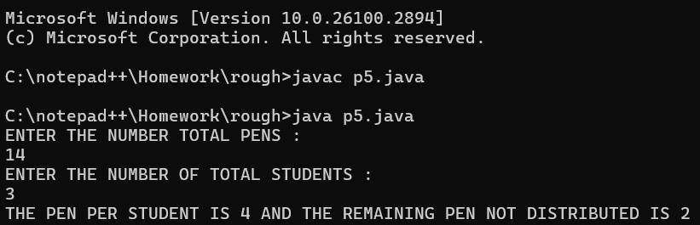

**PROGRAM – 6**

**Q6:** The University is charging the student a fee of INR 125000 for the course. The University is willing to offer a discount of 10%. Write a program to find the discounted amount and discounted price the student will pay for the course.

**CODE:**

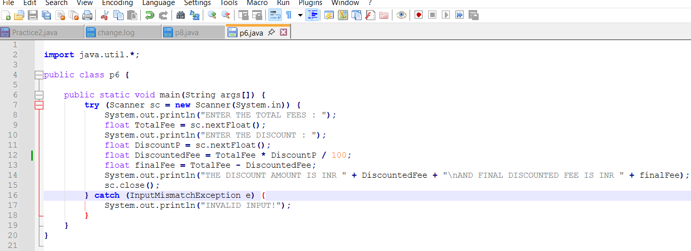

**OUTPUT:**

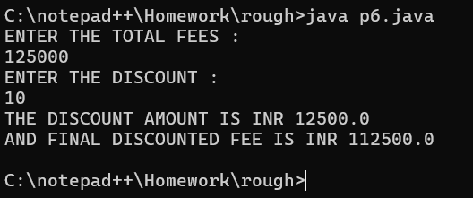

**PROGRAM – 7**

**Q7:** Write a Program to compute the volume of Earth in km^3 and miles^3

**CODE:**

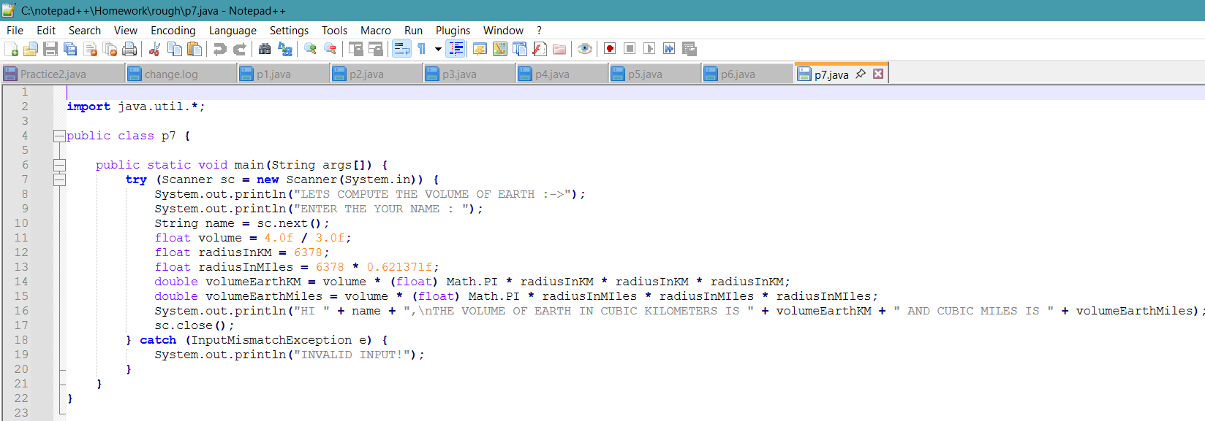

**OUTPUT:**

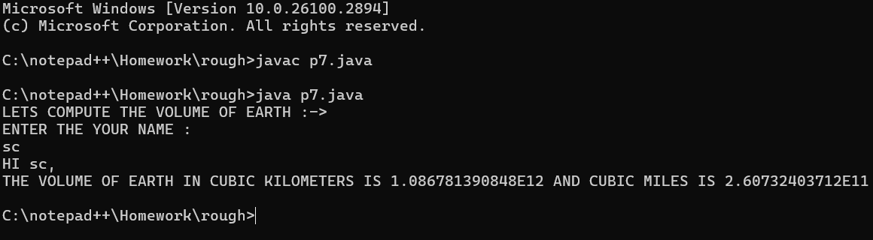

**PROGRAM – 8**

**Q8:** Create a program to convert distance in kilometers to miles.

**CODE:**



**OUTPUT:**



**PROGRAM – 9**

**Q9:** Write a new program similar to the program # 6 but take user input for Student Fee and University Discount

**CODE:**



**OUTPUT:**

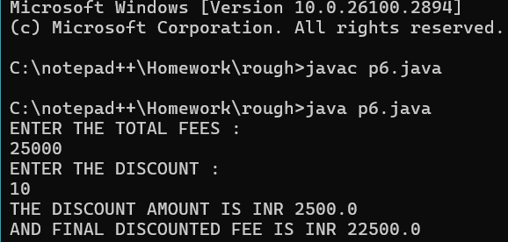

**PROGRAM – 10**

**Q10:** Write a program that takes your height in centimeters and converts it into feet and inches

**CODE:**

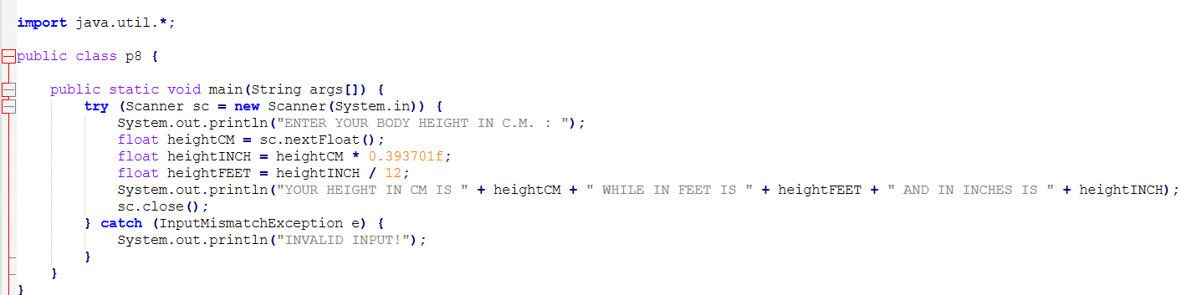

**OUTPUT:**

