**PROGRAM – 1**

**Q1:** Write a TemperaturConversion program, given the temperature in Celsius as input outputs the temperature in Fahrenheit

**CODE:** 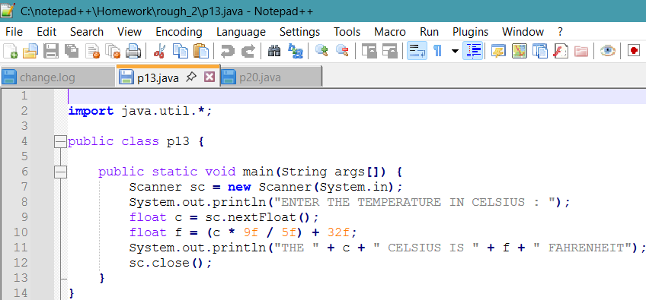

**OUTPUT:**

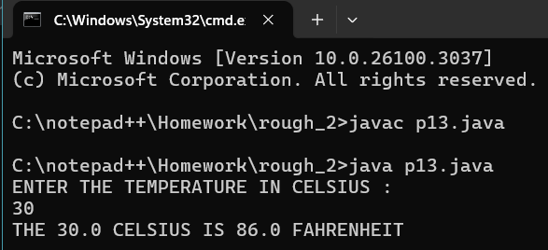

**PROGRAM – 2**

**Q2:** Write a TemperaturConversion program, given the temperature in Fahrenheit as input outputs the temperature in Celsius

**CODE:**

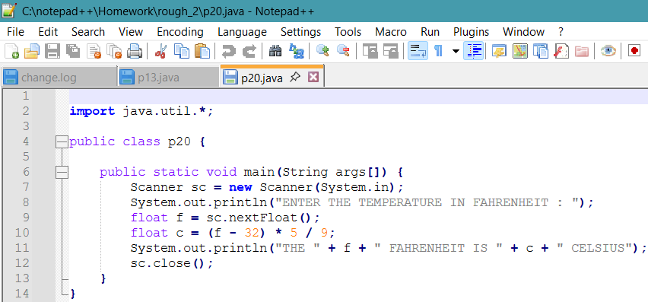

**OUTPUT:**

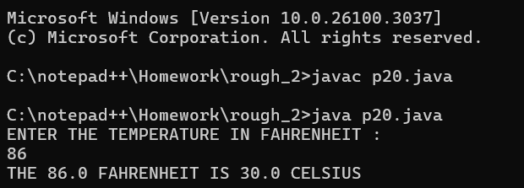

**PROGRAM – 3**

**Q3:**  Create a program to find the total income of a person by taking salary and bonus from user

**CODE:**

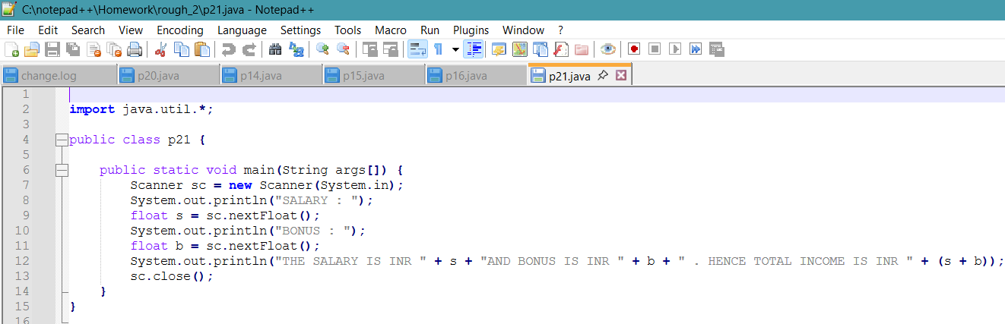

**OUTPUT:**

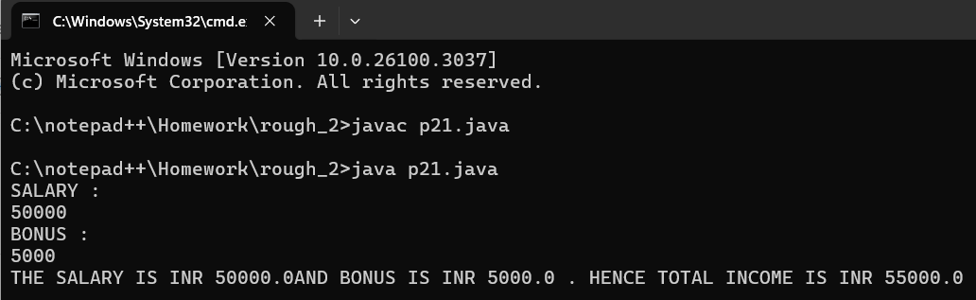

**PROGRAM – 4**

**Q4:** Create a program to swap two numbers

**CODE:**

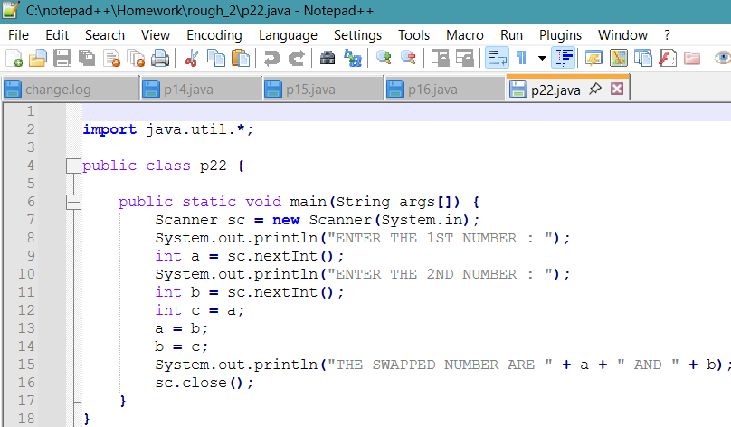

**OUTPUT:**

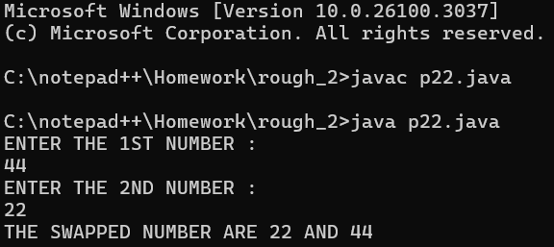

**PROGRAM – 5**

**Q5:** Rewrite the Sample Program 2 with user inputs

**CODE:**

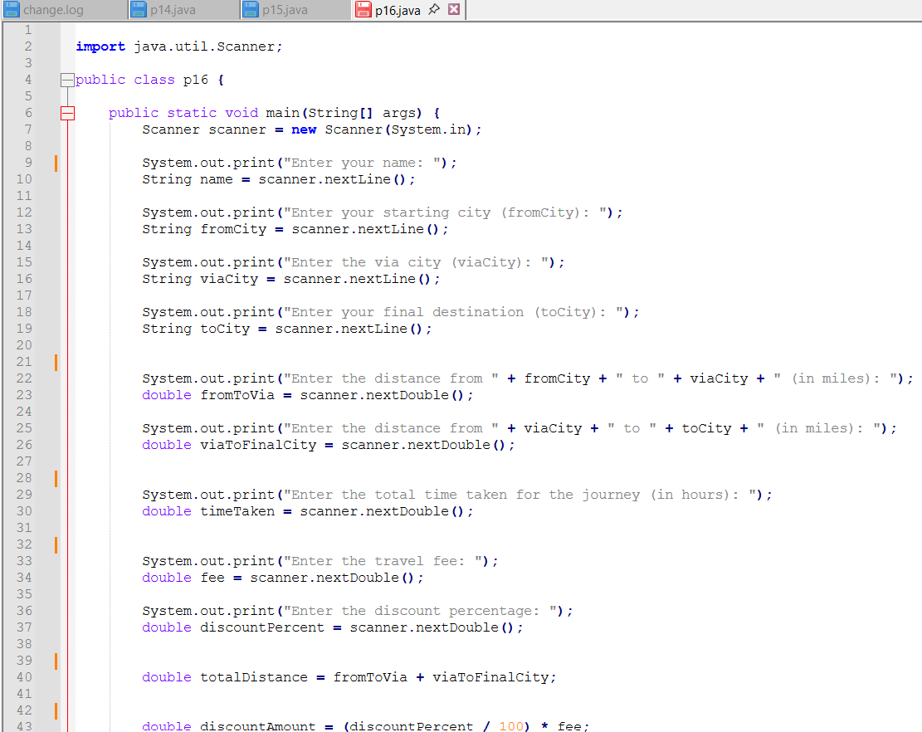

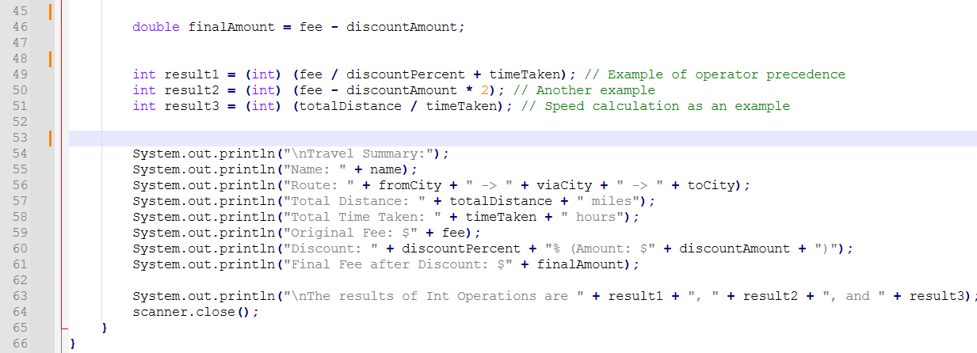

**OUTPUT:**

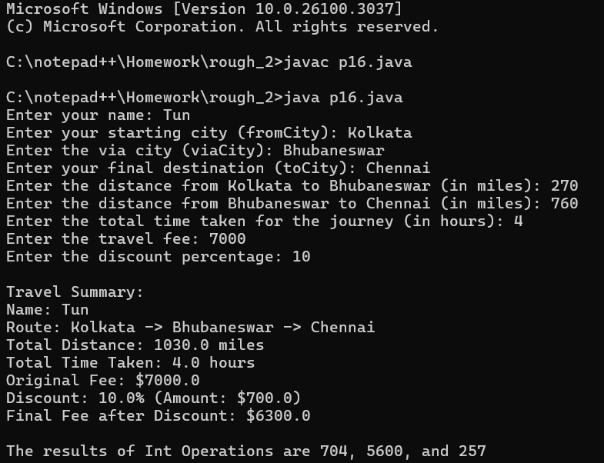

**PROGRAM – 6**

**Q6:**  An athlete runs in a triangular park with sides provided as input by the user in meters. If the athlete wants to complete a 5 km run, then how many rounds must the athlete complete

**CODE:**

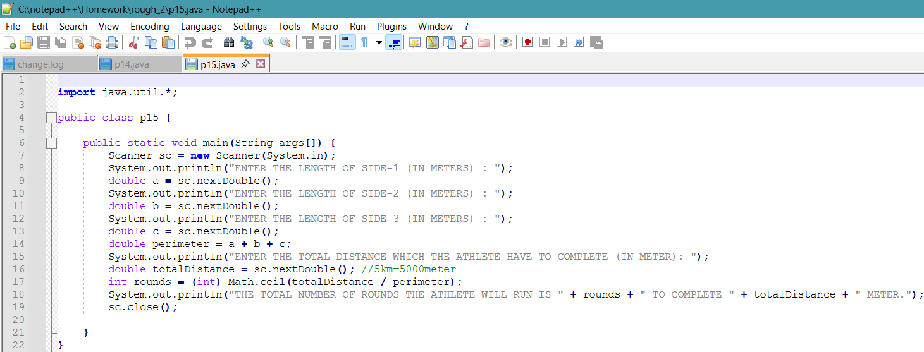

**OUTPUT:**

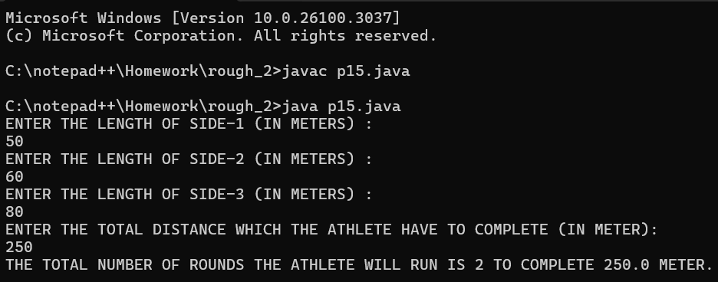

**PROGRAM – 7**

**Q7:** Create a program to divide N number of chocolates among M children.

**CODE:**

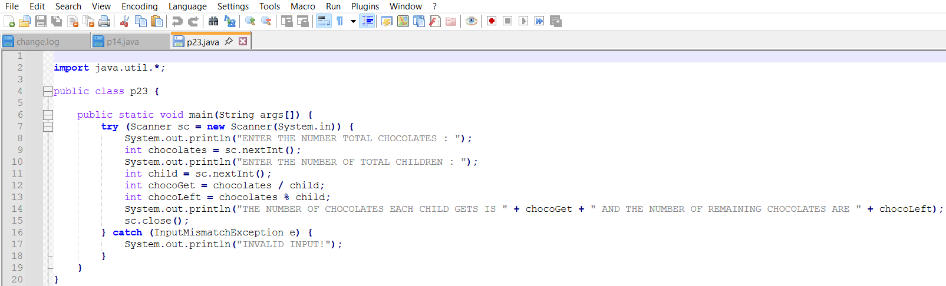

**OUTPUT:**

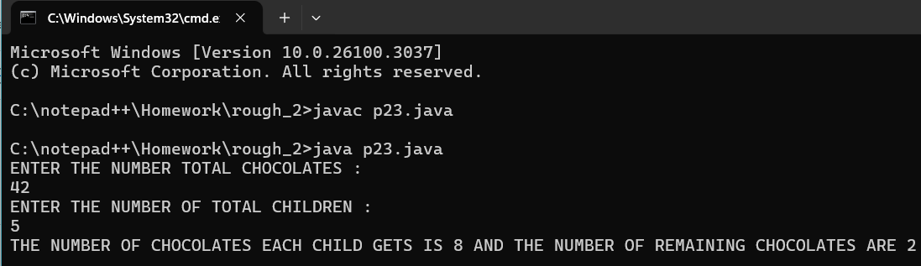

**PROGRAM – 8**

**Q8:** Write a program to input the Principal, Rate, and Time values and calculate Simple Interest.

**CODE:**

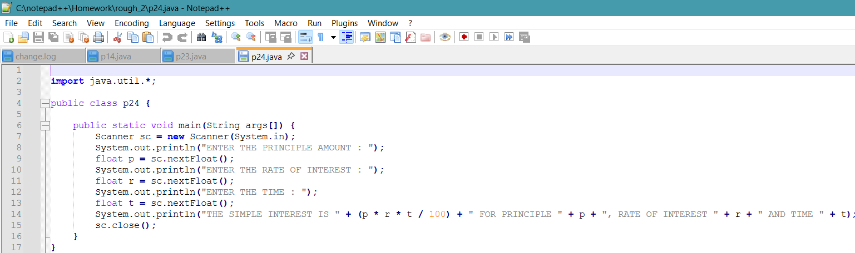

**OUTPUT:**

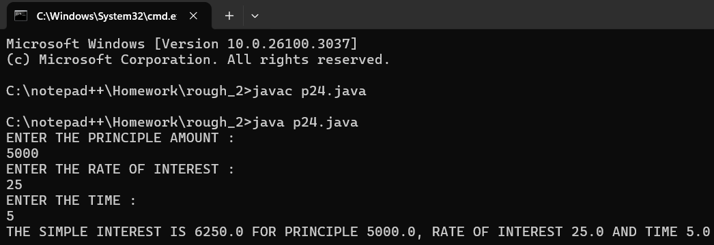

**PROGRAM – 9**

**Q9:** Create a program to find the maximum number of handshakes among N number of students.

**CODE:**

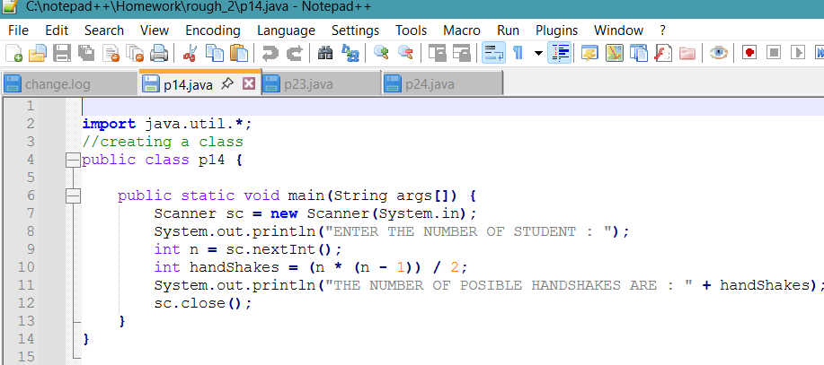

**OUTPUT:**

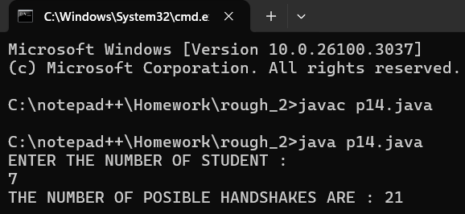

**PROGRAM – 10**

**Q10:** Create a program to convert weight in pounds to kilograms.

**CODE:**

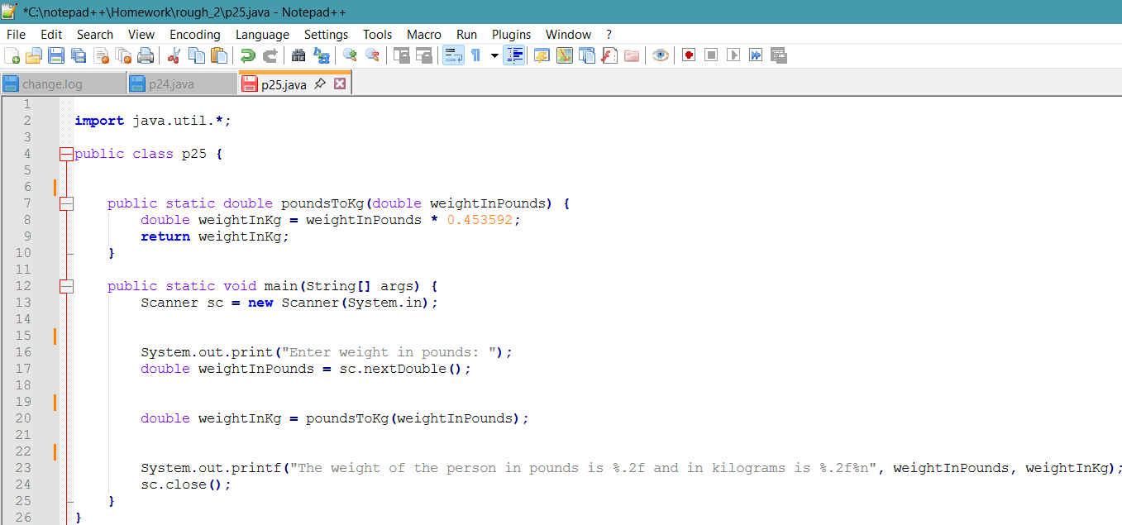

**OUTPUT:**

