**PROGRAM – DIVISIBLE BY FIVE**

**Q1:** Write a program to check if a number is divisible by 5

I/P => number

O/P => Is the number ___ divisible by 5? ___

**CODE:**

import java.util.*;

public class divisibleByFive {

public static void main(String args[]) {

try (Scanner sc = new Scanner(System.in)) {

System.out.println("ENTER A NUMBER : ");

int n = sc.nextInt();

if (n % 5 == 0) {

System.out.println(n + " IS DIVISIBLE BY 5");

} else {

System.out.println(n + " IS NOT DIVISIBLE BY 5");

}

} catch (InputMismatchException e) {

System.out.println("INVALID INPUT!");

}

}

}

**OUTPUT:**

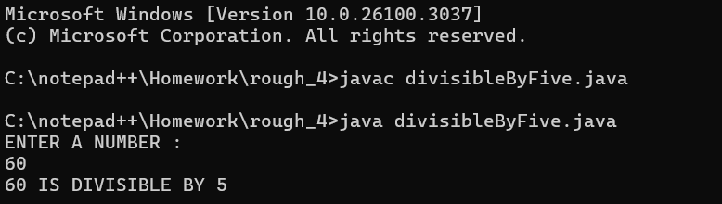

**PROGRAM – SMALLEST OF 3 NUMBERS**

**Q2:** Write a program to check if the first is the smallest of the 3 numbers.

I/P => number1, number2, number3

O/P => Is the first number the smallest? ____

**CODE:**

import java.util.*;

public class smallestNumber {

public static void main(String args[]) {

try (Scanner sc = new Scanner(System.in)) {

System.out.println("ENTER THE FIRST NUMBER : ");

int a = sc.nextInt();

System.out.println("ENTER THE SECOND NUMBER : ");

int b = sc.nextInt();

System.out.println("ENTER THE 3RD NUMBER : ");

int c = sc.nextInt();

String r = (a < b && a < c) ? "YES THE FIRST NUMBER " + a + " IS THE SMALLEST" : "NO THE FIRST NUMBER " + a + " IS NOT THE SMALLEST";

System.out.println(r);

} catch (InputMismatchException e) {

System.out.println("INVALID INPUT!");

}

}

}

**OUTPUT:**

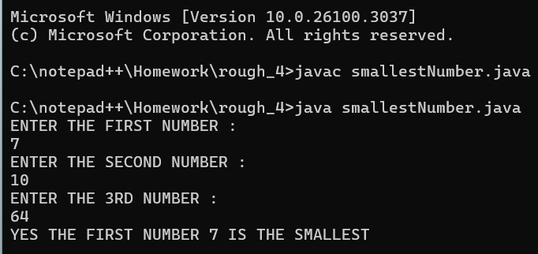

**PROGRAM – LARGEST NUMBER**

**Q3:**  Write a program to check if the first, second, or third number is the largest of the three.

I/P => number1, number2, number3

O/P =>

Is the first number the largest? ____

Is the second number the largest? ___

Is the third number the largest? ___

**CODE:**

import java.util.*;

public class largestNumber {

public static void main(String args[]) {

try (Scanner sc = new Scanner(System.in)) {

System.out.println("ENTER THE FIRST NUMBER : ");

int a = sc.nextInt();

System.out.println("ENTER THE SECOND NUMBER : ");

int b = sc.nextInt();

System.out.println("ENTER THE 3RD NUMBER : ");

int c = sc.nextInt();

String r = (a > b && a > c) ? "YES THE FIRST NUMBER " + a + " IS THE LARGEST" : (b > a && b > c) ? "YES THE 2ND NUMBER " + b + " IS THE LARGEST NUMBER" : "YES THE 3RD NUMBER " + c + " IS THE LARGEST NUMBER";

System.out.println(r);

} catch (InputMismatchException e) {

System.out.println("INVALID INPUT!");

}

}

}

**OUTPUT:**

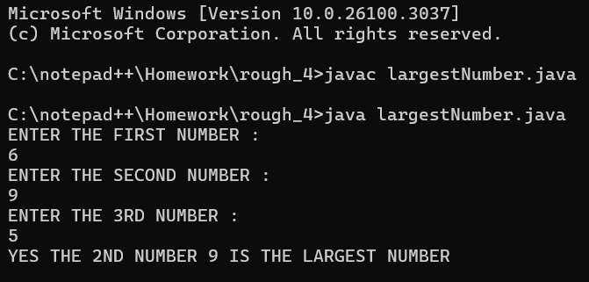

**PROGRAM – SUM OF NATURAL NUMBERS**

**Q4:** Write a program to check for the natural number and write the sum of n natural numbers

**Hint =>**

1. A Natural Number is a positive integer (1,2,3, etc) sometimes with the inclusion of 0
2. A sum of n natural numbers is n * (n+1) / 2

I/P => number

O/P => If the number is a positive integer then the output is

The sum of ___ natural numbers is ___

Otherwise

The number ___ is not a natural number

**CODE:**

import java.util.*;

public class sumOfNaturalNumber {

public static void main(String ars[]) {

try (Scanner sc = new Scanner(System.in)) {

System.out.println("ENTER A NATURAL NUMBER : ");

int n = sc.nextInt();

int result;

if (n >= 0) {

result = n * (n + 1) / 2;

System.out.println("THE SUM OF " + n + " NATURAL NUMBERS IS " + result);

} else {

System.out.println("THE NUMBER IS NOT A NATURAL NUMBER.");

}

} catch (InputMismatchException e) {

System.out.println("INVALID INPUT!");

}

}

}

**OUTPUT:**

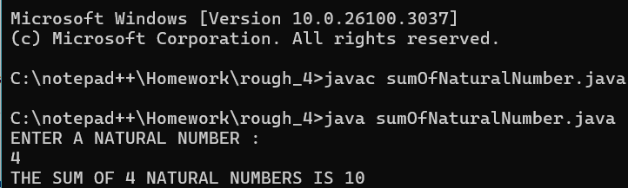

**PROGRAM – ELIGIBLE TO VOTE**

**Q5:** Write a program to check whether a person can vote, depending on whether his/her age is greater than or equal to 18.

**Hint =>**

1. Get integer input from the user and store it in the age variable.
2. If the person is 18 or older, print "The person can vote." Otherwise, print "The person cannot vote."

I/P => age

O/P => If the person's age is greater or equal to 18 then the output is

The person's age is ___ and can vote.

Otherwise

The person's age is ___ and cannot vote.

**CODE:**

import java.util.*;

public class canGiveVote {

public static void main(String args[]) {

try (Scanner sc = new Scanner(System.in)) {

System.out.println("ENTER YOUR AGE : ");

int age = sc.nextInt();

String result = (age >= 18) ? "THE PERSON'S AGE IS " + age + " AND CAN GIVE VOTE" : "THE PERSON'S AGE IS " + age + " AND CANNOT GIVE VOTE";

System.out.println(result);

} catch (InputMismatchException e) {

System.out.println("INVALID INPUT!");

}

}

}

**OUTPUT:**

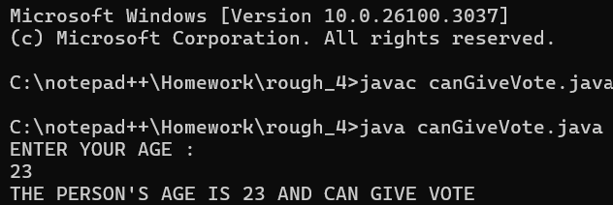

**PROGRAM – WHETHER IT IS POSITIVE, NEGATIVE OR ZERO**

**Q6:**  Write a program to check whether a number is positive, negative, or zero.

**Hint =>**

1. Get integer input from the user and store it in the number variable.
2. If the number is positive, print positive.
3. If the number is negative, print negative.
4. If the number is zero, print zero.

**CODE:**

import java.util.*;

public class positiveNegativeZero {

public static void main(String args[]) {

try (Scanner sc = new Scanner(System.in)) {

System.out.println("ENTER A NUMBER : ");

int n = sc.nextInt();

String result = (n < 0) ? "THE ENTERED NUMBER IS A NEGATIVE NUMBER" : (n == 0) ? "THE ENTERED NUMBER IS ZERO" : " ENTERED NUMBER IS A POSITIVE NUMBER";

System.out.println(result);

} catch (InputMismatchException e) {

System.out.println("INVALID INPUT!");

}

}

}

**OUTPUT:**

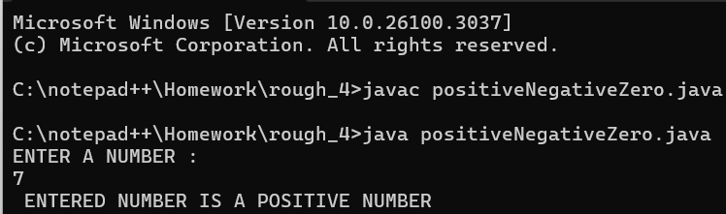

**PROGRAM – WHETHER IT’S A SPRING SEASON**

**Q7:** Write a program SpringSeason that takes two int values month and day from the command line and prints “It’s a Spring Season” otherwise prints “Not a Spring Season”.

**Hint =>**

Spring Season is from March 20 to June 20

**CODE:**

import java.util.*;

public class springSeason {

public static void main(String args[]) {

try (Scanner sc = new Scanner(System.in)) {

System.out.println("ENTER THE MONTH (1-12) : ");

int m = sc.nextInt();

System.out.println("ENTER THE DAY (1-31) : ");

int d = sc.nextInt();

boolean isSpring = (m == 3 && d >= 20) || (m == 6 && d <= 20) || (m > 3 && m < 6);

String result = (isSpring) ? "IT IS A SPRING SEASON" : "IT IS NOT A SPRING SEASON";

System.out.println(result);

} catch (InputMismatchException e) {

System.out.println("INVALID INPUT!");

}

}

}

**OUTPUT:**

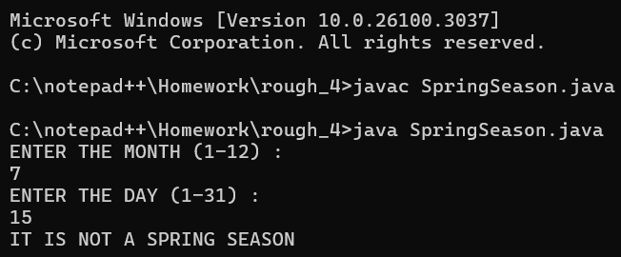

**PROGRAM – ROCKET LAUNCH COUNTDOWN**

**Q8:** Write a program to count down the number from the user input value to 1 using a ***while*** loop for a rocket launch

**Hint =>**

1. Create a variable counter to take user inputted value for the countdown.
2. Use the ***while*** loop to check if the counter is 1
3. Inside a ***while*** loop, print the value of the counter and decrement the counter.

**CODE:**

import java.util.*;

public class rocketLaunchCountdown {

public static void main(String args[]) {

try (Scanner sc = new Scanner(System.in)) {

System.out.println("ENTER COUNTDOWN START VALUE : ");

int countDown = sc.nextInt();

System.out.println("-------------------------------------------");

while (countDown > 0) {

System.out.println(countDown);

countDown--;

}

System.out.println("-------------------------------------------");

System.out.println("LIFTOFF!");

} catch (InputMismatchException e) {

System.out.println("INVALID INPUT!");

}

}

}

**OUTPUT:**

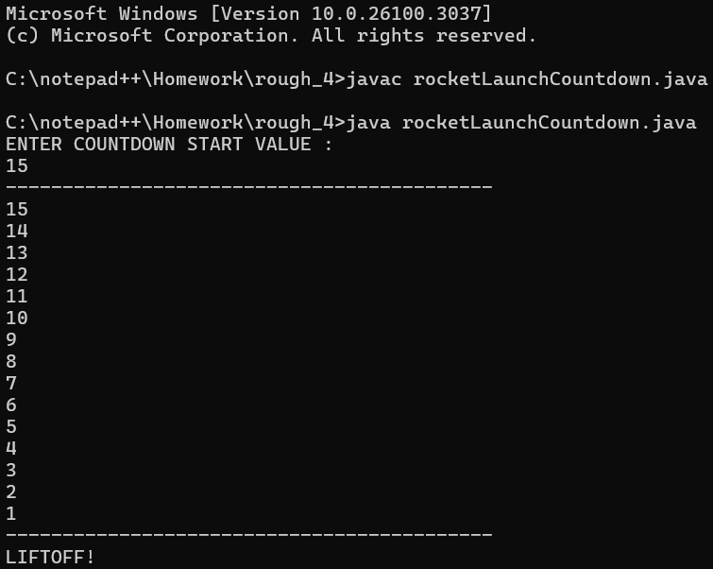

**PROGRAM – ROCKET LAUNCH COUNTDOWN USING FOR LOOP**

**Q9:** Rewrite program 8 to do the countdown using the ***for-***loop

**CODE:**

import java.util.*;

public class rocketLunchCountdownFOR {

public static void main(String args[]) {

try (Scanner sc = new Scanner(System.in)) {

System.out.println("ENTER COUNTDOWN START VALUE : ");

int countDown = sc.nextInt();

System.out.println("-------------------------------------------");

for (int i = countDown; i > 0; i--) {

System.out.println(i);

}

System.out.println("-------------------------------------------");

System.out.println("LIFTOFF!");

} catch (InputMismatchException e) {

System.out.println("INVALID INPUT!");

}

}

}

**OUTPUT:**

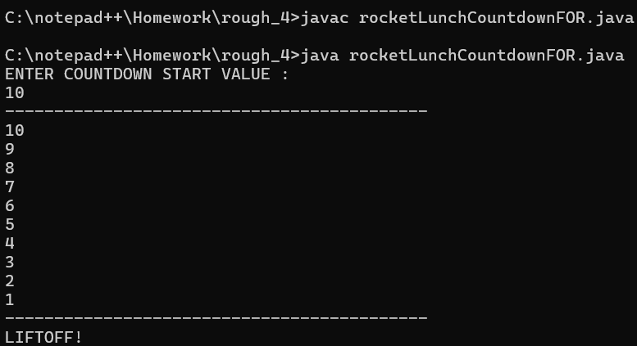

**PROGRAM – SUM OF NUMBERS**

**Q10:** Write a program to find the sum of numbers until the user enters 0

**Hint =>**

1. Create a variable total of type double initialize to 0.0. Also, create a variable to store the double value the user enters
2. Use the ***while*** loop to check if the user entered is 0
3. If the user entered value is not 0 then inside the while block add user entered value to the total and ask the user to input again
4. The loop will continue till the user enters zero and outside the loop display the total value

**CODE:**

import java.util.*;

public class sumUntilZero {

public static void main(String args[]) {

try (Scanner sc = new Scanner(System.in)) {

double total = 0.0;

while (true) {

System.out.println("ENTER A NUMBER (ENTER 0 TO STOP) : ");

int n = sc.nextInt();

if (n == 0) {

break;

}

total += n;

}

System.out.println("THE TOTAL SUM IS : " + total);

}

}

}

**OUTPUT:**

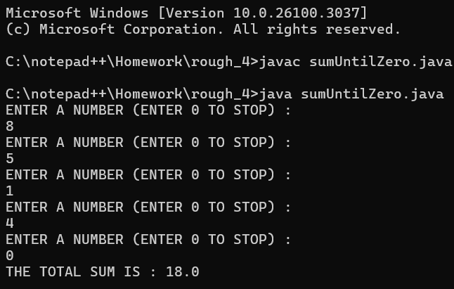

**PROGRAM – SUM OF NUMBERS USING WHILE LOOP**

**Q11:** Rewrite the program 10 to find the sum until the user enters 0 or a negative number using ***while*** loop and break statement

**Hint =>**

1. Use infinite while loop as in while (true)

Take the user entry and check if the user entered 0 or a negative number to break the loop using break;

**CODE:**

import java.util.*;

public class sumUntilZeroAndNegative {

public static void main(String args[]) {

try (Scanner sc = new Scanner(System.in)) {

double total = 0.0;

while (true) {

System.out.println("ENTER A NUMBER (ENTER 0 or NEGATIVE DIGIT TO STOP) : ");

int n = sc.nextInt();

if (n <= 0) {

break;

}

total += n;

}

System.out.println("THE TOTAL SUM IS : " + total);

}

}

}

**OUTPUT:**

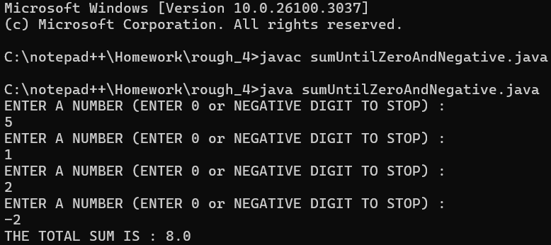

**PROGRAM – SUM OF NUMBERS USING WHILE LOOP**

**Q12:** Write a program to find the sum of n natural numbers using ***while*** loop compare the result with the formulae n*(n+1)/2 and show the result from both computations was correct.

**Hint =>**

1. Take the user input number and check whether it's a Natural number
2. If it's a natural number Compute using formulae as well as compute using ***while*** loop
3. Compare the two results and print the result

**CODE:**

import java.util.*;

public class sumOfNaturalNumerWhileLoop {

public static void main(String ars[]) {

try (Scanner sc = new Scanner(System.in)) {

System.out.println("ENTER A NATURAL NUMBER : ");

int n = sc.nextInt();

int formulaSum, sum = 0, i = 1;

if (n >= 0) {

formulaSum = n * (n + 1) / 2;

while (i <= n) {

sum += i;

i++;

}

System.out.println("SUM USING WHILE LOOP : " + sum);

System.out.println("SUM USING FORMULA :" + formulaSum);

String result = (sum == formulaSum) ? "BOTH RESULTS ARE CORRECT" : "THERE SEEMS TO BE A DISCREPENCY BETWEEN THE TWO RESULTS";

System.out.println(result);

} else {

System.out.println("PLEASE ENTER A NATURAL NUMBER");

}

} catch (InputMismatchException e) {

System.out.println("INVALID INPUT!");

}

}

}

**OUTPUT:**

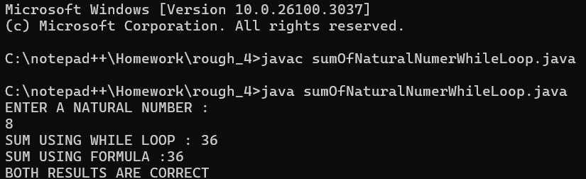

**PROGRAM – SUM OF NUMBERS USING FOR LOOP**

**Q13** Rewrite the program number 12 with the *for* loop instead of a while loop to find the sum of n Natural Numbers.

Hint =>

1. Take the user input number and check whether it's a Natural number
2. If it's a natural number Compute using formulae as well as compute using *for* loop
3. Compare the two results and print the result

**CODE:**

import java.util.*;

public class sumOfNaturalForLoop {

public static void main(String ars[]) {

try (Scanner sc = new Scanner(System.in)) {

System.out.println("ENTER A NATURAL NUMBER : ");

int n = sc.nextInt();

int formulaSum, sum = 0;

if (n >= 0) {

formulaSum = n * (n + 1) / 2;

for (int i = 1; i <= n; i++) {

sum += i;

}

System.out.println("SUM USING FOR LOOP : " + sum);

System.out.println("SUM USING FORMULA :" + formulaSum);

String result = (sum == formulaSum) ? "BOTH RESULTS ARE CORRECT" : "THERE SEEMS TO BE A DISCREPENCY BETWEEN THE TWO RESULTS";

System.out.println(result);

} else {

System.out.println("PLEASE ENTER A NATURAL NUMBER");

}

} catch (InputMismatchException e) {

System.out.println("INVALID INPUT!");

}

}

}

**OUTPUT:**

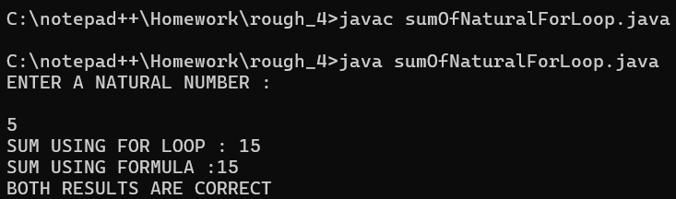

**PROGRAM – FACTORIAL OF AN INTEGER USING WHILE LOOP**

**Q14** Write a Program to find the factorial of an integer entered by the user.

**Hint =>**

1. For example, the factorial of 4 is 1 * 2 * 3 * 4 which is 24.
2. Take an integer input from the user and assign it to the variable. Check the user has entered a positive integer.
3. Using a ***while*** loop, compute the factorial.
4. Print the factorial at the end.

**CODE:**

import java.util.*;

public class factorialWhileLoop {

    public static int facto(int n) {

        int f = 1;

        int i = 1;

        while (i <= n) {

            f *= i;

            i++;

        }

        return f;

    }

    public static void main(String args[]) {

        Scanner sc = new Scanner(System.in);

        System.out.println("ENTER YOUR NUMBER : ");

        int n = sc.nextInt();

        System.out.println("THE FACTORIAL OF " + n + " IS : ");

        System.out.println(facto(n));

    }

}

**OUTPUT:**

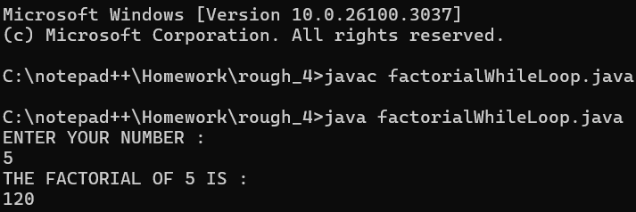

**PROGRAM – FACTORIAL OF AN INTEGER USING FOR LOOP**

**Q15** Rewrite program 14 using for loop

**Hint =>**

1. Take the integer input, check for natural number and determine the factorial using for loop and finally print the result.

**CODE:**

import java.util.*;

public class factorial {

public static int facto(int n) {

int f = 1;

for (int i = 1; i <= n; i++) {

f *= i;

}

return f;

}

public static void main(String args[]) {

try (Scanner sc = new Scanner(System.in)) {

System.out.println("ENTER A NUMBER : ");

int n = sc.nextInt();

System.out.println("THE FACTORIAL OF " + n + " IS : " + facto(n));

}

}

}

**OUTPUT:**

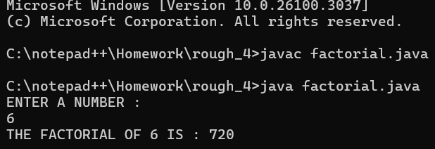

**BONUS :**

**PROGRAM – FACTORIAL OF AN INTEGER USING RECURSION**

**CODE :**

import java.util.*;

public class factorialRecursion {

    public static int facto(int n) {

        int f;

        if (n == 0 || n == 1) {

            return 1;

        } else {

            f = n * facto(n - 1);

        }

        return f;

    }

    public static void main(String args[]) {

        Scanner sc = new Scanner(System.in);

        System.out.println("ENTER YOUR NUMBER : ");

        int n = sc.nextInt();

        System.out.println("THE FACTORIAL OF " + n + " IS : " + facto(n));

    }

}

**OUTPUT :**

