**PROGRAM – ODD AND EVEN NUMBER**

**Q1:** Create a program to print odd and even numbers between 1 to the number entered by the user.

**CODE:**

import java.util.*;

public class oddEven{

public static void main(String args[]){

try(Scanner sc=new Scanner(System.in)){

System.out.println("ENTER THE UPPER LIMIT :");

int n=sc.nextInt();

for(int i=1;i<=n;i++){

if(i%2==0){

System.out.println(i+" IS an Even Number");

}

else{

System.out.println(i+" IS an ODD Number");

}

}

}

catch(InputMismatchException e){

System.out.println("ERROR");

}

}

}

**OUTPUT:**

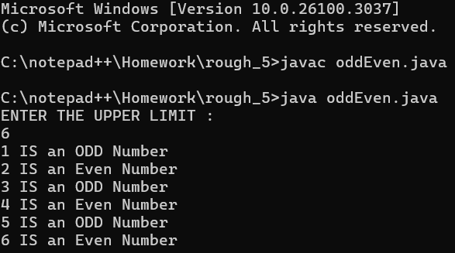

**PROGRAM – BONUS OF EMPLOYEES**

**Q2:** Create a program to find the bonus of employees based on their years of service.

**CODE:**

import java.util.*;

public class bonus {

public static void main(String args[]) {

try (Scanner sc = new Scanner(System.in)) {

System.out.println("YOUR SALARY : ");

int s = sc.nextInt();

System.out.println("YOUR YEAR OF SERVICE : ");

int year = sc.nextInt();

if (year > 5) {

System.out.println("YOU WIIL GET 5% BONUS ON YOUR SALARY");

} else {

System.out.println("YOU WILL NOT GET ANY BONUS");

}

} catch (InputMismatchException e) {

System.out.println("error!");

}

}

}

**OUTPUT:**

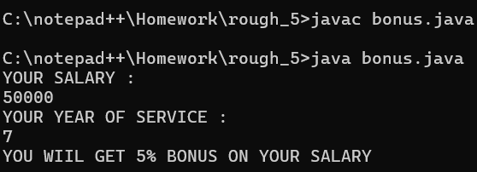

**PROGRAM – MULTIPLICATION TABLE**

**Q3:**  Create a program to find the multiplication table of a number entered by the user from 6 to 9.

**CODE:**

import java.util.*;

public class multiplicationTable {

public static void main(String args[]) {

try (Scanner sc = new Scanner(System.in)) {

System.out.println("ENTER THE DIGIT : ");

int n = sc.nextInt();

for (int i = 1; i <= 10; i++) {

System.out.println("THE MULTIPLICATION TABLE OF " + n + " IS : " + i + " X " + n + " = " + i * n);

}

} catch (InputMismatchException e) {

System.out.println("ERROR!");

}

}

}

**OUTPUT:**

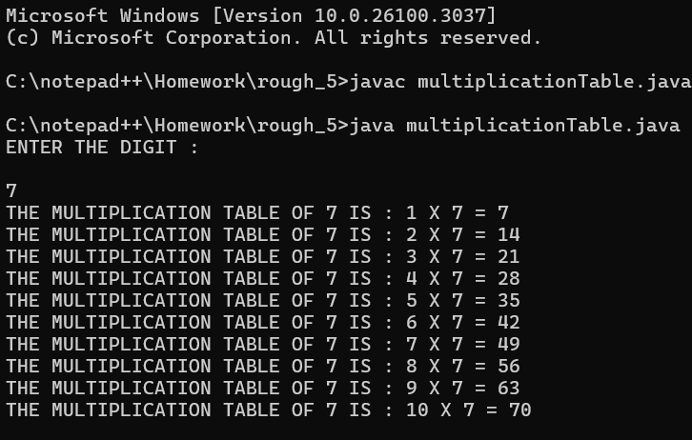

**PROGRAM – FizzBuzz**

**Q4:** Write a program FizzBuzz, take a number as user input, and if it is a positive integer loop from 0 to the number and print the number, but for multiples of 3 print "Fizz" instead of the number, for multiples of 5 print "Buzz", and for multiples of both print "FizzBuzz".

**Hint =>**

1. Write the program and use ***for*** loop

**CODE:**

import java.util.*;

public class fizzBuzz {

public static void main(String args[]) {

Scanner sc = new Scanner(System.in);

System.out.println("enter a number : ");

int n = sc.nextInt();

if (n > 0) {

for (int i = 1; i <= n; i++) {

if (i % 3 == 0 && i % 5 == 0) {

System.out.println("FizzBuzz");

} else if (i % 3 == 0) {

System.out.println("Fizz");

} else if (i % 5 == 0) {

System.out.println("Buzz");

} else {

System.out.println(i);

}

}

} else {

System.out.println("Please Enter the positive Number");

}

}

}

**OUTPUT:**

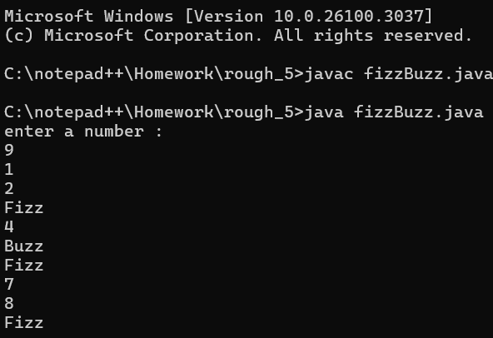

**PROGRAM – FizzBuzz using While loop**

**Q5:** Rewrite the program 5 FizzBuzz using while loop

**CODE:**

import java.util.*;

public class fizzBuzzWhile {

public static void main(String args[]) {

Scanner sc = new Scanner(System.in);

System.out.println("enter a number : ");

int n = sc.nextInt();

if (n > 0) {

int i = 1;

while (i <= n) {

if (i % 3 == 0 && i % 5 == 0) {

System.out.println("FizzBuzz");

} else if (i % 3 == 0) {

System.out.println("Fizz");

} else if (i % 5 == 0) {

System.out.println("Buzz");

} else {

System.out.println(i);

}

i++;

}

} else {

System.out.println("Please Enter the positive Number");

}

}

}

**OUTPUT:**

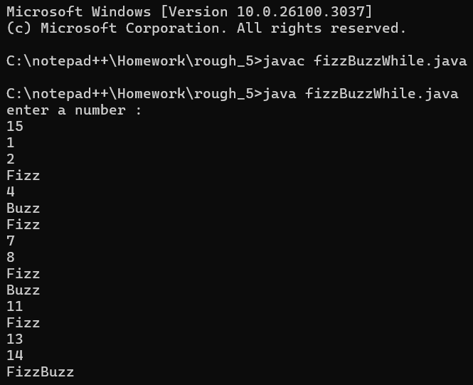

**PROGRAM – FIND YOUNGEST&TALLEST AMONG 3 PEOPLE**

**Q6:**  Create a program to find the youngest friends among 3 Amar, Akbar, and Anthony based on their ages and the tallest among the friends based on their heights

**CODE:**

import java.util.*;

public class youngest {

public static void main(String args[]) {

Scanner sc = new Scanner(System.in);

String names[] = {"AMAR", "AKBAR", "ANTHONY"};

int age[] = new int[3];

int height[] = new int[3];

for (int i = 0; i < names.length; i++) {

System.out.println("ENTER THE AGE AND HEIGHT OF " + names[i] + " :");

age[i] = sc.nextInt();

height[i] = sc.nextInt();

}

int smallest = Integer.MAX_VALUE;

String youngestName = "";

for (int i = 0; i < age.length; i++) {

if (smallest > age[i]) {

smallest = age[i];

youngestName = names[i];

}

}

System.out.println("THE SMALLEST OF THE AGE IS " + smallest + " WHICH IS " + youngestName); // Moved outside the loop

int largest = Integer.MIN_VALUE;

String tallestName = "";

for (int i = 0; i < height.length; i++) {

if (largest < height[i]) {

largest = height[i];

tallestName = names[i];

}

}

System.out.println("THE LARGEST OF THE HEIGHT IS " + largest + " WHICH IS " + tallestName); // Moved outside the loop

sc.close();

}

}

**OUTPUT:**

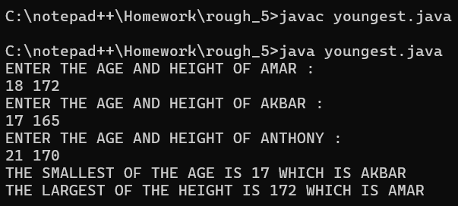

**PROGRAM – FIND FACTORS OF A NUMBER**

**Q7:** Create a program to find the factors of a number taken as user input.

**Hint =>**

1. Get input value for a variable named number.

Run a ***for*** loop from i = 1 to i < number. In each iteration of the loop, check if the number is perfectly divisible by i. If true, print the value of i

**CODE:**

import java.util.*;

public class factors {

public static void main(String args[]) {

Scanner sc = new Scanner(System.in);

System.out.println("ENTER A NUMBER : ");

int number = sc.nextInt();

for (int i = 1; i < number; i++) {

if (number % i == 0) {

System.out.println(i);

}

}

sc.close();

}

}

**OUTPUT:**

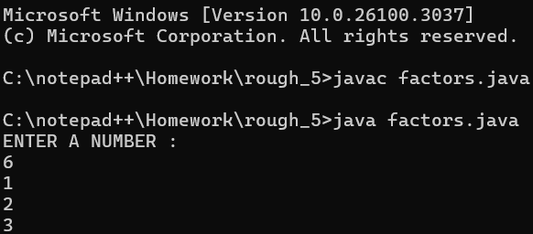

**PROGRAM – PRINT GREATEST FACTOR OF A NUMBER**

**Q8:** Create a program to print the greatest factor of a number beside itself using a loop.

**Hint =>**

1. Get an integer input and assign it to the number variable. As well as define a greatestFactor variable and assign it to 1
2. Create a ***for*** loop that runs from last but one till 1 as in i = number - 1 to i = 1.
3. Inside the loop, check if the number is perfectly divisible by i then assign i to greatestFactor variable and break the loop.
4. Display the greatestFactor variable outside the loop

**CODE:**

import java.util.*;

public class greatestFactor {

public static void main(String args[]) {

Scanner sc = new Scanner(System.in);

System.out.println("ENTER A NUMBER : ");

int number = sc.nextInt();

int greatestFactor = 1;

for (int i = number - 1; i >= 1; i--) {

if (number % i == 0) {

greatestFactor = i;

break;

}

}

System.out.println("THE GREATEST FACTOR IS " + greatestFactor);

sc.close();

}

}

**OUTPUT:**

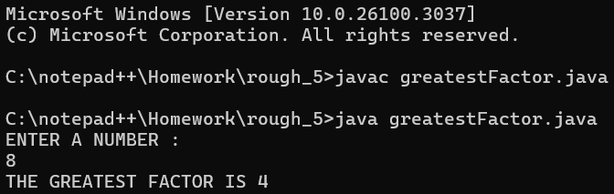

**PROGRAM – POWER OF A NUMBER**

**Q9:** Create a program to find the power of a number.

**Hint =>**

1. Get integer input for two variables named number and power.
2. Create a result variable with an initial value of 1.
3. Run a for loop from i = 1 to i <= power.
4. In each iteration of the loop, multiply the result with the number and assign the value to the result.
5. Finally, print the result

**CODE:**

import java.util.*;

public class powerOfNumber {

public static void main(String args[]) {

try (Scanner sc = new Scanner(System.in)) {

System.out.println("ENTER THE BASE NUMBER : ");

int b = sc.nextInt();

System.out.println("ENTER THE POWER : ");

int p = sc.nextInt();

int result = 1;

for (int i = 1; i <= p; i++) {

result *= b;

}

System.out.println(b + " TO THE POWER OF " + p + " IS : " + result);

} catch (InputMismatchException e) {

System.out.println("INVALID INPUT!");

}

}

}

**OUTPUT:**

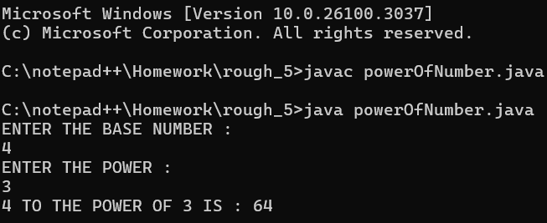

**PROGRAM – MULTIPLE OF A NUMBER**

**Q10:** Create a program to find all the multiple of a number taken as user input below 100.

**Hint =>**

1. Get input value for a variable named number.
2. Run a ***for*** loop backwards: from i = 100 to i = 1.
3. Inside the loop, check if i perfectly divides number.

If true, print the number and ***continue*** the loop

**CODE:**

import java.util.*;

public class multiples {

public static void main(String args[]) {

Scanner sc = new Scanner(System.in);

System.out.println("ENTER THE NUMBER BELOW 100 : ");

int number = sc.nextInt();

System.out.println("MULTIPLES OF " + number + " BELOW 100 :");

if (number >= 0 && number <= 100) {

for (int i = number - 1; i > 1; i--) {

if (number % i == 0) {

System.out.println(i);

}

}

} else {

System.out.println("INVALID INPUT! ENTER A NUMBER WHICH IS IN THE RANGE OF 0-100.");

}

sc.close();

}

}

**OUTPUT:**

