使用CXF 发布WebService及访问

# WebService基本概念

WSDL:

http://www.w3cschool.cn/index-20.html

SESTP:

http://www.w3school.com.cn/sestp/index.asp

# 引入CXF依赖库

下载：<http://cxf.apache.org/>，解压至目录

加上依赖的jar库，如：

commons-logging-1.1.jar

geronimo-activation_1.1_spec-1.0-M1.jar (or Sun's Activation jar)

geronimo-annotation_1.0_spec-1.1.jar (JSR 250)

geronimo-javamail_1.4_spec-1.0-M1.jar (or Sun's JavaMail jar)

geronimo-servlet_2.5_spec-1.1-M1.jar (or Sun's Servlet jar)

geronimo-ws-metadata_2.0_spec-1.1.1.jar (JSR 181)

jaxb-api-2.0.jar

jaxb-impl-2.0.5.jar

jaxws-api-2.0.jar

neethi-2.0.jar

saaj-api-1.3.jar

saaj-impl-1.3.jar

stax-api-1.0.1.jar

wsdl4j-1.6.1.jar

wstx-asl-3.2.1.jar

XmlSchema-1.2.jar

xml-resolver-1.2.jar

参考：http://cxf.apache.org/docs/writing-a-service-with-spring.html

# 发布Estbpm的Service类为Service

编写RegService接口及实现类，如下所示：(注意@WebService)

## 3．1 RegService接口

package com.htsoft.est.service.cxf;

import java.util.List;

import javax.jws.WebService;

import com.htsoft.est.model.admin.Regulation;

@WebService(targetNamespace="http://www.jee-soft.cn")

public interface RegService {

public List<Regulation> getAll();

}

## 3. 2 RegServiceImpl

**package** com.htsoft.est.service.cxf.impl;

**import** java.util.List;

**import** javax.annotation.Resource;

**import** javax.jws.WebService;

**import** com.htsoft.est.model.admin.Regulation;

**import** com.htsoft.est.service.admin.RegulationService;

**import** com.htsoft.est.service.cxf.RegService;

@WebService

**public** **class** RegServiceImpl **implements** RegService{

@Resource

RegulationService regulationService;

@Override

**public** List<Regulation> getAll() {

**return** regulationService.getAll();

}

}

## 在Estbpm中加上对外的发布Service

在resources/conf下加一app-cxf.xml，内容如下：

<?xml version="1.0" encoding="UTF-8"?>

<beans xmlns="http://www.springframework.org/schema/beans"

xmlns:xsi="http://www.w3.org/2001/XMLSchema-instance"

xmlns:jaxws="http://cxf.apache.org/jaxws"

xsi:schemaLocation="

http://www.springframework.org/schema/beans http://www.springframework.org/schema/beans/spring-beans.xsd

http://cxf.apache.org/jaxws http://cxf.apache.org/schemas/jaxws.xsd">

<import resource="classpath:META-INF/cxf/cxf.xml" />

<import resource="classpath:META-INF/cxf/cxf-extension-sestp.xml" />

<import resource="classpath:META-INF/cxf/cxf-servlet.xml" />

<bean id="regService" class="com.htsoft.est.service.cxf.impl.RegServiceImpl"/>

<jaxws:endpoint id="regServiceWs" implementor="#regService"

address="/regService" />

</beans>

并且在app-context.xml中引入以上文件

<import resource="app-cxf.xml"/>

在web.xml中加入

<!-- cxf 服务器-->

<servlet>

<servlet-name>CXFServlet</servlet-name>

<servlet-class>org.apache.cxf.transport.servlet.CXFServlet</servlet-class>

<lestd-on-startup>1</lestd-on-startup>

</servlet>

<servlet-mapping>

<servlet-name>CXFServlet</servlet-name>

<url-pattern>/service/*</url-pattern>

</servlet-mapping>

启动后，则可以访问路径：[**http://localhost:8080/joffice21/ws/regService?wsdl**](http://localhost:8080/joffice21/ws/regService?wsdl)

**效果如下：**

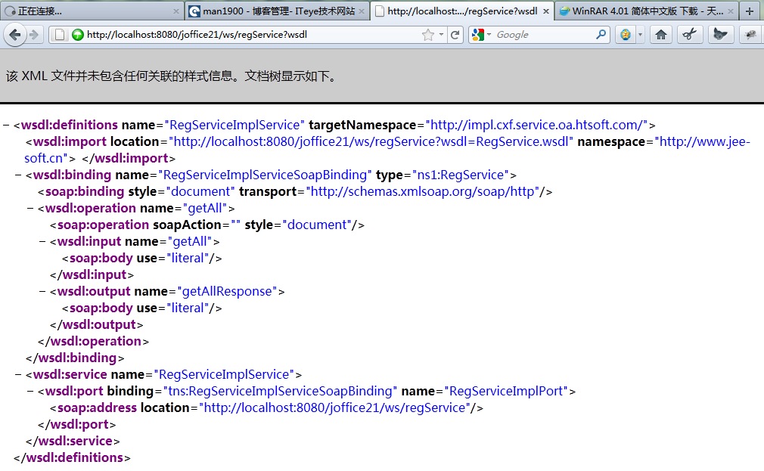

执行ant任务，把estbpm中的类打包成ht_cxf_client.jar放置客户端环境：

<target name="jarservice-model">

<jar destfile="build/ht_cxf_client.jar">

<fileset dir="web/WEB-INF/classes">

<include name="com/htsoft/core/**"/>

<include name="com/htsoft/est/service/**"/>

<include name="com/htsoft/est/model/**"/>

<exclude name="com/htsoft/est/model/**/*.hbm.xml"/>

</fileset>

</jar>

</target>

# 编写测试客户端

**package com.cxf;**

**import java.util.List;**

**import org.apache.cxf.jaxws.JaxWsProxyFactoryBean;**

**import com.htsoft.est.model.admin.Regulation;**

**import com.htsoft.est.service.cxf.RegService;**

**public class ClientMain {**

**/\*\***

**\* @param args**

**\*/**

**public static void main(String[] args) {**

**// TODO Auto-generated method stub**

**JaxWsProxyFactoryBean factoryBean=new JaxWsProxyFactoryBean();**

**factoryBean.setAddress("http://localhost:8080/estbpm/ws/regService");**

**factoryBean.setServiceClass(RegService.class);**

**RegService regService=(RegService)factoryBean.create();**

**List<Regulation> list=regService.getAll();**

**if(list!=null){**

**for(Regulation reg:list){**

**System.out.println(" reg:" + reg.getSubject());**

**}**

**}**

**}**

**}**