# Final Project Writeup

## **An Analysis of the 2017 Wayne County Foreclosure Tax Auction**

**Abstract:**

The Wayne County Tax Foreclosure auction has traditionally been an institution that looks to recoup revenue lost from the failure to pay property taxes[1]. The auction is heavily criticized for issues around the pricing of properties, rampant speculation caused by low cost properties, and the ability for many to purchase a large amount of properties[2]. More deeply examining factors around participation in the auction can help better illuminate who participates and what data on properties may contribute to a winning bid price, or probability of a winning bid from a particular buyer.

**Introduction:**

Wayne County runs a tax auction on yearly basis for foreclosed properties. Properties eligible for foreclosure will have at least three years of property taxes that have gone unpaid, and no payment plan has been established. While the auction is a county wide event our data set consists solely of properties within the City of Detroit. The tax auction has been a long-criticized institution in Wayne County for the redistribution of real estate within poorer communities such as the City of Detroit.

Our data set consists of the 2017 Wayne County Tax Auction results and parcel ownership and blight violation data. Our data was all downloaded from the City of Detroit open data portal using web APIs and python scripts to transfer it to csv format. Tax auction data included a parcel identifier which is a unique method of identifying real estate properties in the City of Detroit along with starting bids, winning bids, and bidder information. The parcel ownership data contains information on a property such as the data built, what kind of structure is on the property along with tax assessment information. Blight violation data includes all blight violations issued to properties by the City of Detroit it includes information on the city code that was violated, fines that were levied against the property owner, and the date that the violation was issued. Council districts were chosen as approximations of geography in the city that corresponds directly to representation within city government.

**General Statistics:**

First maps were created to look at spatial patterns of the tax auction. The first figure below shows winning bids per property by city council district. The amount of purchased properties was highly concentrated in the city council districts outside the city center. This is consistent with previous reports on the tax auction affecting the outer neighborhoods of Detroit while leaving areas growing in affluence less susceptible to its affects. The second figure shows the total amount of money spent per council district. This map shows a shift between the northern council districts from the amount of properties sold to the amount spent. This could indicate that northwest Detroit saw less properties purchased in the auction, but the properties that were purchased in the auction were more valuable.

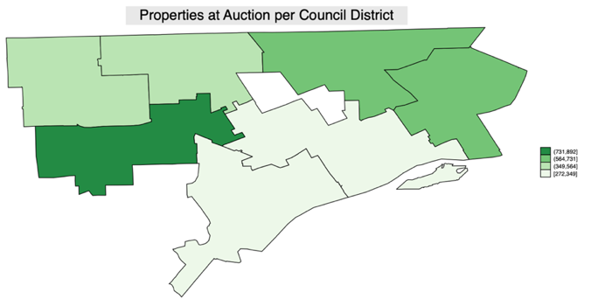

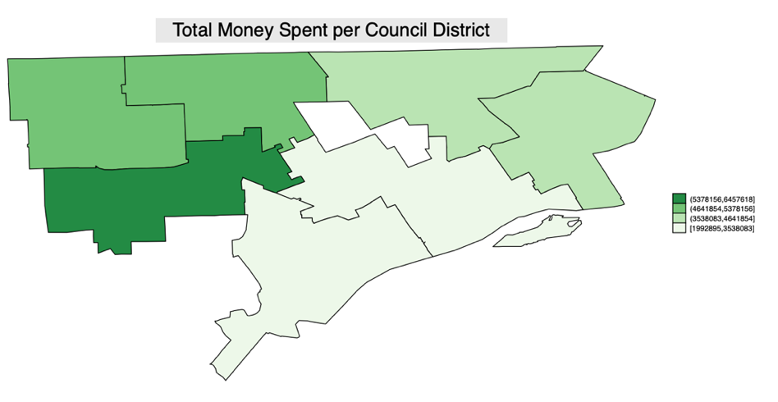

Next potentially important variables for analysis of the tax auction were examined. These included variables on initial asking price and the price of the winning bid. It also included general facets on the property such as land value, number of buildings, square footage, and number of blight violations.

|  |  |  |  |  |  |  |
| --- | --- | --- | --- | --- | --- | --- |
| variable | min | max | mean | median | StdDev | se(mean) |
| starting_bid | 800 | 1302200 | 8495.32 | 6400 | 21911.58 | 350.4172 |
| winning_bid | 500 | 301000 | 8154.242 | 5200 | 12410.58 | 198.474 |
| year_built | 1865 | 1994 | 1936.498 | 1939 | 13.75793 | .226179 |
| sqft | 0 | 563231 | 5119.266 | 4400 | 10871.7 | 173.8638 |
| num_buildings | 0 | 6 | .9634271 | 1 | .2913304 | .0046591 |
| floor_area | 0 | 104896 | 1324.174 | 1080 | 2563.48 | 40.996 |
| land_value | 108 | 553877 | 1632.978 | 789 | 10882.11 | 174.0303 |
| violation_count | 0 | 62 | 2.111509 | 1 | 3.350864 | .0535881 |
|  |  |  |  |  |  |  |

Of the 3,910 properties in the tax auction data set the mean starting bid came to approximately $8400 dollars. However, the mean winning bid price was actually lower at approximately $8100 dollars. This could indicate that the auction allows bidders to purchase properties under the initial asking price from the county government. There was a significant range in the age of properties being sold on the tax auction with the oldest property being developed in 1865 and the youngest in 1994. This is attributable to the long history of Detroit as a city and its rapid development and economic expansion through the years. The number of blight tickets was another significant factor for analysis with the minimum being no blight tickets and the maximum being 62 for a single property. However, the median and mean seem to be more representative of blight violations per property with about 2 on average and a median of 1.

Then bidder information was more closely examined. Wayne County publishes important information on winning bidders such as addresses, names, and zip codes. This allows for analysis into how property ownership changes through the tax auction. Using information on the names and zip codes of bidders a basic classification was created. The first of these groups were those who had a bidder address inside the City of Detroit and those with an address outside the City of Detroit. These findings were particularly interesting because the clear majority of bidders had addresses that were not based within the City of Detroit.

|  |  |
| --- | --- |
| Location of Bidder | Number |
| Bidder not in Detroit | 2,864.0 |
| Bidder in Detroit | 1,046.0 |
| Total | 3,910.0 |

Next these bidder trends were broken down by city council district. This was to examine bidder behavior to see if there were distinct differences or patterns of bidding between bidders located within and outside the city.

|  |  |  |  |  |  |  |  |  |
| --- | --- | --- | --- | --- | --- | --- | --- | --- |
|  | # Properties Won | | | | | | |  |
| Council District | 1 | 2 | 3 | 4 | 5 | 6 | 7 | Total |
| Bidder not in Detroit | 436.0 | 394.0 | 507.0 | 456.0 | 236.0 | 163.0 | 672.0 | 2,864.0 |
| Bidder in Detroit | 128.0 | 112.0 | 224.0 | 140.0 | 113.0 | 109.0 | 220.0 | 1,046.0 |
| Total | 564.0 | 506.0 | 731.0 | 596.0 | 349.0 | 272.0 | 892.0 | 3,910.0 |

This analysis showed similar trends for bidders within and outside of the city with each group of bidders purchasing the most properties within the 3rd and 7th council districts. However, bidders outside the city bought a much larger share of these properties which is relatively consistent with the makeup of winning bids.

Lastly data on what kinds of properties were on sale in the tax foreclosure was examined. The majority of properties were single family homes, but any properties that were foreclosed on by the county are eligible for inclusion in the auction. The next most included property did not have an assigned building type. These typically represent empty lots, or buildings that are not classified as a residence. Lastly, the building types that were least present in the auction were multi-family dwellings. These are typically flats, bungalows, or duplexes that are meant to house multiple families.

|  |  |
| --- | --- |
| Style of building present on parcel | Number |
| Single Family | 3,098.0 |
| No Building Style | 457.0 |
| Two Family Flat | 285.0 |
| Income Bungalow | 35.0 |
| Large Flats | 21.0 |
| Multi Dwelling | 14.0 |
| Total | 3,910.0 |

Next, bid data was more closely examined with intra and inter group variance testing. One-way ANOVA was used to analyze the difference in mean winning bid between different groupings of properties. Analysis was conducted on the difference in mean winning bid on council district, bidder residing within the City of Detroit, building style, and whether or not the bidder was a corporate entity. The ANOVA analysis indicated that the only statistically significant differences among groups were mean bids across building style and mean bids across council district. There was not statistically meaningful difference in the mean winning bids between bidders in Detroit and outside Detroit and whether or not bidders were corporate entities. Below are two bar charts displaying the means that were deemed statistically different between groups.

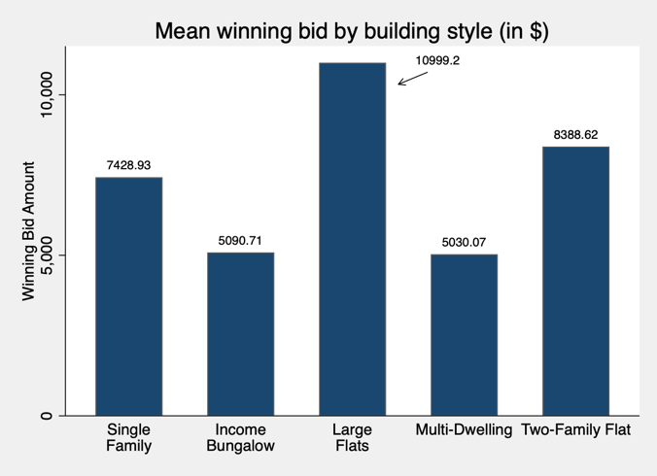 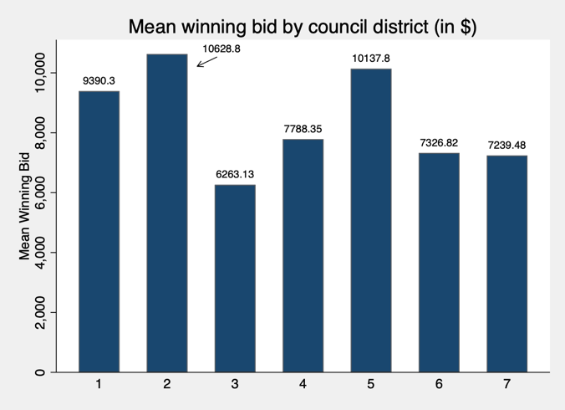

**Regression Analysis of Winning Bids**

|  |  |  |  |  |
| --- | --- | --- | --- | --- |
|  | Model 1 | Model 2 | Model 3 | Model 4 |
|  | winning_bid | ln_winning_bid | ln_winning_bid | ln_winning_bid |
| sqft | 0.368*** |  |  |  |
|  | (0.0306) |  |  |  |
| starting_bid | 0.0716*** |  |  |  |
|  | (0.0152) |  |  |  |
| no_lead_clearance_sum | 3,047*** | 0.293*** | 0.295*** | 0.293*** |
|  | (665.9) | (0.0648) | (0.0663) | (0.0531) |
| num_buildings | 4,173*** | 0.195*** | 0.600 | 0.195*** |
|  | (609.4) | (0.0614) | (0.528) | (0.0729) |
| bidder_in_same_zip_code | 1,462** | 0.224*** | 0.205*** | 0.224*** |
|  | (686.0) | (0.0668) | (0.0703) | (0.0687) |
| ln_sqft |  | 0.489*** | 0.846*** | 0.489*** |
|  |  | (0.0524) | (0.0766) | (0.0598) |
| ln_starting_bid |  | 0.589*** | 0.653*** | 0.589*** |
|  |  | (0.0327) | (0.0376) | (0.0358) |
| Constant | 1,391** | -1.136*** | -5.128*** | -1.136** |
|  | (623.3) | (0.432) | (0.865) | (0.476) |
| Observations | 3,910 | 3,902 | 3,451 | 3,902 |
| R-squared | 0.203 | 0.157 | 0.133 | 0.157 |
| Breusch-Pagan F-Stat |  |  |  |  |

Standard errors in parentheses *** p<0.01, ** p<0.05, * p<0.1

Next, regression analysis was conducted to examine the associations between certain factors and winning bid price. Variables that were included in the OLS regression were square footage of the property, the starting bid for the property, the number of lead clearance blight violations, the number of buildings located on the property, and if the bidder was located in the same zip code as the property being bid on. The initial findings are listed as model 1 in the regression table below. All variables were deemed statistically significant at the $∝=.05$ confidence level.

Primary findings from the first model indicate that all variables have a positive impact on the winning bid price for a property. The most notable results are that every building on a property is associated with approximately a $4,173 increase in winning bid price. Also, that on average if a bidder is in the same zip code as a property, the winning bid price increases by $1,461 as opposed to bidders that do not live in the same zip code as the property. One peculiar finding is that for every increase in lead clearance violations which indicate presence of lead in a property that the winning bid price has an associated increase of $3,046. This could possibly be indicative of speculators bidding on lower quality properties to potentially wait for market increases or use their own resources to fix and begin using as a rental property. Lastly, a 1 square foot increase in property size was associated with a ¢.36 increase in winning bid price. Indicating that larger properties were associated with larger winning bids than smaller properties.

Next, this model was checked for the presence of heteroskedasticity in the data. Each of the dependent variables have varying measurement scales that could end up creating patterns in the residuals. This would lead to distorted standard errors that could potentially impact the model. Using the Breusch-Pagan test for heteroskedasticity indicated that there were issues within the model that needed to be corrected. I began to correct these issues by taking the natural logs of the square footage, starting bid price, and the dependent variable winning bid. This would make the measurement scale of the large variables more similar to the smaller variables included in the model.

Using the Breusch-Pagan tests on individual variables indicated that the square footage variable and the starting bid variables were both sources of heteroskedasticity. Residual versus Predictor plots were then generated to better visualize the heteroskedasticity within the model. Each of the plots had a slight fan pattern over the independent variable with many residuals being above zero. This was a clear visual indication that there were patterns among the residuals that would bias the initial model.

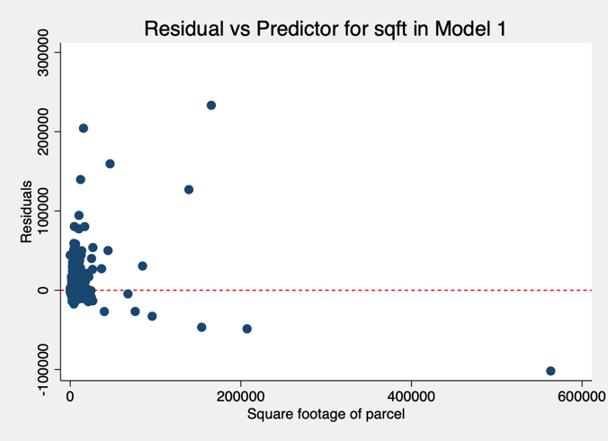 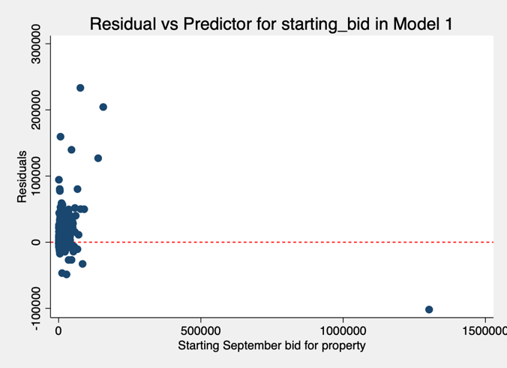

Taking the log of the dependent variable and the two variables and running a new model with the transformed values yielded the plots below. It would appear that transforming the variables reduced the extreme patterns in the data and created a more even spread of residuals over the 0 value. Using the Breusch-Pagan tests on this model also demonstrated that there was less of a probability for heteroskedasticity. The tests for fitted values and the overall model allowed us to fail to reject the null hypothesis of constant variance at the $∝=.05$ confidence level.

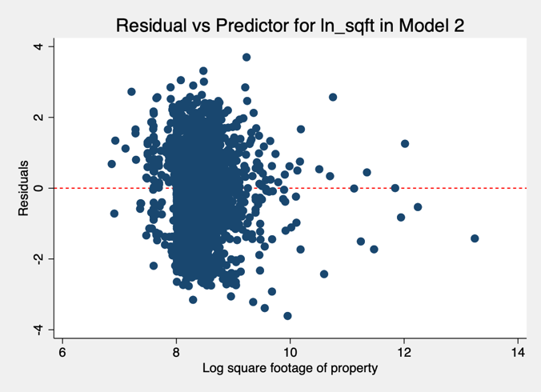 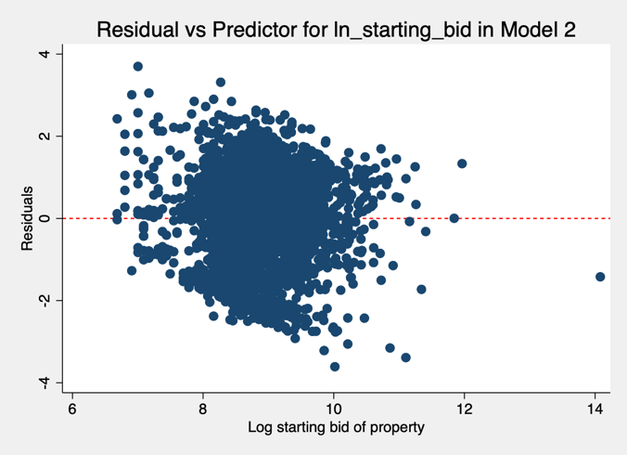

One last strategy was to limit the transformed regression to only use properties that had a defined building style. This would only include structures defined above as being a residential property. However, this did not lead to further fixing of heteroskedasticity according to the Breusch-Pagan tests on the fitted values of the model, or the model as a whole. Finally, after remedying issues with the variables one last regression was run with robust standard errors to ensure accurate calculation of standard errors.

**Logit Analysis of Detroit Bidder Probability**

The next regression analysis performed was a logistic regression model to predict the probability of a winning bidder being located in Detroit. This was to examine which factors may increase the probability of a Detroit based bidder to win a property on the auction. The first regression controlled for factors like property location in city council district, log square footage, and number of buildings. The second regression looked to improve on the first by adding the amount of lead clearance violations and log starting bid amount as controls.

|  |  |  |
| --- | --- | --- |
|  | Model (1) | Model (2) |
|  | bidder_in_detroit | bidder_in_detroit |
| ln_sqft | -0.389*** | -0.458*** |
|  | (0.119) | (0.124) |
| num_buildings | -0.0894 | -0.155 |
|  | (0.129) | (0.134) |
| 2.council_district | -0.108 | -0.131 |
|  | (0.150) | (0.150) |
| 3.council_district | 0.353*** | 0.335** |
|  | (0.130) | (0.131) |
| 4.council_district | 0.000250 | 0.00473 |
|  | (0.141) | (0.142) |
| 5.council_district | 0.394** | 0.396** |
|  | (0.156) | (0.156) |
| 6.council_district | 0.728*** | 0.722*** |
|  | (0.163) | (0.163) |
| 7.council_district | 0.0621 | 0.0529 |
|  | (0.129) | (0.129) |
| ln_starting_bid |  | 0.140** |
|  |  | (0.0692) |
| no_lead_clearance_sum |  | -0.214 |
|  |  | (0.160) |
| Constant | 2.183** | 1.607 |
|  | (1.012) | (1.042) |
|  |  |  |
| Observations | 3,902 | 3,902 |

Standard errors in parentheses *** p<0.01, ** p<0.05, * p<0.1

Both regressions had statistically significant coefficients for log square footage and city council district variables for the 3rd, 5th, and 6th districts. The second model had an additional control for log starting bid that was also statistically significant. However, the additional controls did not increase the predictive power of the regression with each having a correct prediction rate of about 73%.

While not statistically significant, the coefficient for lead clearance violations indicated that a property with more lead violations would be less likely to be purchased by a bidder located in Detroit. Also the number of buildings on a property along with the square footage of a property would decrease the probability of a bidder from Detroit winning. However, almost every city council district would positively affect the probability of being a bidder from Detroit with the exception of a property located in the 2nd city council district.

Next some post-estimation analysis was done with a few cases to see how predicted probabilities change for a given property profile. The first model was used to generate a prediction for a property that had median log square footage was in the 3rd city council district, and had varying number of buildings on the property. The margins plot below shows the different predictions based on number of buildings on the property. The second margins plot shows a similar property with 1 building that varies across city council district.

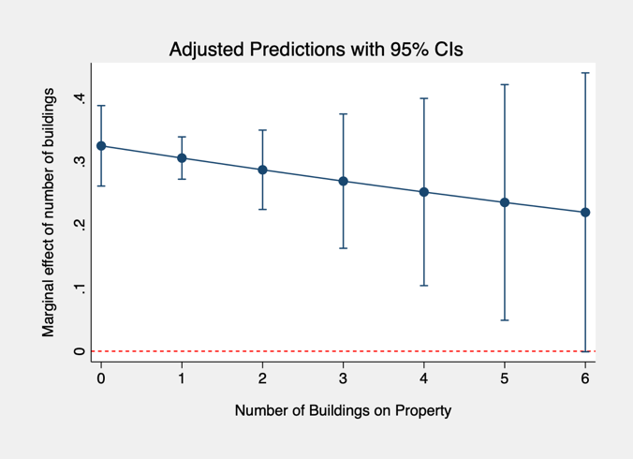 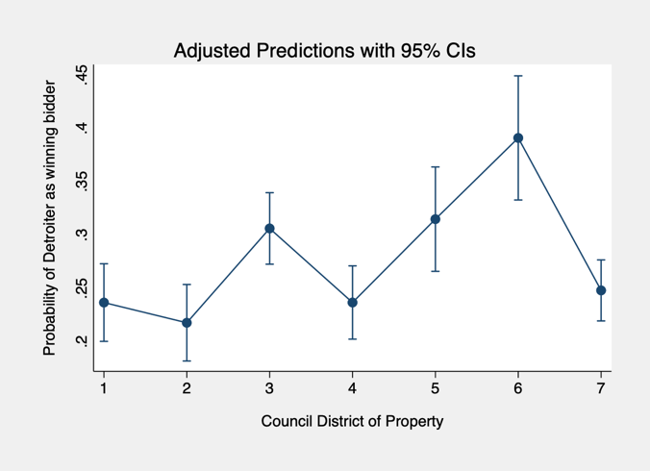

The first plot indicates that as a property has more buildings on it the less likely a property will be won by a bidder located in Detroit. However, the confidence intervals continuously grow larger and larger for each additional building on the property so there is less confidence in this conclusion. The second plot demonstrates that a property with the defined profile in city council districts 5 or 6 have the greatest probability of being won by a Detroit based bidder. All the probabilities predicted in the second plot have relatively small confidence intervals, and are all statistically different from 0. However, all the predicted probabilities for the given property profile are relatively low indicating that even with a shifting city council district a property with that profile would likely not be won by a bidder from Detroit.

**Logit Analysis of Corporate Bidder Probability**

Our final regression analysis concerned what factors contributed to a property being won by a corporate bidder. We again used logistic regression to gauge which properties would end up going to a bidder that was a corporate entity. We controlled for basic factors such as dummies for each city council district, the log starting bid of a property, the log square feet of a property, the amount of lead clearance blight violations present, a dichotomous variable to indicate whether or not the bidder was located in Detroit, and the number of buildings on the property.

The resulting logistic regression is contained in the table below. Generally most coefficients were deemed statistically significant at the $∝=.05$ confidence level. The exception to this were the dummy variable for a property located in the 2nd city council district, and the number of buildings on a property. Being a Detroit-based bidder decreased the probability that a bidder was also a corporate bidder while the square footage of a property would also decrease the probability of being a corporate bidder. Each of the other control variables had a positive effect on the probability that a bidder would be considered a corporate bidder.

One interesting finding from the regression was that the amount of lead clearance violations was associated with an increase in the probability of a property being bought by a corporate bidder. This could potentially be the case because corporations may have greater resources to deal with issues like lead abatement and thus would not be driven away from properties with lead issues.

|  |  |
| --- | --- |
|  | Model (1) |
|  | corporate_bidder |
| 2.council_district | 0.848 |
|  | (0.900) |
| 3.council_district | 2.285*** |
|  | (0.780) |
| 4.council_district | 3.432*** |
|  | (0.750) |
| 5.council_district | 3.124*** |
|  | (0.783) |
| 6.council_district | 1.397 |
|  | (0.948) |
| 7.council_district | 0.789 |
|  | (0.848) |
| ln_starting_bid | 0.581*** |
|  | (0.185) |
| ln_sqft | -0.987** |
|  | (0.400) |
| no_lead_clearance_sum | 1.060*** |
|  | (0.176) |
| bidder_in_detroit | -2.805*** |
|  | (0.592) |
| num_buildings | 0.0635 |
|  | (0.376) |
| Constant | -2.523 |
|  | (3.302) |
| Observations | 3,902 |

Standard errors in parentheses *** p<0.01, ** p<0.05, * p<0.1

When doing post-estimation analysis it was determined our model had a very high success rate at predicting corporate bidders from non-corporate bidders. The model yields a 96.98% correct prediction rate for corporate bidders. However, this could be from the low amount of bidders that actually identify solely as a corporation instead of an individual acting as an agent for a corporation. We also looked at the effects on the probability of being a corporate bidder by predicting probabilities for certain scenarios. The first scenario varied our prediction based on city council district for a bidder that was not based in Detroit bidding on a property with 1 building on it that has had 2 lead clearance violations along with median log square foot and median log starting bid. This yielded the predicted probabilities shown in the margins plot below.

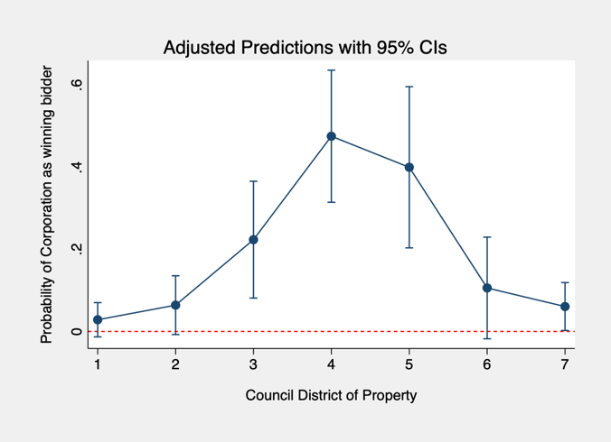

The predicted probabilities for this property to have been won by a corporate bidder is not statistically different from 0 for the 1st, 2nd, and 6th council districts. The predicted probabilities for these scenarios are also very low. However, the greatest probabilities of a property being won by a corporate bidder are in the 3rd, 4th, and 5th council districts. While these properties have are statistically different from 0 they all have some part of their confidence interval overlapping with the other. Each of these predicted probabilities are also not very large. So a property with the profile given above would not be a likely candidate for purchase by a corporate entity.

Another post-estimation analysis varied the amount of lead clearance violations for a similar property that was located in the 4th city council district.

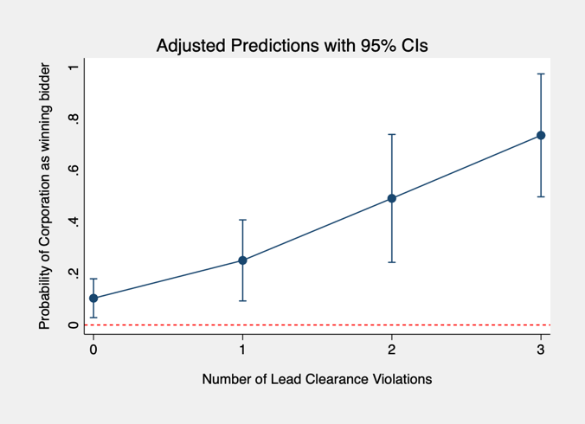

For a similar property profile as stated above the number of lead clearances would increase the probability of a corporate bidder winning the property. The predictions for each of the three scenarios were statistically different than zero, but also have significant overlap in confidence intervals. The probability also steadily rises to be over .5 with 3 lead clearances.

**Conclusions:**

The 2017 Wayne County Foreclosure auction was heavily used by those living outside of Detroit to purchase properties for low prices. Winning bids with the auction are heavily associated with typical housing price metrics such as square footage, and number of buildings on a property. Starting bids also play a significant role in the final bidding price. While no conclusions on the occupancy of properties sold at the auction can be drawn it is obvious the auction has the greatest effect in city council districts that are outside the city center. Current efforts to minimize foreclosure issues to prevent properties from being lost to the foreclosure auction are the best attempts to remedy the issues surrounding the auction. Once a property is listed for auction there is very little than can be done to prevent purchasing by those outside the city.

1. Cwiek, S. (2017, September 4). Here we go again: Wayne County starts 2017 auction of tax-foreclosed properties. Retrieved April 29, 2019, from https://www.michiganradio.org/post/here-we-go-again-wayne-county-starts-2017-auction-tax-foreclosed-properties
2. Kaffer, N. (2019, January 18). Michigan should make these changes to help people keep their homes. Retrieved April 29, 2019, from https://www.freep.com/story/opinion/columnists/nancy-kaffer/2019/01/17/wayne-county-tax-foreclosure-auction-detroit/2552282002/