ASSIGNMENT REPORT

LIBRARY MANAGEMENT SYSTEM

Our aim fort his Library Management System is making it easier to borrowing a book or just glancing over the library.We are doing this process by taking help from some software acknowledge.

This process is held by those functions that shown below:

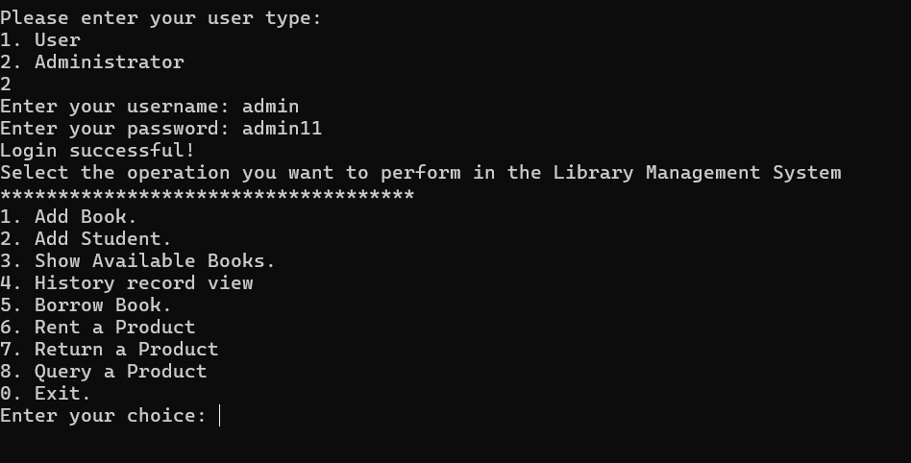

# C:\Users\LENOVO\AppData\Local\Packages\5319275A.WhatsAppDesktop_cv1g1gvanyjgm\TempState\C9108DDE6DD7B4E071129D2F9100FA55\WhatsApp Görsel 2024-05-17 saat 14.35.12_7715117a.jpgLibrary System Report

**Introduction**

This report describes the design and implementation of a library management system software. The system allows students and administrators to borrow, return, and query books. Additionally, administrators can add books, add students, and view available books.

**System Architecture**

The system consists of several main classes:

1. **Student**
2. **Administrator**
3. **Book**
4. **Library**
5. **Products**
6. **Bake**

**1. Student Class**

This class stores and verifies the identity and passwords of students. It includes methods to get student IDs and passwords.

**2. Administrator Class**

This class stores and verifies the identity and passwords of administrators. It includes methods to get administrator IDs and passwords.

**3. Book Class**

This class stores the titles and quantities of books. It includes a method to decrease the quantity when a book is borrowed.

**4. Library Class**

This class maintains lists of books, students, and administrators. It includes methods for adding books, adding students, adding administrators, borrowing books, and querying books.

**5. Products Class**

This class handles operations related to the products in the library. It manages renting, returning, and querying products.

**6. Bake Class**

This class asks the user whether they want to continue with operations and continues or terminates the program based on the user's response.

**Implementation**

**Student Operations**

Students can borrow books, return books, and query books after logging into the system.

**Borrowing Books**

Students can select a book from the available list and borrow it. When a book is borrowed, its quantity decreases by one.

**Returning Books**

Students can return borrowed books. This operation is managed by the Products class.

**Querying Books**

Students can check the availability of books in the library.

**Administrator Operations**

Administrators can add books, add students, and view available books after logging into the system.

**Adding Books**

Administrators can add new books to the library and update the quantity of existing books.

**Adding Students**

Administrators can add new students to the system. The student ID and password are saved in the **student.txt** file.

**Viewing Available Books**

Administrators can view the list of available books in the library. This information is read from the **books.txt** file.

**File Structure**

The system uses two main files:

1. **books.txt**: Stores the titles and quantities of books.
2. **student.txt**: Stores the student IDs and passwords.

**Conclusion**

This library management system allows students and administrators to efficiently manage library operations. Students can borrow, return, and query books, while administrators can add books, add students, and view available books. The system simplifies library management with its user-friendly interface and functional structure.



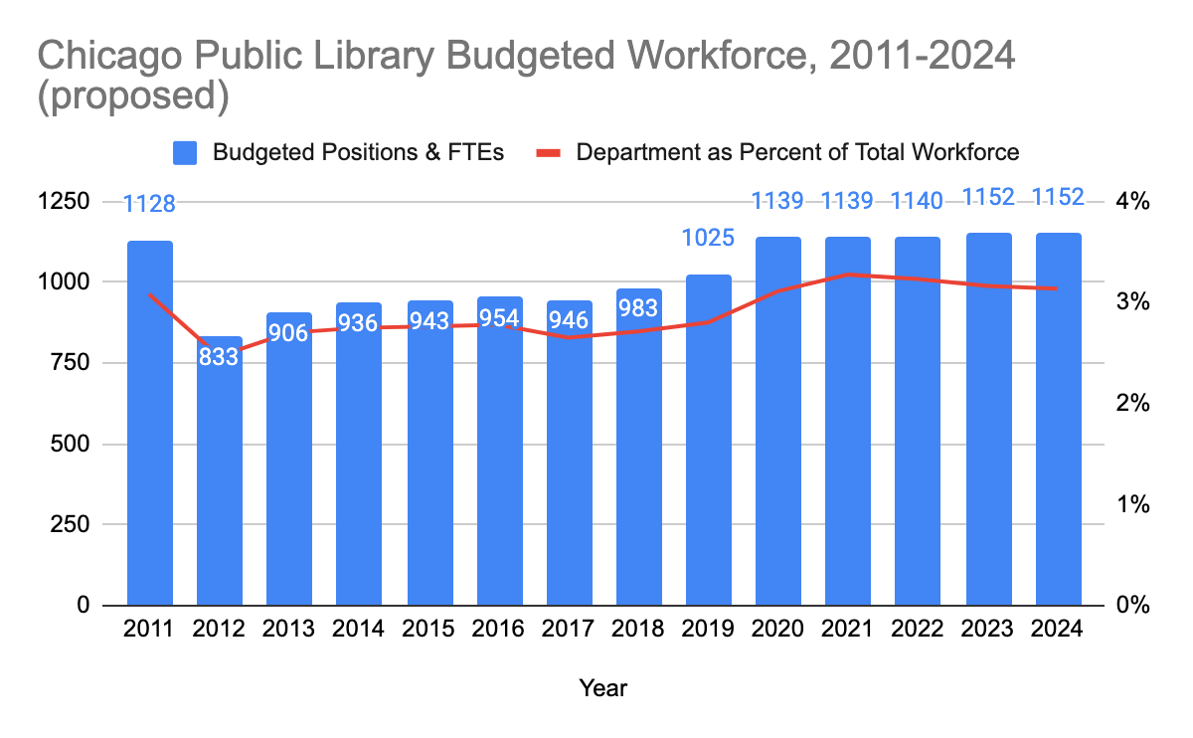As shown libraries getting used frequently and with an increasition.

