Bluejacks Content Management System

User Manual

Table of Contents

Overview 6

Big Picture and Workflow 6

Overview of Main Components 7

User Management 7

Steps 10

Login 10

Create a Course 11

Create or Edit Course Scope & Sequence 14

Create a Lesson 17

Add Framechain Activity 20

Edit Framechain Activity 22

Add Video 22

Add Basic HTML Page Slide 25

Add CloseReader 29

Add Radio Button Task Type 30

Add Check box Task Type 35

Add Drop-Down Task 41

Add Text/Number Field Task 48

Add Text Area Task 54

Add Matching Task 59

Add Text Evidence Task 63

Add Sort-by-2-Categories Task 66

Add Sort-by-3-Categories Task 69

Add Sort-by-Rank (Ordering) Task 72

Add Assessment Activity 74

Edit Assessment Activity 77

Add Upload Content Activity 78

Add Essay Activity 78

Add Short Writing Activity 78

Question Bank 78

Add Radio Button Assessment 79

Add Check box Assessment 84

Add Fill-in-the-Blank Assessment 89

Manage Lesson Objectives 92

Manage Vocabulary 94

Code Snippets 96

CloseReader 96

Click Audio in Frame 96

Interactives 97

From PowerPoint to CMS 97

**Document History**

|  |  |  |
| --- | --- | --- |
| **Document** | **Author** | **Description** |
| 8/17/2015 | Sharon Ching | Include User Management information; update screenshots for task type instructions. |
| 8/7/2015 | Sharon Ching | Revise user manual with updates include: new screenshots to reflect updated UI, new task types and layouts, updates on added/modified functionality – updates ongoing. |
| 7/11/2013 | Sharon Ching | Additional resources field added to all slide editors to accommodate the need to support media assets that cannot be added to any of the existing media input fields. |
| 6/3/2013 | Sharon Ching | Received updated code snippet from ENG on how to link to a CloseReader file. |
| 5/28/2013 | Sharon Ching | Reconfirmed and updated code snippet for adding a link to a CloseReader file |
| 4/2/2013 | Sharon Ching | Per 4/1/2013 server updates – including export package changes – updates to fixes on managing vocab files, assigning videos to video slides, question tags, and assessment activity editors updated – new screenshots to be included as well.  Include new screenshots and directions on how to assemble a text evidence task. |
| 3/23/2013 | Sharon Ching | Per 3/23/2013 server updates – update slide editor and Lesson Management screenshots, update steps on task editors. |
| 3/4/2013 | Sharon Ching | Per 3/3 tool update, equations editor has been implemented in the WYSIWYG editor for question fields.  Update screenshots and add additional notes as UI of tool slowly gets changed and modified. |
| 2/22/2013 | Sharon Ching | Following 2/22 tool updates – added additional steps for lesson management navigation and screenshots of added features in the UI for several of the layouts.  Update some of the field requirements – e.g. difficulty level, Bloom’s are now required for *both* tasks and assessments. |
| 2/8/2013 | Sharon Ching | Updated additional UI change – lesson question field and steps to make changes to lesson and unit descriptions. |
| 2/6/2013 | Sharon Ching | Updated entire document to reflect tool updates and UI changes up to the point of 2/6.  Defined required and optional fields, based on requirements set in metadata requirements document (2/4).  Separated out instructions for Assessment items. |
| 1/7/2013 | Sharon Ching | Revised entire document format. Break down details and steps for every item type and layout format. |
| 1/3/2013 | Sharon Ching | Created initial outline and basic instructions on how to use Bluejacks. |

# Overview

The Bluejacks Content Management System (CMS) – also referred as the Content Authoring Tool (CAT) – is designed to provide Curriculum, Production, and Assessment Teams with the necessary tools to assemble, manage, and publish lessons in one centralized authoring system.

Version 1.0 offered features and tools for the assembly of Framechain, Assessment, Upload Content, and Essay Activities in a lesson.

Version 2.0 included the addition of the Short Writing Activity type and interactive task frame type. Additional updates and enhancements were applied to the tool. A very basic User Management system was also set up.

At the end of 2014, the user interface, extraction sheet import functionality, and lesson search functionality were all updated in Bluejacks.

**Note:** A Quick Guide version of this user manual has also been created. The latest copy can be accessed in the Production folder [on SharePoint](http://eportal.education2020.com/Curriculum/Production%20Library/Content%20Authoring%20Tool/bluejacks-quick-guide.docx).

## Big Picture and Workflow

In the current Course Development production process, the Curriculum Teams complete final lessons in PowerPoint. Once the final lesson PowerPoint has been approved and extracted via the Lesson Extraction Tool, the Production Team can begin assembling the lessons in Bluejacks CMS.

***Note 1:*** *All audio, image, and video assets that are used in a lesson must be first saved on the pre.sandbox media server. The “upload video,” “insert image,” and “browse audio” functions will take the filename of the asset you want to display on a slide.*

***Note 2:*** *The approved file path for media assets associated to frames in framechain activities are:*

*Course > Unit > Lesson > Framechain > Frame > audio.mp3*

*Course > Unit > Lesson > Framechain > Frame > image.jpg, image.png, image.gif*

*Course > Unit > Lesson > Framechain > Frame > video.mp4*

*Example:*

*3008 > 3008-01 > 3008-01-04 > 3008-01-04-05 > 3008-01-04-05-01 > 3008-01-04-05-01-anchor.mp4*

***Note 3:*** *The approved file path for media assets associated with assessment items is:*

*Course > Unit > Lesson > Assessment > image.jpg, image.png, image.gif*

*Example:*

*3008 > 3008-01 > 3008-01-04 > 3008-01-04-assessment > image01.png*

***Note 4:*** *The approved file path for the audio clips associated with vocab items:*

*Course > Unit > Lesson > Vocab > audio.mp3*

*Example:*

*3008 > 3008-01 > 3008-01-04 > 3008-01-04-vocab > 3001-01-04-safari.mp3*

***Note 5:*** *Final confirmation regarding which fields are required or are optional will be provided once those have been determined. Generally speaking, what’s being marked as required right now are the fields that you must complete in order to successfully submit or save the content being created in a given editor.*

## ****Overview of Main Components****

The Bluejacks CMS contains three major components: **Course Management, Lesson Management, and User Administration**.

The **Course Management** component includes:

* Course List
  + Displays the list of all courses (test courses, released, and in-development courses)
  + Displays Add, Import, Export, and Delete Course functionality
* Create New Course
  + Provides a toolset for administrator to manually create a new course
* View Exported Courses
  + Provides a list of all course packages generated in Bluejacks CMS
  + Enables System Administrator to download a course export package to be imported to the LMS environment

The **Lesson Management** component includes:

* Lesson Search
  + Displays search functionality for users to browse, search, and select a lesson to assemble or modify
* Import Lesson Structure
  + Enables Administrators to take a Lesson Extraction sheet (created from the lesson PowerPoint via the Lesson Extraction Tool) and import a lesson to a course. A successful import would create the lesson structure in the system. In other words, the activity names, activity types, and slides/frames would be set up before a User starts entering new content.
* Import Scope & Sequence
  + Enables Administrators the ability to import a course scope and sequence, and create a new course.

The **User Administration** component includes:

* User Management
  + Enables System Administrators to create, delete, modify, and reset CMS user accounts.
  + Displays a list of CMS user accounts and basic account information (including username, first name, last name, email address, and information on when user last logged into the CMS).

# User Management

Bluejacks CMS has a very basic user management system. There are predefined privileges and permissions for each type of user within a user group. There are three predefined user groups: Administrator Group, Production Group, and Assessment Group.

A System Administrator has the ability to create user accounts, modify user details and privileges, deactivate accounts, and delete accounts. Instructions on how to manage user accounts are provided at the top of the page.

Instructions on how to add, modify, and deactivate accounts are provided at the top of the page.

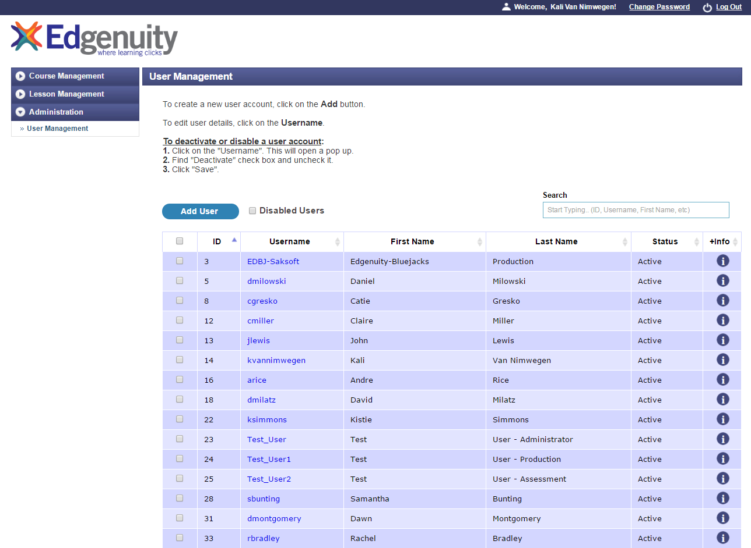

*Screenshot of the User Management Page*

*User accounts can only be **deactivated, not deleted**. Deleting a user account causes content created by that user to be removed from the system, so this functionality was removed.

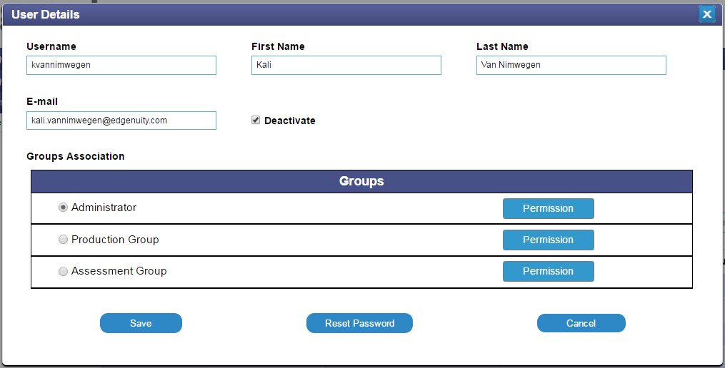

*Screenshot of User Details dialog box*

The System Administrator follows the steps below to create a new user account:

1. Click on the **Add User** button at the top of the User Management page.

1. A User Details dialog box (see screenshot above) will appear, presenting fields to create a username, input the user’s name and e-mail address, and assign a Group. The System Administrator clicks on the **Save** button to save updates.
   1. Click on the **Permissions** button next to a group to read a description of the permissions and privileges associated with that specific user group.
   2. By default, the **Deactivate** check box is marked. If the check box is not marked, the account is inactive and the user cannot log into that account.
2. Once a new account is created, Bluejacks will send out an email to the user with account information and instructions on setting up a password. Note: users may want to check their spam/junk folder for the new account email if it does not readily appear in their email inbox.
3. If a user forgets his or her password, a System Administrator may search for his or her account in Bluejacks and click to the **Reset Password** button. An email with instructions on how to reset one’s password will be sent to the user.

# Steps

### Login

1. Access the Bluejacks content authoring tool with your individual user account. If a user account is not available, a System Administrator may be contacted to create a new one or to send a reset password email.

**URL:** <http://learn.bluejacks.edgenuity.com/login/>

**Recommended Browsers**: Firefox & Chrome

1. Once logged in, a user will be immediately directed to the **Course List** page of the **Course Management** section. The list displays all courses that have been and are currently being authored in Bluejacks. Only System Administrators have permissions to add, edit, and delete courses, modify course attributes, and to export course packages.

For more information on how to export a Bluejacks course package and to import the course to 4.5 Sandbox, please refer to this document called “[Importing Bluejacks Courses](http://eportal.education2020.com/Curriculum/Production%20Library/Content%20Authoring%20Tool/Bluejacks%20Import%20Process.docx).”

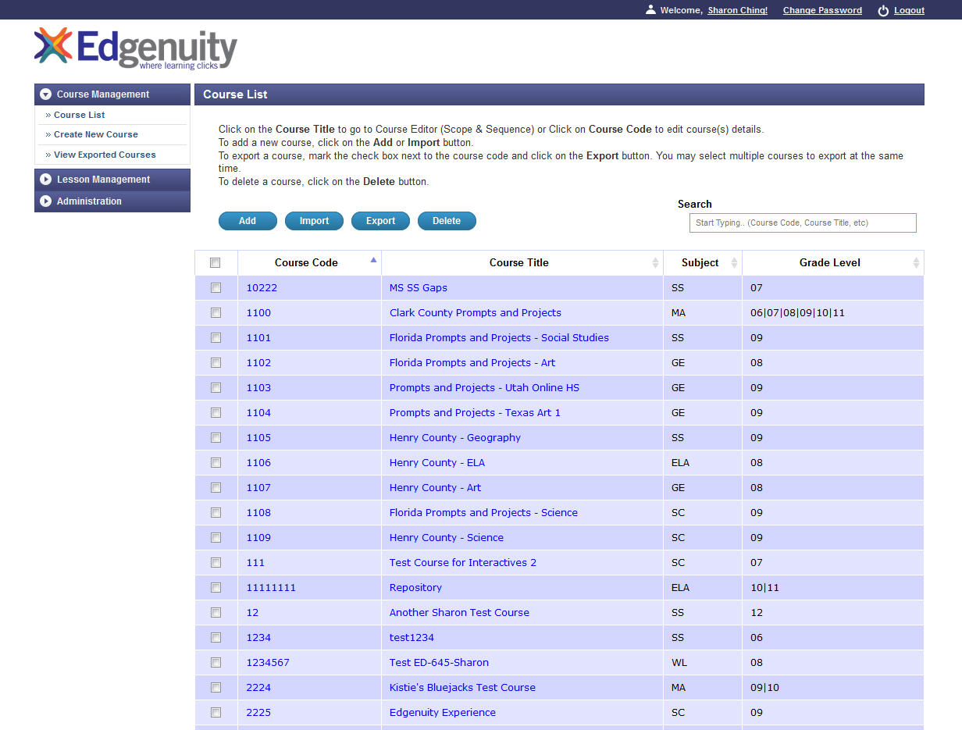

## Create a Course

There are two ways to create a course and its structure in Bluejacks. You can either complete all the necessary attributes in the fields manually or input information into a CSV file for upload.

Four buttons display at the top of the **Course Management** screen: **Add**, **Import, Export,** and **Delete.**

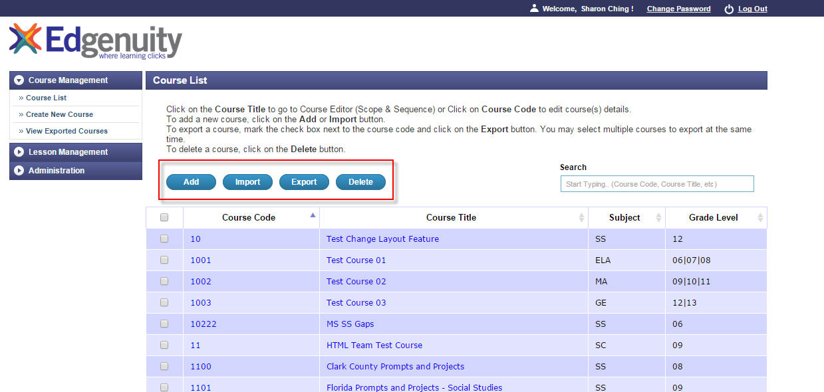

1. You may choose to import a course’s scope & sequence directly into the tool. Make sure you have a completed scope & sequence document (see sample CSV file).

Go to: [Sample Scope and Sequence Upload](http://eportal.education2020.com/Curriculum/Production%20Library/Forms/AllItems.aspx?RootFolder=%2FCurriculum%2FProduction%20Library%2FContent%20Authoring%20Tool&FolderCTID=0x0120001F3ED299B74CD142B33BC71749E19758&View=%7bBFAAC721-E729-4470-8818-711A0F7F969A%7d)

1. Scope & Sequence files will be created by the curriculum teams. Final versions will be passed along to the Production Team. Review the contents of each file. For example, review to ensure that column headings have not been changed and are consistent with the approved S&S structure.
2. Save the updated CSV file (as long as the file extension is correct, the filename is irrelevant to the tool).
3. On the **Course Management** screen, select the **Import** button. You will then be directed to the **Scope and Sequence Import** page. Click on the **Choose File/Browse** button and insert the updated CSV file. Select the **Run Import** button. A successful upload will result in the **Course Management** screen displaying that new course in the main course listing table.

*\*****Note:*** *The tool cannot accept names that include special characters (e.g. hyphens or colons) in the titles. You can omit those characters in the CSV file, upload the file, and then edit the course name within the tool. Or, you can choose to manually create the course instead of using the import feature.*

1. You may also click on the **Add** button above the Course Listing to create a new course. A **Course Details** editor will pop up with a set of input fields. Once you’ve completed the fields, click the **Save** button.

|  |  |  |
| --- | --- | --- |
| **Name** | **Required/Optional** | **Notes** |
| Course Name | Required | Also called “Course Title.” |
| Course Description | Optional |  |
| Course Code | Required |  |
| Subject | Required |  |
| Subject-Sub-category | Optional | More sub-categories may be added in the future if needed. To date, these attributes are not referenced by the Bluejacks importer. |
| Grade Level | Required | May select multiple grades, but they must be consecutive grades, e.g., 9th, 10th, 11th grade but not 9th, 11th, 12th |
| Course Type* | Optional |  |
| Career Pathway* | Optional | Required field for CEE courses. |
| Target Certification* | Optional | Required field for CEE courses. |
| Course Tags* | Optional |  |
| Editorial Tags* | Optional | Additional information that may be used to query or filter a course. |
| Change Information | Optional | Add short description when content has been modified after it has been exported |

*Note: These attributes were listed in the latest Bluejacks Metadata Requirements document (dated 7/2013). Some of these attributes may not be accepted, interpreted, or used by the Bluejacks importer. However, these fields remain present in the Bluejacks CMS for potential future use.*

1. If you’re on this **Course Details** page to review the content or opened it by accident with no desire to make changes, click on the **Cancel** button to close the window.
2. To remove a course:
   1. Go to the **Course Listing** page of **Course Management.** Mark off the checkbox next to the name of the course you wish to remove. Then, click on the **Delete** button at the top of the page. A message prompt will display asking you to confirm whether or not you want to delete that item.

*Note, once you hit the* ***Delete*** *button, the course and all of its content will be permanently deleted. If you hit the* ***OK*** *button, the course will be deleted.*

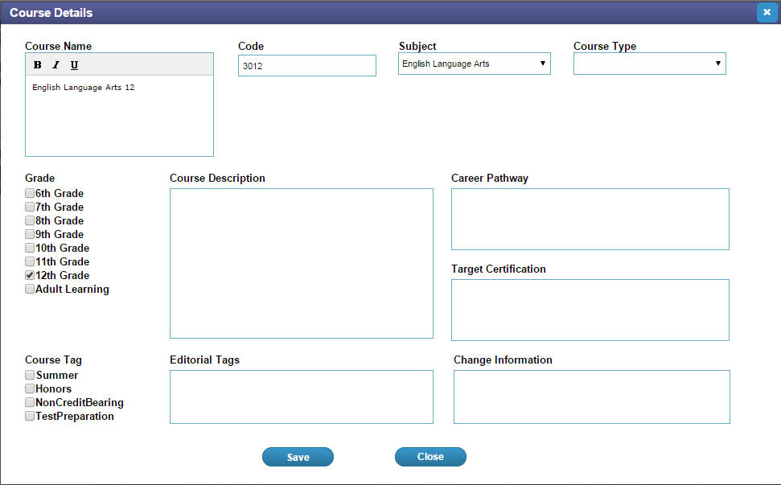

*Screenshot of the Course Details editor*

## Create or Edit Course Scope & Sequence

This section of the tool enables you to add, delete, and modify scope & sequence details on the **Course List** page within **Course Management.**

1. View the course list table in the **Course Management** screen.
2. Click on the **Course Title** of the course you want to change. You will be directed to the **Course Editor** page featuring the Course Scope and Sequence.

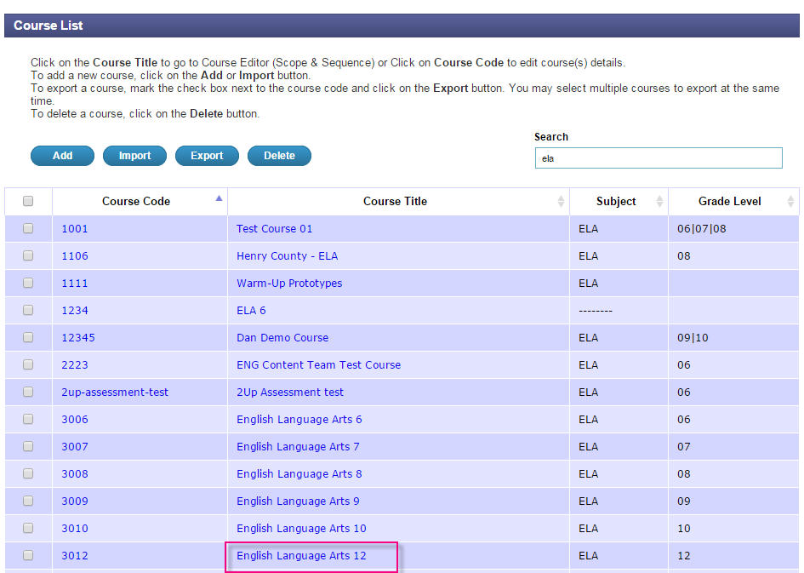

1. View **Scope & Sequence** screen. The unit and lesson information displays in a nested, tree structure.
2. Click on various options to change the view of how a course’s scope & sequence display:

* Click on the **Arrow button** (pointing in the right-hand direction) to expand and reveal all rows and the content contained in them – unit(s) and lesson(s).
* Click on the **Arrow button** (pointing downwards) to close or collapse all opened rows, leaving only the unit row(s) visible.

1. You can manually update fields for the scope & sequence:

* To manually add a new unit, you will click on the **+Unit** button that displays on the top, right-hand corner of the scope & sequence table. It will appear above the first unit row. Once you click on this **Add** link, the new unit will be added sequentially.
* To manually add a new lesson within a unit, you will click on the **Add** link that displays on the top, right-hand corner above the unit row. Once you click on this **Add** link, the new lesson will be added sequentially.

1. Click on the **lesson ID #** (this is system-generated) to open up the **Edit Lesson** screen. You find additional fields including *lesson question*, *change information*, and *original publisher*.

After you make changes, click on the **Save** button. You will then be returned to the **Scope & Sequence** screen.

1. Complete or edit fields and click on the **Save** button. You will then be directed to the main **Course Details Editor**. Click **Save** again and return to the main **Course Management Screen.**

|  |  |  |
| --- | --- | --- |
| **Name** | **Required/Optional** | **Notes** |
| Unit Name | Required |  |
| Unit Number | System-generated | Click on the *unit number*to be directed to a Unit Information editor. |
| Unit Description | Optional |  |
| Lesson Name | Required |  |
| Lesson Number | System-generated | Click on the *lesson number* to be directed to a Lesson Information editor. |
| Lesson Description | Optional | Description will be displayed by LMS. |
| Lesson Question | Optional |  |
| Original Publisher | Required | Can be reached by clicking on the “lesson number.” By default, the option “e2020” is selected. Note: the importer does not actually accept or reference this attribute; it’s another example of earlier metadata requirements that is not in use to date. |
| Change Information | Required if content has been revised | Add short description if content has been modified after the course has already been exported. |

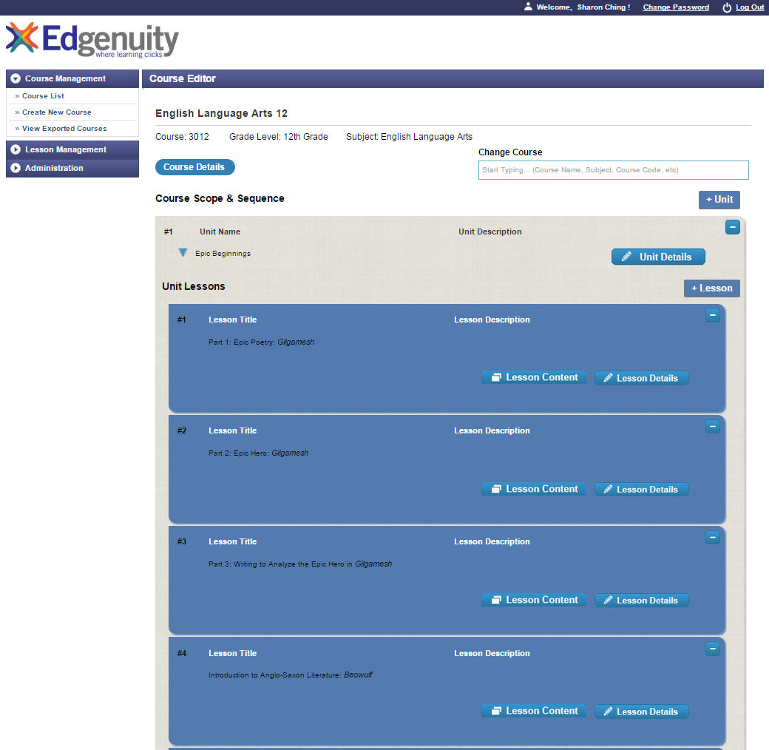

*Screenshot of “Course Scope & Sequence” screen*

## Create a Lesson

Once a course and its scope & sequence are set up, you can begin assembling the lesson. Lesson slides, videos, objectives, assessment items, and vocab are managed in the **Lesson Management** section of the authoring tool.

1. Select the **Lesson Management** menu item on the left-hand navigation menu and click on the **Lesson Search** sub-menu item. The system directs you to the Lesson Search page where you will be presented with two options on how to search for a lesson.
2. If you know the exact lesson number of the lesson you are assembling or editing, you can type in the lesson number in the **Lesson Code** field (example: 3006-01-01 for ELA 6, Unit 1, Lesson 1) and click the **Go** button.
3. Or, you can use the smart search option. You may input a course attribute (name, course code, subject type, or grade level). The system will filter out courses and narrow down the selection to the courses that most closely matches your search terms. Likewise, this functionality is also available as you search for unit and lesson.

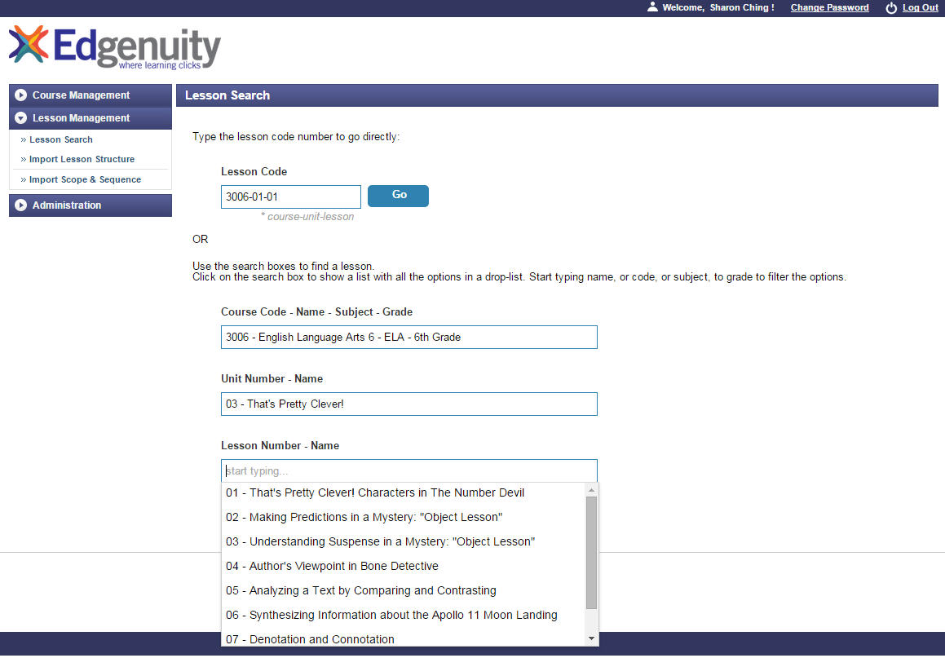

1. Once you have selected a lesson, the system will direct you to the **Lesson Content** page where you will spend the majority of your time in the authoring tool assembling and modifying the slides (frames) that make up the lesson.
2. There are four tabbed sections within the **Lesson Content** page.

|  |  |
| --- | --- |
| **Activities & Slides** | Create/edit activities and assemble frames within each activity. All of these frames (called slides in the tool to reflect the current Course Development process of using PowerPoint to assemble lessons). |
| **Question Bank** | Create and edit individual assessment items for a given lesson. |
| **Objectives** | Create/edit lesson objectives. If you imported a Scope and Sequence CSV file for a course*,* then these fields will already be populated by the time you begin lesson assembly. You may still add, delete, and modify objectives here. |
| **Vocab** | Manage vocabulary items that will present in the Glossary tab in the LMS. Add, modify, and delete vocab items including vocab audio clips (You will browse and assign these audio clips (first saved in the pre.sandbox media server). |

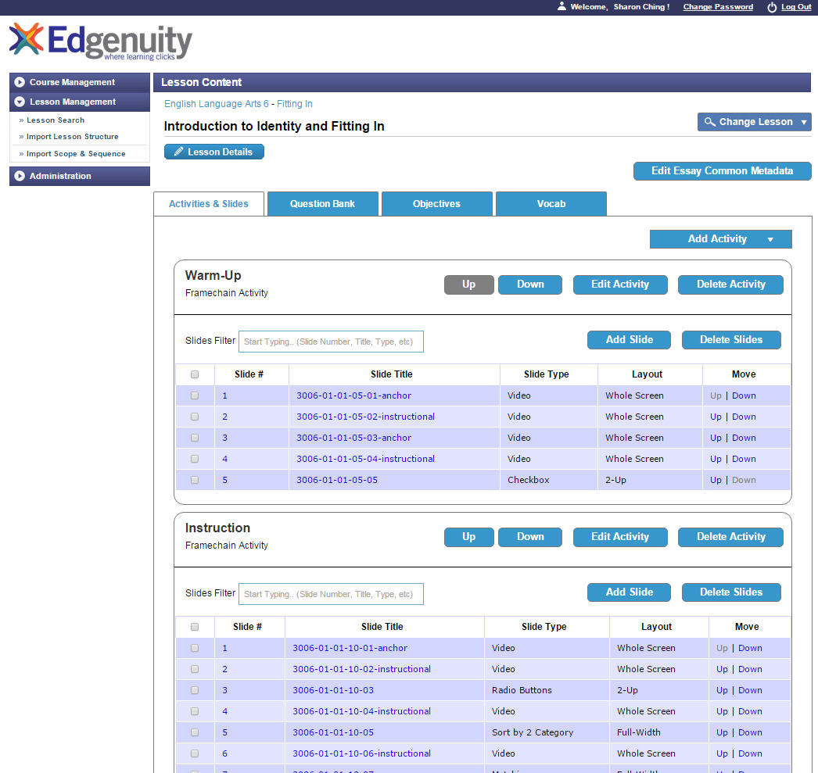

*The following screenshot shows how the* ***Lesson Content page*** *may appear for a lesson that has been assembled in the CMS. The pop-up window displays the slide type and layout selector.*

## Add Framechain Activity

There are four different types of framechain activities that can be created. You must create an activity before building out lesson slides associated with that activity.

1. Click on the **Add Activity** button and select **Framechain Activity** to go to the **Activity Editor.**

|  |  |  |
| --- | --- | --- |
| **Name** | **Required/Optional** | **Notes** |
| Activity Name | Required | May be the same as the activity type selected |
| Activity Type | Required | Select from four options: “Warm-Up”, “Instruction”, “Assignment”, and “Summary”. |
| Additional Instructions | Required | Include the following text for the additional instructions field.  These are the general rules for the additional instructions for Framechain Activities.  Warm-Up: “Get ready for the lesson.”  Instruction: [Lesson question]  Summary: “Review and connect what you learned.”  Assignment: [Title from the first assignment slide] |
| Activity Estimate Time | Required | Time should be written following this format – HH:MM:SS (e.g. 00:10:00 means 10 minutes).  *As shared: a proposal to collect estimated time with the slide editor and have the activity estimated time field be able to display the sum of all that time has been shared with SRM. Not available.* |
| Grading Weight Category | Required | By default, all Framechain Activities has a grade weight value of “Assignment.” |
| Target Population | Optional | Target Population replaces “Accessibility Type” category in V4. May select more than one option. Option generally not selected in Bluejacks courses. |
| Change Information | Optional | Add short description when content is modified after it has been exported. |

1. After filling out the pop-up form, click the **Save** button. You will be brought back to the **Lesson Content** page.
2. The new **Activity** and a blue section area below the activity title now display. This is the area that will list out all the slides you create within that activity. The **Add** and **Delete** buttons that display below the **Activity Name** will allow you to create or delete a slide.

In many instances, the activity name and activity type may be the same. However, there are times when the activity name is more descriptive and specific than the activity type. For example, a science lab may have the activity type, ‘Assignment,’ but the activity name (which is displayed to the student) is called, ‘Virtual Lab.’

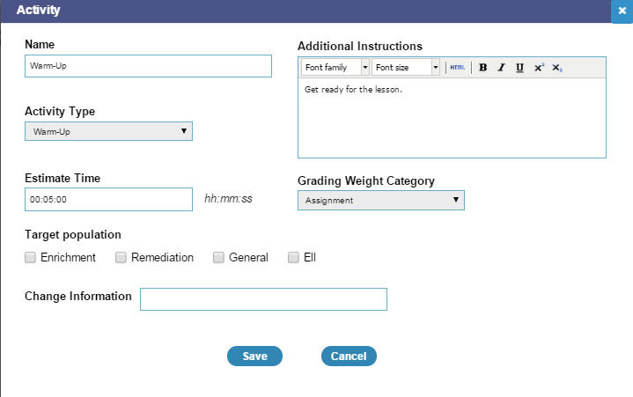

*Screenshot of a Framechain Activity Editor*

## Edit Framechain Activity

To change a framechain activity’s attributes and other related information, you can return to the activity editor and make modifications.

1. Click on the **Edit Activity** button to the right of the Activity Title in the **Lesson Details** page. The Activity Details editor will pop up in a new window.
2. Make edits and then, click the **Save** button.



*Screenshot of a Framechain Activity Editor*

## Add Video

To add a video to a frame, you will need to create a Video Slide within an Activity on the LessonContent page. All files referenced in the Bluejacks CMS are saved in the pre.sandbox media server in their corresponding course structures.

1. In the **Lesson Content** page, click on the **Add Slide** button displayed on the right of the **Framechain Activity** **title**. The slide type and layout selector window should pop up. For slide type, select the **video** option from the drop-down menu. There is only one video layout (whole screen) available. Click on the New Slide button to create a video slide.

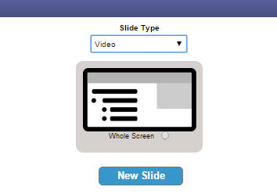

1. Find the row that displays the newly added video slide and click on the new slide’s **Slide #.** You will be directed to the slide editor for the video slide.
2. View video slide editor:

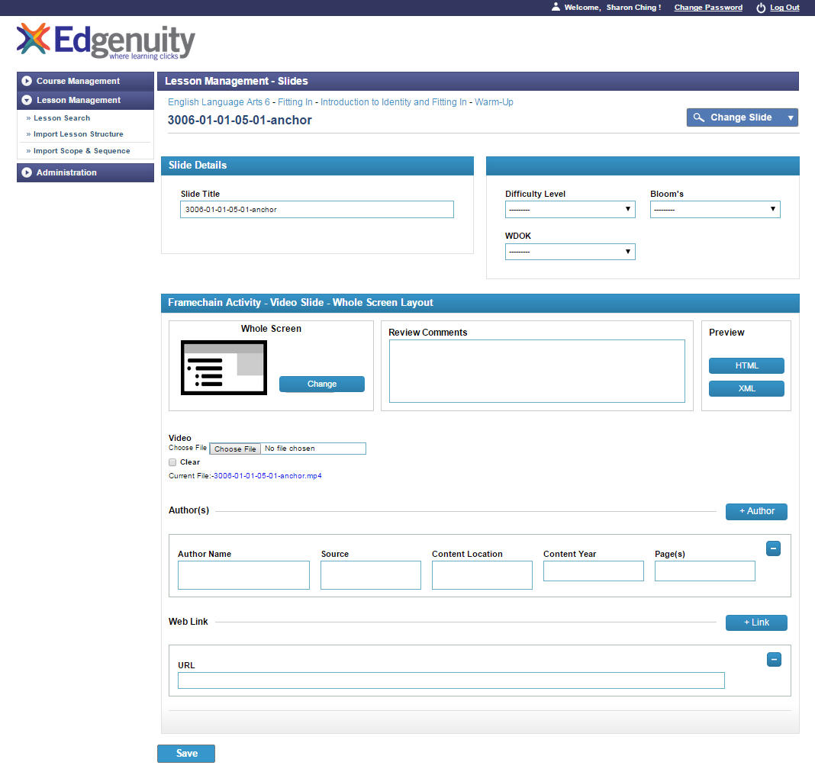

*Screenshot: Video slide in a Warm-Up Activity*

1. Fill in the **Slide Title** field.

**Note:** Refer to the extraction sheet. Copy the filename of the video file and paste it into the slide title field. This will make easier to reference and assign the correct video file to theappropriate video slide.

*Note: many of the fields displayed in the video slide’s editor are leftover fields during earlier versions of the tool and can be disregarded.*

1. In the video field, click on the **Choose File** button and find the correct video in pre.sandbox media server. Select **Insert.**
2. If sources are provided in the video slide within the PowerPoint, copy and paste that content into the **Source** field.
3. Click the **Submit** button. To return back to the **Lesson Content** page, you can click on the blue **Lesson** button displaying at the top of the slide editor.

## Add Basic HTML Page Slide

A basic HTML page slide can be used to create a non-task and/or customized frame in a lesson.

1. In the **Lesson Content** page, click on the **Add Slide** button displayed on the right of the **Framechain Activity** **title**. The slide type and layout selector window should pop up.
2. Select the **Basic HTML Page** option in the drop-down menu and choose a layout.

**Basic HTML (non-task) Layouts**

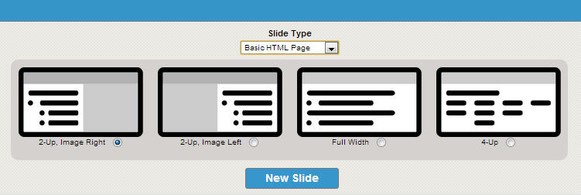

* 2-Up (two columns, left column for text and right column for image)
* 2-Up (two columns, left column for text and right column for image)
* Full-width
* 4-Up (four columns)

1. The new slide will be added to the slide listing that displays below the **Framechain Activity Name**. Click on the **slide #** to go to the slide editor and begin assembly.
2. A slide editor can be divided into three sections: *slide details, task metadata,* and *onscreen elements.* As mentioned earlier, many of the fields were set up in anticipation of future needs. Fill in all the required fields and complete any other fields should you have that information on hand.

Complete Fields

|  |  |  |
| --- | --- | --- |
| **Name** | **Required/Optional** | **Notes** |
| Icon Selector | Optional | Select from drop-down menu. Default value to *no-icon*. |
| Slide Title | Required | This is the slide title used by the authoring tool. Input the frame ID organized from the extraction sheet. This will help with |
| Onscreen Slide Title | Required | This is the title that displays in the slide header. |
| Question Text | Optional | A required field for tasks and assessments; field displays here as part of the basic slide editor template. Functions as a basic WYSIWYG and equation editor. |
| Entry VO Text | Optional | Entry audio script |
| Entry VO Sound | Required | Browse and select audio clip from corresponding frame folder in media server |
| Full bleed Image browser | Required | A separate image browser feature will be available for 2-Up layouts. |
| Image alt text field | Required | Alt text should be added for all the images used in the 2-Up layouts. |
| Column 1 | Required | Input image/text. Use basic WYSIWYG editor (or switch over to the HTML editor mode). |
| Column 2 | Required | Field offered only if 2-Up layout selected. Input image/text. Use basic WYSIWYG editor (or switch over to the HTML editor mode). |
| Column 3 | Required | Field offered only if 4-Up layout is selected. Input image/text. Use basic WYSIWYG editor (or switch over to the HTML editor mode). |
| Column 4 | Required | Field offered only if 4-Up layout is selected. Input image/text. Use basic WYSIWYG editor (or switch over to the HTML editor mode). |
| Review Comments | Optional | If there is more than one person working on a given slide or if someone is reviewing the slide, they can leave comments here. |
| Change Information | Required if content is revised | Add a short description when any content is modified after it has been exported. |
| Source | Optional | Fill in source information if available. |
| Web Link | Optional | Links in this field get filtered through e2020 proxy and are whitelisted. Currently, if you add a hyperlink in a content area, you will need to add that link as well in this field. Future plan is to enable only one-time entry of hyperlink, and tool will be able to pull those <a> tags and populate the <web_links> field for export. |

Depending on the layout selection, you may see a different number of fields.

For example, **Basic HTML Page** offers two types of 2-Up layouts. In the first 2-Up layout, text displays on the left column and images display on the right column. In the second 2-Up layout, text displays on the right column and images display on the left column.

In the instance of the 2-Up (text left, image right) layout, you will see one media content field with a WYSIWYG editor and then an image browser and image alt text field available.

This WYSIWYG editor provides tools that will enable you to:

* Style fonts/text
* Create lists
* Insert hyperlinks
* Browse and insert images (all first saved in pre.sandbox media server)
* Select the equations editor to create equations/formulas
* Select the HTML editor to directly write HTML code

1. In this example of a **Basic HTML Page Slide** using the **Full-width** **layout**.

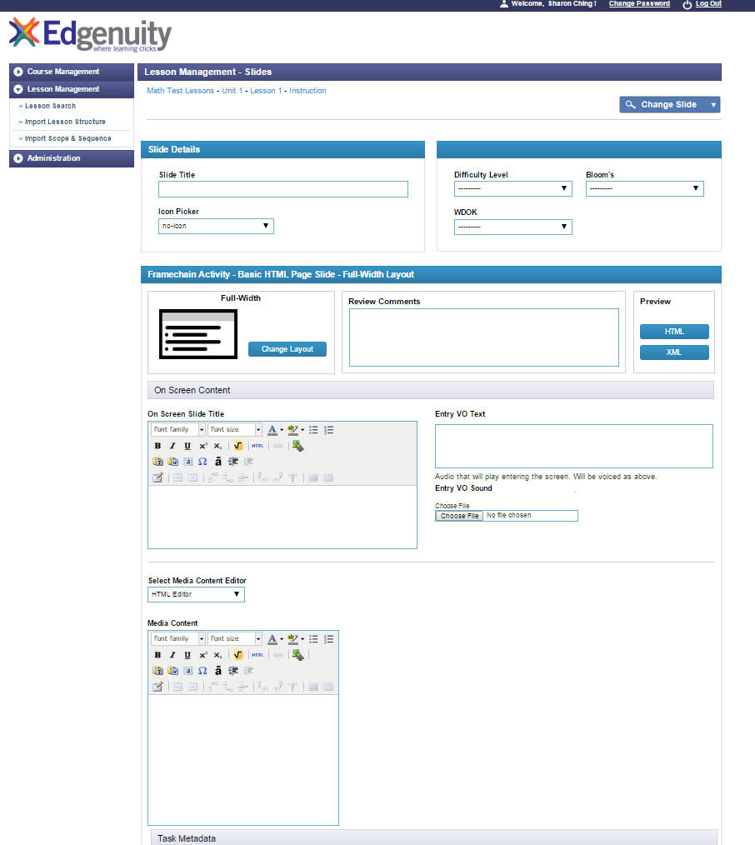

*Screenshot: Slide editor of a Basic HTML page utilizing the Full-width layout*

1. Click the **Submit** button to save the slide in the tool. To return back to the Lesson Management Screen, you can click on the blue Lesson button displaying at the top of the slide editor.
2. Then, click the **HTML** button in the preview area. A new window or tab should open, displaying a rendering of how the slide appears. If interested, you can also click on the **XML** button should you wish to see how the XML rendering appears.

**Note about inserting images:** You can use the Insert/Browse Image feature (select icon on WYSIWYG editor). Bluejacks will dynamically generate a file path (you can view in the HTML Source Editor) that allows you to view the image asset in Bluejacks.

**Note about hyperlinks:** Right now, if you add a hyperlink into a question field, media content field, or a column field, you must also add that same hyperlink in the **Web Link** field. Links found in this field will be filtered through e2020’s web proxy and whitelisted. As of right now, the tool will not be pulling a hyperlink from other fields and populating it in the Web Links field for export. In the future, the hope is to have the system be able to pull hyperlinks from any of the content fields and populate it in the appropriate web links tag in the export package.

**Note about copy and pasting text from PowerPoint:** Text copied and pasted directly from a PowerPoint deck may result in special characters being displayed in the final output (MS may be adding special characters – which you don’t necessarily see when using a word processor, for example). To get around this issue, you may: 1) copy the text on Textpad or Notepad, then copy that text into the desired text field, or b) if adding text to a field with a WYSIWYG/HTML editor, click to open up the HTML editor, and paste the text directly from the PowerPoint into the HTML editor.

## Add CloseReader

**CloseReaders are authored and edited outside of Bluejacks.**

CloseReader (essentially web pages that present more targeted, interactive reading activities) files are organized and saved in the common folder. Currently, the Production Team saves the final CloseReader files [on SharePoint](http://eportal.education2020.com/Curriculum/Production%20Library/Forms/AllItems.aspx?RootFolder=%2FCurriculum%2FProduction%20Library%2Fframe-building-files%2Fcommon%2Fclosereader).

Use the Insert Link feature in the WYSIWYG editor to insert a link to the CloseReader file.

1. Refer to pg. 24 for instructions on how to assemble the **“Add Basic HTML Page Slide.”**
2. To add a link to a CloseReader file, click on the **HTML** icon in the WYSIWYG editor of the media content field. This will open up to the **HTML Source Editor**. Then, copy and paste the code snippet provided below.

<a href=**'link.html**' onclick="window.open(this.href, '_blank’, 'width=800,height=600'); return false;">**link text**</a>

The code snippets in blue, bolded font are the parts of the code that you must edit. Include the correct HTML file name of the CloseReader and the text that will be clicked to open up the CloseReader.

## Add Radio Button Task Type

The radio button item type can be used for tasks. There are four layout options available for a radio button task slide. Depending on the layout selected, a different number of fields may be available.

1. On the **Lesson Content** page, find the **Framechain Activity** where you want to add a radio button task.
2. Click on the **Add Slide** button located below that **Framechain Activity Name**. A slide type and layout selection pop-up appears. Select the **Radio Button** option in the drop-down menu and choose a layout.

**Radio Button Task Layouts**

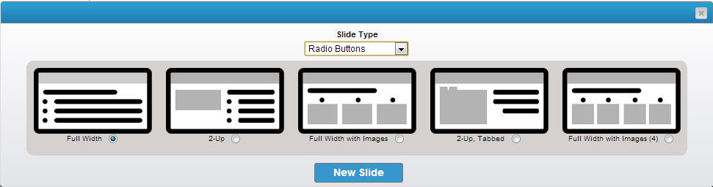

* Full-width
* 2-Up (media content in left column, question/answers in right column)
* Full-width with 3 image answer options (present horizontally)
* 2-Up, Tabbed (media content in tabbed areas in left column, question/answers in right column)
* Full-width with 4 image answer options (present horizontally)

Then, click on the **New Slide** button to create a radio button task slide.

1. The new slide will be added to the slide listing that displays below the **Framechain Activity Name**. Click on the **slide #** to go to the slide editor and begin assembly.
2. A slide editor can be divided into three sections: *slide details, onscreen elements,* and *task metadata.* As mentioned earlier, many of the fields were added to anticipate future needs. Fill in all the required fields and complete any other fields should you have that information on hand.

Depending on the layout selection, you may see a slightly different set of fields.

For example, a **Radio Button Task Slide** offers four layouts: full-width, 2-Up with questions displaying on the right column, full-width horizontal with images used as answer choices displaying horizontally, and two-tabbed 2-Up.

Complete Fields

|  |  |  |
| --- | --- | --- |
| **Name** | **Required/Optional** | **Notes** |
| Slide Title | Required | This is the slide title used by the authoring tool. Oftentimes it will be identical to the Onscreen Slide Title. The distinction is particularly useful, however, when creating video slides. *See earlier section on videos and video slides.* |
| Icon Selector | Optional | Select from drop-down menu. Default value to *no-icon*. |
| Onscreen Title | Required | This onscreen title will display in slide’s title bar or header. |
| Difficulty Level | Optional | Specific requirement for assessments, optional for tasks depending if that information is already provided by editors. |
| Bloom’s | Optional | Specific requirement for assessments, optional for tasks depending if that information is already provided by editors, fields remain in the event that they may be needed at some time in the future. |
| WDOK | Optional | Specific requirement for assessments, optional for tasks depending if that information is already provided by editors, fields remain in the event that they may be needed at some time in the future. |
| Correct Answer | Required | 2/6 – Current export package requires a <correct_answer> tag in the manifest. As of now, for text-based answers, you will need to indicate the correct answer twice – once in this field (copy and paste) and a second time when you mark off the check box next to the answer option field itself. Looking into modifying this step. |
| Distractor Rationale | Required |  |
| Sample Answer | Optional | Include sample answer for open-ended questions, answer explanation for fixed response. |
| Answer Explanation | Optional |  |
| Answer Choice May Be Randomized | Required | By default, this value is set as no (the check box is left unmarked). |
| Answer Explanation | Optional | If provided, include explanation of correct answer. |
| Points | Required | By default, the point value is set as “0.” Tasks in *Assignment Activity* and *Assessment Items* should each be assigned 1 point. |
| Teacher Graded | Required |  |
| Change Information | Required if content is modified after it is exported |  |
| Question Text | Required | A required field for tasks and assessments; field displays here as part of the basic slide editor template. |
| Answer Option | Required | Enter answer option. Can add or delete additional answer option fields. |
| Media Content | Required | Field is available for entry if a 2-Up layout is selected. Use basic WYSIWYG editor (or switch over to the HTML editor mode) to add images, create bulleted lists, style fonts, directly insert HTML code, create equations, etc. |
| Tab 1 Content | Required | Field is available for entry a 2-tabbed layout is selected. Use basic WYSIWYG editor (or switch over to the HTML editor mode). |
| Tab 2 Content | Required | Field is available for entry a 2-tabbed layout is selected. Use basic WYSIWYG editor (or switch over to the HTML editor mode). |
| Entry VO Text | Optional | Entry audio script |
| Entry VO Sound | Required | Browse and select audio clip from corresponding frame folder in media server |
| Hint VO Text | Optional | Hint audio script |
| Hint VO Sound | Optional | Browse and select audio clip from corresponding frame folder in media server |
| Exit VO Text | Optional | Exit audio script |
| Exit VO Sound | Optional | Browse and select audio clip from corresponding frame folder in media server |
| Review Comments | Optional | If there is more than one person working on a given slide or if someone is reviewing the slide, s/he can leave comments here. |
| Source | Optional | Fill in source information if available. |
| Web Link | Optional | Links in this field get filtered through e2020 proxy and are whitelisted. Currently, if you add a hyperlink in a content area, you will need to add that link as well in this field. Future plan is to enable only one-time entry of hyperlink, and tool will be able to pull those <a> tags and populate the <web_links> field for export. |

1. The accompanying screenshot captures a slide editor for a **Radio Button Task** using the **Full-Width** layout. The most unique aspect to this slide editor is the set-up for creating check box answer options.
2. Input a question plus any supporting text (or image) to the **Question** field.

**Note:** All question fields, answer choice fields (in radio button and checkbox layouts only), and column content fields (in basic HTML slides) will have a WYSIWYG editor.

This WYSIWYG editor provides tools that will enable you to:

* Style and format text
* Build tables
* Create lists
* Insert hyperlinks
* Browse and insert images (image assets should be saved on pre.sandbox media server)
* Select the equations editor to create equations/formulas
* Select the HTML editor to directly write HTML code

1. Below, the **Question** field is the **Answer Option** section where you can add, modify, and delete answer options. By default, there should be one answer option field already displaying.

Each answer option has three associated elements:

Correct Answer check box

Answer Option field

Delete button

Unlike check box tasks, radio button tasks can only contain one correct answer.

To add a new answer option, click on the **+Answer** button that displays above the first answer option field. Follow the same process as mentioned above.

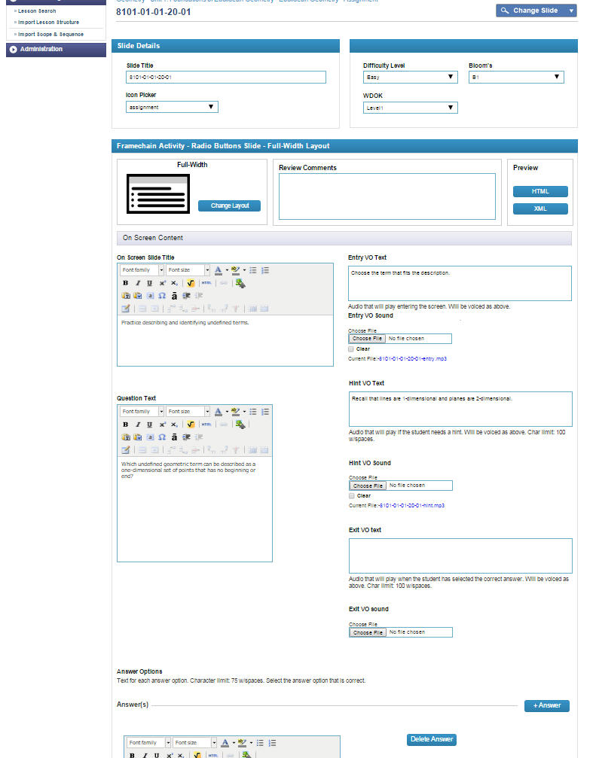

1. Click the **Submit** button to save the slide in the tool.
2. To return back to the **Lesson Content** page, you can click on the **blue Lesson** button displaying at the top of the slide editor.

**Note about hyperlinks:** Right now, if you add an external hyperlink into a question field, media content field, or a column field, you must also add that hyperlink in the **Web Link** field. Links found in this field will be filtered through e2020’s web proxy and whitelisted. As of right now, the tool will not be pulling a hyperlink from other fields and populating it in the Web Links field for export.

**\*Additional Features:** The slide editor also includes a **Change Slides** drop-down at the top of the page that enables a user to switch between slides within an activity and a **Change Layout** button that allows a user to change the layout of the task being authored.

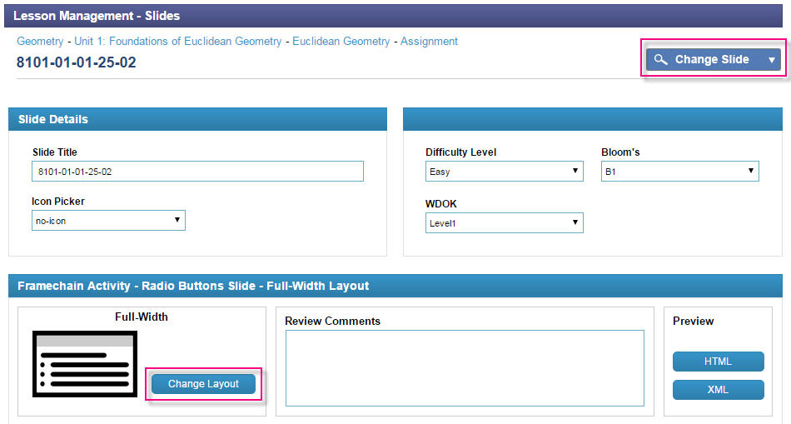

## Add Check box Task Type

The check box item type can be used for creating tasks. There are currently five layout options available for a check box task slide. Depending on the layout selected, a different number of fields may be available.

1. On the **Lesson Content** page, find the **Framechain Activity** section where you want to add a check box task slide.
2. Click on the **Add Slide** button located below that **Framechain** **Activity Name**. A slide type and layout selection pop-up appears. Select the **Check box** option in the drop-down menu and choose a layout.

**Check box Layouts**

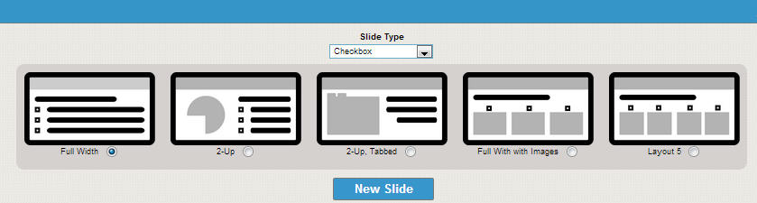

* Full-width
* 2-Up (media content on left column, question/answer on right column)
* 2-Tabbed, 2-Up (media content in tabbed area in left column, question/answer in right column)
* Full-width with 3 images answer options (presented horizontally)
* Full-width with 4 image answer options (presented horizontally)

Then, click on the **New Slide** button to create a check box task slide.

1. The new slide will be added to the slide listing that displays below the **Framechain Activity Name**. Click on the **slide #** to go to the slide editor and begin assembly.
2. A slide editor can be divided into three sections: *slide details, task metadata,* and *onscreen elements.* As mentioned earlier, many of the fields were added to anticipate future needs. Fill in all the required fields and complete any other fields should you have that information on hand.

Depending on the layout selection, you may see a different number of fields.

For example, four layouts are available for the creation of a **Check box Task Slide.** These layouts include: full-width, 2-Up with questions displaying on the right column, full-width horizontal with images used as answer choices displaying horizontally, and two-tabbed 2-Up.

Complete Fields

|  |  |  |
| --- | --- | --- |
| **Name** | **Required/Optional** | **Notes** |
| Icon Selector | Optional | Select from drop-down menu. Default value to *no-icon*. |
| Slide Title | Required | This is the slide title used by the authoring tool. Oftentimes it will be identical to the Onscreen Slide Title. The distinction is particularly useful, however, when creating video slides. *See earlier section on videos and video slides.* |
| Onscreen Title | Required | This onscreen title will display in slide’s title bar or header. |
| Difficulty Level | Optional | Specific requirement for assessments, optional for tasks depending if that information is already provided by editors. |
| Bloom’s | Optional | Specific requirement for assessments, optional for tasks depending if that information is already provided by editors, fields remain in the event that they may be needed at some time in the future. |
| WDOK | Optional | Specific requirement for assessments, optional for tasks depending if that information is already provided by editors, fields remain in the event that they may be needed at some time in the future. |
| Correct Answer | Required | 2/6 – Current export package requires a <correct_answer> tag in the manifest. As of now, for text-based answers, you will need to indicate the correct answer twice – once in this field (copy and paste) and a second time when you mark off the check box next to the answer option field itself. Looking into modifying this step. |
| Distractor Rationale | Required |  |
| Sample Answer | Optional | Include sample answer for open-ended questions, answer explanation for fixed response. |
| Answer Explanation | Optional |  |
| Answer Choice May Be Randomized | Required | By default, this value is set as no (the check box is left unmarked). |
| Answer Explanation | Optional | If provided, include explanation of correct answer. |
| Points | Required | Leave entry with default value, “0,” unless point is provided. |
| Teacher Graded | Required |  |
| Change Information | Required if content is modified after it is exported |  |
| Question Text | Required | A required field for tasks and assessments; field displays here as part of the basic slide editor template. This will include a text editor and equations editor. |
| Answer Option(s) | Required | Enter answer option. Can add or delete additional answer option fields. |
| Media Content | Required | Field is available for entry if a 2-Up layout is selected. Add images, create bulleted lists, style fonts, directly insert HTML code, create equations, etc. |
| Tab 1 Content | Required | Field is available for entry a 2-tabbed layout is selected. Use basic WYSIWYG editor (or switch over to the HTML editor mode). |
| Tab 2 Content | Required | Field is available for entry a 2-tabbed layout is selected. Use basic WYSIWYG editor (or switch over to the HTML editor mode). |
| Entry VO Text | Required | Entry audio script |
| Entry VO Sound | Required | Browse and select audio clip from corresponding frame folder in media server |
| Hint VO Text | Optional | Hint audio script |
| Hint VO Sound | Optional | Browse and select audio clip from corresponding frame folder in media server |
| Exit VO Text | Optional | Exit audio script |
| Exit VO Sound | Optional | Browse and select audio clip from corresponding frame folder in media server |
| Review Comments | Optional | If there is more than one person working on a given slide or if someone is reviewing the slide, s/he can leave comments here. |
| Source | Optional | Fill in source information if available. |
| Change Information | Required if content is revised | Add a short description when any content is modified after it’s been exported. |
| Web Link | Optional | Links in this field get filtered through e2020 proxy and are whitelisted. Currently, if you add an external hyperlink in a content area, you will need to add that link as well in this field. Future plan is to enable only one-time entry of hyperlink, and tool will be able to pull those <a> tags and populate the <web_links> field for export. |

1. Click the **Submit** button to save the slide in the tool.

**Note:** All question fields, answer choice fields (with the exception of the full-width with image layouts), and column content fields (in basic HTML slides) will have a WYSIWYG editor.

This WYSIWYG editor provides tools that will enable you to:

* Style fonts/text
* Create lists
* Insert hyperlinks
* Browse and insert images (all first saved in pre.sandbox media server)
* Select the equations editor to create equations/formulas
* Select the HTML editor to directly write HTML code

1. The accompanying screenshot captures a slide editor for a **Check box Task** using the **Full-Width** layout. The most unique aspect to this slide editor is the set-up for creating check box answer options.
2. Input a question plus any supporting text (or image) to the **Question** field.
3. Below, the **Question** field is the **Answer Option** section where you can add, modify, and delete answer options. By default, there should be one answer option field already displaying.

Each answer option has three associated elements:

Correct Answer check box

Answer Option field

Delete button

Since check box tasks can allow for more than one correct answer, mark off all the check boxes for all the possible correct answers.

To add a new answer option, click on the **+ Answer** button that displays above the first answer option field. Follow the same process as mentioned above.

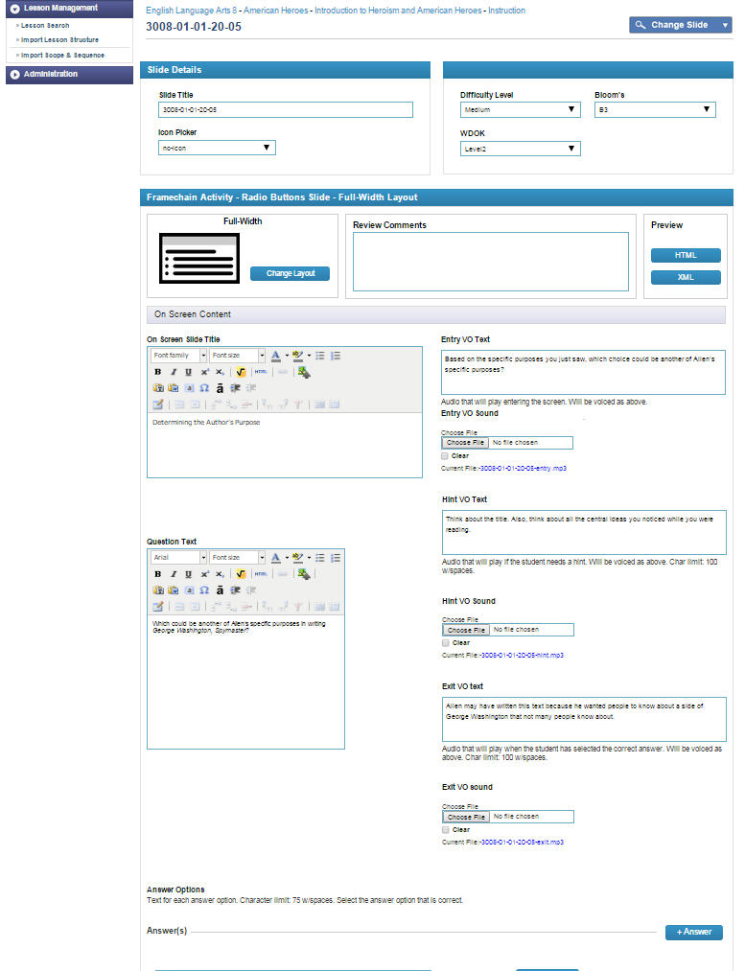

1. Click the **Submit** button to save the slide in the tool.
2. Then, click the **HTML** button in the preview area. A new window or tab should open, displaying a rendering of how the slide appears. If interested, you can also click on the **XML** button should you wish to see how the XML rendering appears.
3. To return back to the **Lesson Management** Screen, you can click on the **blue Lesson** button displaying at the top of the slide editor.

**Note about hyperlinks:** Right now, if you add a hyperlink into a question field, media content field, or a column field, you must also add that hyperlink in the **Web Link** field. Links found in this field will be filtered through e2020’s web proxy and whitelisted. As of right now, the tool will not be pulling a hyperlink from other fields and populating it in the Web Links field for export.

## Add Drop-Down Task

The drop-down item type can be used for tasks. There are three layout options available for a drop-down task slide. Depending on the layout selected, a different number of fields may be available.

1. On the **Lesson Management** screen, find the **Framechain Activity** section where you want to add a drop-down task slide.
2. Click on the **Add** button located below that **Framechain Activity Name**. A slide type and layout selection pop-up appears. Select the **Drop-Down** option in the drop-down menu and choose a layout.

**Drop-down Layouts**

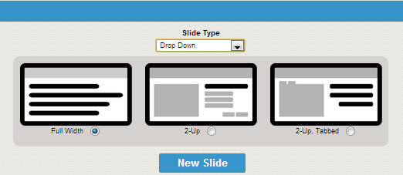

* Full-width
* 2-Up (media content on left column, question/task on right column)
* 2-Tabbed, 2-Up (media content in tabbed area on left column, question/task on right column)

Then, click on the **New Slide** button to create a radio button slide.

1. The new slide will be added to the slide listing that displays below the **Framechain Activity Name**. Click on the **slide #** to go to the slide editor and begin assembly.
2. A slide editor can be divided into three sections: *slide details, task metadata,* and *onscreen elements.* As mentioned earlier, many of the fields were added to anticipate future needs. Fill in all the required fields and complete any other fields should you have that information on hand.

Depending on the layout selection, you may see a different number of fields.

For example, a **Drop-Down Task Slide** offers three layouts: full-width, 2-Up with questions displaying on the right column, and two-tabbed 2-Up.

Complete Fields

|  |  |  |
| --- | --- | --- |
| **Name** | **Required/Optional** | **Notes** |
| Icon Selector | Optional | Select from drop-down menu. Default value to *no-icon*. |
| Slide Title | Required | This is the slide title used by the authoring tool. Oftentimes it will be identical to the Onscreen Slide Title. The distinction is particularly useful, however, when creating video slides. See earlier section on videos and video slides. |
| Onscreen Title | Required | This onscreen title will display in slide’s title bar or header. |
| Difficulty Level | Optional | Specific requirement for assessments, optional for tasks depending if that information is already provided by editors, fields remain in the event that they may be needed at some time in the future. |
| Bloom’s | Optional | Specific requirement for assessments, optional for tasks depending if that information is already provided by editors, fields remain in the event that they may be needed at some time in the future. |
| WDOK | Optional | Specific requirement for assessments, optional for tasks depending if that information is already provided by editors, fields remain in the event that they may be needed at some time in the future. |
| Correct Answer | Required | 2/6 – Current export package requires a <correct_answer> tag in the manifest. As of now, for text-based answers, you will need to indicate the correct answer twice – once in this field (copy and paste) and a second time when you mark off the check box next to the answer option field itself. Looking into modifying this step. |
| Distractor Rationale | Required |  |
| Sample Answer | Optional | Include sample answer for open-ended questions, answer explanation for fixed response. |
| Answer Explanation | Optional |  |
| Answer Choice May Be Randomized | Required |  |
| Answer Explanation | Optional | If provided, include explanation of correct answer. |
| Points | Required | Default value is “1,” unless specified by Editorial. |
| Teacher Graded | Required |  |
| Change Information | Required if content is modified after it is exported | Add description when content is modified after it has been exported. |
| Question Text | Required | A required field for tasks and assessments; field displays here as part of the basic slide editor template. |
| Answer Option(s) | Required | Add all possible answer choices for a given drop-down menu. Each time you add a new drop-down menu in the question text field, a new answer field will be generated. Enter choices and separate each one by hitting the enter/return key. To mark the correct answer, you must add an asterisk at the end of the answer item that is correct for that particular drop-down. |
| Media Content | Required | Field is available for entry if a 2-Up layout is selected. Use basic WYSIWYG editor (or switch over to the HTML editor mode) to add images, create bulleted lists, style fonts, directly insert HTML code, create equations, etc. |
| Tab 1 Content | Required | Field is available for entry a 2-tabbed layout is selected. Use basic WYSIWYG editor (or switch over to the HTML editor mode). |
| Tab 2 Content | Required | Field is available for entry a 2-tabbed layout is selected. Use basic WYSIWYG editor (or switch over to the HTML editor mode). |
| Entry VO Text | Required | Entry audio script |
| Entry VO Sound | Required | Browse and select audio clip from corresponding frame folder in media server |
| Hint VO Text | Optional | Hint audio script |
| Hint VO Sound | Optional | Browse and select audio clip from corresponding frame folder in media server |
| Exit VO Text | Optional | Exit audio script |
| Exit VO Sound | Optional | Browse and select audio clip from corresponding frame folder in media server |
| Review Comments | Optional | If there is more than one person working on a given slide or if someone is reviewing the slide, s/he can leave comments here. |
| Source | Optional | Fill in source information if available. |
| Web Link | Optional | Links in this field get filtered through e2020 proxy and are whitelisted. Currently, if you add a hyperlink in a content area, you will need to add that link as well in this field. Future plan is to enable only one-time entry of hyperlink, and tool will be able to pull those <a> tags and populate the <web_links> field for export. |

1. The accompanying screenshot captures a slide editor for a **Drop-Down Task** using the **Full-Width** layout. The most unique aspect to this slide editor is the set-up for creating check box answer options.
2. Input a question plus any supporting text (or image) to the **Question** field.

**Note:** All question fields, answer choice fields (with the exception of the full-width with image layouts), and column content fields (in basic HTML slides) will have a WYSIWYG editor.

This WYSIWYG editor provides tools that will enable you to:

* Style fonts/text
* Create lists
* Insert hyperlinks
* Browse and insert images (all first saved in pre.sandbox media server)
* Select the equations editor to create equations/formulas
* Select the HTML editor to directly write HTML code

1. To add a drop-down menu inline or below the question text, you will need to click on the **[+]** or **Add Drop-Down** icon in the WYSIWYG editor. It will prompt Bluejacks to create a placeholder in the question field; the number of the placeholder is sequential.

For example, if you want to create a drop-down task that includes text and two drop-down menu items within that text, you will click on the **(+)** button twice.

In the screenshot below, you are creating drop-down items inline. You add the first sentence and then when you want to add the drop-down menu, click on the **(+)** button. It will create a placeholder in the question text field, **_(1)_**.

This will generate an answer field, **Answer 1**. Add in all the possible options for the first drop-down menu. Add an asterisk at the end of the correct text answer.

This would be the same process you take for creating the second drop-down menu, **_(2)_**, and input the answer options in the **Answer 2** field.

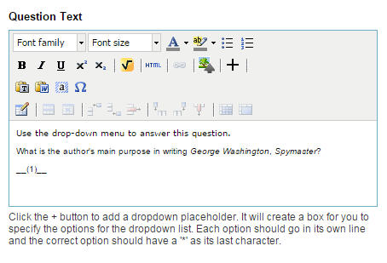

When you click on the **(+)** button, a corresponding **Answer** field is create.

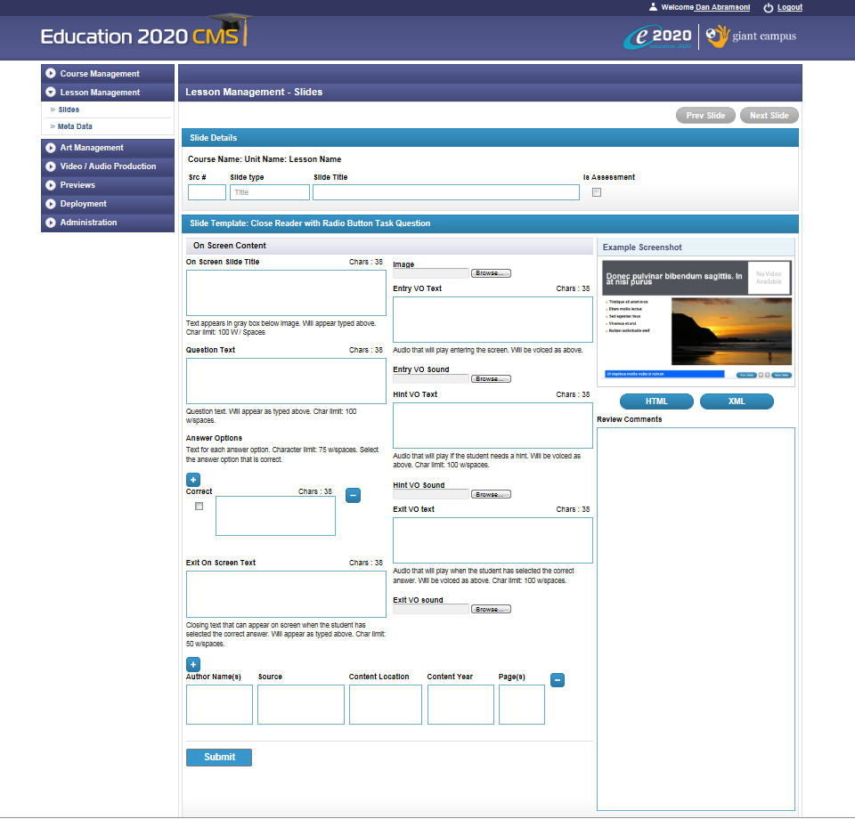

1. Click the **Submit** button to save the slide in the tool.
2. Then, click the **HTML** button in the preview area. A new window or tab should open, displaying a rendering of how the slide appears. If interested, you can also click on the **XML** button should you wish to see how the XML rendering appears.
3. To return back to the **Lesson Content** page, you can click on the **blue Lesson** button displaying at the top of the slide editor.

**Note about hyperlinks:** Right now, if you add a hyperlink into a question field, media content field, or a column field, you must also add that hyperlink in the **Web Link** field. Links found in this field will be filtered through e2020’s web proxy and whitelisted. As of right now, the tool will not be pulling a hyperlink from other fields and populating it in the Web Links field for export.

**Note about hyperlinks:** Right now, if you add a hyperlink into a question field, media content field, or a column field, you must also add that hyperlink in the **Web Link** field. Links found in this field will be filtered through e2020’s web proxy and whitelisted. As of right now, the tool will not be pulling a hyperlink from other fields and populating it in the Web Links field for export.

## Add Text/Number Field Task

The text/number field (“fill in the blank”) item type can be used for tasks. There are three layout options available for a checkbox task slide. Depending on the layout selected, a different number of fields may be available.

1. On the **Lesson Management** screen, find the **Framechain Activity** section where you want to add a text/number field task slide.
2. Click on the **Add** button located below that **Framechain Activity Name**. A slide type and layout selection pop-up appears. Select the **Text/Number Field** option in the drop-down menu and choose a layout.

**Text & Number Field Layouts**

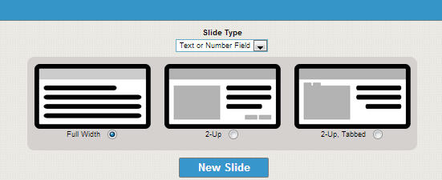

* Full-width
* 2-Up
* 2-Tabbed, 2-Up

Then, click on the **New Slide** button to create a text or number field slide.

1. The new slide will be added to the slide listing that displays below the **Framechain Activity Name**. Click on the **slide #** to go to the slide editor and begin assembly.
2. A slide editor can be divided into three sections: *slide details, task metadata,* and *onscreen elements.* As mentioned earlier, many of the fields were added to anticipate future needs. Fill in all the required fields and complete any other fields should you have that information on hand.

Depending on the layout selection, you may see a different number of fields.

For example, a **Text/Number Field Task Slide** offers three layouts: full-width, 2-Up with questions displaying on the right column, and two-tabbed 2-Up.

Complete Fields

|  |  |  |
| --- | --- | --- |
| **Name** | **Required/Optional** | **Notes** |
| Icon Selector | Optional | Select from drop-down menu. Default value to no-icon. |
| Slide Title | Required | This is the slide title used by the authoring tool. Oftentimes it will be identical to the Onscreen Slide Title. The distinction is particularly useful, however, when creating video slides. See earlier section on videos and video slides. |
| Onscreen Title | Required | This onscreen title will display in slide’s title bar or header. |
| Difficulty Level | Required | Specific requirement for assessments, optional for tasks depending if that information is already provided by editors, fields remain in the event that they may be needed at some time in the future. |
| Bloom’s | Required | Specific requirement for assessments, optional for tasks depending if that information is already provided by editors, fields remain in the event that they may be needed at some time in the future. |
| WDOK | Required | Specific requirement for assessments, optional for tasks depending if that information is already provided by editors, fields remain in the event that they may be needed at some time in the future. |
| Correct Answer | Required | 2/6 – Current export package requires a <correct_answer> tag in the manifest. As of now, for text-based answers, you will need to indicate the correct answer twice – once in this field (copy and paste) and a second time when you mark off the check box next to the answer option field itself. Looking into modifying this step. |
| Distractor Rationale | Required |  |
| Sample Answer | Optional | Include sample answer for open-ended questions, answer explanation for fixed response. |
| Answer Explanation | Optional |  |
| Answer Choice May Be Randomized | Required | By default, this value is set as no (the check box is left unmarked). |
| Answer Explanation | Optional | If provided, include explanation of correct answer. |
| Points | Required | Leave entry with default value, “0,” unless point is provided. |
| Teacher Graded | Required |  |
| Change Information | Required if content is modified after it is exported |  |
| Question Text | Required | A required field for tasks and assessments; field displays here as part of the basic slide editor template. |
| Answer | Required | Add all possible answer choices for a given drop-down menu. Each time you add a new drop-down menu in the question text field, a new answer field will be generated. Enter choices and separate each one by hitting the enter/return key. To mark the correct answer, you must add an asterisk at the end of the answer item that is correct for that particular drop-down. |
| Media Content | Required | Field is available for entry if a 2-Up layout is selected. Add images, create bulleted lists, style fonts, etc. |
| Tab 1 Content | Required | Field is available for entry a 2-tabbed layout is selected. |
| Tab 2 Content | Required | Field is available for entry a 2-tabbed layout is selected. |
| Entry VO Text | Required | Entry audio script |
| Entry VO Sound | Required | Browse and select audio clip from corresponding frame folder in media server |
| Hint VO Text | Optional | Hint audio script |
| Hint VO Sound | Optional | Browse and select audio clip from corresponding frame folder in media server |
| Exit VO Text | Optional | Exit audio script |
| Exit VO Sound | Optional | Browse and select audio clip from corresponding frame folder in media server |
| Review Comments | Optional | If there is more than one person working on a given slide or if someone is reviewing the slide, s/he can leave comments here. |
| Source | Optional | Fill in source information if available. |
| Web Link | Optional | Links in this field get filtered through e2020 proxy and are whitelisted. Currently, if you add a hyperlink in a content area, you will need to add that link as well in this field. Future plan is to enable only one-time entry of hyperlink, and tool will be able to pull those <a> tags and populate the <web_links> field for export. |

**Note:** All question fields, answer choice fields (with the exception of the full-width with image layouts), and column content fields (in basic HTML slides) will have a basic WYSIWYG editor.

This WYSIWYG editor provides tools that will enable you to:

* Style fonts/text
* Create lists
* Insert hyperlinks
* Browse and insert images (all first saved in pre.sandbox media server)
* Select the equations editor to create equations/formulas
* Select the HTML editor to directly write HTML code

1. The accompanying screenshot captures a slide editor for a **Text/Number Field Task** using the **Full-Width** layout. The most unique aspect to this slide editor is the set-up for creating check box answer options.
2. Input a question plus any supporting text (or image) to the **Question** field.
3. To add a drop-down menu inline or below the question text, you will need to click on the **(+)** or **Add Text/Number Field** icon in the editor. It will create a placeholder in the field; the number of the placeholder is sequential.

For example, if you want to create a text/number field task that includes text and two fields for a student input a number or text answer within that text, you will click on the **(+)** button twice.

Click on the area that you want to create a number or text field “placeholder.” When you click on the **(+)** button, a corresponding **Answer** field is create.

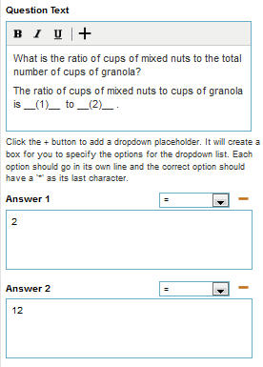

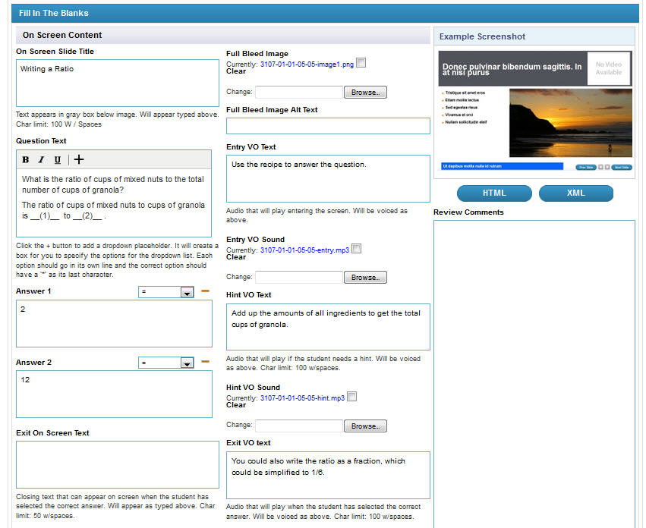

*Screenshot: Slide editor of a number field task being assembled in Bluejacks.*

1. Click the **Submit** button to save the slide in the tool.
2. Then, click the **HTML** button in the preview area. A new window or tab should open, displaying a rendering of how the slide appears. If interested, you can also click on the **XML** button should you wish to see what the XML rendering appears.
3. To return back to the **Lesson Management** Screen, you can click on the **blue Lesson** button displaying at the top of the slide editor.

**Note about hyperlinks:** Right now, if you add a hyperlink into a question field, media content field, or a column field, you must also add that hyperlink in the **Web Link** field. Links found in this field will be filtered through e2020’s web proxy and whitelisted. As of right now, the tool will not be pulling a hyperlink from other fields and populating it in the Web Links field for export.

## Add Text Area Task

The text area item type can be used for tasks. There are three layout options available for a text area slide. Depending on the layout selected, a different number of fields may be available.

1. On the **Lesson Management** screen, find the **Framechain Activity** section where you want to add a text area task slide.
2. Click on the **Add** button located below that **Framechain Activity Name**. A slide type and layout selection pop-up appears. Select the **Text Area** option in the drop-down menu and choose a layout.

**Text Area Layouts**

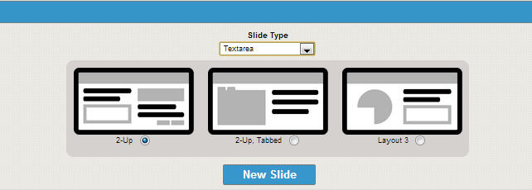

* 2-Up (layout label to change)*: text area on left, sample response and self-assess/self-check question on the right.
* 2-Up, Tabbed: media content in each tabbed section on left, text area on right
* 2-Up: media content in left column, text on right column

Then, click on the **New Slide** button to create a text area slide.

1. The new slide will be added to the slide listing that displays below the **Framechain Activity Name**. Click on the **slide #** to go to the slide editor and begin assembly.
2. A slide editor can be divided into three sections: *slide details, task metadata,* and *onscreen elements.* As mentioned earlier, many of the fields were added to anticipate future needs. Fill in all the required fields and complete any other fields should you have that information on hand.

Depending on the layout selection, you may see a different number of fields.

For example, a **Text Area Task Slide** offers three layouts: a 2-Up where the text area/student response displays on the left column while a set of self-assess/survey check box questions display on the left column; a 2-Up where media content (e.g. images) would display on the left and the text area plus instructional text displays on the left; and a two-tabbed 2-Up where each tab displays a piece of content with the text area/student response area on the right column.

Complete Fields

|  |  |  |
| --- | --- | --- |
| **Name** | **Required/Optional** | **Notes** |
| Icon Selector | Optional | Select from drop-down menu. Default value to no-icon. |
| Slide Title | Required | This is the slide title used by the authoring tool. Oftentimes it will be identical to the Onscreen Slide Title. The distinction is particularly useful, however, when creating video slides. See earlier section on videos and video slides. |
| Onscreen Title | Required | This onscreen title will display in slide’s title bar or header. |
| Difficulty Level | Required | Specific requirement for assessments, optional for tasks depending of that information is already provided by editors, fields remain in the event that they may be needed at some time in the future. |
| Bloom’s | Optional | Specific requirement for assessments, optional for tasks depending of that information is already provided by editors, fields remain in the event that they may be needed at some time in the future. |
| WDOK | Optional | Specific requirement for assessments, optional for tasks depending if that information is already provided by editors, fields remain in the event that they may be needed at some time in the future. |
| Sample Response/Explanation | Required | Background color selection should be available. To come. |
| Self-Check or Self-Assess Question | Required if Text Area/Survey Check box Template selected | Enter the survey/self-assess question. |
| Answer Text | Required | Enter check box answer option. Click on add or delete buttons to create more or less answer choices. |
| Media Content | Required | Field is available for entry if a 2-Up layout is selected. Add images, create bulleted lists, style fonts, directly insert HTML code, create equations, etc.  May be able to select different types of editors for the media content area (HTML editor, full bleed image editor, reading pane editor. |
| Tab 1 Content | Required | Field is available for entry a 2-tabbed layout is selected. |
| Tab 2 Content | Required | Field is available for entry a 2-tabbed layout is selected. |
| Entry VO Text | Required | Entry audio script |
| Entry VO Sound | Required | Browse and select audio clip from corresponding frame folder in media server |
| Exit VO Text | Optional | Exit audio script |
| Exit VO Sound | Optional | Browse and select audio clip from corresponding frame folder in media server |
| Text Area Height | Required | Although the text area in the player will be scrollable, this sets an expected limit on how many lines the student response should be. |
| Keywords | Required |  |
| Review Comments | Optional | If there is more than one person working on a given slide or if someone is reviewing the slide, s/he can leave comments here. |
| Source | Optional | Fill in source information if available. |
| Web Link | Optional | Links in this field get filtered through e2020 proxy and are whitelisted. Currently, if you add a hyperlink in a content area, you will need to add that link as well in this field. Future plan is to enable only one-time entry of hyperlink, and tool will be able to pull those <a> tags and populate the <web_links> field for export. |

**Note:** All question fields, answer choice fields (with the exception of the full-width with image layouts), and column content fields (in basic HTML slides) will have a basic WYSIWYG editor.

This WYSIWYG editor provides tools that will enable you to:

* Style fonts/text
* Create lists
* Insert hyperlinks
* Browse and insert images (all first saved in pre.sandbox media server)
* Select the equations editor to create equations/formulas
* Select the HTML editor to directly write HTML code

1. The accompanying screenshot captures a slide editor for a **Text Area/Self-Assess or Survey Question Task**.



1. Click the **Submit** button to save the slide in the tool.
2. Then, click the **HTML** button in the preview area. A new window or tab should open, displaying a rendering of how the slide appears. If interested, you can also click on the **XML** button should you wish to see what the XML rendering appears.
3. To return back to the **Lesson Management** Screen, you can click on the **blue Lesson** button displaying at the top of the slide editor.

**Note about hyperlinks:** Right now, if you add a hyperlink into a question field, media content field, or a column field, you must also add that hyperlink in the **Web Link** field. Links found in this field will be filtered through e2020’s web proxy and whitelisted. As of right now, the tool will not be pulling a hyperlink from other fields and populating it in the Web Links field in the manifest xml file for export.

## Add Matching Task

The matching item type can be used for tasks. There is only one layout option available for a matching task slide.

1. On the **Lesson Management** screen, find the **Framechain Activity** section where you want to add a basic HTML page slide.
2. Click on the **Add** button located below that **Framechain Activity Name**. A slide type and layout selection pop-up appears. Select the **Matching** option in the drop-down menu. As there is only one layout option available, no additional selection will be required. Click on the **New Slide** button to create a matching task slide.
3. The new slide will be added to the slide listing that displays below the **Framechain Activity Name**. Click on the **slide #** to go to the slide editor and begin assembly.
4. A slide editor can be divided into three sections: *slide details, task metadata,* and *onscreen elements.* As mentioned earlier, many of the fields were added to anticipate future needs. Fill in all the required fields and complete any other fields should you have that information on hand.

Complete Fields

|  |  |  |
| --- | --- | --- |
| **Name** | **Required/Optional** | **Notes** |
| Icon Selector | Optional | Select from drop-down menu. Default value to no-icon. |
| Slide Title | Required | This is the slide title used by the authoring tool. Oftentimes it will be identical to the Onscreen Slide Title. The distinction is particularly useful, however, when creating video slides. See earlier section on videos and video slides. |
| Onscreen Title | Required | This onscreen title will display in slide’s title bar or header. |
| Difficulty Level | Optional | Specific requirement for assessments, optional for tasks depending of that information is already provided by editors, fields remain in the event that they may be needed at some time in the future. |
| Bloom’s | Optional | Specific requirement for assessments, optional for tasks depending of that information is already provided by editors, fields remain in the event that they may be needed at some time in the future. |
| WDOK | Optional | Specific requirement for assessments, optional for tasks depending of that information is already provided by editors, fields remain in the event that they may be needed at some time in the future. |
| Question Text | Required | A required field for tasks and assessments; field displays here as part of the basic slide editor template. |
| Left-column category title | Required | No category title actually displays in the final task. *This field may be removed; for now, you can just leave it blank.* |
| Right-column category title | Required | Enter the name of the right-column matching category. |
| Matching Left text | Required | This text will display in a text box on the left column of the matching task. In the left text field, add the text that should match to the content in the right text field. In the interactive, the left column text boxes will be randomized. The system will using the text pairs you’ve created to mark what is the correct match. |
| Matching Right text | Required | This text will display in a text box on the left column of the matching task. In the left text field, add the text that should match to the content in the right text field. In the interactive, the left column text boxes will be randomized. The system will using the text pairs you’ve created to mark what is the correct match.  Add/delete as many matching text boxes as necessary. |
| Entry VO Text | Required | Entry audio script |
| Entry VO Sound | Required | Browse and select audio clip from corresponding frame folder in media server |
| Hint VO Text | Optional | Hint audio script |
| Hint VO Sound | Optional | Browse and select audio clip from corresponding frame folder in media server |
| Exit VO Text | Optional | Exit audio script |
| Exit VO Sound | Optional | Browse and select audio clip from corresponding frame folder in media server |
| Review Comments | Optional | If there is more than one person working on a given slide or if someone is reviewing the slide, s/he can leave comments here. |
| Source | Optional | Fill in source information if available. |
| Change Information | Required if content is revised | Add a short description when any content is modified after it’s been exported. |

1. A matching task can be viewed as having two columns. In the left column, there are blocks of text. Each block of text has an arrow next to it. A user would be able to click and drag the arrow, attaching it to the block of text that is a correct match.
2. To create the actual matched pairs, you will simply copy and paste the text that appears in the matching text boxes in the PowerPoint. You can ignore the two category fields – those were leftover from an older version of the tool. Remember to click on the **Add [+] button** to create a new matched pair or the **Delete [-]** button.

|  |  |
| --- | --- |
|  | 1. Ignore the **Left Category Text** and **Right Category Text** boxes. You do not need to name the columns for the tiles of the matching task. 2. Copy and paste in the “matched” pairs of text to the appropriate text fields. Follow the order (left column and right column) as assembled in the PowerPoint. 3. To add a new matched pair, click on the **Add (+) button.** Two text fields – the left text and right text – will appear. 4. To delete a matched pair, click on the **Delete (-) button**. You will be prompted to confirm removing the matched pair. |

1. Click the **Submit** button to save the slide in the tool.
2. Then, click the **HTML** button in the preview area. A new window or tab should open, displaying a rendering of how the slide appears. If interested, you can also click on the **XML** button should you wish to see what the XML rendering appears.

**Note about hyperlinks:** Right now, if you add a hyperlink into a question field, media content field, or a column field, you must also add that hyperlink in the **Web Link** field. Links found in this field will be filtered through e2020’s web proxy and whitelisted. As of right now, the tool will not be pulling a hyperlink from other fields and populating it in the Web Links field for export.

## Add Text Evidence Task

The text evidence item type can be used for tasks. There is only one layout option available for a text evidence task slide.

1. On the **Lesson Management** screen, find the **Framechain Activity** section where you want to add a basic HTML page slide.
2. Click on the **Add** button located below that **Framechain Activity Name**. A slide type and layout selection pop-up appears. Select the **Text Evidence** option in the drop-down menu and choose a layout. Then, click on the **New Slide** button to create text evidence task slide.
3. The new slide will be added to the slide listing that displays below the **Framechain Activity Name**. Click on the **slide #** to go to the slide editor and begin assembly.
4. A slide editor can be divided into three sections: *slide details, task metadata,* and *onscreen elements.* As mentioned earlier, many of the fields were added to anticipate future needs. Fill in all the required fields and complete any other fields should you have that information on hand.

Complete Fields

|  |  |  |
| --- | --- | --- |
| **Name** | **Required/Optional** | **Notes** |
| Icon Selector | Optional | Select from drop-down menu. Default value to no-icon. |
| Slide Title | Required | This is the slide title used by the authoring tool. Oftentimes it will be identical to the Onscreen Slide Title. The distinction is particularly useful, however, when creating video slides. See earlier section on videos and video slides. |
| Onscreen Title | Required | This onscreen title will display in slide’s title bar or header. |
| Difficulty Level | Optional | Specific requirement for assessments, optional for tasks depending of that information is already provided by editors, fields remain in the event that they may be needed at some time in the future. |
| Bloom’s | Optional | Specific requirement for assessments, optional for tasks depending of that information is already provided by editors, fields remain in the event that they may be needed at some time in the future. |
| WDOK | Optional | Specific requirement for assessments, optional for tasks depending of that information is already provided by editors, fields remain in the event that they may be needed at some time in the future. |
| Brief Introduction | Required | Input text and provide introduction or directions. |
| Category A Text | Required | Enter the title of the first category of the task. |
| Category B Text | Required | Enter the title of the second category of the task. |
| Question Text Field | Required | Enter the block of text that will need to be dragged and placed to the appropriate category. Highlight the key parts of the text that will be dragged. After highlighting the text, select the <styles> option in the WYSIWYG editor and determine if the correct categorization is A or B. |
| Entry VO Text | Required | Entry audio script |
| Entry VO Sound | Required | Browse and select audio clip from corresponding frame folder in media server |
| Hint VO Text | Optional | Hint audio script |
| Hint VO Sound | Optional | Browse and select audio clip from corresponding frame folder in media server |
| Exit VO Text | Optional | Exit audio script |
| Exit VO Sound | Optional | Browse and select audio clip from corresponding frame folder in media server |
| Review Comments | Optional | If there is more than one person working on a given slide or if someone is reviewing the slide, s/he can leave comments here. |
| Citation (combination of 5 fields) | Optional | Fill in source information if available. |
| Web Link | Optional | Links in this field get filtered through e2020 proxy and are whitelisted. Currently, if you add a hyperlink in a content area, you will need to add that link as well in this field. Future plan is to enable only one-time entry of hyperlink, and tool will be able to pull those <a> tags and populate the <web_links> field for export. |

1. Click the **Submit** button to save the slide in the tool.
2. Then, click the **HTML** button in the preview area. A new window or tab should open, displaying a rendering of how the slide appears. If interested, you can also click on the **XML** button should you wish to see what the XML rendering appears.

|  |  |
| --- | --- |
|  | 1. Add the task instructions in the **Brief Introduction** text field. 2. Add the category titles in the **Category A** and **Category B** fields. 3. Assemble your text evidence passage in the **Question Text** field. Copy and paste the text from the PowerPoint into the field – recommended to add in the HTML source editor (click on HTML icon in WYSIWYG editor). 4. Once you have your passage in the **Question Text Field**, you should return to the WYSIWYG editor mode. You will highlight the first block of text that should be categorized in the first category column. Then, in the **Styles** dropdown in the WYSIWYG editor, select **Category A**. 5. The look of the block of text you just assigned to a category should now change. It should look like a button or tile. In the final output of this task, these tiles will be draggable. 6. Repeat Step 4 as much as necessary to assign blocks of text to Category A or Category B. |

## Add Sort-by-2-Categories Task

The sort-by-2-category item type can be used for tasks.

1. On the **Lesson Management** screen, find the **Framechain Activity** section where you want to add a sort-by-2-categories task slide.
2. Click on the **Add** button located below that **Framechain Activity Name**. A slide type and layout selection pop-up appears. Select the **Sort by 2 Categories** option in the drop-down menu and choose a layout. Then, click on the **New Slide** button to create a sort-by-2-categories task slide.
3. The new slide will be added to the slide listing that displays below the **Framechain Activity Name**. Click on the **slide #** to go to the slide editor and begin assembly.
4. A slide editor can be divided into three sections: *slide details, task metadata,* and *onscreen elements.* As mentioned earlier, many of the fields were added to anticipate future needs. Fill in all the required fields and complete any other fields should you have that information on hand.

Complete Fields

|  |  |  |
| --- | --- | --- |
| **Name** | **Required/Optional** | **Notes** |
| Icon Selector | Optional | Select from drop-down menu. Default value to no-icon. |
| Slide Title | Required | This is the slide title used by the authoring tool. Oftentimes it will be identical to the Onscreen Slide Title. The distinction is particularly useful, however, when creating video slides. See earlier section on videos and video slides. |
| Onscreen Title | Required | This onscreen title will display in slide’s title bar or header. |
| Difficulty Level | Optional | Specific requirement for assessments, optional for tasks depending of that information is already provided by editors, fields remain in the event that they may be needed at some time in the future. |
| Bloom’s | Optional | Specific requirement for assessments, optional for tasks depending of that information is already provided by editors, fields remain in the event that they may be needed at some time in the future. |
| WDOK | Optional | Specific requirement for assessments, optional for tasks depending of that information is already provided by editors, fields remain in the event that they may be needed at some time in the future. |
| Question Text | Required | A required field for tasks and assessments; field displays here as part of the basic slide editor template. |
| Category A Text | Required | Name of Category A |
| Category B Text | Required | Name of Category B |
| Tile (item) Text | Required | Input the text that should be displayed in an individual tile. |
| Category dropdown menu | Required | Select the category (A or B) that the tile should be correctly assigned |
| Entry VO Text | Required | Entry audio script |
| Entry VO Sound | Required | Browse and select audio clip from corresponding frame folder in media server |
| Hint VO Text | Optional | Hint audio script |
| Hint VO Sound | Optional | Browse and select audio clip from corresponding frame folder in media server |
| Exit VO Text | Optional | Exit audio script |
| Exit VO Sound | Optional | Browse and select audio clip from corresponding frame folder in media server |
| Review Comments | Optional | If there is more than one person working on a given slide or if someone is reviewing the slide, s/he can leave comments here. |
| Citation (combination of 5 fields) | Optional | Fill in source information if available. |
| Web Link | Optional | Links in this field get filtered through e2020 proxy and are whitelisted. Currently, if you add a hyperlink in a content area, you will need to add that link as well in this field. Future plan is to enable only one-time entry of hyperlink, and tool will be able to pull those <a> tags and populate the <web_links> field for export. |

1. Click the **Submit** button to save the slide in the tool.
2. Then, click the **HTML** button in the preview area. A new window or tab should open, displaying a rendering of how the slide appears. If interested, you can also click on the **XML** button should you wish to see what the XML rendering appears.

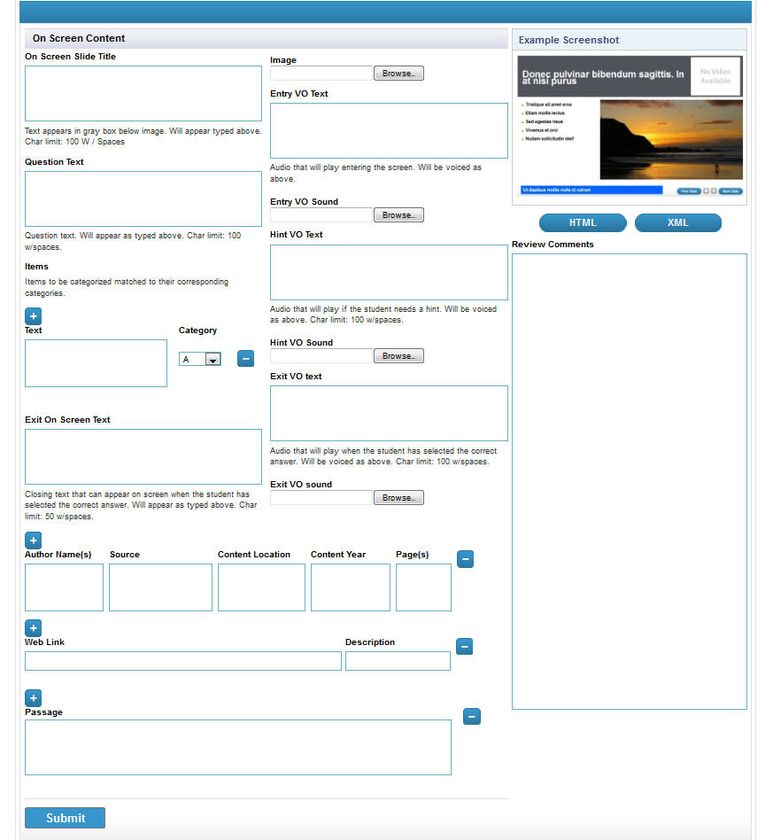

## Add Sort-by-3-Categories Task

The sort-by-3-category item type can be used for tasks. There is only one layout option available for a sort-by-3-category task slide.

1. On the **Lesson Management** screen, find the **Framechain Activity** section where you want to add a sort-by-3-categories task slide.
2. Click on the **Add** button located below that **Framechain Activity Name**. A slide type and layout selection pop-up appears. Select the **Sort by 3 Category** option in the drop-down menu and choose a layout. Then, click on the **New Slide** button to create a sort-by-3-categories task slide.
3. The new slide will be added to the slide listing that displays below the **Framechain Activity Name**. Click on the **slide #** to go to the slide editor and begin assembly.
4. A slide editor can be divided into three sections: *slide details, task metadata,* and *onscreen elements.* As mentioned earlier, many of the fields were added to anticipate future needs. Fill in all the required fields and complete any other fields should you have that information on hand.

Complete Fields

|  |  |  |
| --- | --- | --- |
| **Name** | **Required/Optional** | **Notes** |
| Icon Selector | Optional | Select from drop-down menu. Default value to no-icon. |
| Slide Title | Required | This is the slide title used by the authoring tool. Oftentimes it will be identical to the Onscreen Slide Title. The distinction is particularly useful, however, when creating video slides. See earlier section on videos and video slides. |
| Onscreen Title | Required | This onscreen title will display in slide’s title bar or header. |
| Difficulty Level | Optional | Specific requirement for assessments, optional for tasks depending of that information is already provided by editors, fields remain in the event that they may be needed at some time in the future. |
| Bloom’s | Optional | Specific requirement for assessments, optional for tasks depending of that information is already provided by editors, fields remain in the event that they may be needed at some time in the future. |
| WDOK | Optional | Specific requirement for assessments, optional for tasks depending of that information is already provided by editors, fields remain in the event that they may be needed at some time in the future. |
| Question Text | Required | A required field for tasks and assessments; field displays here as part of the basic slide editor template. |
| Category A Text | Required | Name of Category A |
| Category B Text | Required | Name of Category B |
| Category C Text | Required | Name of Category C |
| Tile (item) Text | Required | Input the text that should be displayed in an individual tile. |
| Category dropdown | Required | Select the category (A, B, or C) that the tile should be correctly assigned |
| Entry VO Text | Required | Entry audio script |
| Entry VO Sound | Required | Browse and select audio clip from corresponding frame folder in media server |
| Hint VO Text | Optional | Hint audio script |
| Hint VO Sound | Optional | Browse and select audio clip from corresponding frame folder in media server |
| Exit VO Text | Optional | Exit audio script |
| Exit VO Sound | Optional | Browse and select audio clip from corresponding frame folder in media server |
| Review Comments | Optional | If there is more than one person working on a given slide or if someone is reviewing the slide, s/he can leave comments here. |
| Citation (combination of 5 fields) | Optional | Fill in source information if available. |
| Web Link | Optional | Links in this field get filtered through e2020 proxy and are whitelisted. Currently, if you add a hyperlink in a content area, you will need to add that link as well in this field. Future plan is to enable only one-time entry of hyperlink, and tool will be able to pull those <a> tags and populate the <web_links> field for export. |

1. Click the **Submit** button to save the slide in the tool.
2. Then, click the **HTML** button in the preview area. A new window or tab should open, displaying a rendering of how the slide appears. If interested, you can also click on the **XML** button should you wish to see what the XML rendering appears.

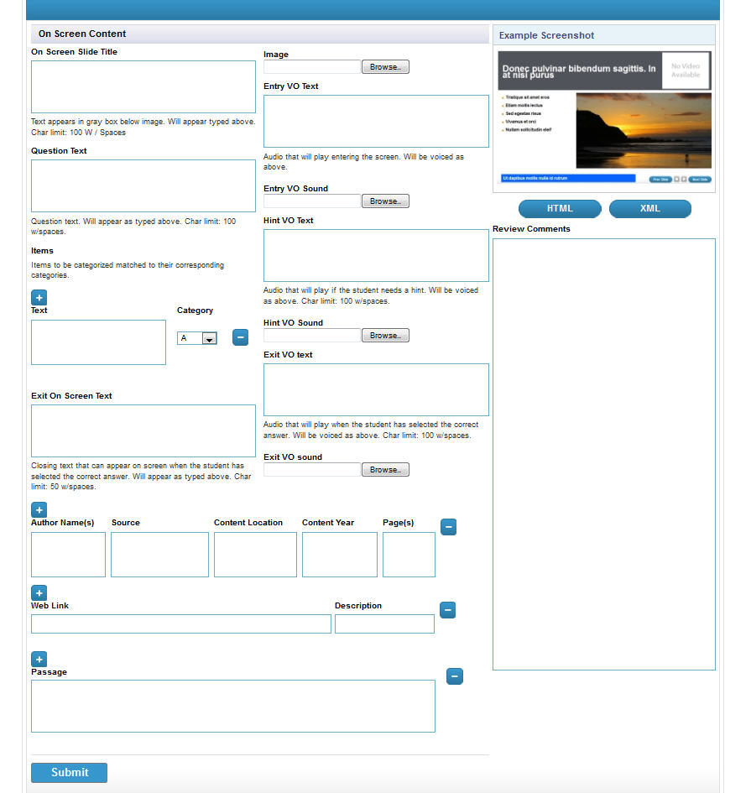

*Screenshot to be updated pending UI fixes to this editor by 3/25/2013*

## Add Sort-by-Rank (Ordering) Task

The sort-by-rank (ordering) item type can be used for tasks. There is only one layout option available for a sort-by-rank (ordering) task slide.

1. On the **Lesson Management** screen, find the **Framechain Activity** section where you want to add a sort-by-rank task slide.
2. Click on the **Add** button located below that **Framechain Activity Name**. A slide type and layout selection pop-up appears. Select the **Sort by Rank** option in the drop-down menu and choose a layout.

**Sort by Rank Layouts**

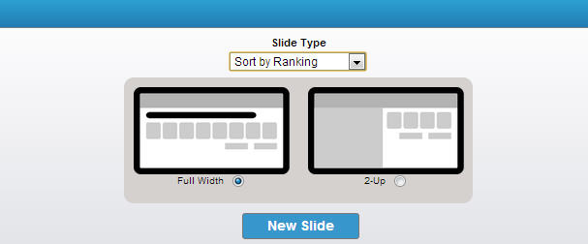

* Full-width
* 2-Up (media content on left, sort-by-rank tiles on right)

Then, click on the **New Slide** button to create a sort-by-ranking slide.

1. The new slide will be added to the slide listing that displays below the **Framechain Activity Name**. Click on the **slide #** to go to the slide editor and begin assembly.
2. A slide editor can be divided into three sections: *slide details, task metadata,* and *onscreen elements.* As mentioned earlier, many of the fields were added to anticipate future needs. Fill in all the required fields and complete any other fields should you have that information on hand.

Complete Fields

|  |  |  |
| --- | --- | --- |
| **Name** | **Required/Optional** | **Notes** |
| Icon Selector | Optional | Select from drop-down menu. Default value to no-icon. |
| Slide Title | Required | This is the slide title used by the authoring tool. Oftentimes it will be identical to the Onscreen Slide Title. The distinction is particularly useful, however, when creating video slides. See earlier section on videos and video slides. |
| Onscreen Title | Required | This onscreen title will display in slide’s title bar or header. |
| Difficulty Level | Optional | Specific requirement for assessments, optional for tasks depending of that information is already provided by editors, fields remain in the event that they may be needed at some time in the future. |
| Bloom’s | Optional | Specific requirement for assessments, optional for tasks depending of that information is already provided by editors, fields remain in the event that they may be needed at some time in the future. |
| WDOK | Optional | Specific requirement for assessments, optional for tasks depending of that information is already provided by editors, fields remain in the event that they may be needed at some time in the future. |
| Question Text | Required | A required field for tasks and assessments; field displays here as part of the basic slide editor template. |
| Answer Option | Required | Enter answer option. Can add or delete additional answer option fields. |
| Media Content | Required | Field is available for entry if a 2-Up layout is selected. Add images, create bulleted lists, style fonts, etc. |
| Entry VO Text | Required | Entry audio script |
| Entry VO Sound | Required | Browse and select audio clip from corresponding frame folder in media server |
| Hint VO Text | Optional | Hint audio script |
| Hint VO Sound | Optional | Browse and select audio clip from corresponding frame folder in media server |
| Exit VO Text | Optional | Exit audio script |
| Exit VO Sound | Optional | Browse and select audio clip from corresponding frame folder in media server |
| Review Comments | Optional | If there is more than one person working on a given slide or if someone is reviewing the slide, s/he can leave comments here. |
| Citation (combination of 5 fields) | Optional | Fill in source information if available. |
| Web Link | Optional | Links in this field get filtered through e2020 proxy and are whitelisted. Currently, if you add a hyperlink in a content area, you will need to add that link as well in this field. Future plan is to enable only one-time entry of hyperlink, and tool will be able to pull those <a> tags and populate the <web_links> field for export. |

1. Click the **Submit** button to save the slide in the tool.
2. Then, click the **HTML** button in the preview area. A new window or tab should open, displaying a rendering of how the slide appears. If interested, you can also click on the **XML** button should you wish to see what the XML rendering appears.

## Add Assessment Activity

**Update: 8/25/2015**

By default, every Bluejacks lesson contains a **Quiz Activity** as the last activity. A user may modify the attributes and names of this activity. Due to system limitations, there is no functionality available that would directly enable a user to create other types of Assessment Activities. These instances would need to be managed after the course has been exported from Bluejacks and published to the 4.5 environments for customization.

|  |  |  |
| --- | --- | --- |
| **Name** | **Required/Optional** | **Notes** |
| Activity Name | Required | May be the same as the activity type selected |
| Activity Type | Required |  |
| Additional Instructions | Optional | These instructions would display in the LMS, visible to both students and teachers. |
| Tools | Optional | Multiple tools may be selected for each activity. The player will display tools at the lesson level, |
| References | Optional | The selected tools should be pushed up to the lesson during export. |
| Activity Estimate Time | Required | Time should be written following this format – MM:SS (e.g. 10:00 means 10 minutes).  *As shared: a proposal to collect estimated time with the slide editor and have the activity estimated time field be able to display the sum of all that time has been shared with SRM. TBD.* |
| Grading Weight Category | Required for Assessment |  |
| Target Population | Optional | Target Population replaces “Accessibility Type” category in V4. May select more than one option. |
| Change Information | Optional | Add short description when content is modified after it has been exported. |

1. Then, click the **Save** button.

In many instances, the activity name and activity type may be same. But, there are times when the activity name is more descriptive and specific than the activity type. For example, a science lab may have the activity type, ‘Assignment,’ but the activity name (which is displayed to the student) is called, ‘Virtual Lab.’

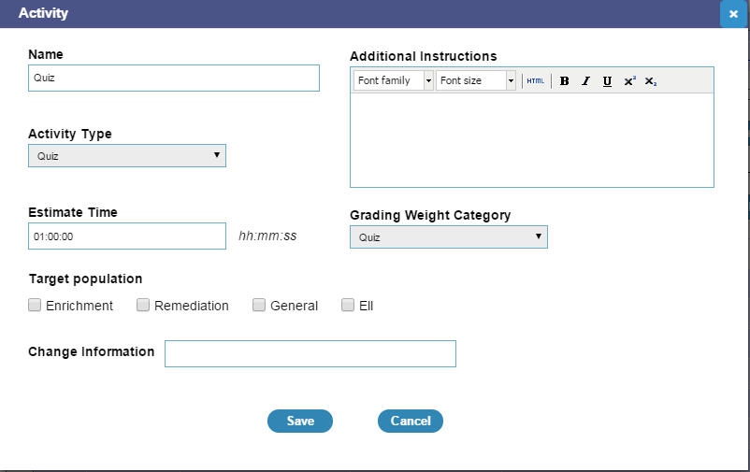

*Screenshot of Assessment Activity Editor*

## Edit Assessment Activity

To change a framechain activity’s attributes and other related information, you can return to the activity editor and make modifications.

1. Click on an **Activity Title** in the **Lesson Management** screen. You will be directed to an editor specifically for that activity.
2. Then, click the **Save** button.

In many instances, the activity name and activity type may be same. But, there are times when the activity name is more descriptive and specific than the activity type. For example, a science lab may have the activity type, ‘Assignment,’ but the activity name (which is displayed to the student) is called, ‘Virtual Lab.’



*Screenshot of an Assessment Activity Editor*

## Add Upload Content Activity

Separate documentation and instructions are provided.

<http://eportal.education2020.com/Curriculum/Production%20Library/Content%20Authoring%20Tool/Adding%20Upload%20Content%20Activities%20in%20Bluejacks.docx>

## Add Essay Activity

Separate documentation and instructions are provided.

<http://eportal.education2020.com/Curriculum/Production%20Library/Content%20Authoring%20Tool/Adding%20Essay%20Activities%20in%20Bluejacks.docx>

## Add Short Writing Activity

Separate documentation and instructions are provided.

<http://eportal.education2020.com/Curriculum/Production%20Library/Content%20Authoring%20Tool/Adding%20Short%20Writing%20Activities%20in%20Bluejacks.docx>

## Question Bank

In general, 26 questions or assessment items are created for a single lesson. Another way to describe this set of questions is to say that we are building a question bank. 26 assessment items or questions are assembled for each lesson. Quizzes, tests, exams, reviews, spiral review, and prescriptive tests will be populated with these question items depending on how they are tagged.

All items are authored and managed within the **Question Bank** tabbed section in the **Lesson Content** page.

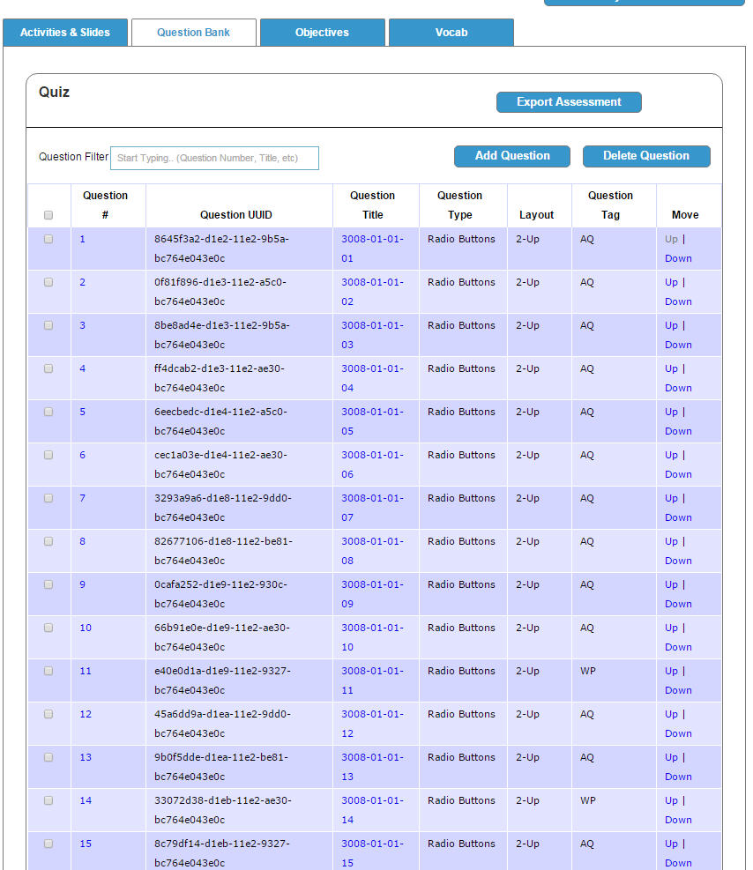

## Add Radio Button Assessment

The radio button item type can be used for assessments. There are four layout options available for a radio button assessment item. Depending on the layout selected, a different number of fields may be available.

1. On the **Lesson Management** screen, find the **Assessment Activity** section where you want to add a radio button task slide.
2. Click on the **Add** button located below that **Assessment Activity Name**. A slide type and layout selection pop-up appears. Select the **Radio Button** option in the drop-down menu and choose a layout.

**Radio Button Layouts**

* Full-width
* 2-Up
* 2-Tabbed, 2-Up
* Full-width with 3 images answer options
* Full-width with 4 image answer options

1. Then, click on the **New Slide** button to create a radio button assessment item.
2. The new slide will be added to the slide listing that displays below the **Assessment Activity Name**. Click on the **slide #** to go to the slide editor and begin assembly.
3. A slide editor can be divided into three sections: *slide details, task metadata,* and *onscreen elements.* As mentioned earlier, many of the fields were added to anticipate future needs. Fill in all the required fields and complete any other fields should you have that information on hand.

Depending on the layout selection, you may see a different number of fields

For example, a **Radio Button Assessment Item** supports four layouts: full-width, 2-Up with questions displaying on the right column, full-width horizontal with images used as answer choices displaying horizontally, and two-tabbed 2-Up.

Complete Fields

|  |  |  |
| --- | --- | --- |
| **Name** | **Required/Optional** | **Notes** |
| Icon Selector | Optional | Select from drop-down menu. Default value to no-icon. |
| Slide Title | Required | This is the slide title used by the authoring tool. Oftentimes it will be identical to the Onscreen Slide Title. The distinction is particularly useful, however, when creating video slides. See earlier section on videos and video slides. |
| Onscreen Title | Required | This onscreen title will display in slide’s title bar or header. |
| Question Tag | Required | At least one question tag must be selected, multiple or all selections are acceptable as well. |
| Objective(s) | Required | Tag at least one objective, multiple selections are acceptable. |
| Passage | Optional | If assessment question refers to a passage, input the passage identifier (or URL) -> to confirm |
| Difficulty Level | Required |  |
| Bloom’s | Required |  |
| WDOK | Required |  |
| Correct Answer | Required |  |
| Distractor Rationale | Required |  |
| Sample Answer | Optional | Include sample answer for open-ended questions, answer explanation for fixed response. |
| Answer Choice May Be Randomized | Required | Default value is set as unchecked, meaning “not” randomized. |
| Answer Explanation | Optional | If provided, include explanation of correct answer. |
| Points | Required | Leave entry with default value, “0,” unless point is provided. |
| Teacher Graded | Required |  |
| Change Information | Required if content is modified after it is exported |  |
| Question Text | Required | A required field for tasks and assessments; field displays here as part of the basic slide editor template. |
| Answer Option | Required | Enter answer option. Can add or delete additional answer option fields by clicking on the “+” or “-“ buttons displayed next to the answer option field. |
| Media Content | Required | Field is available for entry if a 2-Up layout is selected. Add images, create bulleted lists, style fonts, directly insert HTML code, create equations, etc. |
| Tab 1 Content | Required | Field is available for entry a 2-tabbed layout is selected. |
| Tab 2 Content | Required | Field is available for entry a 2-tabbed layout is selected. |
| Entry VO Text | Required | Entry audio script |
| Entry VO Sound | Required | Browse and select audio clip from corresponding frame folder in media server |
| Hint VO Text | Optional | Hint audio script |
| Hint VO Sound | Optional | Browse and select audio clip from corresponding frame folder in media server |
| Exit VO Text | Optional | Exit audio script |
| Exit VO Sound | Optional | Browse and select audio clip from corresponding frame folder in media server |
| Review Comments | Optional | If there is more than one person working on a given slide or if someone is reviewing the slide, s/he can leave comments here. |
| Citation (combination of 5 fields) | Optional | Fill in source information if available. |
| Web Link | Optional | Links in this field get filtered through e2020 proxy and are whitelisted. Currently, if you add a hyperlink in a content area, you will need to add that link as well in this field. Future plan is to enable only one-time entry of hyperlink, and tool will be able to pull those <a> tags and populate the <web_links> field for export. |

1. Click the **Submit** button to save the slide in the tool.
2. Then, click the **HTML** button in the preview area. A new window or tab should open, displaying a rendering of how the slide appears. If interested, you can also click on the **XML** button should you wish to see what the XML rendering appears.
3. The accompanying screenshot captures a slide editor for a **Radio Button Assessment Item** using the **Full-Width** layout. The most unique aspect to this slide editor is the set-up for creating check box answer options.
4. Input a question plus any supporting text (or image) to the **Question** field.
5. Below, the **Question** field is the **Answer Option** section where you can add, modify, and delete answer options. By default, there should be one answer option field already displaying.

Each answer option has three associated elements:

Correct Answer check box

Answer Option field

Delete button

Unlike check box tasks, radio button tasks must have only one correct answers.

To add a new answer option, click on the **Add** button that displays above the first answer option field. Follow the same process as mentioned above.



**Note about hyperlinks:** Right now, if you add a hyperlink into a question field, media content field, or a column field, you must also add that hyperlink in the **Web Link** field. Links found in this field will be filtered through e2020’s web proxy and whitelisted. As of right now, the tool will not be pulling a hyperlink from other fields and populating it in the Web Links field for export.

## Add Check box Assessment

The check box item type can be used for tasks. There are four layout options available for a check box task slide. Depending on the layout selected, a different number of fields may be available.

1. On the **Lesson Management** screen, find the **Assessment Activity** section where you want to add a check box assessment.
2. Click on the **Add** button located below that **Assessment** **Activity Name**. A slide type and layout selection pop-up appears. Select the **Check box** option in the drop-down menu and choose a layout. Then, click on the **New Slide** button to create a check box assessment item.

The new slide will be added to the slide listing that displays below the **Assessment Activity Name**. Click on the **slide #** to go to the slide editor and begin assembly.

**Check box Layouts**



* Full-width
* 2-Up (media content on left column, question/answer on right column)
* 2-Tabbed, 2-Up (media content in tabbed area in left column, question/answer in right column)
* Full-width with 3 images answer options
* Full-width with 4 image answer options*

*Future goal is to have one full-width layout with image answer options; you would be able to determine whether you want 3 or 4 image answer options.*

Then, click on the **New Slide** button to create a check box assessment item.

1. A slide editor can be divided into three sections: *slide details, task metadata,* and *onscreen elements.* As mentioned earlier, many of the fields were added to anticipate future needs. Fill in all the required fields and complete any other fields should you have that information on hand.

Depending on the layout selection, you may see a different number of fields with varying functionalities.

For example, four layouts are available for the creation of a **Check box Assessment.** These layouts include: full-width, 2-Up with questions displaying on the right column, full-width horizontal with images used as answer choices displaying horizontally, and two-tabbed 2-Up.

Complete Fields

|  |  |  |
| --- | --- | --- |
| **Name** | **Required/Optional** | **Notes** |
| Icon Selector | Optional | Select from drop-down menu. Default value to no-icon. |
| Slide Title | Required | This is the slide title used by the authoring tool. Oftentimes it will be identical to the Onscreen Slide Title. The distinction is particularly useful, however, when creating video slides. See earlier section on videos and video slides. |
| Onscreen Title | Required | This onscreen title will display in slide’s title bar or header. |
| Question Tag | Required | At least one question tag must be selected, multiple or all selections are acceptable as well. |
| Objective(s) | Required | Tag at least one objective, multiple selections are acceptable. |
| Passage | Optional | *If assessment question refers to a passage, input the passage identifier (or URL) -> to confirm* |
| Difficulty Level | Required |  |
| Bloom’s | Required |  |
| WDOK | Required |  |
| Correct Answer | Required |  |
| Distractor Rationale | Required |  |
| Sample Answer | Optional | Include sample answer for open-ended questions, answer explanation for fixed response. |
| Answer Choice May Be Randomized | Required | Default value is set as unchecked, meaning “not” randomized. |
| Answer Explanation | Optional | If provided, include explanation of correct answer. |
| Points | Required | Assessment Team request (2/27) - |
| Teacher Graded | Required |  |
| Change Information | Required if content is modified after it is exported |  |
| Question Text | Required | A required field for tasks and assessments; field displays here as part of the basic slide editor template. |
| Answer Option | Required | Enter answer option. Can add or delete additional answer option fields by clicking on the “+” or “-“ buttons displayed next to the answer option field. |
| Media Content | Required | Field is available for entry if a 2-Up layout is selected. Add images, create bulleted lists, style fonts, directly insert HTML code, create equations, etc. |
| Tab 1 Content | Required | Field is available for entry a 2-tabbed layout is selected. |
| Tab 2 Content | Required | Field is available for entry a 2-tabbed layout is selected. |
| Entry VO Text | Required | Entry audio script |
| Entry VO Sound | Required | Browse and select audio clip from corresponding frame folder in media server |
| Hint VO Text | Optional | Hint audio script |
| Hint VO Sound | Optional | Browse and select audio clip from corresponding frame folder in media server |
| Exit VO Text | Optional | Exit audio script |
| Exit VO Sound | Optional | Browse and select audio clip from corresponding frame folder in media server |
| Review Comments | Optional | If there is more than one person working on a given slide or if someone is reviewing the slide, s/he can leave comments here. |
| Citation (combination of 5 fields) | Optional | Fill in source information if available. |
| Web Link | Optional | Links in this field get filtered through e2020 proxy and are whitelisted. Currently, if you add a hyperlink in a content area, you will need to add that link as well in this field. Future plan is to enable only one-time entry of hyperlink, and tool will be able to pull those <a> tags and populate the <web_links> field for export. |

1. Click the **Submit** button to save the slide in the tool.
2. Then, click the **HTML** button in the preview area. A new window or tab should open, displaying a rendering of how the slide appears. If interested, you can also click on the **XML** button should you wish to see what the XML rendering appears.
3. The accompanying screenshot captures a slide editor for a **Check box Task** using the **Full-Width** layout. The most unique aspect to this slide editor is the set-up for creating check box answer options.
4. Input a question plus any supporting text (or image) to the **Question** field.
5. Below, the **Question** field is the **Answer Option** section where you can add, modify, and delete answer options. By default, there should be one answer option field already displaying.

Each answer option has three associated elements:

Correct Answer check box

Answer Option field

Delete button

Since check box tasks can allow for more than one correct answer, mark off all the check boxes for the task to accept all the possible correct answers.

We will use the same set of checkbox layouts to create traditional and survey checkboxes.

* + For traditional checkboxes, we will mark off the correct answers.
  + For survey checkboxes, we will mark off 0 correct answers.

1. To add a new answer option, click on the **Add** button that displays above the first answer option field. Follow the same process as mentioned above.

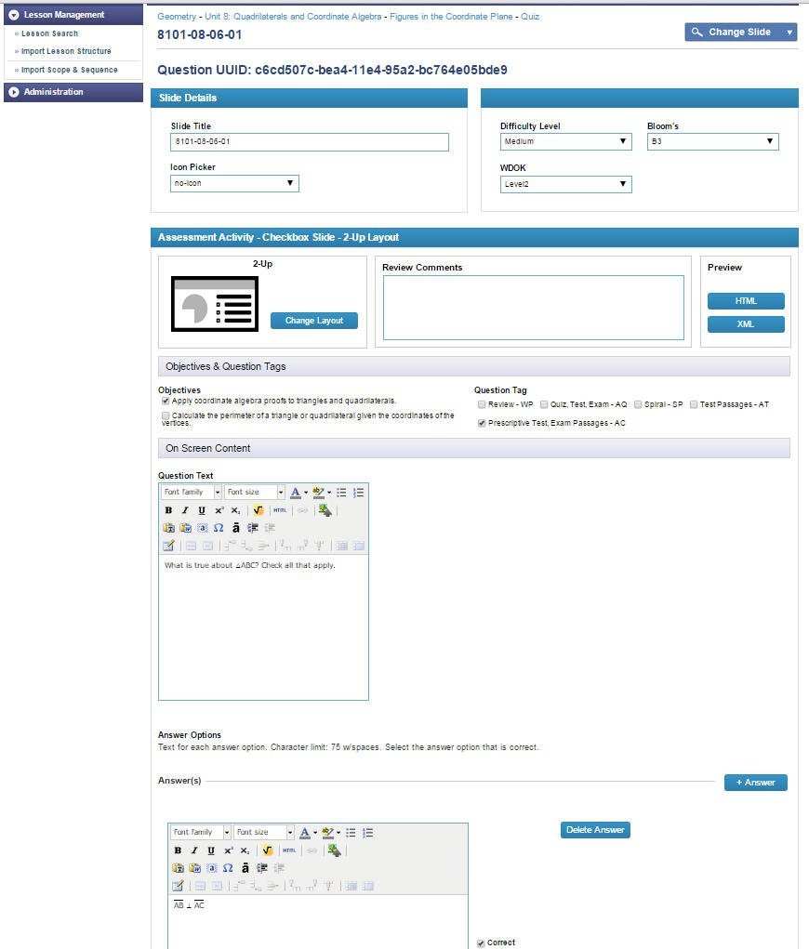

**Note about hyperlinks:** Right now, if you add a hyperlink into a question field, media content field, or a column field, you must also add that hyperlink in the **Web Link** field. Links found in this field will be filtered through e2020’s web proxy and whitelisted. As of right now, the tool will not be pulling a hyperlink from other fields and populating it in the Web Links field for export.

## Add Fill-in-the-Blank Assessment

The fill-in-the-blank assessment type allows users to author text and number field assessment items. There are three layout options available for a checkbox task slide. Depending on the layout selected, a different number of fields may be available.

1. On the **Lesson Management** screen, find the **Assessment Activity** section where you want to add a text/number field task slide.
2. Click on the **Add** button located below that **Assessment Activity Name**. A slide type and layout selection pop-up appears. Select the **Text/Number Field** option in the drop-down menu and choose a layout. Then, click on the **New Slide** button to create a radio button slide.
3. The new slide will be added to the slide listing that displays below the **Assessment Activity Name**. Click on the **slide #** to go to the slide editor and begin assembly.

1. A slide editor can be divided into three sections: *slide details, task metadata,* and *onscreen elements.* As mentioned earlier, many of the fields were added to anticipate future needs. Fill in all the required fields and complete any other fields should you have that information on hand.

Depending on the layout selection, you may see a different number of fields.

For example, a **Text or** **Number Field Assessment Slide** offers three layouts: full-width, 2-Up with questions displaying on the right column, and two-tabbed 2-Up.

Complete Fields

|  |  |  |
| --- | --- | --- |
| **Name** | **Required/Optional** | **Notes** |
| Icon Selector | Optional | Select from drop-down menu. Default value to no-icon. |
| Slide Title | Required | This is the slide title used by the authoring tool. Oftentimes it will be identical to the Onscreen Slide Title. The distinction is particularly useful, however, when creating video slides. See earlier section on videos and video slides. |
| Onscreen Title | Required | This onscreen title will display in slide’s title bar or header. |
| Difficulty Level | Required |  |
| Bloom’s | Required |  |
| WDOK | Required |  |
| Correct Answer | Required |  |
| Distractor Rationale | Required | *Should not be required for Number Field Assessments.* |
| Sample Answer | Optional | Include sample answer for open-ended questions, answer explanation for fixed response. |
| Answer Choice May Be Randomized | Required | Default value is set as unchecked, meaning “not” randomized. |
| Answer Explanation | Optional | If provided, include explanation of correct answer. |
| Points | Required | Leave entry with default value, “0,” unless point is provided. |
| Teacher Graded | Required |  |
| Change Information | Required if content is modified after it is exported |  |
| Correct Answer | Required |  |
| Question Text | Required | A required field for tasks and assessments; field displays here as part of the basic slide editor template. |
| Answer Option | Required | Enter answer option. Can add or delete additional answer option fields. |
| Media Content | Required | Field is available for entry if a 2-Up layout is selected. Add images, create bulleted lists, style fonts, directly insert HTML code, create equations, etc. |
| Tab 1 Content | Required | Field is available for entry a 2-tabbed layout is selected. |
| Tab 2 Content | Required | Field is available for entry a 2-tabbed layout is selected. |
| Entry VO Text | Required | Entry audio script |
| Entry VO Sound | Required | Browse and select audio clip from corresponding frame folder in media server |
| Hint VO Text | Optional | Hint audio script |
| Hint VO Sound | Optional | Browse and select audio clip from corresponding frame folder in media server |
| Exit VO Text | Optional | Exit audio script |
| Exit VO Sound | Optional | Browse and select audio clip from corresponding frame folder in media server |
| Review Comments | Optional | If there is more than one person working on a given slide or if someone is reviewing the slide, s/he can leave comments here. |
| Citation (combination of 5 fields) | Optional | Fill in source information if available. |
| Web Link | Optional | Links in this field get filtered through e2020 proxy and are whitelisted. Currently, if you add a hyperlink in a content area, you will need to add that link as well in this field. Future plan is to enable only one-time entry of hyperlink, and tool will be able to pull those <a> tags and populate the <web_links> field for export. |

1. Click the **Submit** button to save the slide in the tool. To return back to the Lesson Management Screen, you can click on the blue Lesson button displaying at the top of the slide editor.
2. Then, click the **HTML** button in the preview area. A new window or tab should open, displaying a rendering of how the slide appears. If interested, you can also click on the **XML** button should you wish to see what the XML rendering appears.
3. The accompanying screenshot captures a slide editor for a **Number Field Assessment** using the **Full-Width** layout. The most unique aspect to this slide editor is the set-up for creating check box answer options.
4. Input a question plus any supporting text (or image) to the **Question** field.
5. To add a fill-in-the-blank inline or below the question text, you will need to click on the **(+)** or **Add Fill-in-the-Blank** icon in the editor. It will create a placeholder in the question field, the number of the placeholder is sequential.

For example, if you want to create a drop-down task that includes text and two drop-down menu items within that text, you will click on the **(+)** button twice.

When you click on the **(+)** button, a corresponding **Answer** field is create.

You must select what type of fill-in-the-blank question it should be

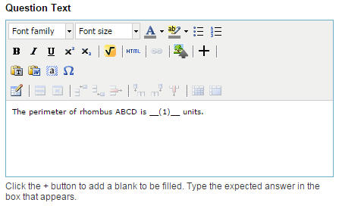

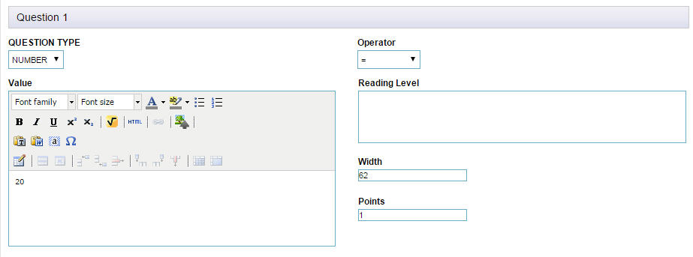

## Manage Lesson Objectives

Lesson objectives can be managed in both the Course Management and Lesson Management components of Bluejacks. The instructions here provide details on how to add, modify, and delete them specifically in Lesson Management.

1. On the **Lesson Content** page, click on the **Objectives** tab to access the editors for authoring and managing objectives.
2. By default, Bluejacks will display at least one objective editor.

1. Enter the **Objective** in the objective text field and assign a **Rank**. Ultimately, it doesn’t technically matter in the Edgenuity platform as the system will infer rank by the order of the objectives. You can choose to leave this field empty.
2. Click the **Save** button to submit and save your new objective. Once the system has successfully saved the objective, a new objective editor will display by default. To add multiple objectives at once, you may choose to click on the **Add Objective** button at the top of the page as needed. To remove an objective, click on the **Delete Objective** button located to the right of each individual objective.

**Note:** Importing the course’s scope & sequence should populate the objective fields for all of the course’s lessons. You should not need to manually add new objectives when assembling a lesson, but may make edits to existing ones in the tool if assigned to do so.

Complete Fields

|  |  |  |
| --- | --- | --- |
| **Name** | **Required/Optional** | **Notes** |
| Objective | Required | Minimal text formatting/styling available – does not support creation of equations or formulas. |
| Rank | Required | The rank also implies the order of objectives and shows how they will display in the LMS. This field can be left empty in Bluejacks. |

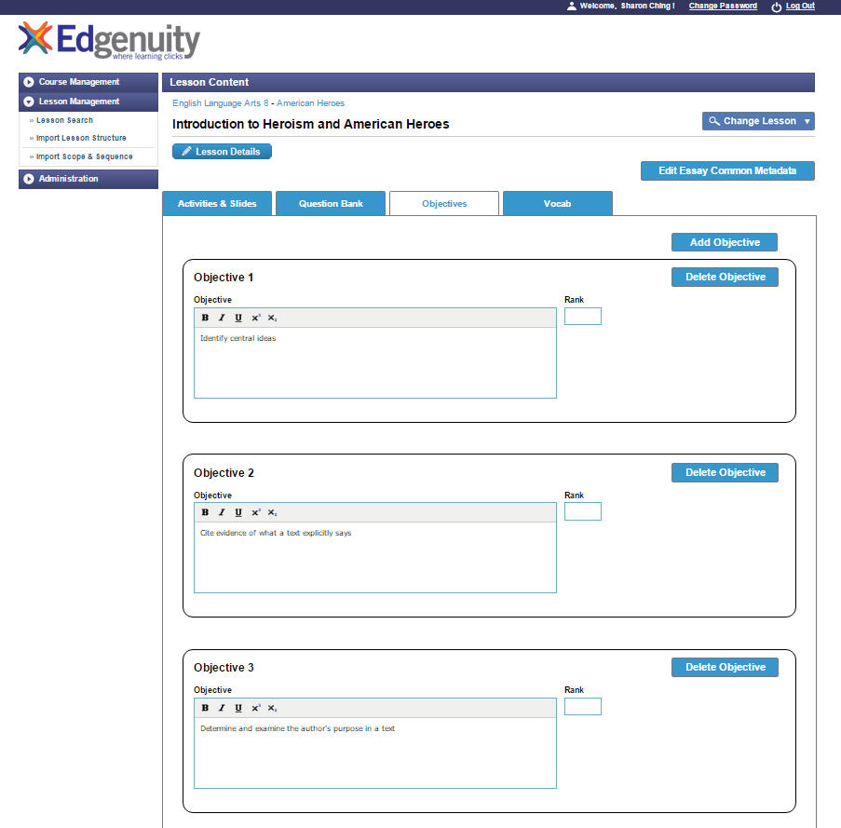

*Screenshot of Objectives Manager page.*

## Manage Vocabulary

In the **Lesson Management** section of the authoring tool, you can also set up a list of vocabulary words and definitions. In a lesson, vocab words may appear on what is described as a **Words to Know** slide. Each of the words, definitions, and audio clips assembled in the **Vocab** section of **Lesson Management** will be used to populate the glossary in the new player’s lesson pane.

1. On the **Lesson Management** screen, select the **Vocab** tab. Here you will be able to add, modify, and delete vocabulary items.
2. A table displays rows of vocab items. By default, one row will all fields associated to a single vocab entry is available.
3. Make sure the vocab audio file has been recorded, saved, and moved to pre.sandbox media server. Refer to the page 6 for instructions on naming conventions for vocab audio files. Search for audio file and insert.
4. It is advisable to click on the **Save** button after each vocab entry. Then, go back to the top of the page in click on the **Add** **Vocab** button to create a new entry row. Complete all the fields and click on the **Save** button again. Repeat the process as necessary. To remove an entry, click on the **Delete** button that displays on the right-hand side of each individual row.

|  |  |  |
| --- | --- | --- |
| **Name** | **Required/Optional** | **Notes** |
| Vocab Word | Required |  |
| Definition | Required |  |
| Word Type | Required | Assign whether it is academic or domain. |
| Audio file | Required | Assign audio clip of word pronunciation. |

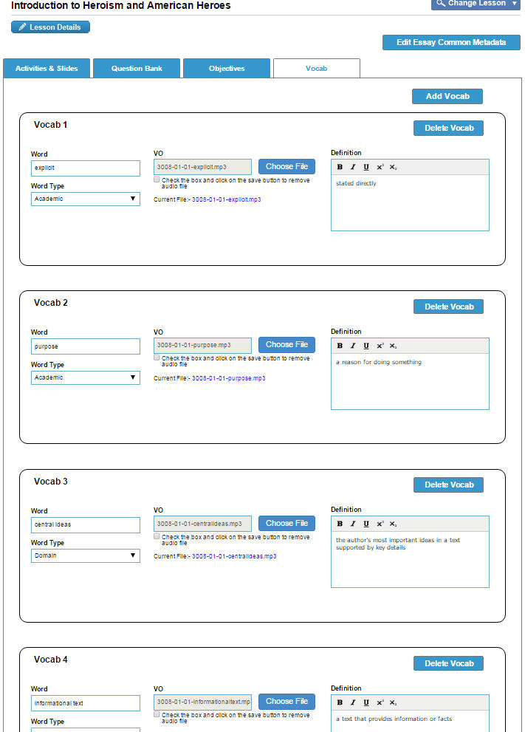

*Screenshot: Vocab items created for an ELA 8 lesson.*

## Code Snippets

This section includes code snippets that can be copied and pasted into the HTML source editor of a given field’s WYSIWYG editor. Please note that these are sample snippets and some modification (e.g. the exact filename) should be made prior to adding them into a slide template.

### CloseReader

As noted in the **Add CloseReader** section, CloseReaders are developed by a third-party vendor and outside of the Bluejacks CMS. In Bluejacks, you will simply insert the link in a question or media content field using this snippet:

**|@@CommonFolder@@|/closereader/CourseName/Lesson/CloseReaderFilename.html**

Make sure to set the target attribute to “blank” so that the CloseReader web page will open in a new tab or window when clicked. You can add this attribute manually in the HTML source editor or select the target option in the **Insert Link** Editor.

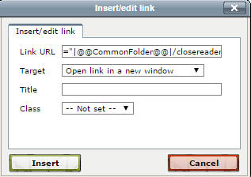

**Example:**

<a href="|@@CommonFolder@@|/closereader/ELA/3006-01-01/3006-01-01-CR1_01.html" target="_blank">Click link for CloseReader</a>

### Click Audio in Frame

To include an audio clip within a slide or frame, you will need to do the following:

1. Go to the appropriate field (question, media content, or column fields) in a slide editor and click on the HTML icon in the WYSIWYG editor. This will pop open the HTML editor.
2. In the HTML editor, copy and paste this code snippet:

<a href= javascript:API.Audio.playAudio(‘**audiofilename.mp3**')><b class="blue">**link text**</b></a>

1. The parts of the code that is in bolded, blue font should be modified. You will only need to include the filename and not a full path for the audio clip.
2. Then, in the **Resources Field** near the bottom of the slide editor, you will click and browse for this same exact audiofilename.mp3 that you just added in the HTML editor. You will need to have two inputs of this audio file in order for the click audio frame media file to be exported successfully.

### Interactives

To include an interactive (e.g. math interactive created by Karl Stock or an interactive in a virtual lab), you will need to do the following:

1. Go to the appropriate field (question, media content, or column fields) in a slide editor and click on the HTML icon in the WYSIWYG editor. This will pop open the HTML editor.
2. In the HTML editor, copy and paste this code snippet:

iframe style="width: 100%; height: 100%;" src="**interactivetodisplayiniframe.html**" width="320" height="240"></iframe>

1. The parts of the code that is in bolded, blue font should be modified. You will only need to include the filename and not a full path for the audio clip.

## From PowerPoint to CMS

Here is an example of how you can assess the content on a PowerPoint slide and relate it to the relevant fields available in the authoring tool.

**PowerPoint slide of a task in an Instruction Activity**

This is a task frame that has a reading pane on the left column and a question with radio button answer choices on the right column.

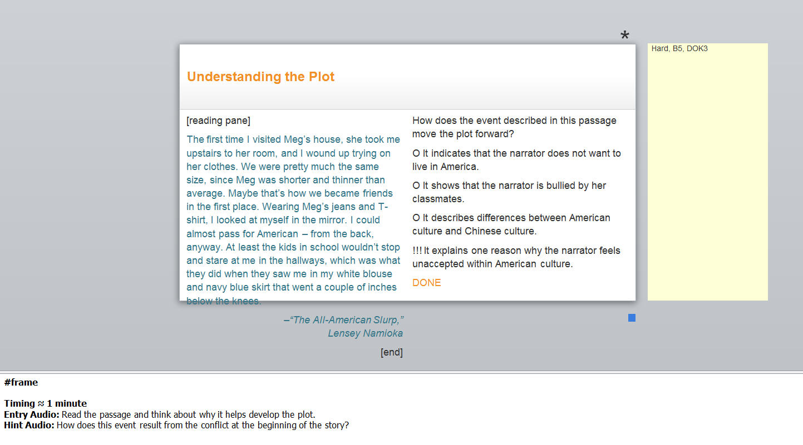

**In Bluejacks**

Click on the **Add** button that displays below the Instruction Activity.

Slide Type: Radio Button

Layout: 2-Up

The left column area is referred as the **Media Content** area. You can choose among three possible media content editors. In this case, you would select the **Reading Pane Editor.**

|  |  |
| --- | --- |
|  | 1. Select the reading pane editor in the **Media Content** dropdown menu to display the reading pane fields. 2. Select “pane-blue” in the **color** field to create a reading pane with a blue background (other colors are also available for possible future use). 3. Input text in **passage** field. 4. Input text in **attribution** field. |

The right column area is where the question and answer choices display. You will input content in the **Question** field and **Answer Options** field.

|  |  |
| --- | --- |
|  | 1. Input the content that is part of the **question**. Use the WYSIWYG editor and the equations editor, browse and insert an image, or switch to the HTML editor if you want to write or modify HTML code. 2. Create **Answer Options** by clicking on the [+} button to add a new answer option. Mark off the **correct** checkbox for the option that should be the correct answer. |

In the task editor, there are also audio clip fields. You can add the scripts of the audio clips and browse for audio files from pre.sandbox media server.

|  |  |
| --- | --- |
|  | 1. From the PowerPoint, copy the audio text to the relevant **VO text fields**. 2. Click on the browse button next to the **VO Sound field** and search through the pre.sandbox media server to find the appropriate audio clip file. 3. Repeat Steps 1 and 2 to add entry, hint, and/or exit audio clips. 4. Click on the **Submit** button to save the audio clip files you’ve browsed and inserted. |