Test Case Name | EAQ184
Test Case Owner: | Maria Dominguez | Reviewed Date:
Date of last update: | 09/19/2025 | Sign Off Date:
EAQ184 – WMS – WMS- PrintLabel issues

Description:
Issue 1: When attempting to print a label with quantity 4, the system throws a Java error, even though the CR setting allows up to 5 labels before prompting.
Issue 2: When the RF Picking Label Format CR is left blank, the system still displays a list of random printers in the label printing dialog.
Issue 3: The system throws a Java error when attempting to print labels.

Solution:
Fixed the corner cases in PrintLabel like empty input fields. Also fixed the scenario where if a user submits after editing of the input field.
Test Plan Outline:

Setup: Before executing this test case we need:

- Auth keys
  - Super user.
- Assign the login user with valid location and it should have the printers in that.
- CR Label Print Quantity Control set to empty and 5
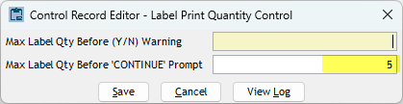

- RF Picking Label Format set:
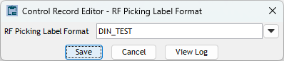

Summary: This tracker reviews implements label printing in WMS Picking

 | Test Description | Environment | Expected Results
1 | Verify Print Label Qty < Max Label Qty Before ‘CONTINUE’ Prompt When Max Label Qty Before (Y/N) Warning is Empty | SOLAR/WMS | Labels Successfully printed without any prompt, no error message
2 | Verify Print Label Qty > Max Label Qty Before ‘CONTINUE’ Prompt When Max Label Qty Before (Y/N) Warning is Empty | SOLAR/WMS | Prompt should be displayed, if select Yes labels are printed
3 | Verify Print Label Qty < Max Label Qty Before (Y/N) Warning qty When Max Label Qty Before ‘CONTINUE’ Prompt is Empty | SOLAR/WMS | Labels Successfully printed without any prompt, no error message
4 | Verify Print Label Qty > Max Label Qty Before (Y/N) Warning qty When Max Label Qty Before ‘CONTINUE’ Prompt is Empty | SOLAR/WMS | Prompt should be displayed, if select Yes labels are printed
5 | Verify Print Label when Max Label Qty Before (Y/N) Warning qty and Max Label Qty Before ‘CONTINUE’ Prompt qty are Empty | SOLAR/WMS | Labels Successfully printed without any prompt, no error message
6 | Verify Print Label when CR RF Picking Label Format is empty | SOLAR/WMS | Message displayed, Format is required. No labels printed
7 | Verify all the scenarios in Product Barcode Labels screen | SOLAR/WMS | Same Results expected

Testing Steps

R8.6TEST (SOLAR/WMS)

Scenario 1: Verify Print Label Qty < Max Label Qty Before ‘CONTINUE’ Prompt When Max Label Qty Before (Y/N) Warning is Empty

Steps to Replicate:
- Log in to WMS.
- Navigate to Picking
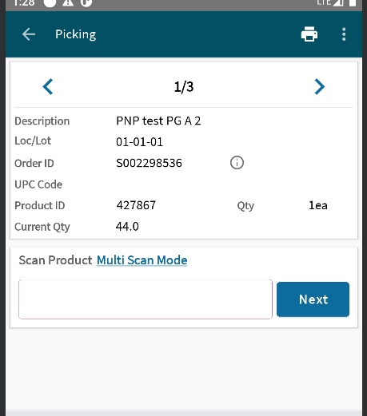
- Open the 3 dots(⋮) → Print Label.
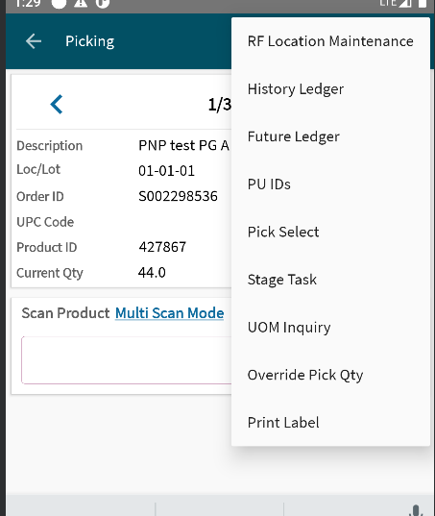
- Enter quantity 4 and click Print.
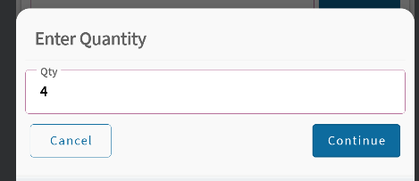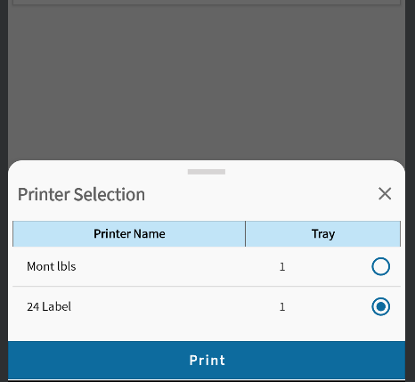

- Select printer and press Print
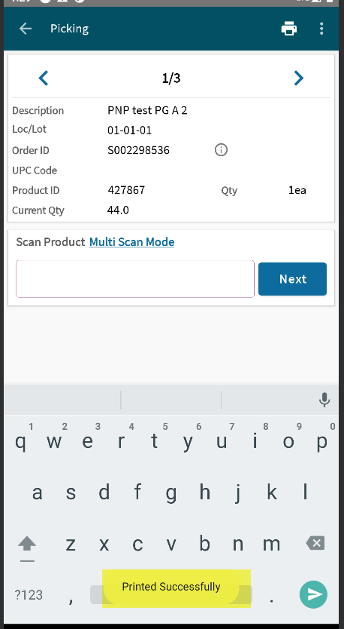

Expected Result: “Labels Successfully printed without any prompt, no error message”

Scenario 2: Verify Print Label Qty > Max Label Qty Before ‘CONTINUE’ Prompt qty When Max Label Qty Before (Y/N) Warning is Empty

Steps to Replicate:
- Repeat scenario 1, this time enter qty 6 > Max Label Qty Before ‘CONTINUE’ Prompt qty
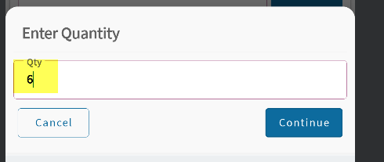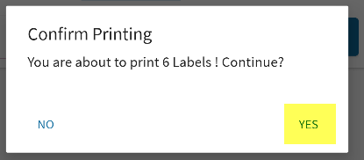
Expected Result: *** Prompt should be displayed, If select YES the labels are printed***

Scenario 3: Verify Print Label Qty < Max Label Qty Before (Y/N) Warning qty When Max Label Qty Before ‘CONTINUE’ Prompt is Empty

Steps to Replicate:
- Log in to Solar
- Change CR Label Print Quantity Control to set as follows:
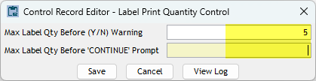
- Save and exit
- Repeat scenario 1
Expected Result: “Labels Successfully printed without any prompt, no error message”

Scenario 4: Verify Print Label Qty > Max Label Qty Before (Y/N) Warning qty When Max Label Qty Before ‘CONTINUE’ Prompt is Empty
Note: Here we need same setup than scenario 3

Steps to Replicate:
- Login to Solar
- Set CR as scenario 3
- Repeat steps from scenario 2
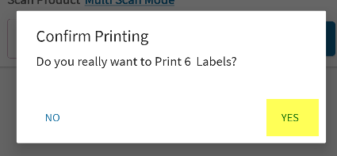
Expected Result: *** Prompt should be displayed, If select YES the labels are printed***

Scenario 5: Verify Print Label when Max Label Qty Before (Y/N) Warning qty and Max Label Qty Before ‘CONTINUE’ Prompt qty are Empty

Steps to Replicate:
- Log in to Solar
- Change CR Label Print Quantity Control to set as follows:
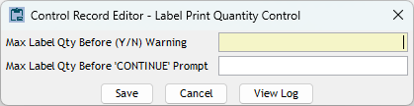
- Save and exit
- Login to WMW
- Go to Picking card.
- Click 3-dot menu → Print Labels.
- Enter quantity = 6
Expected Result: *** Labels Successfully printed without any prompt, no error message ***

Scenario 6: Verify Print Label when CR RF Picking Label Format is empty

Steps to Replicate:
- Login to Solar
- Go to Control Maintenance and open CR RF Picking Label Format
- Set the CR Empty and save
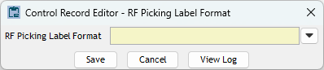

- Go to Picking screen
- Click 3-dot menu → Print Labels.
- Enter quantity = 1
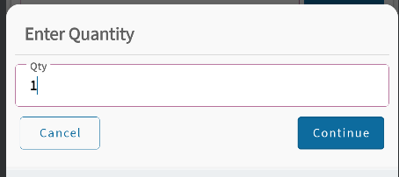
- Press Continue
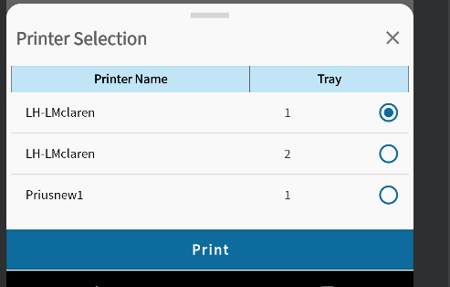
- Press Print
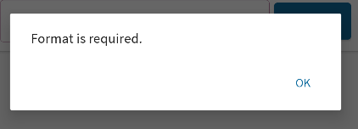
Expected Result: *** Message is displayed, Format is required"

- Press OK
Expected Result: *** No labels printed"

Scenario 7: Verify all the scenarios in Product Barcode Labels screen

Steps to Replicate:
- Repeat scenario 1, but this time navigate to Barcode Labels>Product Barcode Labels
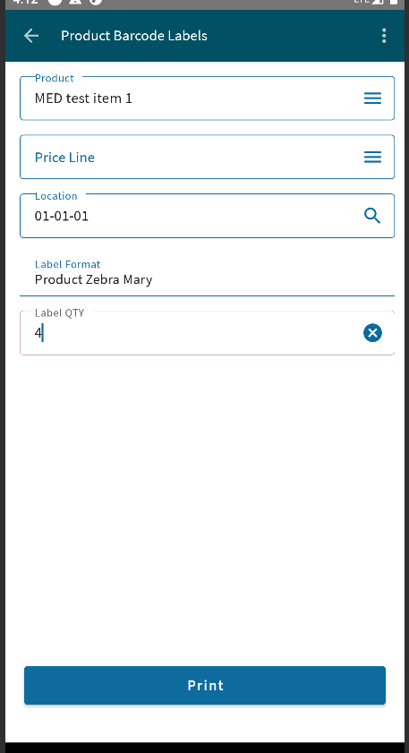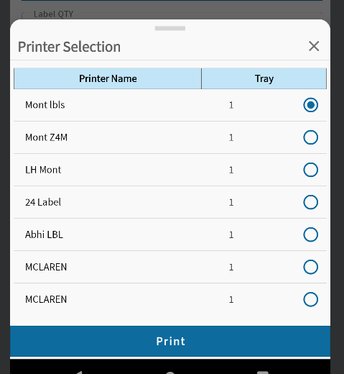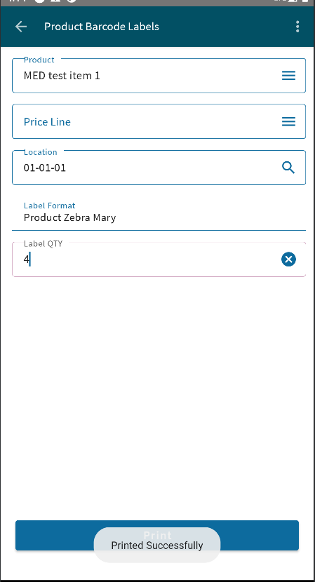
Expected Result: Same than scenario 1

- Repeat scenario 2 but this time navigate to Barcode Labels>Product Barcode Labels
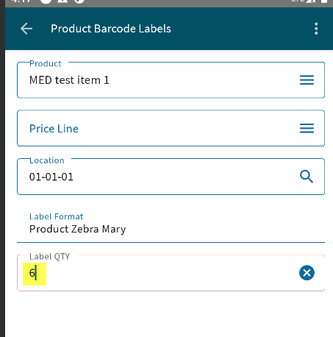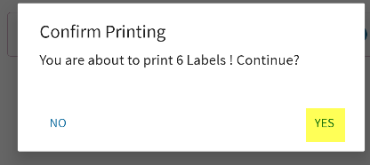
Expected Result: Same than scenario 2

- Repeat scenario 3 but this time navigate to Barcode Labels>Product Barcode Labels
Expected Result: Same than scenario 3

- Repeat scenario 4 but this time navigate to Barcode Labels>Product Barcode Labels
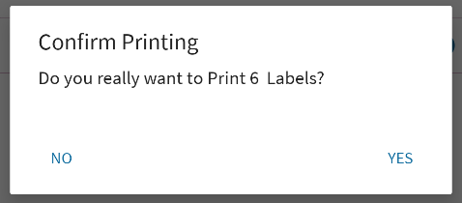
Expected Result: Same than scenario 4

- Repeat scenario 5 but this time navigate to Barcode Labels>Product Barcode Labels
Expected Result: Same than scenario 5

