Cognac
- A variety of brandy named after the commune of Cognac, France. It is produced in the surrounding wine-growing region in the departments of Charente and Charente-Maritime.
- Cognac production falls under French appellation d'origine contrôlée (AOC) designation, with production methods and naming required to meet certain legal requirements
- The choice of grape varieties is strictly regulated in the Cognac specifications. Ugni Blanc, Folle Blanche, Colombard. Cognac is made from white grapes low in sugars and with high acidity.
- The brandy must be twice distilled in Charentais copper pot stills.
- Aged at least two years in French oak barrels from Limousin or Tronçais.

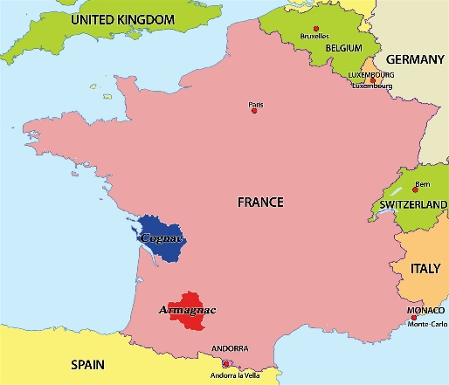Blue is Cognac. Red is Armagnac, a distinct brandy region.

INTERESTING INFORMATION
- The appellation d'origine contrôlée (AOC) is a label that identifies an agricultural product whose stages of production and processing are carried out in a defined geographical area – the terroir – and using recognized and traditional know-how. The specificity of an AOC product is determined by the combination of a physical and biological environment with established production techniques transmitted within a human community, Together, these give the product its distinctive qualities.

- Distillation takes place in traditionally shaped Charentais copper alembic stills, the design and dimensions of which are also legally controlled. Two distillations must be carried out; the resulting eau de vie is a colorless spirit of about 70% alcohol.

- Eau de Vie means Brandy, translated it means water of life.

- Cognac matures in the same way as whiskies and wines barrel-age, and most cognacs spend considerably longer "on the wood" than the minimum legal requirement.

- The white wine used in making cognac is very dry, acidic, and thin. Though it has been characterized as "virtually undrinkable", it is excellent for distillation and aging.

Our Cognacs

Martell – Oldest cognac still in production. Started in 1715.
- Blue Swift – VSOP finished in Bourbon barrels.
- Cordon Bleu – Produced since 1912.
- XO - Borderies and Grande Champagne. Highly esteemed regions within Cognac.

Ferrand Section des Anges –
- 1st Cru – grapes only from Grand Champagne.
- Average age of 30 years.

Hennesy – One of the 4 Big Cognac house including; Martell, Courvoisier & Remy Martin
- XO – Aged in young barrels for bold flavor
- VS – Average age of 2-5 years

Courvoisier – Notes of peach, toasted almond with a hint of vanilla.
- Average age of 8-12 years

Cognac aging designations
- V.S. (Very Special) or ✯✯✯ (three stars) designates a blend in which the youngest brandy has been aged for at least two years in a cask.
- V.S.O.P. (Very Superior Old Pale) or Reserve designates a blend in which the youngest brandy is aged for at least four years in a cask.
- Napoléon designates a blend in which the youngest brandy is aged for at least six years.^{[13]} It is not to be confused with "the Cognac of Napoleon", a sobriquet for Courvoisier.
- X.O. (Extra Old) The minimum age of the youngest brandy used in an X.O. blend was increased to 10 years in April 2018; this rule was originally scheduled for implementation in 2016, but was postponed due to inadequate stocks The Napoleon designation, previously unofficial, is used to specifically denote those blends with a minimum age of six years that do not meet the revised X.O. definition.
- X.X.O. (Extra Extra Old) is a specific indication given to wine spirits that have been aged for at least 14 years.
- Hors d'âge (Beyond Age) is a designation which BNIC states is equal to X.O., but in practice the term is used by producers to market a high-quality product beyond the official age scale.

