1. Object oriented elements that you write the code for:
   1. Classes: You can find an example of a class in the HomeController.java file on 38.

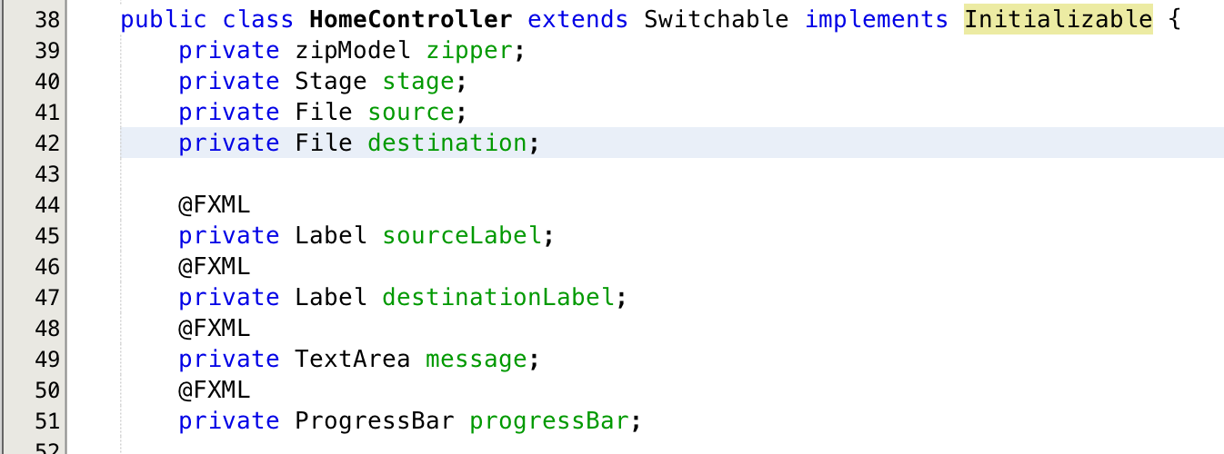

* 1. Subclasses: You can see an example of a subclass in the same screenshot above. HomeController extends the Switchable class thereby making it a subclass.
  2. Abstract Class: You can see an example of an abstract class in the Switchable.java file on 18.

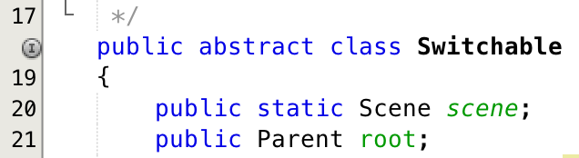

* 1. Interface: There are 2 examples of interfaces used in this program. The first one is with Notification which is a functional interface in the Notification.java file on line 13. The second interface I used can be found in userAuth.java on line 11.

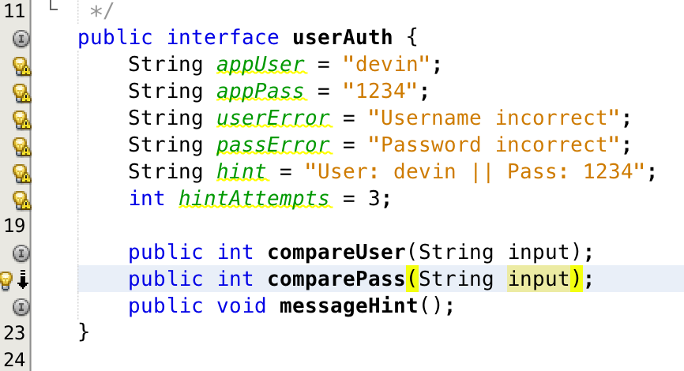

1. Code elements that utilize:
   1. One or more collection classes: You can see an example of a collection class in the Switchable.java file on line 22.



* 1. Exception Handling: You can see examples of exception handling throughout my entire program. A specific example is in the HomeController.java file on line 69. It takes the exception and sends it to the displayExceptionAlert function on line 191 to display.

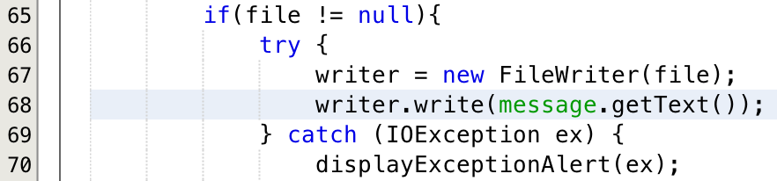

\*\*\*\* Same File \*\*\*\*

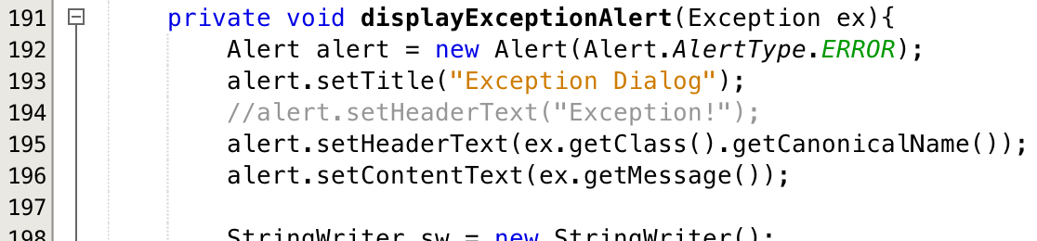

1. The application must have a clearly defined model (as in the M in MVC): You can see an example of a model in my zipModel.java file. It takes in variables from the controller and does the legwork in zipping your directory.

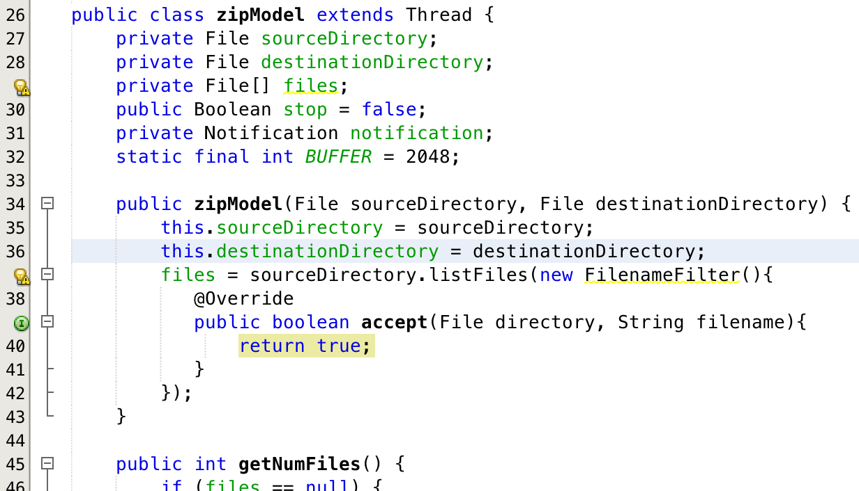

1. The UI must utilize multiple scenes and at least one of the scenes will have the contents of the scene graph changed based on the application state: You can find an example of switching through multiple scenes when you login to my app or click on the View App Info button. When you try to login it will display different content depending on if you have the username or password wrong. You can find this example in the HubController.java file starting on line 73 and ending on 95.

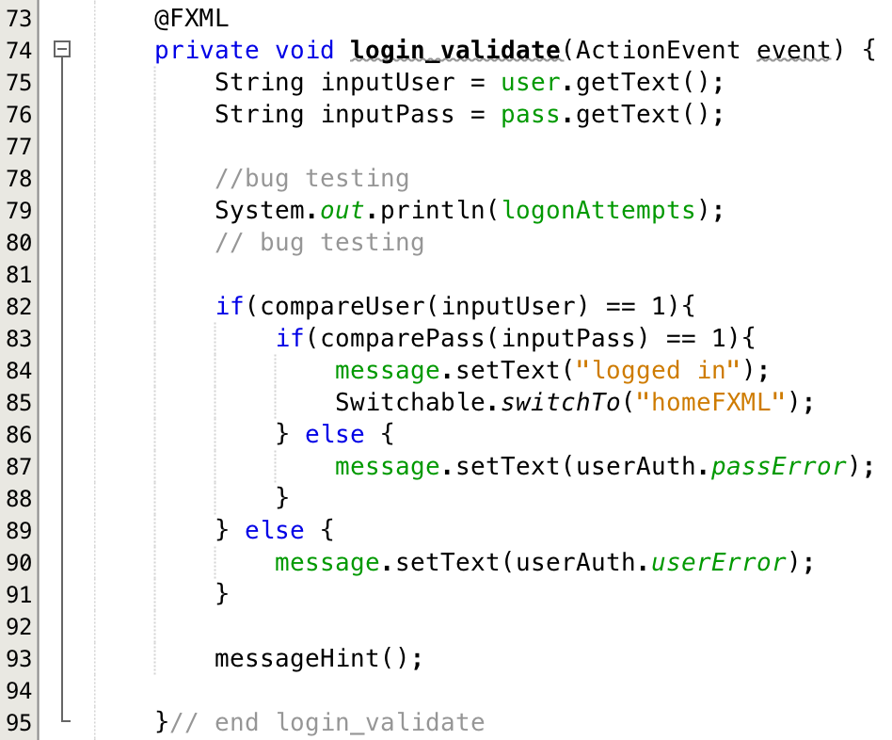   
\*\*\*Note: (1), (2) and (3) at bottom show how the same scene changes based on the state\*\*\*

1. There must be a way to access “About” information that includes information about you and the application: There is an about page included in my app. It’s file structure is AboutFXML.fxml and AboutController.java

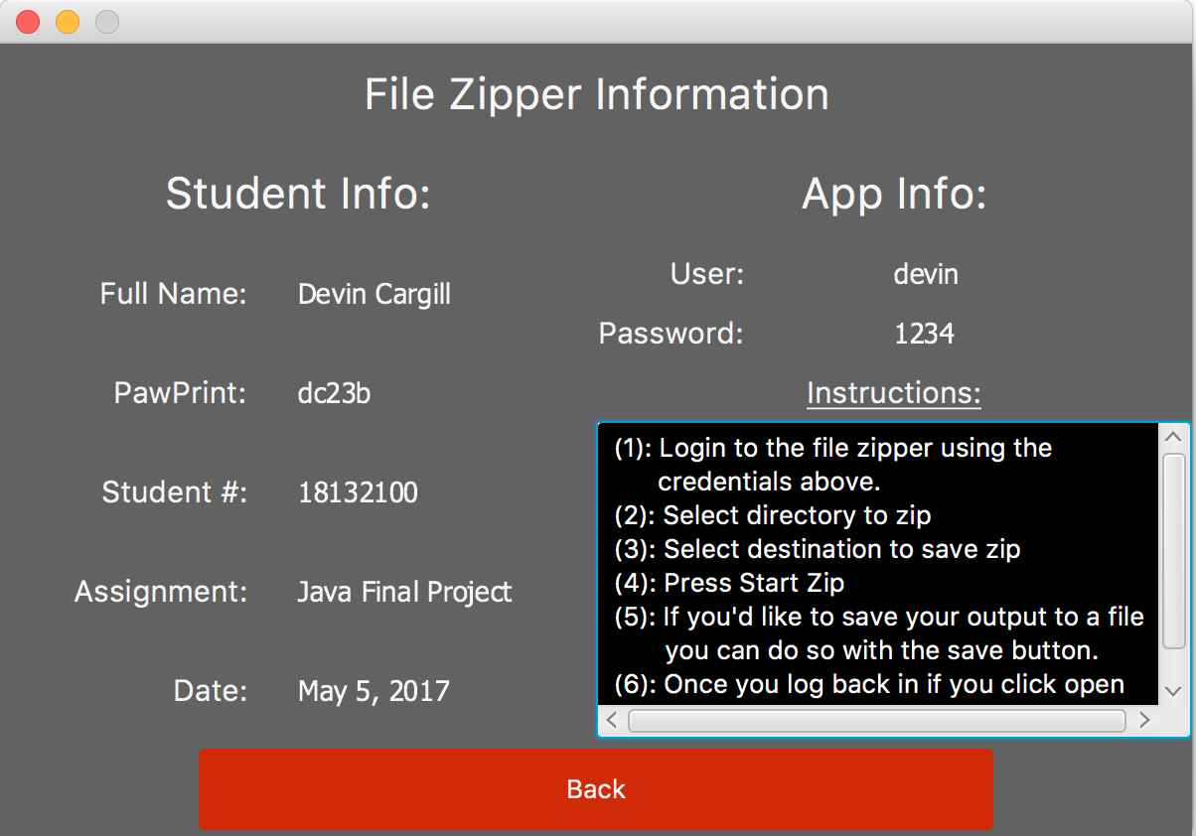

1. The application must save data and load data. The target for saving/loading data can be files, a network service, and/or a database: You can see an example of this in the HomeController.java file from line 58 to 132. This functionality exists when you login.

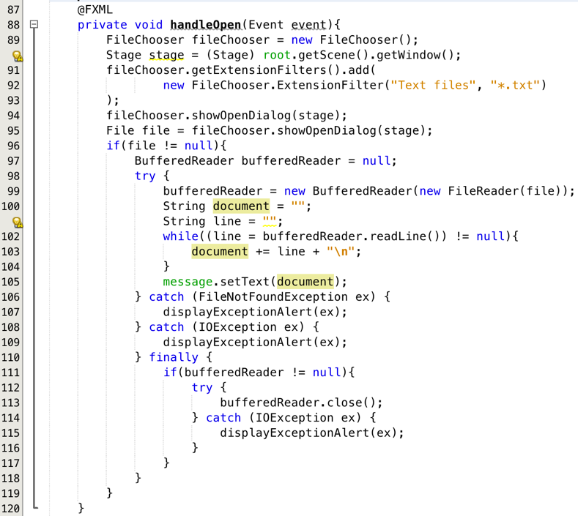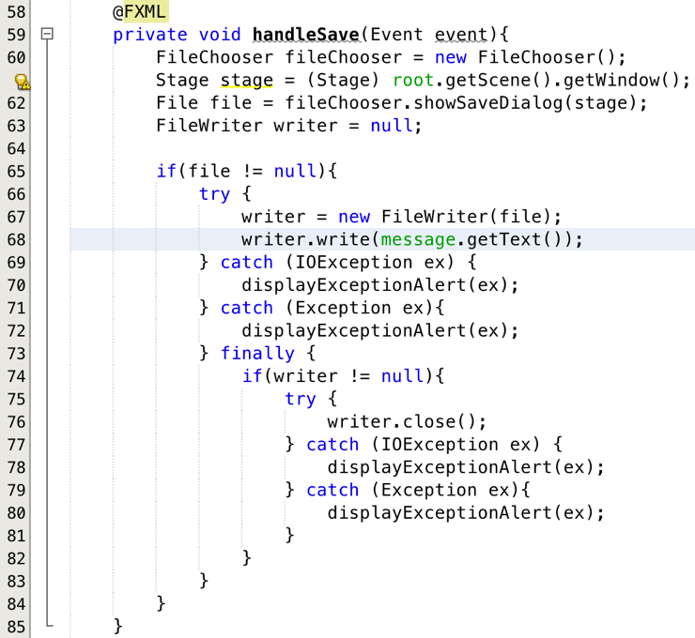

Additional Notes: To login and test use the following:

User Name: devin

Password: 1234

(this information exists on the about page for your reference)

Additional Screenshots:

1. Bad Username State:

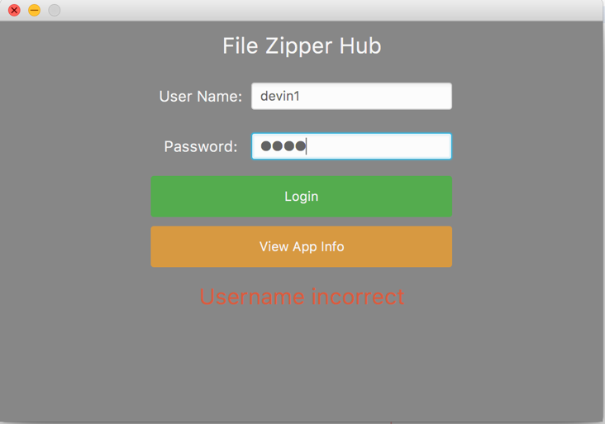

1. Bad Password State:

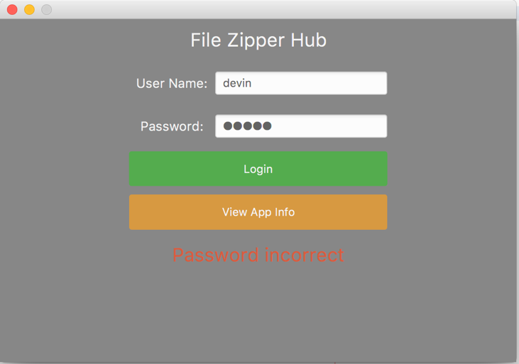

1. Got them wrong more than 3 times state:

