**Frameless shower screen – Weighing up the alternatives**

September 2017

Frameless glass is what everyone wants for their bathroom, but have you considered all the options?

Let’s take a look at the ins and outs of the different types.

**Shower** **screens types**;

There are three types of shower screens retailed in Australia. ***Fully*** ***framed***, ***semi*** ***framed*** (often called perimeter framed) and ***frameless*** ***glass***.

**Made to measure** or **Pre – sized;**

Shower screens are manufactured as ***pre*** – ***made*** or ***made*** ***to*** ***measure***. We discuss this at ***made*** ***to*** ***measure*** ***or*** ***pre*** – ***sized*** ***frameless*** ***shower ……….what’s the difference?***

**Fully** **framed**;

Fully frame is available in swinging door (normally inwards only), sliding and fixed panels.

The glass is generally thin and as suggested by its name, there is a frame around all panels. The glass is often laminated, which is the cause of those old showers you may have seen that have milky bubbles trapped inside the glass.

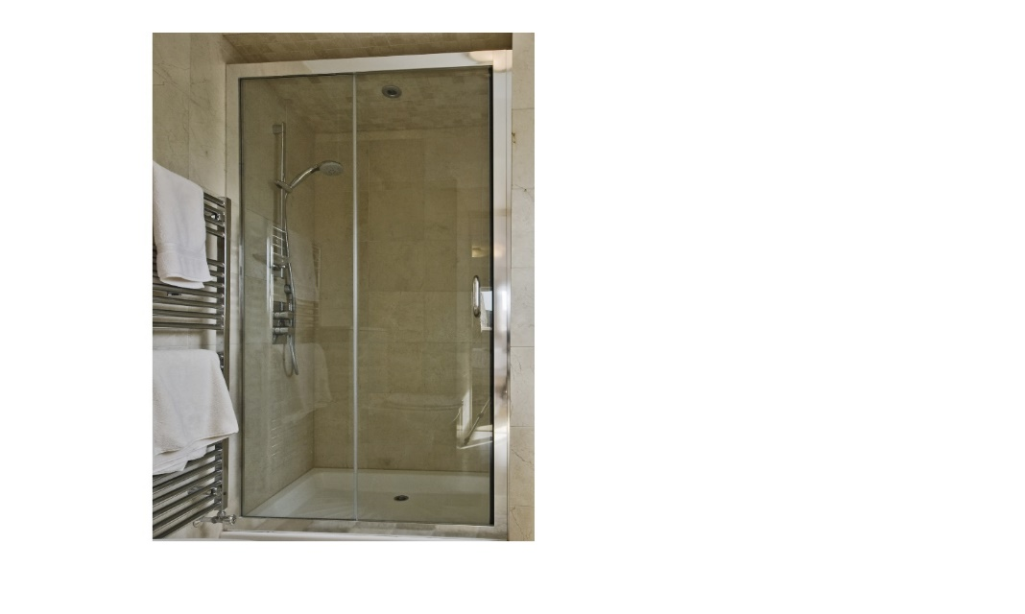Fully framed generally looks basic and somewhat dated. The frames, particularly on sliding models can be difficult to clean. On the up side, they are normally the best option for water control, as the frame across the threshold keeps surface water inside the cubicle even under extreme use. Fully framed is by far the cheapest.

**Semi** **Framed**;

Semi Framed is generally available in swinging door only, which opens in and out.

Semi framed usually incorporates a frame top and bottom, with vertical frame against the walls only.

The door itself is pivot hinged with no frames down the vertical edges. This leaves a visual finish that is fairly tidy. The glass thickness is generally 6mm, which can look a touch flimsy. Semi Framed is a moderate priced option.

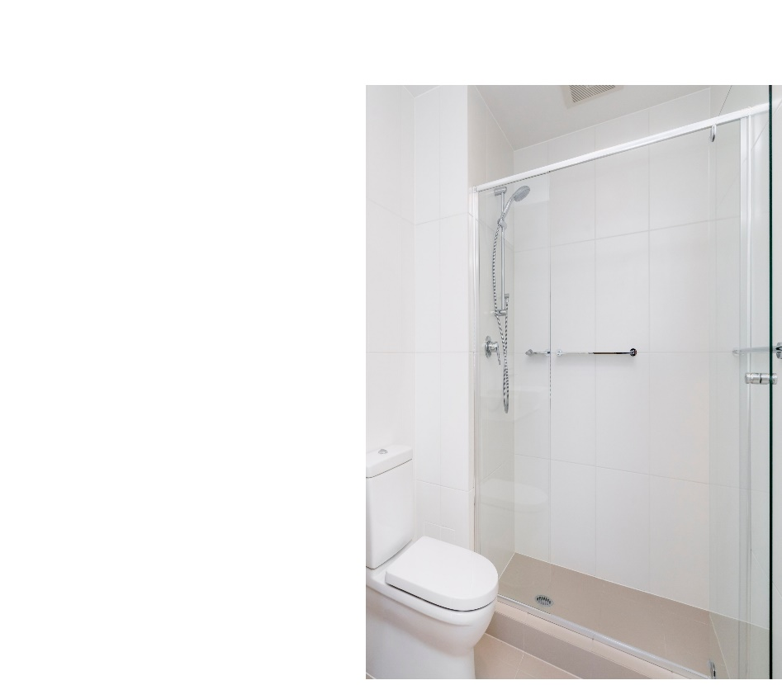

**Frameless Glass;**

Frameless glass is available in swinging, sliding and fixed. This style has no frame at all, as the name suggests. The glass comes in thickness’s of 8mm, 10mm and 12mm. 8mm is generally used on small panels and budget models. 12mm glass is occasionally used but can cause issues with doors becoming too heavy. 10mm is the common glass thickness. The standard glass composition has a noticeable green tinge (more noticeable because the glass is thick). Clearer glass is available, we discuss this at ***frameless*** ***shower*** ***glass*** ***types……is glass really just glass*** .

Frameless is the more expensive shower choice.

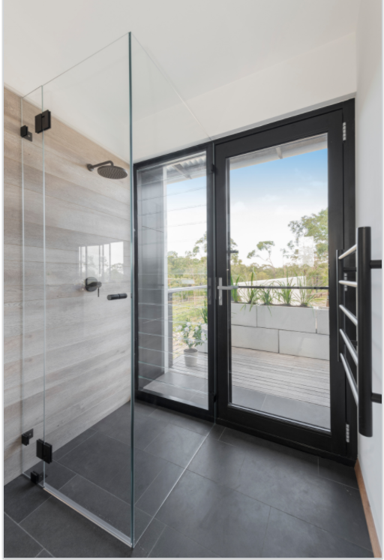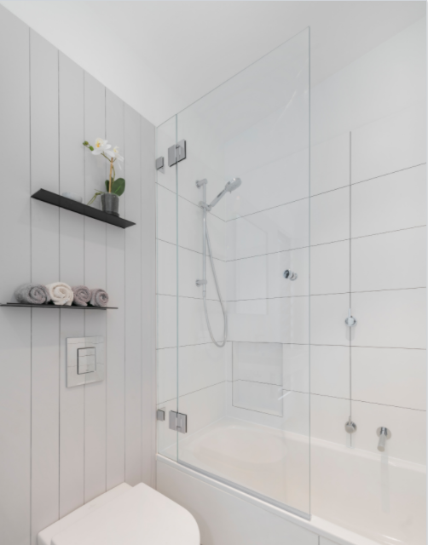

***Our opinion***

Fully framed and semi framed are serviceable and are useful for budget bathrooms.

Frameless glass has that look of sophistication that is needed to finish off a designer bathroom. The real beauty of frameless comes with not seeing the glass. There is a special type of glass which is almost invisible. Hardware comes in different finishes, so consider how this works in with your other fittings, tiles and design theme in the bathroom and throughout the home.

At ***FSO*** we have all the frameless shower options.