[b;block=begin;comm=w:p]

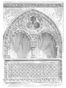

[b.number;ope=changepic;from= [val];default=current;adjust]

[b;block=end;comm=w:p]

**[onshow.tipo]** **No. [onshow.cite]**

**Tema: [onshow.referencia]**

[onshow.contenido]

cc: [onshow.copias]

Adj: [onshow.adjuntos]

[onshow.mosca_remitente]