**Class-23**

Date: 22-02-2024

# jQuery Tutorial

## What You Should Already Know

Before you start studying jQuery, you should have a basic knowledge of:

* [HTML](https://www.w3schools.com/html/default.asp)
* [CSS](https://www.w3schools.com/css/default.asp)
* [JavaScript](https://www.w3schools.com/js/default.asp)

If you want to study these subjects first, find the tutorials on our

What is jQuery?

jQuery is a lightweight, "write less, do more", JavaScript library.

The purpose of jQuery is to make it much easier to use JavaScript on your website.

jQuery takes a lot of common tasks that require many lines of JavaScript code to accomplish, and wraps them into methods that you can call with a single line of code.

jQuery also simplifies a lot of the complicated things from JavaScript, like AJAX calls and DOM manipulation.

The jQuery library contains the following features:

* HTML/DOM manipulation
* CSS manipulation
* HTML event methods
* Effects and animations
* AJAX
* Utilities

**Tip:** In addition, jQuery has plugins for almost any task out there.

Why jQuery?

There are lots of other JavaScript libraries out there, but jQuery is probably the most popular, and also the most extendable.

Many of the biggest companies on the Web use jQuery, such as:

* Google
* Microsoft
* IBM
* Netflix

Adding jQuery to Your Web Pages:

There are several ways to start using jQuery on your web site. You can:

* Download the jQuery library from jQuery.com
* Include jQuery from a CDN, like Google

## Downloading jQuery

There are two versions of jQuery available for downloading:

* Production version - this is for your live website because it has been minified and compressed
* Development version - this is for testing and development (uncompressed and readable code)

Both versions can be downloaded from [jQuery.com](http://jquery.com/download/).

The jQuery library is a single JavaScript file, and you reference it with the HTML <script> tag (notice that the <script> tag should be inside the <head> section):

<head>  
<script src="jquery-3.7.1.min.js"></script>  
</head>

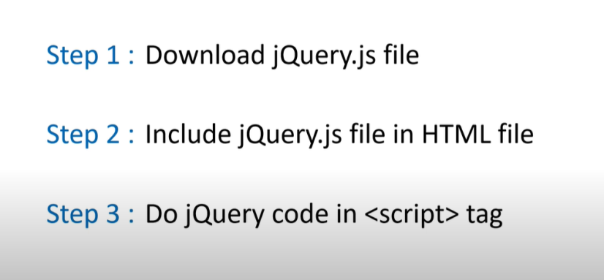

jQuery Syntax

The jQuery syntax is tailor-made for **selecting** HTML elements and performing some **action** on the element(s).

Basic syntax is: **$(*selector*).*action*()**

* A $ sign to define/access jQuery
* A (*selector*) to "query (or find)" HTML elements
* A jQuery *action*() to be performed on the element(s)

Examples:

$(this).hide() - hides the current element.

$("p").hide() - hides all <p> elements.

$(".test").hide() - hides all elements with class="test".

$("#test").hide() - hides the element with id="test".

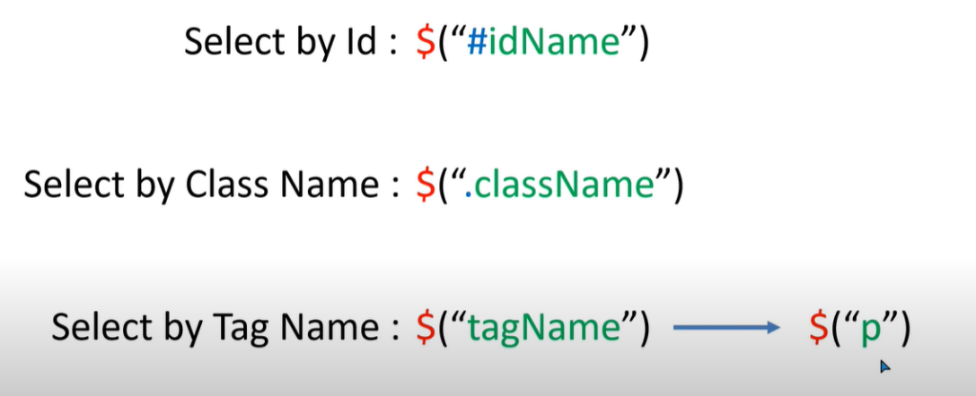

The Document Ready Event

You might have noticed that all jQuery methods in our examples, are inside a document ready event:

$(document).ready(function(){  
  
  *// jQuery methods go here...*  
  
});

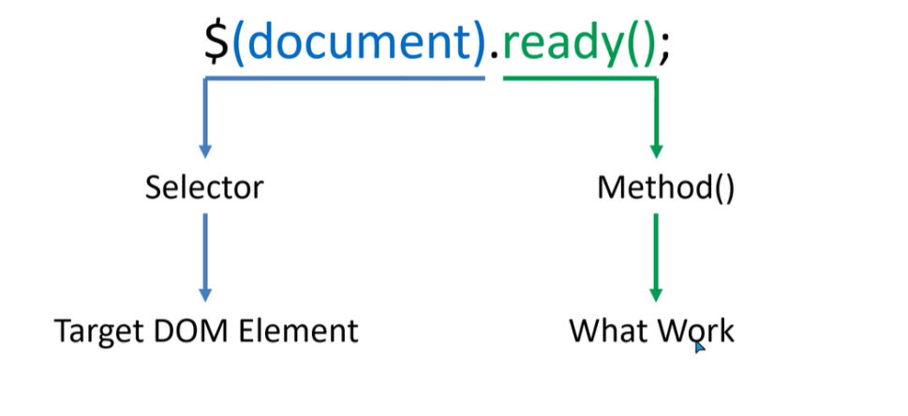

This is to prevent any jQuery code from running before the document is finished loading (is ready).

It is good practice to wait for the document to be fully loaded and ready before working with it. This also allows you to have your JavaScript code before the body of your document, in the head section.

Here are some examples of actions that can fail if methods are run before the document is fully loaded:

* Trying to hide an element that is not created yet
* Trying to get the size of an image that is not loaded yet

**Tip:** The jQuery team has also created an even shorter method for the document ready event:

$(function(){  
  
  *// jQuery methods go here...*  
  
});

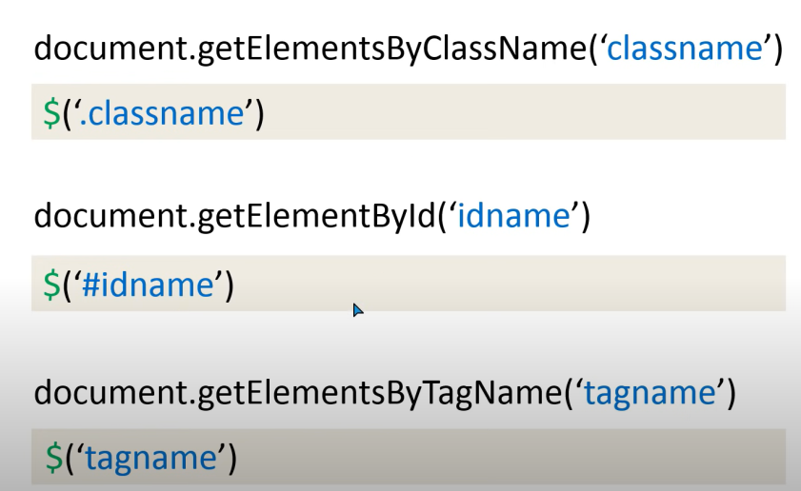

Example:  var a = document.getElementById("tags").innerHTML;

        console.log(a);

Example:

        $(document).ready(function(){

            alert(1);

        });

# jQuery Selectors Tutorial :

**Advance Selector:**

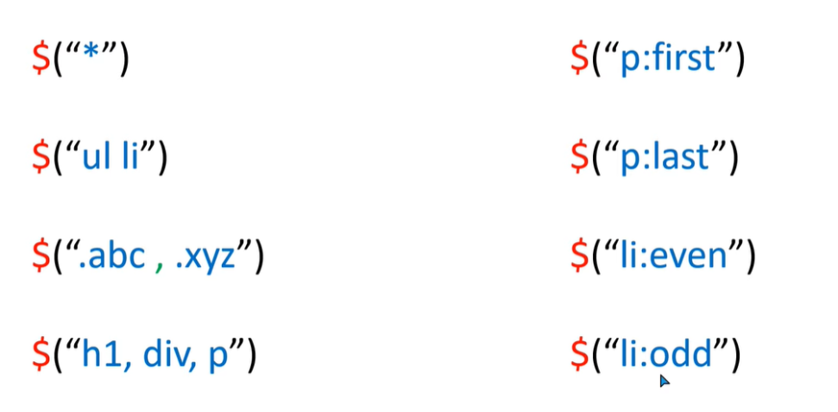

# jQuery - css() Method

To return the value of a specified CSS property, use the following syntax:

css("*propertyname*");

### Example:

$("p").css("background-color", "yellow");

Set Multiple CSS Properties :

To set multiple CSS properties, use the following syntax:

css({"*propertyname*":"*value*","*propertyname*":"*value*",...});

The following example will set a background-color and a font-size for ALL matched elements:

### Example

$("p").css({"background-color": "yellow", "font-size": "200%"});

# jQuery Mouse Events:

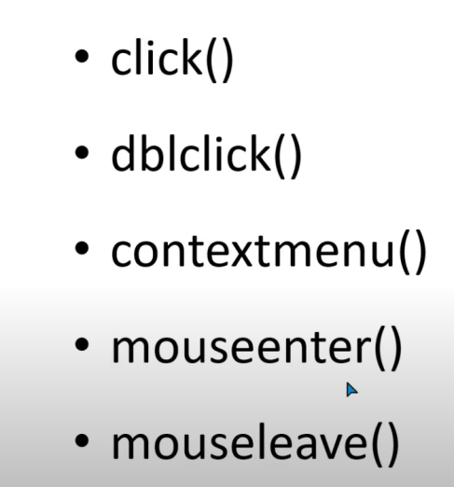

Click Event Function

Example:

$(".box").click(function(){

$(".box").css("background","green")

});