Trang Ho

Chadique Goodluck

Marciana Davis

Raymond Williams

Sekou Kaba

Final Project: Walmart Database

**Purpose/Goals**

Walmart’s IT infrastructure is called Retail link (SQL Developer). Retail link is the backend program of a database which is known “to rival the pentagon in data infrastructure”. They monitor and update all purchases and logistics. Our goal as an independent SQL Development team is to come up with an SQL update of the current database so it can be fully integrated into their systems for deployment.

**E-R Diagram**

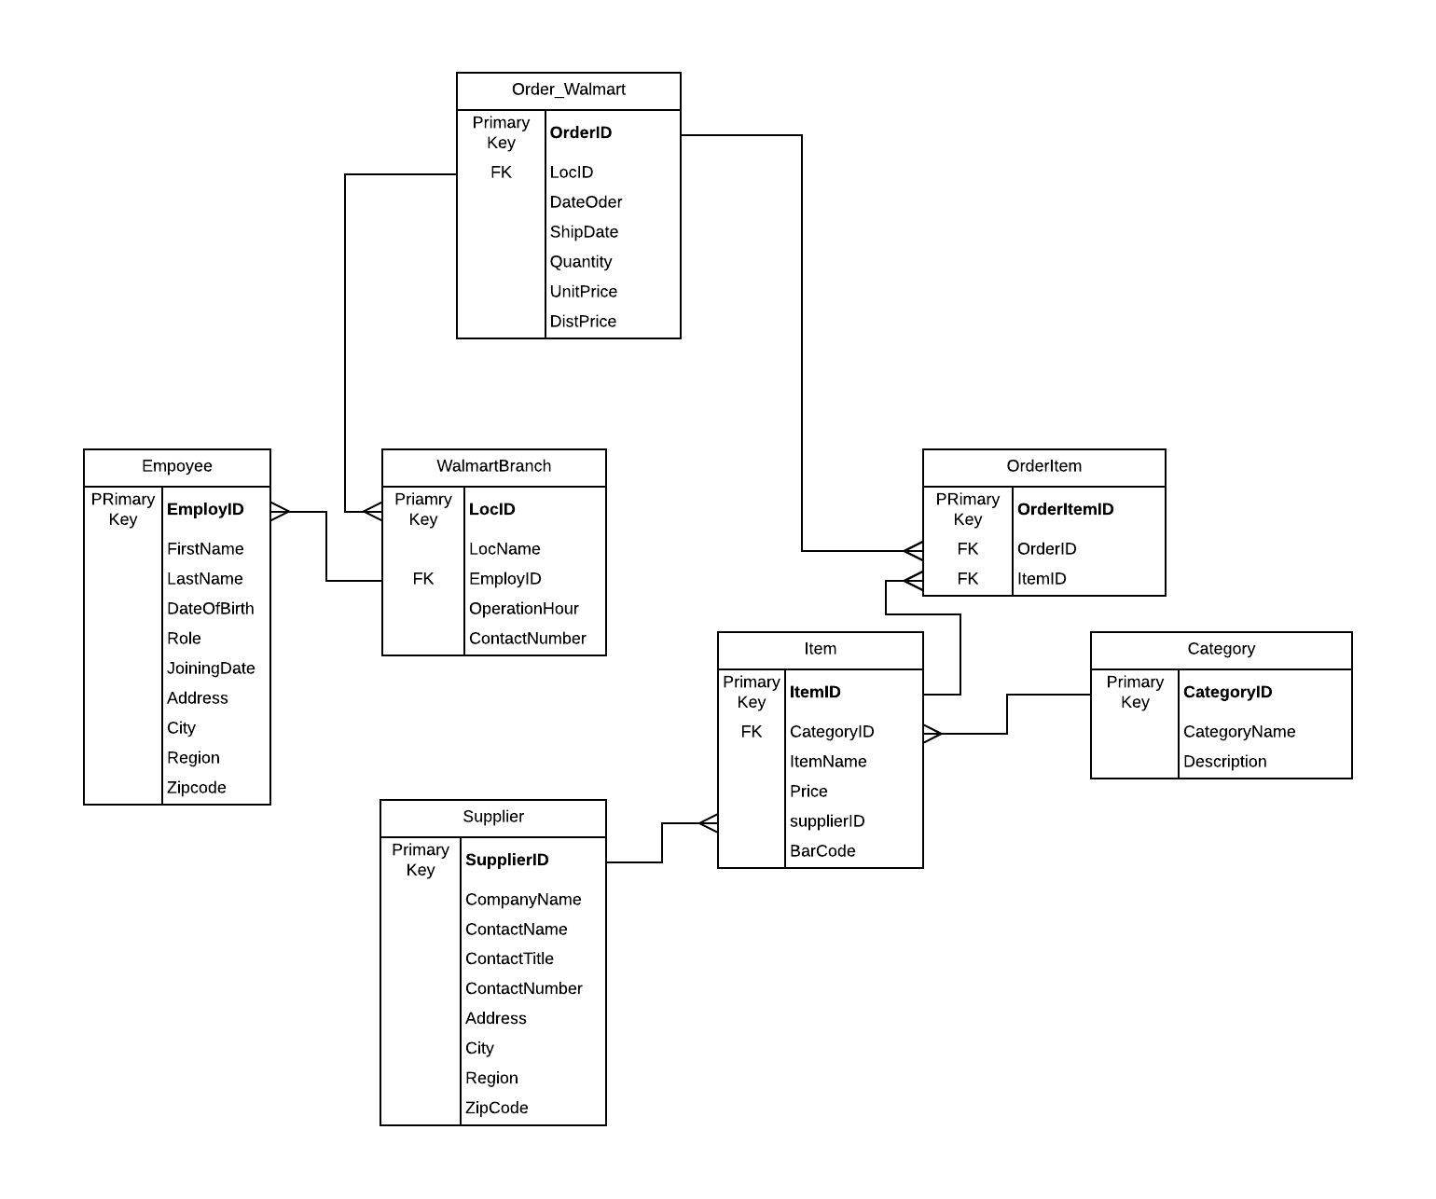

**Tables**

*Employee*

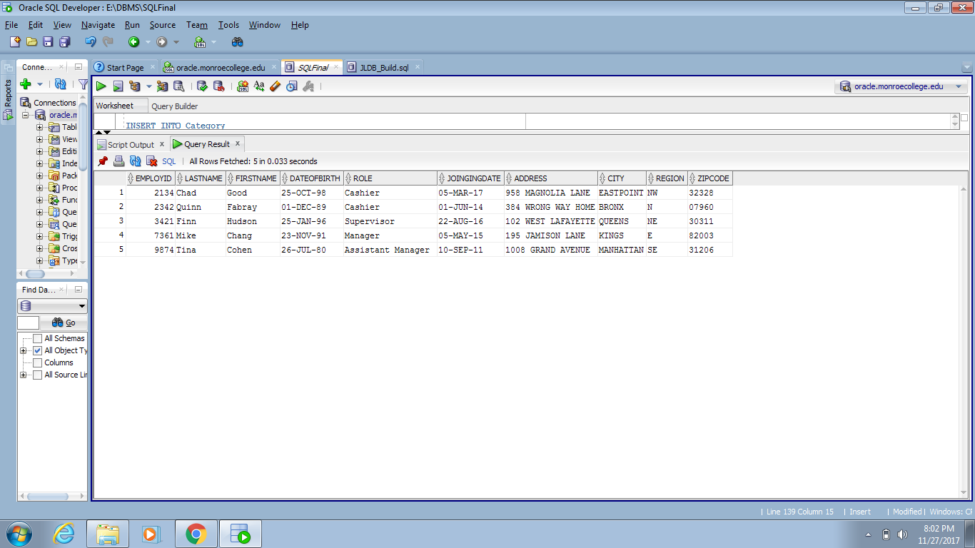

*Supplier*

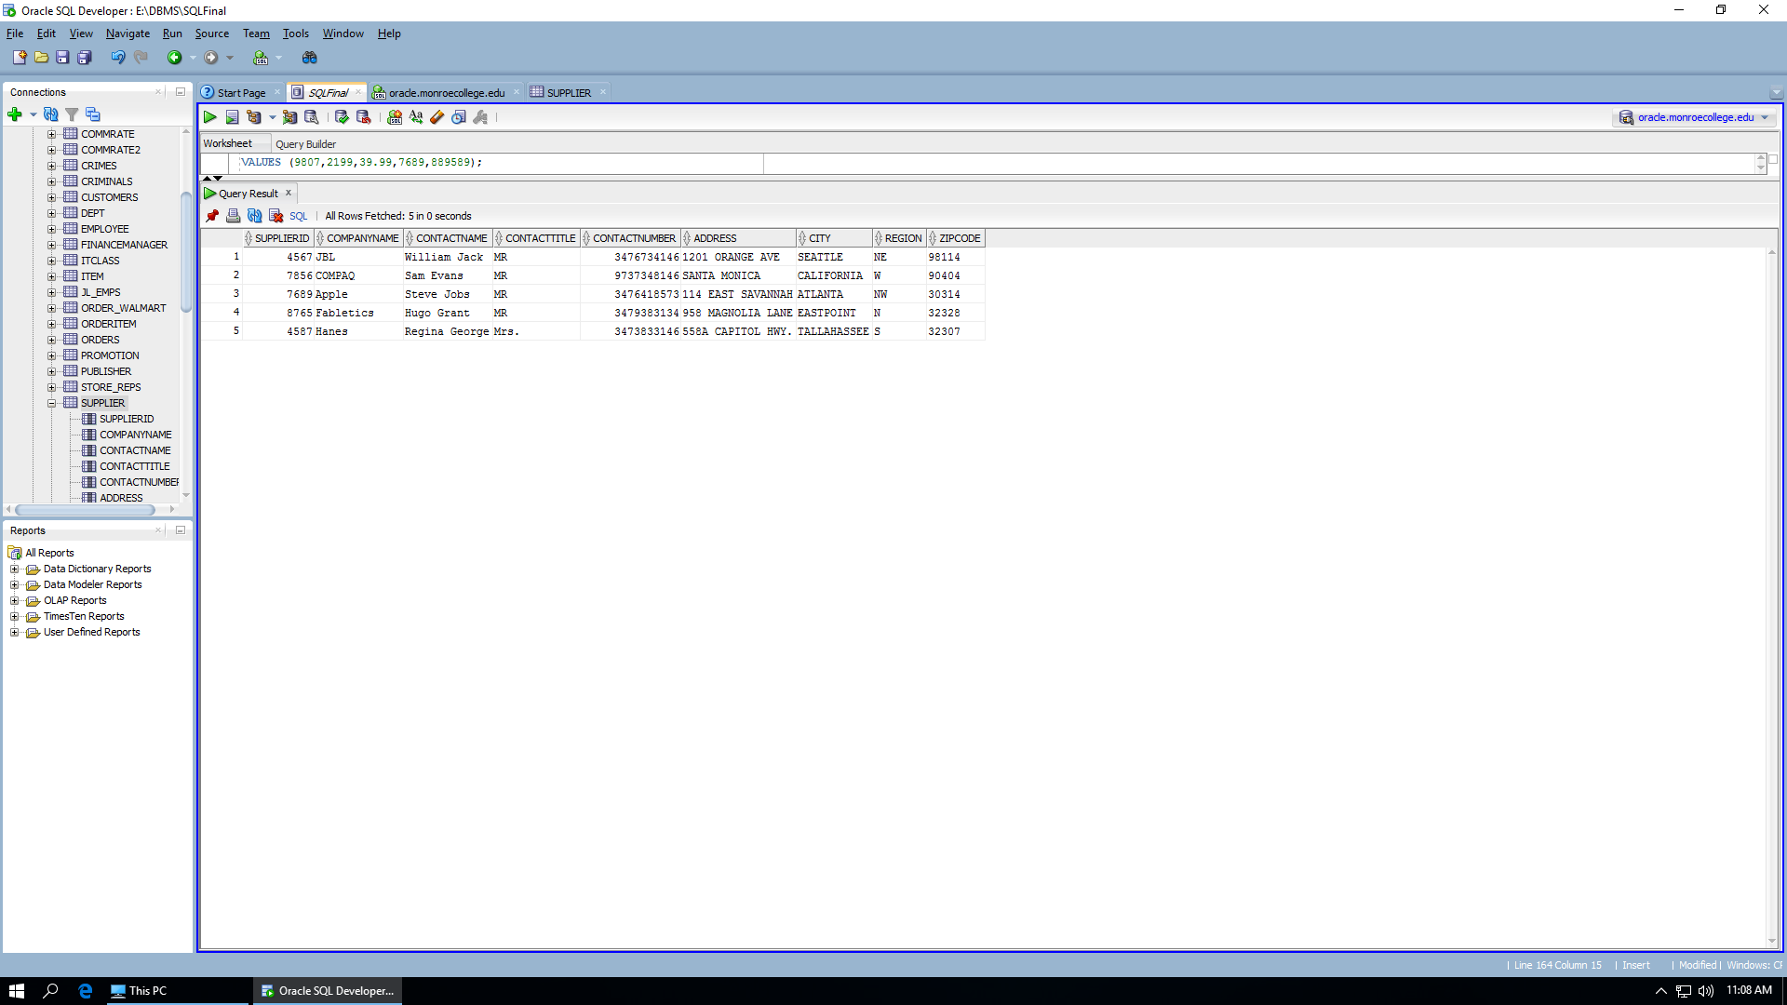

*Walmart Branch*

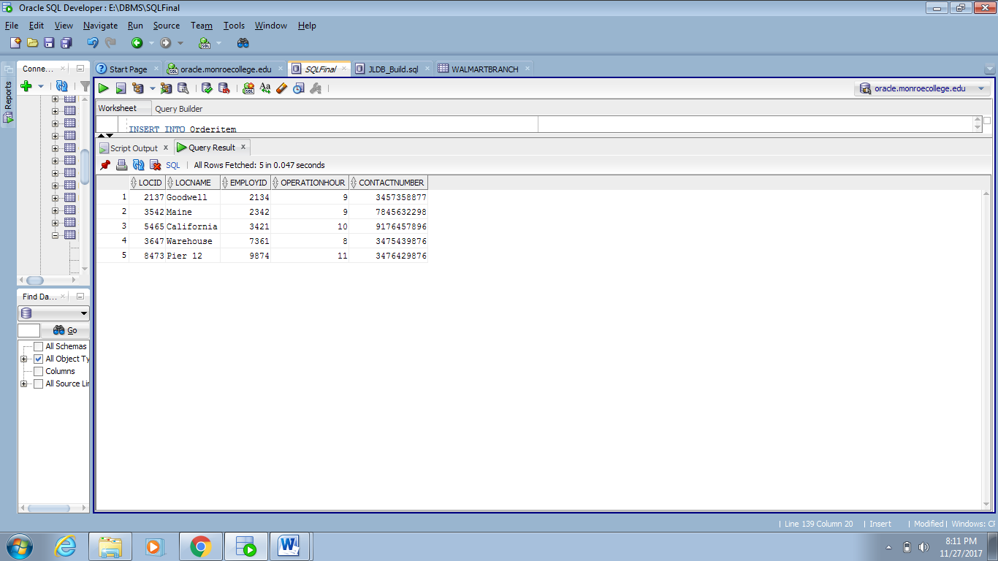

*Order_Walmart*

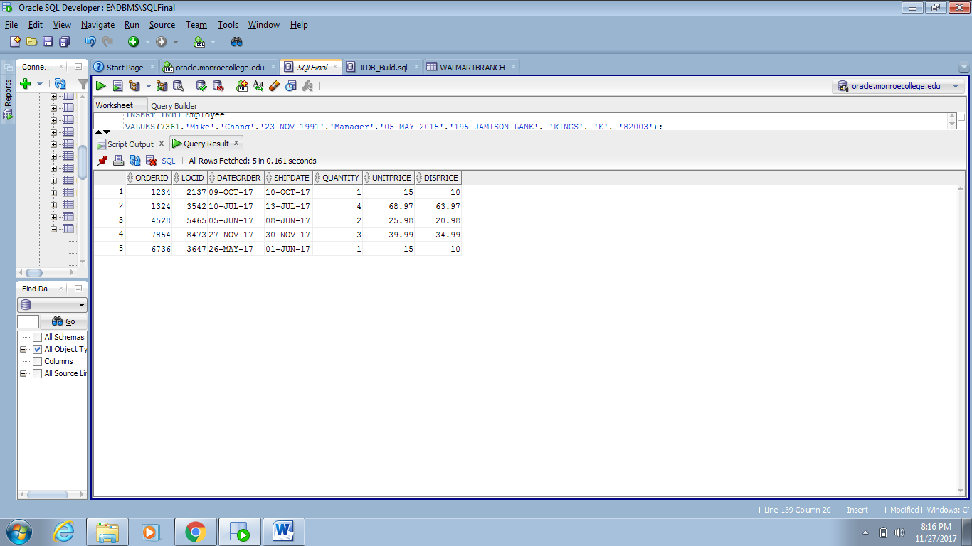

*Item*

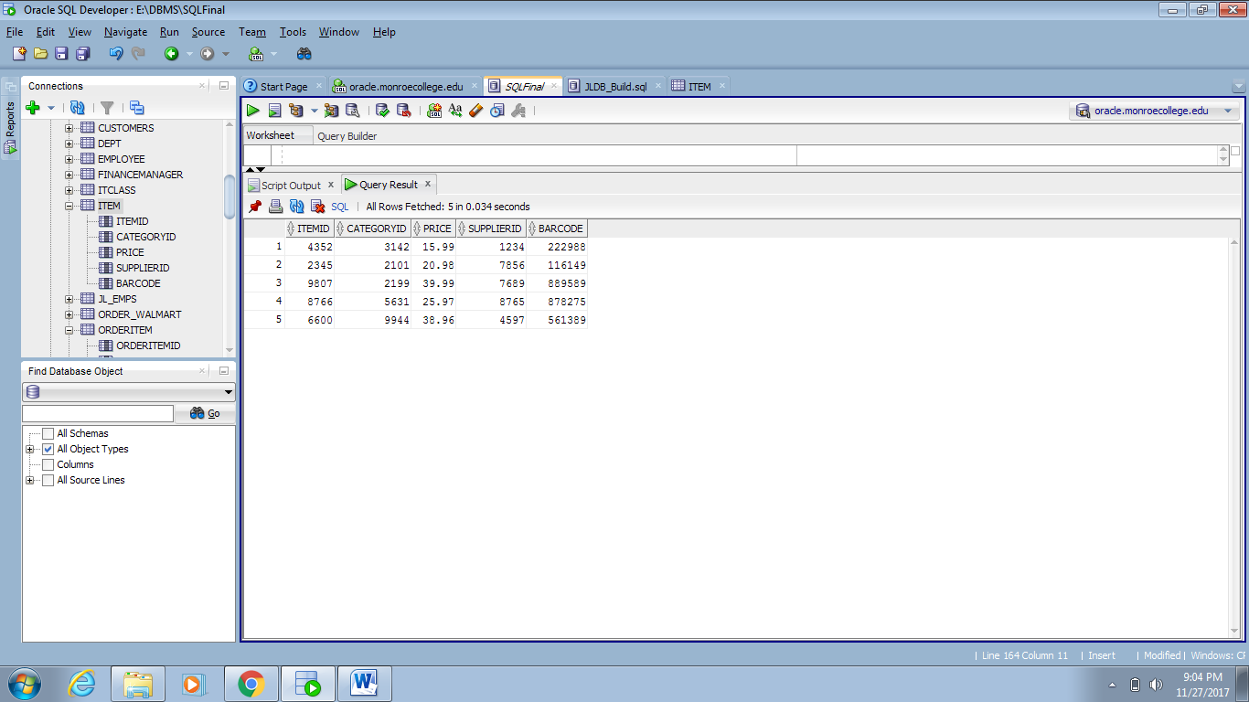

*OrderItem*

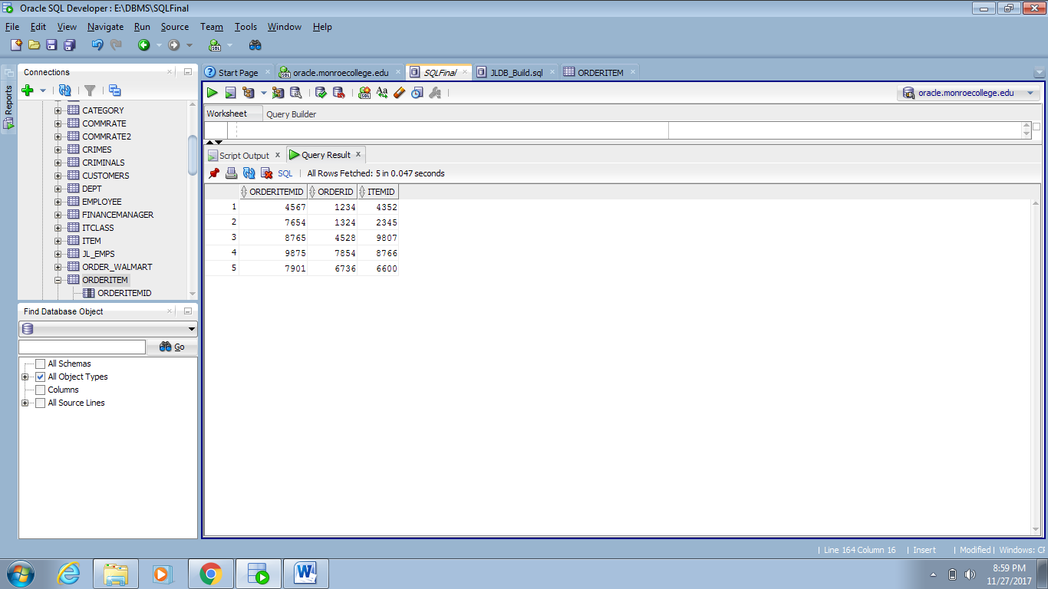

*Category*

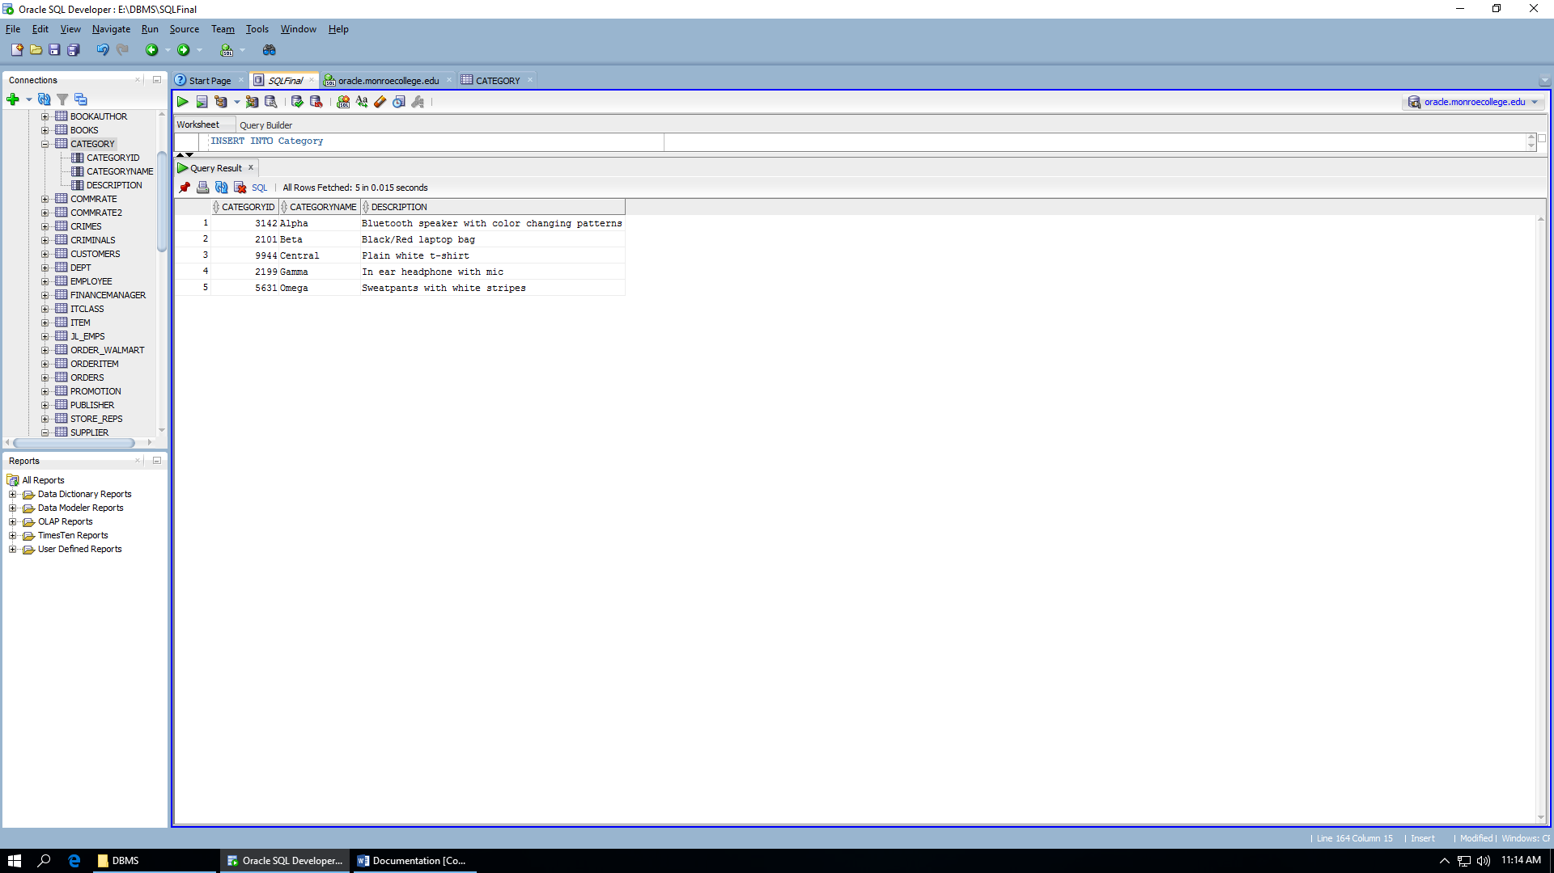

**Constraints**

This database contains the four out of the five main constraints which are PRIMARY KEY, FOREIGN KEY, UNIQUE, and CHECK. All tables utilized a Primary Key with their respective Foreign keys:

* Walmart Branch Table: EmployeeID
* Order_Walmart Table: LocID
* Item Table: CategoryID
* OrderItems Table: OrderID & ItemID

The unique constraint was used in Supplier Table for the Company Name and the Item Table for the SupplierID. The check constraint was used in the Region Table.

**Challenges**

While developing this update, we did face a few challenges for the Retail Link System Database. One of the problems were ensuring that the one-to-many relationships were correct and logical for querying purposes. Another issue was creating and adding tables in SQL Developer, the software was complicated. In the end, time consumption was the biggest issue on the project since we had to make sure the deadline and expectations were met.

**Benefits**

In this update of the system, we have made the data more organized. It is easier to find, read, and query it in searches. Along with making the system more smoother to update in transition when needed with more table expansion. We also ensured that all orders are kept in check and tracked properly whether it’s a warehouse who need to move or store new items or business associates wanting to track their shipments status.