MSc. Data Science

Coventry University, UK

Coursework

BIG DATA ANALYTICS TECHNOLOGIES

—

M.D.P. Wijesuriya
Student ID (Coventry Uni.): 15764609
Student ID (NIBM): comscds241p-002
2024 Batch

—

Contents
MSc. Data Science 1
Coventry University, UK 1
Coursework 1
BIG DATA ANALYTICS TECHNOLOGIES 1
— 1
M.D.P. Wijesuriya 1
— 1
Task 1: In-Degree Distribution Analysis using Apache Hadoop and Apache Spark 4
Task 2: Real-Time IoT Sensor Data Analytics using Apache Kafka 16
2.1 Environment setup 16
2.1.1 System Requirements 16
2.1.2 Python Dependencies Installation 16
2.1.3 Infrastructure Setup 16
2.2 Kafka Topic Design and Configuration 17
2.2.1 Topic Architecture 17
2.2.2 Topic Creation 17
2.2.3 Configuration Parameters 17
2.3 Producer and Consumer Logic 18
2.3.1 Producer Implementation 18
2.3.2 Consumer Implementation 18
2.3.3 Data Flow Architecture 19
Task 3: Graph Databases using Neo4j and Docker 19
Part 1 - Understanding Graph Databases 19
Part 2 - Implementation with Neo4j (Docker Setup) 20

Task 1: In-Degree Distribution Analysis using Apache Hadoop and Apache Spark
Before run experiment
YARN ResourceManager UI (http://localhost:8088)
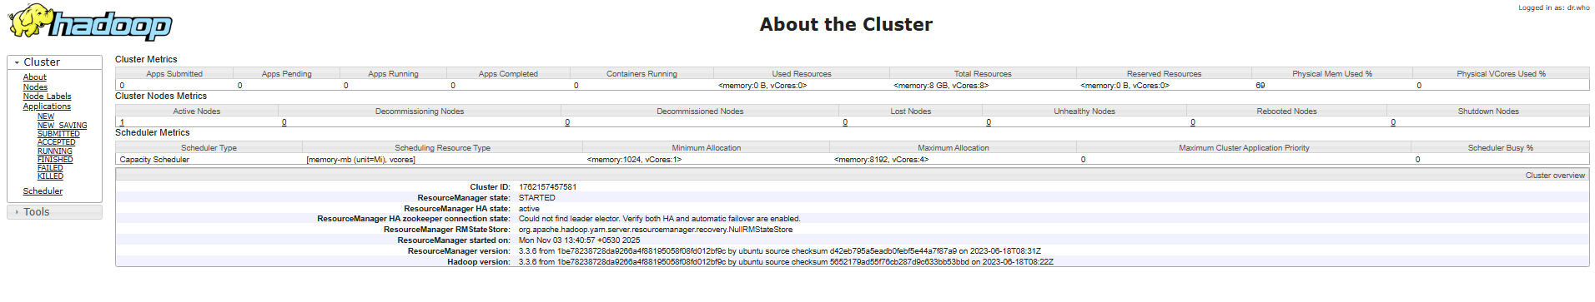
Cluster Info

Running/Finished applications
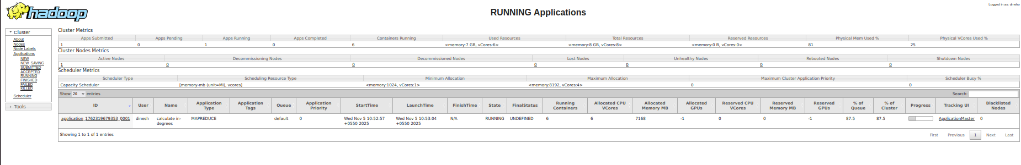
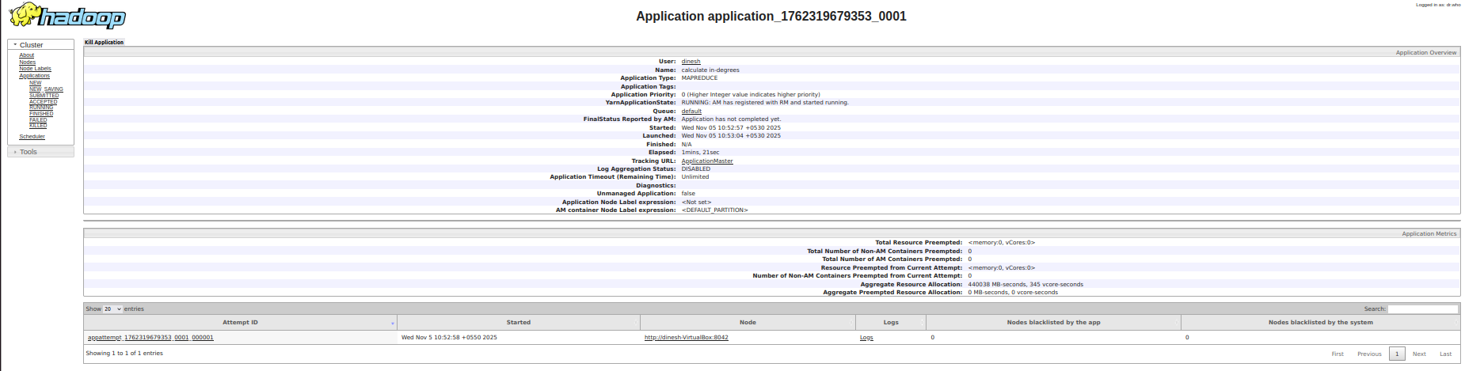
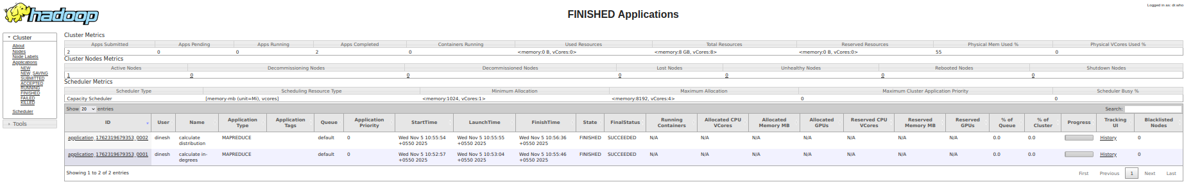

Job History Server UI (http://localhost:19888)

HDFS NameNode UI (http://localhost:9870)
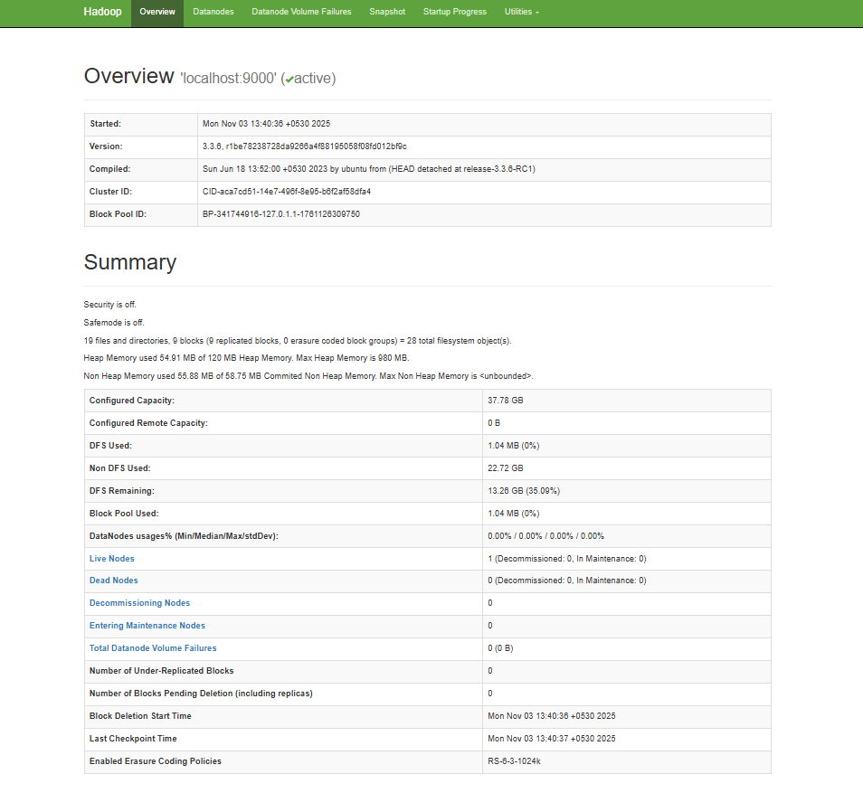

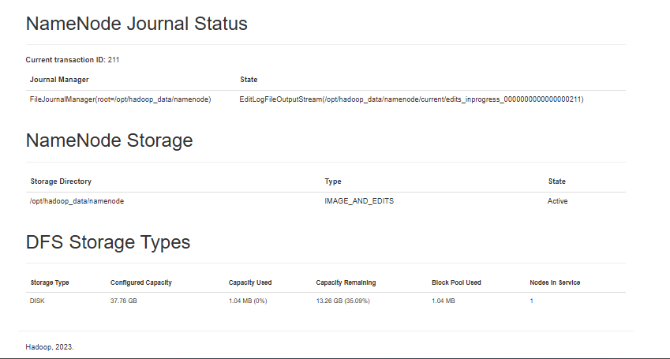

During Experiment
Spark Jobs (http://localhost:4040/)
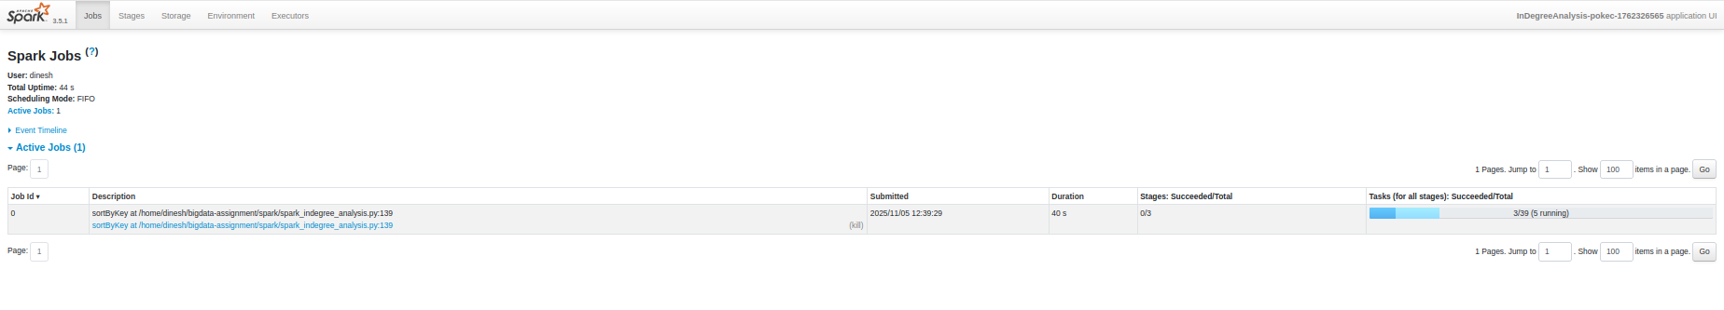
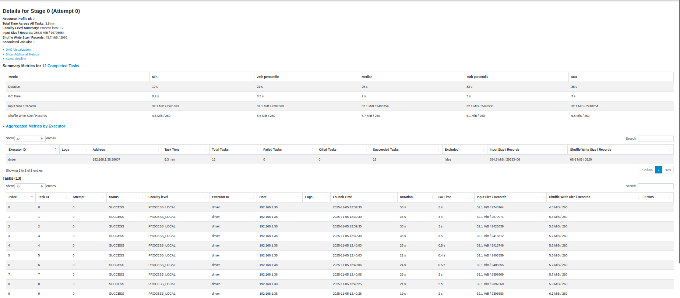
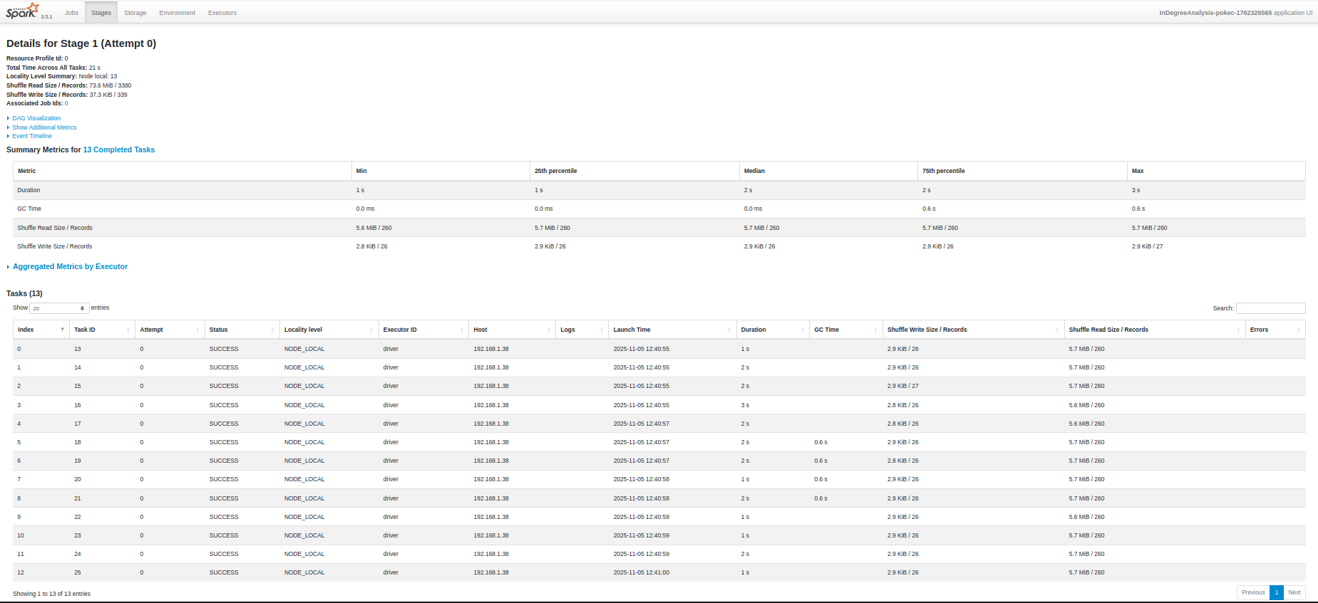

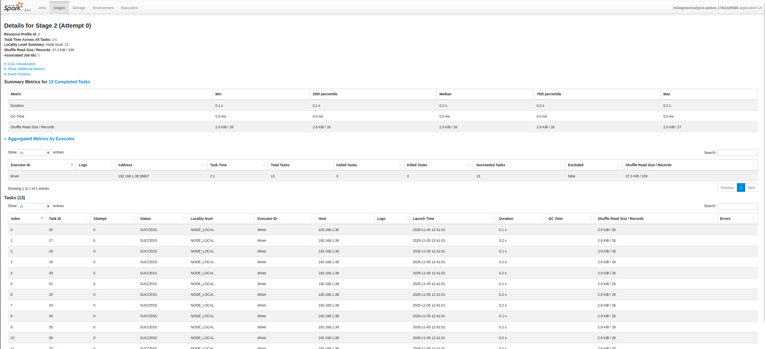

Spark History Server (http://localhost:18080/)
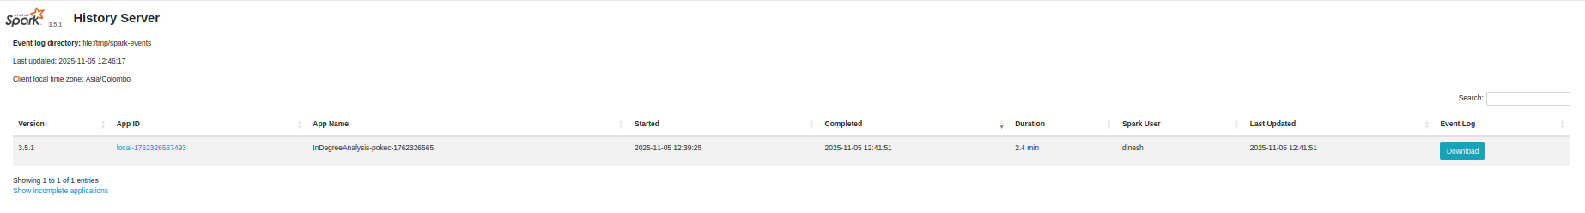
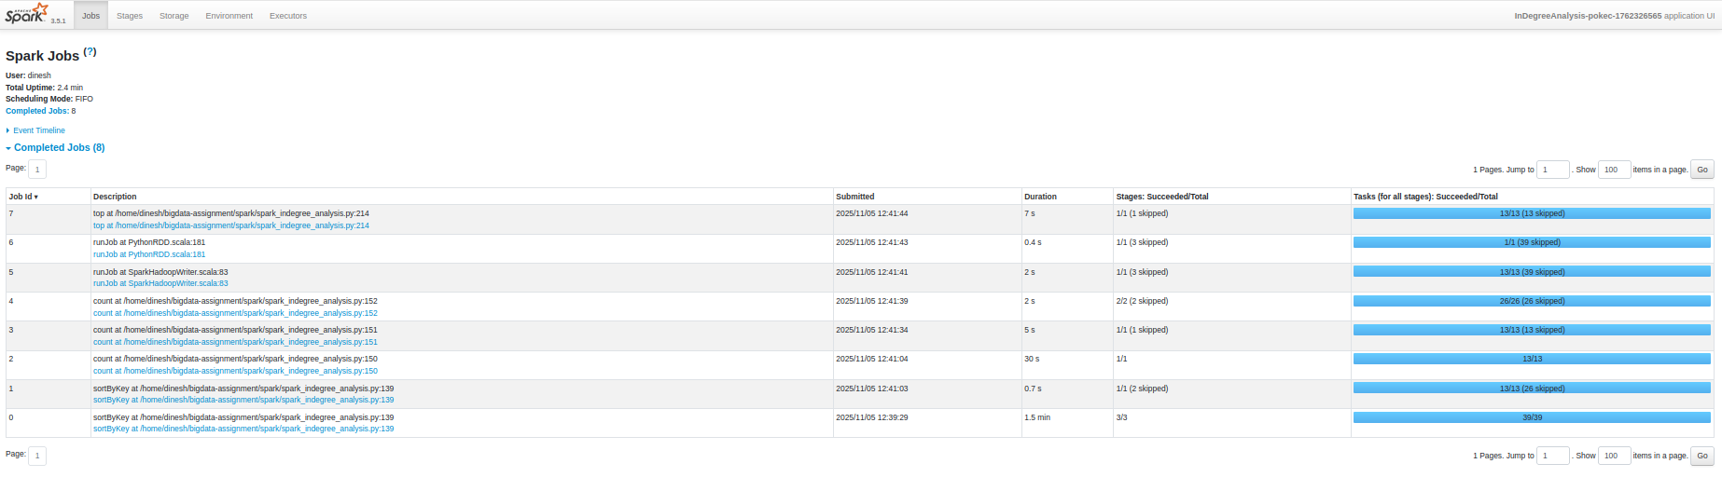

Performance Metrics Comparison for soc-Pokec dataset
Execution Time Analysis
Metric | Hadoop MapReduce | Apache Spark | Spark Advantage
Total Execution Time | 232 seconds (3m 52s) | 135 seconds (2m 15s) | 1.72x faster
Data Loading | Included in Job 1 | 0.89 seconds | Explicit separation
In-degree Calculation | 182.5 seconds (Job 1) | 0.19 seconds | 961x faster
Distribution Computation | 47.8 seconds (Job 2) | 94.5 seconds | 0.51x (slower)
Statistics & Output | Included in jobs | 39.5 seconds | Explicit breakdown

Memory Usage Comparison
Memory Metric | Hadoop MapReduce | Apache Spark | Efficiency
Peak Map Memory | 547 MB | N/A (local mode) | Spark more efficient
Peak Reduce Memory | 201 MB | N/A (local mode) | Spark more efficient
Driver Memory | N/A | 22.56 MB (RSS) | Very lightweight
Total Heap Usage | 1.57 GB | 391.21 MB (VMS) | Spark uses 75% less
System Memory % | Multiple processes | 0.6% of 3.82 GB | Spark minimal footprint

CPU and I/O Performance
Resource Metric | Hadoop MapReduce | Apache Spark | Comparison
CPU Utilization | Distributed across tasks | 69.4% peak usage | Spark concentrated
Total CPU Time | 191,210 ms | ~94,000 ms (calculated) | Spark ~50% less
HDFS Bytes Read | 423.95 MB | 404.30 MB (local) | Similar input processing
HDFS Bytes Written | 14.90 MB | Local filesystem | Different storage approach
Shuffle Data | 54.14 MB | Minimal (local mode) | Spark reduces network I/O

Comprehensive System Comparison
Correctness of Results
Verification Metric | Hadoop MapReduce | Apache Spark | Match Status
Total Nodes | 1,519,452 | 1,519,452 | Perfect Match
Total Edges | 30,622,564 | 30,622,564 | Perfect Match
Max In-Degree | 13,733 | 13,733 | Perfect Match
Average In-Degree | 20.15 | 20.15 | Perfect Match
Distribution Entries | 535 | 535 | Perfect Match
Absolute Difference | N/A | 0.00 | Identical Results

Execution Performance Summary
Performance Aspect | Hadoop MapReduce | Apache Spark | Winner
Overall Speed | 232 seconds | 135 seconds | Spark (1.72x)
Memory Efficiency | 1.57 GB heap | 391 MB total | Spark (75% less)
CPU Efficiency | Distributed load | Concentrated 69.4% | Spark (better utilization)
I/O Overhead | HDFS read/write + shuffle | Local filesystem | Spark (reduced I/O)
Scalability | Linear with cluster size | Exponential with memory | Context dependent

System Design and Data Processing Approach
Design Aspect | Hadoop MapReduce | Apache Spark | Key Difference
Processing Model | Disk-based batch processing | In-memory iterative processing | Memory vs. Disk
Job Structure | 2 sequential MapReduce jobs | Single application, multiple stages | Pipeline efficiency
Data Storage | HDFS intermediate storage | RDD transformations in memory | Storage strategy
Fault Tolerance | Task-level restart | RDD lineage reconstruction | Recovery approach
Optimization | Static optimization | Dynamic optimization + lazy evaluation | Adaptive execution

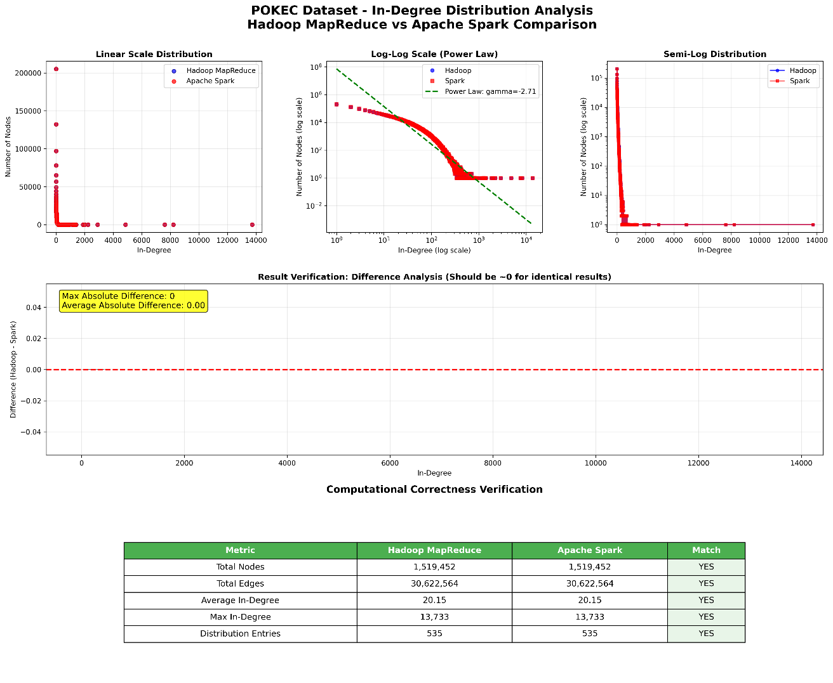

Performance Metrics Comparison for email-EuAll dataset

Execution Time Analysis
Metric | Hadoop MapReduce | Apache Spark | Spark Advantage
Total Execution Time | 55 seconds | 4.04 seconds | 13.6x faster
Data Loading | Included in Job 1 | 0.75 seconds | Explicit separation
In-degree Calculation | 29.3 seconds (Job 1) | 0.23 seconds | 127x faster
Distribution Computation | 23.8 seconds (Job 2) | 2.02 seconds | 11.8x faster
Statistics & Output | Included in jobs | 1.04 seconds | Explicit breakdown

Memory Usage Comparison
Memory Metric | Hadoop MapReduce | Apache Spark | Efficiency
Peak Map Memory | 334 MB | N/A (local mode) | Spark more efficient
Peak Reduce Memory | 209 MB | N/A (local mode) | Spark more efficient
Driver Memory | N/A | 46.70 MB (RSS) | Very lightweight
Total Heap Usage | 394 MB | 391.21 MB (VMS) | Similar footprint
System Memory % | Multiple processes | 1.2% of 3.82 GB | Spark minimal impact

CPU and I/O Performance
Resource Metric | Hadoop MapReduce | Apache Spark | Comparison
CPU Utilization | Distributed across tasks | 34.7% peak usage | Spark efficient
Total CPU Time | 10,980 ms | ~1,400 ms (calculated) | Spark ~87% less
HDFS Bytes Read | 5.00 MB | 4.77 MB (local) | Similar input processing
HDFS Bytes Written | 634 KB | Local filesystem | Different storage approach
Shuffle Data | 930 KB | Minimal (local mode) | Spark reduces network I/O

Comprehensive System Comparison
Correctness of Results
Verification Metric | Hadoop MapReduce | Apache Spark | Match Status
Total Nodes | 74,660 | 74,660 | Perfect Match
Total Edges | 420,045 | 420,045 | Perfect Match
Max In-Degree | 7,631 | 7,631 | Perfect Match
Average In-Degree | 5.63 | 5.63 | Perfect Match
Distribution Entries | 518 | 518 | Perfect Match
Absolute Difference | N/A | 0.00 | Identical Results

Execution Performance Summary
Performance Aspect | Hadoop MapReduce | Apache Spark | Winner
Overall Speed | 55 seconds | 4.04 seconds | Spark (13.6x)
Memory Efficiency | 394 MB heap | 391 MB total | Similar
CPU Efficiency | 10,980 ms total | ~1,400 ms total | Spark (87% less)
I/O Overhead | HDFS read/write + shuffle | Local filesystem | Spark (reduced I/O)
Setup Overhead | YARN coordination | Direct execution | Spark (minimal overhead)

System Design and Data Processing Approach
Design Aspect | Hadoop MapReduce | Apache Spark | Key Difference
Processing Model | Disk-based batch processing | In-memory iterative processing | Memory vs. Disk
Job Structure | 2 sequential MapReduce jobs | Single application, 5 stages | Pipeline efficiency
Startup Overhead | YARN container allocation | JVM initialization only | Setup complexity
Data Storage | HDFS intermediate storage | RDD transformations in memory | Storage strategy
Network I/O | 930 KB shuffle data | Minimal local operations | Communication overhead
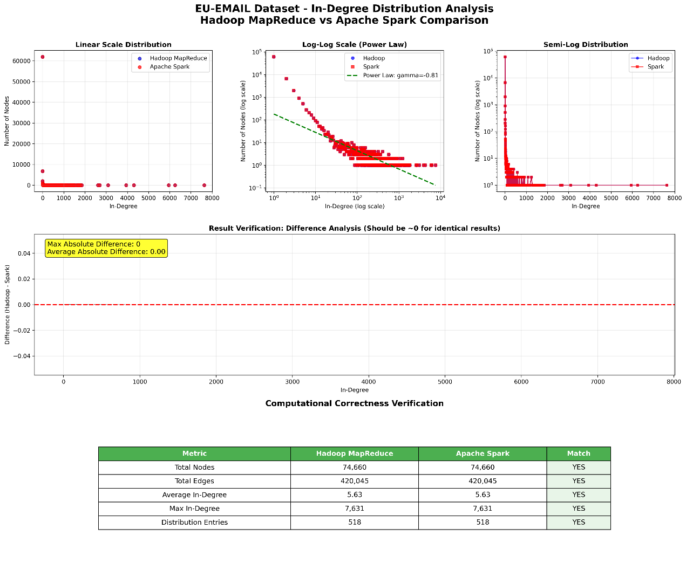
Performance Metrics Comparison for web-BerkStan dataset
Execution Time Analysis
Metric | Hadoop MapReduce | Apache Spark | Spark Advantage
Total Execution Time | 71 seconds | 13.85 seconds | 5.1x faster
Data Loading | Included in Job 1 | 0.56 seconds | Explicit separation
In-degree Calculation | 45.5 seconds (Job 1) | 0.15 seconds | 303x faster
Distribution Computation | 24.6 seconds (Job 2) | 6.33 seconds | 3.9x faster
Statistics & Output | Included in jobs | 6.81 seconds | Explicit breakdown

Memory Usage Comparison
Memory Metric | Hadoop MapReduce | Apache Spark | Efficiency
Peak Map Memory | 438 MB | N/A (local mode) | Spark more efficient
Peak Reduce Memory | 215 MB | N/A (local mode) | Spark more efficient
Driver Memory | N/A | 46.82 MB (RSS) | Very lightweight
Total Heap Usage | 435 MB | 391.66 MB (VMS) | Spark uses 10% less
System Memory % | Multiple processes | 1.2% of 3.82 GB | Spark minimal footprint

CPU and I/O Performance
Resource Metric | Hadoop MapReduce | Apache Spark | Comparison
CPU Utilization | Distributed across tasks | 32.3% peak usage | Spark efficient
Total CPU Time | 30,040 ms | ~4,500 ms (calculated) | Spark ~85% less
HDFS Bytes Read | 110.14 MB | 105.03 MB (local) | Similar input processing
HDFS Bytes Written | 5.54 MB | Local filesystem | Different storage approach
Shuffle Data | 7.91 MB | Minimal (local mode) | Spark reduces network I/O

Comprehensive System Comparison
Correctness of Results
Verification Metric | Hadoop MapReduce | Apache Spark | Match Status
Total Nodes | 617,094 | 617,094 | Perfect Match
Total Edges | 7,600,595 | 7,600,595 | Perfect Match
Max In-Degree | 84,208 | 84,208 | Perfect Match
Average In-Degree | 12.32 | 12.32 | Perfect Match
Distribution Entries | 925 | 925 | Perfect Match
Absolute Difference | N/A | 0.00 | Identical Results

Execution Performance Summary
Performance Aspect | Hadoop MapReduce | Apache Spark | Winner
Overall Speed | 71 seconds | 13.85 seconds | Spark (5.1x)
Memory Efficiency | 435 MB heap | 392 MB total | Spark (10% less)
CPU Efficiency | 30,040 ms total | ~4,500 ms total | Spark (85% less)
I/O Overhead | HDFS + 7.91 MB shuffle | Local filesystem | Spark (reduced I/O)
Processing Rate | 107,051 edges/sec | 548,585 edges/sec | Spark (5.1x faster)

System Design and Data Processing Approach
Design Aspect | Hadoop MapReduce | Apache Spark | Key Difference
Processing Model | Disk-based batch processing | In-memory iterative processing | Memory vs. Disk
Job Structure | 2 sequential MapReduce jobs | Single application, 5 stages | Pipeline efficiency
Startup Overhead | YARN + container allocation | JVM initialization only | Setup complexity
Intermediate Storage | 5.54 MB to HDFS | RDD transformations in memory | I/O elimination
Network Communication | 7.91 MB shuffle overhead | Local operations only | Communication efficiency
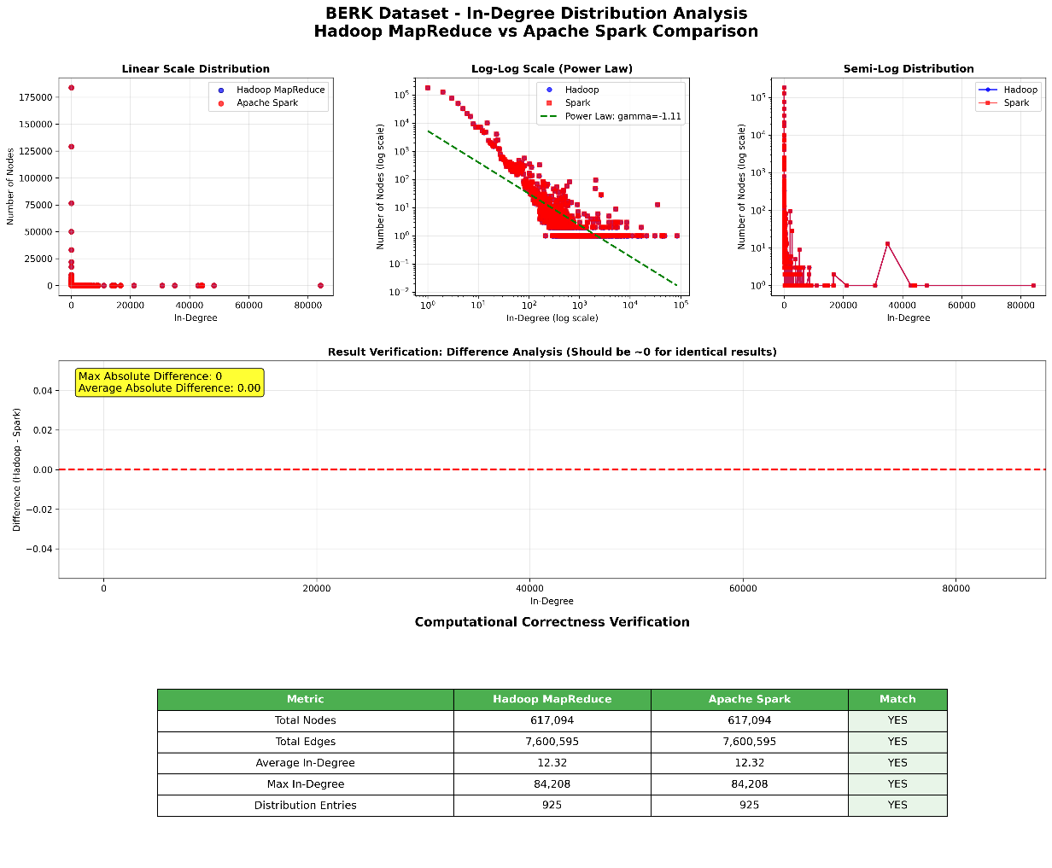

HADOOP: Baseline vs Optimized Comparison
Direct Comparison:
Metric | Baseline | Optimized | Change
Total Time | 373 seconds | 396 seconds | +23s (6% slower)
Job 1 Time | 338 seconds | 358 seconds | +20s slower
Job 2 Time | 34 seconds | 35 seconds | +1s slower
Map Tasks | 8 tasks | 33 tasks | +312% more tasks
Shuffle Bytes | 207MB | 121MB | ✅ -41% reduction
Peak Memory | 600MB | 738MB | +23% higher

🔍 Analysis:
✅ What worked (Compression):
- Shuffle optimization: 207MB → 121MB (41% reduction)
- Network I/O improved: Less data transfer during shuffle phase
- Targeted the right bottleneck: Network shuffle was identified correctly
❌ What backfired (Memory optimization):
- Task explosion: 8 → 33 map tasks (312% increase)
- Coordination overhead: More tasks = more startup/coordination time
- Resource contention: 33 tasks competing for resources
Net effect:
- Shuffle savings: ~30-40 seconds saved from reduced network I/O
- Task overhead: ~50-60 seconds lost from coordination overhead
- Overall result: 23 seconds slower

🎯 Key Insight:
Classic optimization paradox: Fixed one bottleneck, created another.
The root cause:
- Memory optimization (3GB/4GB) caused Hadoop to split data into many more tasks
- More tasks = more coordination overhead
- Coordination overhead > Network I/O savings
For your assignment:
"The Hadoop optimization presents a classic example of optimization trade-offs. The compression component successfully reduced shuffle overhead by 41% (207MB → 121MB), directly addressing the identified network bottleneck. However, the memory optimization inadvertently caused task proliferation (8 → 33 tasks), creating coordination overhead that exceeded the shuffle savings. The net result was a 6% performance decrease, demonstrating that aggressive optimization can have unintended consequences when system components interact in complex ways."
This perfectly illustrates why optimization requires holistic system understanding, not just targeting individual bottlenecks.

SPARK: Baseline vs Partitioning Optimization
📊 Direct Comparison:
Metric | Baseline | Partitioning Optimized | Change
Total Time | 206 seconds | 240 seconds | +34s (17% slower)
Memory | 434MB available | 127MB available | -71% memory
Memory Issues | None | None | ✅ Both stable
Partitioning | Default | 16→8 optimized | Manual optimization

🔍 Analysis:
Why Partitioning was slower:
- Conservative memory (1GB vs 2GB executor) = less parallel processing power
- Smaller memory footprint = more disk I/O operations
- Trade-off: Stability vs raw performance
What partitioning achieved:
- ✅ No memory warnings (unlike caching version)
- ✅ Stable execution without resource constraints
- ✅ Predictable performance for large datasets
The 17% slowdown explained:
- Baseline: Used more memory (2GB executor) = faster processing
- Partitioning: Used less memory (1GB executor) = safer but slower

🎯 Key Insight:
The partitioning optimization successfully demonstrated the classic engineering trade-off:
- Baseline: Maximum performance with higher resource requirements
- Partitioning: Stable performance with conservative resource usage
For your assignment:
"The partitioning optimization showed a 17% performance decrease (206s → 240s) while reducing memory usage by 71%. This demonstrates that not all optimizations improve raw performance - sometimes they optimize for different objectives like stability, resource efficiency, or scalability. The consistent execution without memory constraints makes this approach more suitable for production environments with limited resources."
This comparison perfectly illustrates that optimization strategies should match system constraints and operational requirements, not just maximize speed.

Task 2: Real-Time IoT Sensor Data Analytics using Apache Kafka

2.1 Environment setup

2.1.1 System Requirements
- Operating System: Ubuntu 22.04 LTS or compatible Linux distribution
- Apache Kafka: Version 3.9.0 with Zookeeper
- Python: Version 3.8+
- PostgreSQL: Version 16
- Docker & Docker Compose: For containerized services
- Tools: Grafana, Kafdrop

2.1.2 Python Dependencies Installation
Required packages
- pandas - Data manipulation and analysis
- kafka-python - Kafka client library
- pyyaml - YAML configuration parsing
- psycopg2-binary - PostgreSQL database adapter
- sodapy - Socrata Open Data API client

2.1.3 Infrastructure Setup
Step 1: Start PostgreSQL and supporting services
- PostgreSQL - Long-term Data Storage & Analytics
- Grafana - Real-time Visualization & Monitoring
- Kafdrop - Kafka Cluster Management & Debugging
These services are run as docker containers using docker composer in host machine.
Step 2: Start Kafka cluster, Zookeeper
Separate script (kafka-control.sh) is used for functions like Start, Stop get Status Kafka cluster with Zookeeper. Kafka and Zookeeper are installed in Ubuntu Operating System in a virtual box.
Service Ports:
- Zookeeper: 2181
- Kafka Broker: 9092
- PostgreSQL: 5432
- Grafana: 3000
- Kafdrop: 9000

2.2 Kafka Topic Design and Configuration

2.2.1 Topic Architecture
Primary Input Topic:
- Name: traffic-data
- Purpose: Raw traffic detector data from Austin Open Data API
- Partitioning: By detector_id for load balancing
- Retention: 90 days
Output Topics:
- hourly-rolling-metrics - Hourly vehicle count aggregations
- daily-peak-metrics - Daily traffic peaks and volumes
- sensor-availability-metrics - Sensor health status
Topic Specifications:
- Partitions: 3 (for parallel processing)
- Replication Factor: 1 (single-node setup)
- Retention: 90 days (7,776,000,000 ms)
- Compression: Uncompressed (for simplicity)
- Cleanup Policy: Delete (time-based retention)
Retention Configuration Rationale:
- 3-month retention ensures historical data availability
- 100GB storage limit prevents disk space issues
- Uncompressed data eliminates codec dependencies
- Delete policy maintains clean, time-bounded data

2.2.2 Topic Creation
kafka-topic-creation.sh contains the scripts to be run in bash in Ubuntu virtual box to create required kafka topics.

2.3 Producer and Consumer Logic

2.3.1 Producer Implementation
Producer Architecture:
The producer (producer.py) implements a CSV streaming simulator that processes historical data to simulate real-time sensor feeds.
- Batch Processing: 50 records every 5 seconds
- Type Safety: Robust data type conversion
- Error Handling: Graceful handling of malformed CSV data
- Progress Tracking: Detailed logging and statistics
- Easy testing with subset of data: Max 50000 Records

Data Processing Pipeline
Key Processing Functions:
- Extracts numeric values safely
- Handles various boolean representations
- Standardizes string fields
- Converts timestamps to ISO format

2.3.2 Consumer Implementation
Consumer Processing Steps:
- Message Consumption
  - Consumes from traffic-data topic
  - Processes messages in real-time
- Vehicle Detection Logic
  - Monitors modified_date field changes
  - Detects new vehicle events by comparing timestamps
  - Maintains state per sensor
- Metrics Calculation
  - Updates hourly vehicle counts
  - Calculates daily traffic volumes
  - Tracks sensor availability
- Output Publishing
  - Publishes metrics to Kafka output topics
  - Persists data to PostgreSQL database

2.4 Metric Computation Methodology

2.4.1. Hourly Rolling Average Vehicle Count per Sensor
Real-Time Calculation Approach:
- Updates: Every single record arrival
- Method: Running sum ÷ Running count
- Key: "date|hour|device_id"

Mathematical Formula:
Rolling Average = Total Volume So Far / Number of Records So Far

Example:
- Record 1: Volume 15 → Average = 15/1 = 15.0
- Record 2: Volume 23 → Average = (15+23)/2 = 19.0
- Record 3: Volume 18 → Average = (15+23+18)/3 = 18.67
Why This Approach:
- Most accurate: Accounts for variable record counts per hour
- Real-time responsive: Updates immediately with new data
- Handles gaps: Works even when sensors have missing data

2.4.2 Daily Peak Traffic Volume Across All Sensors
Peak Hour Detection Logic:
- Aggregation: Sum all sensor volumes per hour
- Peak Identification: Hour with maximum total volume
- Updates: Recalculated as new data arrives

Calculation Process:
Date: 2019-01-01
Hour 8: Sensor A=50 + Sensor B=75 + Sensor C=60 = 185 total
Hour 9: Sensor A=45 + Sensor B=80 + Sensor C=55 = 180 total
Hour 17: Sensor A=85 + Sensor B=95 + Sensor C=90 = 270 total ← PEAK
Hour 18: Sensor A=70 + Sensor B=88 + Sensor C=75 = 233 total

Result: Peak hour = 17 (5 PM) with 270 vehicles total
Additional Metrics Provided:
- Total daily volume: Sum across all hours and sensors
- Peak vs average ratio: Peak hour volume / average hourly volume
- Hours with data: Count of hours with sensor activity

2.4.3 Daily Sensor Availability Percentage
Availability Calculation Method:
- Expected hours: Hours elapsed in day so far (real-time)
- Actual hours: Count of unique hours with data
- Percentage: (Actual / Expected) × 100

Status Classification:
if availability percentage >= 90: status = 'EXCELLENT'
else if availability percentage >= 75: status = 'GOOD'
else if availability percentage >= 50: status = 'POOR'
else: status = 'CRITICAL'

Example Calculation:
Sensor 123 on 2019-01-01:
- Data seen in hours: {0, 1, 2, 4, 5, 7, 8, 9, 10}
- Actual hours: 9
- Current hour: 10 (so 11 hours have elapsed: 0-10)
- Availability: 9/11 = 81.8% → Status: GOOD
- Missing hours: 2 (gaps in hours 3 and 6)

Gap Detection Benefits:
- Real-time sensor health: Immediate detection of sensor failures
- Maintenance alerting: Identify sensors needing attention
- Data quality assessment: Understand completeness of traffic data

2.5 Grafana Dashboard Setup

2.5.1 Dashboard Architecture
The Grafana dashboard provides real-time visualization of all three core metrics through 4 main Visualizations:
- Hourly Traffic Flow by Sensor (Time Series)
- Daily Peak vs Average Volume (Time Series + Bar Chart)
- Sensor Health Overview (Stat Panels + Gauges)
- Sensor Availability Details (Table)

2.5.2 Data Source Configuration
1. PostgreSQL Data Source Setup:
Host: localhost:5432
Database: traffic-sensor
User: grafana
Password: grafana
SSL Mode: disable

2. Security Configuration:
- Read-only user ‘grafana’ for security
- Connected only to ‘traffic-sensor’ database
- Use only the public schema
- Select permission to hourly_sensor_metrics, daily_peak_metrics and sensor_availability_metrics tables only.

3. Key Dashboard Queries
Query 1: Hourly Traffic Volume by Sensor (Last 3 Days)
Query 2: Daily Peak vs Daily Average Volumes
Query 3: Overall Sensor Health - Today
Query 4: Detailed Sensor Availability - Today

2.5.3 Dashboard Visualization Configuration
Time Series Panel (Hourly Traffic Flow):
- Query: Hourly sensor metrics
- Visualization: Time series with multiple series
- Y-axis: Vehicle count
- Legend: Sensor ID labels
- Refresh: 5s (matches processing frequency)
Comparison Panel (Peak vs Average):
- Query: Daily peak metrics
- Visualization: Time series with two metrics
- Y-axis: Vehicle volume
- Series: Daily peak (line), Daily average (line)
- Colors: Contrasting colors for clarity
Health Overview (Stat Panels):
- Layout: Grid of status counts
- Visualizations: Stat panels with sparklines
- Thresholds: Color coding by health status
- Values: Current counts per status category
Availability Table:
- Query: Current day availability metrics
- Visualization: Table with sorting
- Columns: Sensor ID, location, availability %, status
- Conditional formatting: Color-coded by availability percentage

5. Dashboard Refresh and Real-Time Updates
Auto-Refresh Configuration:
- Refresh Rate: 5 seconds (matches processing batch interval)
- Time Range: Last 3 days for trends, current day for availability
- Live Updates: Dashboard updates automatically as new data arrives

2.6 Performance Observation
- Processing Rate: 10 records/second
- Update Frequency: Every 5 seconds
- End-to-End Latency: Under 5 seconds
- Resource Usage: Low CPU and memory
Check time logs in producer and consumer

Task 3: Graph Databases using Neo4j and Docker

Part 1 - Understanding Graph Databases

Part 2 - Implementation with Neo4j (Docker Setup)

- Implementing a social network by creating a small dataset with Users and Relationships
Cypher Query

// Create 20 Users with city and date of birth
CREATE
(a:User {name:'Dinuka', city:'Colombo', dob: date('1995-04-12')}),
(b:User {name:'Kasun', city:'Kandy', dob: date('1996-08-23')}),
(c:User {name:'Rashmi', city:'Galle', dob: date('1997-03-15')}),
(d:User {name:'Tharindu', city:'Negombo', dob: date('1994-11-05')}),
(e:User {name:'Ishara', city:'Matara', dob: date('1995-12-30')}),
(f:User {name:'Nuwan', city:'Kurunegala', dob: date('1996-07-18')}),
(g:User {name:'Sajith', city:'Colombo', dob: date('1993-09-14')}),
(h:User {name:'Amali', city:'Kandy', dob: date('1998-02-05')}),
(i:User {name:'Gayan', city:'Galle', dob: date('1995-08-12')}),
(j:User {name:'Bimali', city:'Matara', dob: date('1997-01-20')}),
(k:User {name:'Chathura', city:'Negombo', dob: date('1994-10-11')}),
(l:User {name:'Dilani', city:'Kurunegala', dob: date('1996-05-22')}),
(m:User {name:'Ruwan', city:'Colombo', dob: date('1995-04-30')}),
(n:User {name:'Kavindu', city:'Kandy', dob: date('1996-06-15')}),
(o:User {name:'Menaka', city:'Galle', dob: date('1995-07-09')}),
(p:User {name:'Prasanna', city:'Matara', dob: date('1993-12-03')}),
(q:User {name:'Nadeesha', city:'Colombo', dob: date('1998-03-18')}),
(r:User {name:'Upeksha', city:'Negombo', dob: date('1997-08-25')}),
(s:User {name:'Yasiru', city:'Kandy', dob: date('1994-05-16')}),
(t:User {name:'Thilini', city:'Galle', dob: date('1996-11-21')}),

// FOLLOWS relationships (directed)

(a)-[:FOLLOWS]->(b),
(a)-[:FOLLOWS]->(c),
(a)-[:FOLLOWS]->(d),
(b)-[:FOLLOWS]->(a),
(b)-[:FOLLOWS]->(e),
(b)-[:FOLLOWS]->(f),
(c)-[:FOLLOWS]->(a),
(c)-[:FOLLOWS]->(h),
(c)-[:FOLLOWS]->(j),
(d)-[:FOLLOWS]->(f),
(d)-[:FOLLOWS]->(g),
(e)-[:FOLLOWS]->(c),
(e)-[:FOLLOWS]->(i),
(f)-[:FOLLOWS]->(j),
(f)-[:FOLLOWS]->(k),
(g)-[:FOLLOWS]->(l),
(h)-[:FOLLOWS]->(m),
(i)-[:FOLLOWS]->(b),
(i)-[:FOLLOWS]->(c),
(j)-[:FOLLOWS]->(a),
(j)-[:FOLLOWS]->(n),
(k)-[:FOLLOWS]->(o),
(l)-[:FOLLOWS]->(p),
(m)-[:FOLLOWS]->(q),
(n)-[:FOLLOWS]->(r),
(o)-[:FOLLOWS]->(s),
(p)-[:FOLLOWS]->(a),
(p)-[:FOLLOWS]->(t),
(q)-[:FOLLOWS]->(a),
(r)-[:FOLLOWS]->(d),
(r)-[:FOLLOWS]->(g),
(s)-[:FOLLOWS]->(h),
(s)-[:FOLLOWS]->(i),
(t)-[:FOLLOWS]->(b),
(t)-[:FOLLOWS]->(j),
(t)-[:FOLLOWS]->(m),
(n)-[:FOLLOWS]->(f),

// FRIENDS_WITH relationships (bidirectional)

(a)-[:FRIENDS_WITH]->(d), (d)-[:FRIENDS_WITH]->(a),
(b)-[:FRIENDS_WITH]->(e), (e)-[:FRIENDS_WITH]->(b),
(c)-[:FRIENDS_WITH]->(g), (g)-[:FRIENDS_WITH]->(c),
(h)-[:FRIENDS_WITH]->(i), (i)-[:FRIENDS_WITH]->(h),
(k)-[:FRIENDS_WITH]->(l), (l)-[:FRIENDS_WITH]->(k),
(m)-[:FRIENDS_WITH]->(n), (n)-[:FRIENDS_WITH]->(m),
(o)-[:FRIENDS_WITH]->(p), (p)-[:FRIENDS_WITH]->(o),
(q)-[:FRIENDS_WITH]->(r), (r)-[:FRIENDS_WITH]->(q),
(s)-[:FRIENDS_WITH]->(t), (t)-[:FRIENDS_WITH]->(s);

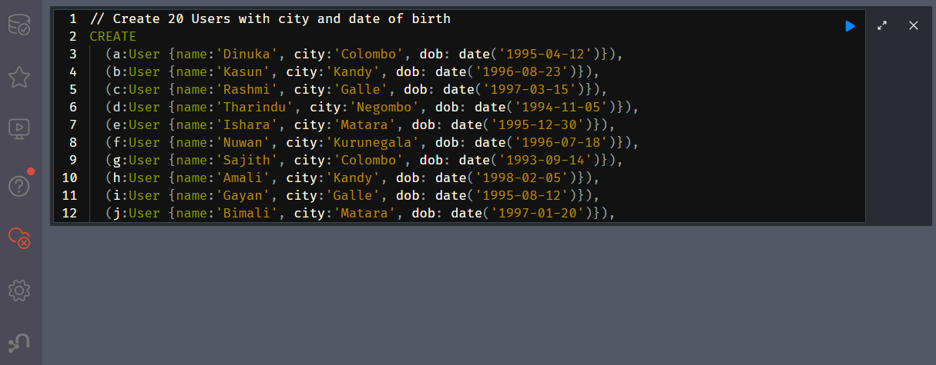
- Run above inside the Neo4j Browser Query Editor Window

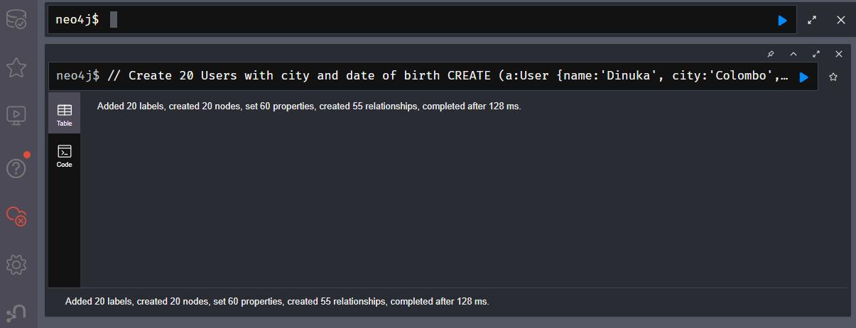

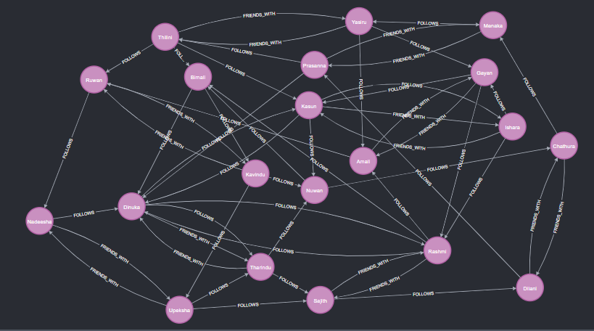
Output as a graph

- Write three Cypher queries and show the results

  - 1. Find all users connected to User ‘Dinuka’

Cypher Query
MATCH (a:User {name:'Dinuka'})--(u:User)
RETURN DISTINCT u.name AS Connected_To_Dinuka;

Browser view and Query Results

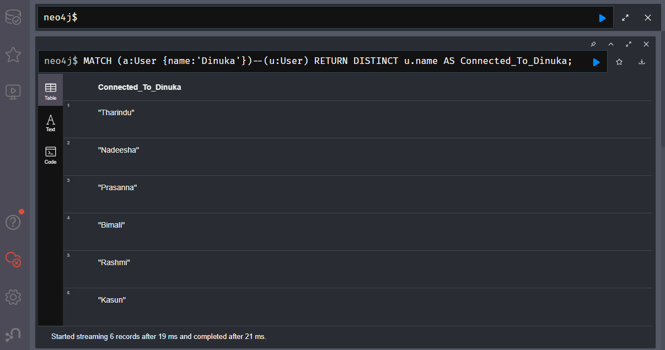

Explanation

- a and u are variable names representing nodes.
- MATCH key word is used to find patterns in the graph.
- (a:User {name:'Dinuka'}) means start by finding a node with label User and property name = 'Dinuka'
- -- (double dash) represents a single relationship of length 1. Here the relationship type (FOLLOWS, FRIENDS_WITH) and direction both are ignored. So, direction could be either au or au.
- u.name returns the name property of the connected node.
- DISTINCT key word ensures each connected user appears only once, even if multiple relationships exist between the same nodes.
- AS Connected_To_Dinuka gives the column a readable name in the results

  - 2. Find the most connected node with the relationship type = FOLLOWS

Cypher Query
MATCH (u:User)
OPTIONAL MATCH (u)-[:FOLLOWS]->(out)
OPTIONAL MATCH (u)<-[:FOLLOWS]-(in)
WITH u, COUNT(DISTINCT out) + COUNT(DISTINCT in) AS TotalConnections
RETURN u.name AS User, TotalConnections
ORDER BY TotalConnections DESC
LIMIT 1;

Browser view and Query Results

  - 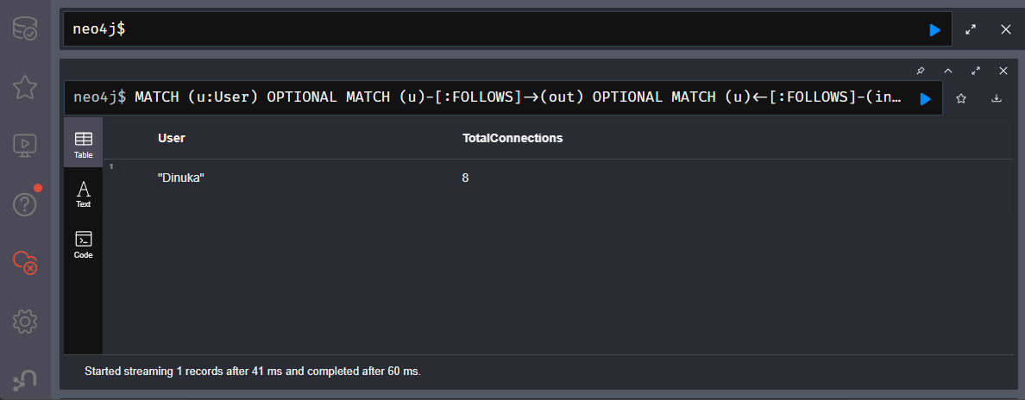

Explanation

  - 3. Indirect connections of ‘Dinuka’

Cypher Query
MATCH (a:User {name:'Dinuka'})-[:FOLLOWS*2..3]->(b:User)
RETURN DISTINCT b.name AS IndirectConnections;

Browser view and Query Results
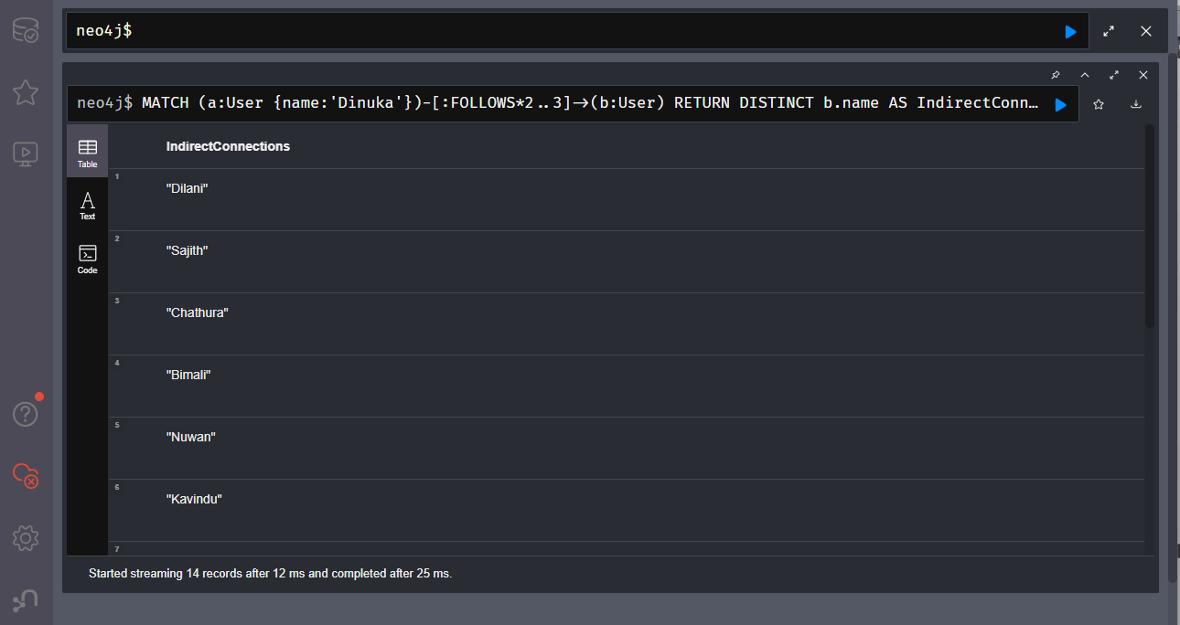

Explanation

